Module: Project Management
Module code: LCLM5003
Module Lecturer: Doreen Amundam
Assignment Title: A program portfolio
PART A: Poster
Part B: Feedback
Part C: Program Management Plan
Student Name: Monica Stancu
Student Code: 2330346

Table of Contents

- Presentation of Poster
- Feedback from the poster Presentation
- A project Management Plan

Project management Plan

- Introduction
- Project Description
- Scope
- Work Breakdown Structure (WBS)
- Quad Chart
- Gantt Chart
- Stakeholder Involvement
- Resource Allocation
- Risk Analysis
- Conclusion
- References

PART A: POSTER

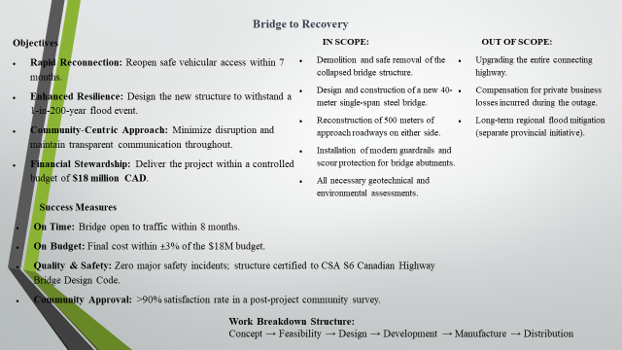

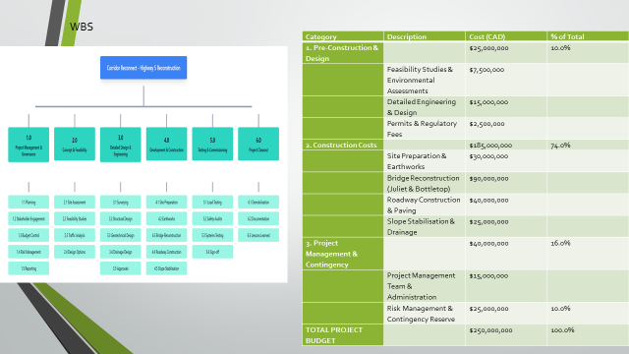
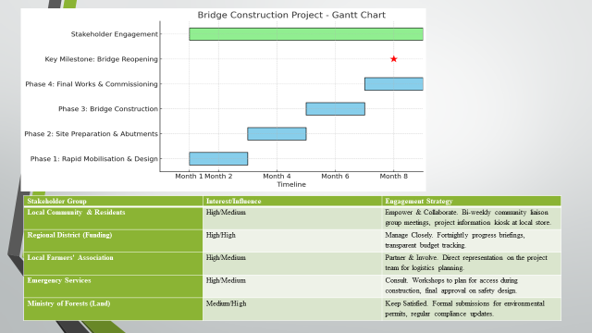

PART B: FEEDBACK
Poster presentation Evaluation Form
student number - 2330346

Content/Score | 1 | 2 | 3 | 4 | 5
Introduction/project description |  |  |  | X
Quad chart (Purpose, stakeholders, desired result, measurement) |  | X
Work breakdown structure and resources allocation |  |  | X
Presentation/Professionalism |  | X

What you did well | Introduction and project description
What needs improvement | Quad chart  Evaluation

Considering the tutor and peer feedback on my project presentation, I am also pleased that introduction and project description appeared as a strong point of my work. This recognition establishes my ability to present the situation and objectives of the project in a good way. Introduction provided clear description of the problem, justification as well as the results expected and this clearly guided the rest of the presentation. I attempted to draw the attention of my audience in a way that was properly structured and interesting to talk about the purpose of the project, which was evidently an attraction to the assessors.
However, the feedback also added that the Quad Chart and Evaluation parts should be enhanced significantly. The Quad Chart is a key factor as it is a summary of what the project is expected to accomplish, a list of the stakeholders, the expected outcomes and the expected performance. Reflectively, my initial draft was lopsided and too meager in relating the objectives to measurable outcomes. The feedback also informed me that, though I had the main objectives of the project, I was failing to show how the main objective of the project would be achieved or measured. The final project plan will be concluded by redesigning the Quad Chart to contain the clearly defined roles of the stakeholders, brief description of the deliverables, and clear performance measures in accordance with the SMART criteria.
Concerning the Evaluation section, it is, at this point, that I need to understand that I should have been more systemic in the measurement of success and progress. These responses have made me adopt a systematic system of assessment, such as the application of the Key Performance Indicators (KPIs) and the risk assessment tools, to ensure that results can be quantified and that the results can be compared against the initial targets. I will also combine qualitative and quantitative methods of evaluation to make my ultimate project assessment more credible.
The other area that I will also work on, according to peer feedback, would be visual presentation and clarity. In spite of the fact my presentation was professional, I received informal peer feedback that indicated that some of my visuals including diagrams and charts were textually intensive. Thus, I would make visual information more straightforward and make colours and designs identical in the slides to make them more interesting.
In conclusion, the experience of the feedback has been a priceless part of learning. It has taught me that there is a need to balance between conceptual clarity and technical accuracy. I am sure that with the help of the revision of my Quad Chart and Evaluation framework and with the assistance of the enhancement of my visual presentation, my final project plan will be more coherent, professional, and analytical. This reflection has, in the end, enhanced my knowledge on effective project communication and planning critical skills towards my professional growth within the business and management environments.

PART C: A project Management Plan

Corridor Reconnect: Rebuilding Highway 5 (Coquihalla)

1. Introduction
The rising occurrence of extreme weather has made infrastructure resilience a highest government priority in all parts of the world. In Canada, the British Columbia Ministry of Transportation and Infrastructure (MoTI) initiated the project Corridor Reconnect to process a 40-kilometre stretch of Highway 5 (Coquihalla Highway), the part of the highway that was severely damaged in floods in 2021. Being a key mode of transport between the Lower Mainland and the hinterland of the province, its closure had a devastating impact on the economy, social, and logistical activities in the entire British Columbia. The project is an indication of a national need to construct adaptive and climate resilient infrastructure that can withstand the upcoming environmental shocks.
The current Project Management Plan (PMP) represents a systematic, ordered process of the Coquihalla Highway restoration by following the guidelines of the Project Management Body of Knowledge (PMBOK) and PRINCE2 models (Axelos, 2023). It outlines such critical elements as project scope, work breakdown structure (WBS), quad chart, Gantt schedule, stakeholder engagement, resource allocation, and risk management strategies. This is to be achieved by the main goal of providing a strong and fully functional two-lane road system within the next twelve months and meeting a high level of safety, environmental conservation, and cost-effectiveness. Outside the restoration, the undertaking is a road map to long term resilience and reliability of the critical transport routes in Canada during a period of rising climate dangers as well as a guide to proactive management of infrastructure.

2. Project Description
The Corridor Reconnect project is created due to the catastrophic nature of the infrastructure damage which happened due to the atmospheric river event that hit southern British Columbia in November 2021. The drastic weather wiped out whole portions of Highway 5, bridges collapsed, and slopes were no longer stable leading to the effect of cutting off the travel between major areas. The British Columbia Ministry of Transportation and Infrastructure (MoTI) implemented a quick but strong reconstruction process to overcome this crisis. The project has a total budget of CAD 250 million to be financed by provincial and federal programs of disaster recovery and will be done within a period of twelve months (20232024). Its short-term aim is to have a fully operational 2 lane highway open in nine months to restore much-needed connectivity to communities and industries that rely on the Coquihalla Highway.
In addition to restoration, there is long-term resilience and sustainability incorporated in the project design and implementation process. Some of the major works were the reconstruction of the Juliet Creek and Bottle top bridges, slope stabilisation and the installation of new better drainage systems to eliminate future washouts. The project is also based on the compliance with MoTI engineering standards, safety rules, and financial discipline, i.e., spending within the range of +-5 of the approved budget (MoTI, 2023). Time, cost, technical quality, and satisfaction of the stakeholders will be used to gauge the success of the project and accountability will be established at every level. Moreover, Corridor Reconnect is consistent with the National Disaster Mitigation Program by Public Safety Canada (2022) which helps support the further involvement of the province in the construction of climate-resilient infrastructure and adaptive disaster management frameworks.

3. Scope
The scope of the project identifies clearly the activities that will or will not be part of the Corridor Reconnect initiative in order to plan, execute, and control it properly. The project includes all the necessary activities that are needed to recover the 40-kilometre stretch of the Coquihalla Highway after the damage sustained by the floods in 2021. These activities include the clearing and removal of the site, reconstruction of the Juliet Creek and Bottle top bridges, resealing and re-marking of the highway surface and installation of new drainage systems as well as slope stabilisation measures including rock bolting and meshing. The project also involves the installation of temporary traffic management and control systems to facilitate safe operations in the process of construction.
On the other hand, other factors are beyond the reach of this initiative to ensure focus and efficiency of resources. These are repairs of local access roads or of individual dwellings, long term landscaping and ecological restoration, and the widening of the highway to four lanes, which will be undertaken as part of another future development project. The most notable deliverables include a two-lane highway that will be fully operational, two new reinforced bridges constructed, improved drainage systems, stabilized slopes, and safety and engineering standards that have been adhered to. The project is limited by certain factors, such as the CAD 250 million budget, the construction periods, which are subject to weather conditions, and the environmental regulatory demands (Kerzner, 2022). It presupposes stable material supply chains and collaborative stakeholder participation, as well. These boundaries and deliverables ensure that the scope is clear, aligns with the objectives and provides good control over the project results which is in line with scope management framework of the PMBOK.

4. Work Breakdown Structure (WBS)
The Work Breakdown Structure decomposes the project into manageable work packages to improve scheduling, cost estimation, and accountability.
Level | Task Description | Deliverable | Responsible Party
1 | Project initiation | Project charter, feasibility report | MoTI Project Board
2 | Planning and design | Project management plan, permits, design drawings | Project Manager
3 | Site clearance | Cleared and secured corridor | Contractor A
4 | Bridge reconstruction | Two reinforced bridges (Juliet Creek & Bottle top) | Contractor B
5 | Pavement works | Repaved 40 km road surface | Construction Crew
6 | Drainage and slope stabilisation | Installed culverts, mesh, and rock bolts | Geotechnical Team
7 | Traffic management | Temporary traffic control systems | Traffic Engineers
8 | Inspection and handover | Quality assurance and compliance reports | MoTI Inspectors
Table 1. Work Breakdown Structure
This structure supports hierarchical management and ensures that all deliverables contribute directly to the project’s overall objectives (Nicholas and Steyn, 2020).

5. Quad Chart
The Quad Chart provides stakeholders and decision-makers with a quick reference to the project's key components.
Quadrant | Details
Purpose | Restore and strengthen a 40 km section of the Coquihalla Highway to reconnect the province after the 2021 flood disaster.
Stakeholders | MoTI, Contractors A & B, Public Safety Canada, local communities, transport operators, environmental authorities.
Desired results | Operational two-lane highway with reinforced bridges, enhanced drainage, and slope stability.
Measurement | Completion within 12 months, cost control ± 5 %, compliance with MoTI standards, stakeholder satisfaction survey results.
Table 2. Quad Chart – Corridor Reconnect
In accordance with PRINCE2 principles for benefits realisation, the chart shows alignment between strategic objectives and quantifiable success criteria (Axelos, 2023).

6. Gantt Chart
The one-year project timeline shows how important tasks are scheduled and completed.
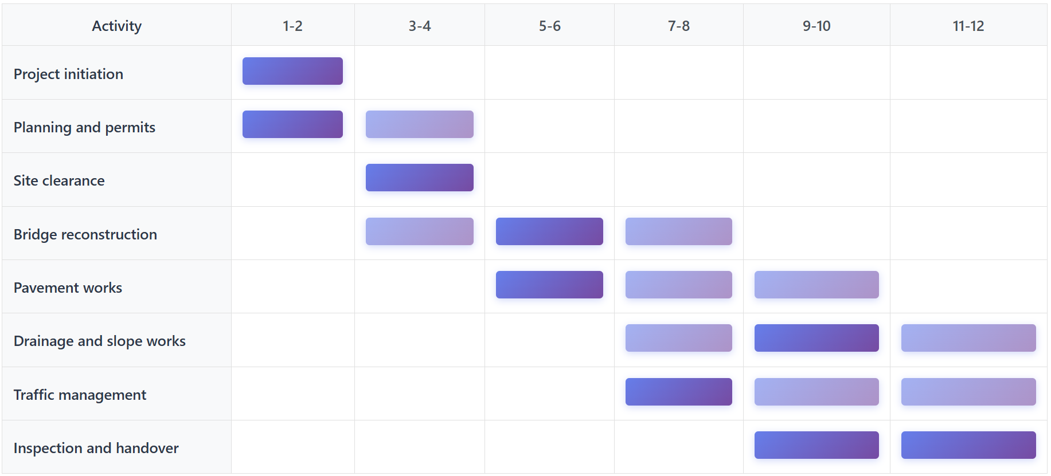
Table 3. Simplified Gantt Chart (Months 1–12)
Logical dependencies between tasks are evident in the schedule. For instance, in order to maximize time, drainage projects and bridge reconstruction partially overlap (Lock, 2021). Contingency buffers are included in the 12-month timeline to account for possible supply or weather delays.

7. Stakeholder Involvement
The stakeholder management of the Corridor Reconnect project has a significant impact on the success due to the ability to reduce conflict, increase accountability, and project goal alignment because of effective collaboration, communication, and engagement. The British Columbia Ministry of Transportation and Infrastructure (MoTI) is the main sponsor, which is leading and controlling by its Major Projects Division. Under this form of government, funding, strategic direction and approving of key decisions falls under the jurisdiction of the MoTI Project Board to keep the project in line with provincial priorities and public expectations. The Project Manager is in charge of daily coordination, reporting as well as monitoring compliance and is the main channel between the stakeholders and the team.
Contractors A and B are involved in the implementation stage, and they will be involved in carrying out the main engineering and construction activities, which include rebuilding bridges and resurfacing the highway. The construction work is facilitated by Public Safety Canada so that it is consistent with the national standards of resilience and safety, and Environmental Agencies control the adherence to sustainability and biodiversity preservation requirements. Also, local communities and businesses are involved directly caused by the highway closure and rebuilding and to make sure that their views shape the project results, local communities and businesses are consulted and their views assessed post-project. The stakeholder engagement is based on the MoTI Infrastructure Engagement Framework (2023) that provides monthly progress meetings, risk review meetings, and public communication bulletins. This formalized design facilitates openness, builds trust between all parties, and upholds ongoing conformity with the stakeholder engagement process group of the PMBOK (Burke, 2021), which builds proper governance and co-ownership of the project success.

8. Resource Allocation
The allocation of resources is core in achieving the objectives of the Corridor Reconnect project in ensuring a good balance between cost, time and quality. The project is based on a tactical blend of provincial funds, specialized human resources, and contemporary building tools in order to achieve outcomes within specific limits (Meredith et al., 2020). The project uses the so-called triple constraint model, which highlights the interdependence of time, cost, and scope management, to ensure that changes in one sphere are balanced against the other two to ensure overall integrity of the project.

Resource Type | Description | Allocated Budget (CAD) | Responsible Unit
Financial | Total project fund | 250,000,000 | MoTI Finance Division
Human resources | Engineers, supervisors, skilled and unskilled labour | 95,000,000 | MoTI and Contractors
Materials | Asphalt, steel, concrete, culverts, geotechnical mesh | 80,000,000 | Procurement Division
Equipment | Excavators, cranes, pavers, drones, monitoring systems | 45,000,000 | Logistics Unit
Contingency | 5 % risk reserve | 12,500,000 | MoTI Risk Fund
Overheads | Administration, permits, safety, and communication | 17,500,000 | Administration Unit
Table 4. Resource Allocation Summary
The distribution of human resources depends on the critical path of the project, with such specialists as structural engineers, geotechnical specialists, and environmental consultants being assigned to the phase at which their skills will have the most significant effect. This method increases productivity and reduces bottlenecks especially on high priority areas such as bridge reconstruction and slope stabilization. Digital project management tools are used to schedule and track equipment and material resources in order to optimize utilization and minimize downtime.
The procurement procedures are governed by competitive bidding processes which carry transparency, equity, and adherence to the Canadian government procurement regulations. The integration of financial discipline and strategic resource deployment will enable the project team to achieve an efficient use of the public funds and achieve the performance goals as well as hold accountable. The general objectives of the project, including the ability to meet the long-term infrastructure requirements of British Columbia, timely delivery, and fiscal responsibility, are enabled by this systematic approach to the management of the resources.

9. Risk Analysis
Corridor Reconnect project takes an organized and proactive approach to risk management with references to the ISO 31000 framework and/or MoTI Project Risk Management Guidelines (2023). This is done by evaluating the risk associates in the most systematic manner by first identifying the possible threats, evaluating the probability and the impact and devising the efficient remedies to avoid the exposure to the technical, financial, environmental, and operational risks. When the practices are incorporated at the initial stage of the project life cycle, the team is able to foresee any uncertainties and manage them within the project scope before they are allowed to impact the performance or the projects schedule.
Risk Category | Description | Likelihood | Impact | Mitigation Strategy
Weather delays | Heavy rain or snow halting construction | High | High | Build seasonal flexibility into schedule; deploy temporary covers and heating systems
Supply chain disruption | Delay in material or equipment delivery | Medium | High | Use local suppliers; maintain buffer inventory
Cost overruns | Inflation or unplanned design changes | Medium | High | Strict change-control procedures; maintain 5 % contingency
Safety incidents | Worker injuries or accidents on-site | Low | High | Comprehensive safety training, PPE, audits
Environmental compliance | Failure to meet environmental standards | Low | Medium | Ongoing environmental monitoring and reporting
Community dissatisfaction | Noise, access, or disruption complaints | Medium | Medium | Public information sessions; rapid complaint resolution
Technical failures | Structural weakness post-construction | Low | High | Independent quality assurance and third-party testing
Table 5. Risk Register
A continuous monitoring system is used by the project to monitor key risk indicators and implement timely mitigation measures with the help of early-warning reports to ensure control and flexibility (Hillson and Simon, 2020). Moreover, lessons learned are also recorded and discussed in monthly MoTI oversight meetings, a culture of continuous improvement and sound decision-making is encouraged. This cyclical process makes organizations more resilient so that present and future infrastructure projects can have an advantage of acquired experience and greater risk readiness.

10. Conclusion
The Corridor Reconnect project is a prime example of how structured project management approaches can be successfully implemented into the provision of complex infrastructure restoration that has high efficiency, safety, and sustainability. The project plan incorporates the concepts of both PMBOK and PRINCE2 which allow the execution to be disciplined by clearly delimiting the scope, hierarchy form of work breakdown structures (WBS), and scheduling time in Gantt chart. The initiative can reduce ambiguity through the development of clear deliverables, roles, and responsibilities that improve coordination among the contractors, the engineers, and the government agencies. With a risk-responsive WBS, resource allocation is kept in line with the project milestones allowing the project to respond adaptively to any arising issues.
Furthermore, the introduction of eco-friendly design, including slope stabilisation mechanisms and improved drainage systems, exemplifies a high level of the concern with long-term sustainability and the reduction of the negative impacts of disasters. The resource allocation and budgeting structure of the project facilitates financial accountability without being rigid to contingencies, but by sticking to the governance standards of MoTI. Constant risk tracking and a clear communication plan also enhance the trust of the stakeholders and build citizen trust. Finally, the project establishes a national standard of a swift recovery of infrastructure in response, and as such, it is consistent with the goals of the National Disaster Mitigation Program in Canada. Its success will not only reestablish essential economic and social connectivity between the Lower Mainland and the interior of British Columbia, but will also demonstrate how the modern project management approach can turn the recovery process into a long-term and resilience-driven solution to the problems.

11. References
Axelos (2023) Managing Successful Projects with PRINCE2, 7th edn. London: The Stationery Office.
British Columbia Ministry of Transportation and Infrastructure (MoTI) (2023) Post-Event Review: 2021–2022 Hydrologic Events and Transportation Infrastructure. Queen’s Printer, Victoria.
Burke, R. (2021) Project Management: Planning and Control Techniques, 6th edn. Chichester: Wiley.
Hillson, D. and Simon, P. (2020) Practical Project Risk Management: The ATOM Methodology, 3rd edn. Newtown Square, PA: PMI.
Kerzner, H. (2022) Project Management: A Systems Approach to Planning, Scheduling, and Controlling, 13th edn. Hoboken, NJ: Wiley.
Lock, D. (2021) Project Management, 12th edn. London: Routledge.
Meredith, J. R., Mantel, S. J. and Shafer, S. M. (2020) Project Management: A Managerial Approach, 10th edn. Hoboken, NJ: Wiley.
Nicholas, J. M. and Steyn, H. (2020) Project Management for Engineering, Business, and Technology, 6th edn. London: Routledge.
Patel, R. and Kim, J. (2021) ‘Rapid-Response Infrastructure Reconstruction: Methodologies for Post-Disaster Recovery’, International Journal of Project Management, 39(5), pp. 512–525.
Public Safety Canada (2022) National Disaster Mitigation Program: Case Study on Resilient Infrastructure. Government of Canada Publications.
Project Management Institute (2021) A Guide to the Project Management Body of Knowledge (PMBOK Guide), 7th edn. Newtown Square, PA: PMI.

