Faiz Khan
2221958
reflective Journal Support Link Project

Contents
Introduction 2
Scope of my contribution 2
Team performance and collaboration 3
Personal reflection 4
Technical Reflection 5
Limitations and risk factors 6
Related works & References 8
Future Work 8
Conclusion 9
Bibliography 10

Introduction

As part of our team project for the Hackathon, I worked on a digital initiative called Support Link, a platform designed to connect individuals with local charities, services and facilities. The project aimed to reduce barriers faced by people experiencing homelessness or hardship. My specific contribution was managing the social media and outreach strategy. This reflective journal discusses my experience, my contribution, team dynamics, technical and personal reflections, as well as challenges and limitations we faced.

Scope of my contribution

My main responsibility was to plan, set up and manage the social media platforms for Support Link. I created and used both X.com and Facebook pages designing the layout with consistent branding using our logo and colour palette and writing accessible, empathetic content tailored to our target users. Posts included project updates, awareness messages, inspirational quotes and links to relevant services.
[1] “As stated by Gather they say, Consistency helps your audience recognise your brand instantly. Over time, a strong, recognisable brand builds trust. When people see familiar elements, including your logo, colours, or style- they feel reassured that your brand is reliable and professional.” So, this shows if you have a good colour scheme and you kept it consistent, this will make the brand well known and people will like it.
I also contributed to the marketing plan, specifically through social media premotion. I worked closely with Ellise to ensure that our online outreach reflected the values of the project. In team presentations, I explained how digital platforms can increase visibility and promote access to support service in a stigma-free, user-friendly way.

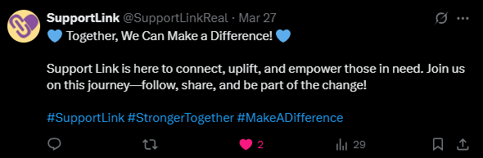

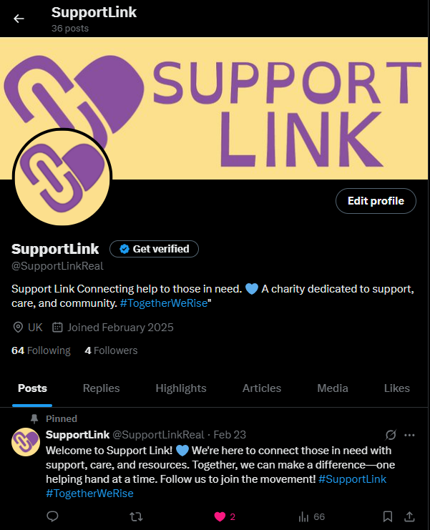

Team performance and collaboration

Overall, our team functioned very well, with a clear division of roles:
- David, I, Che and Kai worked on the web development aspects.

- Ellis and I collaborated on marketing.

- Daniel and Ellis led the design.

- Kai and Che handled the database.

- David also supported logistics and finances.

We used Discord for regular updates and shared Word documents to collaborate effectively. We also held weekly meetings every Thursday in the library where David booked a room for us to work together and plan the next steps. These group sessions helped us stay focused, sharing tasks and support each other’s as we worked toward our final presentation.
One of the main strengths of our group was that everyone had a defined role and contributed based on their skills. While there were occasional scheduling conflicts due to classes, this didn’t impact our progress because we maintained strong communication and adapted when needed. We worked together consistently and stayed motivated throughout the project which made the final presentation a success.
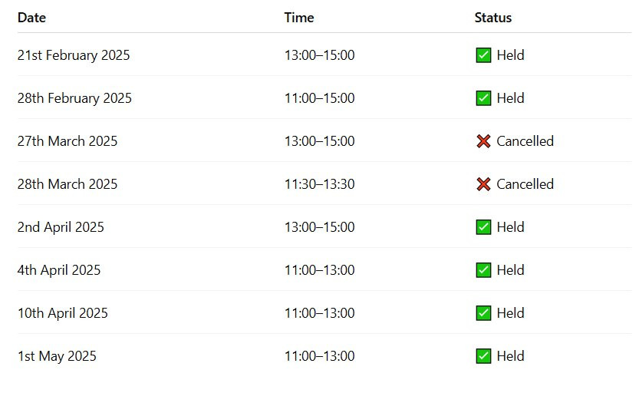

Team Rating: 5/5
Everyone contributed meaningfully. We communicated very well and we delivered the project as a team with strong collaboration and shared commitment.

Personal reflection

Working in a team taught me the importance of adapting communication style especially when coordinating with members who were juggling other tasks. I also realised how powerful social media can be in shaping a message and creating trust, especially for vulnerable communities.
Creating social media content wasn’t just about promotion, it was about building a safe supportive tone. I researched the best practices for writing posts that avoid stigma and foster inclusiveness, such as using respectful language, community-focused messaging and positive imagery. [2] “As stated by Mueen Ahmed KK he says, Social media platforms have the potential to be potent allies in the fight against mental health stigma. Through campaigns, collaborations, and the creation of supportive online communities, social media can foster empathy, understanding, and acceptance of mental health challenges.” So, this shows that some social media community help vulnerable people with improving their mental health and supporting them.
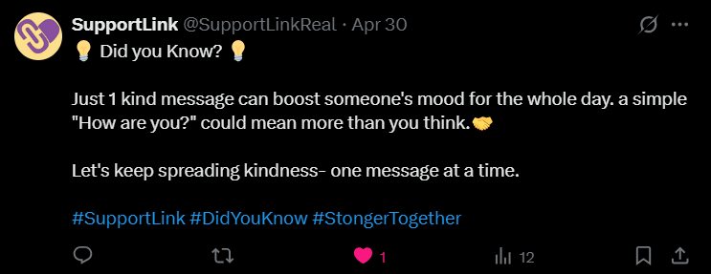
This project also taught me how to align marketing content with the mission of good social media project, rather than thinking about likes or follows.

Technical Reflection

Although my main focus was social media, I also gained experience working with the website team, particularly understanding how the user interface and mobile-friendliness affected how we linked from social media platforms to the site. I was involved in discussions on how the location-based search and offline accessibility features would work. This helped me understand the back-end limitations, such as needing reliable geo-location data and ensuring that pages load quickly, even with slow internet connections.
From a technical standpoint, using platforms like X.com and Facebook also required me to think about character limits, images sizing and post scheduling element, I had not previously considered in detail. I also learned how to interpret basic analyses where I created google forms and posted it to the social media platforms.
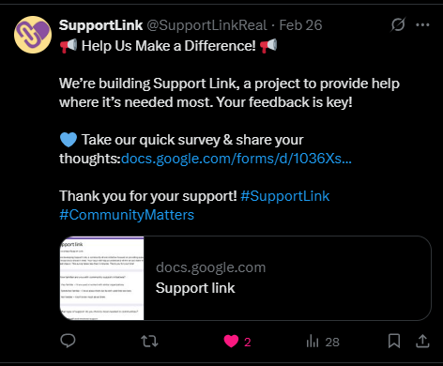
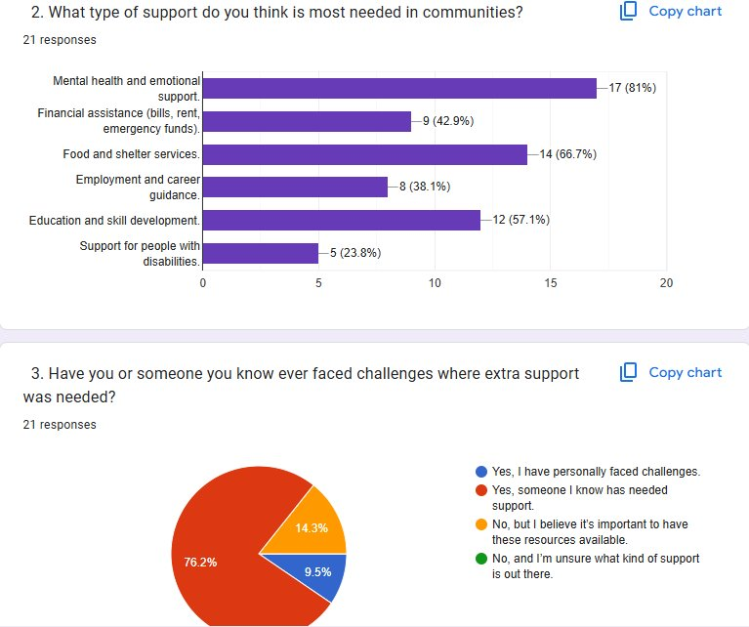

Limitations and risk factors

Despite our success, there were clear limitations:
- Reach of social media

While we set up professional-looking pages, we couldn’t gather many followers due to time constraints. Realistically, building a genuine audience would take weeks or months, not days.

- Content Scheduling & Management

All social media posts were done manually by me. Without automated tools, maintaining consistent, well-timed content was time-consuming and less efficient. For a full launch, we’d need a structured posting schedule and possible additional support to manage engagement.

- Data Accuracy

Our posts included general information about support services but the accuracy and regular updating of this content would be essential in real-world platform. This raises long-term maintenance and responsibility challenges.

- Offline Access

While our website is mobile-friendly and works on smartphones users would still need to actively search for it online. This presents a challenge for individuals who aren’t aware of the platform or don’t regularly use the internet.

It highlights a limitation in relying solely on digital outreach and suggests that future versions of the project could benefit from local awareness campaigns or partnerships with community to help spread the word.
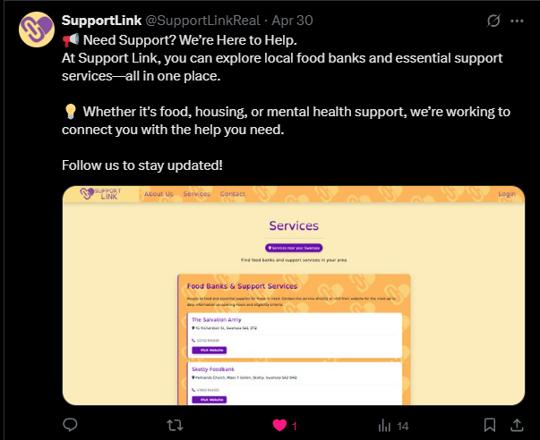

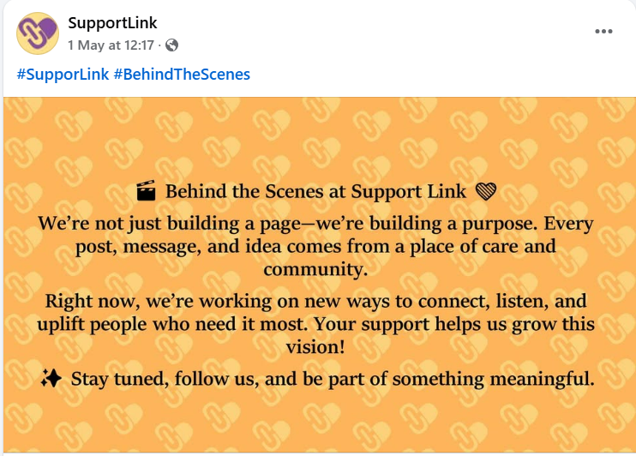

Related works & References

To guide my approach, I referred to:

- Gather (2025) – On the importance of consistency on social media

- Mueen Ahmed KK (2023) – The role of social media platforms in addressing mental health stigma

Future Work

If I were to continue the project, I would propose:
- Expanding to Instagram or TikTok for younger audiences.

- Collaborating with local influencers or partner charities to improve reach.

- Using automated post scheduling tools.

- Introducing a community blog with service stories, testimonials, or updates.

Conclusion

This project was a valuable learning experience both technically and personally. It pushed me to think beyond traditional social media and consider the real impact of digital outreach in a social care context. While we faced challenges in communication and scale, I’m proud of the role I played in building the voice and presence of Support Link. The experience reinforced the importance of empathy, teamwork and accessible design in teach-based charity work.

Bibliography

[1] | Gather, “Why Consistent Branding is Key on Social Media,” Gather, 03 January 2025. [Online]. Available: https://www.gathersocial.co.uk/blog/why-consistent-branding-is-key-on-social-media#:~:text=The%20Importance%20of%20Consistency%20on%20Social%20Media&text=Consistency%20helps%20your%20audience%20recognise,brand%20is%20reliable%20and%20professional.. [Accessed 03/05/2025 May 2025].
[2] | M. A. KK, “The Role of Social Media Platforms in Addressing Mental,” Cabidigitallibrary, 2 April 2023. [Online]. Available: https://www.cabidigitallibrary.org/doi/pdf/10.5555/20230397008#:~:text=Social%20media%20platforms%20have%20the,acceptance%20of%20mental%20health%20challenges.. [Accessed 04/05/2025 May 2025].

