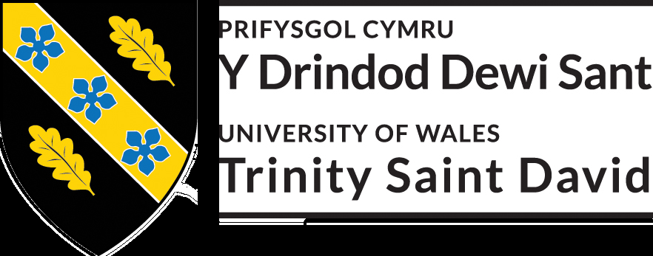

ASSESSMENT 2
CASE STUDY

EFFECTIVE TEAMWORK & COMMUNICATION BMSW4002 (C2)

RUJI BEGUM 1915094
UWTSD
FRIDAY 3RD JULY 2020
LECTURER MELANIE SQUIRE

CONTENT PAGE
INRODUCTION.............................................................................. 1
TERM OF REFERENCE................................................................... 2
IMPORTANT OF COMMUNICATION IN ORGANIZATION.............. 3
IMPORTANCE OF VERBAL AND NON-VERBAL ............................ 3.1
THE COMMUNICATION PROCESS.................................................3.2
CHARACTERISTIC OF FEEDBACK....................................................3.3
COMMUNICATION BARRIERS........................................................4
TABLE.............................................................................................4.1
TEAMWORK THEORIES IN THE ORGANIZATION............................5
CONCLUSION.................................................................................6

INTRODUCTION

Working in an expanded Café means working in a fast-paced environment that needs staffs to think and react to any tasks quickly and being able to make decisions fast. To run the café smoothly interactive relations of communication amongst the staff themselves. Communication is a major role in teamwork. Also, Effective communication within the workplace plays a significant impact on success of the organization.
Building strong rapports with everyone in the organization will build loyalty their employees and engage better with good productivity.
After researching different articles and websites relating to this café matter, using the theories and models of the authors and researchers like Claude Shannon (1948) Warren Weaver (1949) and Bruce Tuckman (1965) Meredith Belbin (1969) I will be able to direct the café supervisor on running the café smooth and effectively.

PAGE 1

TERM OF REFERENCE
Karen Jones and Simon Phillips are the owner of a busy café shop in Swansea city centre. The big café currently employs 21 staff members ranging in age and experience. In the café there are ten waiting staffs, three cleaners, three cooks, one pot washer, two shift supervisors, Karen, and Simon act as general managers. The staffs working at the café are all part-time, working different hours. The store opens between the hours of 8.00am-7.00pm Monday to Saturday. All the waiting staff have different primary duties, this includes serving customers, taking orders, taking payments and barista duties.
The business was just a small coffee shop that has grown rapidly over a matter of year, employing only five people. The rapid expansion and moving to a bigger premise meant having more employees to ensure the business runs smoothly. With One waiting staff being on a long-term sickness, only ad hoc may work a shift, this might cause miscommunications between them.

PAGE 2

The importance of two ways communication in organization
Communication is a major role in different facets of human life. From the 20th century, different scholars have studied many angles of mathematics, psychology, system analysis, etc. The first model for communication was developed by Claude Shannon (1948) and introduction by (Warren Weaver) to be published. Using the basic methods of communication is a process of sending and receiving messages. Two-way communication is creating a better environment, where people can share thoughts and ideas and opinions, this also improves the relationships. The two-way communication is needed to solve problems in a better way.
Shannon Weaver (1948) models
sender (Information source), is the person who makes, selects the channel and sends the Message,
Encoder (Transmitter), encodes and changes the message into signals,
Channel used medium to send message.
Decoder (receiver) machine used to change signals or binary data to message. the receiver then changes the message to signals.
Receiver (Destination) person receives the message and delivers gives feedback to the message.
Noise a physical disturbance like people, environment that does not let the message deliver the way it was sent.

Importance of verbal and non-verbal communication
To communicate effectively through spoken language and nonverbal methods. Communication is used in different types of elements. (details above) Defining the non-verbal as action sent or interpreted as intentional are sent or received and get feedback from the receiver. Verbal and non-verbal communication is learnt over time and is known in different ways to culture. (Burgoon, Boiler & Woodall, 1988) what creates a very strong connection with the language and non-verbal codes to make an effective communication as they both have a similar symbols and behaviours.
Non-verbal function plays a different role to convey personal identity, emphasise to help relay message and display emotions.

PAGE 3

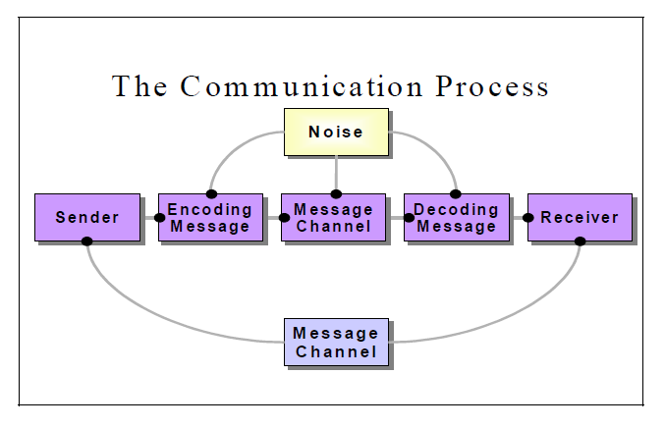
figure 1. The communication process (Jasmin Adili 2011)
The model demonstrates explains how communication works together to create the process. The process includes to parts sender and receiver. Sender is also known as the communicator is the one will communicate by encoding the message they want to send and the receiver, receives information and translates into meaning with their understanding.

Table 1. Characteristic of feedbacks for effective and ineffective Interpersonal communication in Human Management (Luthans 2011)
EFFECTIVE FEEDBACK | INEFFECTIVE FEEDBACK
Intended to help the employee | Intended to belittle the employee
Specific | General
Descriptive | Evaluative
Useful | Inappropriate

Timely | untimely
Employee readiness for feedback | Makes employee defensive
Clear | Not understandable
Valid | Inaccurate

Communication barriers
sometimes communication is not easy due to communication barriers. This prevents from message being sent properly and ineffectively causing it to misunderstandings. With noise and disturbance in communication (in environment) might be obstacle in the message being sent to the receiver. To avoid with issues like this in the café some cafes, have wireless order taking pads for the waiters to reduce them from running back and forth from the kitchen. This has a benefit of productivity in the business, it can also have a disadvantage sometimes with poor wireless connection.
Within the café working in the kitchen or the weather being too hot or cold can affect in communications due to staffs may feel tired or getting distracted. This causes the sender unable to send the message effectively which then sends limited message the receiver. (Guo & Sanchez 2005)
Another communication barrier is called semantic and language barriers. This barrier is linked with an individual person knowing of each word and what is means. Verbal and non-verbal communications are understood to be the most powerful and commonly used methods in communication. How does the language cause barriers with communication process? With verbal language it contains more than one meaning with one word while different words can be pronounced same way. This can be hard to understand during a conversation. I make it more precise emotional, cultures barriers, educational backgrounds process dissimilar linguistic understanding.

table 2. The stage of an individual’s receiving the message (Rai 2008)
Noticing  The physical stage | Being aware of the message sent to the receiver by his senses
Understanding  The intelligent stage | Being able to understand the language in the message. Ideas and concepts in the message must be within the readers knowledge
Acceptance | Emotional response of the receiver towards his message. Emotional may cause misunderstanding or fail to understand the message being sent

PAGE 4
How teamwork theories in the organization can improve teamwork
Forming- Storming Norming- Performing
The above model was developed by Bruce Tuckman (1965) known to develop team theories and formed ideas. Tuckman’s (1965) theory explains the way to deal with team task with initial formation after completing a project. All these phases are important for the team to grow, deal with problems, face challenges, plan work, get solutions and show the results. A fifth phase was added later by Tuckman to cover and finish of the project. (Adjourning and Transforming)
forming team member work independently, they are motivated best behaviour and focused on themselves. They learn about new ideas, challenges, then agree with the goals to achieve them. Storming the next step team development, teams sort itself out and start to build trust in each other. They voice opinions and sometimes this as a result can cause conflict between team. Norming, with this theory the team share the same goals. They have ambition to work towards success. They start tolerating and take team members the way they are and move forward. Performing, achieving common goals and sometimes reach higher level of success unexpectedly. At this stage they are motivating and have knowledge, make decision without supervision.
Communication in the organization is a big concept that compromises activities of communication which takes place in the organization. This operates sending information in a different pattern within the organization.
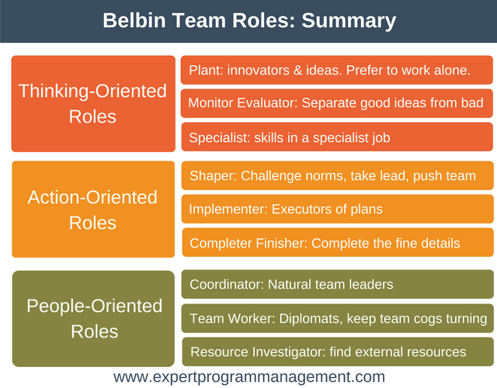

PAGE 5
CONCLUSION
With using the most of above theories the café can improve in teamwork. This will also help the supervisor to able to manage the teams effectively and smoothly. As a result of one waiter being on a long-term sickness, this leaves with one worker down in the café. After analysing the case study, I have concluded with using the theories and models on listed above the Café still can be managed and run effectively.
What I would suggest to the owner of the café Karen Jones and Simon Phillips is to have two supervisors but not on same shifts who they could liaise with on the day to day running of the place. The manager will liaise with the supervisor and the supervisor will liaise with the front staff, that way the managers can concentrate on the most important part of the business which is the customers. For example a member of staff is off sick, the managers will tell the on duty superiors that a member of a staff being on sick and then this information will be passed by the supervisor to all the on duty staff members , that way the staff will know that they will need to cover their own work and share the off duty staff work too. That way the place will run smoothly. All member of staff in the café will need day to day information and that information must be shared through good communication.
The head chef will be in charge on day to running of the kitchen. Who will have a second chef he will liaise with. The head chef will delegate to the second chef who will then delegate to the rest of the kitchen staffs.

REMEMBER

WHAT? WHAT DO YOU REALLY WISH TO COMMUNICATE?
WHOM? TO WHOM DO YOU WISH TO COMMUNICATE?
WHY? WHY DO YOU NEED TO COMMUNICATE?
HOW? HOW CAN YOU BEST COMMUNICATE?
WHEN? WHEN IS THE BEST TIME TO COMMUNICATE?

PAGE 6

