
OME – Systems Engineering, Systems Thinking Design Report (ACDA5021)

23/04/2026

Nathan Rowe - 1910544
Declaration
I declare that this report is the product of my own work and is not being submitted for any other degree etc.

Contents
1 Introduction 1
2 Systems Engineering Approach and Toolset 1
3 Customer Requirements 2
3.1 Explicit Requirements 2
3.2 Derived Safety Requirements 2
4 Critical System Functionality 3
5 Concept and Design Choices 3
5.1 Concept Exploration Using SE Tools 3
5.2 Safety Design Choices 4
6 Identifying Failure Modes 4
7 Identifying Critical Design Features 5
8 Manufacturing 5
9 Identifying Critical Processes 6
9.1 Process Control Measures 6
10 Disposal 6
11 Conclusion 7

References

[1] | HSE, MIL-STD-882E, 2001.
[2] | D. Holley, “Systems Engineering map,” [Online]. [Accessed 2026].
[3] | D. Holley, Systems Engineering Case Study, 2026.
[4] | UNMAS, Guide for the application and development of International Mine Action Standards, 2003.
[5] | IEC 60812, Taguchi, 1993.
[6] | ISO, Quality Management Systems - Requirements, 2015.

Introduction
This report describes the application of established Systems Engineering (SE) tools to the development of a conceptual solution for a mine-detection, clearing, and marking system, intended to enable the safe passage of medical supply convoys through a mined route in desert terrain. The work was undertaken as part of a multidisciplinary team.
The operational scenario presented a combination of constraints and requirements. A humanitarian medical convoy must traverse a mined area located within a steep‑walled pass, where diversion is impractical, aerial support is prohibited due to a persistent MANPAD threat, and ground mobility is limited to light vehicles such as Land Rovers and Hilux pickups. The convoy must pass quickly, with minimal delay, and the cleared route must remain safe for subsequent civilian traffic with no specialist support available.
The Safety Lead role was responsible for ensuring that hazards associated with detection, clearance, marking, manufacture, and end‑of‑life disposal were identified, assessed, and mitigated to a level that could be justified as As Low As Reasonably Practicable (ALARP). The ALARP principle is a recognised basis for proportional risk reduction in UK and international safety practice [1]. This required early integration of safety considerations into the design process using SE tools, so that safety informed concept selection and design decisions could be made.
This report explains how the SE toolset was used to support the design process through identification of key customer requirements, critical system functionality, concept derivation, potential failure modes, critical design features, manufacturing considerations, process controls, and disposal. All discussion is framed from the Safety Lead perspective.

Systems Engineering Approach and Toolset
A structured SE approach using the supplied [2] toolset as shown in [Figure 1] and was adopted to manage the full design lifecycle of the product. Due to project time constraints, not all system functions were decomposed in full depth, and functional means analysis was applied to safety‑critical areas.
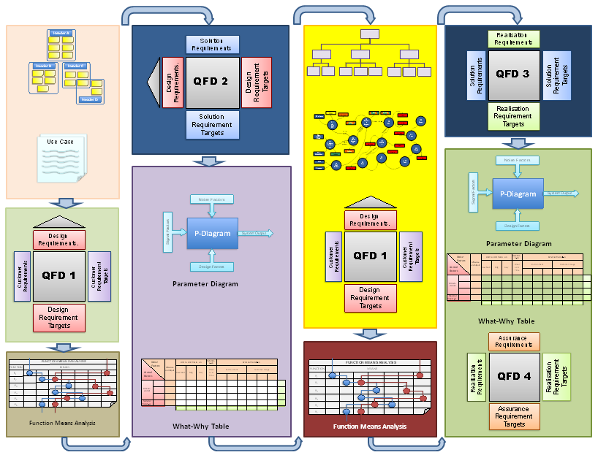
Figure 1 - Systems Engineering Toolset
The SE toolset was applied to conduct the following activities:
- Stakeholder and customer requirements analysis
- Creation of safety requirements
- Functional decomposition and functional flow
- Concept generation
- Design comparisons and selection
- Hazard identification and qualitative risk assessment
- Identification of safety‑critical features
- Lifecycle safety consideration
The SE framework enabled traceability between hazards, requirements, functions, and design decisions. For a system operating near civilians and humanitarian convoys, this traceability was essential for achieving justified risk reduction instead of relying on assumptions.

Customer Requirements

Explicit Requirements
From the project brief [3], the following customer requirements were identified:
- Enable safe passage of light civilian vehicles through a mined route
- Operate within steep-walled desert terrain where diversion is not feasible
- Avoid use of helicopters or aerial systems
- Be transportable and deployable using light vehicles only
- Clear and mark a route rapidly to minimise time on operation
- Leave the route safe for subsequent non‑specialist civilian use
These requirements defined the operational envelope but did not fully define the safety constraints required to achieve them.

Derived Safety Requirements
A structured What–Why analysis was used to examine the underlying functions behind the explicit customer requirements as given in [Figure 2]. This ensured that operational demands such as rapid route clearance and non‑specialist civilian use were traced to their fundamental safety implications, including minimised hazard exposure, predictable system behaviour, and controlled residual risk. The result directly informed the origin of safety requirements applied as constraints during concept development, some of which are listed as follows:
- Minimal use and carriage of energetic materials at forward locations
- Tolerance to small‑arms fire and fragmentation without inadvertent hazardous effects
- Fail‑safe behaviour in the event of mechanical or system malfunction
- Minimised exposure of personnel to mined areas during detection and clearance
- Avoidance of residual unexploded or hidden hazards following clearance
These derived safety requirements became constraints on concept development and ruled out some existing mine‑clearance approaches at an early stage.
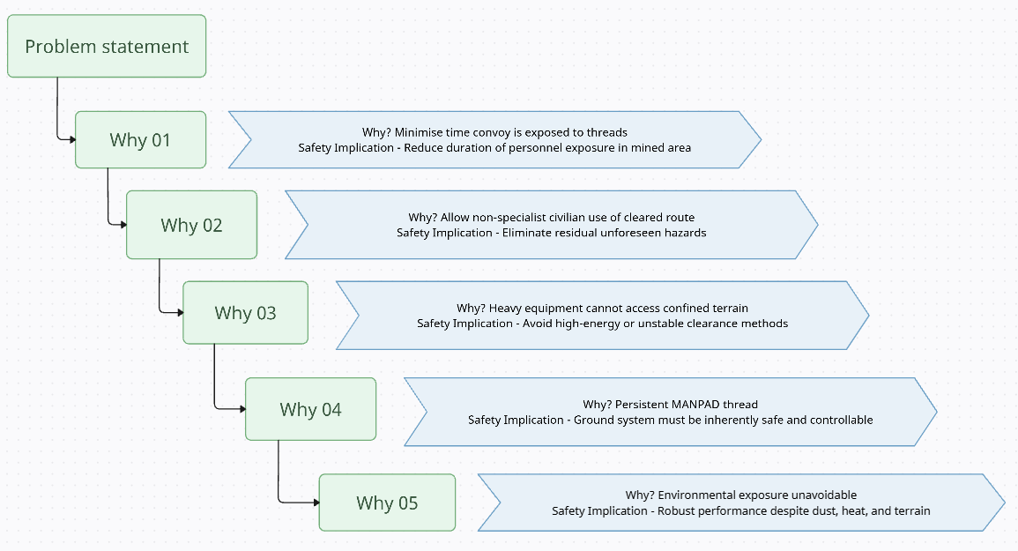
Figure 2 - What-Why Diagram

Critical System Functionality
Functional decomposition was used to identify what the system must do before determining how it might be implemented. From a safety perspective, the following critical system functions were identified:
- Detect potential mine threats within the route corridor
- Neutralise or remove hazards sufficiently to allow safe vehicle passage
- Mark cleared routes clearly and unambiguously
- Maintain system stability and control on uneven terrain
- Prevent unintended hazardous initiation or escalation
- Transition to a safe state following failure
Separating function from implementation allowed the team to explore concepts without prematurely committing to unsafe or impractical solutions. This functional analysis was particularly important in avoiding reliance on methods unsuitable for light‑vehicle deployment or contested environments. These functions were treated as safety‑relevant and informed subsequent hazard identification and concept trade‑off activities.

Concept and Design Choices

Concept Exploration Using SE Tools
A range of mine clearance methods and technologies were considered at high level through a functional means analysis. This excluded the use of a Python‑style clearance system, as it directly conflicted with the deployment and safety constraints defined in the project brief. Humanitarian clearance standards discourage heavy or high‑energy systems where they introduce disproportionate risk or logistical burden [4].
Using systems‑engineering trade‑off analysis, each concept was assessed against safety, deployability, manufacturability, speed, and lifecycle risk. Concepts requiring heavy vehicles, extensive logistical support, or large quantities of energetic material were rejected early due to incompatibility with safety requirements and operational constraints.

Safety Design Choices
Concept selection prioritised:
- Reduced reliance on high‑energy clearance methods
- Solutions compatible with light‑vehicle transport and operation
- Concepts that limited secondary hazards such as fragmentation, blast, or residual unexploded material
- Predictable and repeatable behaviour, even if peak clearance rate was reduced
The selected concept represented a balance between rapid clearance and controlled risk, demonstrating how safety considerations influenced architecture rather than constraining it after the fact.

Identifying Failure Modes
Potential failure modes were identified using a Parameter Diagram (P‑diagram) approach as used in [5] is given in [Figure 3].
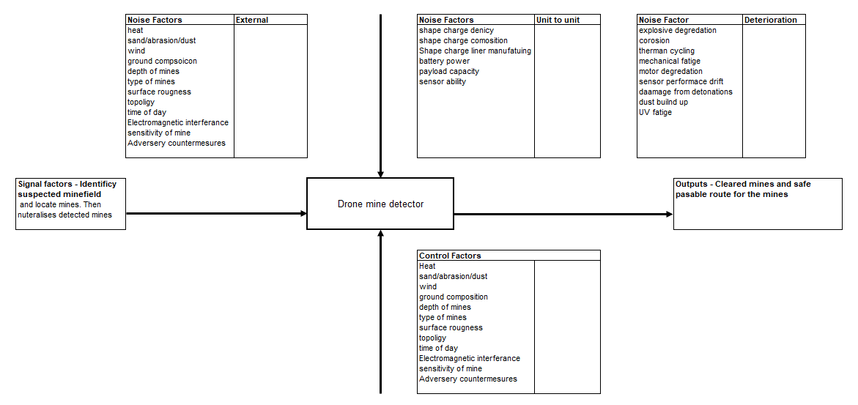
Figure 3 - P-diagram
This enabled systematic consideration of system inputs, intended outputs, control factors, and sources of variation. This supported early identification of failure mechanisms driven by loss of control, environmental influence, or design sensitivity.
- Key failure modes included:
- False negatives during detection leading to uncleared hazards
- Mechanical failure resulting in loss of vehicle control in confined terrain
- Inadvertent activation due to environmental factors
- Misinterpretation or loss of route marking
- System immobilisation causing obstruction within the pass
Each failure mode was assessed qualitatively in terms of severity and likelihood. High‑consequence, low‑tolerance failures were targeted for mitigation during design concept planning.
The impact of uncontrolled variation was further examined using a noise factors analysis. Environmental conditions such as terrain irregularity, soil composition, temperature, dust, and operational factors including vehicle alignment and operator variability were identified as significant contributors to performance degradation. These noise factors were treated as credible sources of detection failure and informed conservative safety assumptions within the design.

Identifying Critical Design Features
From the hazard and failure analysis, several safety‑critical design features were identified, including:
- Features ensuring stability and control on uneven or confined terrain
- Detection system performance thresholds tied to safe clearance assumptions
- Marking methods resistant to environmental degradation
- Physical separation and shielding of hazardous elements
- Design features enforcing safe states under fault conditions
The systems‑engineering process ensured these features were explicitly recognised and treated as safety‑critical, with implications for verification and manufacturing control.

Manufacturing
From a safety standpoint, manufacturing considerations were integrated early. A first‑stage Quality Function Deployment (QFD) analysis, focused on manufacturing, was applied to translate customer and safety‑derived requirements into critical engineering and manufacturing characteristics, as given in [Figure 4]. This supported prioritisation of robustness, simplicity, and tolerance to variation. Manufacturing variability is a recognised contributor to latent safety hazards, with errors in fabrication and assembly frequently introducing risks that are not evident during operational design analysis [6]. From a safety perspective, this was particularly important, as hazards often arise during manufacture and assembly rather than operational use.
Designs requiring complex or tightly controlled manufacturing environments were deprioritised in favour of robust repeatable processes.
Manufacturing Functionality | Importance | Select manufacturing approach | Fabricate structural components | Assemble system | Integrate Sub-systems | Integrate explosive components | Quality assurance | Manufacture at scale | Control manufacturing cost | Enable field repair manufacture | Package for transport | Dispose of manufacturing waste
Manufacturing Requirements
Low cost Manufacture | 1 | 9 | 3 | 3 | 3 | 3 | 3 | 9 | 9 | 3 | 1 | 1
Rapid Manufacture | 4 | 9 | 9 | 9 | 9 | 9 | 9 | 9 | 3 | 1 | 1 | 1
Simple assembly | 3 | 3 | 9 | 9 | 9 | 3 | 3 | 9 | 3 | 9 |  | 3
Scalable production | 3 | 9 | 9 | 9 | 9 | 3 | 3 | 9 | 3 |  |  | 3
Quality and repeatability | 5 | 3 | 9 | 9 | 9 | 9 | 9 | 9 | 3 |  | 1
Supply Chain robustness | 4 | 3 | 3 | 9 | 3 | 9 | 3 | 9 | 9 | 3 | 3
Safe Manufacture | 5 | 9 | 3 | 9 | 9 | 9 | 9 | 9 | 9 | 3 | 9 | 3
Ease of repair | 2 | 3 | 3 | 3 | 3 | 1 | 1 | 1 | 3 | 9
Figure 4 - QFD 1 Manufacturing

Identifying Critical Processes
A process importance assessment was conducted to identify manufacturing and integration steps where variation or error would have a disproportionate impact on safety and system integrity, as given in [Figure 5]. This analysis informed prioritisation of critical processes requiring enhanced control, verification, and oversight as part of the safety strategy.
Critical process steps were identified and are given in [Figure 5].

Figure 5 - Manufacturing Process Importance Chart

Process Control Measures
These steps informed both design simplification and identification of necessary process controls.
Applying the hierarchy of risk controls, the Safety Lead promoted:
- Inherent safety through design simplification
- Engineering controls to limit hazardous exposure
- Environmental and quality controls during manufacture
- Procedural controls only where design mitigation was not feasible
Residual risks were explicitly acknowledged, documented, and assigned ownership, supporting a defensible ALARP position consistent with safety-engineering best practice.

Disposal
End of life (EOL) considerations were addressed as part of the overall system lifecycle. Disposal and removal from service were recognised as hazardous phases.
Safety driven design decisions reduced EOL risk by:
- Minimising hazardous materials within the system
- Enabling disassembly without specialist equipment
- Avoiding creation of long‑term residual hazards in cleared areas
This was critical given the humanitarian context and the likelihood of continued civilian interaction with the environment.

Conclusion
The application of a structured systems‑engineering toolset enabled the development of a mine detection, clearing, and marking system concept that balanced operational necessity with safety and lifecycle responsibility. From the Safety Lead perspective, the SE framework ensured that hazards were identified early, design decisions were informed by risk, and safety considerations were embedded into requirements, functions, and concept selection.
The approach demonstrated that safety is a critical enabler of robust, deployable solutions in constrained operations. Continued use of this systems engineering approach is recommended for future concept development and qualification phases, with more time being allowed to be spent conducting sub-system decomposition.

