Lab – Understanding Ethernet Cable Standards
Topology
Addressing Table
Device | Interface | IP Address | Subnet Mask | Default Gateway
PC-A | NIC | 192.168.10.1 | 255.255.255.0 | N/A
PC-B | NIC | 192.168.10.2 | 255.255.255.0 | N/A
Objectives
Part 1: Analyze Ethernet Cabling Standards and Pinouts
Part 2: Build an Ethernet Crossover Cable
Part 3: Test an Ethernet Crossover Cable
Background / Scenario
In this lab, you will build and terminate an Ethernet crossover cable and test it by connecting two PCs together and pinging between them. You will first analyze the Telecommunications Industry Association/Electronic Industries Association (TIA/EIA) 568-A and 568-B standards and how they apply to Ethernet cables. You will then construct an Ethernet crossover cable and test it. Finally, you will use the cable you just constructed to connect two PCs together and test it by pinging between them.
Note: With autosensing capabilities available on many devices, such as the Cisco 1941 Integrated Services Router (ISR) switch, you may see straight-through cables connecting like devices.
Required Resources
- One length of cable, either Category 5 or 5e. Cable length should be 0.6 to 0.9m (2 to 3 ft.)
- 2 RJ-45 connectors
- RJ-45 crimping tool
- Wire cutter
- Wire stripper
- Ethernet cable tester (optional)
- 2 PCs (Windows 7 or 8)
- Analyze Ethernet Cabling Standards and Pinouts
The TIA/EIA has specified unshielded twisted pair (UTP) cabling standards for use in LAN cabling environments. TIA/EIA 568-A and 568-B stipulates the commercial cabling standards for LAN installations; these are the standards most commonly used in LAN cabling for organizations and they determine which color wire is used on each pin.
With a crossover cable, the second and third pairs on the RJ-45 connector at one end of the cable are reversed at the other end, which reverses the send and receive pairs. The cable pinouts are the 568-A standard on one end and the 568-B standard on the other end. Crossover cables are normally used to connect hubs to hubs or switches to switches, but they can also be used to directly connect two hosts to create a simple network.
Reflection:
Write a research report (Max word count 600) on Cat 5e and 6 Ethernet cable standards.

Ethernet cables

Introduction
In the beginning of the 2000s cat 5e was introduced and become the standard networking cable, cat 5e was 10x faster than the cat5 cables which were available at the time. Not long after cat 5e was introduced cat6 was made which better performance and speed compared with cat 5e. both cat 5e and cat 6 are backward compatible [1] which means they are both available to work with older equipment, this makes the transfer over cheaper and more efficient. There aren’t many visual differences between cat 5e and cat 6 other than cat 6 uses copper wiring, however you can identify which one you are using as most of them have the category printed on the side of with wiring.

Speed
Cat 5e cables are capable of delivering 1 GB network speed, this has now become what most people and organizations expect as their minimum speed, this speed was a huge upgrade comparing with cat 5 but doesn’t compare so good with cat 6. Cat 6 cables can give speeds of up to 10 GB which is 10x faster compared with cat 5e. Many high-speed networks use cat 6 as their standard networking cable because of its speed. Cat 6 cables are able to achieve higher speeds as they have a higher performance (250MHz) than the cat 5e cables (100MHz) which is more than double the performance speed.

Cost
The cost of both the cables depends on the length, quality, manufacturer and seller, however cat 6 is more expensive as it comes with higher speed [1]. Cat 6 cables are about 10-20% more expensive than its predecessor cat 5e however both cables are still relatively cheap and its usually better to get the cat 6 cable if your planning for the future [2].You can get cat 6 cables which are cheaper than cat 5e however these are unlikely to be of a high quality and caution should be taken when buying as you may not get the same speed as a high quality.

Max length
The maximum length of both the cat 5e and cat 6 cables is 100 meters [1] however, with the cat 6 cables the speed drops after 50 meters with the speed going from 10GB to 1GB which is the same as the cat 5e cable. Cat 5e cables maintains 1GB speed for the full 100 meters. If 10GB speed is needed for 100 meters it is possible to get cat 6a cables.

Wiring
Both cat 5e and cat 6 cables are twisted and they also both use copper wires. The main difference between the cables is the frequency between each twist, cat 5e cables are usually twisted 1.5-2 for every centimeter and cat 6 cables have 2+ twists per centimeter. The higher the twist rate which cat 6 cables offer allows for two way communication and improved performance.

Performance
The performance of the cat 6 cable is higher than cat 5e with cat 6 cables having 250MHz and cat 5e having 100 MHz. However, the performance might be capped on the cat 6 cable to the slowest device on the network.

Conclusion
Cat 6 cables are much faster than the cat 5e cables however there are many different things which need to be taken into consideration if you are planning on upgrading to cat 6. The main consideration is the length in which the cable is going to be distributed, if the cable needs to be longer than 50 meters then it is pointless upgrading as both cat 5e and cat 6 cables have the same speed over 50 meters. Another consideration is how much is expected to be travelling over the cable, if you only need a max of 1 GB then there is no need to upgrade as you wouldn’t need the 10 GB speed.

  - Analyze diagrams and tables for the TIA/EIA 568-A standard Ethernet cable.
The following table and diagrams display the color scheme and pinouts, as well as the function of the four pairs of wires used for the 568-A standard.
Note: In LAN installations using 100Base-T (100 Mb/s), only two pairs out of the four are used.
568-A 10/100/1000Base-TX Ethernet
Pin Number | Pair Number | Wire Color | 10Base-T Signal  100Base-TX Signal | 1000Base-T Signal
1 | 2 | White/Green | Transmit | BI_DA+
2 | 2 | Green | Transmit | BI_DA-
3 | 3 | White/Orange | Receive | BI_DB+
4 | 1 | Blue | Not Used | BI_DC+
5 | 1 | White/Blue | Not Used | BI_DC-
6 | 3 | Orange | Receive | BI_DB-
7 | 4 | White/Brown | Not Used | BI_DD+
8 | 4 | Brown | Not Used | BI_DD-

The following diagrams display how the wire color and pinouts align with an RJ-45 jack for the 568-A standard.
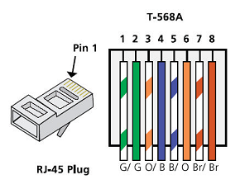
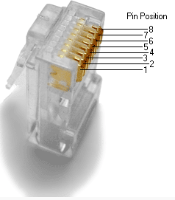
  - Analyze diagrams and tables for the TIA/EIA 568-B standard Ethernet cable.
The following table and diagram display the color scheme and pinouts for the 568-B standard.
568-B 10/100/1000-BaseTX Ethernet
Pin Number | Pair Number | Wire Color | 10Base-T Signal  100Base-TX Signal | 1000Base-T Signal
1 | 2 | White/Orange | Transmit | BI_DA+
2 | 2 | Orange | Transmit | BI_DA-
3 | 3 | White/Green | Receive | BI_DB+
4 | 1 | Blue | Not Used | BI_DC+
5 | 1 | White/Blue | Not Used | BI_DC-
6 | 3 | Green | Receive | BI_DB-
7 | 4 | White/Brown | Not Used | BI_DD+
8 | 4 | Brown | Not Used | BI_DD-
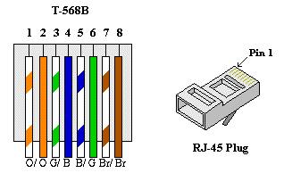

- Build an Ethernet Crossover Cable
A crossover cable has the second and third pairs on the RJ-45 connector at one end, reversed at the other end (refer to the table in Part 1, Step 2). The cable pinouts are the 568-A standard on one end and the 568-B standard on the other end. The two following diagrams illustrate this concept.
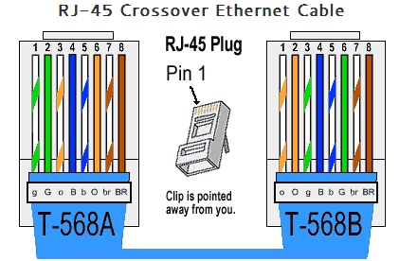
  - Build and terminate a TIA/EIA 568-A cable end.
    - Determine the cable length required. (Your instructor will let you know the cable length you should make.)
Note: If you were making a cable in a production environment, the general guideline is to add another 12 in. (30.48 cm) to the length.
    - Cut off a piece of cable to the desired length and using your wire stripper, remove 5.08 cm (2 in.) of the cable jacket from both ends.
    - Hold the four pairs of twisted cables tightly where the jacket was cut away. Reorganize the cable pairs into the order of the 568-A wiring standard. Refer to the diagrams, if necessary. Take as much care as possible to maintain the twists in the cable; this provides noise cancellation.
    - Flatten, straighten, and line up the wires using your thumb and forefinger.
    - Ensure that the cable wires are still in the correct order for the 568-A standard. Using your wire cutters, trim the four pairs in a straight line to within 1.25 to 1.9 cm (1/2 to 3/4 in.).
    - Place an RJ-45 connector on the end of your cable, with the prong on the underside pointing downward. Firmly insert the wires into the RJ-45 connector. All wires should be seen at the end of the connector in their proper positions. If the wires are not extending to the end of the connector, take the cable out, rearrange the wires as necessary, and reinsert the wires back into the RJ-45 connector.
    - If everything is correct, insert the RJ-45 connector with cable into the crimper. Crimp down hard enough to force the contacts on the RJ-45 connector through the insulation on the wires, thus completing the conducting path. See the following diagram for an example.
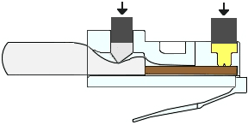
  - Build and terminate a TIA/EIA 568-B cable end.
Repeat steps 1a to 1g using the 568-B color wiring scheme for the other end.
- Test an Ethernet Crossover Cable
  - Test the cable.
Many cable testers will test for length and mapping of wires. If the cable tester has a wire map feature, it verifies which pins on one end of the cable are connected to which pins on the other end.
If your instructor has a cable tester, test the crossover cable for functionality. If it fails, check with your instructor first as to whether you should re-cable the ends and re-test.
  - Connect two PCs together via NICs using your Ethernet crossover cable.
    - Working with a lab partner, set your PC to one of the IP addresses shown in the Addressing Table (see page 1). For example, if your PC is PC-A, your IP address should be set to 192.168.10.1 with a 24-bit subnet mask. You partner’s IP address should be 192.168.10.2. The default gateway address can be left empty.
    - Using the crossover cable you made, connect the two PCs together via their NICs.
    - On the PC-A command prompt, ping the PC-B IP address.
Note: The Windows firewall may have to be temporarily disabled for pings to be successful. If the firewall is disabled, make sure you re-enable it at the conclusion of this lab.
    - Repeat the process and ping from PC-B to PC-A.
Assuming IP addressing and firewall are not issues, your pings should be successful if the cables were properly made.
Reflection
  - Which part of making cables did you find the most difficult?
The part I found most difficult was trying to connected the cables into the connectors as the calbles were very small and it was difficult getting them into the connector holes.
  - Why do you have to learn how to make a cable if you can easily buy pre-made cables?
Making your own ethernet cables instead of buying pre made ones is very useful for most organisations or individuals as it allows you to get a custom length cable, making your own is also cheaper than buying the premade ones.

