
People and organisations
Lisa Mary Pearce (1707150) | Recommendations  Perception
Jaskiranjeet Kaur (2106987) | Teamwork or leadership
Bartosz Malinowski (2005342) | Introduction  Motivation
Michael Andrew Membury (2015708) | Teamwork or leadership
Marc Attreed (2102934) | Conclusion  Communication
Assignment 2 – Group 1


Contents

Page 2 - Introduction

Page 3 - Communication

Page 5 - Perception

Page 6 - Motivation

Page 8 - Recommendations

Page 9 - Conclusion

Page 10 - References

Page 12 - Appendix

Introduction

In the rush of today's life, we often forget that there are people who need our help. People who, for various reasons, found themselves in a difficult life situation and need someone who will show them how to get out of it and return to normal life.
As a group we were tasked with raising awareness or funds for a local charity in Swansea, we chose Matthew House, a Swansea-based charity that specializes in helping homeless people. When choosing an organisation, we suggested that it should be a local charity that is well-known to people in need. This makes it easier to reach as many people as possible who need help. It was also important that the organization we choose was not limited to only one type of assistance but provided a comprehensive range of support so that everyone who needs help can find something for themselves. Homeless people are 17 times more likely to be victims of violence. More than 30 per cent of people sleeping on the street have been deliberately hit or kicked. Homeless people are more than 9 times more likely to take their own life than the rest of society. (Crisis, 2017)

Matthew house was founded in 2016 with the help of The Hill Church, which supported the purchase of the property in which there is a charity organization. In the past, in the same building, help was already offered to the neediest, but unfortunately, it had to be withheld for about 2 years (matthewshouse.org.uk, 2020). Thanks to the help of the volunteers, after many months of hard work, the building was ready for use and the organization was able to start its activities.

The main activities of Matthew house are:

Matt’s café- The real junk food project (TRJF) is an international café initiative aimed at sourcing food from large retail chains that have been destined for landfills. From the obtained food, dishes are prepared for people who need them.
The Matts café is the first registered cafe in Swansea to join the project.
In four years, 97,000 meals have been served in the Matts café, with 14,000 prepared during the first lockdown, and 25,000 since last March (Perkins, L. 2021).

The homeless period- Matts house tries to collect clothes for the neediest people and distributes dignity packs for women and men in Swansea.
A typical dignity pack includes tampons and pads, wet wipes, tissues, toothbrush and toothpaste, underwear, socks, deodorant.
As of August 2019, they have distributed over 800 Dignity Packs across our beautiful city (matthewshouse.org.uk, 2020).

Matts showers- It gives the possibility of using large shower cabins for those most in need.

Matt’s laundry-provide a referral-based laundry service focused to serve rough sleepers in our city.

Matts cwtch - have created a safe place to offer friendly advocacy and support from trained volunteers to anyone in need at Matthew’s House.

Matts community choir -A community choir using music and friendship to reduce isolation and improve wellbeing.

As a group, we have produced a group report in which we have evaluated the group dynamic and highlighted areas such as teamwork, leadership, motivation, perception, and communication. We will evaluate areas that have worked well and others that could be improved upon in the future.

Communication
Communication is the passing of information from one source to another, this can be vocal communication, physical actions or body language, effective communication is the system of information, instructions or directions being given to another person and the interpretation by the receiver, for this communication to be effective the messages must be conveyed clearly without the message becoming unclear and/or changed (Communication Theory, 2014). Communication within a team environment is key for the teams' overall success, effective communication can ensure all team members are aware of what role they have within the group and also provide a channel to raise any issues they may have. Effective communication is quality over quantity, it is important to keep communication topics on point to confuse members and ensure the team remain on track, however, too little or poor communication can lead to messages becoming unclear, goals being missed, or work duplicated (Nuclino, 2021).
Within our team we decided to use Microsoft Teams as our means of communication, we decided to use this platform due to its ease of holding meetings, sending files and the chat facility. We found Teams to be very efficient and if we were to do this type of collaborative work again Teams would certainly be considered. We did have some issues while using Microsoft Teams, we found that some members did not have notifications set up on their devices and were not getting our messages, one quick conversation between team members resolved this issue and were able to contribute once this had been resolved. Since lockdown Microsoft Teams has become the go-to tool for many organisations globally, it is a collaborative tool and can allow employers to check in on employees (Pammi, 2021).
Poole’s model for small group communication suggests that four tracks are defining the communication style that a group follows (Communication Theory, 2017).
- Task track – The formation of a group and introduction of a group task. This track is essential to the task as all group members need to be fully aware of the task at hand. Within our team, we discussed our task and selected a charity in which to support. We came up with suggestions of what we could do to raise funds and awareness for Matthew’s house.
- Relation track – This stage is where members within a team become familiar with their team members, this is where common interests are identified. This stage in our group was affected due to some of the group predominantly studying from home.
- Topic track – This stage is often where the methods of the group goals come into question, questions can be both negative and positive. This stage within our group was during our change to solely raising awareness due to a delay in communication from the charity.
- Break Points – During this stage topics can often waiver to other subjects, especially when the group share common interests. Our group would often discuss other modules within the course during this stage.

The drawback of communication being predominantly online as opposed to in-person is that members can easily miss messages from members of a group or messages can be misunderstood, within our team on five members only three were regular contributors to discussions either face to face or online. A meeting schedule was discussed on our first meeting, and we arranged for these to go ahead following in-class lectures on a Friday as this is when we were all together and able to communicate effectively. Unfortunately, attendance was poor for the meetings so alternative meetings were arranged on occasions. As per the image below from (Innovecs, 2020) 17% of people working remotely found they had issues with collaborating or communicating while working remotely. The team members with the lowest contributions to discussions were remote learners so this may have had an impact in this case.
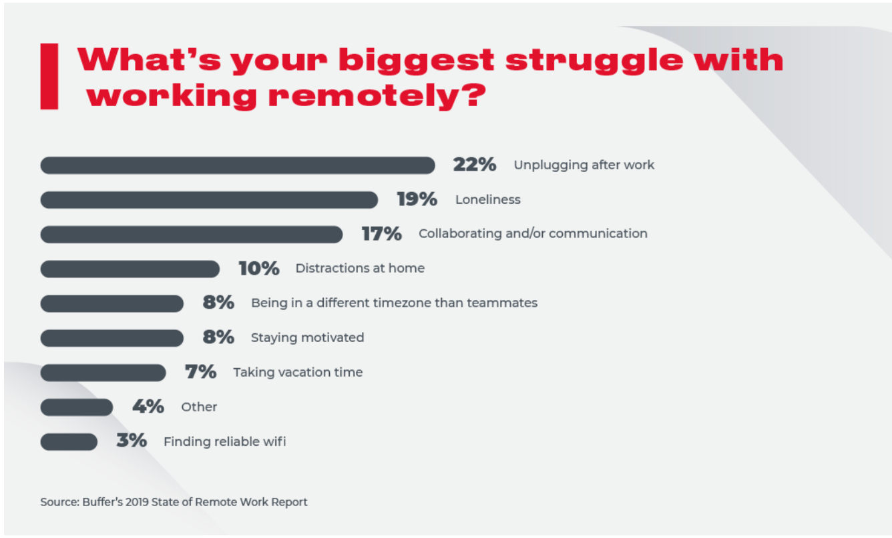
Communication with our chosen charity was a slow process, due to the Covid-19 pandemic our charity was unable to meet with us face to face and we were restricted to telephone calls and messaging, messages were very slow, and replies could often take up to a week for a reply and calls would go to voicemail. Due to the slow communication process, we were forced to change our goals from raising funds for this worthwhile cause to raising awareness, by doing this we relied less on the interaction of the charity and were able to promote the fantastic work they do in the local community in Swansea.
Overall communication within our team could have been improved but the technology used was the correct one for the job on this occasion.

Perception
Definition of perception is:
“The Dynamic Psychological process responsible for attending to, organising and interpreting sensory data”.
Source: Buchanan, David, A.P778.
Perception is the root of all management and organisational behaviour and in any situation can be analysed in terms of its connotations. It also gives a unique image of a person individually as it is a reality that organisation managers take care and organise and make judgements both positive and negative when sending the message across. Communication is a key factor, and it is an important role within an organisation as if there is no communication the company would not know what is going on or what their employees would like or do.
How people interact with each other is subject to change as they get to know each other and working together can do that. Understanding of a person's personality will go beyond the sensations of the brain in what information it receives, with verbal signals which are what is said and nonverbal signals which include body language, head language a person's posture and the persona appearance in the way they speak, and their facial expression can say quite a lot of a person.
The Managers relationship with their employees will notice a recruit as their characteristics such as appearance and the way they dress, and their body language will be a lot different from their previous staff which have been there a long time. Perception can be deceiving as things are not what they appear to be, and you can get the wrong assumption about a person and sometimes your thoughts and opinions and words can sometimes be the wrong thing as there are always different situations and you should never jump to conclusions as things don't always seem what they appear to be;(Kingsley Jeremy 13/10/2017, accessed 8/12/21).
Perception within the team was not much interaction with some of the team members, but on the other hand, the remaining members were constantly interacting with each other. We didn't get to know each other as most of the class was online and when we were in class the tasks were when everyone contributed even though they weren't in this group. There was no communication from other team members as to when we were given the task of the assessment, they knew they had to contribute in one way or another. We got to know each other by video calls who went online and got to know their personality through facial expressions and their body language by the way they were sitting or fidgeting. So, we got the work done and we have all done our best as the best is always good enough, but some things can be improved on which you will see in the recommendations section later in the report/essay. Motivation, communication, and teamwork is an important part of a team/ group exercise, plus the managers need to communicate much more to help their employees feel better about themselves and to motivate them more by giving them incentives like bonuses and praise.

Motivation
Motivation is the process that initiates, directs, and maintains goal-oriented behaviour. It is what makes you act. (Cherry, K. 2020) It is the driving force behind human actions.
Motivation is a key element if we are focused on achieving our goals and succeeding in life.
When working in a group, each member must be motivated to do his or her best to ensure the success of the project. If one member of the group fails to perform his or her task, the whole project will fail. To make sure that everyone in the group is motivated to succeed, it is worth paying attention to Maslow's Hierarchy of Needs Theory. American psychologist and behavioural scientist Abraham Maslow developed a theory consisting of 5 levels. He stated that people are motivated to satisfy five basic needs. (Teambuilding.co.uk. 2019)
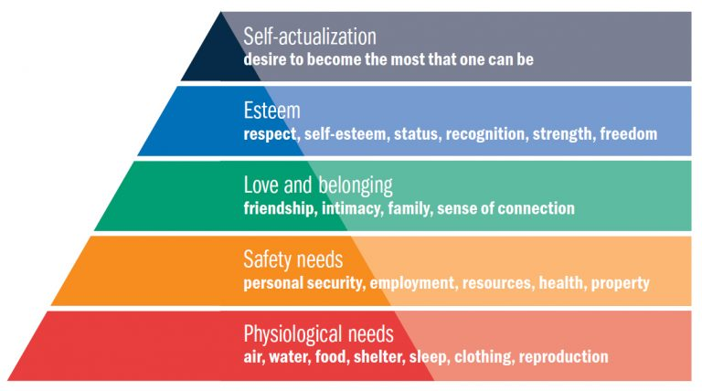

‌ Policechiefmagazine.org. (2021).

Needs are arranged hierarchically. Maslow suggests that we start by satisfying the lowest needs. Then move on to the higher needs until all five needs have been met ( Tanner, R. 2019).
The first four levels are referred to as deficiency needs. If any of these levels of needs are not met, we may feel distracted, depressed, and it will prevent us from reaching higher levels.
If we can meet all the "deficiency needs" we can move on to discovering our "growth needs" this is a unique human need for development. Setting a goal and wanting to achieve it is not enough. Everyone who has ever set a goal for themselves realises that to achieve success, you need to have the ability to persevere and overcome obstacles. (Cherry, K. 2020).

Different types of motivation are often described as extrinsic or intrinsic:

Extrinsic motivation is understood as actions on behalf of people to motivate them. It can include rewards, pay rises, promotions, praise but also punishments such as withholding bonuses, disciplinary actions. Members within our team would have been motivated by extrinsic motivation as they would have wanted to achieve the best possible marks for their work, not doing the work would have had negative repercussions to the group member and this would have been a motivation.

Intrinsic motivation is characterised by the fact that it is we who decide to take action to achieve a goal. We do something because it gives us pleasure and we do not expect any reward for our actions. Intrinsic motivation is what drives us to act and keeps us going. Members of the group would not be influenced by intrinsic motivation as members would have a personal incentive to achieve the goal, however, this could be disputed as the member would have pleasure in achieving their goals regardless of the rewards.

Recommendations

Following the conclusion of our group project, some recommendations for changes for future projects would be –

- Due to our charity Matthew’s house being slow to respond to our messages and questions the first recommendation would be to make an early change of charity to ensure the group could achieve all its objectives. Change, in business is vital for a business to grow and this is the same for this group, while the group were stuck waiting for communication from the charity this caused a large amount of downtime where the group were unproductive. Changes to the direction of a project can propel a project into success (Kalm, 2016), and had the group had changed direction early in the process we could have saved ourselves from having to amend its objectives. Organisations that are slow to communicate with both external and internal customers can encounter challenges as people are less likely to want to engage with them, for an organisation to remain productive no matter if it is a charity or a retail giant its communication channels must remain strong (Wells, 2017). Understandably this is a very busy time for charities, especially with the festive season so slower communication is understandable but unfortunately, due to the delays in this case the group were unable to raise funds for this fantastic charity.
- More frequent meetings between team members could have ensured engagement from all members of the team, unfortunately, some members of the group had little to no communication with the group and this led to confusion with the other members, which led to others having to cover their allocation of tasks. Team meetings allow members to share information with one another and by having more regular meetings a team can identify issues quicker (Stapleton, 2015). (Cornett, 2019) suggests that regular meeting allows teams to share their expertise with other members and allow for better collaboration. If we had held more regular meetings others could have shared their expertise and we could have achieved more as a collective group.

Conclusion
In conclusion for a group assignment to be successful, a group needs a fine mix of all subjects mentioned within this report. Teamwork, leadership, motivation, perception, and communication are essential for a team to produce a high-quality output. This group has achieved mixed results in raising awareness for the chosen charity Matthews House. Communication with the charity was impacted due to current global circumstances, however, following a change of initiative from raising funds to raising awareness the group have brought attention the projects such as Matt’s café, Matts showers or the reverse advent calendar through a Facebook group in which a Just Giving link was also shared to raise funds. Similarly, communication within the group was affected due to the lack of interaction with messages and tasks assigned.
Motivation within some areas of the team seemed to be lacking as there was no contribution for the duration of the assignment, this can cause resentment from other members of the team in general circumstances as other team members may have to cover the missing work.
Perception within a team is the way a team member translates the data that has been provided to a group, our group understood the goals that were set and plans were quickly put in place in which we would achieve our goals.
Based on our teams' performance we have taken points in which we can improve if we were to work as a collective group again, taking our successes and failures into account we can guarantee that we can improve on our performances going forward.

References

Cherry, K. (2020). Motivation: Psychological factors that guide behaviour. [online] Verywell Mind. Available at: https://www.verywellmind.com/what-is-motivation-2795378.
‌
Crisis (2017). About homelessness | Crisis | Together we will end homelessness. [online] Crisis. Available at: https://www.crisis.org.uk/ending-homelessness/about-homelessness/.

Communication Theory, 2014. Effective Communication. [Online]
Available at: https://www.bing.com/search?q=effective+communication&qs=n&form=QBRE&msbsrank=6_7__0&sp=-1&pq=effective+communication&sc=7-23&sk=&cvid=D8BA28F905334F59B1684425AD898E0D
[Accessed 14 12 2021].
Communication Theory, 2017. Communication Theory. [Online]
Available at: https://www.communicationtheory.org/pooles-model-small-group-communication/
[Accessed 5 1 2022].
Cornett, I., 2019. 4 Ways Effective Meetings Benefit Your Organization. [Online]
Available at: https://www.eaglesflight.com/blog/4-ways-effective-meetings-benefit-your-organization
[Accessed 7 1 2022].
Innovecs, 2020. 11 REMOTE WORK CHALLENGES AND WAYS TO COPE WITH THEM. [Online]
Available at: https://innovecs.com/blog/remote-work-challenges/
[Accessed 6 12 2021].
Kalm, M., 2016. Why change is important in business. [Online]
Available at: https://businesspartnermagazine.com/why-change-is-important-in-business/#:~:text=Time%20for%20a%20dose%20of%20reality%3A%20change%20in,of%20the%20day.%20The%20world%20changes%20every%20day.
[Accessed 7 1 2022].
Nuclino, 2021. Effective Team Communication in the Workplace. [Online]
Available at: https://www.nuclino.com/articles/effective-team-communication
[Accessed 5 12 2021].
Pammi, S., 2021. Microsoft Teams - Empowering Collaboration. [Online]
Available at: https://techcommunity.microsoft.com/t5/microsoft-teams-community-blog/microsoft-teams-empowering-collaboration/ba-p/2770641
[Accessed 6 12 2021].
Stapleton, S., 2015. 10 Reasons Why Team Meetings Are Important. [Online]
Available at: https://www.simonstapleton.com/wordpress/2012/04/18/10-reasons-why-team-meetings-are-important/
[Accessed 7 1 2022].
Wells, K., 2017. 6 Effects of Poor Workplace Communication in Business. [Online]
Available at: https://fsd.servicemax.com/2017/11/08/6-business-impacts-poor-communication/#:~:text=%206%20Effects%20of%20Poor%20Workplace%20Communication%20in,the%20workplace%20comes%20lower%20productivity%20because...%20More%20
[Accessed 7 1 2022].
Perkins, L. (2021). The homeless charity fed thousands with meals during the pandemic. [online] WalesOnline. Available at: https://www.walesonline.co.uk/news/wales-news/swansea-homeless-charity-fed-homeless-20719790.
‌
Policechiefmagazine.org. (2021). [online] Available at: https://www.policechiefmagazine.org/forced-criminality/maslow-pyramid/

Tanner, R. (2019). Motivation – Applying Maslow’s Hierarchy of Needs Theory. [online] Management is a Journey®. Available at: https://managementisajourney.com/motivation-applying-maslows-hierarchy-of-needs-theory/.

Teambuilding.co.uk. (2019). Abraham Maslow Team Building Theory. [online] Available at: https://www.teambuilding.co.uk/theory/team-building-theory-maslow.html.
‌
‌

Appendix
Lisa Mary Pearce (1707150) | Recommendations  Perception
Jaskiranjeet Kaur (2106987) | Teamwork or leadership
Bartosz Malinowski (2005342) | Introduction  Motivation
Michael Andrew Membury (2015708) | Teamwork or leadership
Marc Attreed (2102934) | Conclusion  Communication

