Student Name: Tayyib Malik
Student Number: 2414555
Module: Project Management
LCLM5003
Lecturer: Samuel Ofori

Contents
Poster……………………………………………….3
Reflective Essay Feedback (Part B) ……………4
Project Management Plan (Part C) ……………...6
References …………………………………………..13

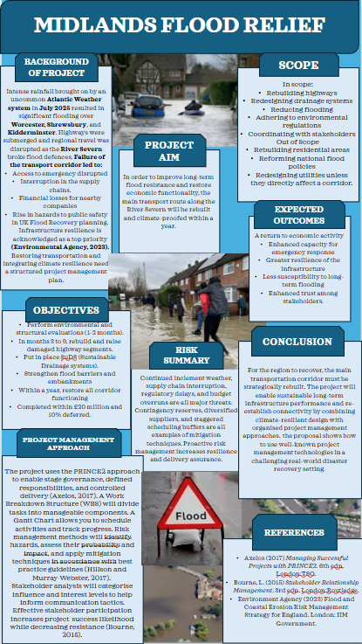
Poster

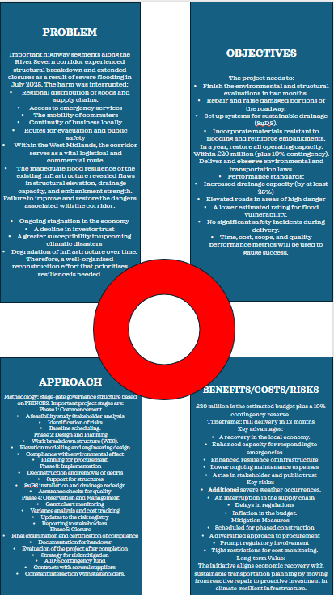

Flood Recovery Transport Corridor Reconstruction Project – West Midlands

Reflective Essay on Feedback (Part B)
My teachers and peers gave me insightful comments when I presented my project proposal poster on the Flood Recovery Transport Corridor Reconstruction Project. I was able to assess the success of my original project idea, presentation approach, and use of project management principles thanks to this input. Additionally, it made it possible for me to pinpoint particular advantages and disadvantages that I would take into consideration while creating the final project management plan.
The project’s appropriateness and relevancy were one of its key advantages. It was though to be a robust and practical solution to the scenario given in the assignment requirement to concentrate on rebuilding the main transit route that was severely flooded. The research showed a thorough comprehension of the broader effects of infrastructure interruption on regional connectivity, economic recovery, and emergency services accessibility, according to the instructor. This demonstrated my ability to connect the project’s goal to practical difficulties, which is a crucial component of successful project planning.
The poster’s logical content arrangement and clear structure were other advantages. The project’s goal, objectives, scope, aims, risks, and expected outcomes were all described in an understandable manner. Within the limited space on the poster, that the main ideas were effectively communicated through the use of concise bullet points. Peers also noted that the project’s overall message was simple to comprehend and that the goals were reasonable and doable in the allotted timeframe.
Nevertheless, a number of flaws were found that must be fixed in the final submission. The poster’s unclear identification and classification of stakeholders was a major problem. While several groups named, their responsibilities, impact, and degree of engagement in the project were not fully explained. My tutor and peers found it quite challenging to comprehend and understand how stakeholder involvement will be handled as a result. In order to address this, the final project plan will have a thorough stakeholder analysis that identifies important stakeholders and their roles.
The lack of important project planning tools that should have been displayed on the poster was another significant weakness spotted. Despite written discussions on topics like scope, scheduling, hazards, and costs, the Quad chart was not displayed physically on the main poster, I did it on a separate page. In the same way, a Gantt Chart that displayed the project schedule, task order, and activity durations was absent. These resources would have enhanced the poster’s professionalism and offered more convincing proof of project preparation.
Additionally, several parts of the poster included lengthy paragraphs instead of concise bullet points like various other sections, which made it harder for my tutor and peers to immediately identify the most crucial information and decreased readability. Shorter headlines, phrases, and diagrams, would have enhanced the presentation as a whole because posters are meant to convey information rapidly and attractively. Furthermore, financial information and resource allocation were only addressed in passing and lacked a clear visual representation. I will enhance the final project management plan’s clarity, visual presentation, and degree of planning information in response to the feedback I’ve received.

Part C
- Introduction
Worcester, Shrewsbury, and Kidderminster were among the West Midlands towns that experienced devastating floods in July 2025 due to heavy and sustained rains brought on by an uncommon Atlantic weather system. Infrastructure and public services were severely disrupted as a result of the River Severn exceeding critical capacity levels and breaching flood defences in many places. Electricity and communication networks were momentarily disrupted, roads were flooded, and bridge structures were compromised. Economic activity and public safety were greatly impacted by these disturbances, which restricted the flow of people, products, and emergency services.
In order to sustain social and economic stability and promote regional growth, transport infrastructure is essential. Recovery is crucial for resuming regular operations and guaranteeing long-term resilience when major transport routes are disrupted. This project management plan suggests rebuilding a major transport route that was impacted by floods. In order to lessen potential to future flood occurrences, the project intends to re-establish connectivity while implementing sustainable technical solutions.
Access to jobs, social connectedness, and regional production are all greatly aided by transportation infrastructure. In order to speed up recovery and minimise long-term financial losses after natural catastrophes, damaged infrastructure must be quickly restored. The rebuilding of a major transport corridor that was impacted by flooding is the main goal of the project management plan. While using climate-resilient architectural solutions to reduce susceptibility to future flood occurrences, the project seeks to restore safe transportation flow. In order to illustrate organised planning, stakeholder involvement, risk management, and performance monitoring -all of which are seen to be crucial for the successful completion of projects – the study employs acknowledged project management practices (Kerzner, 2017).

- Project Description
A significant transport corridor that runs alongside parts of the River Severn will be rebuilt and upgraded as part of the project. Significant degradation of road surfaces, erosion of bridge foundations, and collapse of traditional drainage systems were all brought on by flooding. Access to emergency services, logistical operations, and commuter patterns were all adversely impacted by this corridor’s disturbance.
Resurfacing damaged roads, fortifying bridge structures, putting in place sustainable urban drainage systems (SuDS), strengthening flood defence barriers, and enhancing traffic safety infrastructure including lighting and signs are all part of the reconstruction process. The use of permeable building materials and elevated road levels in flood-prone areas are two examples of climate-adaptive design strategies that will be put into practice. These upgrades are intended to lessen long-term maintenance expenses and potential flood vulnerability.
The project has an estimated £10 million budget and is expected to be finished in eight months. If completed successfully, the region’s infrastructure resilience will be improved, connection will be restored, and economic recovery will be supported.

- Project Scope
Maintaining control over deliverables and avoiding needless extension of project objectives depend on clearly defining the project’s scope (Project Management Institute, 2021).
In Scope
- Evaluation of the structural integrity of roads and bridges affected by flooding.
- The main transport corridor’s reconstruction and resurfacing.
- Inspections for safety compliance and bridge strengthening.
- Installation of environmentally friendly drainage systems
- Strengthening flood protection infrastructure.
- Enhancements to safety and traffic management.
- Environmental observation and adherence to regulations.
Out Scope
- Rebuilding private property and residential buildings.
- Plans for compensating impacted residents.
- Modest remote road repairs that aren’t connected to the corridor.
- Long-term initiatives for urban development.
Effective resource allocation and project monitoring will be made possible by clearly defined scope boundaries.

- Work Breakdown Structure
One essential project management technique for breaking down large projects into smaller, more manageable parts is the Work Breakdown Structure (WBS). The WBS facilitates efficient planning, scheduling, cost estimates, resource allocation, and performance monitoring by breaking down the whole project scope into precisely specified work items (Kerzner, 2017). A organised work breakdown structure (WBS) is especially crucial for infrastructure rebuilding projects because of its technical complexity, numerous stakeholders, and requirement to coordinate successive construction operations.
  - Level 1: Project Phases
Project Initiation, Planning and Design, Procurement, Construction, Monitoring and Control, and Project Closure are the six main stages of the transport corridor rebuilding project. Every phase contributes to the accomplishment of the project’s overall goals and marks a crucial point in the project lifecycle.

  - Level 2 Key Deliverables and Activities

Project Initiation Phase
The establishment of the project’s basis is the main goal of this phase. Stakeholder identification and analysis, feasibility studies to establish technical and economic viability, initial risk assessments, and obtaining financial permission from pertinent authorities are among the activities that will take place. To make roles, responsibilities, and reporting processes clear, project governance structures will also be established.

Planning and Design Phase
In-depth engineering studies will be carried out during this stage to evaluate the degree of flood damage and ascertain the needs for reconstruction. To guarantee adherence to sustainability laws, environmental impact assessments will be conducted. Technical drawings, building requirements, and cost estimates will be created by engineering design teams. To direct project execution, plans for risk management, communication tactics, and quality assurance will also be created.

Procurement Phase
During the procurement phase, competitive tendering procedures are used to choose competent contractors. To guarantee adherence to environmental, safety, and quality requirements, contracts will be drafted. We will obtain materials including flood defence equipment, drainage components, steel reinforcements, and asphalt. In order to guarantee construction preparedness, workforce mobilisation and equipment allocation will also be finished during this phase.

Construction Phase
The project’s primary implementation step is represented by this phase. Damaged road surfaces will be removed, roads will be rebuilt and resurfaced, bridge structures will be strengthened and stabilised, sustainable drainage systems will be installed, and flood protection barriers will be reinforced. Plans for traffic control will be put into place to reduce disruptions to drivers while work is underway. Adherence to quality and safety requirements will be ensured by routine site inspections.

Monitoring and Control Phase
Quality inspections, safety audits, and progress reports will all be used to regularly monitor project performance. Construction quality, cost performance, and schedule adherence will all be monitored using key performance indicators. In order to preserve alignment with project objectives, any deviations from the project plan will be handled through corrective measures (Project Management Institute, 2021).

Project Closure Phase
In order to verify that the rebuilt infrastructure complies with engineering requirements, the last stage will entail thorough testing and inspection. Stakeholder assessments, financial reporting, and final paperwork will be finished. To assist with next flood recovery initiatives, lessons learnt will be recorded. After that, the transport corridor will officially reopen to the public.

- Quad Chart
Key project information may be presented in an understandable and visually appealing manner using the Quad Chart, a concise project management tool. The scope, timeline, cost, and hazards of a project are its four essential components. Because it enables decision-makers to rapidly comprehend project goals, limits, and overall viability, this tool is especially helpful for conveying crucial project facts to stakeholders (Turner, 2014). The Quad Chart is a crucial tool for strategic planning and stakeholder alignment in major infrastructure projects like the rehabilitation of transport corridors.

  - Scope
The main goals and deliverables of the project are described in the Quad Chart’s scope element. In this instance, the scope is centred on improving and rebuilding the main transportation route that was impacted by the flooding. The construction of sustainable drainage systems, the strengthening of flood defence measures, the repair and resurfacing of roadways, and the reinforcement of bridge structures are important deliverables. To guarantee long-term operation, the scope also includes upgrades to safety infrastructure and traffic control systems. In addition to preventing scope creep, clearly outlining the scope inside the Quad Chart guarantees that all stakeholders have a shared understanding of the project’s goals (Project Management Institute, 2021).

  - Schedule
An overview of the project timeframe and significant milestones is given by the schedule component. It is anticipated that the renovation of the transit corridor would be finished in eight months. Project starting and site assessment (Month 1), comprehensive planning and procurement (Month 2), construction activities (Months 3-6), testing and inspection (Month 7), and final project closure (Month 8) are important benchmarks. Stakeholders may easily determine whether the project timeframe is achievable and reasonable by viewing this information in the Quad Chart. Additionally, it facilitates efficient progress tracking and the detection of any delays.

  - Cost
The project’s expected financial needs are summed up in the Quad Chart’s cost element. This project has a total budget of about £10 million, which covers building expenditures, personnel costs, the purchase of materials, and contingency funds. As it offers flexibility to handle unforeseen expenses like material price hikes or weather-related delays, contingency funding is especially crucial for infrastructure projects. To maintain the project’s financial viability and provide value for the money, effective cost management is crucial (Kerzner, 2017).

  - Risks
The primary uncertainties that might impact a project’s success are highlighted by the risk component. Adverse weather, supply chain interruptions, inflation-related cost increases, delays in regulatory permits, and possible community opposition to construction operations are some of the project’s main hazards. By including these risks in the Quad Chart, stakeholders can see them right away. Additionally, it encourages the creation of mitigation mechanisms including flexible scheduling, supplier diversity, early regulatory body participation, and efficient community communication. In order to minimise interruption and guarantee project success, proactive risk management is crucial (Project Management Institute, 2021).

  - Importance of the Quad Chart in This Project
In general, the Quad Chart facilitates effective communication between project teams, stakeholders, and decision-makers by offering a high-level overview of the project’s essential criteria. It guarantees that all stakeholders stay in agreement with the project’s goals, schedule, budget, and risk profile and facilitates well-informed decision-making by simplifying complicated information. The Quad Chart is a useful tool for preserving clarity, enhancing transparency, and facilitating the effective completion of this transport corridor renovation project.

- The Gantt Chart
The project schedule will insist of:
Month 1: Site inspections and initiation
Month 2: Thorough preparation and acquisition
Month 3-6: Construction-related activity
Month 7: Performance evaluation and testing
Month 8: Closing and reopening the project
Task dependencies and milestone tracking will be shown visually on a Gantt Chart.

- Stakeholder Involvement
Particularly in public infrastructure projects involving a variety of interest groups, stakeholder participation is essential to project success (Freeman, 1984). Local governments, transit authorities, environmental organisations, emergency services, local companies, and community members are important stakeholders. Public discussions, internet communication channels, and organised progress reporting are some of the engagement tactics. Throughout the project lifespan, a stakeholder power-interest grid will be utilised to prioritise communication and guarantee productive teamwork.

- Allocation of Resources
Allocating resources effectively guarantees that project goals are met within financial and schedule restrictions (Project Management Institute, 2021).
Project managers, civil engineers, construction labourers, and environmental specialists are examples of human resources. Heavy construction machinery, asphalt, steel reinforcing, and drainage components will make up the material resources. Government infrastructure investment and contingency funds to cover unanticipated expenses are examples of financial resources.

- Risk Analysis
Projects to rebuild infrastructure confront a number of unknowns. Unfavourable weather, inflation-related increases in material costs, supply chain interruptions, delays in regulatory clearances, and possible community opposition to building projects are some of the main hazards. Flexible scheduling, supplier diversification, early interaction with regulatory bodies, and ongoing performance monitoring are all part of risk reduction techniques. Prioritising mitigation strategies will be made possible by using risk matrices to evaluate effect and likelihood (Project Management Institute, 2021).

- Monitoring, Sustainability and Success Evaluation
Key performance indicators including schedule adherence, cost performance, quality compliance, and safety requirements will all be part of project monitoring. Monthly stakeholder reports and regular progress meetings will make it easier to monitor performance and take prompt steps to correct problems. Environmentally friendly drainage systems, low-carbon building techniques, and the preservation of regional ecosystems are all examples of sustainability considerations.
The timely completion of the project, enhanced transportation dependability, economic recovery metrics, and stakeholder satisfaction will all be used to gauge its success. Lessons learned will be documented in post-project reviews, which will guide future efforts to plan for flood resilience.

- Project Governance, Communication and Future Recommendations
Throughout the course of a project, a well-defined governance structure will specify roles, duties, and decision-making power. Technical reporting to funding organisations, internet updates, and public information sessions are examples of effective communication tactics. Accountability and stakeholder trust in infrastructure delivery are improved by transparent governance (Turner, 2014).
Future suggestions include enhancing interagency cooperation, investing more in flood predicting technology, and incorporating climate-resilient criteria into regional transportation planning regulations. Future extreme weather event readiness will be enhanced via ongoing learning from project results.

- Conclusion
A vital calculated reaction to the terrible floods that occurred throughout the West Midlands in July 2025 is the Flood Recovery Transport Corridor Reconstruction Project. The destruction brought about by the River Severn breaching its defensive walls brought to light the fragility of vital transport infrastructure and the substantial effects that such interruptions may have on community well-being, public safety, and economic activity. Therefore, restoring the main transport corridor is crucial for both the short-term recovery and the long-term resilience of the area.
This project management plan has shown how organised project management principles may be applied to efficiently plan, carry out, and oversee the rehabilitation process. A comprehensive framework for planning project operations, managing resources, and reducing possible uncertainties is provided by essential components such as the Work Breakdown Structure, Gantt Chart, Quad Chart, and Risk Analysis. Stakeholder engagement techniques guarantee that the requirements and expectations of all pertinent stakeholders are taken into account, encouraging cooperation and lowering the likelihood of disputes during the course of this project. These strategies are in line with accepted project management techniques, which highlight the significance of control, communication, and planning in attaining effective project outcomes (Project Management Institute, 2021).
Additionally, the initiative prioritises climate resilience and sustainability. The rebuilt transit corridor will be more resilient to adverse weather occurrences in the future thanks to features including sustainable drainage systems, stronger flood barriers, and adaptable building techniques. In addition to lowering long-term maintenance costs, this proactive strategy advances more general environmental and policy goals pertaining to infrastructure resilience and climate adoption.
If this project is completed successfully, there will be several long-term advantages, such as greater economic activity in the area, better accessibility for emergency services, and improved transportation dependability. Additionally, it will boost public trust in infrastructure systems and show how well organised project management techniques can handle challenging real-world problems. But it’s crucial to recognise that project outcomes might be impacted by variables including weather variations, cost changes, and regulatory restrictions. Thus, throughout the project, effective governance, proactive risk management, and ongoing monitoring will all be crucial.
In summary, this project offers a thorough and workable solution to the problems caused by transport infrastructure that has been devasted by flooding. Rebuilding the transport corridor will aid in recovery, improve resilience, and assist sustainable regional growth in the West Midlands by fusing technical know-how with organised project management techniques.

References
Freeman, R.E. (1984) Strategic Management: A Stakeholder Approach. Boston: Pitman.
Kerzner, H. (2017) Project Management: A Systems Approach to Planning, Scheduling and Controlling. 12th edn. Hoboken: John Wiley & Sons.
Project Management Institute (PMI) (2021) A Guide to the Project Management Body of Knowledge (PMBOK Guide). 7th edn. Pennsylvania: Project Management Institute.
Turner, J.R. (2014) Handbook of Project-Based Management. 4th edn. New York: McGraw-Hill.

