ACCB4017_SOFTWARE_DEVELOPMENT_ASSIGNMENT_AS1_BRIEF_SEP_2021
Table of Contents
A1. List, variable, list element and in-built functions 3
A2. Explain user-defined functions and it’s importance with two parameters 4

PART A

A1. List, variable, list element and in-built functions
List and Variables
A list is a collection of parameters that can be of the same type or different and are present in an ordered way. Lists are mutable which means that the parameters that have been stored in them can be changed for convenience (Johnson, McQuistin and O'Donnell, 2020). On the other hand, variables act as containers to store values that can be of any type. Lists contain multiple values of different types of data whereas variables only contain a single value of a specific type.
Accessing a List
In order to explain the process with the help of which the elements of a list can be accessed, a list shown below has been considered.
List = [1, 2, 3, 4, 5]
To access the values stored in the list shown above, an indexing method can be used. For instance, to access ‘Mark’ present in the list, code can be written as
Print (List [2])
Output - 3
Five built-in functions in a list and their applications on the above example
Functions | Description | Examples
Len() | The len () function provides the length of the list which is present. | len(List)  Output - 5
sum() | The sum () function provides the value of the sum of all the elements that are present in the list (Bynum et al. 2021). | sum(List)  Output - 15
min() | The min () function generates the minimum value that is present in the given list. | min(List)  Output - 1
max() | The max () function provides the maximum value that is present in the list. | max(List)  Output - 5
reversed() | The reversed () function returns the list with elements in reverse order. | reversed(List)  Output - [ 5,4,3,2,1 ]
Table 1: Five Built-in Functions in Python
(Source: Created by Learner)

A2. Explain user-defined functions and its importance with two parameters
When a function is created by a user, then that type of function is called user-defined function(Richie-Helford and Rokem, 2018). The keyword def is used to form a user-defined function. The syntax that is used to define the user-defined functions is shown below
def function_name ():
statements
Importance of these functions in programming
The list below provides the details of the importance of functions made by users:
- The use of user-defined functions reduces the size and complexity of the program (Levitskyet al. 2018).
- By using the user-defined functions, the codes can be easily debugged and thus maintenance of the program becomes simple.
- The user-defined functions can be called for as many times as required which increase the reusability of the program and reduces its repeatability (Satoh and Nishita, 2019).
Explanation of functions made by user with two parameters
The code below provides the view of the method that can be used to understand the working of functions formed by users.
def add_two (a,b):
return a+b
c = add_two(2,3)
print (c)
Output - 5
Table 2: Functions Example
(Source: Created by Learner)
It can be observed from the code above that the name of the given function is add_two and it takes two arguments which are a and b. The function returns the value of the sum of a and b. Now, when the function is called with argument values 2 and 3, it prints the value as 5. In this way, a user-defined function works in python and eases the operations performed by the user.

PART B
The four tasks have been implemented below.

Task 1
In this task, car object class has been created to add their properties and display it on the screen.
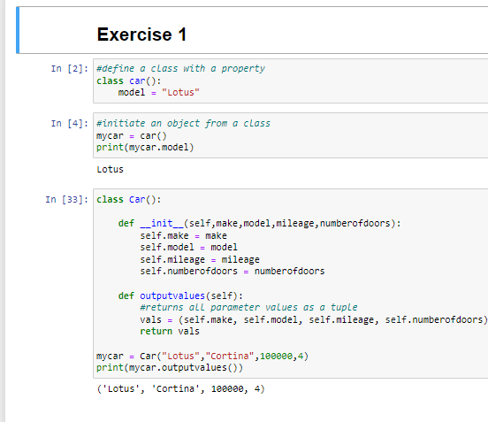

Task 2
The radius of the circle has taken as input and display the area of it.
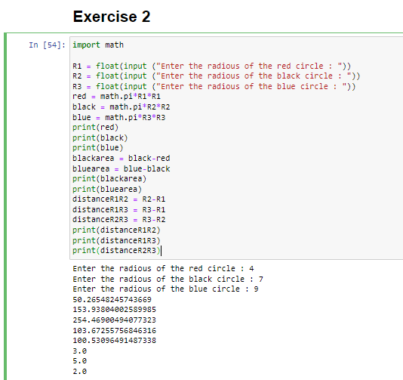

Task 3
The employee details have been taken and display it on the screen. The age and salary details have evaluated based on the gender. The graph has been plotted based on the gender and age, salary distribution.
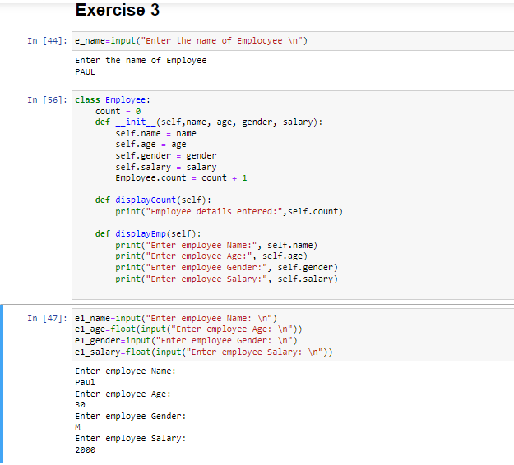
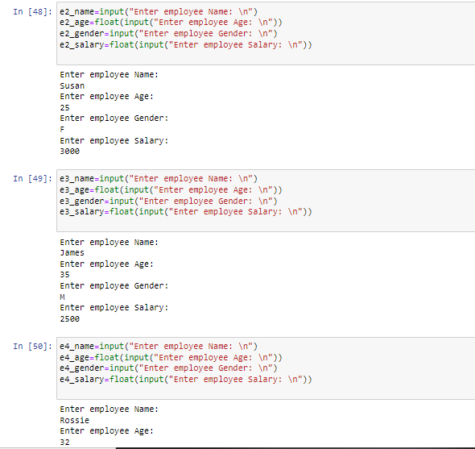
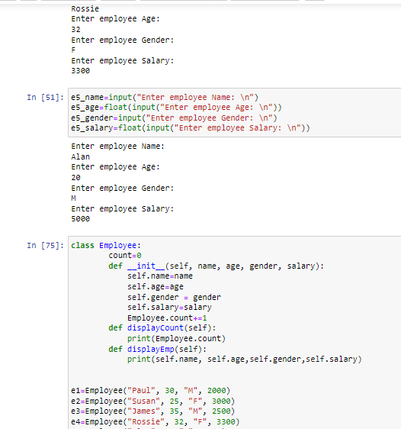
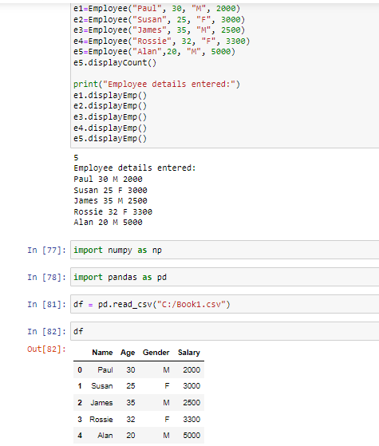

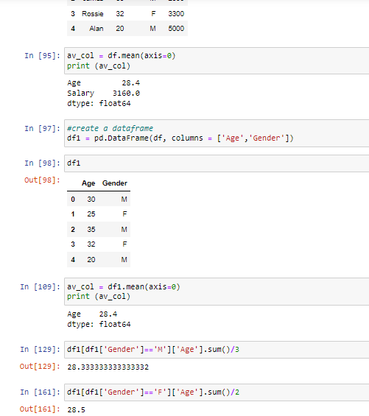
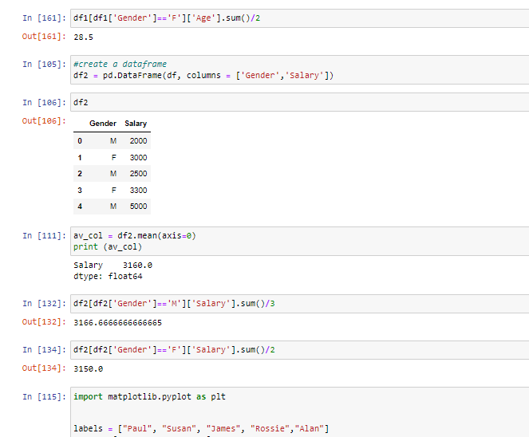
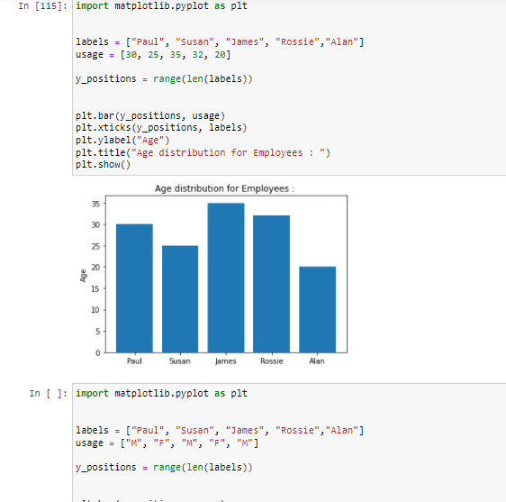
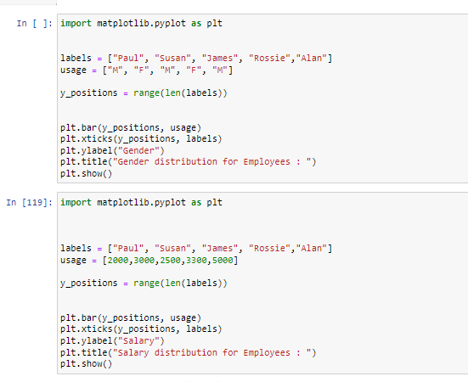
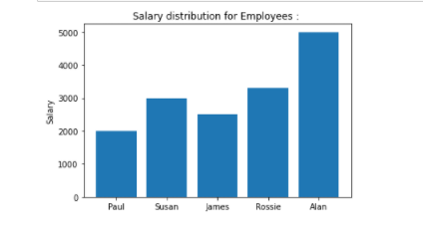

Task 4
Spinning game has created and implemented in this task. Screenshots for this codes are as follows:

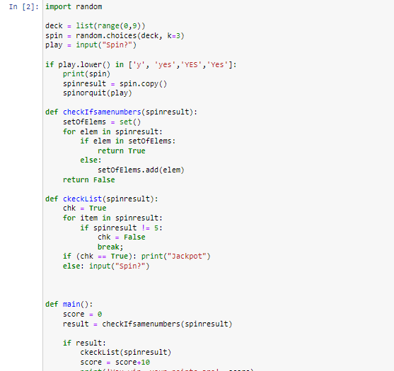
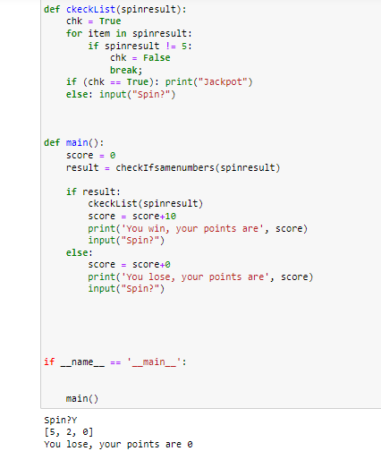

Reference List
Johnson, F., McQuistin, S. and O'Donnell, J., 2020, January. Analysis of Student Misconceptions using Python as an Introductory Programming Language. In Proceedings of the 4th Conference on Computing Education Practice 2020 (pp. 1-4).
Bynum, M.L., Hackebeil, G.A., Hart, W.E., Laird, C.D., Nicholson, B.L., Siirola, J.D., Watson, J.P. and Woodruff, D.L., 2021. A Brief Python Tutorial. In Pyomo—Optimization Modeling in Python (pp. 203-216). Springer, Cham.
Richie-Halford, A. and Rokem, A., 2018. Cloudknot: A python library to run your existing code on aws batch. In Proceedings of the 17th python in science conference (pp. 8-14).
Levitsky, L.I., Klein, J.A., Ivanov, M.V. and Gorshkov, M.V., 2018. Pyteomics 4.0: five years of development of a Python proteomics framework. Journal of proteome research, 18(2), pp.709-714.
Satoh, M. and Nishita, S., 2019. Correlating Program Code to Output for Supporting Program Understanding. In Proceedings of the International MultiConference of Engineering and Computer Scientists (pp. 13-15).

