Ways of Perceiving
(M4X01559)
Word Count 1240

Death and Depression
My chosen theme and topic for this project is ‘Death and depression’. After brainstorming ideas I chose this theme in particular because as death and depression have equally fascinated, scared and tormented people in vastly different ways. Variations of these different ways can be seen throughout the art world in past centuries and in recent years. Many high profile and recognizable artist have personally suffered or struggled to cope with the depression and death that has plagued them for most of their lives.
In recent years, research has shown that depression has been increasing the mortality rate in younger generations. A cause of this is more pressure from social media these days on how to be perfect and how you should be living your life. In particular more than half of the cases of depression start at the age of 14 and young adults are getting more affected, according to a government funded study, (BBC News, 2017). My idea for the layout out for my exhibition is to consume and surround the viewer by different examples of work that show how different artists have approached and expressed the theme. With the hope the viewer leaves with an understanding/ feeling of how people express/show there relation to the theme in different ways.

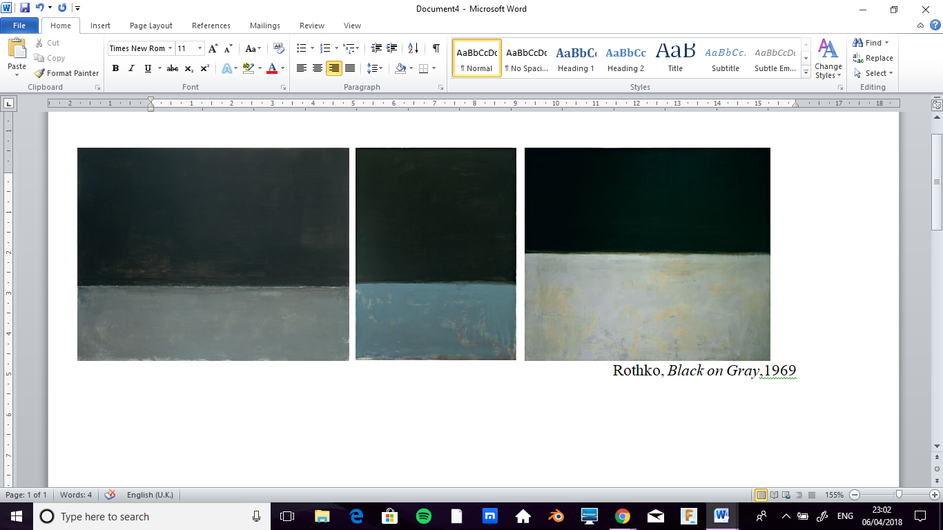
Rothko was a Jewish Latvian born American abstract painter, who saw, suffered and lived through my struggles in his life. He and his family fled to America and at only 10 yrs, old his father died, lived through both world wars and the great depression which influenced his way of thinking. He was a heavy drinker and his health had started to worsen towards his death. Then in 1970, he committed suicide while taking an overdose of anti-depressants. Before his death his work had taken a much darken tone and used darker colours compared to ones used in his earlier years, reflecting his current state of mind.
In the exhibition I will be showing three of his final paintings, the Black on Gray series. These were his final series which he completed in 1969, the underlying tone and meaning of this series was death. Like his other paintings Rothko used abstract painting methods to show human emotions and see the world like him, (2006:36) ‘It is our function as artists to make the spectator see the world our way—not his way.’ in this case sadness, death, silence were shown. Each of the paintings varies in size and layout reflecting the uneasy and unsure mind set he was in at the time due to his depression.
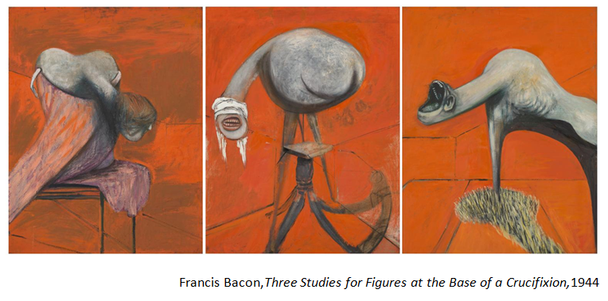

Next up is Francis Bacon. An Irish born British bold, emotionally charged painter. Throughout his life he was obsessed by death which haunted him and his work and was a theme often explored by him. As he said, (Giacobetti, 2003),’ I think about death every day’.
After some research and debating I decided to show his 1944, Triptych of three studies for figures at the base of the crucifixion. The first reason why I choose this piece was because it’s in a way, a response to one of the most painful forms of death, the crucifixion. The work itself doesn’t show a cross or the actual death. It’s the three figures altered, deformed human like responses towards the crucifixion/death that trap the viewers mind in speculation on what they feel and the story they are telling, (1998:95), ‘death is the sanction of everything the narrator can report’. Now the second reason why I chose this piece was that it was first exhibited and shown in April 1945, which was the same time that the footage and pictures of the Nazi concentration camps were released to the world. Even though the paintings were not made as a response to this, it does give a bold response on how much death and suffering can be caused by fellow humans during ww2.

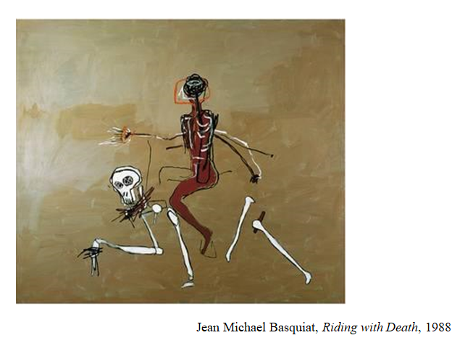
The next artist in the exhibition is Jean-Michel Basquiat. Basquiat was American neo expressionism painter who unfortunately only had an eight year career making him one of the shortest lived but most successful artists of the 20th century, due his death in 1988 at the age of 27. He suffered from depression and in his last few years it had gotten worse especially after the death of his friend Andy Warhol. He died from a drug overdose of heroin as he had become more dependent on them. The reason why I picked him is because it’s a good example how depression doesn’t just target older generations but younger ones as well and how it can cause more problems to get worse, according to (Hoban, 1998), ‘In the months before his death, Basquiat claimed he was doing up to a hundred bags of heroin a day’.
The piece which will be on show is one of his last works, riding with death (1998). The painting is quite simple minimal compared to a lot of his work, this may be because he is trying to show a simple message. The paining appears to be a man riding a skeleton of a horse, maybe Basquiat was trying to show that he is simply riding on a path towards his death as he knew his depression and drug problem was getting worse and he couldn’t see the way out.

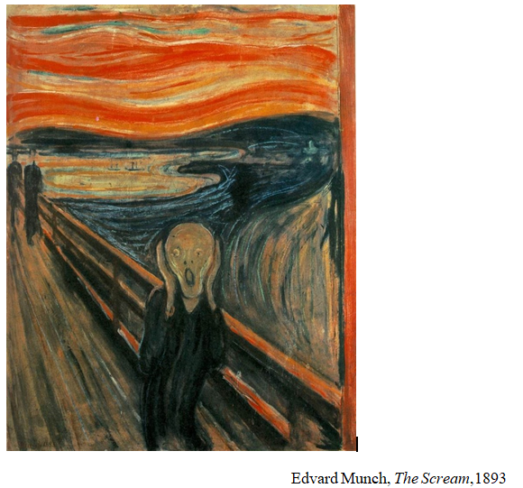
The scream (1893) by Edvard Munch was the next piece I decided would be shown in the exhibition. Edvard was a Norwegian painter and printmaker who suffered from chronic depression and lived through many traumas in is life that haunted him, such as his mothers and sister’s death before he turned 15.
His mental state detreated so badly at one stage he was hospitalized for a few months, which helped him with some problems but he still suffered from his depression. During the time it was painted his other sister who also suffered from manic depression was a patient in an asylum, which may have provided inspiration for the piece. Also his own problems inspired the piece as he had big fears/ anxiety about the world, (2007:251), ‘My fear of life is necessary to me, as is my illness. Without anxiety and illness, I am a ship without a rudder’. The image itself provokes a response from the viewer, on why the figure is screaming at and how it connects to each and one of us as we feel a connection to it.

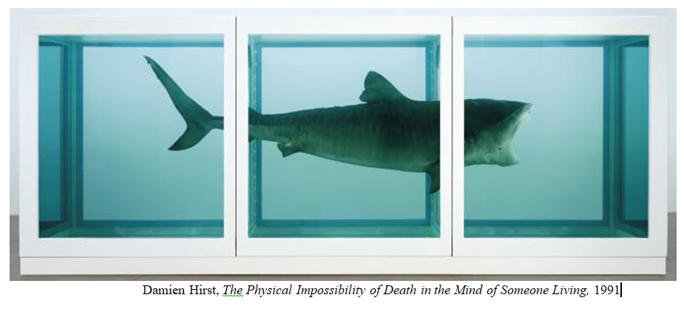

The final artist on show will be Damien Hirst. Hirst is an English artist born in 1965 who has been fascinated by death for most of his life and has been a constant theme in his work, as he said in a n interview, (2012:96), ‘Once I’d realised that [death] was a fact, and much more of a fact than God, religion, or any of those sort of things, or Father Christmas, then I used to just perversely think about it all the time. And I still do.’ The work showing of his will be, The Physical Impossibility of Death in the Mind of Someone Living. One of the reasons why I want this piece is because I wanted at least one piece of work you could view at all angles, in a way to see a deathlike form every angle. Then the other reason was because the shark is a deadly animal that represents death and causes fear in many people. To which the viewer can’t help but act with curiosity towards to see a physical example of death.
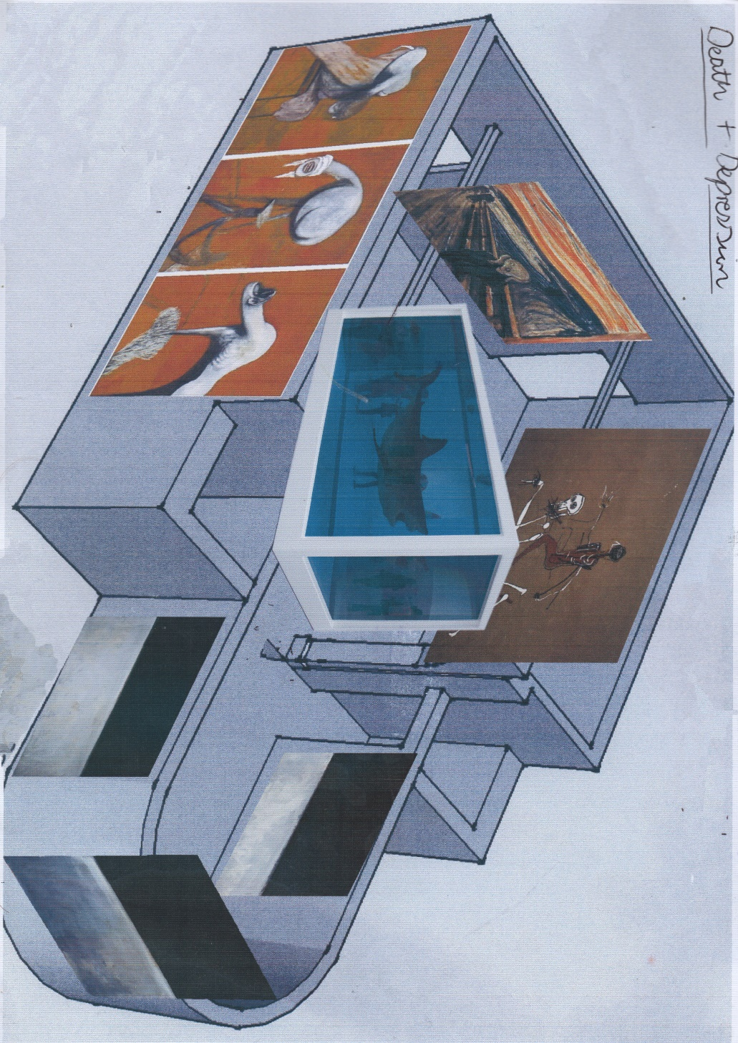

References
- BBC News. (2017). 1 in 4 girls 'shows signs of depression'. [Online] Available at: http://www.bbc.co.uk/news/health-41310350 [Accessed 20 Oct. 2017].
- Rothko. (1969)Black on Gray [acrylic on canvas].National gallery of art, Washington.
- Rothko. (1969)Black on Gray [acrylic on canvas].National gallery of art, Washington.
- Rothko. (1969)Black on Gray [acrylic on canvas].Kate Rothko Prizel, New York.
- Rothko, M. and López Remiro, M. (2006). Writings on art. New Haven: Yale University Press, p.36.
- Francis Bacon. (1944) Three Studies for Figures at the Base of a Crucifixion [oil paint on three boards].Tate, London.
- Giacobetti, F. (2003). Francis Bacon: the last interview. Independant. [Online] Available at: https://www.independent.co.uk/arts-entertainment/art/features/francis-bacon-the-last-interview-8368727.html [Accessed 13 Jun. 2003]
- Alphen, E. (1998). Francis Bacon and the loss of self. London: Reaktion Books, p.95.
- Jean Michael Basquiat. (1988) Riding with Death[ Acrylic and Crayon on Canvas].Private Collection
- Hoban, p. (1998). Basquiat. [Online] Archive.nytimes.com. Available at: https://archive.nytimes.com/www.nytimes.com/books/first/h/hoban-basquiat.html
- Edvard Munch. (1893) The Scream[oil, pastel and crayon on cardboard]. Munch Museum, Norway.
- Prideaux, s. (2007). Edvard Munch: Behind the Scream. New haven: Yale University Press, p.251.
- Damien Hirst. (1991) The Physical Impossibility of Death in the Mind of Someone Living [Tiger shark in formaldehyde]. Steven A. Cohen, Connecticut
- Hirst, D., Gallagher, A. and Craig-Martin, M. (2012). Damien Hirst. Millbank, London: Tate publishing, p.96.

Reading list
- Rothko, M. and López Remiro, M. (2006). Writings on art. New Haven: Yale University Press
- Achim Borchardt-Hume. (2008). Rothko. London: Tate
- James E.B. Breslin. (1998). Mark Rothko: A Biography. Chicago: University of Chicago Press
- Alphen, E. (1998). Francis Bacon and the loss of self. London: Reaktion Books
- John Russel. (1993). Francis Bacon. London: Thames and Hudson
- Ian Dunlop. (1977). Edvard Munch. London: Thames and Hudson
- Angela Lampe. (2012). Edvard Munch: the modern eye. London: Tate
- Hirst, D., Gallagher, A. and Craig-Martin, M. (2012). Damien Hirst. Millbank, London: Tate

