LCHS4009

PROFESSIONAL DEVELOPMENT WITHIN HEALTH AND SOCIAL CARE: COMPONENT 2

Student Name : Nida Jamil
Student Id: 2516924
Lecturer’s name: Dilhara Mampitiya

Table of Contents
Task 1: Two-page professional CV 3
Task 2: Personal Statement for the Healthcare Assistant Position at Archvale, UK 5
Overview 5
Career Aim 5
Education and Qualifications 5
Professional Experience 5
Professional skills and personal strengths 6
Task 3: SWOT Analysis and Personal Development Plan (PDP) 7
SWOT Analysis 7
Personal Development Plan (PDP) 8
Monitoring and evaluation 9
Task 4: Reflection on Component 1 Presentation Using Gibbs’ Reflective Cycle 11
Description 11
Feelings 11
Evaluation 11
Analysis 12
Conclusion 12
Action Plan 12
References 13
Appendix 15
Job advert 15

Task 1: Two-page professional CV
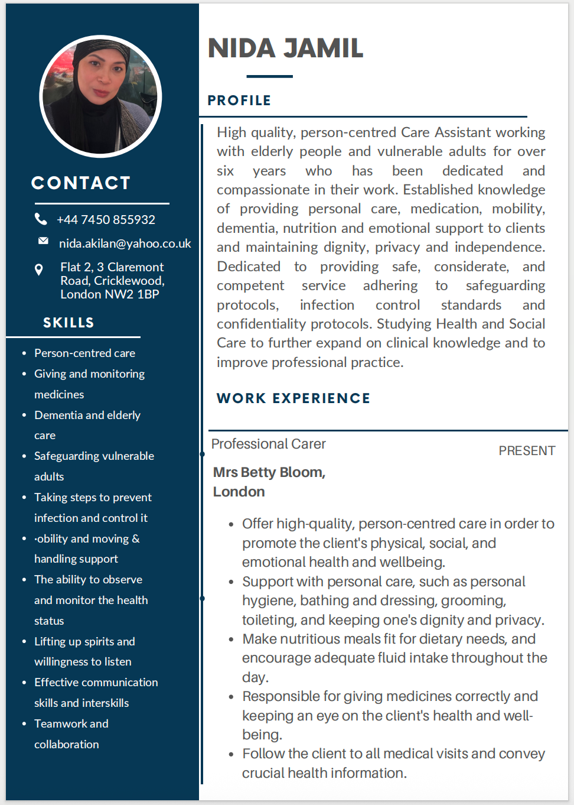
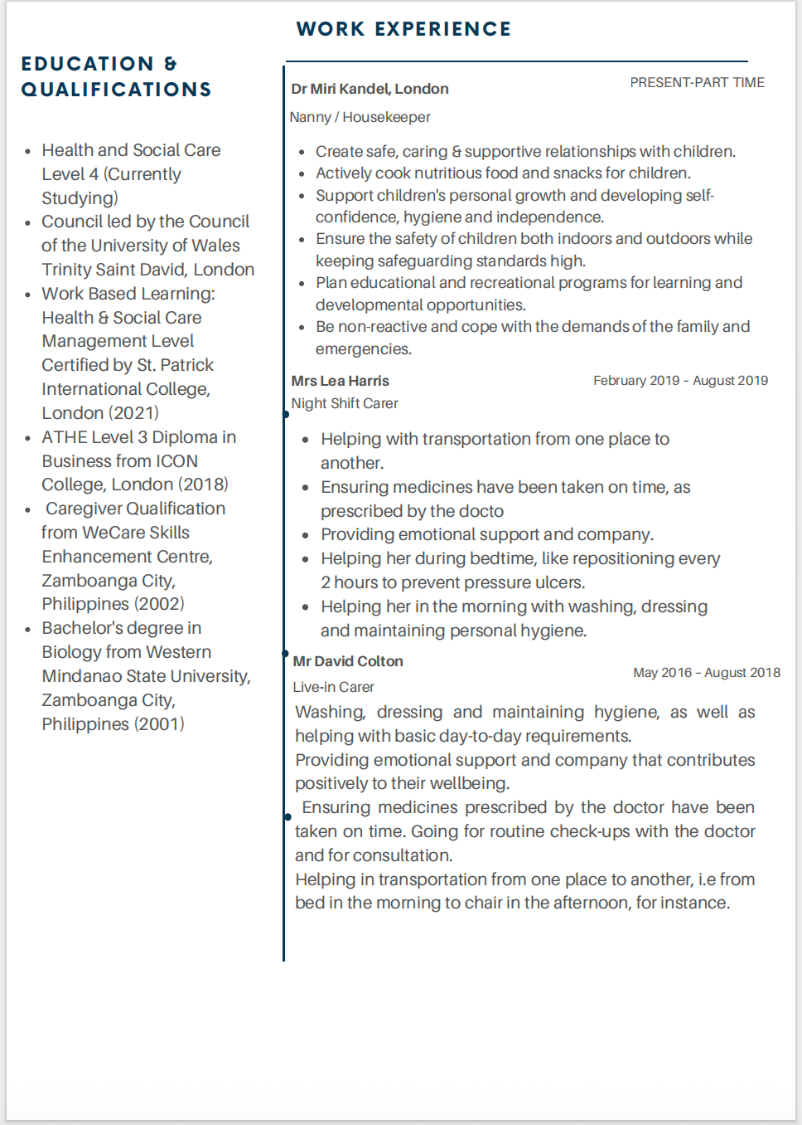

Task 2: Personal Statement for the Healthcare Assistant Position at Archvale, UK

Overview
I gladly seek an interview for the job of Healthcare Assistant (HCA) at Archvale because I love to help people who want to live with dignity and in a comfortable manner within a safe environment. Senek et al. (2025) noted that the HCA roles fluctuate considerably depending on the setting, but they can involve recording and observing the condition of the patients.
From when I began as a professional career, I have helped others conduct their daily activities, personal care, medication and emotional wellbeing. Through my learning and qualifications in Biology and Health and Social Care, including hands-on experience, I have gained the necessary knowledge and skills to ensure that I can provide caring and person-centred care.

Career Aim
My long-term career goal is to gain experience and be able to care for people of all ages, in a competent, safe and compassionate way as a Healthcare Assistant. In my opinion, everyone should be treated with dignity, kindness and respect, irrespective of their physical and mental state. Roth et al. (2022) explained that Human dignity is a moral concept which can be seen to play an important role in the moral justification of global human rights. I also aspire to further develop my career in the future through further training and progression in the Health and Social Care sector.

Education and Qualifications
My education has well equipped me with practical and theoretical knowledge of health care. I completed a Bachelor of Science in biology, which mainly helped me to understand basic physiology, human anatomy, and health-related concepts. I also got a caregiver qualification where I learned the principles of teamwork, personal care, supporting vulnerable individuals and infection prevention. These qualifications have increased my understanding of confidentiality, safeguarding, teamwork, person-centred care and professional ethics.

Professional Experience
For the last few years, I have been lucky to work as a professional carer in various care settings and have learned a great deal from this. I have supported clients to perform personal care tasks including washing, dressing, caring for hair and nails, getting around and ensuring their dignity and privacy are respected. I have assisted others to take their medication safely and have observed their condition, preparing healthy food for them and accompanying them to medical appointments and reported any changes to family members or health care professionals.

Professional skills and personal strengths
I have acquired a variety of work skills which have been useful in my learning and career; they are relevant skills for my role as a Healthcare Assistant. These include effective communication, teamwork, time management, observation skills, understanding of safeguarding, safeguarding awareness, understanding and preventing infection, accurate record keeping, confidentiality and provision of person-centred care.
Some of the strengths that I have personally developed are the ability to care and empathise with others, to be patient, trustworthy, adaptable and positive. I am also dedicated to lifelong learning and dutifully accept any knowledge-sharing opportunity that helps me build my knowledge and practice.

Task 3: SWOT Analysis and Personal Development Plan (PDP)

SWOT Analysis
Strengths
My best skill has been my many years of experience providing personal care, emotional support, medication and daily living support to those with varying healthcare needs. Caring attitude, patience, understanding, empathy and communication skills contribute to providing high-quality person-centred care. As per Morris et al. (2021), the carer addresses key patient safety issues and key points where they can make their care safer in primary care. I am able to work in a team, respect confidentiality, and always work professionally. I have various skills in healthcare domain including
KEY SKILLS
- Person-centred care
- Giving and monitoring medicines
- Dementia and elderly care
- Safeguarding vulnerable adults
- Taking steps to prevent infection and control it
- Mobility and moving & handling support
- The ability to observe and monitor the health status
- Lifting up spirits and willingness to listen
- Effective Communication skills and Inter-personal skills
- Teamwork and collaboration
Weaknesses
I have a wide range of care experience and am aware that I do not have much first-hand experience of using electronic patient record systems and direct experience of working in the NHS. I would like to develop my leadership skills and grow in confidence in bigger professional groups and audiences. I see these weaknesses, and I see ways to improve them; I can learn more and improve through experience.
Opportunities
Working at Archvale would offer excellent opportunities for continuous professional development via mentoring, structured training and practical learning. Archvale (2023) stated that the main mission of Archvale is to empower GP practices to deliver exceptional care. So I will also have opportunities to optimise my clinical knowledge and progress into more senior healthcare roles. All these opportunities will support both my long-term career development and personal development.
Threats
Working in healthcare can be emotionally and physically demanding because of shift patterns, high workloads and caring for vulnerable individuals. These challenges may sometimes affect wellbeing and performance. Although I can manage these threats by maintaining a healthy work-life balance, seeking support from colleagues, continuously optimising my professional flexibility and knowledge and attending wellbeing programs.

Personal Development Plan (PDP)
Coopersmith (2022) stated that a PDP is an important tool which helps me to address requirements and monitor my professional growth. This is a different tool for leaders to further develop their capacity for managing uncertainty. The following plan highlights the important areas to which I intend to develop over the next two years to become a highly able healthcare assistant at Archvale.
Development Goal | Actions to Achieve the Goal | Timeframe | Resources Required | Success Measures
Improvement in my clinical knowledge and practical healthcare skills | I will attend mandatory healthcare training, complete CPD courses, study healthcare guidelines, and learn from experienced colleagues during daily practice. | 6 to 12 months | Training sessions, online learning resources, supervisor support, and CPD courses are the required resources for this. | This will be checked by improved confidence, positive supervisor feedback, and successful completion of training programmes.
Development of stronger communication and digital documentation skills | I will attend communication workshops and practice accurate care documentation. Further, I will improve computer skills and regularly request feedback from senior staff. | 12 to 24 months | Here are the appropriate resources: communication training, digital healthcare systems, mentoring, and workplace practice. | Here are the steps to check: accurate documentation, improved communication with patients and colleagues, and positive performance reviews.
Prepare for a future career in a Senior Healthcare Assistant role | I will achieve this by working with experienced senior staff, as well as attending leadership training, accepting additional responsibilities, and continuing professional learning. | Within 24 months | The workshops of leadership mentoring, workplace experience, as well as professional development courses would be very helpful in this. | If there is increased leadership confidence, successful completion of leadership training, and readiness for promotion opportunities, then my success can be assured.

Monitoring and evaluation
I will review my PDP on a daily basis and plan to review it every three months to monitor my progress and address key areas which need further improvement. I will also seek feedback from my colleagues, supervisors and mentors to evaluate my learning and performance. Self-reflection, continuous learning and regular evaluation will help me remain motivated, and I will ensure that I continue to develop the professional skills required to provide compassionate, safe and high-quality care during my healthcare career.

Task 4: Reflection on Component 1 Presentation Using Gibbs’ Reflective Cycle

Description
In my presentation, I studied the importance of teamwork as a skill for the profession of Health and Social Care where I worked in a team to improve my skills. I explained the importance of teamwork regarding patient safety, team working and making clinical decisions. Moreover talked about the SBAR team system and an example of a Healthcare Assistant noticing signs of suspected Sepsis and letting the Registered Nurse know. Lastly, I considered my own strengths in teamwork management and decided that the most important one I could learn more about was 'how to escalate to senior professionals and show confidence'.

Feelings
Our self-confidence increased prior to the presentation as we had our own research and were preparing the slides in a proper manner. I was also apprehensive about conducting myself in public. The more I went through the presentation, the more confident I became in myself and could easily explain my concepts. When the end of the presentation came, I felt good about myself because I was able to give out the main content. Heydari and Beigzadeh (2024) found that reflection is a critical element for learning, which plays a fundamental role in enhancing skills and knowledge. However, as I was going on, I realised that I should build confidence in my speaking ability when it comes to professional scenarios.

Evaluation
Overall, the presentation was a precise and effective experience of learning where I worked on Tuckman's Model and reviewed the role of teamwork in the workplace. For that, I have searched and prepared for the topic within a regional and optimised format. The presentation was shown to be more practical and relevant to the role of the Healthcare Assistant, with the use of the SBAR example. Working in a group or team helped me to understand patient safety and multi-professional team; this helped to solidify the presentation even more. In terms of experience, I offered high-quality person-centred care in order to promote the client's physical, social and emotional health and wellbeing. I also support with personal care, such as personal hygiene, bathing and dressing, grooming, toileting and keeping one's dignity and privacy where I applied my knowledge and teamwork abilities to resolve issues. I am capable to make nutritious meals, fit for dietary needs and encourage adequate fluid intake throughout the day.

Analysis
This presentation allowed me to recognise that teamwork is a fundamental skill within the organisation of healthcare in teamwork programs. I discovered that effective team work, like the SBAR model, can help avoid misunderstandings, promote timely decision-making, and improve outcomes of healthcare-related processes. Praveena et al. (2025) explained that the Gibbs reflective cycle, known as a theoretical model launched by Graham Gibbs in 1988, facilitates a systematic framework. On my own as a performer, I recognised I must become more confident when reporting concerns and conveying information and ideas in a calm manner with active listening. Having these skills will benefit my future skills and work, as well as my studies. I am high quality, person-centred Care Assistant working with elderly people and vulnerable adults for over six years who has been dedicated and compassionate in the work that will help me to get a job in my healthcare domain easily.

Conclusion
In this presentation, I learnt more about effective teamwork team work leadership in Health and Social Care and how beneficial this is when providing safe, person-centred care. I felt I already had a good head on how to prepare and I was good at the subject knowledge but not as confident as in presentation delivery. Overall, it has been a positive experience, inspiring me to further develop my abilities in this field.

Action Plan
For future presentations, I will practice continuous speaking to enhance my skills and language, then further perform again and acquire feedback from my fellow scholars and tutors. According to Simonsmeier et al. (2020), one kind of feedback is the feedback of peers, which has become a crucial factor for teaching and learning strategies. I will also improve my skills in making eye-to-eye contact and projecting my voice and self-assurance when communicating with others in a team. In subsequent scenarios, and on my next placement or job, I will apply the SBAR system to reporting patients' concerns to my leaders at Archvale. These actions will enable me to build my confidence to communicate with team members and become a more effective Healthcare Assistant.

References
Archvale (2023) Archvale. [online] Available at: https://www.archvale.co.uk/about [(Accessed: 6 August 2026).
Coopersmith, K., (2022) ‘Personal development planning and vertical leadership development in a VUCA world’, The Journal of Values-Based Leadership, 15(1), p.10. Available at: https://scholar.valpo.edu/cgi/viewcontent.cgi?article=1380&context=jvbl (Accessed: 6 August 2026).
Heydari, S. and Beigzadeh, A., (2024) ‘Medical students’ perspectives of reflection for their professional development’, BMC Medical Education, 24(1), p.1399. Available at: https://link.springer.com/article/10.1186/s12909-024-06401-2 (Accessed: 6 August 2026).
Praveena, K.S., Juslin, F., Patil, C.M. and Bhargavi, K., (2025) ‘Using gibb's reflective model approach for enhancing project-based learning among students through reflective assessment’, Journal of Engineering Education Transformations, pp.148-155. Available at: https://journaleet.in/index.php/jeet/article/view/2071 (Accessed: 6 August 2026).
Simonsmeier, B.A., Peiffer, H., Flaig, M. and Schneider, M., (2020) ‘Peer feedback improves students’ academic self-concept in higher education’, Research in Higher Education, 61(6), pp.706-724. Available at: https://link.springer.com/article/10.1007/s11162-020-09591-y (Accessed: 6 August 2026).
Morris, R.L., Ruddock, A., Gallacher, K., Rolfe, C., Giles, S. and Campbell, S., (2021) ‘Developing a patient safety guide for primary care: A co‐design approach involving patients, carers and clinicians’, Health Expectations, 24(1), pp.42-52.Available at: https://onlinelibrary.wiley.com/doi/pdfdirect/10.1111/hex.13143 (Accessed: 6 August 2026).
Roth, K., Mollvik, L., Alshoufani, R., Adami, R., Dineen, K., Majlesi, F., Peters, M.A. and Tesar, M., (2022) ‘Philosophy of education in a new key: Constraints and possibilities in present times with regard to dignity’,Educational Philosophy and Theory, 54(8), pp.1147-1161. Available at: https://www.tandfonline.com/doi/pdf/10.1080/00131857.2020.1851189 (Accessed: 6 August 2026).
Senek, M., Long, J., Ohlsen, S., Finn, R., Weich, S., Ryan, T. and Wood, E., (2025) ‘Factors affecting the retention of healthcare assistants in English mental health services: a qualitative interview study’, BMC Health Services Research, 25(1), p.505.Available at: https://link.springer.com/content/pdf/10.1186/s12913-025-12665-1.pdf (Accessed: 6 August 2026).

‌

Appendix

Job advert
https://www.linkedin.com/jobs/view/4446918927/


