Developing Innovation and Creativity: Grocery Home Delivery
JUST GROCERY
Name of the Student: IFTEY JEWEL
Student ID: 1708789
Name of the University: UWTSD
Lecturer: MD NAZMUL HASAN
BMSW6102

Task 1: Written Submission

Introduction
In this pandemic situation which is being created due to COVID-19, The Grocery delivery service is facing a massive problem in the supermarket. The following my personal study of the innovative measures that the supermarket chain can take for tackling the various challenges that it faces in the market. In my opinion, this needs to be overcome by them so that they are capable of operating in a significant way possible. For this reason, the business firm in the market needs to come up with an idea so that they can flourish in the marketplace (Madsen et al. 2020). I think the idea needs to be unique in nature and should be able to grab the attention of ordinary people. This needs to be understood by the business firm so they are capable of adopting the strategy that will be beneficial for the growth of the firm in the marketplace. Suppose the company is operating in the retail business. In that case, they need to look after the matter properly so that they are capable of coming up with the new idea regarding a product or service (Shaker et al. 2020).
I believe that my new service idea which is called Just Grocery is a new and unique idea regarding about the grocery home delivery service so that the ordinary people can purchase the product from the e-commerce site and get their essential needs to be delivered at their doorsteps during this pandemic situation. This will ultimately assist the company in flourishing in the market and grabbing the attention so that just Grocery is capable of generating a massive amount of money from the marketplace in the process. Thus, proper care needs to be taken by the firm so that just Grocery can receive the goals.

Unique Service Proposition
Just Grocery is looking after to provide customers with the grocery home delivery service so that they are able to sale their product with the help of the outlet across the United Kingdom from Tesco as well as Asda and Sainsbury stores. The service Just Grocery is providing will be delivered within the 3 miles from the store and possess some charge of £4.99 and the grocery items that the customer purchase from the website will be delivered same day within 30 minutes. This unique service that the Just Grocery is willing to provide during this pandemic situation will assist them to flourish in the market and let them gain the goals that they have set in the marketplace (Grashuis, Skevas and Segovia 2020). This type of service is critical as well as essential for the ordinary people, and they will readily avail the service from the firm as this is relatively safe and help them to get their grocery products to deliver at the end (Hobbs 2020). Therefore, the firm needs to look after the matter so they can adopt the appropriate strategy to grab the attention of the people and encourage them to avail the service in the process.
Just Grocery is also providing menus that the customers need in their daily life so that they can select the items without any hassle and also the firm is willing to adopt the cashless transaction so that there is no human contact in the process. The online transaction that can be done with Paypal and also directly from the debit/credit card payment (Dannenberg et al. 2020). The firm is also intending to provide offers and discounts in the grocery items, and that will automatically let them grab the attention of the people.
In my opinion, this idea will assist Just Grocery in expanding in the marketplace and in gaining the success that they are looking for in the market, also help them to become popular in the end. The company is also looking after the selling of the household essential along with the grocery items so they will be able to become the number one company who are selling Grocery as well as a household essential in the process (Sharma et al. 2020).
I also think that the company will take care of safety packaging. but eco-friendly packaging so that the delivery person does not come in contact with the items and provide full safety and sanitation of the products that the customers have ordered from the website of the company. This unique idea for the service will assist the firm to flourish in the market, and the people will be willing to avail the service even if they need to pay the delivery charge in the process. This is so as the people can get a helping hand and without going outside, they can purchase their grocery items and the essential commodities which is in regular use in the households.
I think there is a need to be looked after properly so that just Grocery can market their service in the social media platform during this pandemic situation as the social media marketing is cheaper as well as faster. I have found that during the pandemic situation the people hardly going out of their house and that is the main reason there is no point for the company to bear the expense of traditional form of marketing (Pantano et al. 2020). But the company can invest in television commercials along with social media marketing so that they can reach to the people in less possible time and cheaper rate. Hence, this is the main reason the Just Grocery needs to look after the matter so they can grab the attention of the ordinary people and can encourage them to avail the service from the company in the process. This will ultimately let the company to acquire the profit and also help them to gain popularity among the consumers in the end (Baker et al. 2020). So, proper care needs to be taken by the Just Grocery so they can acquire the target that they have set in the marketplace and are assisting them in providing the best quality service to the ordinary people in the market where they will be operating.

E-Commerce
In my opinion, when the e-commerce side of the business is concerned, the Just Grocery will look after the online business. I think for this reason they will develop an online website as well as a mobile application like Amazon and also needs to look after the online payment service like PayPal and transaction from the debit and credit card. This is important for the Just Grocery to looked after as they are providing the grocery home delivery to the customers and are maintain the social distancing during this pandemic situation (Gao et al. 2020). I think the Just Grocery also needs to include the delivery charge for the service that they are going to charge to the customers for providing their Grocery and the essential commodities at their doorsteps. This is necessary for the firm to looked after so that they can adopt the appropriate e-commerce strategy, which will automatically assist them in growing in the market and in acquiring the target in the end (Pantano et al. 2020). This is critical for the company to look after as they are adopting the strategy of zero contact, The payment needs to be done prepaid by the customers, and there should not be any option like cash on delivery as that will encourage the human contact during this pandemic situation.
The Just Grocery will look after the safety of the staff who is going for the delivery, and that is the main reason proper precaution will be maintained in the process and encouraging the people to do online transaction during the purchase. The Just Grocery will look after the marketing process, and that should be done online so that they can reach to the customers in less possible time and at a much faster rate (Ota, Sangita Ray and Kumar 2020). If the company is unable to do so, then they will not be able to acquire the target that they are looking for in the market where they will be operating. The company need to develop their website as well as a mobile application like Amazon and eBay simple and customers friendly. The Just Grocery firm also needs to provide the customers with discounts and offers so that they can grab the attention and encourage them to purchase a product from the company.
There are other important aspects as well for the Just Grocery to look after is that they need to contact with the clients who will provide them with the resources and in this case groceries and essential commodities (Hashem 2020). The firm will target grocery store all around the United Kingdom so that they can provide the service to the customers all around the country and also to the grocery stores. This will also enable the grocery stores to reach to the customers with the platform that the Just Grocery is launching in the United Kingdom and that will assist the grocery stores to operate in an effective way possible and continue the business without thinking about the delivery of the products in the end. The delivery charges that have been added by the Just Grocery, i.e., £4.99 pound is the money that the company is making and also providing the discounts to the customers assist them in attracting more number of people to avail the service from them (Pan, Cui and Qian 2020). This will ultimately help the company to charge the grocery stores some nominal amount for providing them with the customers and helping them to sale their products during this pandemic situation. As per the General Data Protection Regulation, the Just Grocery will adopt security measures like uploading a firewall in the system and also appoint an engineer so that they can keep track of whether data is breaching or not. These will automatically enable the company to protect the data of the customers like name, address, and bank details as this are critical data that will be looked after properly by the company in the e-commerce. This strategy requires to be adopted by the company properly so they can acquire the target in the marketplace and are able to sustain in it in the process (Chaudhary 2020). The company will take proper care and able to adopt the strategy properly so that they are capable to acquire the target audience and also will be able to grab the attention of the clients who will let them operate in the market and to continue the business in an effective way possible in the end.

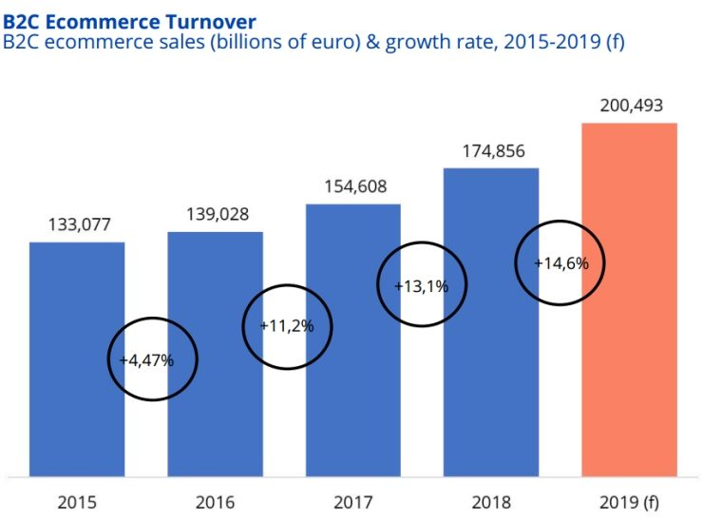
Fig. 1: E-Commerce Growth in the United Kingdom
(Source: Created by Author)
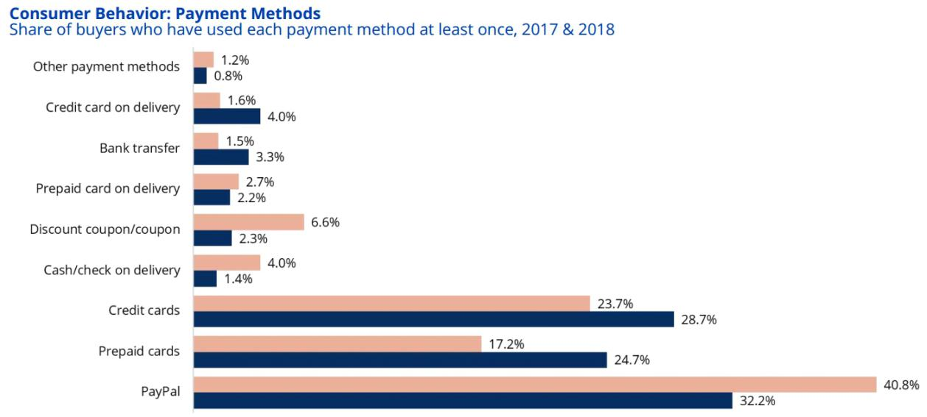
Fig. 2: Use of Payment Mode in the United Kingdom
(Source: Created by Author)

The eccomerce website link :

https://ai4088420.wixsite.com/justgrocery

Marketing
As per the Innovation idea the Just Grocery will look after the target audience who are mainly the parents and single adults or people who are living alone so that they can make the content as well as take pictures so that they can post it in the social media platform. This automatically assists the Just Grocery to flourish in the market as this is an era of technology and during this pandemic situation people are more into the social media platforms and to grab the attention the company will advertise their ads in a proper and attractive way possible (Grashuis, Skevas and Segovia 2020). If they are capable of grabbing the attention of the people in the market, then they will be capable of acquiring the target that they are looking for and will let them grow in the market where they are operating in the end. The Just Grocery will also look after the service and promote them properly in Facebook as well as in Instagram and Twitter by paying the influencers so as to gain the popularity, and the people get encouraged to avail the service from the company (Pantano et al. 2020).
The Just Grocery should be able to reach out to the customers in a significant way possible so that they are capable of grabbing the attention. As the company is providing a vital service in the market, they will be able to flourish in the end. For this reason, the firm will adopt the email marketing as well and if the company is able to provide the best quality service along with the best deals and offers they will automatically grab the attention of the consumers. They will become popular in the process (Hobbs 2020). So, this is critical for the growth of the company in the market, and they will be able to undertake the strategy that will assist them in operating efficiently in the market. The Just Grocery will also make promotion for the clients as well so that they can grab the attention of the clients on whose behalf they will be delivering the grocery items and essential commodities to the consumers in the market.
Marketing of the service or the product that the organization is providing is very much vital as this is the only way through which the company is able to provide the first-hand information to the consumers. This has to be attractive and catchy so that they can grab the attention of the people and encourage them to avail the service from the business firm (Roggeveen and Sethuraman 2020). This is the sole reason the Just Grocery will adopt the strategy as well as channels for the marketing process properly keeping in mind the needs and wants of the people. This will help them to acquire the success and let them grab the attention, and for this reason, proper care plays a vital role for the company to become popular in the market.
Therefore, this need to be looked after by the Just Grocery in an effective way possible and let them acquire the target that they are looking for. If the firm is able to grab the attention of the customers and the clients, then they will be able to acquire the target that they have set in the marketplace (Berry et al. 2020). This will also let them provide the necessary service to the customers during this pandemic situation, and this will automatically make them popular if they are able to market their service in an effective way possible. Hence, it can be said that the marketing is the vital factor that needs to be looked after properly by the company and make them popular among the consumers. During this pandemic situation, this kind of service is the only thing that is being required by the customers so that they are able to order the Grocery as well as essential items from the supermarket without coming into contact with anyone (He and Harris 2020). So, proper care should be taken by the Just Grocery in marketing the service through social media so that the ordinary people are aware of the unique service that the Just Grocery is providing in the marketplace.

Conclusion
Lastly, it can be said that the just Grocery has come up with a unique idea regarding the delivery service during this pandemic situation. This will assist them to grow in the market and to gain the success that Just Grocery looking for in the marketplace. If the business firm can provide the best deals along with the best quality service, then the consumers will avail the service even after the pandemic situation in the United Kingdom. This will make the organization popular among the consumers and also helps the society to remain safe and purchase their Grocery and essential products from Just Grocery.

References
Aymerich-Franch, L. and Ferrer, I., 2020. The implementation of social robots during the COVID-19 pandemic. arXiv preprint arXiv:2007.03941.
Baker, S.R., Farrokhnia, R.A., Meyer, S., Pagel, M. and Yannelis, C., 2020. How does household spending respond to an epidemic? consumption during the 2020 covid-19 pandemic (No. w26949). National Bureau of Economic Research.
Berry, L.L., Danaher, T.S., Aksoy, L. and Keiningham, T.L., 2020. Service Safety in the Pandemic Age.
Brownlee, W., Bourdette, D., Broadley, S., Killestein, J. and Ciccarelli, O., 2020. Treating multiple sclerosis and neuromyelitis optica spectrum disorder during the COVID-19 pandemic. Neurology.
Bublitz, M.G., Czarkowski, N., Hansen, J., Peracchio, L.A. and Tussler, S., 2020. Pandemic Reveals Vulnerabilities in Food Access: Confronting Hunger Amidst a Crisis. Journal of Public Policy & Marketing, p.0743915620929998.
Chaudhary, H., 2020. Analyzing the Paradigm Shift of Consumer Behavior Towards E-Commerce During Pandemic Lockdown. Available at SSRN 3664668.
Cox, D.J., Plavnick, J.B. and Brodhead, M.T., 2020. A proposed process for risk mitigation during the COVID-19 pandemic. Behavior analysis in practice, pp.1-7.
Dannenberg, P., Fuchs, M., Riedler, T. and Wiedemann, C., 2020. Digital transition by COVID‐19 pandemic? The German food online retail. Tijdschrift voor economische en sociale geografie, 111(3), pp.543-560.
DUYGUN, A. and ŞEN, E., 2020. Evaluation of Consumer Purchasing Behaviors in the COVID-19 Pandemic Period in the Context of Maslow's Hierarchy of Needs. PazarlamaTeorisi ve Uygulamaları Dergisi, 6(1), pp.45-68.
Gao, X., Shi, X., Guo, H. and Liu, Y., 2020. To buy or not buy food online: The impact of the COVID-19 epidemic on the adoption of e-commerce in China. PloS one, 15(8), p.e0237900.
Grashuis, J., Skevas, T. and Segovia, M.S., 2020. Grocery shopping preferences during the COVID-19 pandemic. Sustainability, 12(13), p.5369.
Grashuis, J., Skevas, T. and Segovia, M.S., 2020. Grocery shopping preferences during the COVID-19 pandemic. Sustainability, 12(13), p.5369.
Hashem, T.N., 2020. Examining the Influence of COVID 19 Pandemic in Changing Customers' Orientation towards E-Shopping. Modern Applied Science, 14(8).
He, H. and Harris, L., 2020. The Impact of Covid-19 Pandemic on Corporate Social Responsibility and Marketing Philosophy. Journal of Business Research.
Hobbs, J.E., 2020. Food supply chains during the COVID‐19 pandemic. Canadian Journal of Agricultural Economics/Revue canadienne d'agroeconomie.
Hobbs, J.E., 2020. Food supply chains during the COVID‐19 pandemic. Canadian Journal of Agricultural Economics/Revue canadienne d'agroeconomie.
Laguna, L., Fiszman, S., Puerta, P., Chaya, C. and Tárrega, A., 2020. The impact of COVID-19 lockdown on food priorities. Results from a preliminary study using social media and an online survey with Spanish consumers. Food Quality and Preference, 86, p.104028.
Li, J., Hallsworth, A.G. and Coca‐Stefaniak, J.A., 2020. Changing Grocery Shopping Behaviours Among Chinese Consumers At The Outset Of The COVID‐19 Outbreak. Tijdschrift voor economische en sociale geografie, 111(3), pp.574-583.
Li, K.J. and Li, X., 2020. COVID-19 Pandemic: Social Distancing, Public Policy, and Market Response. Public Policy, and Market Response (May 5, 2020).
Madsen, T.E., Dobiesz, V., Das, D., Sethuraman, K., Agrawal, P., Zeidan, A., Goldberg, E., Safdar, B. and Lall, M.D., 2020. Unique Risks and Solutions for Equitable Advancement during the Covid-19 Pandemic: Early Experience from Frontline Physicians in Academic Medicine. NEJM Catalyst Innovations in Care Delivery, 1(4).
Nah, F.F.H. and Siau, K., 2020, July. COVID-19 Pandemic–Role of Technology in Transforming Business to the New Normal. In International Conference on Human-Computer Interaction (pp. 585-600). Springer, Cham.
Ota, R., Sangita Ray, S. and Kumar, R., 2020. A Study on the Indian Consumer mindset towards online shopping during the pandemic period: A special reference to Flipkart. Science, Technology and Development, 9(7), pp.197-204.
Oyebode, O., Ndulue, C., Adib, A., Mulchandani, D., Suruliraj, B., Orji, F.A., Chambers, C., Meier, S. and Orji, R., 2020. Health, Psychosocial, and Social issues emanating from COVID-19 pandemic based on Social Media Comments using Natural Language Processing. arXiv preprint arXiv:2007.12144.
Pan, S.L., Cui, M. and Qian, J., 2020. Information resource orchestration during the COVID-19 pandemic: A study of community lockdowns in China. International Journal of Information Management, p.102143.
Pantano, E., Pizzi, G., Scarpi, D. and Dennis, C., 2020. Competing during a pandemic? Retailers’ ups and downs during the COVID-19 outbreak. Journal of Business Research.
Pantano, E., Pizzi, G., Scarpi, D. and Dennis, C., 2020. Competing during a pandemic? Retailers’ ups and downs during the COVID-19 outbreak. Journal of Business Research.
Pantano, E., Pizzi, G., Scarpi, D. and Dennis, C., 2020. Competing during a pandemic? Retailers’ ups and downs during the COVID-19 outbreak. Journal of Business Research.
Pantano, E., Pizzi, G., Scarpi, D. and Dennis, C., 2020. Competing during a pandemic? Retailers’ ups and downs during the COVID-19 outbreak. Journal of Business Research.
Roggeveen, A.L. and Sethuraman, R., 2020. How the COVID Pandemic May Change the World of Retailing. Journal of Retailing.
Shaker, M.S., Oppenheimer, J., Grayson, M., Stukus, D., Hartog, N., Hsieh, E.W., Rider, N., Dutmer, C.M., Vander Leek, T.K., Kim, H. and Chan, E.S., 2020. COVID-19: pandemic contingency planning for the allergy and immunology clinic. The Journal of Allergy and Clinical Immunology: In Practice.
Sharma, H.B., Vanapalli, K.R., Cheela, V.S., Ranjan, V.P., Jaglan, A.K., Dubey, B., Goel, S. and Bhattacharya, J., 2020. Challenges, opportunities, and innovations for effective solid waste management during and post COVID-19 pandemic. Resources, conservation and recycling, 162, p.105052.
Sharma, H.B., Vanapalli, K.R., Cheela, V.S., Ranjan, V.P., Jaglan, A.K., Dubey, B., Goel, S. and Bhattacharya, J., 2020. Challenges, opportunities, and innovations for effective solid waste management during and post COVID-19 pandemic. Resources, conservation and recycling, 162, p.105052.
Smith, J.A. and Judd, J., 2020. COVID‐19: Vulnerability and the power of privilege in a pandemic. Health Promotion Journal of Australia, 31(2), p.158.
Wrycza, S. and Maślankowski, J., 2020. Social Media Users’ Opinions on Remote Work during the COVID-19 Pandemic. Thematic and Sentiment Analysis. Information Systems Management, pp.1-10.

