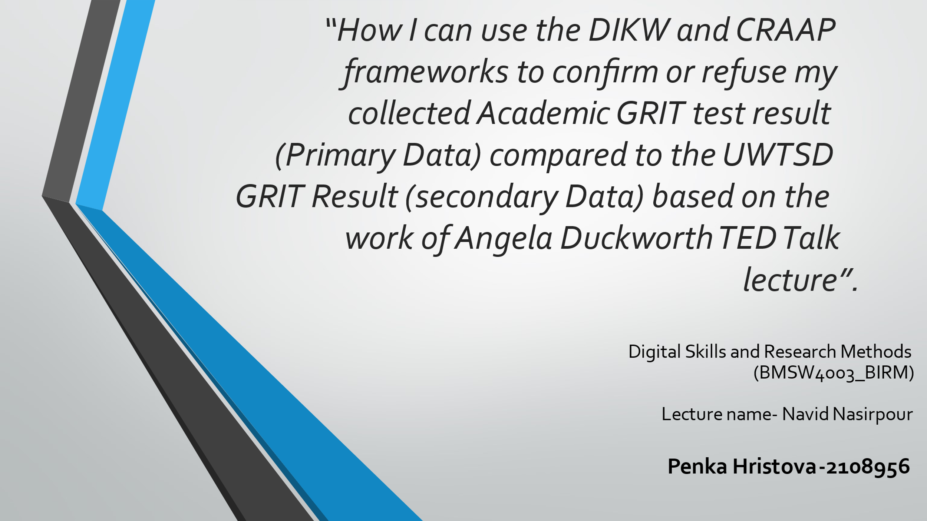

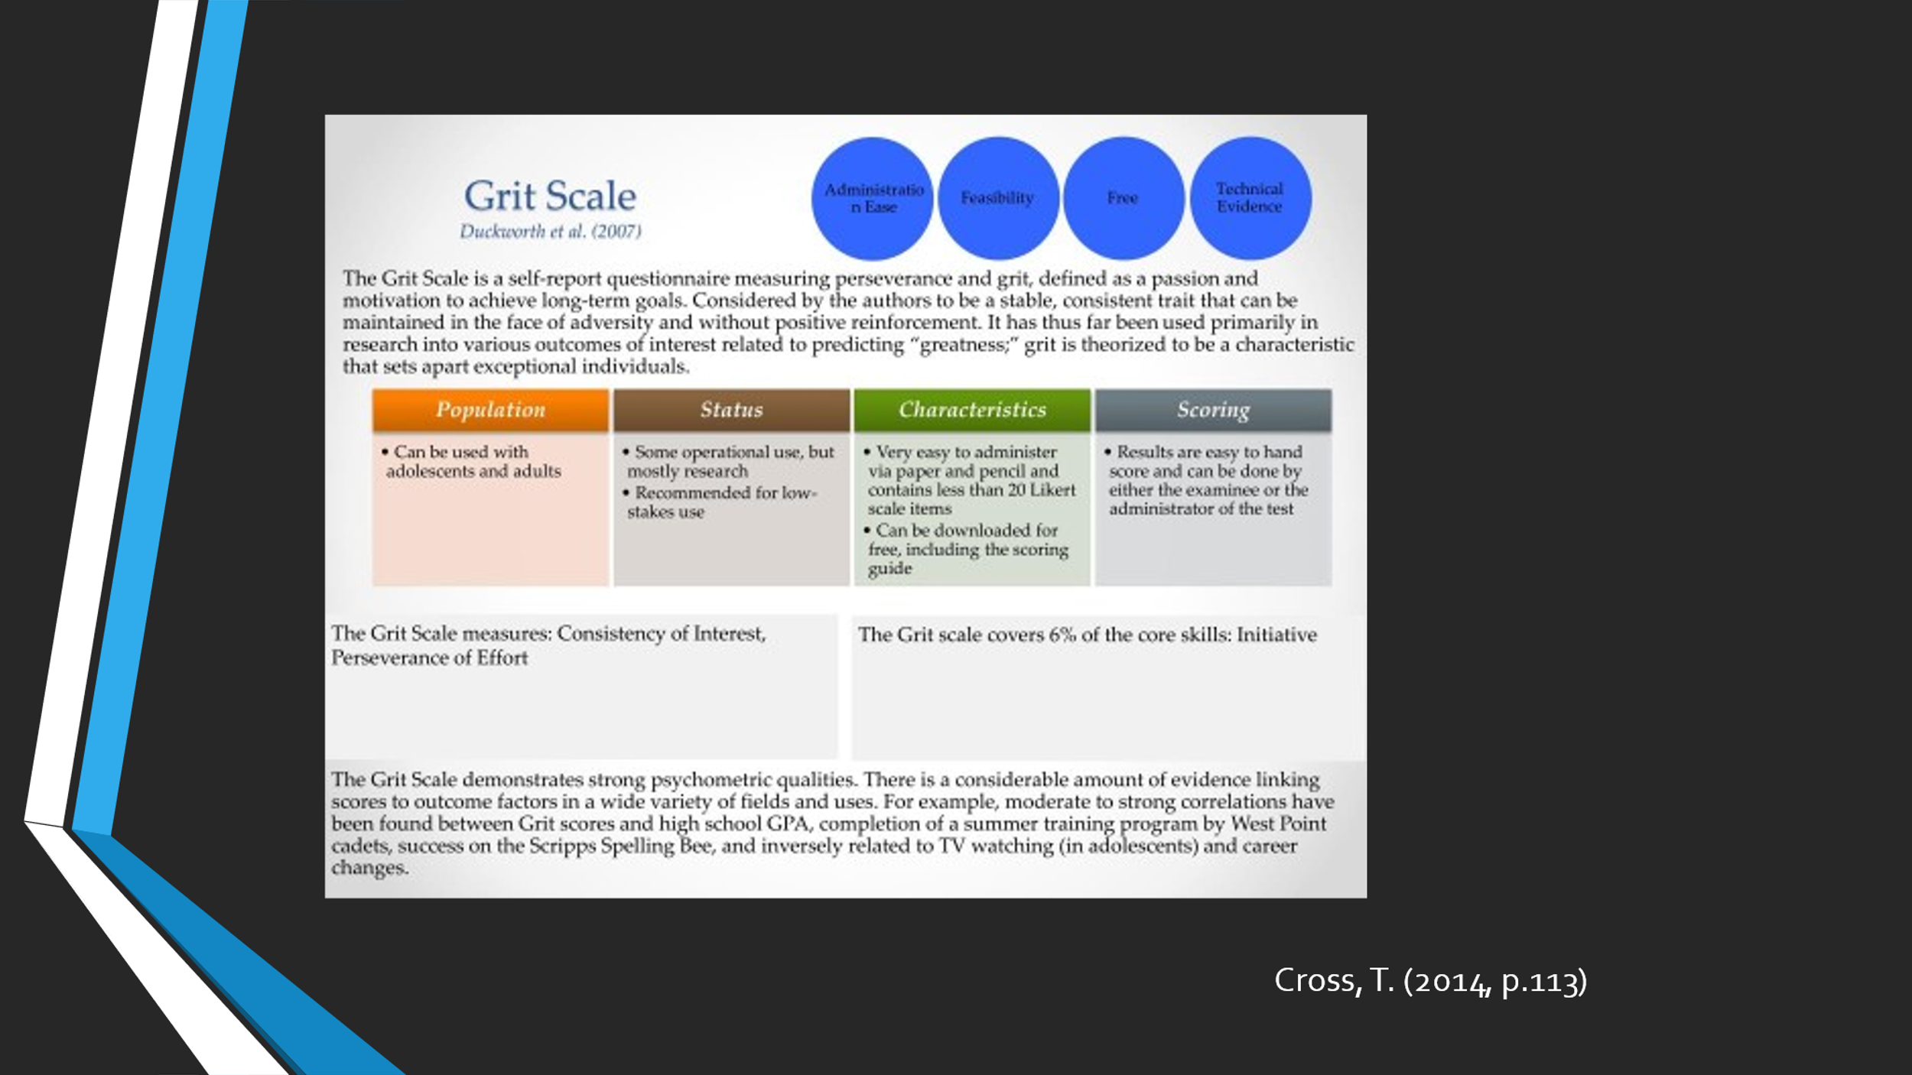
The understanding of Grit remains low; it’s unrelated to talent and can be adversely associated and Angela explains the importance of the Growth Mindset, which recognizes that learning ability is not fixed and may change with effort. The abbreviation CRAAP stands for Context, Relevance, Authority, Accuracy, and Purpose. Information timeliness is referred to as currency; Relevance refers to how important the information is to your needs. The source of the information is referred to as the authority. Accuracy refers to the content's dependability, veracity, and correctness. The reason for the information's existence is its objective. A DIKW Pyramid represents the relationships between data, information, knowledge, and wisdom; each piece represents a step up the pyramid: data, information, knowledge, and wisdom are the first four. Each stage adds value to the model data by answering a question. The more meaning and context we add to our data, the more information, and insights we gain, allowing us to make better, data-driven decisions. DIKW's building blocks are predetermined – data comes first, followed by information, knowledge, wisdom, and lastly, knowledge comes at the top. The use of DIKW and CRAAP to evaluate ones’ primary GRIT scores is compared to the use of UWTSD Grit scores, which is secondary data, in the context of Angela’s approach.


Using the CRAAP test, the secondary is evaluated for its currency and used to compare my current scores and how valid the comparison should be instead of the secondary data. Evaluating the sources of data used is of prime importance in enhancing the validity of the information when used for a present purpose, such as making comparisons; when conducting research, you want to obtain the data that is most relevant to the present purpose for backing up one’s claims (Portillo, Johnson and Johnson, 2021). This necessitates a thorough examination of the data you discover. The data is to determine which sources are most relevant to your topic and assignment. The evaluation is also done to make sure that the study is of high quality and trustworthiness, to find professional opinions, research, and expert viewpoints on your issue. In this case, the data comes from an authoritative source as a comparator, and the authors have the right credentials and qualifications, being a university (Wachowski and Kohl, n.d.). The accuracy is also utilized in resolving the data for its correctness, truthfulness, and reliability; making comparisons of the present primary data to the secondary source must consider the veracity of the secondary data, and this is done through CRAAP. The data purpose then also becomes important because the secondary data must have a purpose relevant to the current primary data (Grit test results).

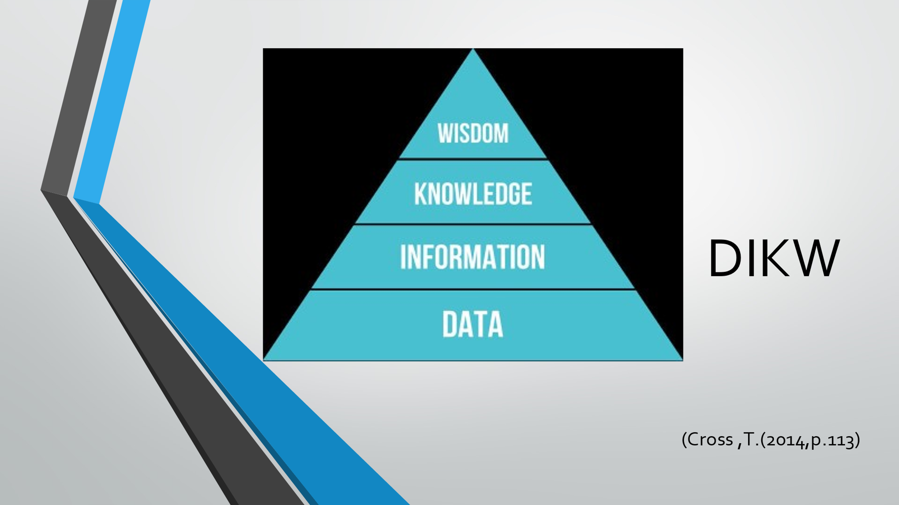

A collection of information in a raw or unstructured form, such as numbers or letters, is referred to as data. Data, on the other hand, might be meaningless without context, and by providing context and value to the statistics, they now have greater meaning. The network of relationships between data points is known as data context. Those links can be made via metadata or simply detected and correlated (Artyukhov, Volk, and Vasylieva, 2021). Contextual metadata offers value by allowing users to extract information from data. In assessing the current Grit scores, the data being used as a reference must contain relevant context to make the comparison realistic and seamless. As Angela states, it is not about ability only; used in this perspective, it is not just about the availability of data; the data must have some context that ties it to the present primary data to make it possible to make comparisons (Yang, Baets and Lachat, 2019). While the data (secondary) looks relevant as it contains Grit scores and the highest academic level. However, it is data, whose scores they are, and why they are made available to the public; is its data for a single student, a collection of data for the best students or for a university, or people that succeed in life?

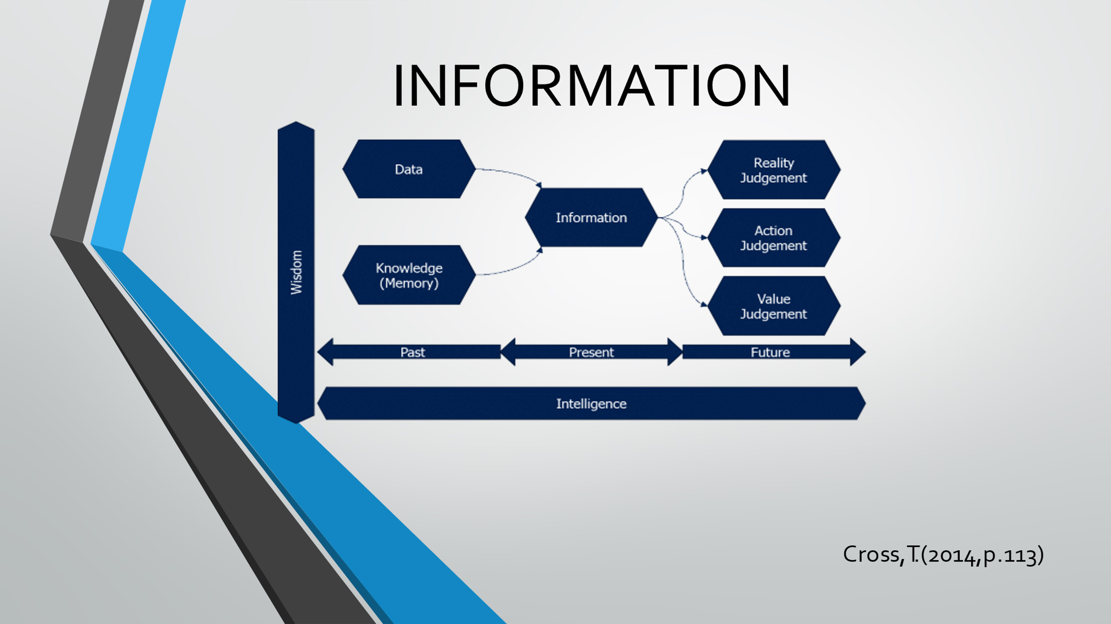

Next on the DIKW Pyramid's building blocklist is information. This refers to data that is already "cleaned" of mistakes and errors and processed further so that it may be measured, visualized, and resolve for a specific purpose. Data handling can encompass different actions varying on the purpose, such as mixing disparate sets of data (aggregation), ensuring that the obtained data is relevant and accurate, and so on (validation). We may extract significant information from data and make it more helpful for us by asking relevant questions about 'when, what, how, where, who, and, where.' The information must either be structural or functional; information is structured or organized data that has been prepared in such a way that it is relevant for a specific context or purpose and therefore, is valuable, meaningful, relevant, and useful. The information must be able to change something, such as perception; this ascribes to the functional nature of the information. Further, the primary data must be compared to the secondary data in the context of subjectiveness versus symbolism; information, in this case, can be symbolic, meaning being universal and being subjective so that the symbols are attached to its meaning.

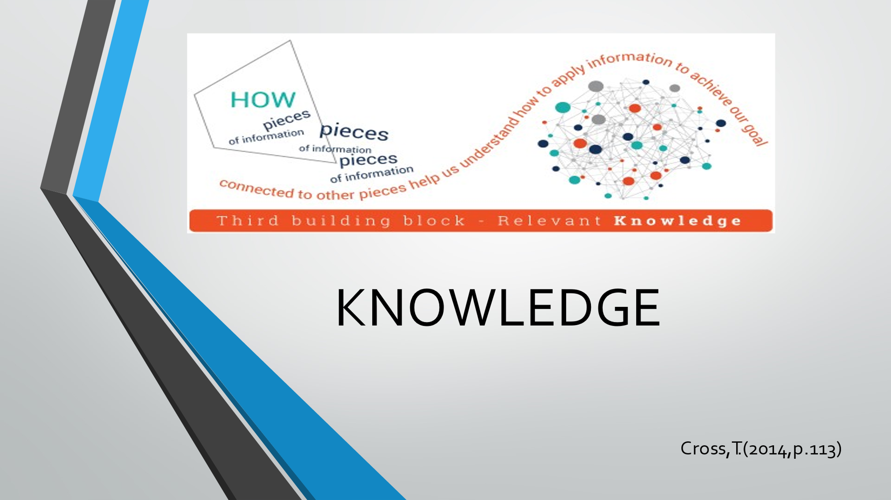

Concerning knowledge, the next concept in the pyramid, questions that include "How" the information is collected from the data relevant to our objectives? "How" are the bits and pieces of this data linked together to add greater meaning and value? And, maybe most crucially, "how" can we use the information to accomplish our objective. When we learn how to use the information to achieve our goals rather than just comprehending it as a collection of facts, it is transformed into knowledge. Businesses frequently use this knowledge to gain a competitive edge. We get richer insights as we identify relationships that aren't presented as information, moving us higher up the DIKW pyramid. Knowledge infuses depth in the comprehension of data so that information becomes functionally useful. As per the DIKW model, knowledge is understood about information; knowledge pertains to a fluid blend of values, framed experiences, expert insight, contextual information, and grounded intuition that offers an environment and framework for assimilating and processing new information and experiences. About the secondary data, the question to be asked is if they provide such values and experiences to generate new experiences, such as when performing comparative analysis.



At the summit of the DIKW hierarchy is wisdom; where questions like "why do something" and "what is best" are considered and answered. Wisdom, in other terms, is knowledge put into practice. It can also be said that, whereas data and information are related to what we do now and what we want to do in the future, knowledge, and wisdom are associated with what we want to achieve in the future. Understanding is established as a separate layer between knowledge and wisdom in this context, and wisdom is referred to as appraised understanding. Wisdom is also integrated knowledge—information that has been made useful; the ability to make excellent judgments and decisions without having to think about them. In this perspective, the present Grit scores are evaluated based on the usefulness of the information it contains about the secondary data; what might be derived from the secondary data when the present data is compared that is useful and adds value to the exercise. The comparison must generate useful wisdom; which can be termed as insights to conclude that the exercise has added value that can be acted upon.

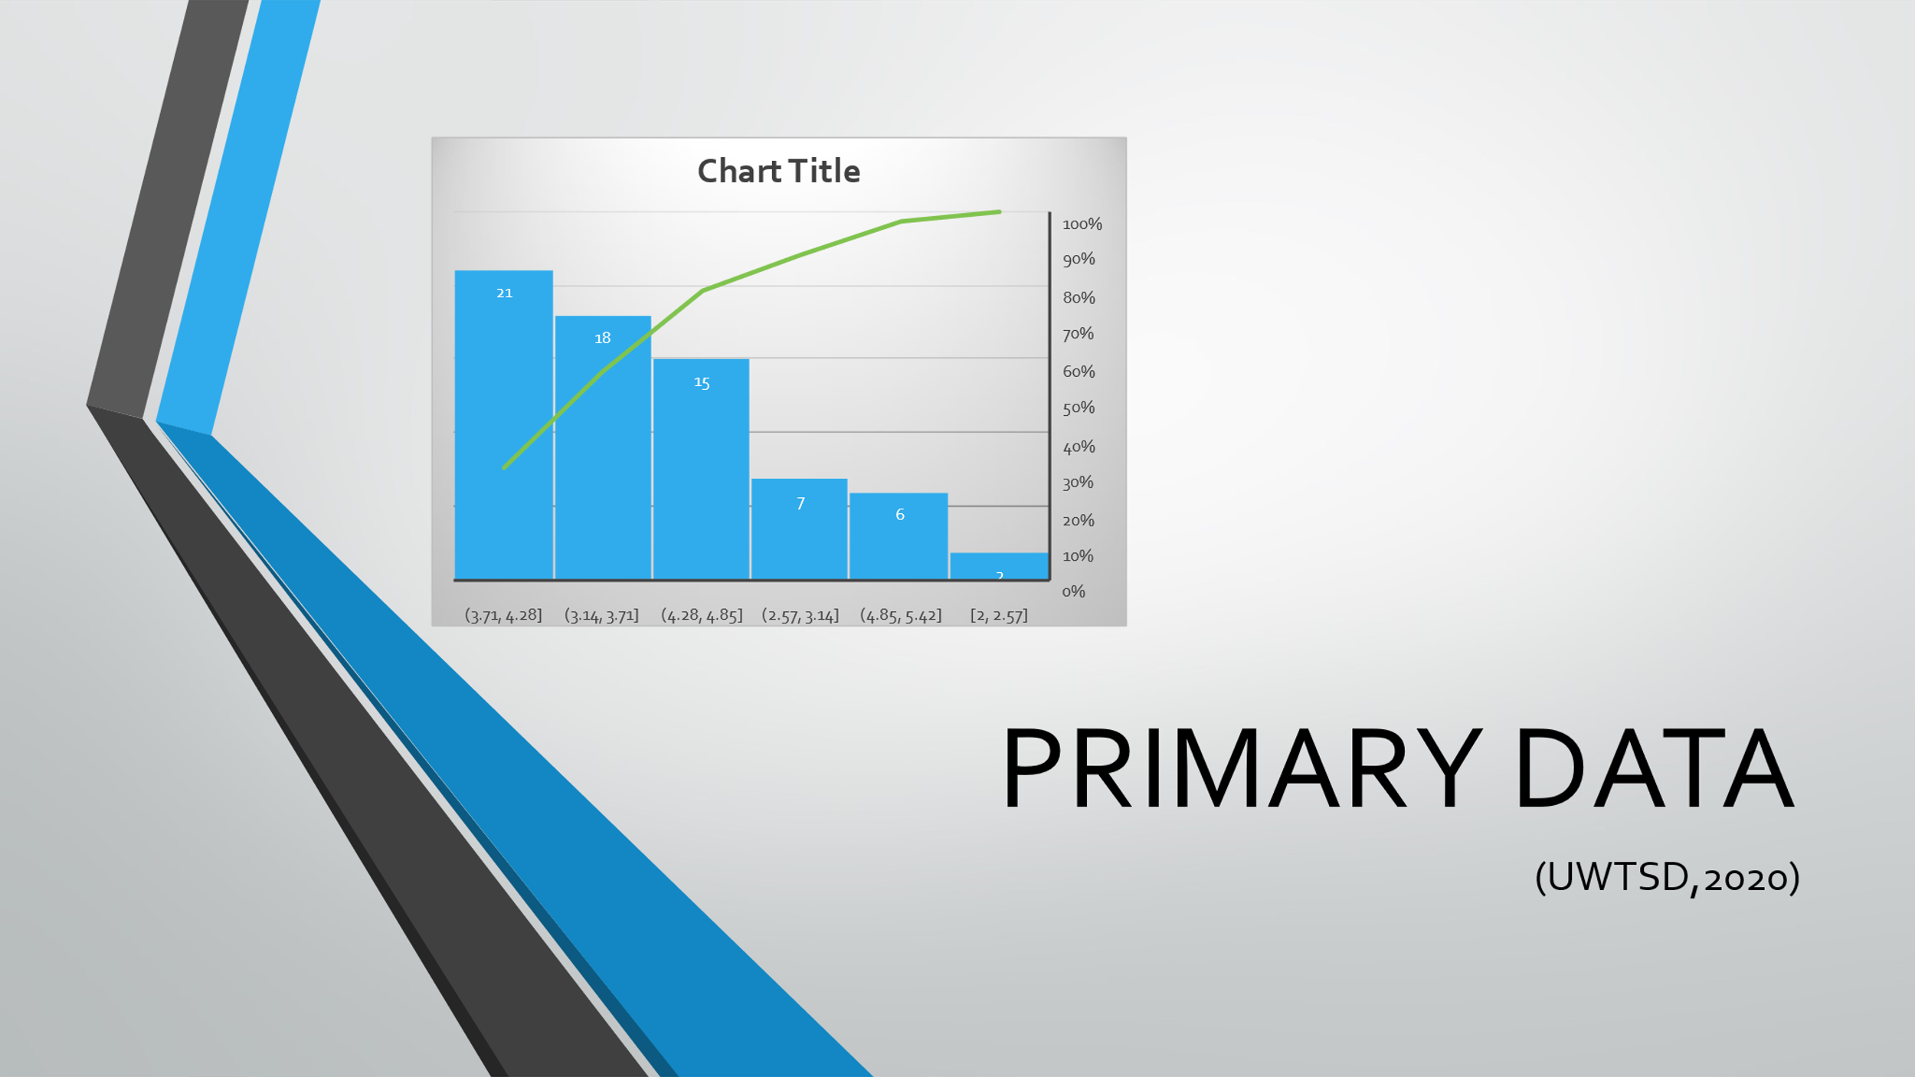

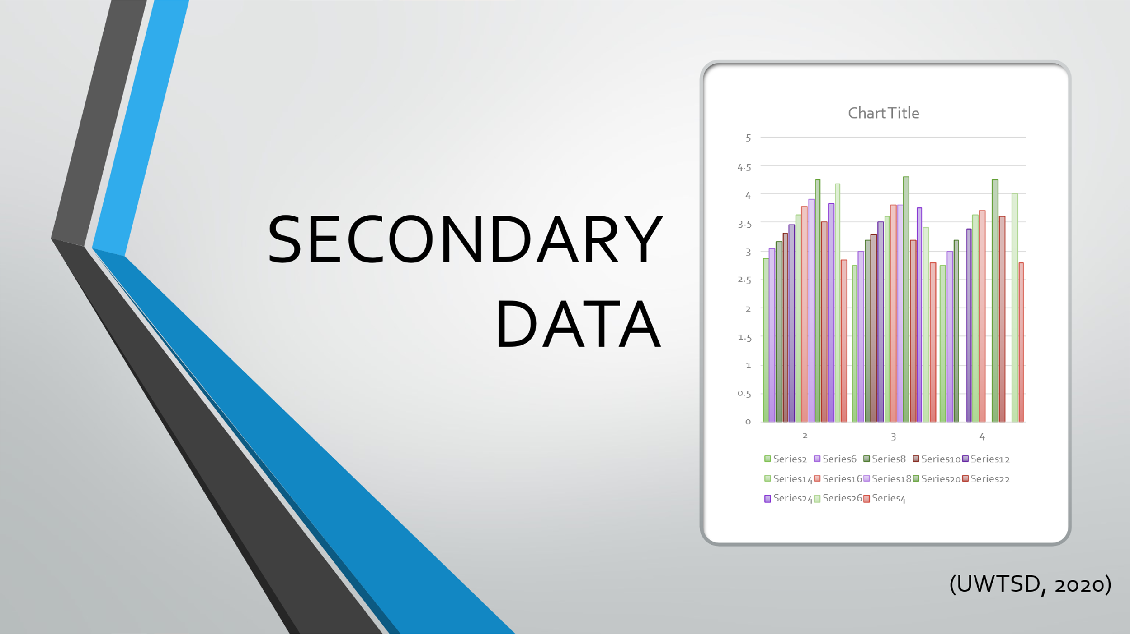

The Grit Scale measures a person's capacity to maintain focus and passion while pursuing long-term goals. Intrapersonal skills are the key constructs tested; the test is given to people aged 10 to adult, and scores range from 1 (not at all gritty) to 5 (very gritty) (very gritty), indicating that it is administered using a Likert-type scale. The relevance of the Growth Mindset, which understands that learning ability is not permanent and may change with effort, is explained by Angela. Grit is unrelated to talent and can be negatively correlated. The secondary data is processed for its currency and used to compare my current scores and how valid the comparison should be in the absence of the secondary data using the CRAAP test. Data is a collection of information in its raw or unstructured form, such as numbers or letters. Data, on the other hand, maybe useless without context, and statistics now have more meaning as a result of the context and value provided. Data context is a network of relationships between data points. These connections can be formed through metadata or by simply detecting and correlating data. Information is the second building component in the DIKW Pyramid. This is data that has already been "cleaned" of errors and is being processed further so that it may be measured, visualized, and resolve.

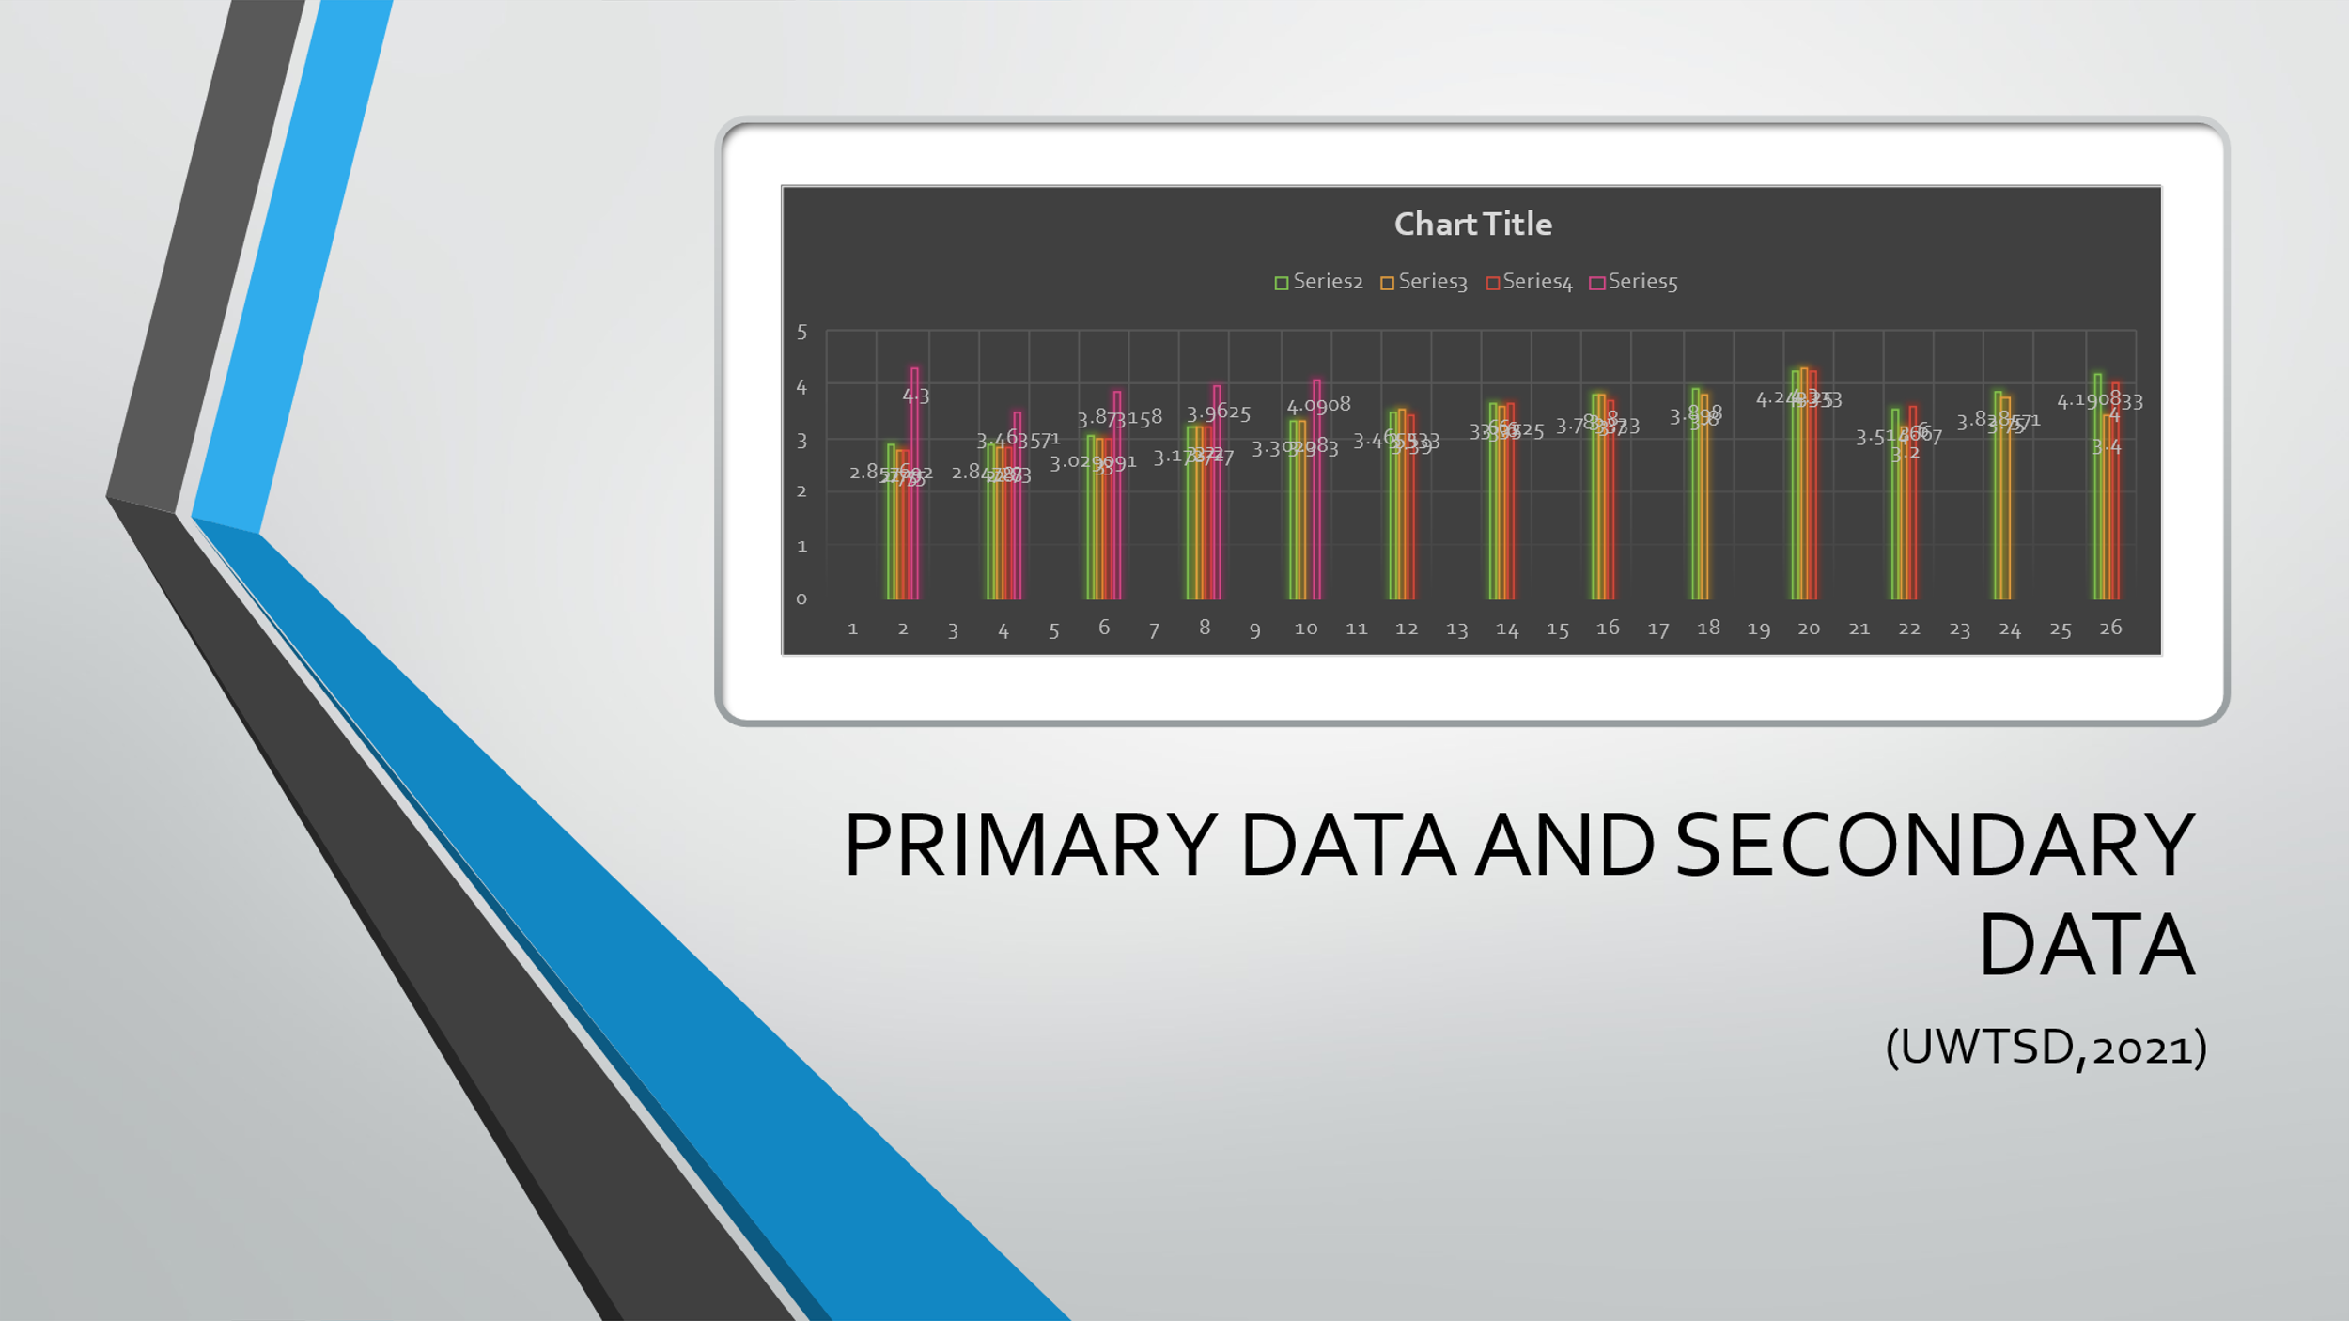
This slide shows the differences in the data in terms of the information provided; the secondary data provides largely similar data to the present Grit scores. Raw numbers and information are the building blocks of data. In contrast to data, information delivers insights based on obtained data. The DIKW (data-information-knowledge-wisdom) hierarchy or pyramid is a widely used model or construct in information science and knowledge management. The nature of the pyramid is explained, as well as its historical background. The pyramid's conceptual components — data, information, knowledge, and wisdom — are briefly explained. The DIKW Pyramid's modern developments, criticisms, and rebuttals are discussed. In today's world, the DIKW Pyramid would be regarded as disappointing.


Artyukhov, A., Volk, I. Vasylieva, T., (2021).’. Quality Evaluation of Consumer Health Information Websites Found on Google Using DISCERN, CRAAP, and HONcode. Medical Reference Services Quarterly, 40(4), pp.396-407.
Sturman, E. Zappala-Piemme, K., (2017). Development of the grit scale for children and adults and its relation to student efficacy, test anxiety, and academic performance. Learning and Individual Differences, 59, pp.1-10.
Von Culin, K., Tsukayama, E., Duckworth, A., (2014). Unpacking grit: Motivational correlates of perseverance and passion for long-term goals. The Journal of Positive Psychology, 9(4), pp.306-312.
Wichowski, D. Kohl, L., n.d. Establishing Credibility in the Information Jungle. Online Credibility and Digital Ethos, pp.229-251.
Yang, C., Baets, B. Lachat, C., (2019). From DIKW pyramid to graph database: a tool for machine processing of nutritional epidemiologic research data. 2019 IEEE International Conference on Big Data (Big Data),.

