University of Wales Trinity Saint David

School of Engineering

Analysis and stimulation of a Centrifugal Clutch

Stress analyses and Dynamics

ACMA5010

Hussain Khan

1701219

Date

26/03/2021
Table of Contents
1 Introduction 1
1.1 Aims 1
1.2 Objectives 1
2 Development of Centrifugal Clutch 2
2.1 Choice of Materials 4
2.2 Typical Application 4
2.3 Operating Conditions 4
3 Advantages of Centrifugal Clutches 5
4 Electromagnetic Clutches 6
4.1 Applications of an Electromagnetic Clutch 6
4.2 Modern Automation of Manufacturing Process 7
4.3 Advantages and Disadvantage of Electromagnetic Clutches 7
5 Task B 8
5.1 Working out the Diameter of the Outer Drum 8
5.2 Engagement Speed 8
5.3 Engagement Speed 9
5.4 Finding Torque 10
5.5 Discussion on the Graph for Torque 11
5.6 Finding Maximum Angular Torque 12
6 References 13

Figure 1- Centrifugal Weights (Bird & Ross, 2012). 2
Figure 2- Centrifugal clutch Construction (Mech4Study, 2017). 2
Figure 3- BMW 52Se Dual Mass Flywheel Car (Nath, 2020). 3
Figure 4- Dry Friction Clutch (Nath, 2020). 3
Figure 5 Centrifugal Clutch Line Diagram (Ram, 2019). 4
Figure 6- Electromagnetic Clutch (Mechollic, 2021). 6

Introduction

Aims
The aim of this report is to write a technical report on solving, analysing and stimulating the behaviour on the dynamics of a mechanical system by using a traditional analytical method and also a computer-based stimulation.

Objectives
The objective of this report is to look at various resources via internet, newspaper articles, journals and books. The report will include the history about Centrifugal Clutches and how it was developed, choices of materials, applications and its operating conditions. The last objective is to find the advantages of the Centrifugal Clutch and the current application of electromagnetic clutches.

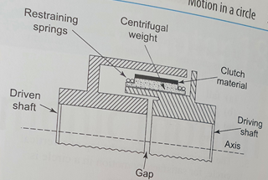
Development of Centrifugal Clutch
Figure 1- Centrifugal Weights (Bird & Ross, 2012).
A clutch is a mechanism for the transfer of motion from an engine to a gearbox or other machinery, in a controlled way so that when the system parts engage, the outcome (rotation of parts) is smooth (Bird & Ross, 2012). The principle of the centrifugal clutch (CFC) is that when the driven shaft (DS) rotates, the centrifugal weights (see figure 1) move outwards radially, as the rotational speed of the shaft increases. Movement of the weights is restricted by retaining springs (see figure 1) and as the DS rotates towards the designated speed, the clutch material engages with the DS, and through friction, the DS will rotate. In this way, the DS can reach high speeds of rotation in a smooth and timely manner (Bird & Ross, 2012). CFCs are utilised in mechanical systems which require the exertion of high starting torques, at fast speed and in a smooth fashion. Historically, the material used for the clutch would have been asbestos, but for health and safety purposes, this has been replaced with modern materials (Bird & Ross, 2012).

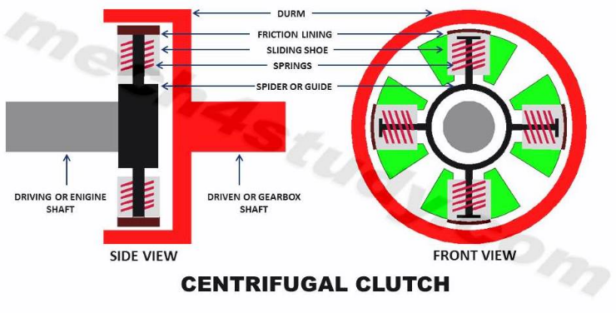
There have been developments in the concepts of the Centrifugal Clutch. New CFC concepts were developed, using the ‘pseudo-rigid-body model (PRBM), the rigid-body replacement synthesis, force-deflection analysis, compliance potential evaluation and compliant concept evaluation’ (Crane, 2003). Such methods helped to develop and model four new compliant designs, which presented the potential for low-cost centrifugal clutch applications. The Floating Opposing Arm (FOA) clutch allowed the doubling of the ‘torque capacity metric’ in comparison with existing designs. Additional development has focused on the relationship between torque and engagement speed, and various prototypes have been tested to gauge their torque speed relationship (Crane, 2003). (See figure 2, which shows a diagram of a Centrifugal clutch).

Figure 2- Centrifugal clutch Construction (Mech4Study, 2017).

Nath highlights the application of CFC’s in the car manufacturing industry; there has been rapid development of the Centrifugal Clutch in the recent decades, in relation to weight reduction, improved refinement and the need to transmit higher torque at lower engine speeds (Nath,2020). Compared to Crane’s point of view Nath states that the recent development has seen the centre damper springs removed from the Original Equipment (OE) clutch friction plate, popularised by the adoption of Dual Mass Flywheels, which are a feature of diesel car engines and other universal uses of the CFC (centrifugal clutch). Self-adjusting clutches have also emerged, incorporating a self-adjustment mechanism which, however, requires the correct fitting from a suitably trained technician to avoid mechanical failure (Nath, 2020). Figure 3 shows an image of the BMW dual mass flywheel and self-adjusting clutch. Figure 4 shows the first design of the single plate dry clutch.

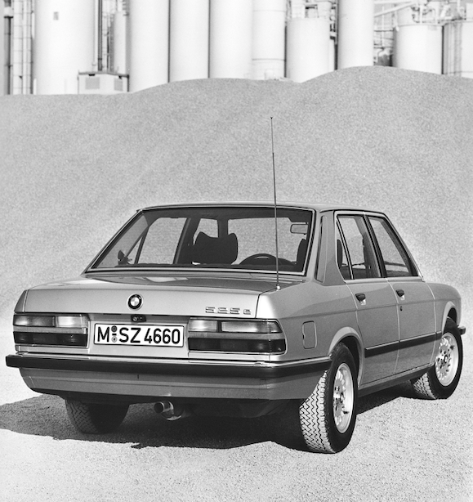
Figure 3- BMW 52Se Dual Mass Flywheel Car (Nath, 2020).

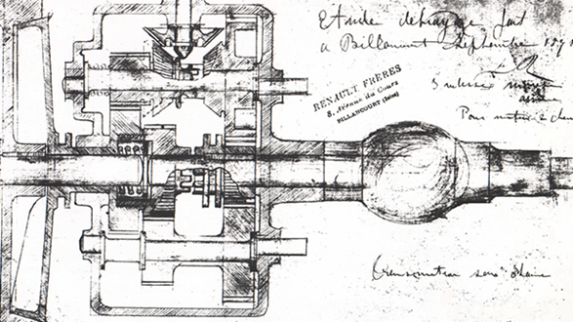
Figure 4- Dry Friction Clutch (Nath, 2020).

Choice of Materials
When considering the different materials used for CFC operating conditions, Rohan (2021) states that the temperature of the friction material can be regulated based around the alteration of the groove pattern and area. Organic based friction linings operate at lower temperatures than their inorganic counterparts (Rohan 2021).
Rohan (2021), refers to the application of SOLIDWORKS 2020 in the design of different groove configurations of clutches, whilst using ANSYS 2020 R2 for simulating and analysing the thermal stability of different materials for the clutch facings (Rohan 2020).

Typical Application
In relation to the typical application of CFCs, the choice of materials used for the design of a Centrifugal Clutch would have to take into consideration the heat transfer characteristics of the clutch facing parts. Finite Element Analysis (FEA) is a method used to determine the thermal characteristics of a dry friction clutch disc, followed by an analysis of the comparison between the organic and inorganic materials used (Rohan, 2021)

Operating Conditions
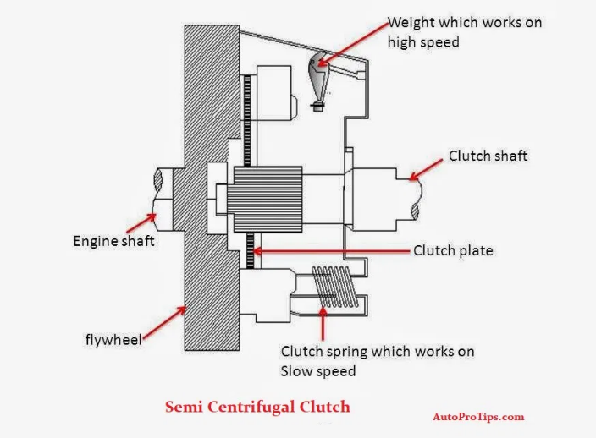
In relation to the operating conditions of the CFC, Crane (2003) describes how the CFC’s mechanism operates with only one degree of freedom, due to the direction and magnitude of all of the applied forces that operate within the clutch. With the use of software, the mechanism position of the clutch in relation to speed can be used, along with the variations based on the centrifugal force acting on varying component parts: spring constants, link lengths and segment masses. Centrifugal forces are assumed to act at the centre of the Pseudo-rigid-body-model (PRBM) links, which operate perpendicular to the PRBM links, in small rotations (Crane, 2003).
Figure 5 Centrifugal Clutch Line Diagram (Ram, 2019).
See figure 5, which shows the semi centrifgal clutch application and how it operates.

Advantages of Centrifugal Clutches
There are several advantages with the CFC, and as reported by BLM (2019), the clutch mechanism automatically engages and disengages, therefore, they do not require any form of control mechanism, as CFCs work on the Laws of Physics (BLM, 2019).
Additionally, CFCs are more cost effective than other clutch types, due to fewer parts involved; there is no requirement for a battery and other components (BLM, 2019).
The other advantage of CFCs according to BLM (2019), is that they require low maintenance when it comes to servicing, which makes them more cost effective. CFCs have the advantage of having less chance of the engine stalling and becoming damaged, due to heavy loads and abrupt starts that can place a level of stress on the engines. CFCs are described as incorporating progressive engagement with the load that is a lot safer, as the Centrifugal Clutch specialises in smooth and shockless acceleration (BLM, 2019).

Lastly, BLM (2019) talked about the advantages of the Centrifugal Clutch in relation to greater engagement speed control, whereby they have a mechanism which progressively engages the clutch to increase torque from the engine to the load. This ensures a longer lifespan and more energy is saved on the start-up of the engine (BLM,2019).

Electromagnetic Clutches
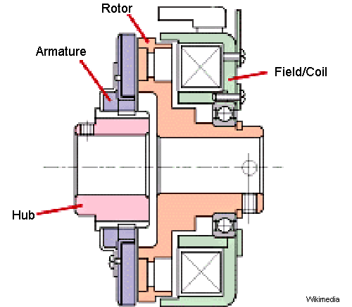
Prior to discussing the current applications of Electromagnetic Clutches in modern manufacturing processes, this section will describe the basic function of these clutches, to provide an insight into their suitability for certain applications. The main parts of the Electromagnetic Clutch are a coil shell, armature, rotor and hub. The armature plate is lined with a friction material coating and the coil is placed behind the rotor (Mechollic, 2021). During activation of the clutch, the coil is energised by an electric circuit, which generates a magnetic field (Mechollic, 2021). Therefore, the rotor section of the clutch becomes magnetised. The armature is pulled towards the rotor once this magnetic field surpasses the air gap between the rotor and the armature (Mechollic, 2021). The torque is transferred at the contact surface through the frictional force which is created. Removal of the voltage to the coil results in a loss of contact (Mechollic, 2021).
Figure 6- Electromagnetic Clutch (Mechollic, 2021).
Figure 6 shows the diagram of an Electromagnetic Clutch.

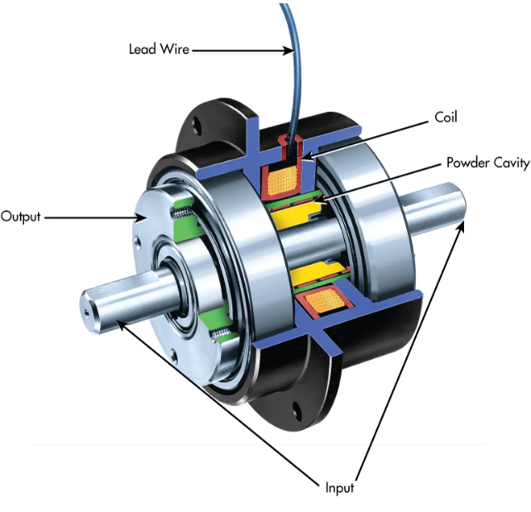
Applications of an Electromagnetic Clutch
Figure 7-Electromagnetic Clutch (Flemming, 2017).
Typical applications for Electromagnetic Clutches would be where controlled slip is required, such as with tensioning in winding applications. The accurate, electrically controlled adjustable torque ability of Electromagnetic Clutches is an optimum feature, providing smooth and repeatable torque. The torque can be accurately controlled relevant to the applied current with these clutches, providing soft starting for suitable applications (Flemming 2017).

Typical applications for Electromagnetic Clutches would be where controlled slip is required such as with tensioning in winding applications. The accurate, electrically controlled adjustable torque ability of Electromagnetic Clutches is an optimum feature, providing smooth and repeatable torque. The torque can be accurately controlled relevant to the applied current with these clutches, providing soft starting for suitable applications (Flemming, 2017).

Modern Automation of Manufacturing Process
Electromagnetic Clutches can be used for remote applications and do not require mechanical linkages to activate them. Printing machinery, conveyor drives, copier machines and factory automation - are some of the applications Electromagnetic Clutches are used for (Mechollic, 2021).

Advantages and Disadvantage of Electromagnetic Clutches
The advantage of the Electromagnetic Clutches is that a complicated relation is not required to control the clutch. However, they do come with disadvantages: they are high cost, their operating temperature is limited because at high temperatures the insulation of the electromagnet damaged (Mechollic, 2021). Lastly, there is a risk of overheating when it comes to the engagement and the brushes that energise the coils need regular maintenance (Mechollic, 2021).

Task B

Working out the Diameter of the Outer Drum
D₀ = (95 + 9)x 2 = 208mm

Engagement Speed
∑f_{e} = 0
Fc – kx = 0
m . ω_{e}². r = kx

x = 9mm (distance shoe) – 4mm (thickness)
= 5mm
ω_{e}² = $\frac{k x }{m r }= \frac{7.5 x {10}^{3} x 5 x {10}^{-3}}{0.275 x 0.1}$
ω_{e} = $\sqrt{1363.64}$
ω_{e} = 36.93 rad/s
ω_{e} = $\frac{36.93 x 60}{2π} rpm$
ω_{e} = 353 rpm

Engagement Speed

fc = mω²r
= 0.275 x ${\left(\frac{550 x 2π}{60 }\right)}^{2}x 0.1$
fc = 91.23N
on each shoe
fc = 91.23 x 4
fc = 364.921N

ω= 550 rpm
∑ fc = N
Fc – Kx =N
91.23 – (7.5 x 10³ x 5 x 10⁻³) = N
N = 91.23 – 37.5
N = 53.73N (on each shoe)
N = 53.73 x n
N = 53.73 x 4
= 214.92 N
fc of engagement
fce = m ωe² r
= 0.275 ${\left(\frac{353 x 2π}{60}\right)}^{2}x0.1$
fce = 37.58N (on each shoe)
fce = 37.58 x 4
fce = 150.32N

Finding Torque

fr = N x µ
fr = 53.73 x 0.35
fr = 18.8N (for one shoe)
= 18.8 x 4
fr = 75.2N
T = f x r
= µ (fc – fce) R
= 0.35(91.23 -37.54) x0.1
T = 1.88Nm (for one shoe)
= 1.88 x 4
T = 7.52Nm

Discussion on the Graph for Torque

From the graph they can observe that the coefficient of friction increases the torque on the driven shaft increase. This increases the torque more & more significantly as they move towards higher rpms for the driving shaft.
By comparing three sets of data of rpm they chose 450rpm and the coefficient was 0.35 and started as low starting point 32.85NM, then using the coefficient friction for 0.3 the starting point was decreasing it started at 28.15NM. The last coefficient of friction for 450rpm was 0.4 and this had a massive increase in the result, as the starting point was higher than the previous two figures. 37.55NM.
The second set of data of rpm they chose was 550rpm using coefficient of 0.35,0.3 and 0.4. from 0.35 the starting point was higher, and it was going increasing and decreasing with 0.3 and 0. 4. From 0.4 they can see the friction was greater than the previous 2 sets of data, as it had a straight line and went straight to the top of the graph slope.
The third set of data they chose was 700rpm and this result beaten the 450 and 550rpm, because it had the best torque result and rpm. The starting point was higher of the coefficient 0.35, 0.3 and 0.4.

Finding Maximum Angular Torque

µ = 0.4
T max = 4.4Nm; I = $\frac{1}{2} mr^{2}$ (solid disc)
I =$\frac{1}{2} x 0.75 x{\left(\frac{0.212}{2}\right)}^{2}$
I = 4.2135 x 10⁻³ m⁴
T = Iα
4.4 = 4.2135 x 10⁻³α
α= $\frac{4.4}{4.2135x{10}^{-3}}$
α= 1044.4 rad/s²
(for 1 shoe)
T max = 17.6 Nm; I = 4.2135x10⁻³m⁴
α = $\frac{T}{I}= \frac{17.6}{4.2135x{10}^{-3}}$
α = 4,177rad/s²

References
BLM Centrifugal Solutions, 2019. Advantages and Disadvantages of Centrifugal Clutches. [Online]
Available at: https://www.blm-cm.com/blog/advantages-disadvantages-centrifugal-clutches/
[Accessed 01 April 2021].
Crane, N. B., 2003. Compliant Centrifugal Clutches: Design, Analysis, and Testing. [Online]
Available at: https://scholarsarchive.byu.edu/etd/79/
[Accessed 30 03 2021].
Crane, N. B., 2003. Compliant Centrifugal Clutches: Design, Analysis, and Testing. [Online]
Available at: https://scholarsarchive.byu.edu/cgi/viewcontent.cgi?referer=&httpsredir=1&article=1078&context=etd
[Accessed 01 April 2021].
Flemming, F., 2021. What’s the Difference Between Torque-Control Solutions?. [Online]
Available at: https://ogura-clutch.com/downloads/editorials/TorqueControl_PDFlayout.pdf
[Accessed 04 April 2021].
John Bird, C. R., 2012. Centrifugal Clutch. In: Routledge, ed. Mechanical Engineering Principles. 2nd ed. London and New York: Routledge, p. 203.
Mecholic, 2021. Electromagnetic Clutch Working, Applications, Advantages and Disadvantages. [Online]
Available at: https://www.mecholic.com/2016/01/electromagnetic-clutch-working-application-advantages.html#google_vignette)
[Accessed 04 April 2021].
Nath, A., 2020. History in the making – the single-plate dry clutch. [Online]
Available at: https://autotechnician.co.uk/history-in-the-making-the-single-plate-dry-clutch/#prettyPhoto
[Accessed 31 March 2021].
Ramesh, M. R., 2021. Optimizing thermal performance of a dry rigid clutch by varying groove pattern and friction material. [Online]
Available at: https://www.sciencedirect.com/science/article/pii/S2214785321001735?via%3Dihub
[Accessed 31 March 2021].

Ram, (2019) Line Diagram [Online Image]
[Accessed 21st April 2021)
https://ogura-clutch.com/downloads/editorials/TorqueControl_PDFlayout.pdf
Mech4Study, (2017) Centrifugal Clutch Construction [Online Image]
[accessed 31st March 2021]
https://www.mech4study.com/2017/11/centrifugal-clutch-principle-parts-construction-working-advantages-disadvantages-and-application.html
Bird, (2012) Centrifugal Clutch Weights [Book Image]
Nath ,(2020) Single Dry Plate Clutch & The BMW 52e[Online]
[Accessed 4th April 2021]
https://autotechnician.co.uk/history-in-the-making-the-single-plate-dry-clutch/

Flemming, (2021) Magnetic Particle Clutch [Online Image]
[Accessed 5th April 2021]
https://ogura-clutch.com/downloads/editorials/TorqueControl_PDFlayout.pdf
Mecholic (2021) Electromagnetic Clutch [Online Image]
[Accessed 5th April 2021]
https://www.mecholic.com/2016/01/electromagnetic-clutch-working-application-advantages.html#google_vignette

