
Applied Leadership and Management in the Workplace
Module Assignment Submission
Student Name: | Adela-Maria Fanatan
Student Number: | 2221979
Module No: | BMSK5012
Module Title: | Understanding & Engaging in the Customer Experience

Statement of Confirmation of Authenticity
By the act of making this submission, the student declares that this is the work of the student named above. The work has not, in whole or in part, been knowingly presented elsewhere for assessment, or where assessment has been built on a previous assessment, this has been identified. Where materials have been used from other sources it has been properly acknowledged. If this statement is untrue, the student acknowledges that an assessment offence has been committed.
Attention is drawn to the plagiarism and unfair practice policies of both the University and of ILM.

Contents
1.0 Introduction 3
2.0 Critically evaluate the elements that influence the ability of your organisation to maximise customer value 4
2.1. Customer value 4
2.1.1 Customers engagement value 5
2.1.2 Customer Knowledge Value (CKV) 6
2.2 Customer experience 7
3.0 Demonstrate a critical understanding of your organisation’s quality processes and its effectiveness in meeting customer requirements. 9
3.1 Quality management processes 9
3.2 Total Quality Management 11
4.0 Conclusion 12
References 13
Appendices 15

1.0 Introduction

This report has been written in order to critically assess the elements that influence the organisation ability to deliver the best possible experience, products or services to the customer.
The organization presented in this report is a dental practice that is focused on delivering a quality service, satisfying the client by guiding and strictly following the rules and practices imposed by the organisation that regulates the body of dentists in the UK.
The position held in the dental practice is dental nurse. A position that allowed me to observe and analyse the environment and practices of the organisation, as well as the behaviour of patients.
Value is debated in the first chapter of this report. Understanding customers and delivering value is vital for long-term business success. Companies must identify customer needs, offer great experiences, and adopt customer-focused strategies to remain competitive.
Furthermore, the report is debating the quality process and the effectiveness to meet customer expectations.
In the last chapter, is presented a briefly conclusion of the presented report.

2.0 Critically evaluate the elements that influence the ability of your organisation to maximise customer value

Nowadays companies declare “that their strategies are customer driven” Simons (2014) and “without a good understanding of customers a business is unlikely to be successful in the long run” Harris & Schaefer (2017). From the previous statements we understand that is crucial for the business success, that a company identify and understand customer’s needs. At the same time helping them to satisfy their requirements by offering them a great experience.

The term "customer" in management theory is flexible and context-dependent, often defined as: “the people or entities that buy your products and services and supply your revenue” Simons (2014). Viewing "customers" as a flexible concept highlights the need for customized strategies to address the varied needs within the value chain. Whether interacting with end users or working across internal departments, treating everyone as a customer fosters a culture of service and mutual collaboration according to Simons (2014).

In conclusion, understanding and meeting customer needs is essential for long-term business success. The term "customer" can apply to different groups, from end users to internal teams, depending on the context. By treating everyone as a customer and focusing on delivering a great experience, companies can build a culture of service and collaboration that drives success.

2.1. Customer value

The term "value" is often interpreted differently by individuals based on their personal preferences, priorities. Boyles (2022) sustain that maximizing value “is a central objective” for businesses, making it essential for leaders to understand how to define and generate it for their organizations.

“Value in business markets is the worth in monetary terms of the technical, economic, service, and social benefits a customer company receives in exchange for the price it pays for a market offering” Anderson and Narus (1998).

When defining value in relation to customers, it's important to recognize that it operates in two distinct dimensions. First, there is the value of the customer to the company - reflecting their contribution to revenue, profitability, or long-term business growth. Second, there is the value perceived by the customer - “Customers make purchases based on perceived value” Boyles (2022) or "customers evaluate a product or service, they weigh its perceived value against the asking price" (Almquist et al., 2016), in other words the benefits they believe they received from a product, service, or experience relative to what they paid or expected. Both perspectives are critical for building a successful customer-centric approach.

Kumar (Maund, 2018) highlights the importance for companies to “quantify the value derived from the customer engagement process”.
Following Kumar (Maund, 2018) theory regarding Customer Engagement Value (CEV), we understand that CEV captures not only the direct value from purchases but also the indirect value from customers interactions that benefit the organization. It underlines the role of engaged customers as active participants in the process of creating mutual value.

In conclusion, understanding and maximizing value is a critical business objective, requiring equal attention to both the value customers bring to the organization and the value they perceive. A customer-focused approach requires addressing both types of value effectively. According to Kumar's (Maund, 2018) idea of Customer Engagement Value, businesses can benefit from both the direct value of purchases and the indirect value of customer interactions, creating shared benefits and supporting long-term success.

2.1.1 Customers engagement value

Customer Engagement Value (CEV) include both the direct and indirect contributions of customers but highlights the value derived from their active participation and interactions with the organization moreover their purchases Kumar (Maund, 2018):

- Direct: - “through their purchases”,
- example from the workplace: when patient pay for their treatment, they bring financial value for dental practice.

- Indirect - “referrals to potential customers”, inspiring/guiding other people that are current or maybe potential clients, offer review/feedback based on their customer experience with the aim of bringing improvements.
- An example related with workplace: when a patient is pleased with his experience at the dentist, he would recommend the dental practice and the dentist to his family and friends, he will write a positive review on social media, also he will be happy to provide feedback about his experience. All this information provides “great value” for the organisation and “allows them to learn what their customers think” Kumar (Maund, 2018).

We understand that finding the “right set of customers” who bring value to the organization can play a key role in boosting profits (Kumar, Maund, 2018). The CEV framework (see Appendix A) helps identify and assess the right customers that actively engage with the company and contribute positively to the profits.

The CEV Framework emphasises how customers generate profits for a company:

- Direct Contributions:
  - Customer Lifetime Value (CLV): The future cash flow that a customer generates over the time in connection with company.

- Indirect Contributions:
  - Customer Referral Value (CRV)/Business Reference Value (BRV): The value from referrals or testimonials that bring in new customers.
  - Customer Influence Value (CIV): The influence a customer has on others’ purchasing decisions.
  - Customer Knowledge Value (CKV): The perceptions and feedback that customers provide, by helping the company to improve.

The components form the Customer Brand Value (CBV) and reflects the impact that customer engagement has on the performance of the organisation.

2.1.2 Customer Knowledge Value (CKV)

Kumar (Maund, 2018) dedicates an entire chapter in which he discusses the importance of customer knowledge. He defines Customer Knowledge Value (CKV): “the monetary value attributed to a customer by a firm due to the profit generated by implementing an idea /suggestions /feedback from that customer”.

Kumar (Maund, 2018) emphasized that companies “should be particularly concerned about what their customers say they want and need”. Gathering data, information, and feedback from highly engaged customers, understanding their needs can play a crucial role in the process of developing a new product / services or for improvements purposes.

Customer contribution can be defined as: “the extent to which a customer is involved in the manufacturer’s new product development (NPD) process, and it delineates customer participation along two specific dimensions: customer participation as an information resource (CPI) and customer participation as a codeveloper (CPC)” Tomczyk (2016).

Customer Knowledge Value (CKV) represents the monetary and strategic value obtained from the feedback, opinions, and suggestions of customers provided to a company. This feedback has an important contribution for Knowledge Management (KM) processes by capturing customer perceptions that influence product/service development a requirement for a new product success (Kumar et al., 2010, pp. 297‒310), increase production efficiency, improve customer experience, and maximize profits.

An effective KM process, is based on storing, analysing, and leveraging customer information, enables companies to transform CKV into actionable knowledge, creating competitive advantage and encouraging continuous improvement.

Some examples from workplace related to customer knowledge value:
Collecting information: a dental practice can gather patient information using:
- patient records (medical history, treatment plan, preferences regarding treatment);
- survey regarding their experiences at the dentist: staff interaction, comfortable treatment.
- behavioural data: frequency of treatment, missed appointments.
Analysing and Organizing Knowledge:
- The practice uses a customer relationship management (CRM) system to store and analyse this data.
- Patterns are identified, such as:
  - A segment of patients prefers evening appointments.
  - Private treatment vs NHS treatment
  - Several patients value email reminders for check-ups but dislike phone calls.
  - Some patients request more detailed explanations of treatments to feel sure that they are making the right choices. Coulter, A. (2018).
Applying Knowledge to Create Customer Value:
- Personalized Services:
  - Offer individual arrangement slots based on patient preferences: evening availability Marbouh et al. (2020).
  - Provide private treatment if patient request: teeth whitening, composite filling instead of amalgam filling, veneers as cosmetic treatment.
- Proactive Engagement:
  - Send personalized email reminders or updates about promotions: discounted teeth whitening.
  - Send reminders to patients with overdue check-ups, highlighting the benefits of preventive care.
- Improving Experience:
  - Use patient feedback to make the clinic environment more comfortable (e.g., play relaxing music or install water dispenser in waiting area).
Creating Value for the Practice:
- Increased Loyalty and Retention:
  - Satisfied patients are more likely to return for routine care and additional treatments Ferreira et al. (2023).
- Higher Referrals:
  - Happy patients recommend the practice to friends and family, boosting reputation Manacorda et al. (2017).
- Operational Efficiency:
  - Knowing and understand patient preferences reduces missed appointments and ensures better management of time and resources McLean et al. (2014).

2.2 Customer experience

Most managers now realize they “must deliver value not just through their offerings, but also from the entire customer journey” Freitas (2023). Focusing on the full journey improves customer satisfaction, boosts sales, and increases long-term loyalty.

“Customer journey” as described by Freitas (2023) is defined by other scholars as “Customer experience”.

Shaw and Hamilton (2016) discuss the concept of "Customer Experience" defining it as “a customer perception of their rational, physical, emotional, subconscious, and psychological interaction with any part of an organisation.”

Customer Experience “is the summation of all interactions and touches between the customer and the company” Goodman & Broetzmann (2019) like a face-to-face interaction in a store, a transaction from a website, a call to customer service, a TV ad, or even by seeing a truck with the company’s name. Often, it is a mix of these things. Shaw and Hamilton (2016) highlight that Customer Experience is based on the customer’s perception, and "perception is reality." In this context, how the customer perceives their experience describes what it is for them. These perceptions create memories, and they represent an important part of Customer Experience.

Nowadays customers have elevated standard regarding their customer service experiences. According to Goodman and Broetzmann (2019) customers “have way more choices than ever”, buying bread should be something simple. If we think that a few years ago white bread was the only choice, nowadays a client can choose between white loaf of bread, rye loaf of bread, gluten free, sliced bread, traditional bread, different types and “the more product choices customers have that are similar, the more they use the experience surrounding that product or outcome as their primary tool for differentiation and decision making.“ Goodman and Broetzmann (2019). They debate that customers are smarter and more informed, thanks to the internet, that can provide an instant access to reviews, comparisons, and perceptions. This has transferred power to customers, who can decide based on knowledge from various sources, not just brand reputation or advertising. Businesses must carefully monitor feedback, trends, and issues if they want to stay ahead.

3.0 Demonstrate a critical understanding of your organisation’s quality processes and its effectiveness in meeting customer requirements.

3.1 Quality management processes

Quality “is defined as the essential character of something” Bynum (2005).
In the business world quality is defined as: “degree to which a set of inherent characteristics of an object fulfils requirements” [ISO 9000:2015, 3.6.2] Moreover, is considered by Platt (2022) as a crucial part of the business success. He debates that a company which is able to create and deliver high quality products and services has higher chances to be successful.

Quality management is described by the International Organization for Standardization (ISO) as “the path to continuous improvement”. Quality management represent the process of building a culture of excellence in all the parts of a company. It focuses on continuing improvement, meeting regulations, and making sure quality is part of every product or service. This approach leads to happier customers, stronger loyalty, and more repeat business.

The quality management system is considered to be a: “collection of processes and procedures which ensure your business runs as intended and continuously delivers high-quality products and services that meet regulatory and customer requirements.” ISO 9001:2015. We understand that quality management processes are the ability to improve the products or services in order to meet customer expectations. At the same time, it fosters a culture that improve communication and collaboration across organisation, encourage to reduce waste, and promote ongoing development.

According to Shah (2020) Quality Management System involves of four parts (see Appendix B):

1) Quality planning:
- evaluate customer’s needs.
- create system models tailored after their requirements.
- provide systems and processes that help to manage the service.

2) Quality Control:
- intend to maintain and measure the standards of quality.
- set quality indicator as measurement tools of quality.
- measure regularly and compare against the indicators.
- support improvement and the right action when needed.

3) Quality Assurance:
- regularly verifies to ensure that customers’ needs are meet.
- lead periodic assessments.
- evaluate if the service provided is aligned with customer’s needs.

4) Quality improvement:
- enhancing the process that meet and exceed the customer’s expectations.
- focus on what is important for the client, “Patient-centred care (PCC) is recognised as a key dimension of quality within health care according to the Institute of Medicine” Mills et al. (2014).
- use diverse tools and teams to drive solutions.
- encourage creativity and innovation in order to create effective solution.

Quality Management System can be effectively applied to a Dental Practice to ensure a high-quality patient care by following the regulation and the protocols set by the General Dental Council, that enhance operational efficiencies, and to support the improvement process. “The quality of health centres, patient satisfaction, and loyalty are three key factors that enable health care providers to improve their services and cost-effectiveness.” Setyawan et al. (2020)

1) Quality Planning in Dental Practice:
- identify patient need: most of the time we are dealing with patient that are struggling with fear of the dentist or treatment, anxiety, panic attacks.
- create a system model that encounter patient needs: train staff to communicate effectively using an empathetic approach and techniques for managing anxious patients.
- implementing process: provide longer appointment in order to ensure that dentist has enough time to explain the treatment and patient to be able to discuss their fears.

2) Quality Control in Dental Practice - “Patient satisfaction is becoming an increasingly important indicator of quality dental care.” Butters and Willis (2000).
- measure standard of quality: - following the protocols of instruments sterilisation.
- maintain a logbook of daily checks of equipment maintenance to ensure that autoclaves and other tools are in perfect order function.
- if an audit find gaps, example improper handling of sterilised instruments, ensure that staff undergo to training session to reinforce their knowledge regarding sterilisation methods.

3) Quality Assurance in Dental Practice
- all the dental professionals registered with the GDC have to follow the Standards for dental team - a framework of our quality assurance processes.
- ensure to meet patients need and at the same time to comply with the Standards.
- conduct audit to ensure that procedure and protocols are following the health regulations.
- identify and resolve gaps, the treatment appointments for patients that need a dental lab-work will be provided only in the afternoon session or in the next day after the postage had delivered the package from the lab. In this way we can prevent that the time for a treatment session is not wasted, the same as patient time.

4) Quality Improvement in Dental Practice
- using patient feedback to identify areas for improvement.
- patient feedback reveal that one of the causes of missed appointments is because they forgot about the appointment.
- at peers review it has been addressed the matter and the following action was implemented: in the afternoon one clerical staff will give a courtesy call to all the patients from the tomorrow day list to gently remind and confirm their appointment. In this way we can avoid wasting a treatment slot.

3.2 Total Quality Management

Total Quality Management also know by using the acronym TQM is defined by the scholars as: “a structured and a comprehensive approach towards organizational management, which aims to improve the quality of products and services produced by an organization through ongoing refinements in response to continuous feedback” Gimenez-Espin et.al (Shaikh, 2020) or according to Oakland (2013) “philosophy, culture, strategy or management style of a company according to which all persons in the same, study, practice, participate and promote continuous quality improvement”.

4.0 Conclusion

In conclusion, this report discuss the ability of an organization to maximize customer value is ingrained in the understanding of customer needs and the capacity to consistently exceed their expectations. Businesses must keep the balance between customer value - what customers contribute to the organization and the benefits they perceive. This approach emphasizes the importance of frameworks like Customer Engagement Value (CEV), which incorporate direct and indirect contributions, such as referrals and feedback. By capturing information and customer perception using tools like Customer Knowledge Value (CKV), the organizations can transform customer feedback into actionable improvements that foster innovation and strengthen competitive advantage.
Moreover, is introduced the application of quality management processes that ensures customer value is consistently delivered. In the same chapter is related the Quality management process to Dental practices, are presented some case related to dental business.
Total Quality Management (TQM) supports these efforts by embedding a culture of excellence and continuous feedback, enhancing both service quality and patient satisfaction.

References

Almquist, E., Senior, J., & Bloch, N. (2016, September). The Elements of Value. Harvard Business Review; Harvard Business Review. https://hbr.org/2016/09/the-elements-of-value

Anderson, J., & Narus, J. (1998). Business Marketing: Understand What Customers Value. Harvard Business Review. https://hbr.org/1998/11/business-marketing-understand-what-customers-value

Boyles, M. (2022). How Do Businesses Create Value for Stakeholders? | HBS Online. Business Insights Blog. https://online.hbs.edu/blog/post/how-do-businesses-create-value

Butters, J. and Willis, D. (2000), A comparison of patient satisfaction among current and former dental school patients. Journal of Dental Education, 64: 409-415. https://doi.org/10.1002/j.0022-0337.2000.64.6.tb03359.x

Coulter, A. (2018, June 19). How to provide patients with the right information to make informed decisions. The Pharmaceutical Journal. https://pharmaceutical-journal.com/article/ld/how-to-provide-patients-with-the-right-information-to-make-informed-decisions

Ferreira, D. C., Vieira, I., Pedro, M. I., Caldas, P., & Varela, M. (2023). Patient Satisfaction with Healthcare Services and the Techniques Used for Its Assessment: a Systematic Literature Review and a Bibliometric Analysis. Healthcare, 11(5), 639. https://www.ncbi.nlm.nih.gov/pmc/articles/PMC10001171/

Freitas, J. D. (2023, March 31). What Is the Optimal Pattern of a Customer Journey? Harvard Business Review. https://hbr.org/2023/03/what-is-the-optimal-pattern-of-a-customer-journey

Goodman, J. A., & Broetzmann, S. M. (2019). Strategic customer service : managing the customer experience to increase positive word of mouth, build loyalty, and maximize profits. AMACOM.

Harris, F., & Schaefer, A. (2017). Block 4 Marketing (Second edition). The Open University. (Original work published 2015)

Kumar, V., Aksoy, L., Donkers, B., Venkatesan, R., Wiesel, T., Tillmanns, S. (2010).
Undervalued or overvalued customers: capturing total customer engagement value.
Journal of Service Research, 13 (3), 297–310.

Manacorda, T., Erens, B., Black, N., & Mays, N. (2017). The Friends and Family Test in general practice in England: a qualitative study of the views of staff and patients. British Journal of General Practice, 67(658), 370–376. https://doi.org/10.3399/bjgp17x690617

Marbouh, D., Khaleel, I., Al Shanqiti, K., Al Tamimi, M., Simsekler, M. C. E., Ellahham, S., Alibazoglu, D., & Alibazoglu, H. (2020). Evaluating the impact of patient no-shows on service quality. Risk Management and Healthcare Policy, 13(13), 509–517. https://doi.org/10.2147/RMHP.S232114

Maund, A. (2018). BA in leadership and management: skills for the workplace. Student yearbook, 1st year. Sage.

McLean, S., Gee, M., Booth, A., Salway, S., Nancarrow, S., Cobb, M., & Bhanbhro, S. (2014). Patterns and influences on health-care attendance behaviour: a narrative overview of key themes and issues. In www.ncbi.nlm.nih.gov. NIHR Journals Library. https://www.ncbi.nlm.nih.gov/books/NBK260108/

Mills, I., Frost, J., Cooper, C., Moles, D. R., & Kay, E. (2014). Patient-centred care in general dental practice - a systematic review of the literature. BMC Oral Health, 14(1). https://doi.org/10.1186/1472-6831-14-64

Oakland, J. S. (2013). Total quality management and operational excellence : text with cases. Routledge.

Platt, N. (2022). What Is Quality in a Business? Www.linkedin.com. https://www.linkedin.com/pulse/what-quality-business-neil-platt

Quality assurance of pre-registration dental education
https://www.gdc-uk.org/education-cpd/dental-education/quality-assurance/learning-outcomes-and-behaviours

Setyawan, F. E. B., Supriyanto, S., Ernawaty, E., & Lestari, R. (2020). Understanding patient satisfaction and loyalty in public and private primary health care. Journal of Public Health Research, 9(2). https://doi.org/10.4081/jphr.2020.1823

Shah, A. (2020). How to move beyond quality improvement projects. BMJ, 370, m2319. https://doi.org/10.1136/bmj.m2319

Shaw, C., & Hamilton, R. P. (2016). The intuitive customer: 7 imperatives for moving your customer experience to the next level. Palgrave Macmillan.

Shaikh, A. (2020). Total Quality Management report on Disneyland. Academia.edu. https://www.academia.edu/24655813/Total_Quality_Management_report_on_Disneyland

Simons, R. (2014, March). Choosing the Right Customer. Harvard Business Review. https://hbr.org/2014/03/choosing-the-right-customer

Tomczyk, P. (2016). Customer knowledge valuation model based on customer lifecycle. Marketing i Zarządzanie. 46. 87-94. 10.18276/miz.2016.46-09.

Appendices
Appendix A

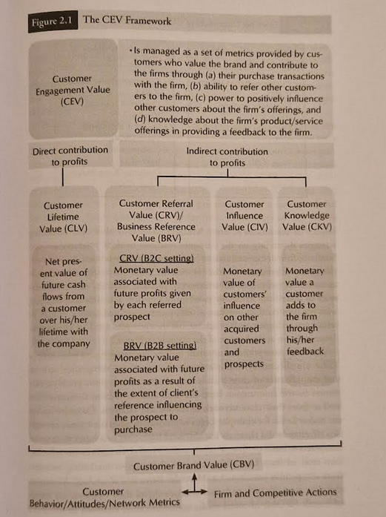

The Customer Engagement Value Framework

Maund, A. (2018). BA in leadership and management: skills for the workplace. Student yearbook, 1st year. Sage.

Appendix B

The framework of Quality Management System

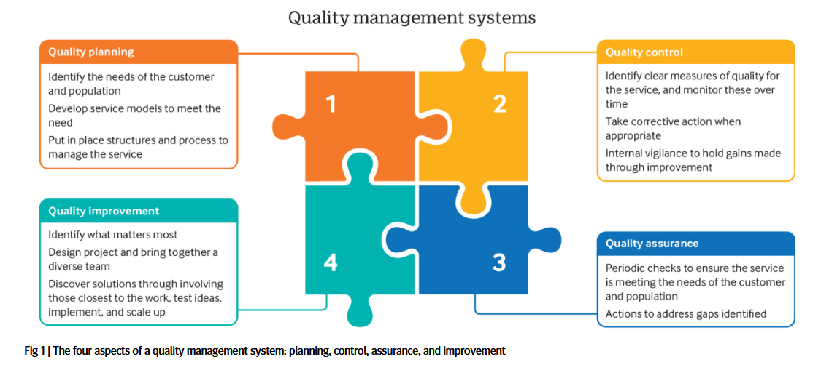

Available online at:
https://qi.elft.nhs.uk/wp-content/uploads/2020/07/How-to-move-beyond-quality-improvement-projects.pdf

