BA Leadership and Management
Module: Managing the Customer Experience

Module code: BMSW 5103

Assignment Title: Customer Relationship Management Emerging Themes

Kamil Lenczowski
Student number:
2120445
Lecturer: Dr King

Executive summary
This report talks about why it is important for businesses to treat their customers well, especially for two UK-based companies called Revolut and Monzo. It explains what customer experience means and how companies can use CRM to manage how they interact with customers. The report also looks at the different ways that companies and customers can work together to make a good customer experience. By understanding these things, companies can make sure their customers are happy and loyal, and avoid getting bad reviews. The report recommends that companies should focus on making their customers happy.
Table of Contents
Executive summary 2
Introduction 1a 4
Overview of Revolut 5
Customer Expectations formula 6
Examining the Customer Experience of Revolut 7
Touchpoints 7
Revolut’s Touchpoints 7
Exploring Customer and Brand experience 9
Examination of Revolut’s business model and Strategies 10
CRM and Revolut 11
Findings and conclusion 12
Introduction 1b 13
Literature review 14
Understanding concepts and how they can help companies. 14
Firm’s perspective 14
From the firm’s point of view 14
Co-creation perspective 14
Discussion 15
Conclusion 17
References 18
Appendix 20

Introduction 1a

The following report will paint a picture of customer expectations in various ways. It focuses on examining a specific organization in the market, Revolut, and based on its structure, the report will investigate in detail whether there is a typical model of customer experience or if it can be improved. Describing the meaning of customer experience is unexpectedly difficult. The customer experience can be understood in various smaller and more detailed pieces, but most are closer to being correct. The way people interpret it is individual, and each person is right in their own way. Defining customer expectations can be exceptionally difficult, and it is widely understood based on existing concepts. This work aims to approach the following:

• Examining the customer experience on an example of Revolut.
• Explaining the touchpoint formula and assessing Revolut's customer touchpoints.
• Exploring the concepts of Customer Experience and Brand Experience.

In this report, the theme of customer expectations will be described in formulas that are fundamental to understanding business and customer nature, how these two elements can cooperate, what available tools link them together, and how to see the whole mechanism and improve it. This report will provide an overview of Revolut's business model, how long they have been on the market, and its concepts. The report will examine Revolut's business and other businesses under existing formulas and models and will compare whether the company is following any of the strategies based on available sources and thoughts.

Revolut, the chosen company, will be the main subject of this work, and it will provide a rough idea of how they are performing in CRM (customer relationship management). However, as an example, it will be contrasted with other entrepreneurs who are performing similarly or differently.

Overview of Revolut
According to Revolut’s website, Revolut is a UK-based financial technology company. This company provides customers with banking services such as money transfers or currency exchange, through a mobile app. It was founded in 2015 by Nikolay Satoransky and Vlad Yatsenko. Revolut has got over 15 million customers around the globe and is valued at 33 billion dollars. (2021).
Their offer includes:
- Multi-currency account
- Debit cards
- Cryptocurrency exchange and additional Solvo app for crypto investing.
- An app to easy operating transactions such as exchange currencies at interbank rates, and transfer money to other Revolut account holders without any fees.
Additional features such as travel insurance, cashback, or accessing the airport’s lounges.
As an innovative approach to the banking system, Revolut has gained to be very popular in users’ opinions.

Customer Expectations formula
The definition of customer expectations is widely understood by people, and each definition has its unique way of describing it based on individual opinions. According to Andre Schwager and Chris Mayer (February 2007), customer experience does not improve until it becomes a top priority and a company’s work processes, systems, and structure change to reflect that. "Customers don't expect you to be perfect. They do expect you to fix things when they go wrong." - Shep Hyken. The quote emphasizes the importance of companies being able to handle and resolve issues when they arise, rather than trying to be perfect all the time. This suggests that customers are generally understanding mistakes if they feel the company takes responsibility and works to make things right, without involving the customers too much. This definition can be applied to how you feel about a company, as it involves the interaction of how the company performs, distributes its services and goods, and delivers them in a way that connects with people's feelings. It can be viewed from two perspectives: the firm's perspective and the co-creation perspective.
- The firm’s perspective. (see part B)
- The co-creation perspective. (see part B)

Examining the Customer Experience of Revolut
When examining the customer experience, we need to focus on specific touchpoints and evaluate the effectiveness of Revolut’s current customer experience.

Touchpoints
The touchpoints are moderated channels that support the customer experience which builds up the customer journey. According to the article which discusses the matter (Nicolas Maechler, Kevin Neher, and Robert Park march 2016). We can see multiple ways in which companies can improve the customer experience by shifting from a focus on individual touchpoints to a focus on the overall customer journey. A touchpoint is any interaction that a customer has with a company, such as visiting a website or speaking with customer service. The article argues that by understanding needs we can design a corridor of a touchpoint that can rise customer satisfaction. The companies will also need to focus on the customer journey from beginning to and every customer is equal.

Revolut’s Touchpoints
- Company’s website
- Mobile app
- Customer support channels
- Social media (Twitter)
Following Revolut’s reviews and customers’ opinions widely is seen that Revolut created a corridor of channels and the customers seem to appreciate and would recommend it.

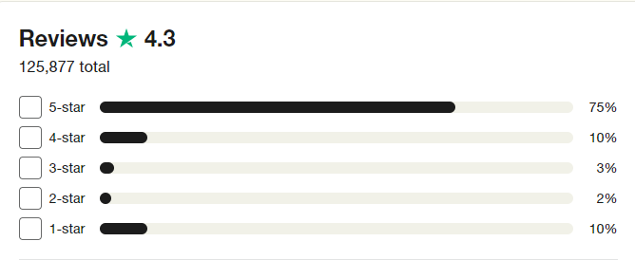Accessed on the Trustpilot website (https://www.trustpilot.com/review/www.revolut.com)

The company is also dealing with bad reviews as follow:
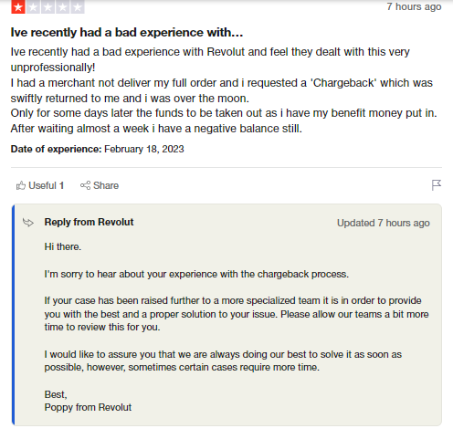
Accessed on the Trustpilot website (see at appendix)

Exploring Customer and Brand experience
‘Brands vary in the extent to which they provide their consumers with memorable experiences. Some brands do not occupy a salient position in memory despite frequent usage’ (Park et al., 2010) regarding the cited words the article reviews how brand experience can be positive and negative and how it can be important to make the customers feel well about the brand. On how important for the business is create a memorable experience, when customers identify with the brand they are more likely to stay and loyalty will only stand up in the long-term approach.
Loyalty to a brand is highly important and fundamental for those who are willing to have a good customer relationship and willing to exist on the market for many years. This report is focused on the Revolut example, it is recommended to look at customer reviews, generated at the Trustpilot website, and understand how is significant to picturise if the review can deprescribe the good or bad brand experience.
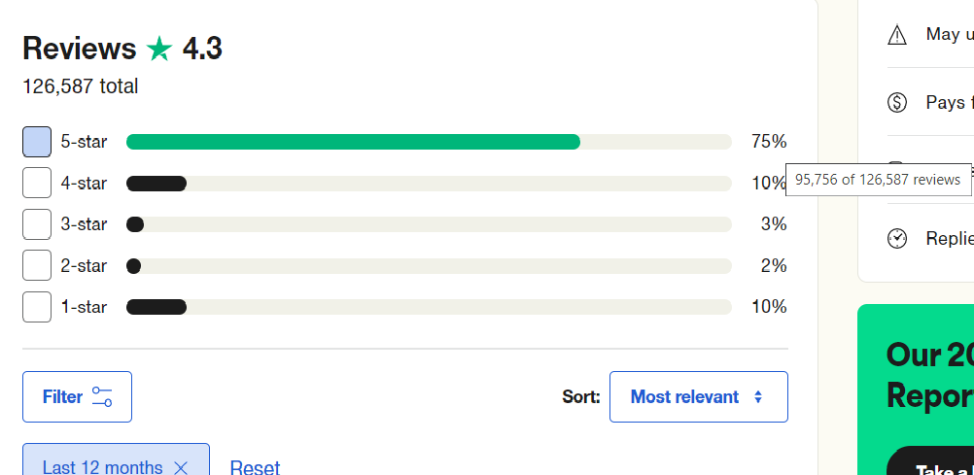
(source www.trustpilot.com) 95,756 of 126,587 customers have god good feelings about the brand
Unfortunately, the results are not 100% positive.

Examination of Revolut’s business model and Strategies
Revolut is acting to be a modern platform and organize that is analysing CRM data in an affordable and good way. The organization provides efficient and responsive customer service from customer reviews and feedback online, it seems Revolut’s CRM system is a generally effective approach in addressing customer concerns and resolving customer issues promptly.
Revolut also offers multiple channels for customer support, including their app with chat, phone, and email, which allows customers to easily get in touch. Overall it appears Revolt is willing to put massive effort into customer satisfaction and has a robust CRM system in place to support this goal.

CRM and Revolut
‘CRM is a highly fragmented environment and has come to mean different things to different people (McKie, 2000). One view of CRM is the utilization of customer-related information or knowledge to deliver relevant products or services to customers’ (Levine, 2000)

The following work is simply a demonstration of how CRM is highly important in business performance. CRM, which stands for Customer Relationship Management, refers to the process of managing interactions with customers in a business context. However, to them, CRM is highly fragmented and means different things to different people (McKie, 2000).
According to McKie (2000), this lack of clarity makes it difficult to establish a true definition.
Lavine (2000) suggests that one way to define CRM is to use customer-related information to offer the best and most relevant products or services to customers. This assumes that data is used wisely to better understand customers’ needs and preferences and tailor goods accordingly to meet those needs. As a part of the CRM approach is customer service, it has hot a huge impact on how the customers would like to contribute to the company.

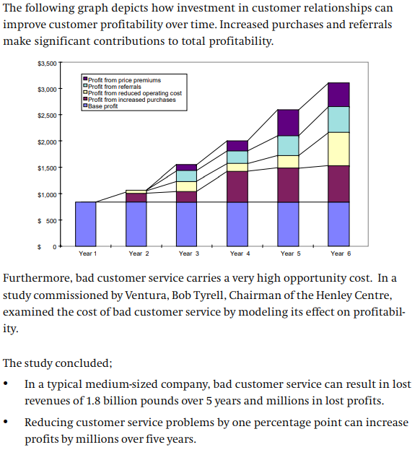
Source (Kelly D. Conway, President Julie M. Fitzpatrick, Senior Vice President eLoyalty)

Findings and conclusion
It is important to state that the business of Revolut’s example appears to be using good strategies and using CRM data to meet the goals, however, it is pivotal to note that businesses and their strategies can change over time. It is recommended to be focused on customer relationships and customer experience to avoid negative feedback, Revolut is performing well but still receiving negative feedback, and it must continue to improve its customer experience to maintain satisfaction and loyalty.

Introduction 1b
This section of the article explores two significant viewpoints concerning customer experience - the firm's and co-creation perspectives. It highlights how comprehending these concepts can influence the customer experience offered by IT companies and their services. To exemplify essential aspects, the article analyses two UK tech companies - Revolut and Monzo - that offer similar banking services and are popular among UK customers. By studying these companies, readers can gain a better understanding of how these different perspectives can affect the customer experience.

Literature review

Understanding concepts and how they can help companies.
Understanding these two perspectives can help IT firms develop effective customer experience strategies that fit with their goals and values. For example, a firm can use customer feedback to improve the quality of its products and services, while also providing personalized experiences that reflect its brand identity. By combining the firm’s perspective with the co-creation perspective, IT companies can create the best deal and approach the customer experience that prioritizes both customer and company growth.

Firm’s perspective
From the firm’s perspective, customer experience refers to the sum of all the interactions and touchpoints that customers have with the company, from initial contact, and throughout the whole purchase approach.
According to Verhoef (2009), the study of customer experience seems to be an ongoing process and only positive customer experiences can lead to higher customer satisfaction, loyalty, and advocacy. The firm’s perspective (Berry et al, 2002; Stuart and Tax 2004):

From the firm’s point of view
The firm is essentially responsible for designing and crafting an experience for the customer to receive. To be more clear the whole process of crafting customer experience is complex, it is necessary to understand that the companies in the early stages many years ago were more to be focused on producing goods or delivering the service in the way how they wanted to do it. Nowadays the customers take a relevant place in this customer-firm chain relation and mark down the standards of value. The value can be seen in variable aspects and is the customer’s perception of the balance between benefits received from a product or service and the sacrifices made to experience those benefits (Buttle and Maklan, 2015).

Co-creation perspective
The Co-creation perspective points out the importance of collaboration on the platform as firms and customers and engaging together. According to the Journal of Business Research (84, 2018).
They defined in the article that Co-creation is a collaborative process between business and consumers where both parties actively engage in the creation of value. This process involves the exchange of ideas and knowledge, which effectively supports getting innovative fully functional, and emphatic service or product that meets the needs and performances of both sides. In other words, co-creation involves working together to develop solutions that satisfied both needs and goals of consumers and businesses. The above perspective can be implemented in many sectors of the market.

Discussion
This work mainly focused on two business organizations operating in the IT industry, and fully keen to depict, how important is that every aspect of customer experience are important, and has to be understood and kindly adopted into the business to understand the targets. The mentioned businesses Revolut and Monzo are both digital banks that offer a range of financial services to customers through their mobile apps. These companies have gained popularity in recent years, both are operating in the UK. Its popularity has been growing due to its provision of an easy and convenient app, friendly interfaces, innovative features and seems to be both focused on achieving a high level of customer experience, which can be challenging given the diverse range of clients and nationalities using their services in the UK. Support this work demonstrates how the app has been designed with simplicity in mind.

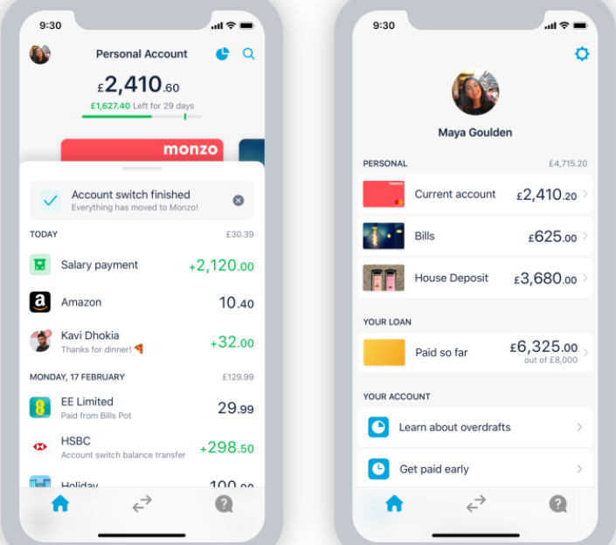
(source: https://monzo.com/blog/2019/09/20/the-monzo-app-is-changing)
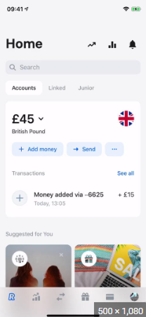
(source: https://www.google.com/search?q=revolut+app+design&sxsrf=AJOqlzVdPuQSAZ4t-ryRVwBhzuEwkTd2UQ:1677888641315&source=lnms&tbm=isch&sa=X&ved=2ahUKEwjZucCj_sD9AhUWhFwKHSGjAFkQ_AUoAXoECAEQAw&biw=1536&bih=688&dpr=1.25#imgrc=If0is58YtmYrMM)
An important fact is that online banking is a very risky product that requires customers to trust the products. After a while, the company can review customer satisfaction. This is a prime example of how important is to follow the principles through the customer journey. Revolut is ahead of other banks. From the information gathered on their website, it is clear that they offer a range of new products to encourage and meet customer expectations, which helps to enhance their customer experience. Revolut offers a ‘concierge’ service which provides customers with access to a personal assistant who can help with a variety of tasks, such as booking flights, making restaurant reservations and finding local events. In this case, Revolut is differentiating itself from traditional banks. Findings are compared and it seems that both companies are similarly the same but the understanding of customers is slightly different. Monzo’s strategy focused on simplicity and transparency for clients. Monzo’s app is designed to be easy to use and understandable by the clients. Monzo provides more detailed data on the app such as real-time spending notifications and budget-tracking tools. The information is more highlighted for the customers and spending is more thoroughly. From the point of the customer’s view, they are available through customer service 24/7 which has got a huge impact on customer experience.
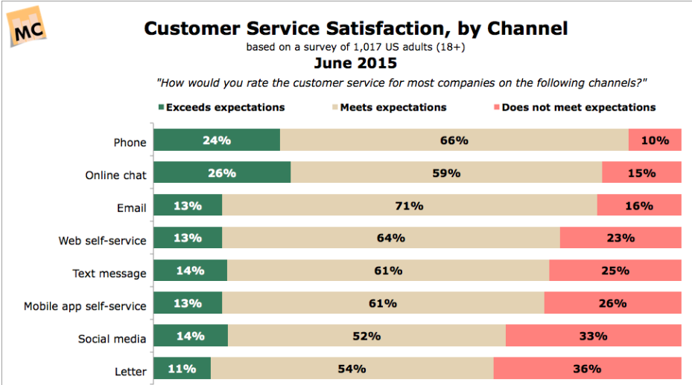

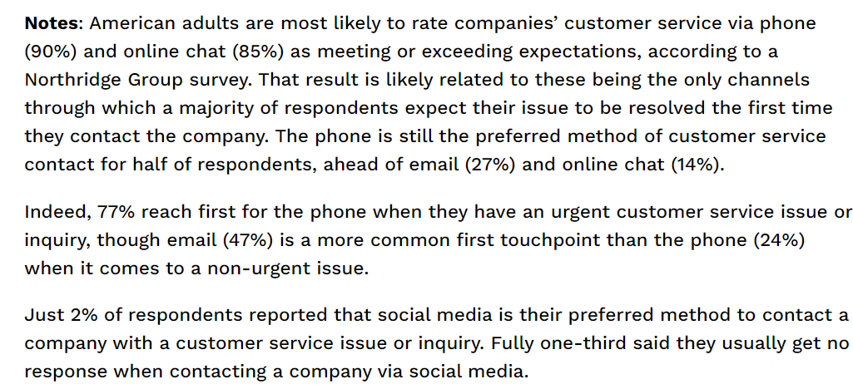
An advantage of co-creation is that companies can involve customers in building new ideas and innovations to create a more personalized customer experience. However, a disadvantage is the potential lack of control over what the customer wants, which may not align with the company’s goals. Another negative aspect of this approach is it can also be more time-consuming as everything belongs to the customer’s rules.

Conclusion
Through the analysis of these UK tech companies, it is visible that successful firms have found ways to balance both perspectives. To be more clear for example, Monzo’s app allows customers to provide feedback or manage spending in real-time spending notifications. Another fact is that the company stains to understand a massive group of customers and comity with them. By understanding the needs and preferences of customers and involving them in the value-creation process, IT Firms can build a long-lasting relationship with their customers and gain a competitive advantage in the marketplace. It is pivotal that Tech companies are aware of all aspects and try to encourage customers with corridors to achieve satisfactory relationships and drive business success.
It is necessary to highlight the fact that both companies deal with people who are looking for a modern banking experience with easy-to-use apps and useful money management tools. This fact has got a huge impact on the market and companies need to be clever and get used to all available channels, training their staff accountable to the customer market needs.

References

Berry L L, Carbone L P and Haeckel S H (2002) Managing the total customer experience. (Essay), MIT Sloan management review, 43(3), p. 85–. Available at: https://librarysearch.uwtsd.ac.uk/discovery/fulldisplay?docid=cdi_proquest_journals_224971237&context=PC&vid=44WHELF_UWTSD:44WHELF_UWTSD_VU1&lang=en&search_scope=Search_ELEC&adaptor=Primo%20Central&tab=Everything&query=any,contains,Berry,%20L.%20Carbone,%20P.%20and%20Haeckel,%20S.%20H.%20(2002),%20%E2%80%9CManaging%20the%20Total%20Customer%20Experience,%E2%80%9D%20MIT%20Sloan%20Management&offset=0
Bull C (2003) Strategic issues in customer relationship management (CRM) implementation. Business Process Management Journal, 9(5), pp. 592-602. Available at: https://www.proquest.com/docview/220297992/12C3FDB87AF4F3FPQ/5?accountid=130472
Buttle F, Maklan S (2019) Customer Relationship Management: Concepts and Technologies (4th ed.), Routledge. https://doi.org/10.4324/9781351016551
Curry D (2023) Revolut Revenue and Usage Statistics, Business of Apps, available at https://www.businessofapps.com/data/revolut-statistics
Dillet R (2022) Former Revolut employees launch Solvo, an app that simplifies crypto investing, TechCrunch, available at: https://techcrunch.com/2022/09/29/former-revolut-employees-launch-solvo-an-app-that-simplifies-crypto-investing/
Maechler N, Neher K, Park R (2013) From touchpoints to journeys: Seeing the world as customers do, McKinsey&Company, available at: https://www.mckinsey.de/~/media/McKinsey/Business%20Functions/Marketing%20and%20Sales/Our%20Insights/From%20touchpoints%20to%20journeys%20Seeing%20the%20world%20as%20customers%20do/From_touchpoints_to_journeys_Seeing_the_world_as_customers_do.pdf
Miočević D (2007) Book review: Buttle, F.: “Customer relationship management: concepts and tools”, Tržište. Faculty of Economics & Business, Zagreb, CROMAR (Croatian Union of Marketing Associations), pp. 141–144. Available at: https://doaj.org/article/5380f917e39140f69e8b82162d249ae5
Prahalad C K, Ramaswamy V (2004) Co-creation experiences: The next practice in value creation, Journal of interactive marketing, 18(3), pp. 5–14. Available at: https://librarysearch.uwtsd.ac.uk/discovery/fulldisplay?docid=cdi_proquest_journals_229626995&context=PC&vid=44WHELF_UWTSD:44WHELF_UWTSD_VU1&lang=en&search_scope=MyInst_and_CI&adaptor=Primo%20Central&tab=Everything&query=any,contains,Co-creation%20experiences:%20The%20next%20practice%20in%20value%20creation
Schwager A, Meyer C (2007) Understanding Customer Experience, Harvard Business Review, available at: https://moodle.uwtsd.ac.uk/pluginfile.php/623971/mod_resource/content/1/Understanding%20Customer%20Experience_HBR.pdf
Stokburger-Sauer N, Ratneshwar S. and Sen S (2012) Drivers of consumer–brand identification, International journal of research in marketing, 29(4), pp. 406–418. Available at: https://doi.org/10.1016/j.ijresmar.2012.06.001
Tang L, & Gekara V (2018) The importance of customer expectations: An analysis of CSR in container shipping, J Bus Ethics 165, 383–393, available at: https://link-springer-com.ezproxy.uwtsd.ac.uk/content/pdf/10.1007/s10551-018-4062-4.pdf
Verhoef P C (2009) Customer Experience Creation: Determinants, Dynamics and Management Strategies, Journal of retailing, 85(1), pp. 31–41. Available at: https://doi.org/10.1016/j.jretai.2008.11.001

Appendix

Revolut’s website: https://www.revolut.com
Trustpilot review of Revolut: https://www.trustpilot.com/review/www.revolut.com
Conway K D, Fitzpatrick J M (1999) The Customer Relationship Revolution - A Methodology for Creating Golden Customers, eLoyalty, available at: http://ctiforum.com/technology/CRM/wp03/custrelrev.pdf
What Is Brand Experience? YouTube Video: https://www.youtube.com/watch?v=7fzezYzTGZA
Review of Revolut’s metal card service: https://www.finder.com/uk/revolut-metal-card#:~:text=ve%20put%20together.-,Other%20benefits%20of%20Revolut%20Metal,answer%20your%20request%20via%20email.
Anonymous (2015) Customer Service Satisfaction, by Channel, Marketing Charts, available at: https://www.marketingcharts.com/customer-centric-55798
Monzo’s website: https://monzo.com/

