Programme:- MSc in Public health and social care in practice
Module name:- Population health and digital health promotion
Module code:- LCHS7007
Name: Pruthvi Asodarya
STUDENT ID: 2319296
Lecturer Name:- Dr. Ping Wu
Table of Contents
BLOG - A 3
BLOG - B 5
REFERENCES 7
POSTURE 7

BLOG - A

The Digital Lifeline: Tackling Obesity with MyFitnessPal
DO YOU KNOW ABOUT THE OBESITY?
Obesity is a burgeoning public health crisis, impacting millions worldwide. According to the World Health Organization (2024), global obesity rates have nearly tripled since 1975, with over 650 million adults classified as obese in 2016. This epidemic poses significant health risks, including heart disease, diabetes, and certain cancers, leading to increased mortality rates and substantial economic burdens on healthcare systems. Addressing obesity is therefore critical, requiring innovative and effective interventions (Finkelstein et al, 2012).
One such intervention is MyFitnessPal, a digital technology application designed to assist individuals in tracking their diet and exercise to achieve weight loss and maintain a healthy lifestyle (Mangieri et al, 2019). This blog critically examines the impact of MyFitnessPal on promoting health and combating obesity.
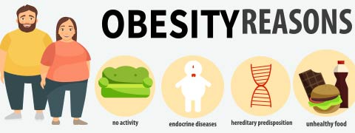
MyFitnessPal: A Digital Health Promotion Tool

MyFitnessPal is a smartphone application and website that offers a comprehensive platform for tracking nutrition and physical activity (Mangieri et al, 2019). Users can log their daily food intake and exercise routines, setting personalised goals based on their health objectives (Mangieri et al, 2019)s. The app's extensive database includes over 11 million foods, providing detailed nutritional information to help users make informed choices (Mangieri et al, 2019).
The primary mechanism through which MyFitnessPal promotes health is by enhancing self-monitoring and accountability. Users gain insights into their eating habits and physical activity levels, fostering greater awareness and encouraging healthier behaviours. This self-regulation is crucial for weight management and overall well-being (Mangieri et al, 2019).
Features of App:
Here are the features of the app…
- Food Logging: Extensive database with over 11 million foods.
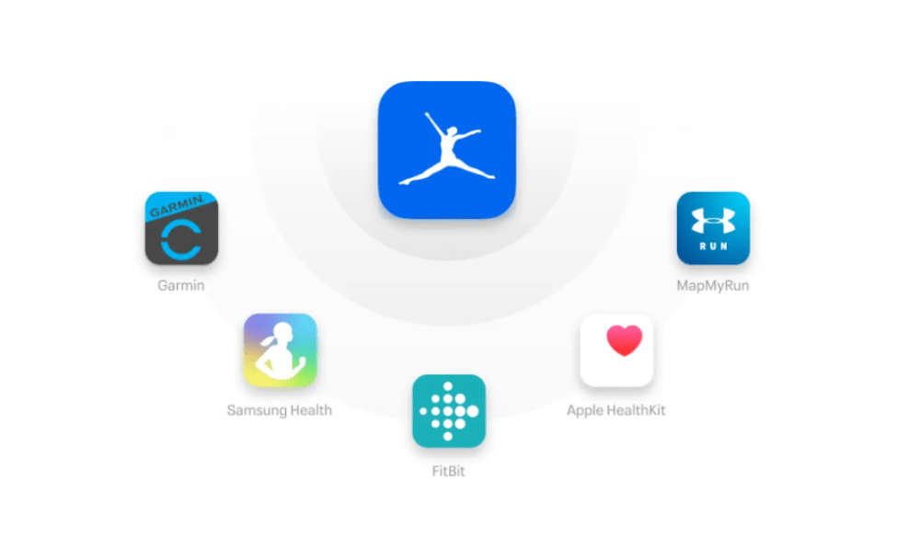
- Exercise Tracking: Log various physical activities.
- Personalised Goals: Customisable health objectives.
- Nutritional Information: Detailed breakdown of macronutrients and micronutrients.
- Barcode Scanner: Quick and accurate food logging.
- Wearable Integration: Sync with fitness trackers for automatic data input.
- Community Support: Peer support and motivation from millions of users.
(Karduck et al, 2018)
- Progress Reports: Visual and detailed weight loss and fitness progress tracking (Karduck et al, 2018).
- Reminders and Notifications: Regular prompts to log food and exercise (Karduck et al, 2018).
- Recipes and Meal Plans: Access to various healthy recipes and meal planning tools (Karduck et al, 2018).
- Expert Advice: Tips and articles from nutritionists and fitness experts (Karduck et al, 2018).
- Challenges and Rewards: Gamification elements to boost user engagement (Karduck et al, 2018).

Advantage of App
- MyFitnessPal is available on various platforms, making it accessible to a broad audience. Its user-friendly interface allows for easy integration into daily routines (Hobson, 2021).
- The app's extensive food database and exercise tracking capabilities provide a holistic view of users' health behaviours (Hobson, 2021).
- MyFitnessPal allows users to set customised goals based on their specific health needs and preferences, enhancing its relevance and effectiveness (Hobson, 2021).
Disadvantages of the App
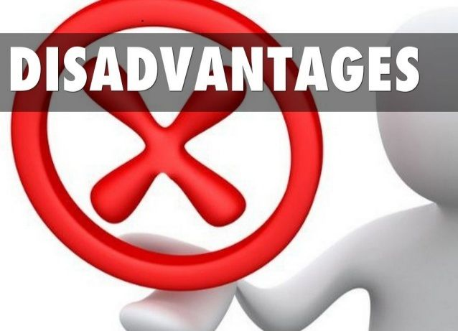
- The accuracy of self-reported data can be questionable. Users may underreport their caloric intake or overestimate their physical activity, leading to inaccurate assessments (Slazus et al, 2022).
- Sustained engagement with the app can be challenging. Many users may abandon the app after initial enthusiasm wanes, reducing its long-term effectiveness (Hobson, 2021).
- Like any digital platform, MyFitnessPal can suffer from technical glitches or user interface issues that may hinder its usability (Slazus et al, 2022).
Addressing the Solutions
- Incorporating features like barcode scanners and integration with wearable fitness trackers can improve the accuracy of logged data. This would provide more reliable information on users to base their health decisions on (Slazus et al, 2022).
- Introducing gamification elements, such as challenges and rewards, can boost user engagement. Providing incentives for consistent usage may help maintain long-term adherence (Slazus et al, 2022; Hobson, 2021).
- Offering regular updates, tips, and educational content can keep users informed and motivated. Integrating expert advice from nutritionists and fitness coaches could also add value (Slazus et al, 2022; Hobson, 2021).

BLOG - B

Reclaiming Rest: Addressing Sleep Deprivation with SlumberTrack
Insomnia:
Sleep deprivation and insomnia are pervasive public health issues with far-reaching consequences on both individual and societal levels. According to the Centers for Disease Control and Prevention (CDC), insufficient sleep is a significant health concern affecting approximately one-third of adults in the United States, with even higher prevalence among certain demographic groups such as students, shift workers, and caregivers (Chattu et al, 2018). Chronic sleep deprivation is linked to a host of health problems, including obesity, diabetes, cardiovascular disease, and mental health disorders like depression and anxiety (Riemann et al, 2022). Furthermore, sleep deprivation can impair cognitive function, leading to an increased risk of accidents and decreased productivity (Riemann et al, 2022). Given these widespread impacts, addressing sleep deprivation through innovative digital health interventions is crucial.

Introducing SlumberTrack: A Comprehensive Sleep Health App
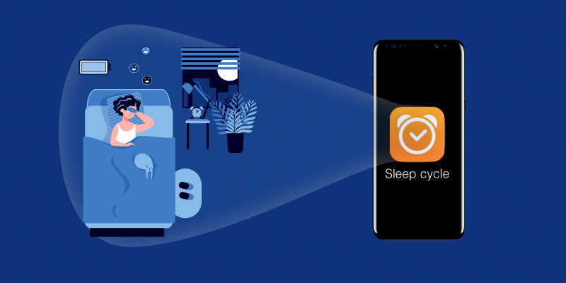
SlumberTrack is a cutting-edge digital technology designed to combat sleep deprivation and promote healthy sleep habits. This app integrates several features tailored to address the multifaceted nature of sleep issues. Key features include:

- Sleep Tracking and Analysis: Utilising smartphone sensors and wearable technology, SlumberTrack monitors sleep patterns, duration, and quality, providing users with detailed insights and personalised feedback (Choi et al, 2018).
- Sleep Hygiene Education: The app offers evidence-based educational content on sleep hygiene practices, such as maintaining a consistent sleep schedule, creating a restful environment, and avoiding stimulants before bedtime (Stanković et al, 2021).
- Guided Sleep Meditations and Relaxation Techniques: Users can access a library of guided meditations, breathing exercises, and progressive muscle relaxation techniques designed to facilitate relaxation and improve sleep onset (Stanković et al, 2021).
- Cognitive Behavioral Therapy for Insomnia (CBT-I): SlumberTrack includes CBT-I modules, which are considered the gold standard for treating chronic insomnia. These modules help users identify and change behaviours and thoughts that negatively impact sleep (Stanković et al, 2021).
- Smart Alarms and Sleep Coaching: The app features smart alarms that wake users during light sleep phases, reducing grogginess, and provides personalised sleep coaching based on users' data and progress (Choi et al, 2018).
Benefits of the App

- SlumberTrack's use of data analytics allows for highly personalised recommendations, increasing the likelihood of adherence and effectiveness (Huberty et al, 2021).
- As a mobile app, SlumberTrack is easily accessible to a wide audience, breaking down barriers related to the cost and availability of traditional sleep therapy (Huberty et al, 2021).
- By combining sleep tracking, education, relaxation techniques, and CBT-I, SlumberTrack offers a holistic solution that addresses multiple facets of sleep health (Huberty et al, 2021).
- Digital health technologies like SlumberTrack can be scaled rapidly to reach large populations, making them ideal for addressing widespread public health issues (Huberty et al, 2021).
Shortfalls of the App

- Users may become overly reliant on the app, neglecting to develop intrinsic motivation and self-regulation skills (Pan et al, 2020).
- The collection and storage of sensitive health data raise privacy and security concerns, which could deter some users from fully engaging with the app (Huberty et al, 2021).
- Not all individuals have access to smartphones or the internet, potentially exacerbating health disparities among underserved populations (Huberty et al, 2021).
- Sustaining long-term user engagement with the app can be challenging, particularly if users do not see immediate improvements in their sleep (Pan et al, 2020).
Solutions to rectify the shortfalls
- Incorporating features that gradually encourage users to develop and rely on intrinsic motivation and self-regulation skills, rather than solely on the app (Pan et al, 2020).
- Implementing state-of-the-art encryption and data protection protocols to ensure user data is secure and privacy concerns are addressed (Huberty et al, 2021).
- Collaborating with community organisations and public health initiatives to provide access to the app in underserved areas, potentially through subsidised devices or internet access programs (Pan et al, 2020).
- Using gamification, social support features, and regular updates to keep users engaged and motivated to continue using the app (Pan et al, 2020).

REFERENCES

Chattu, V.K., Manzar, M.D., Kumary, S., Burman, D., Spence, D.W. and Pandi-Perumal, S.R., 2018, December. The global problem of insufficient sleep and its serious public health implications. In Healthcare (Vol. 7, No. 1, p. 1). MDPI.

Choi, Y.K., Demiris, G., Lin, S.Y., Iribarren, S.J., Landis, C.A., Thompson, H.J., McCurry, S.M., Heitkemper, M.M. and Ward, T.M., 2018. Smartphone applications to support sleep self-management: review and evaluation. Journal of Clinical Sleep Medicine, 14(10), pp.1783-1790.

Finkelstein, E.A., Khavjou, O.A., Thompson, H., Trogdon, J.G., Pan, L., Sherry, B. and Dietz, W., 2012. Obesity and severe obesity forecasts through 2030. American journal of preventive medicine, 42(6), pp.563-570.

Hobson, G., 2021. Use of the My Fitness Pal Mobile Application to Decrease Body Mass Indexes and Improve Depressive Symptoms. Brandman University.

Huberty, J.L., Green, J., Puzia, M.E., Larkey, L., Laird, B., Vranceanu, A.M., Vlisides-Henry, R. and Irwin, M.R., 2021. Testing a mindfulness meditation mobile app for the treatment of sleep-related symptoms in adults with sleep disturbance: A randomized controlled trial. Plos one, 16(1), p.e0244717.

Karduck, J. and Chapman-Novakofski, K., 2018. Results of the clinician apps survey, how clinicians working with patients with diabetes and obesity use mobile health apps. Journal of nutrition education and behavior, 50(1), pp.62-69.

Mangieri, C.W., Johnson, R.J., Sweeney, L.B., Choi, Y.U. and Wood, J.C., 2019. Mobile health applications enhance weight loss efficacy following bariatric surgery. Obesity research & clinical practice, 13(2), pp.176-179.

Pan, Q., Brulin, D. and Campo, E., 2020. Current status and future challenges of sleep monitoring systems: Systematic review. JMIR Biomedical Engineering, 5(1), p.e20921.

Riemann, D., Benz, F., Dressle, R.J., Espie, C.A., Johann, A.F., Blanken, T.F., Leerssen, J., Wassing, R., Henry, A.L., Kyle, S.D. and Spiegelhalder, K., 2022. Insomnia disorder: State of the science and challenges for the future. Journal of sleep research, 31(4), p.e13604.

Slazus, C., Ebrahim, Z. and Koen, N., 2022. Mobile health apps: An assessment of needs, perceptions, usability, and efficacy in changing dietary choices. Nutrition, 101, p.111690.

Stanković, M., Nešić, M., Čičević, S. and Shi, Z., 2021. Association of smartphone use with depression, anxiety, stress, sleep quality, and internet addiction. Empirical evidence from a smartphone application. Personality and individual differences, 168, p.110342.

WHO, 2024 https://www.who.int/news-room/fact-sheets/detail/obesity-and-overweight

POSTER



