

Defending Platform Leadership through Trusted AI-Enabled Home Intelligence in Rightmove plc’s UK Residential Property Portal Market
Prepared for the Board of Directors of Rightmove plc

Master of Business Administration
Module: Strategic Management
Module code: LCMB7003
Lecturer: Hoang Nguyen
Student name: Md Mahtabur Rahman Tarek
Student ID: 2504937

Submission date: 10-08-26

Contents
1. Organisational Context and Strategic Scope 3
2. External and Internal Analysis 5
2.1 External Environment 5
2.2 Internal Environment 7
2.3 SWOT Synthesis 9
2.4 Integrated Strategic Diagnosis 10
3. Comprehensive and Holistic View of the Organisation 11
3.1 CSR Strategy and Alignment with Business Objectives 11
3.2 Balanced Scorecard 13
4. Strategic Choices and Implementation 15
4.1 Competitive Structure and Business-Level Options 15
4.2 Recommended Strategic Choice 16
4.3 Implementation, Risks and Mitigation 17
4.4 Concluding Board Recommendation 19
5. Gibbs Reflective Account 19
5.1 Description 19
5.2 Feelings 19
5.3 Evaluation 20
5.4 Analysis 20
5.5 Conclusion 21
5.6 Action Plan 21
References 22

1. Organisational Context and Strategic Scope
Halifax, Countrywide, Connells, and the Royal & Sun Alliance created Rightmove in 2000. In 2002, it started charging for listings and went public in 2006. Rightmove plc (2026d) suggests examining the UK online residential property site sector as the business currently concentrates on UK home-moving rather than foreign property intermediation. The firm offers trustworthy tools and information to help people move and provide them confidence (Rightmove plc, 2026c). These remarks are better for strategy than a phoney conventional purpose as they illustrate the customer problem and the trust required to decide future growth.
A multi-sided platform is the model. While anybody may explore for free, real estate brokers, rental agents, and home builders may buy memberships, advertising packages, and digital items. Rightmove creates buyer interest and approved leads from listings. Repeated contacts assist the firm in developing data and enhancing professional goods. When cooperation benefits another party, digital platforms may be secured. Governance actions may either boost loyalty or trigger backlash (de Reuver, Sørensen and Basole, 2018; Cennamo, 2021). Rightmove’s principal established competitors in the UK residential property portal market are Zoopla and OnTheMarket, while estate-agent websites, social media channels and emerging AI-enabled property-search services create additional substitution pressure (Rightmove plc, 2026a). Figure 1 demonstrates that Rightmove's edge is a tool for improvement, not a website feature.
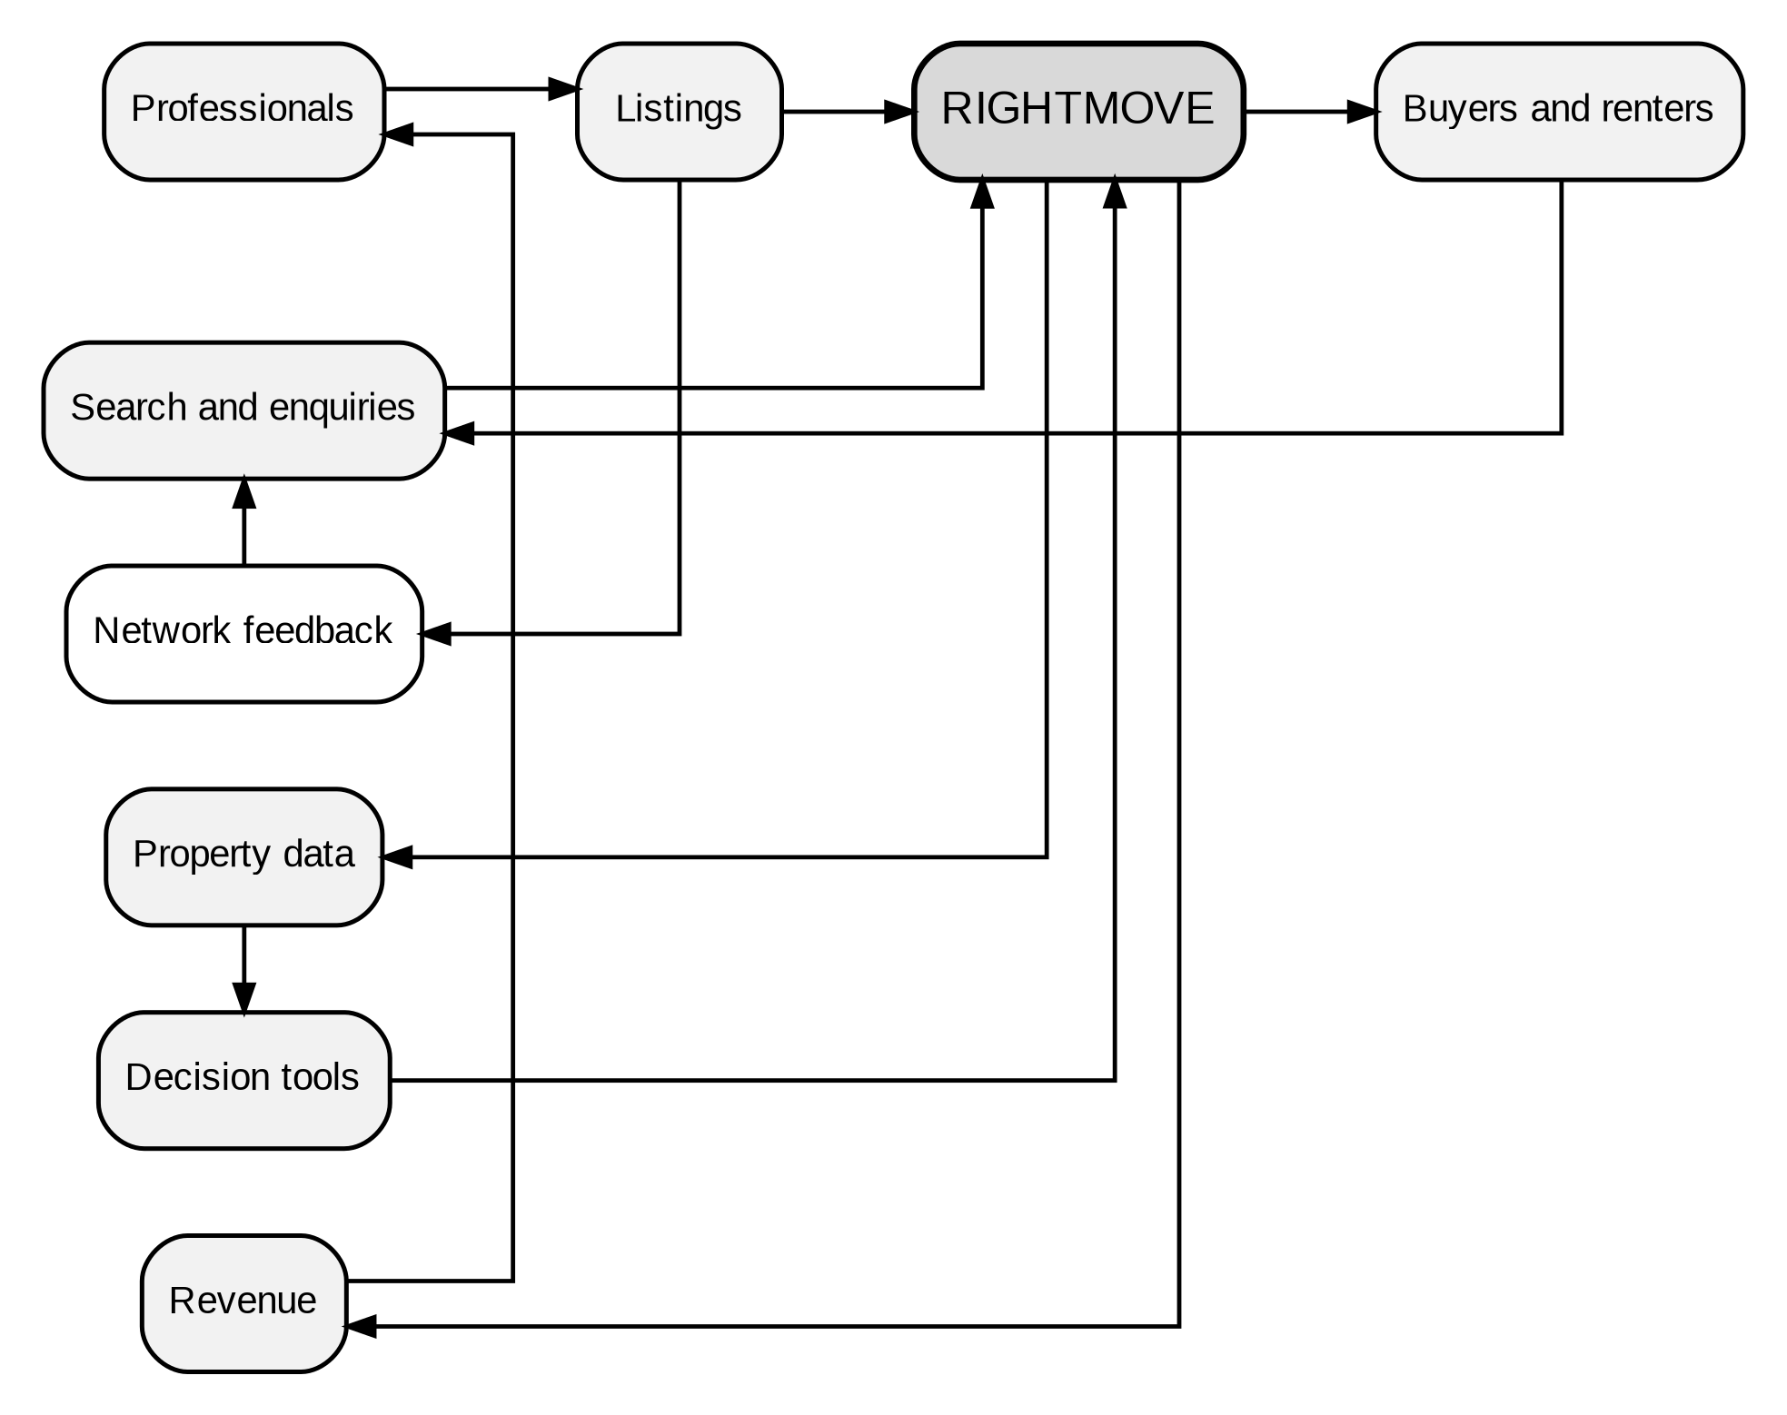
Figure 1: Rightmove’s UK Residential Multi-Sided Platform and Value-Creation Logic
Source: Consultant synthesis developed from Rightmove plc (2026a) and Cennamo (2021).
Rightmove’s platform scale provides substantial evidence of market leadership and strengthens the cross-sided network effects underpinning its value proposition. Rightmove had 19,272 core members, £425.1 million in revenues, £297.7 million in operating profit, 89% of UK property site traffic, and more than 85% of their traffic was direct or organic (Rightmove plc, 2026a). Corporate reporting is established by management, but financial, audience and involvement factors assist market leadership. The main strategic strain also can be observed. The slow building of new houses affected the competitiveness of customers and estate agents, leading to a review of pricing and dependence on partners, and a decrease in revenue growth for July 2026 from 8-10% to 6-8%, as stated by Reuters (2026). Rightmove has to protect its marketing network and deliver reliable local choice services which are less vulnerable to the property market cycle.

2. External and Internal Analysis

2.1 External Environment
The outside world is important since Rightmove’s market is influenced by government policies, family finances, technology and data laws. PESTEL provides a framework for scanning. However, the categories limit the ability to correlate events. As Whittington et al. (2023) have pointed out, strategic interpretation should be about the impact of one development on customer behaviour, partner economics and platform risk, not six lists. Figure 2 outlines the key relationships.
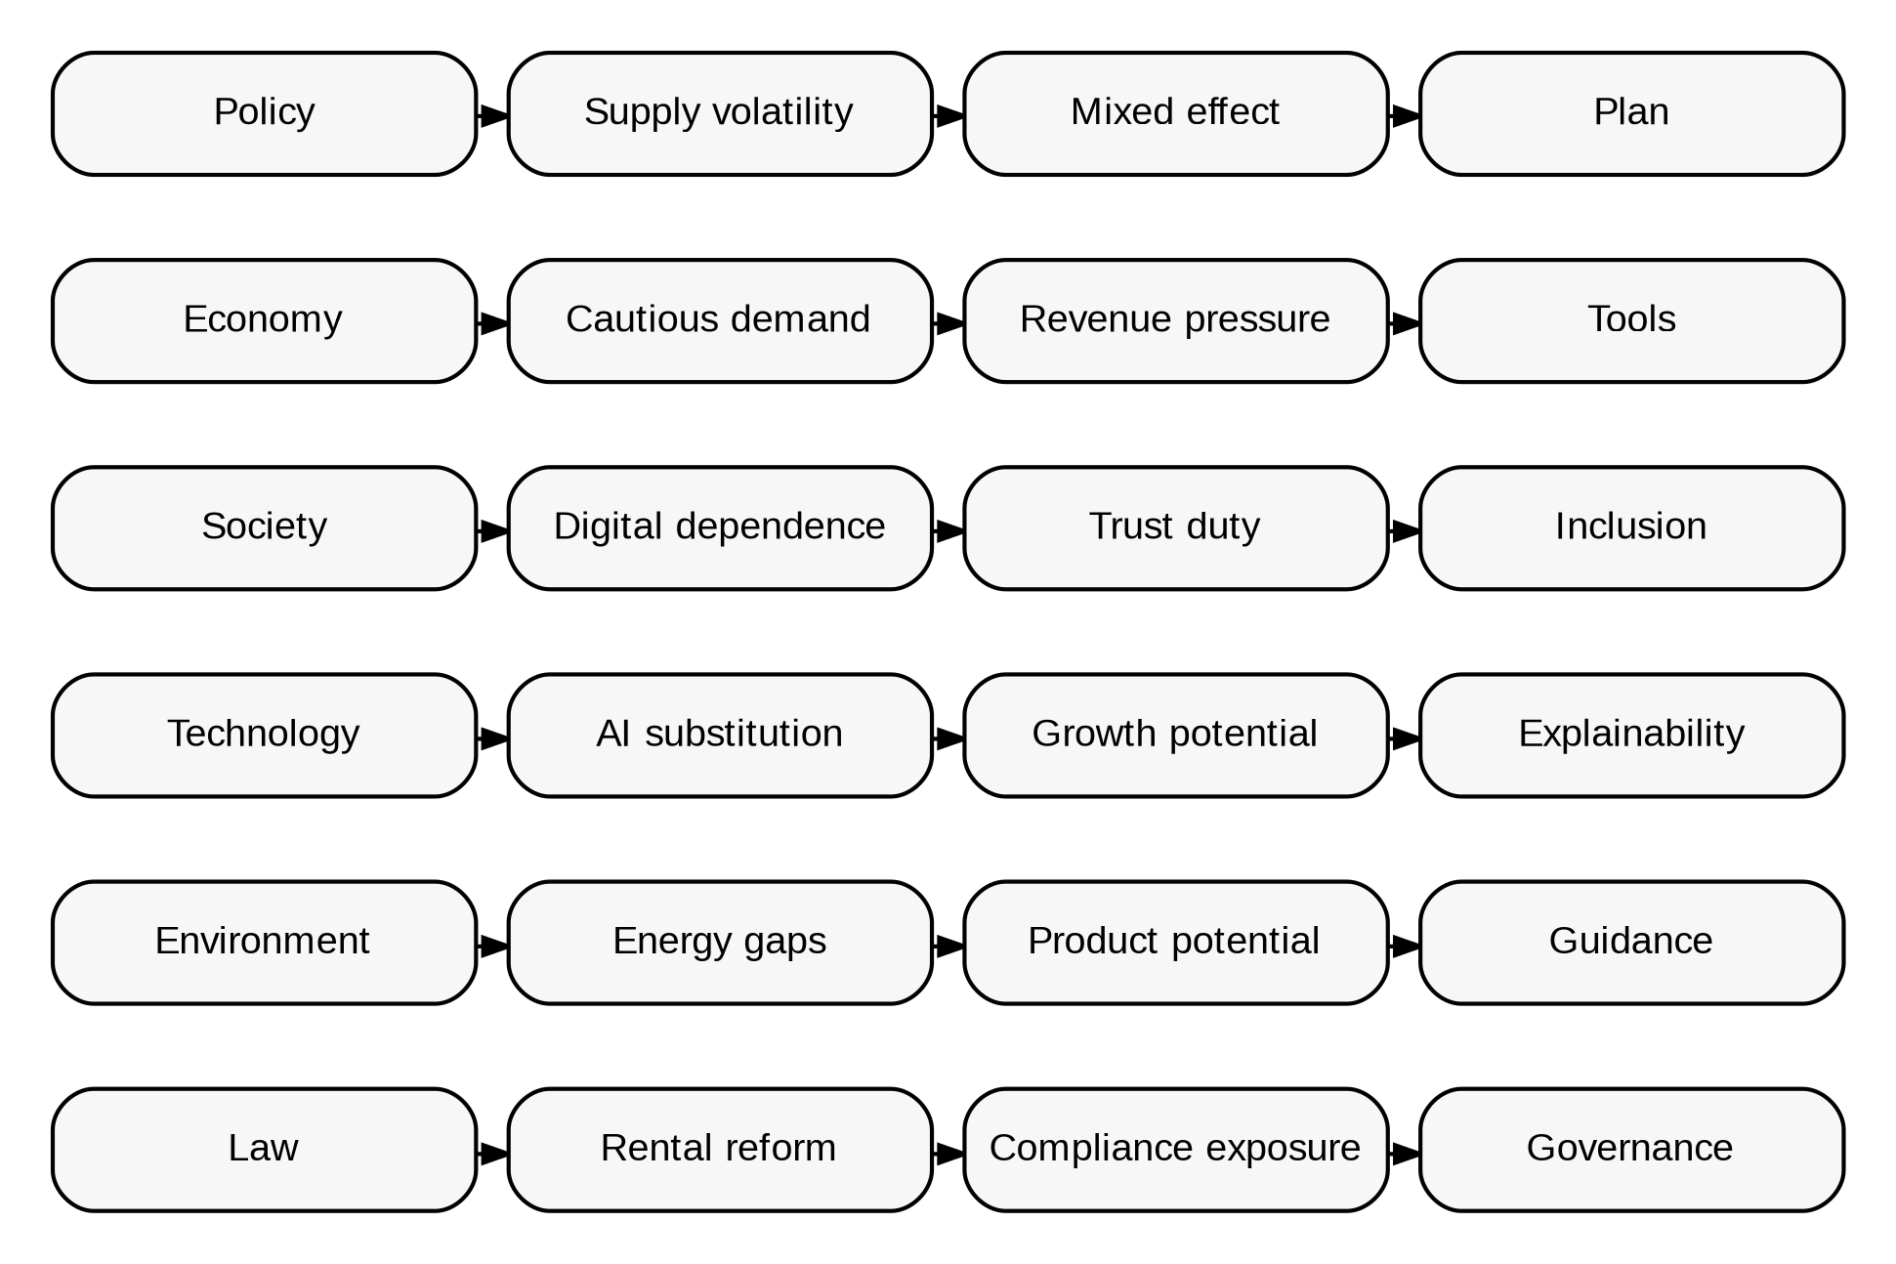
Figure 2: PESTEL Drivers and Their Strategic Effects on Rightmove
Source: Bank of England (2026), HM Revenue & Customs (2026), Information Commissioner’s Office (2026), Ministry of Housing, Communities and Local Government (2026a, 2026b, 2026c), Office for National Statistics (2026) and Whittington et al. (2023).
Odds are offered up in both directions in politics and supply. There were 33,960 seasonally adjusted home starts in England in the first quarter of 2026. This was 9% lower than the previous quarter, but 18% greater than 2025 (Ministry of Housing, Communities and Local Government, 2026b). The Building Safety Regulator has supplied an unusually high amount of data to recent reports. Thus, the yearly increase may not be true. The official publication suggests that readers should use figures with caution (Ministry of Housing, Communities and Local Government, 2026b). Buyers of New Homes are demanding advertising and marketing, so unpredictability is key. Rightmove should not merely throw money toward improving performance. It is designed to help marketers spend their limited marketing budgets based on planning data, demand data and lead conversion data. That would be an unstable data service potential.
Outside of transactions, the economy is tighter. UK domestic agreements were 98,700 (seasonally adjusted) in June 2026, up 2% on 2025. Completions occur two to four months after first offers, and hence do not represent current confidence (HM Revenue & Customs, 2026). The Bank Rate for July 29, 2026, was 3.75%. Energy prices are volatile, and inflation may not stay low, the MPC remarked (Bank of England, 2026). Average UK private rents were £1,388 in June, and average property prices were £271,000 in May (Office for National Statistics, 2026). People want to know about affordability and mortgage readiness and total-occupancy costs, but they also want to avoid disinformation. Decision tools must communicate restrictions, assumptions and data timelines without boosting confidence.
The UK property market is changing with social customs and government regulations, and Rightmove is becoming more of a watchdog. Online property platforms are not suitable for finding homes for sale. This is because their search tools and structure can influence customers’ tastes, mobility and engagement with the housing market. This power provides for political accountability. Meers (2024) highlights how rental platforms' simple actions may have unjust repercussions. Design decisions may affect law and society. These concerns have grown since the Renters' Rights Act took effect on May 1, 2026. The Act ended Section 21 evictions, restricted rent increases, and strengthened safeguards for families with children or on welfare (Ministry of Housing, Communities and Local Government, 2026a). Rightmove should use partner standards, inclusive design, and audit trails for governance, not only ethics.
Technology has pros and cons. Rightmove claims Google Cloud is helping with chat search and 31 AI projects. Large language models accounted for less than 0.5% of traffic by May 2026 (Rightmove plc, 2026a, 2026b). Even if quick disintermediation is limited, AI might alter homebuying. Rightmove should differentiate itself by providing property-specific information that is explainable and continues to build customer trust and decision quality (Glikson and Woolley, 2020; Puntoni et al., 2021; Shin, 2021).
Data and computer security restrict possibilities. According to the Information Commissioner’s Office (2026), other AI threats include government, transparency, lawfulness, fairness, truth, security, minimisation and individual rights. False lifestyle assumptions or price counsel might damage Rightmove’s brand and make it hard to find properties. Establish privacy-by-design, monitoring and human escalation, and only then increase. But the reaction that is about obedience misses the issue. Research on digital transformation reveals that organisations get long-term benefits when technology changes the way they operate and generate revenue while solving structural and moral problems (Vial, 2019; Warner and Wäger, 2019).
Environmental pressures are equal to the platform’s information advantage. In the first three months of 2026, England issued 416,000 domestic Energy Performance Certificates, including 48,000 for new houses. The Ministry of Housing, Communities and Local Government (2026c) cautions that the register is not an exhaustive list of all dwellings. Rightmove is committed to sustainability and wants to be a leader. They aim for net zero direct operations by 2030 and value chain-wide by 2040 (Rightmove plc, 2026e). Office emissions are not the only strategic opportunity. Explicit and regularly updated estimations of verified energy-cost ranges, EPC restrictions and retrofit routes may enable customers to make wiser decisions and develop distinctive partner services.

2.2 Internal Environment
VRIO works better if it works on resources as coherent bundles instead of separate pieces. Grant (2024) said that the talents and resources of a corporation are essential in defining the competitive advantage of a company. Platform research, however, suggests that it is the ecosystem roles and interfaces that determine whether complementary assets reinforce each other (Jacobides, Cennamo and Gawer, 2018; Gawer, 2021). Figure 3: Assesses Rightmove’s customers, links, data, technology and daily duties.
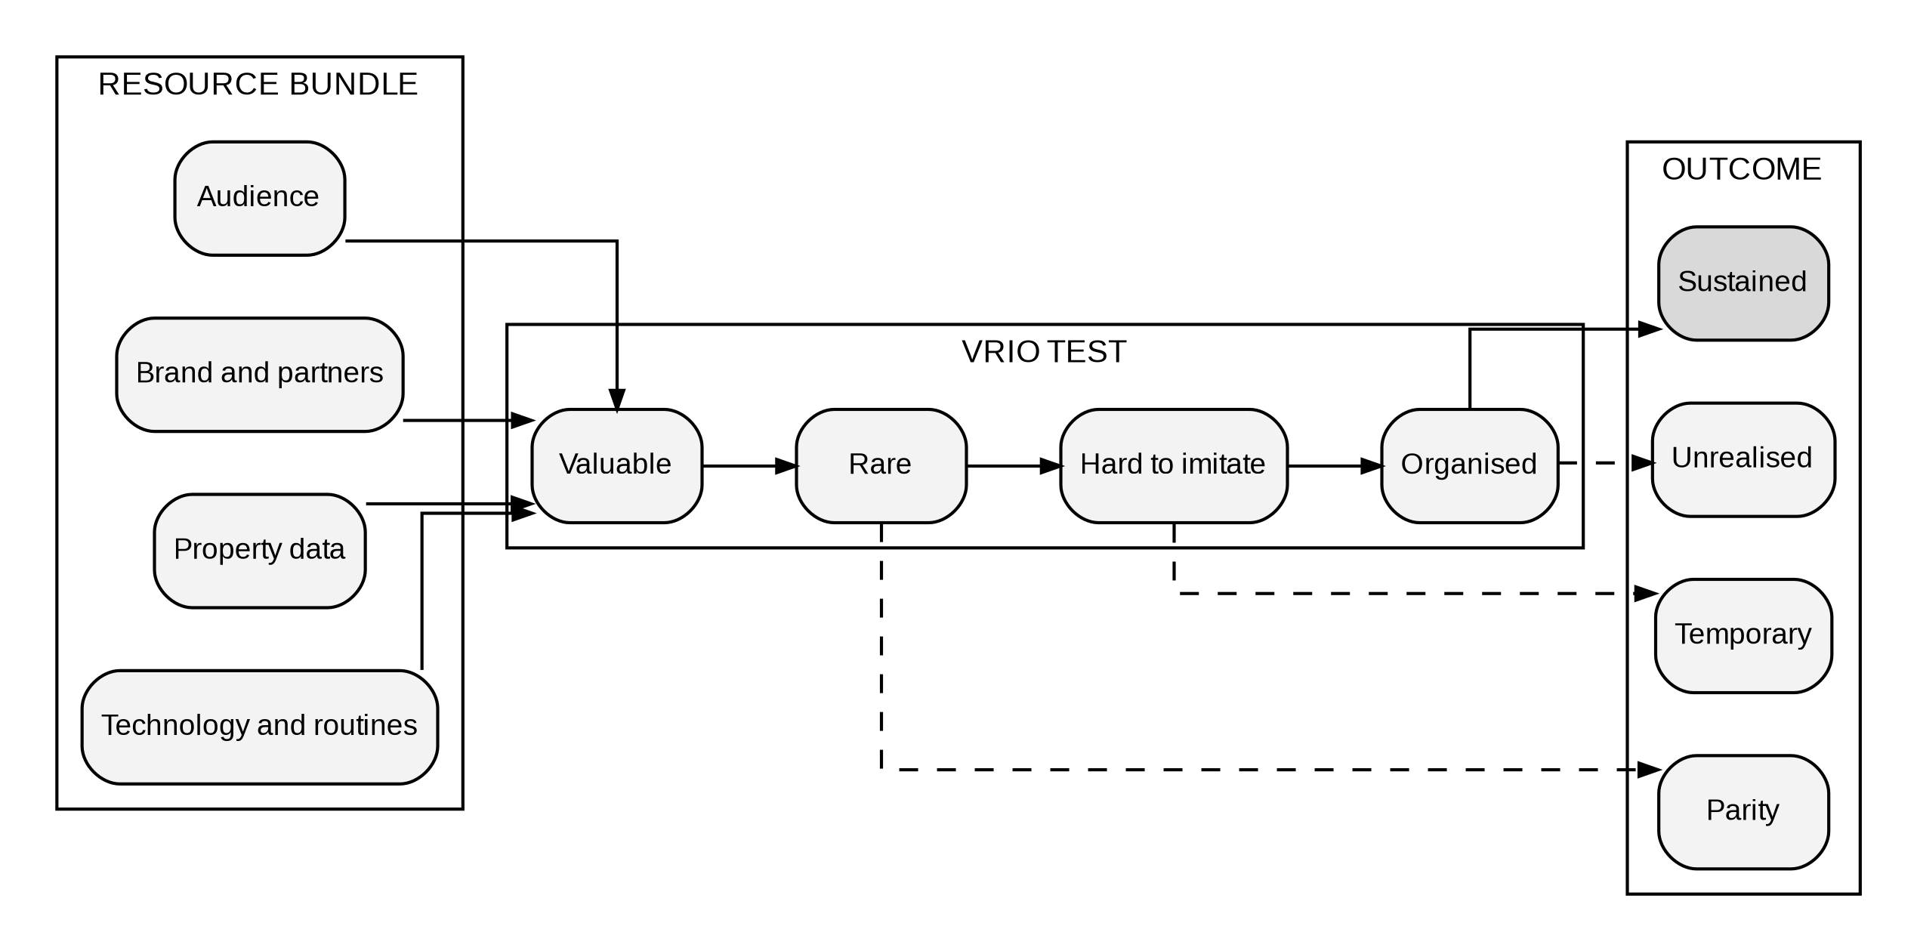
Figure 3: Rightmove’s Resource Bundles and the Path to Competitive Advantage
Source: Grant (2024) and Rightmove plc (2026a).
The audience size and direct traffic are attractive for professional clients and create inquiries. The site is less reliant on sponsored acquisition, with 89% of portal time and over 85% of traffic being direct or organic, and over 90% of estate agents continue with the site, validating its significance to firms (Rightmove plc, 2026a). This is a unique position in the UK and one that is hard to reproduce since a new entrant has to bring on board listings and consumers. However, this position is not entirely unique because agents can list on multiple portals, consumers may change their search behaviour and dissatisfaction may reduce participation. The estate-agent competition accusation illustrates that network influence has to be well-managed, not that partners have no options (Reuters, 2026).
The network becomes better as the property data enhances the outcomes. In 2025, Rightmove had more than four petabytes of data, of which 90% was proprietary, 200 models and 6,000 product releases (Rightmove plc, 2026a). Data volume is neither exceptional nor useful. Data network effects need attention, feedback learning, user-centred design and legality to improve service without losing trust (Gregory et al., 2021). Rightmove’s history records, live listing flow and behavioural indications are difficult to replicate in value, but depend on source, representativeness and permitted use.
The value of technology and AI features is just temporary, as rivals may acquire cloud infrastructure and models. Mikalef and Gupta (2021) believe that the potential of AI is linked to the integration of technical, human and organisational resources, whereas Sjödin et al. (2021) suggest that AI develops via data flows, co-creation and ecosystem integration. It is possible with the speed of release frequency and Rightmove's link with Google Cloud, but the reliance on a large source might standardise the stack. Competitive differentiation should therefore arise from reliable property context, integrated partner processes and rigorous quality criteria rather than from the model provider alone.
The last VRIO test in the package is organisation and expertise. Rightmove had a Great Place to Work score of 89% in 2025, 10,625 training hours and £589 per employee training expenditures (Rightmove plc, 2026f). These inputs suggest finance, but need responsible-AI knowledge and cross-functional decision rights. A better organisation would align product, data, legal, security, sustainability, and customer teams via release gates and common outcomes. Cash generation enables this redesign, but the forecast decline in 2026 suggests investment must be balanced with quantifiable learning. The VRIO assessment therefore produces a selective conclusion. Audience, data and professional relationships may support sustained advantage, whereas generic technology, capital and isolated features remain imitable.

2.3 SWOT Synthesis
Table 1 is limited to factors of external and internal evidence. This is not an expanded list, but a prioritised one, as normal SWOT lists separate issues from cause and effect and strategic choices (Whittington et al., 2023).
Table 1: Prioritised SWOT Analysis for Rightmove in the UK Residential Property Portal Market
Dimension | Evidence | Strategic implication
Strengths | Audience, partners and data. | Create trusted services.
Weaknesses | UK, listings and pricing concentration. | Prove value; diversify.
Opportunities | AI, affordability, rental, energy. | Build trusted home intelligence.
Threats | Weak new homes, AI, regulation, cyber. | Use staged governance and co-design.
Source: Rightmove plc (2026a), Reuters (2026) and Ministry of Housing, Communities and Local Government (2026a; 2026b; 2026c).
The table shows that power and risk share components. Concentration boosts data and audience liquidity, and connects performance to the UK’s living conditions and partner involvement. Unrelated diversification would weaken strategic coherence because it would move Rightmove beyond the market in which its data, audience and partner relationships provide defensible advantages. Disciplined adjacency makes superior choices of current information and helps out professional customers.

2.4 Integrated Strategic Diagnosis
The integration identifies three Board issues. Initially, Rightmove's talent is concentrated in one national housing ecosystem. This clustering boosts network advantages but renders income growth vulnerable to new home shortages and sensible bargaining. The decreased July prediction revealed that cyclical issues are an earnings concern, not just a future worry (Reuters, 2026). Thus, close partners and customer services must develop new revenue streams without abandoning the market where trust and data are stronger.
Following this, dependable partners and money are brought together. Average advertising revenue and higher-value packages still have high margins. Advertising keeps consumers engaged. A strategy that boosts partner collaboration but not inquiry, productivity, or transparency may harm the resource bundle. Rietveld and Schilling (2021) argue that governance, involvement, and value sharing are as crucial as technological abilities in platform competitiveness. Thus, new services should be co-designed with homebuilders and agencies, priced appropriately, and evaluated by customer satisfaction rather than use.
After that, AI can differentiate and allow customers to avoid property platforms. Based on that, Rightmove is secure because they have direct traffic. Apart from that, the strategic concern is about consumer decision-making governance when discovery becomes a discussion. The company should switch from listing-based search to verified housing data on neighbourhood, affordability, energy efficiency, value, and rental compliance. This strategy employs resources rivals cannot readily combine, and effective governance reduces the risk that inaccuracy or unfairness would erode Rightmove's business model's stakeholder confidence.
The board should limit home intelligence before investing. The examination of platforms reveals that growth is more effective when adding services that stimulate participation and complementarity, rather than extension of scope (Gawer, 2021; Rietveld and Schilling, 2021). For Rightmove, the focus should be on property selection, affordability, energy efficiency and compliance for renters. Rightmove’s strong data resources and professional-partner access provide a credible basis for this focused expansion. Unless ownership improves data quality, trust or the economy, only real estate, insurance and residential services should use managed partnerships. This line minimises channel conflicts and simplifies. And it standardises future proposals including a service should build buyer confidence, strengthen professional-customer connections and expand the essential platform via learning. If these requirements are not met, development may worsen the situation without increasing the benefit. This is important, since AI decreases the cost of adding features, but not testing. Disciplined scope is a skill where Rightmove can try new ideas fast, yet still be responsible for its brand judgements.

3. Comprehensive and Holistic View of the Organisation

3.1 CSR Strategy and Alignment with Business Objectives
At Rightmove, sustainability is underpinned by three pillars - environmental, social and governance. These obligations are only strategically important if they affect platform choice. Strategic CSR creates value via image, partner reciprocity, risk reduction and new ideas, not only honesty (Vishwanathan et al., 2020). Stakeholder theory focuses on the relationships between consumers, professional customers, workers, regulators, communities, and investors, especially when one group is benefiting at the price of another (Dmytriyev, Freeman, and Hörisch, 2021). This is a partial integration of Rightmove's CSR into its business model, although the results are still uneven.
Rightmove’s environmental strategy has a coherent architecture. Rightmove’s goal is to cut its Scope 1, 2 and 3 emissions by 90% by 2040 vs 2020 levels. They have a target to reduce Scope 1 and 2 emissions by 47.6% and Scope 3 emissions by 42% by 2030 (Rightmove plc, 2026e). These goals make people more accountable even if a digital office business does not affect the home market like a real estate organisation. The Greener Moves pillar is different because it uses data, expertise and the audience to enable lower-carbon choices. One problem is that company statements tend to focus on objectives, rather than evidence-based changes in consumer choice. Sustainability will be linked to product usefulness, and information will become actionable by adding verified energy costs, EPC coverage warnings and retrofit possibilities to search.
Rightmove’s social strategy engages employees, schools and the community to build the company’s capabilities and confidence among stakeholders. Rightmove plc (2025) claimed its employees were engaged, had career progression, could contribute and gave £318,826 to charity. These indications are a symptom of companies pouring into retaining their employees and culture. But they do not suggest the employees have the knowledge to spot digital exclusion, unjust results or discrimination in the platform’s design. This difference is important for companies, since Rightmove is more than just a property information holder. Its search capabilities, results and third-party material presentation may vary the rental alternatives. Real estate built on platforms may hide the unequal impacts of data and digital intermediaries (Fields and Rogers, 2021). Meers (2024) suggests that interface design may also ameliorate unfair rental practices. Rightmove should include more CSR data than labour participation. It might include quantitative accessibility testing, algorithmic fairness ratings, and clear reporting on remedial actions.
Rightmove plc (2026c) states that its governance framework supports system safety, regulatory compliance and customer experience. A strategic weakness is that existing security and compliance processes may not adequately address model drift, explainability, disputed valuations or the treatment of vulnerable renters. Banned usage, data sources, human assessment, complaint filing and high-impact AI reporting should be part of a Responsible Home Intelligence Charter. In this kind of governance, responsible behaviour would be different sorts of assurance, but risk would be there. Therefore, CSR would help businesses accomplish their goals by minimising regulators’ penalties, establishing confidence among partners, making customers accept the product and creating a stronger reason for firms to grow.

3.2 Balanced Scorecard
Table 2 represents an AI-based home intelligence strategy proposed by consultants, objectives, KPIs, baselines, targets and implementation stages. The Balanced Scorecard links financial performance to customer linkages, excellence in internal processes and learning and growth. It only works if the measures are causal, not performance indicators (Quesado, Aibar Guzmán and Lima Rodrigues, 2018). Therefore, sustainability and responsible AI policies are incorporated in all four views instead of becoming a distinct group with weak links (Hansen and Schaltegger, 2018).
Table 2: Consultant-Proposed Balanced Scorecard for Rightmove’s AI-Enabled Home Intelligence Strategy
Perspective | Strategic objective | KPI | Verified baseline | Consultant-proposed target | Strategic initiative | Strategic rationale
Financial | Increase revenue diversification while protecting the profitability of the core portal | Strategic-growth revenue as a proportion of group revenue | Strategic-growth revenue was £29.1 million, representing approximately 6.8% of group revenue in 2025 | Increase strategic-growth revenue to 12% of group revenue by 2029 while maintaining an operating-margin floor of 65% | Release investment in stages according to revenue, trust and partner-retention performance | Revenue diversification would reduce dependence on conventional listing income without weakening financial discipline
Customer | Protect consumer leadership and professional-customer trust during platform expansion | Share of time spent on property portals and estate-agent retention | Rightmove recorded an 89% share of portal time and estate-agent retention above 90% in 2025 | Maintain at least 85% portal time share and estate-agent retention of at least 90% throughout implementation | Co-design tools with agents and housebuilders, introduce a consumer trust index and monitor qualified-enquiry quality | Maintaining participation on both sides of the platform is necessary to preserve network effects
Internal business processes | Ensure that AI-enabled services are accurate, explainable, secure and compliant before release | Proportion of high-impact AI models completing data-quality, bias, privacy, security and explainability assurance | No comparable public assurance baseline has been disclosed | Require 100% of high-impact AI models to complete documented assurance before release by the end of 2027 | Introduce responsible-AI release gates, audit logs, model-drift monitoring, human escalation and data-provenance controls | Strong internal controls would reduce regulatory, reputational and consumer-harm risks
Learning and growth | Develop the organisational capabilities required for responsible AI-enabled platform innovation | Proportion of relevant employees completing responsible-AI certification and employee engagement | Employee engagement was 89%, while 10,625 training hours were recorded in 2025 | Certify all relevant product, data, legal, security and customer roles by the end of 2027 while maintaining engagement above 85% | Provide role-specific training, protected learning time and cross-functional responsible-AI workshops | Skilled employees and shared governance routines are required to convert technology into sustainable competitive advantage
Source: Rightmove plc (2026a, 2026f). Baselines are reported company data, while all future targets are consultant proposals.
The scorecard establishes an opening to a series of learning and growth. Responsible AI that is built into the business processes should enhance model assurance, data governance and discipline in product development. According to the discussion, better process quality increases customer confidence. It also has a positive impact on qualified leads and professional customers, which leads to corporate income and stability. So, management is required to judge strategy success based on meeting guarantees, trust and customer retention to pass the test rather than only focusing on adoption or revenue growth.
Financial aims should defend short-term margins, not extend them. £29.1m in strategic-growth revenue in 2025 constituted 6.8% of the group’s sales and grew 25% (Rightmove plc, 2026a). The 12% contribution in 2029 is aggressive but consistent. A 65% margin threshold ensures that invest without compromising model rigour. Client needs include 90% partner retention, 85% access time shared. This avoids diversity harm to the heart of the network. The suggestion sets a standard and requires five points to be added instead of utilising Rightmove’s customer trust index.

4. Strategic Choices and Implementation

4.1 Competitive Structure and Business-Level Options
The Five Forces may be used for the multi-sided platform in Figure 4, where professional customers provide valuable listings. Complementors, buyers and users overlap in traditional businesses. However, the framework may still evaluate profit pressure (Grant, 2024) when overlaps are detected. Competitive rivalry is moderate to high because established portals, agent-owned channels and rapid product imitation maintain continuous innovation pressure. Agents’ concern for the audience of Rightmove may, however, multi-home, coordinate jointly and fight commercial circumstances - providing them moderate to high professional customer power.
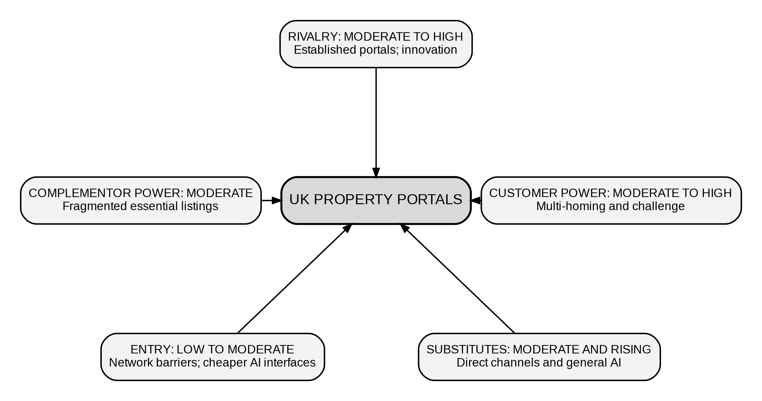
Figure 4: Porter’s Five Forces in the UK Online Residential Property Portal Market
Source: Rietveld and Schilling (2021) and Reuters (2026).
The complementor power provided is an average. A combined inventory is significant even if agencies are split. New enterprises are at low to moderate risk. New customers and listings create a circular barrier. And cloud services and AI make it cheaper to design interfaces. Substitution is minor but growing, thanks to direct agency sites, social media, digital-first intermediaries and AI discovery. Rightmove should concentrate on focused differentiation and associated product development rather than competing on lower price. Cost leadership is hard to sustain, because cutting prices could impact sales without the benefit of the platform innovations that give it an edge. Instead, they can set themselves apart by offering dependable property data, streamlining the way clients are served, and facilitating professional cooperation. This may improve Rightmove’s perceived value and lower its price competitiveness.

4.2 Recommended Strategic Choice
Rightmove can transform from a house-selling website to an AI-powered home information platform. The focus should be on the current market, but new services provide more accurate pricing, mortgage readiness, energy costs, upgrade options, valuations, rental compliance and neighbourhood characteristics. Digital real estate growth is increasingly supported by data, digital networks and decision support technologies. Rightmove may develop its ability to provide more valuable services rather than doing irrelevant tasks (Naeem, Rana and Nasir, 202\).
Also, Ansoff’s product-development strategy promotes adding new services to a firm’s existing market rather than entering unrelated sectors (Whittington et al., 2023). So, product development is possible via use of Rightmove’s UK domestic community, professional-customer relationships and property data. The BCG Matrix is less useful since there are no market share data for the internal business divisions. The right way, the acceptable way, the feasible way is SAFe. It responds to consumer needs, housing market cycles and AI-driven search. It might help consumers, professionals and investors. The combination of Rightmove’s financial resources, huge amounts of private data and AI and cloud capabilities means this approach is more likely to succeed, although issues still persist with governance and integration (Rightmove plc, 2026a).
Figure 5: Strategic Logic for Rightmove’s Transition to Trusted Home Intelligence
Source: Whittington et al. (2023).
The projected growth of Rightmove should be in line with its strategic resources, as shown in Figure 5. Transparency, confidence, customer opt-outs and a clear delineation between property information and financial advice will contribute to establishing trust. Explainability may help people to agree with AI conclusions, although badly phrased answers may lead to false trust rather than understanding (Shin, 2021). Rightmove should not be expanding globally unless it can help the UK information ecosystem.

4.3 Implementation, Risks and Mitigation
Data-driven implementation should take place in 3 phases spanning 24-36 months. The first phase should be focused on the creation of the Responsible Home Intelligence Charter, data quality and privacy checks and limited testing with consumers, renters, marketers and homebuilders. During phase 2, demonstrated technologies must be used in the individual and expert search processes, to give energy cost information, to help tenants comply with the laws and to provide clear price ranges. Only services that provide confidence, trust, retention and commercial performance should grow in Phase 3. This tiered strategy saves money and image risk by altering or eliminating inefficient services before they consume a lot of resources.
Table 3: Implementation Priorities, Risks and Mitigation Measures
Workstream | Milestone | Risk | Control
Governance, months 0-6 | Approve Charter. | Bias, errors, privacy. | Challenge, escalation, audit logs.
Pilots, months 4-18 | Test priority tools. | Poor data, false precision. | Ranges, monitoring, stop rules.
Partners, months 3-24 | Co-design workflows and terms. | Resistance, channel conflict. | Share value; prove leads.
Scale, months 12-36 | Scale products meeting Scorecard gates. | Skills, integration, returns. | Train, stage funding, review.
Source: Consultant proposal informed by Information Commissioner’s Office (2026).
Table 3 identifies who does what and treats responsible governance as a delivery workstream rather than a legislative review. Implement provenance controls, benchmark datasets, pre-release testing, human escalation and continuous drift monitoring to avoid model bias and hallucinations. Role-based access, attack testing and training for emergencies lessen privacy and security issues. Co-design, clear pricing, and assurance that technologies improve lead quality and do not replace agents are needed to overcome partner opposition. Investment risk should be controlled through financing gates linked to the Balanced Scorecard, preventing sunk-cost pressures from driving the expansion of underperforming products.
A Board-sponsored steering committee should oversee implementation and hold the responsible executive functions accountable for delivery. The Chief Operating Officer should manage daily implementation, the Chief Data Officer should oversee model and data assurance, and the Chief Revenue Officer should remain accountable for professional-partner value. Each of the legal, security, consumer and sustainability specialists should suggest a problem. The dynamics capacity study focuses on detecting, seizing and transforming as a continuous renewal process, rather than a one-off technology initiative (Warner and Wäger, 2019). The three-month learning evaluations should test assumptions, compare user groups and remove features that make things happen without good judgement. This helps to keep the network secure as it expands and demonstrates investors and partners how the organisation learns strategically.

4.4 Concluding Board Recommendation
The Board should support a gradual transition to trusted home intelligence, as it works with Rightmove’s resources and listing cycles and AI-powered discovery. The corporation must make decisions that maintain customer interest, partner relationships, private data and brand confidence while adjusting the use of these assets. AI updates matter less than control and co-created value. And without action, Rightmove may find itself topping the listings but losing power on move-related decisions.

5. Gibbs Reflective Account

5.1 Description
I understood the assignment was a Board decision, not guidelines. Rightmove was picked since their market leadership meant renewal was a priority, not a turnaround. I looked at UK home sites, then I looked at academic databases, government statements, corporate reports and financial news. Sources were checked for timeliness, trustworthiness, usefulness and support. Numbers, limitations and strategic implications were monitored using a matrix of evidence. The figures were done before the text, so it is easier to spot weak direct links. The Gibbs structure was chosen since the guided phases move reflection from telling to analysing and acting (Holder et al., 2019).

5.2 Feelings
Initially, I was comfortable with using models but not with managing a moving database. Rightmove’s findings are so powerful that they might make to trust management assumptions too readily. I was concerned that the events of July 2026 would make the results worthless and that the word limit would lead to overexplanation. Confidence rose after separating verifiable facts from consultant suggestions and continuously asking for evidence. This was useful when the uncertainty resulted in checks, but not when I continued to acquire material after the strategic conflict was obvious. This shows that discipline may harden time management and not make that smarter.

5.3 Evaluation
Several strategies worked effectively. Based on the analysis, misleading housing-start reporting and lagging transactions were discovered after repeated readings of the proof grid's source data. For easy comparison, claims, counterevidence, and constraints were stated individually. Section word budgets-maintained balance, while determining if each point affected the Board's strategic choice minimised superfluous explanation. Early searching was too wide, PESTEL categories were distinct, and figure planning was late. Revision fixed these issues by removing extraneous information, connecting drivers to answers, and scheduling citation and presentation audits.

5.4 Analysis
I learnt how evidence is viewed. An 89% portal time share seemed impregnable. Revisiting platform studies showed again that scale benefits if governance allows participation. The recommendation changed to a conditional resource pack from a list of strengths when VRIO. AI growth is easily copyable, yet explainable tools based on property data and partner processes, and trust combine complementary resources. Turning fact into conditional judgement is critical reflection, when preconceptions are challenged (Bassot, 2023).
Strategic problem-based evidence made cognitive learning easier. Interest rates, rents, transactions and instructions were assigned to affordability and cyclicality, implying interrelationships concealed by PESTEL labels. Completed transactions grew based on time delays and market groupings, even with less activity in new homes. This avoided saying that home demand was rebounding everywhere. On re-reading, the Board deleted text that did not amend a resource determination, decision or implementation control.
Each figure needed a cause and effect link, and drawing these figures encouraged metacognition. Figure 1 demonstrated that trust between professional customers and consumers strengthens network effects. Regulation raises prices and the demand for the product, as seen in Figure 2. The Balanced Scorecard was designed to see whether the plan could be managed without faking the results. Self-regulated learning is improved by structured input (Theobald, 2021). A three-pass review of evidence, analysis and presentation found unsupported adjectives, grouped citations and unmarked targets.
Corporate reports included hard facts, but they were mostly success stories. Outside data and analysis substantiated the company’s assertions. Triangulation did minimise overconfidence but did not remove the uncertainty since the releases were experimental and AI use was developing. Timed gates, owners, and signs telling when to continue, alter, or stop the approach worked.

5.5 Conclusion
It enhanced my platform approach, source credibility and delivery know-how. I learned that reference quantity does not immediately make reports better. Comparisons of evidence, awareness of temporal gaps, questioning of source motive and linkage of frames to one possibility were valuable. I also did a lot of study before choosing a subject. And once the scope is set, reading and writing have a purpose. The idea was that a suggestion would specify what should be true, how this would monitor progress, and when management would have to alter or kill the plan.

5.6 Action Plan
I will define the market limits and preliminary decision question on day one for future consultation. I will complete a matrix for each claim, source quality, limitation, implication, and proposed section in the first research session. Research will be divided into two collecting periods, and synthesis will be required before searching. The section word counts and the principal reason will be chosen before writing starts in the first third of the session. Three final audits are planned. The evidence audit will examine facts and citations, the analytical audit will check paragraphs, and the presentation audit will check figures, tables, page numbers and consistency. Formative input will be required since the diagnosis is still varied, with two days allowed for reading and revision.

References
Bassot, B. (2023) The Reflective Practice Guide: An Interdisciplinary Approach to Critical Reflection. 2nd edn. Abingdon: Routledge. Available at: https://www.routledge.com/The-Reflective-Practice-Guide-An-Interdisciplinary-Approach-to-Critical/Bassot/p/book/9781032234540 (Accessed: 6 August 2026).
Bank of England (2026) Monetary Policy Summary and Minutes, July 2026, 30 July. Available at: https://www.bankofengland.co.uk/monetary-policy-summary-and-minutes/2026/july-2026 (Accessed: 6 August 2026).
Cennamo, C. (2021) ‘Competing in digital markets: A platform-based perspective’, Academy of Management Perspectives, 35(2), pp. 265-291. Available at: https://doi.org/10.5465/amp.2016.0048.
de Reuver, M., Sørensen, C. and Basole, R.C. (2018) ‘The digital platform: A research agenda’, Journal of Information Technology, 33(2), pp. 124-135. Available at: https://doi.org/10.1057/s41265-016-0033-3.
Dmytriyev, S.D., Freeman, R.E. and Hörisch, J. (2021) ‘The relationship between stakeholder theory and corporate social responsibility: Differences, similarities, and implications for social issues in management’, Journal of Management Studies, 58(6), pp. 1441-1470. Available at: https://doi.org/10.1111/joms.12684.
Fields, D. and Rogers, D. (2021) ‘Towards a critical housing studies research agenda on platform real estate’, Housing, Theory and Society, 38(1), pp. 72-94. Available at: https://doi.org/10.1080/14036096.2019.1670724.
Gawer, A. (2021) ‘Digital platforms’ boundaries: The interplay of firm scope, platform sides, and digital interfaces’, Long Range Planning, 54(5), 102045. Available at: https://doi.org/10.1016/j.lrp.2020.102045.
Glikson, E. and Woolley, A.W. (2020) ‘Human trust in artificial intelligence: Review of empirical research’, Academy of Management Annals, 14(2), pp. 627-660. Available at: https://doi.org/10.5465/annals.2018.0057.
Goodchild, B. and Ferrari, E. (2024) ‘Intermediaries and mediators: An actor-network understanding of online property platforms’, Housing Studies, 39(1), pp. 102-123. Available at: https://doi.org/10.1080/02673037.2021.2015297.
Grant, R.M. (2024) Contemporary Strategy Analysis. 12th edn. Hoboken, NJ: Wiley.
Gregory, R.W., Henfridsson, O., Kaganer, E. and Kyriakou, H. (2021) ‘The role of artificial intelligence and data network effects for creating user value’, Academy of Management Review, 46(3), pp. 534-551. Available at: https://doi.org/10.5465/amr.2019.0178.
Hansen, E.G. and Schaltegger, S. (2018) ‘Sustainability Balanced Scorecards and their architectures: Irrelevant or misunderstood?’, Journal of Business Ethics, 150, pp. 937-952. Available at: https://doi.org/10.1007/s10551-017-3531-5.
HM Revenue & Customs (2026) UK monthly property transactions commentary, 31 July. Available at: https://www.gov.uk/government/statistics/monthly-property-transactions-completed-in-the-uk-with-value-40000-or-above/uk-monthly-property-transactions-commentary--2 (Accessed: 6 August 2026).
Holder, N.A.K.A., Sim, Z.L., Foong, C.C. and Pallath, V. (2019) ‘Developing a reflection guiding tool for underperforming medical students: An action research project’, Tuning Journal for Higher Education, 7(1), pp. 115-163. Available at: https://doi.org/10.18543/tjhe-7(1)-2019pp115-163.
Information Commissioner’s Office (2026) AI and data protection risk toolkit. Available at: https://ico.org.uk/for-organisations/uk-gdpr-guidance-and-resources/artificial-intelligence/guidance-on-ai-and-data-protection/ai-and-data-protection-risk-toolkit/ (Accessed: 6 August 2026).
Jacobides, M.G., Cennamo, C. and Gawer, A. (2018) ‘Towards a theory of ecosystems’, Strategic Management Journal, 39(8), pp. 2255-2276. Available at: https://doi.org/10.1002/smj.2904.
Meers, J. (2024) ‘The new “lettings agent’s window”: Interface design and discrimination on online rental platforms’, Information, Communication & Society, 27(9), pp. 1843-1865. Available at: https://doi.org/10.1080/1369118X.2024.2333836.
Mikalef, P. and Gupta, M. (2021) ‘Artificial intelligence capability: Conceptualization, measurement calibration, and empirical study on its impact on organizational creativity and firm performance’, Information & Management, 58(3), 103434. Available at: https://doi.org/10.1016/j.im.2021.103434.
Ministry of Housing, Communities and Local Government (2026a) ‘When will the Renters’ Rights Act come into force?’, 30 April. Available at: https://www.gov.uk/government/news/when-will-the-renters-right-act-come-into-force (Accessed: 6 August 2026).
Ministry of Housing, Communities and Local Government (2026b) Housing supply: Indicators of new supply, England, January to March 2026, 19 June. Available at: https://www.gov.uk/government/statistics/housing-supply-indicators-of-new-supply-england-january-to-march-2026/housing-supply-indicators-of-new-supply-england-january-to-march-2026 (Accessed: 6 August 2026).
Ministry of Housing, Communities and Local Government (2026c) Energy Performance of Buildings Certificates Statistical Release: January to March 2026, England and Wales. Available at: https://www.gov.uk/government/statistics/energy-performance-of-building-certificates-in-england-and-wales-january-to-march-2026/energy-performance-of-buildings-certificates-statistical-release-january-to-march-2026-england-and-wales (Accessed: 6 August 2026).
Naeem, N., Rana, I.A. and Nasir, A.R. (2023) ‘Digital real estate: A review of the technologies and tools transforming the industry and society’, Smart Construction and Sustainable Cities, 1, article 15. Available at: https://doi.org/10.1007/s44268-023-00016-0.
Office for National Statistics (2026) Private rent and house prices, UK: July 2026, 22 July. Available at: https://www.ons.gov.uk/economy/inflationandpriceindices/bulletins/privaterentandhousepricesuk/july2026 (Accessed: 6 August 2026).
Puntoni, S., Reczek, R.W., Giesler, M. and Botti, S. (2021) ‘Consumers and artificial intelligence: An experiential perspective’, Journal of Marketing, 85(1), pp. 131-151. Available at: https://doi.org/10.1177/0022242920953847.
Quesado, P., Aibar Guzmán, B. and Lima Rodrigues, L. (2018) ‘Advantages and contributions in the balanced scorecard implementation’, Intangible Capital, 14(1), pp. 186-201. Available at: https://doi.org/10.3926/ic.1110.
Reuters (2026) ‘UK’s Rightmove cuts annual revenue growth forecast on weaker new home building’, 31 July. Available at: https://www.reuters.com/world/uk/uks-rightmove-cuts-annual-revenue-growth-forecast-weaker-new-home-building-2026-07-31/ (Accessed: 6 August 2026).
Rightmove plc (2026a) Annual Financial Report for the year ended 31 December 2025, 27 February. Available at: https://www.investegate.co.uk/announcement/rns/rightmove--rmv/annual-financial-report/9449857 (Accessed: 6 August 2026).
Rightmove plc (2026b) Trading Statement, 8 May. Available at: https://www.investegate.co.uk/announcement/prn/rightmove--rmv/trading-statement/9558481 (Accessed: 6 August 2026).
Rightmove plc (2026c) Rightmove for investors. Available at: https://plc.rightmove.co.uk/ (Accessed: 6 August 2026).
Rightmove plc (2026d) Our history. Available at: https://plc.rightmove.co.uk/our-history/ (Accessed: 6 August 2026).
Rightmove plc (2026e) Environment. Available at: https://plc.rightmove.co.uk/environmental-social-and-governance-esg/environment/ (Accessed: 6 August 2026).
Rightmove plc (2026f) Social. Available at: https://plc.rightmove.co.uk/environmental-social-and-governance-esg/social/ (Accessed: 6 August 2026).
Rietveld, J. and Schilling, M.A. (2021) ‘Platform competition: A systematic and interdisciplinary review of the literature’, Journal of Management, 47(6), pp. 1528-1563. Available at: https://doi.org/10.1177/0149206320969791.
Shin, D. (2021) ‘The effects of explainability and causability on perception, trust, and acceptance: Implications for explainable AI’, International Journal of Human-Computer Studies, 146, 102551. Available at: https://doi.org/10.1016/j.ijhcs.2020.102551.
Sjödin, D., Parida, V., Palmié, M. and Wincent, J. (2021) ‘How AI capabilities enable business model innovation: Scaling AI through co-evolutionary processes and feedback loops’, Journal of Business Research, 134, pp. 574-587. Available at: https://doi.org/10.1016/j.jbusres.2021.05.009.
Theobald, M. (2021) ‘Self-regulated learning training programs enhance university students’ academic performance, self-regulated learning strategies, and motivation: A meta-analysis’, Contemporary Educational Psychology, 66, 101976. Available at: https://doi.org/10.1016/j.cedpsych.2021.101976.
Vial, G. (2019) ‘Understanding digital transformation: A review and a research agenda’, Journal of Strategic Information Systems, 28(2), pp. 118-144. Available at: https://doi.org/10.1016/j.jsis.2019.01.003.
Vishwanathan, P., van Oosterhout, H., Heugens, P.P.M.A.R., Duran, P. and van Essen, M. (2020) ‘Strategic CSR: A concept building meta-analysis’, Journal of Management Studies, 57(2), pp. 314-350. Available at: https://doi.org/10.1111/joms.12514.
Warner, K.S.R. and Wäger, M. (2019) ‘Building dynamic capabilities for digital transformation: An ongoing process of strategic renewal’, Long Range Planning, 52(3), pp. 326-349. Available at: https://doi.org/10.1016/j.lrp.2018.12.001.
Whittington, R., Regnér, P., Angwin, D., Johnson, G. and Scholes, K. (2023) Exploring Strategy. 13th edn. Harlow: Pearson.

