Exploring the perception of police and their role in dealing with mental health incidents

School – University of Wales Trinity Saint David

Due Date – 08/04/24

Word Count – 6070


Personal Declaration

This work has not previously been submitted or accepted in substance for a degree and is not concurrently being submitted for any of degree.

Statement One
I hereby provide my consent for this dissertation if accepted to be available on the universities computer system for anyone who has consent to use that system to access.

Signed: D Hadley Date: 09/02/24

Statement Two
I hereby provide my consent for this dissertation if accepted to be available for photocopying and for library loan as well as the title and summary to be made available to other organisations.

Signed: D Hadley Date: 09/02/24

Statement Three
This dissertation is my own independent work and investigation unless otherwise stated or referenced. All sources can be located in the reference section along with their acknowledgements.

Signed: D Hadley Date: 09/02/24

Statement Four
This dissertation is being submitted as part of the requirements to achieve a pass in the degree course.

Signed: D Hadley Date: 09/02/24

Acknowledgements

Firstly, I would like to thank my police family. Without their support and encouragement, I would not have made it this far through the PCDA programme and be able to continue doing the job that I love.

I would especially like to thank Police Sergeant 6266 Rollnick. Sgt Rollnick took me under his wing and showed me what it was to be an on the street police officer. He imparted words of advice, tactics and skills and most of all encouraged my enthusiasm in the relentless pursuit of criminality. Without him I would not be the police officer I am today.

I would also like to thank the police officers that have come before me in completing the PCDA programme who, whilst too numerous to mention have offered me advice and encouragement in getting to this stage.
Finally, I would like to thank my family. Without their support and understanding I would not have been able to complete this dissertation, for this I am truly grateful.

Abstract

The primary aim of this dissertation was to explore the perception of the police and their attendance at mental health incidents. The researcher has carried out an in-depth analysis of those perceptions with a mixture of serving police officers and people without any policing experience to establish what their thoughts and opinions were on the subject and how that weighs up against real word examples of the current state of resources being deployed to people in mental health crisis.

The dissertation initially looks at current research split into two categories, the first being mental health in general and the services and agencies set up to deal with it. The second research category then goes into evaluating the current primary roles of the police service and its general expectations and objectives. Following on from established research and publications, the dissertation then goes on the to ask the question, what is current public perception on the role of the police in relation to mental health incidents by conducting a study asking key questions relating to what they think the police should be doing with their time and resources and where the primary responsibility for dealing with people in mental health crisis actually lies.

Table of Contents
Chapter 1 – Introduction 08

- – Introduction 08
1.1– Background and Rationale 08
1.2 – Aims and Objectives 09

Chapter 2 – Literature Review 10

2.0 – Introduction 10
2.1 – Background – Mental Health 10
2.2 – Background – Core policing Roles 12
2.3 – Aims of Research 13
Chapter 3 – Research Methodology 15

3.0 – Introduction 15
3.1 – Research Strategy 15
3.2 – Data Collection 16
3.3 – Sampling – Design and Aims of Interview 16
3.4 – Data analysis 17
3.5 – Limitations 17

Chapter 4 - Analysis of Findings
4.0 – Introduction 19
4.1 – Question 1 – Establishing the participants background and Age 19
4.2 – Question 2 – What of the following types of calls do you feel police 20
should be allocating the MOST resources in dealing with?
4.3 – Question 3 – What of the following types of calls do you feel police 21
should be allocating the LEAST resources in dealing with?
4.4 – Question 4 – Do you feel that there is sufficient funding and resourcing 22
in general, to deal with mental health incidents?
4.5 – Question 5 – What service do you think is best placed to deal with 23
mental health incidents?
4.6 – Question 6 - Do you feel that the police have sufficient powers in 24
place to deal with mental health incidents?
4.7 – Question 7 – If you or someone you knew was experiencing a 24
mental health crisis, who would you call first?

Chapter 5 – Conclusion 26

5.0 – Introduction 26
5.1 – Main Findings 26
5.2 – Limitations to Dissertation 27
5.3 – Future Research and Recommendations 27
5.4 – Conclusion 28

Bibliography 29

Appendices

Appendix A – Blank Interview Sheet 33
Appendix B – Research Proposal Sheet 35
Appendix C – Ethics Form 39

List of Figures

Figure 3.1 – Gantt Chart utilised. (Self-created, 2023) 18

Figure 4.1 – Graph displaying split between respondents. (SurveyMonkey, 1999) 19

Figure 4.2 – Graph displaying split between age groups. (SurveyMonkey, 1999) 20

Figure 4.3 – Graph displaying results of Question 2. (SurveyMonkey, 1999) 21

Figure 4.4 – Graph displaying results of Question 3. (SurveyMonkey, 1999) 22

Figure 4.5 – Graph displaying results of Question 4. (SurveyMonkey, 1999) 22

Figure 4.6 – Graph displaying results of Question 5. (SurveyMonkey, 1999) 23

Figure 4.7 – Graph displaying results of Question 6. (SurveyMonkey, 1999) 24

Figure 4.8 – Graph displaying results of Question 7. (SurveyMonkey, 1999) 25

Exploring the perception of police and their role in dealing with mental health incidents

- - Chapter One: Introduction

This dissertation will look at the perception of police and their role in dealing with mental health incidents impact that has on other policing roles. It will discuss the types of mental health reports that police are attending along with policing core objectives and roles.

  - – Background and rationale

The researcher has specifically chosen this subject for a number of reasons relating to having firsthand experience in. The researcher is a serving police officer in a large metropolitan area that covers a diverse range of people and geographical area. He has actively served as a uniformed constable for over 4 years and joined the police service not just to help people, but to do so through the relentless pursuit of criminality. Crime is something that unfortunately has an effect on everyone and all walks of life, whether directly or indirectly the actions of criminals touch everyone to varying lines of degree and sits the sole responsibility of the police. In his experience, whilst there is a role of police during mental health crisis situations this is often not the case with incidents that are passed onto us and other agencies, whether that be Ambulance Service or other social services are passing over their deficient in ability to respond to the police all too often.

Whilst exploring modern day policing it will ask important questions as to the expectations from the greater members of the public as to how the police should be spending their time and whether they are ultimately doing enough to not only protect the public but also detecting and preventing crime. Through this process it will also gather direct data from serving police officers as well as members of the public as to their perspective on their role within mental health incidents and how the demand of such incidents affects their ability to perform their call policing roles.

Research suggests the numbers of people suffering from mental health crisis is growing and with that so is the demand on emergency services to respond to such events. All public services are arguably in a state of financial crisis with it becoming the norm to tighten purse strings and cut budgets and ultimately concludes in a situation where for a variety of reasons means they are unable to function to the demand of their mandate. (Brunier, 2022)

Social care which ultimately is charged with providing support to mental health conditions are rarely equipped or available to act when a person does find themselves in crisis and therefore people look to the police to provide that first response. Ultimately this puts a police officer into a situation where their training and legal powers are left deficient, and actions taken often may not be in the best interest of the patient. Furthermore, we find often that those actions taken are in contradiction to medical health professionals once they take over care and the patient is often released to fall back into the cycle of police attendance. Mental health incidents have become a substantial and time-draining event which will often tie up multiplate police officers for many hours which will take them away from their other core roles. With heavy budget restrictions and a lack of people and resources this ultimately reduces their ability to be out on the streets detecting and preventing crime by their presence. (Policymogal, 2022)

  - – Aims & Objectives

The aim of this dissertation is to observe the perception of police and their role in dealing with mental health incidents in line with other agencies and services. It will also attempt to provide recommendations in regard to responding to that perception from the results drawn.

The aims of this research will be achieved by completing the following objectives: -

- To research and analyse current academic literature with a view of understanding current demand and expectations of the police service.
- To identify suitable research techniques and approach to obtain the required information.
- To conduct the primary research ethically and effectively in order to obtain relevant and unbiased research.
- To provide comprehensive results with an aim of providing transparency towards the perception of the police and their role within mental health incidents.

Chapter 2 – Literature Review

2.0 - Introduction

The purpose of this chapter is to provide an overview and analysis of relevant and key examples from academically valued sources in regard to the topic of mental health and core policing roles. A literature review is a method of displaying the author’s knowledge of a field of study. It forms part of the role in seeking new lines of inquiry, discovering variables that may be relevant to a topic and can establish context of a topic or problem. (Randolf, 2019)

2.1 – Background – Mental Health

Everyone, just as they have physical health also has mental health. It is described by some as internal weather and is effectively how we are feeling inside (Mental Health, 2003). It is a state of personal wellbeing that when in a positive state can affect a person’s ability to learn, form and maintain relationships with other people as well as their ability to express and feel a range of emotions both positive and negative (Definition of Mental Health, 2023). When comparison is made between mental health and the weather, one could describe a sunny and pleasant day as feeling happy and positive and a darker, stormy day as a negative mood. These feelings and behaviours can change frequently depending on a number of factors and ultimately effect our actions in extreme ways (Mental Health, 2003).

The concept of mental health crisis in an individual is a difficult one to define. There is a wide usage of the word crisis that often is associated with the word stress. It is agreed however that a crisis is an acute and special kind of stress. Crisis can often result in physical tension which can be characterized in four phases. These are measured by firstly an initial rise in tension, leading to a lack of success in dealing with it and moving to further tension incorporating feelings of helplessness and emotional upset. Next would come a further rise in tension developing into emergency problem solving mechanisms. An individual might try measures that would normally attempt to result the problem and should the problem continue, that tension can escalate beyond a threshold that they can cope with resulting in major disorganisation (Eastham, 1970).

The latest data from the Office of National Statistics, suggests that depression rates within the UK since the COVID-19 pandemic began have doubled. This indicates that there is a growing mental health crisis in the UK. Whilst mental health crisis can affect anyone, there is particular concern for those living in deprived areas, woman, vulnerable adults and disabled people (Bibby, 2021).

With this rise in depression rates in UK has also come a reduction in the stigma associated with mental health and a surge in interest in mental healthcare. Many more people are now presenting in mental health crisis and with specific mental health needs that under the current system which dates back many years is simply unable to cope with.

Historically, since the creation of the National Health Service (NHS) there has been a single means of emergency transport to Accident and Emergency departments which are largely designed to deal with physical problems. As the world has changed, there are now new developments in dealing with mental health emergencies including crisis teams but the logistics of providing that immediate response to someone in crisis is still found to be lacking. This has ultimately led to the ambulance service being stretched and having to deal with a larger volume of call demand exacerbated by the increase in mental health emergencies (Molodynski, 2020).

Crisis Team Services are designed for people whose mental health crisis is at a stage that is so bad that they would potentially admit to an in-patient ward. Its users are usually suffering from severe mental illness but are a first point of contact for people with a variety of mental health issues. They are able to be contacted either by referral from a general practitioner or contacting 111 on a telephone. Persons already known to mental health services will have their information held on file in order to greatly assist them (NHS, 2023). Whilst the service is aimed at providing an overall response to a person in crisis, the teams are generally restricted to those already under some form of secondary mental healthcare. Because of this, people in general crisis will find that the crisis teams will inevitably learn on the emergency services such as police or ambulance should the risk level reach a certain criterion.

In a study conducted by National Mental Health Policing Portfolio on behalf of all police forces with the exception of British Transport Police (BTP) in 2014 it was recognised that it is difficult to establish just how much time was spent responding to mental health related calls. It did however not that Police officers believed that between 40% and 75% of policing incidents involved vulnerable people where mental health may be a contributing factor. It was recognised even back in 2014 that improvements in recording of this data needed to be improved which in recent years has been achieved (Jones, 2014).

Section 136 of the Mental Health Act 1983 is the only legal power open to a police constable when dealing with someone in mental health crisis. The power states: -

If a person appears to a constable to be suffering from mental disorder and to be in immediate need of care or control, the constable may, if he thinks it necessary to do so in the interests of that person or for the protection of other persons –

- Remove the person to a place of safety within the meaning of section 135, or
- If the person is already at a place of safety within the meaning of that section, keep the person at that place or remove the person to another place of safety (Mental health Act, 1983).

Whilst this power may seem adequate for dealing with people suffering from mental health crisis. There is a stipulation within that legislation that states that the power does not apply to any person that is present in a house, flat or room where that person or any other person is living including yard, garden, garage, or outhouse connected to that dwelling. A large percentage of persons in mental health crisis do so in their homes which means too often Police are put in a position where they are required to take actions that they have very limited legal powers to accomplish that goal. Further complicating this police power is the understanding that it is a lengthy process that requires the subject to remain in police presence until suitable mental health professionals can be located and an assessment conducted (Jones, 2014).

2.1 – Background – Core Policing Roles

Sir Robert Peel established the London Metropolitan Police Force in 1829 and is considered to be the father of modern policing. In its establishment was created 3 core ideas and nine policing principles. The core ideas were to have a goal of preventing crime rather than catching criminals with the theory that is police were able to stop crime before it was to happen then they would not have to punish its citizens or suppress their rights. The second idea was to earn public support with every member of the community sharing the responsibility of preventing crime and the importance of respecting community principles through being impartial and having officers who represent and understand the community (Peel, 2017). The first point of the nine policing principles is the basic mission to prevent crime and disorder.

The police service as a whole has changed and adapted since its conception in response to the changing social and economic circumstances of the world. The police are expected to prevent crime, investigate offences, to sustain public order all the while helping those in immediate danger and to catch criminals. Whilst the majority would agree that these tasks are core policing roles most observers are said to reject the idea that the police are simply crime fighters. The College of Policing has published figures suggesting that non-crime related incidents make up 83% of calls to police which suggest a massive array of circumstances that people are calling police for (Muir, 2023).

When breaking down the types of calls police attend it quickly becomes apparent just how diverse a responsibility police forces actually do have. Domestic related assaults, road traffic collisions, burglary, theft, robbery, public order, child safety, harassment, and sudden deaths. This list could go on but ultimately the police have that unique role in society where they are likely to come into contact and overlap the remits and responsibilities of other services on a daily basis.

The danger comes from when the gap between public expectations and what the police are increasingly having to do grows. Due to cuts in funding and ultimately there not being enough resources to deploy in 2015, Leicestershire police employed a policy where attempted break-ins at residential address were not fully investigated. This was done in an effort to better deploy their crime scene investigators as it was deemed that few locations contained any forensic evidence and therefore their deployment to other incidents was better served. Most people would agree that if your house was broken into you would want everything done to bring the perpetrators to justice, when this simply isn’t done due to officers committed to welfare calls the question has to be raised whether there are other services that should be picking up that slack (BBC, 2015).

Public opinion data suggest that people want police to be accessible, more bobbies on the beat and speedy response to calls for help. British policing as an idea has for almost two centuries has rested on the notion of ‘policing by consent’. People at large want a police service that is effective but also fair and aligned with their values. (Yesburg, 2019)

2.1 – Aims of Research

This studies aim is to discover the perception of police officers and members of the public of core roles and responsibilities in relation to mental health incidents by the police and other services. By examining those expectations, I hope to be able to establish whether specifically the police service is managing to maintain those expectations and if there are failings where they might be found. The current research examined indicates that there is an awareness of the rising examples of people in mental health crisis and the difficulties from all agencies and services in meeting that demand. What however is lacking is a clear and concise plan as to whether changes need to be made by the police and other services in how these incidents or dealt with or whether acceptance of the status quo is needed, and the role of policing is to change moving forward. In 2023, the Metropolitan Police Service changed its policy to state they would no longer be attending emergency calls relating to mental health incidents unless there was an immediate threat to life. The service having given a deadline for health and social care services to respond and prepare accordingly. This deadline is looming and is a direct response to concerns over police attendance at these incidents.

I will look to put questions aimed directly at serving police officers to discuss their expectations before and after joining the police. Their perception of the percentage and type of calls that they are attending and their opinions on the current state of the expectations put to them. It will also examine what their opinion is in regard to the services who should be taking primary responsibility for mental health calls and where police assistance should begin and end.

I will also look to put questions aimed directly to members of the public who do not have a policing background. They will be able to provide a contrasting opinion to serving policing officers in regard to the expectation of those policing roles and their awareness towards the difficulty and challenges currently found by services responding to mental health incidents.

Chapter 3 - Research Methodology

3.0 - Introduction

The focus of the previous chapter has looked at existing research and literature in the world of mental health and its impact on modern day policing. The aim of this chapter however will be to explain to the person reading how this study will be carried out and is known as the methodology.

Research methodology is a framework used to research and solve the problem of using the most feasible and best methods to conduct research whilst maintaining the objectives and aims of a person’s research (Pamplona, 2022). In simple terms explaining the methodology of a dissertation is explaining the ways in which information is analysed following collection and will explain the reasons why that technique of data collection was made (StudySmarter, 2022).

3.1 Research Strategy

My first challenge has been deciding on a research strategy to allow me to gather the relevant information around my chosen subject. I have considered a number of options around this and ultimately decided on a combination of survey and questionnaire approach utilising an online survey creation tool. On examination of the processes, I have concluded that utilising an online survey method boasts a number of advantages to a researcher, the first one being time. An online research survey is capable of being constructed in a matter of minutes once the questions and topics and known. From then through a simple process enabled by software, the survey is capable of being distributed to a large amount of people in a short amount of time regardless of any separation by geographic distances or commitments. The process also allows for the collation of results and answers from the participants into easy to read and analyse processes. Online surveys also boast the ability to be conducted with minimum costs. When compared to paper surveys for example they are much cheaper as there are no fees for the paper, printing and distribution that would be associated with them. (Wright, 2005)

I had initially considered evaluating an interview type style approach. Interviews are a standard method utilised to gain qualitative information and data and can often provide an insight into behaviour. They can be utilised on a single subject or in focus groups and allows the subjects to provide wider answers and affords them to provide more detailed answers to questions put to them. It also allows for greater control on selection of participants meaning a researcher is able to finitely target those of which they feel more relevant to their study. The interview questions can focus on the primary objectives of the research but allow for fluid follow up questions that simply can not be factored into a pre-written questionnaire. They do also have negative factors to be considered. Due to the live nature of the format, it is important for the interviewer to be diligent in the recording of the answers and to be proactive and inquisitive enough to expand on answers given where appropriate. There is also the consideration that when answers are being provided in a face-to-face format and not in a semi-anonymous format that the results may be skewered by the answers given. (Bolderson, 2012) On review I have concluded that in order to interview a large enough sample size my limitations would be on allowing myself enough time to complete this. With a one-on-one style approach my time would be limited by availability of both myself and the subject of the interview, the length of time such an interview would take to ask, allow to be answers and properly record the answer.

3.2 Data Collection

In the world of research and data collection sits the terms ‘primary’ and ‘secondary’ research. Primary research is a methodology that encompasses data collection as opposed to reviewing and relying on previously collected research and data. The information collected is technically owned by the collector and is usually collected with a view to address a specific problem or inform around a specific topic. This research method allows an organization to select the types of respondents from a specific and targeted sample and conduct the research to establish their responses and opinions from within that group sample. (Bhat, 2023) Due to the constraints surrounding the dissertation including but not being limited to time, resources, personal and work commitments the data obtained in this dissertation has been obtained by means of an online interview comprised of pre-written questions and multiple-choice answers allowing for the participants to easily obtain a copy and complete within minutes. This data is then automatically collated into easy-to-read displays in order to easily analyse patterns and trends. The software used for this process has been carefully selected to accomplish the goals and the website SurveyMonkey was selected as it boasted the ability to achieve the required objectives. According to the SurveyMonkey website, they allow users to quickly utilise their intuitive platform and provide answers to more than twenty million questions each day through being a global leader in online surveys. (SurveyMonkey, 1999)

3.3 – Sampling – Design of Interview

The researcher has designed 20 online interviews to take place as part of the research into the subject. The participants have been selected randomly from nearby social circles although the specific participants and their answers remain unknown to the researcher. The object set out and achieved however was to split the responses evenly between serving or ex-police officers and members of the public with no policing experience. The objective here would be to analyse any trends between police officers who have direct experience involving mental health incidents and members of the public with no specific or direct knowledge or experience dealing with mental health incidents. In a review conducted in 2007 it was established that the public perception towards the police was often dependent on the publics idea of what policing practices were. The implication being that a normal member of the public would not understand the processes and procedures in place to responding and dealing with all manner of calls would affect their perception of how well the police were doing their job and how their core responsibilities could be affected by dealing with other types of calls. (Awan, 2018)

3.4 - Data Analysis

All data and researched gather via the online surveys was facilitated through the website ‘SurveyMonkey’. Utilising their free and proprietary software the results were quickly able to be compiled into colourful and easy to read graphs detailing the response. Utilising this software the researcher has been able to quickly establish trends and patterns within the response to the questions and present the findings.

3.5 - Limitations

The primary limitation to the researcher in relation to this dissertation comes down to time constraints. Due to full time work constraints coupled with regular and substantial other commitments, compromises surrounding the research and analysis process would always need to be considered. Consideration surrounding the number of research participants was taken with aim to have enough to obtain a positive conclusion to the answers. Having too many participants which would ultimately provide too much information to analyse was also a concern that needed to be met. With that in mind the researcher decided to keep the participants down to a smaller number in hope that the results gained would be able to be evaluated properly and diligently.

As part of the process of managing the researcher’s time correctly, a Gantt chart was created to assist in managing the time in regard to completing the dissertation. Whilst the tool can be utilised in a number of ways, the researcher has utilised it in regard to this project to manage deadline timeframes and ensure that the research has progressed in line with the overall deadline of the project. A Gantt chart is a coping tool that assists with the complicatedness of projects. Its primary use is to allow the user a simple understanding of the importance of time and timing in relation to the project. (Geraldi, 2012)

Month/Objective | 08/23 | 09/23 | 10/23 | 11/23 | 12/23 | 01/24 | 02/24 | 03/24 | 04/24
Proposal
Ethics Form
Literature Review
Research Chapter
Analysis of Results
Findings & Conclusion
Final Deadline

Figure 3.1 – Gantt chart relating to progression of research.

Chapter 4 – Analysis of Findings

4.0 – Introduction

The methodology of this dissertation has been adequately outlined within the previous chapter. This chapter will make efforts to provide the results and findings of the project in a simple and easy to read format.

4.1 – Question 1 – Establishing the participants background and Age

There are a total of 20 participants to the online survey who responded and consented to participate. The objective of the survey was to split the respondents into two overall categories with 10 participants (50%) coming from police backgrounds and 10 participants (50%) coming from non-police backgrounds. This was established from the question posed “Do you currently work/have worked as a police officer”. The results show that 10 participants answers ‘Yes’ whilst 9 responded ‘No’ with one respondent not replying to the question.

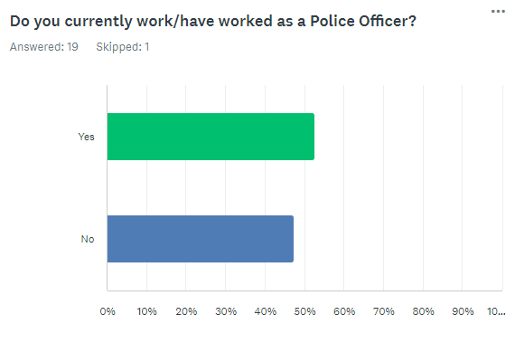
Figure 4.1 – Graph displaying split between respondents. (SurveyMonkey, 1999)

The results of this question showed that 6 respondents were aged between 18 and 25, 8 respondents were aged between 26 and 35 and that 6 respondents were aged between 36 and 45. There was no respondents aged above 45.

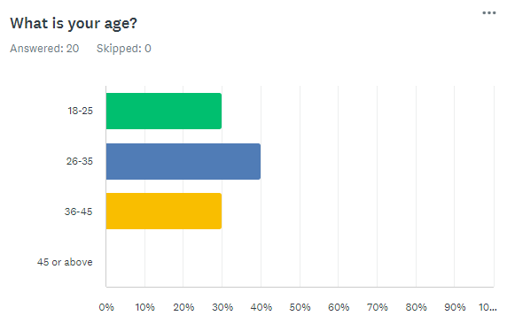
Figure 4.2 – Graph displaying split between age groups. (SurveyMonkey, 1999)

4.2 – Question 2 – What of the following types of calls do you feel police should be allocating the MOST resources in dealing with?

In regard to this question, the options listed were: -

Option 1 – Burglary, Robbery and Theft Incidents
Option 2 – Domestic Related Incidents
Option 3 – Road Traffic Related Incidents
Option 4 – Mental Health Related Incidents
Option 5 – Neighbourhood dispute related incidents

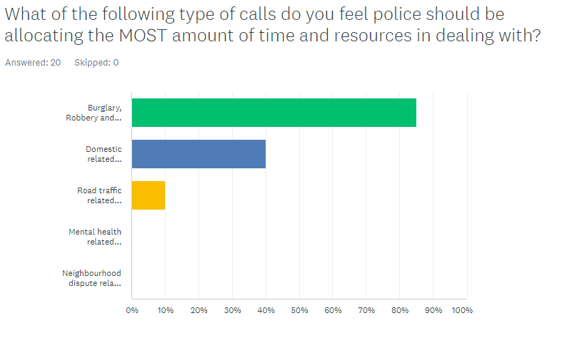
Figure 4.3 – Graph displaying results of Question 2. (SurveyMonkey, 1999)

The results showed a trend of 85% of people selecting Option 1, 40% of people selecting Option 2 and 10% of people selection Option 3. The results indicate that the majority of people taking the survey feel that Option 1 which encompasses core policing objectives is clearly a priority in their minds. It has been noted that there is no responses showing Option 4 or Option 5 as is considered a priority to this question.

4.3 – Question 3 – What of the following types of calls do you feel police should be allocating the LEAST resources in dealing with?

In regard to this question, the options listed were: -
Option 1 – Burglary, Robbery and Theft Incidents
Option 2 – Domestic Related Incidents
Option 3 – Road Traffic Related Incidents
Option 4 – Mental Health Related Incidents
Option 5 – Neighbourhood dispute related incidents

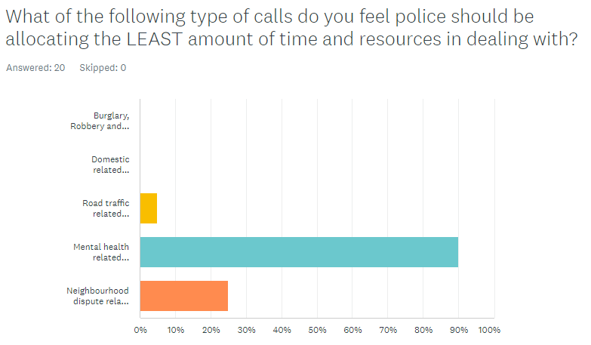
Figure 4.4 – Graph displaying results of Question 3. (SurveyMonkey, 1999)

The results as seen in figure 4.4 show that the majority of respondents or around 90% believe that police should not be dealing with mental health related incidents when compared to the other options with around 25% of people also thinking that Neighbourhood disputes should also be handled by other means.

4.4 – Question 4 – Do you feel that there is sufficient funding and resourcing in general to deal with mental health incidents?

In response to this question, 90% of answers indicating that they do not feel there is sufficient funding and resources being used. 5% of the respondents indicated that they felt there was enough funding with the final 5% indicating that they did not know.
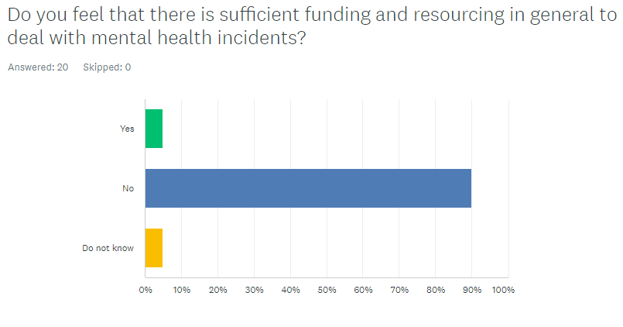
Figure 4.5 – Graph displaying results of Question 4. (SurveyMonkey, 1999)

4.5 – Question 5 – What service do you think is best placed to deal with mental health related incidents?

This question was split into 5 options including the core emergency service roles and social services but has also allowed for an ‘other’ option to be selected and identified.
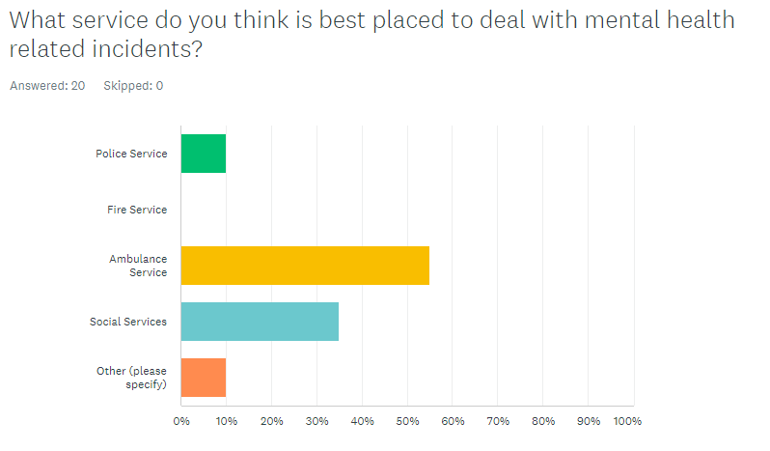
Figure 4.6 – Graph displaying results of Question 5. (SurveyMonkey, 1999)

As per figure 4.6 you can see that around 55% of responses indicate that mental health incidents belong in the realms of the ambulance service with 35% of the responsibility being taken up by social services. 10% of participants feel that the police are best placed to deal with these types of incidents with a further 10% selecting other and providing the responses of Mental Health Services and joint responsibility between ambulance and police services.

4.6 – Question 6 – Do you feel that the police have sufficient powers in place to deal with mental health incidents?

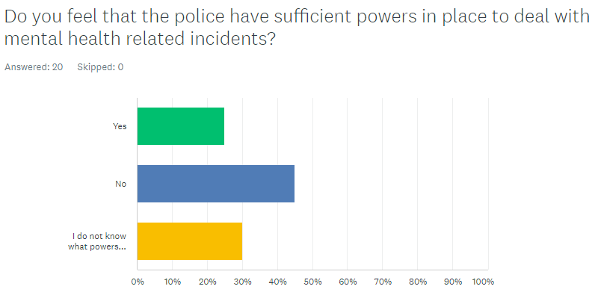
Figure 4.7 – Graph displaying results of Question 6. (SurveyMonkey, 1999)

This question is the first to show no clear trend with all options showing similar trends. The answers were kept simple with a ‘Yes’, ‘No’ and a ‘ I do not know what powers police have’ options. 25% of respondents answered yes, 45% of answers were no with 30% stating that they did not know what powers police had regarding mental health incidents. Given that 50% of the respondents were police officers it is likely that would be aware of their powers and therefore their answers would rest within the yes or no boxes. This would leave 30% of the answers coming non-police participants indicating that 60% of those subjects were not aware of police legislation and powers relating to mental health. This is an avenue to explore as an understanding of what police can and can not do when dealing with people in mental health crisis could have an impact on their answers to other questions posed.

4.7 – Question 7 – If you or someone you knew was experiencing a mental health crisis, who would you call first?

This question is somewhat charged and might not be something that a person may have ever thought of doing or something that someone has had to do in the past. Because of this the researching has anticipated the results to be varied as their answer could be influenced by a number of factors. These could include past experiences of what had worked previously, or a perception of who is likely to turn up quicker or be more equipped to deal with the specific incident that the participant is conjuring up following the prompt from the question. Nevertheless, the question allows for a good indication of should a person actually need to contact someone to help deal with a mental health incident, who are they in fact going to call?

The question, as shown in figure 4.8 provided the following options: -

Option 1 – Police Service
Option 2 – Ambulance Service
Option 3 – Fire Service
Option 4 – NHS Direct
Option 5 – Other

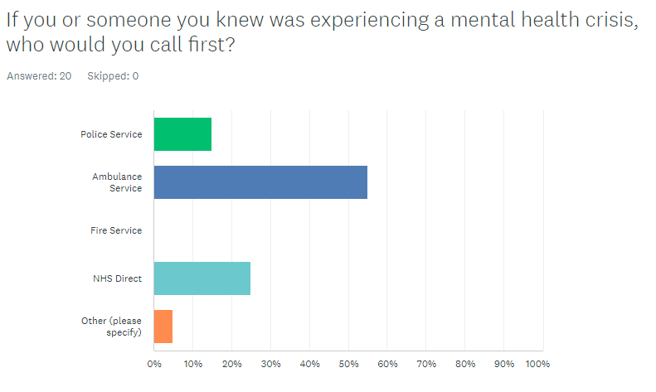
Figure 4.8 – Graph displaying results of Question 7. (SurveyMonkey, 1999)

The results showed that 55% of respondents felt that they would contact the ambulance service in the first instance. 25% would contact NHS direct and 15% would consider calling the police first. It was noted that 5% of subjects indicated that they would contact mental health services in the first instance and that no one would call the fire service.

Chapter 5 – Conclusion

5.0 – Introduction

Whilst the previous chapters of this dissertation have documented the introduction, research and planning as well as the results and analysis phases of the project, this chapter will document whether the researcher has achieved the objectives set out. It will also provide an answer and conclusion to the research question of that being “What is the perception of the police and the public on their attendance at mental health incidents?”

5.1 – Main Findings

The researcher has confirmed that the majority of people still believe in the core policing principles and want police to be detecting, investigating, and preventing volume crime such as burglaries, robberies and theft as a priority. In the same breath, the people questioned have stated that police services should be allocating the least amount of time and resources in dealing with mental health related incidents. These types of incidents being ones that should be primarily dealt with by other services including NHS and Ambulance service in the first instance. An overwhelming 90% of participants have stated that they do not feel there is enough funding and resources currently being put into dealing with mental health incidents.

Furthermore, the data suggests that 60% of non-police participants are unfamiliar with current legislation in place that allows police constables to deal with mental health incidents with nearly half of working police officers considering that they do not have sufficient or adequate powers to allow them to effectively deal with these situations. These figures would suggest that ordinary members of the public, whilst supportive that other agencies should be engaging with these situations, are not fully educated on just how difficult it is for the average officer to be thrust into situations that they are ill equipped to be resolving solely.

It has also been established that whilst well over half of participants would contact the ambulance service in the first instance when dealing with a mental health crisis, 15% of the people who still feel that it is not the police’s primary responsibility would still contact them if put in a situation that required a response.

5.2 – Limitations to the dissertation

The largest limitation surrounding the research undertaken is the size of the survey. Due to the dissertation level and the other limitations already mentioned the sample size reviewed is conceded to be small. This, if only reviewed on the word limit imposed could not be helped under the circumstances and has limited the scope of the analysis and the content covered through the research phase of the dissertation. Furthermore, the completion of this project alongside working the demanding role of police constable coupled with the work demands that come with this have further impacted the scope of this dissertation.

5.3 – Future Research & Recommendations

Due to the amount of data obtained from the relatively small sample size this research project could only be taken so far. Given further opportunity a large sample size could be obtained and encompassed more variables from the participants. The researcher would particularly be interested in expanding the questions to encompass more specific knowledge tests to further establish the perception verses reality of what the modern police officer is currently dealing with. This could be done in a variety of ways but one such way would be to provide real world examples of calls that are being responded to by police and other services. Provided a detailed overview of the circumstances of the call, it could be then put to the participant what they feel an acceptable method of responding to it would be, culminating to which service should be deployed in order to deal with it. The subject, once providing their opinion on the topic could be informed as to the actual expected response to that call would be, the service utilised and the likely outcome to such a situation. This type of format would not only serve to provide data and information to the researcher but also impart knowledge to the participants directly in order to educate them on the specifics and how the marry up with their perceptions.

The researcher would also be interested in separating the results between police and non-police participants with a view to fully be able to compare how the results vary or are similar. This would further the understanding of any corelation between the two parties between the perception and reality of the current state of mental health calls and their impact on police services.

5.4 – Conclusion

This dissertation has successfully achieved its aims and objectives and been able to provide a broad answer to the question on what the perception of the police and the public on their attendance at mental health incidents currently is. The researcher has been able to demonstrate research and analysis of current academic literature and understand the current demand and expectations. The researcher has been able to identify current research techniques and obtain required information. The researcher has been able to conduct primary research ethically and effectively and provide comprehensive results.

It is the researchers hope that it has provided relevant and conclusive answers to questions raised and as part of the research been able to highlight the current state of policing and the impact on mental health incidents is having on it.

Bibliography

Awan, I. et al. (2018) Understanding the public perception and satisfaction of a UK ..., Understanding the Public Perception and Satisfaction of the UK police Constabulary. Available at: https://www.open-access.bcu.ac.uk/5429/1/PPR.pdf (Accessed: 07 April 2024).

Bhat, A. (2023) Primary research: What it is, Purpose & methods + examples, QuestionPro. Available at: https://www.questionpro.com/blog/primary-research/ (Accessed: 09 February 2024).

Bibby, J. (2021) Latest data highlights a growing mental health crisis in the UK, The Health Foundation. Available at: https://www.health.org.uk/news-and-comment/news/latest-data-highlights-a-growing-mental-health-crisis-in-the-uk?psafe_param=1&gclid=EAIaIQobChMI-Irlx6CtggMVA_jtCh1w4wmLEAAYAiAAEgJv5fD_BwE (Accessed: 05 November 2023).

Bolderson, A. (2012) Conducting a research interview, Conducting a Research Interview. Available at: https://www.jmirs.org/article/S1939-8654(11)00132-9/pdf (Accessed: 01 April 2024).

Brunier, A. (ed.) (2022) Covid-19 pandemic triggers 25% increase in prevalence of anxiety and depression worldwide, World Health Organization. Available at: https://www.who.int/news/item/02-03-2022-covid-19-pandemic-triggers-25-increase-in-prevalence-of-anxiety-and-depression-worldwide (Accessed: 01 April 2024).

Definition of Mental Health (2023) Imperial College London. Available at: https://www.imperial.ac.uk/counselling/mental-health-guidelines/definition/ (Accessed: 05 November 2023).

Eastham, K., Coates, D. and Allodi, F. (1970) The concept of crisis - Katherine Eastham, Donald Coates, Federico ..., Concept of Crisis. Available at: https://journals.sagepub.com/doi/10.1177/070674377001500508 (Accessed: 05 November 2023).
Geraldi, J. and Lechter, T. (2012) Gantt charts revisited: A critical analysis of its roots and implications to the management of projects Today, International Journal of Managing Projects in Business. Available at: https://www.emerald.com/insight/content/doi/10.1108/17538371211268889/full/html (Accessed: 01 April 2024).

Jones, C. (2014) PMH0013 - evidence on policing and Mental Health, Inquiry into Policing and Mental Health. Available at: https://committees.parliament.uk/writtenevidence/50659/pdf/ (Accessed: 05 November 2023).

Leicestershire police ‘ignore’ attempted burglaries at odd-numbered houses (2015) BBC News. Available at: https://www.bbc.co.uk/news/uk-england-leicestershire-33788264 (Accessed: 06 November 2023).

Mental health act 1983 (1983) Legislation.gov.uk. Available at: https://www.legislation.gov.uk/ukpga/1983/20/section/136 (Accessed: 05 November 2023).

Mental Health Foundation (2003) About mental health, Mental Health Foundation. Available at: https://www.mentalhealth.org.uk/explore-mental-health/about-mental-health (Accessed: 05 November 2023).

Molodynski, A. et al. (2020) Supporting people in mental health crisis in 21st-century Britain, BJPsych bulletin. Available at: https://www.ncbi.nlm.nih.gov/pmc/articles/PMC7684783/ (Accessed: 05 November 2023).

Muir, R. (2023) Great expectations: What do the public want from the police?, The Police Foundation. Available at: https://www.police-foundation.org.uk/2016/09/great-expectations-what-do-the-public-want-from-the-police/ (Accessed: 06 November 2023).

NHS (2023) Swansea Crisis Team, NHS choices. Available at: https://111.wales.nhs.uk/localservices/ViewLocalService.aspx?id=10812&s=Health#:~:text=Crisis%20Team%20services%20are%20for,to%20an%20in%2Dpatient%20ward. (Accessed: 05 November 2023).

Pamplona, F. (2022) What is methodology in research and how can we write it?, Mind the Graph Blog. Available at: https://mindthegraph.com/blog/what-is-methodology-in-research/ (Accessed: 18 December 2023).

Peel, R. (2017) Sir Robert Peel’s policing principles, Law Enforcement Action Partnership. Available at: https://lawenforcementactionpartnership.org/peel-policing-principles/ (Accessed: 06 November 2023).

Policymogal (2022) Policymogul. Available at: https://policymogul.com/key-updates/22371/police-cars-used-as-ambulances-as-whttps://policymogul.com/key-updates/22371/police-cars-used-as-ambulances-as-welsh-nhs-recorded-worst-ever-waiting-timeselsh-nhs-recorded-worst-ever-waiting-times (Accessed: 01 April 2024).

Randolf, J. (2019) A guide to writing the Dissertation Literature Review, Scholarworks. Available at: https://scholarworks.umass.edu/cgi/viewcontent.cgi?article=1219&context=pare (Accessed: 01 April 2024).

StudySmarter (2022) StudySmarter UK. Available at: https://www.studysmarter.co.uk/explanations/english/summary-text/methodology/ (Accessed: 18 December 2023).

SurveyMonkey (1999) About Us, SurveyMonkey. Available at: https://uk.surveymonkey.com/about/?ut_source=footer (Accessed: 01 April 2024).

Wright, K. (2005) Researching Internet, Academic.oup.com. Available at: https://academic.oup.com/jcmc/article/10/3/JCMC1034/4614509 (Accessed: 01 April 2024).

Yesburg, J. and Bradford, B. (2019) Affect and trust as predictors of public support for armed police, Affect and Trust as Indicators of Public Support for Police. Available at: https://www.researchgate.net/publication/325573136_Affect_and_trust_as_predictors_of_public_support_for_armed_police_Evidence_from_London (Accessed: 07 April 2024).

Appendix A – Blank Interview Form

Thank you for taking the time to complete the following questionnaire. By continuing, you are consenting to participate in the study. You have the right to withdraw from the study at any time and without reason. All responses will be treated with strict confidentiality and will be anonymized. No personal information will be published. The results and findings of this survey may be used for research and academic purposes, but individual responses will unidentifiable.

- Do you consent to participate in this study?
Yes
No

- Do you currently work/have worked as a Police Officer? Yes/No
Yes
No

- How old are you?
18-25
26-35
36-45
46 or above

- What of the following types of calls do you feel police should be allocating the most amount of time and resources in dealing with?
Theft, robbery & burglary incidents
Domestic related incidents
Road traffic related incidents
Mental health related incidents
Neighbourhood dispute incidents
Other

- What of the following types of calls do you feel police should be allocating the least amount of time and resources in dealing with?
Theft, robbery & burglary incidents
Domestic related incidents
Road traffic related incidents
Mental health related incidents
Neighbourhood dispute incidents
Other

- Do you feel that there is sufficient funding and resourcing to deal with mental health incidents?
Yes
No
Don’t Know

- What service do you think is best placed to deal with mental health related incidents?
Police Service
Fire Service
Ambulance Service
Social Services
Other -

If selected other, please explain what service.

- Do you feel that police have sufficient powers in place to deal with mental health incidents?
Yes
No
Don’t know

- If you or someone you knew was experiencing a mental health crisis, who would you call first?
Police Service
Ambulance Service
Fire Service
NHS Direct
Other –

Appendix B – Research Proposal Sheet



UNDERGRADUATE DISSERTATION
RESEARCH PROPOSAL FORM

Please complete the following research proposal and submit it to Turnitin.

Which project option are you taking? Please tick:

8,000 word project: 8000 word project selected
OR
4,000 word project and presentation:

NAME: Daryl Hadley | STUDENT ID No.: 2031238
DRAFT RESEARCH TITLE QUESTION:
INTRODUCTION:

Title – Exploring the correlation between police attendance at mental health incidents and the impact on proactive policing.

This topic is of interest to me as I joined the police in order to help people by means of combatting crime. Policing as a role is extremely diverse with highs and lows but when it comes to job satisfaction there is nothing to me that beats making an real and instant impact in the lives of people then catching criminals through proactive policing. As a police officer I have first hand experienced the impact of responding to mental health incidents where ultimately police are limited with powers and restricted by policies in dealing with incidents that are ultimately not directly in the police remit and should fall to other social and emergency services. I feel that it is worth for consideration for an undergraduate dissertation as it is an important subject that has real world impact on UK residents.

Recent studies have been conducted into the cost and demand on mental health to police which have highlighted the resources used into responding to these type of calls and the potential impact that is having on other demands of modern policing The dissertation will explore some of these topics with a view to examine those pros and cons and establish the opinion of people within those services as well as members of the public.

By conducting the research and speaking to both people involved in the provision of these services and public perception I will be able to present a more accurate account of the current affect police interaction with mental health calls is having on proactive policing.

Through the process of my initial research into the topic I have reviewed recent publications by the Metropolitan Police Service into the Cost and Demand of Mental Health. (Metpol, 2018)

I have also reviewed a report by West Midlands Police around the prediction of volume of demands from mental health related incidents. (Data Analytics, 2020)

SUMMARY OF RESEARCH OBJECTIVES:

My objectives will be as following: -

To review real world data in relation to the number and type of calls police attend over a set period and the percentage of those calls that are mental health related.
To review the real world data of mental health calls attended by ambulance and mental health services
To review how current perception within the police regarding mental health services
To review how current public perception is around police involvement in mental health calls.

LITERATURE REVIEW:

I will be utilising a number of key literature including journals, articles and government reports relating to the cost of responding to mental health calls on modern policing and the impact that it is having on other roles within the police services. Whilst these articles mostly focus on fiscal costs and general ways in which they affect police resources, I will look more closely at its affect on proactive policing measures which ultimately affect the detection and prevention of crime by diverting those resources away.

SUMMARY OF RESEARCH –SURVEY METHOD:

My research methods will include review of outstanding journals and reviews regarding mental health calls for emergency services.
I will look at core policing rolls centred around proactive policing in the response environment
I will utilise survey methods to allow people from multiple demographics to provide opinions and answers impartially and anonymously.

The survey will be online and utilise questions that cover information surround trends.

SUMMARY OF SAMPLING FRAMEWORK:

I will be looking at achieving target samples from 3 separate groups where possible.

The first will be serving police officers who are currently working on response teams and therefore more effected by attending mental health calls and can accurate provide experiences and opinions on the key questions asked.

The second demographic will be around members of the general public. It will encompass opinion on mental health demands, where the responsibility lands in dealing with them and the expectations that they have on the police in general.

The third group will be working within mental health services and their opinions on how police are currently managing demand.

ETHICAL ISSUES:

Potential conscious and unconscious bias surround mental health issues when posing questions to people completing questionnaires as well as myself given I have personal opinions relating to my own experiences.

TIME SCALE:

As set by university deadlines will ultimately dictate the deadlines for the stages of my research. I will review these deadlines and plan to achieve objectives in a timely manner. There will need to be considerations in relation to working full time.
REFERENCE LIST:

Data Analytics (2020) WMP briefing paper analysis of School Catchment Areas and violence, Predicting the Volume of Demand from Mental Health Related Police Incidents . Available at: https://www.westmidlands-pcc.gov.uk/wp-content/uploads/2021/02/14122020-EC-Agenda-Item-3c-Analysis-of-school-catchment-areas-and-violence-%E2%80%93-proposal.pdf?x92803 (Accessed: 28 August 2023).

Met Pol (2018) Met strategic digital enabling framework 2021-25 - metropolitan police, Cost and Demand of Mental Health to the Metropolitan Police Service and the Public . Available at: https://www.met.police.uk/SysSiteAssets/media/downloads/force-content/met/about-us/met-strategic-digital-enabling-framework-2021-2025.pdf (Accessed: 28 August 2023).

Appendix C – Application for Ethical Approval

APPLICATION FOR ETHICAL APPROVAL

RESEARCH STUDENTS
This form is to be completed by the student within SIX months for full-time students and TWELVE months for part time students, after the commencement of the research degree or following progression to Part Two of your course.

Once complete, submit this form via the MyTSD Doctoral College Portal at (https://mytsd.uwtsd.ac.uk).

This document is also available in Welsh.

RESEARCH STAFF ONLY
All communications relating to this application during its processing must be in writing and emailed to pgresearch@uwtsd.ac.uk , with the title ‘Ethical Approval’ followed by your name.

STUDENTS ON UNDERGRADUATE OR TAUGHT MASTERS PROGRAMMES should submit this form (and receive the outcome) via systems explained to you by the supervisor/module leader.

In order for research to result in benefit and minimise risk of harm, it must be conducted ethically. A researcher may not be covered by the University’s insurance if ethical approval has not been obtained prior to commencement.

The University follows the OECD Frascati manual definition of research activity: “creative work undertaken on a systematic basis in order to increase the stock of knowledge, including knowledge of man, culture and society, and the use of this stock of knowledge to devise new applications”. As such this covers activities undertaken by members of staff, postgraduate research students, and both taught postgraduate and undergraduate students working on dissertations/projects.

The individual undertaking the research activity is known as the “principal researcher”.

Ethical approval is not required for routine audits, performance reviews, quality assurance studies, testing within normal educational requirements, and literary or artistic criticism.

Please read the notes for guidance before completing ALL sections of the form.

This form must be completed and approved prior to undertaking any research activity. Please see Checklist for details of process for different categories of application.

SECTION A: About You (Principal Researcher)
1 | Full Name:
2 | Tick all boxes that apply: |  | Member of staff: | ☐ | Honorary research fellow: | ☐
 | Undergraduate Student | ☒ | Taught Postgraduate Student | ☐ | Postgraduate Research Student | ☐

3 | Institute/Academic Discipline/Centre: | UNIVERSITY OF WALES ST DAVIDS
4 | Campus: | N/A
5 | E-mail address: | 2031238@student.uwtsd.ac.uk
6 | Contact Telephone Number: | 07929714515
 | For students:
7 | Student Number: | 2031238
8 | Programme of Study: | PROFESSIONAL POLICING
9 | Director of Studies/Supervisor:

SECTION B: Approval for Research Activity
1 | Has the research activity received approval in principle?  (please check the Guidance Notes as to the appropriate approval process for different levels of research by different categories of individual) |  | YES | ☐ | NO | ☐
 |  |  |  |  | Date
2 | If Yes, please indicate source of approval (and date where known): Approval in principle must be obtained from the relevant source prior to seeking ethical approval | Research Degrees Committee |  | ☐
2 |  | Institute Research Committee |  | ☐
2 |  | Other (write in) |  | ☐

SECTION C: Internal and External Ethical Guidance Materials
 | Please list the core ethical guidance documents that have been referred to during the completion of this form (including any discipline-specific codes of research ethics, location-specific codes of research ethics, and also any specific ethical guidance relating to the proposed methodology). Please tick to confirm that your research proposal adheres to these codes and guidelines. You may add rows to this table if needed.
1 | UWTSD Research Ethics & Integrity Code of Practice | ☒
2 | UWTSD Research Data Management Policy | ☒
3 | [List any other relevant documents here] | ☐

SECTION D: External Collaborative Research Activity
If there are external collaborators then you should gain consent from the contact persons to share their personal data with the university. If there are no external collaborators then leave this section blank and continue to section E.
1 | Institution
2 | Contact person name
3 | Contact person e-mail address
4 | Is your research externally funded? |  | YES | ☐ | NO |  | ☐
5 | Are you in receipt of a KESS scholarship? |  | YES | ☐ | NO |  | ☐
6 | Are you specifically employed to undertake this research in either a paid or voluntary capacity? | Voluntary | YES | ☐ | NO | ☐
7 |  | Employed | YES | ☐ | NO | ☐
8 | Is the research being undertaken within an existing UWTSD Athrofa Professional Learning Partnership (APLP)? | If YES then the permission question below does not need to be answered. | YES | ☐ | NO |  | ☐
9 | Has permission to undertake the research has been provided by the partner organisation? | (If YES attach copy)  If NO the application cannot continue | YES | ☐ | NO |  | ☐

Where research activity is carried out in collaboration with an external organisation
10 | Does this organisation have its own ethics approval system? | YES | ☐ | NO | ☐
 | If Yes, please attach a copy of any final approval (or interim approval) from the organisation (this may be a copy of an email if appropriate).

SECTION E: Details of Research Activity
1 | Indicative title: | Exploring the correlation between police attendance at mental health incidents and the impact on proactive policing.
2 | Proposed start date: | 28/08/2023 | Proposed end date: | 08/04/23
Introduction to the Research (maximum 300 words per section)
Ensure that you write for a Non-Specialist Audience when outlining your response to the points below:
- Purpose of Research Activity
- Proposed Research Question
- Aims of Research Activity
- Objectives of Research Activity
Demonstrate, briefly, how Existing Research has informed the proposed activity and explain
- What the research activity will add to the body of knowledge
- How it addresses an area of importance.
3 | Purpose of Research Activity  The purpose of the research activity will be to collect and review various sources of information relating to a number of relevant topics which can include but are not limited to: -  Number and type of mental health incidents reported to police.  Number and type of mental health incidents reported to ambulance.  Number and type of calls that police officers are being deployed to.  Speaking to serving and ex police officers to establish perceived involvement with mental health calls and the impact on proactive policing.  Speaking to members of the public to establish their perception of the role of police and whether they are fulfilling their objectives.  Speaking to members of mental health services to establish their perception of the role of police and whether they are fulfilling their objectives.  (this box should expand as you type)
4 | Research Question  - Do frontline police officers believe that the amount of proactive policing they are doing has declined.  - Do frontline police officers believe that the amount of time with mental health is increasing.  - Understand if there is a correlation between the two issues and if they are in fact linked.  - Understand if the recruitment of 20,000 new officers has assisted in reducing this trend, or if there are other issues at play.  (this box should expand as you type)
5 | Aims of Research Activity  To prove or disprove the theory that the demand on police to attend mental health incidents is having a negative impact on proactive policing.  (this box should expand as you type)
6 | Objectives of Research Activity  My objectives will be to identify key demand indicators surrounding mental health calls for police and to identify key demand indicators for proactive policing objectives.  (this box should expand as you type)
Proposed methods (maximum 600 words)
Provide a brief summary of all the methods that may be used in the research activity, making it clear what specific techniques may be used. If methods other than those listed in this section are deemed appropriate later, additional ethical approval for those methods will be needed. You do not need to justify the methods here, but should instead describe how you intend to collect the data necessary for you to complete your project.

7 | I will be reviewing online publications both academic and business postings, Written literature as well as speaking to FRONT line emergency responders.  Methods that may be used I the research activity will be reviewing online academic and published material relating to the subject matter in order to establish current information relating to the subject.  I will also plan to use an online survey method to obtain anonymous information from both police and members of the public.  (this box should expand as you type)
Location of research activity
Identify all locations where research activity will take place.

Online
8 | The research activity will primarily take place online with internet resources, academic publications, organisation and business positing as well as the use of email, social boards and questionaires.  I will take opportunity to research using any physical, hard copy items.  (this box should expand as you type)
Research activity outside of the UK
If research activity will take place overseas, you are responsible for ensuring that local ethical considerations are complied with and that the relevant permissions are sought. Specify any local guidelines (e.g. from local professional associations/learned societies/universities) that exist and whether these involve any ethical stipulations beyond those usual in the UK (provide details of any licenses or permissions required). Also specify whether there are any specific ethical issues raised by the local context in which the research activity is taking place, for example, particular cultural and/or legal sensitivities or vulnerabilities of participants. If you live in the country where you will do the research then please state this.
9 | I do not plan to conduct any research activity outside of the United Kingdom. I will however keep this in mind should I come across anything that does indeed originate from outside the UK. I do not foresee any ethical issues raised from the study although I will be conscious of sensitivity around mental health in relation to police responses.  (this box should expand as you type)

10 | Use of documentation not in the public domain: Are any documents NOT publicly available? | NO | ☒
10 |  | YES | ☐
11 | If Yes, please provide details here of how you will gain access to specific documentation that is not in the public domain and that this is in accordance with the current data protection law of the country in question and that of England and Wales.  (this box should expand as you type)

 | Does your research relate to one or more of the seven aims of the Well-being of Future Generations (Wales) Act 2015? | YES | NO
12 | A prosperous Wales | ☐ | ☐
13 | A resilient Wales | ☐ | ☐
14 | A healthier Wales | ☒ | ☐
15 | A more equal Wales | ☐ | ☐
16 | A Wales of cohesive communities | ☐ | ☐
17 | A Wales of vibrant culture and thriving Welsh language | ☐ | ☐
18 | A globally responsible Wales | ☐ | ☐
19 | If YES to any of the above, please give details:
Ultimately mental heath is an important part of welfare of the people of Wales and any study into improving the mental heath services to aid those people is a positive.

(this box should expand as you type)

SECTION F: Scope of Research Activity
 | Will the research activity include: | YES | NO
1 | Use of a questionnaire or similar research instrument? | ☒ | ☐
2 | Use of interviews? | ☒ | ☐
3 | Use of focus groups? | ☐ | ☒
4 | Use of participant diaries? | ☐ | ☒
5 | Use of video or audio recording? | ☐ | ☒
6 | Use of computer-generated log files? | ☒ | ☐
7 | Participant observation with their knowledge? | ☐ | ☒
8 | Participant observation without their knowledge? | ☐ | ☒
9 | Access to personal or confidential information without the participants’ specific consent? | ☐ | ☒
10 | Administration of any questions, test stimuli, presentation that may be experienced as physically, mentally or emotionally harmful / offensive? | ☐ | ☒
11 | Performance of any acts which may cause embarrassment or affect self-esteem? | ☐ | ☒
12 | Investigation of participants involved in illegal activities? | ☐ | ☒
13 | Use of procedures that involve deception? | ☐ | ☒
14 | Administration of any substance, agent or placebo? | ☐ | ☒
15 | Working with live vertebrate animals? | ☐ | ☒
16 | Procedures that may have a negative impact on the environment? | ☐ | ☒
17 | Other primary data collection methods. Please indicate the type of data collection method(s) below. | ☐ | ☒
 | Details of any other primary data collection method:  (this box should expand as you type) | ☐ | ☒
If NO to every question, then the research activity is (ethically) low risk and may be exempt from some of the following sections (please refer to Guidance Notes).

If YES to any question, then no research activity should be undertaken until full ethical approval has been obtained.

SECTION G: Intended Participants
If there are no participants then do not complete this section, but go directly to section H.

 | Who are the intended participants: | YES | NO
1 | Students or staff at the University? | ☒ | ☐
2 | Adults (over the age of 18 and competent to give consent)? | ☒ | ☐
3 | Vulnerable adults? | ☐ | ☒
4 | Children and Young People under the age of 18? (Consent from Parent, Carer or Guardian will be required) | ☐ | ☒
5 | Prisoners? | ☐ | ☒
6 | Young offenders? | ☐ | ☒
7 | Those who could be considered to have a particularly dependent relationship with the investigator or a gatekeeper? | ☐ | ☒
8 | People engaged in illegal activities? | ☐ | ☒
9 | Others. Please indicate the participants below, and specifically any group who may be unable to give consent. | ☐ | ☒
 | Details of any other participant groups:  (this box should expand as you type) | ☐ | ☒

Participant numbers and source
Provide an estimate of the expected number of participants. How will you identify participants and how will they be recruited?
10 | How many participants are expected? | 10-30  (this box should expand as you type)
11 | Who will the participants be? | Response police officers. Members of mental health services. Members of public  (this box should expand as you type)
12 | How will you identify the participants? | The participants will be anonymous although questions within the questionnaire can be used to identify if they have come from mental health services or police.  (this box should expand as you type)

 | Information for participants: | YES | NO | N/A
13 | Will you describe the main research procedures to participants in advance, so that they are informed about what to expect? | ☒ | ☐ | ☐
14 | Will you tell participants that their participation is voluntary? | ☒ | ☐ | ☐
15 | Will you obtain written consent for participation? | ☒ | ☐ | ☐
16 | Will you explain to participants that refusal to participate in the research will not affect their treatment or education (if relevant)? | ☒ | ☐ | ☐
17 | If the research is observational, will you ask participants for their consent to being observed? | ☒ | ☐ | ☐
18 | Will you tell participants that they may withdraw from the research at any time and for any reason? | ☒ | ☐ | ☐
19 | With questionnaires, will you give participants the option of omitting questions they do not want to answer? | ☒ | ☐ | ☐
20 | Will you tell participants that their data will be treated with full confidentiality and that, if published, it will not be identifiable as theirs? | ☒ | ☐ | ☐
21 | Will you debrief participants at the end of their participation, in a way appropriate to the type of research undertaken? | ☒ | ☐ | ☐
22 | If NO to any of above questions, please give an explanation
 | (this box should expand as you type)

 | Information for participants: | YES | NO | N/A
24 | Will participants be paid? | ☐ | ☒ | ☐
25 | Is specialist electrical or other equipment to be used with participants? | ☐ | ☒ | ☐
26 | Are there any financial or other interests to the investigator or University arising from this study? | ☐ | ☒ | ☐
27 | Will the research activity involve deliberately misleading participants in any way, or the partial or full concealment of the specific study aims? | ☐ | ☒ | ☐
28 | If YES to any question, please provide full details
N/A

(this box should expand as you type)

SECTION H: Anticipated Risks

Outline any anticipated risks that may adversely affect any of the participants, the researchers and/or the University, and the steps that will be taken to address them.

If you have completed a full risk assessment (for example as required by a laboratory, or external research collaborator) you may append that to this form.
1 | Full risk assessment completed and appended? |  | Yes | ☒
1 |  |  | No | ☐
2 | Risks to participants  For example: sector-specific health & safety, emotional distress, financial disclosure, physical harm, transfer of personal data, sensitive organisational information
 | Risk to participants:  Personal Data (GDPR)  (this box should expand as you type) | How you will mitigate the risk to participants:  Survey will be anonymous  (this box should expand as you type)
3 | If research activity may include sensitive, embarrassing or upsetting topics (e.g. sexual activity, drug use) or issues likely to disclose information requiring further action (e.g. criminal activity), give details of the procedures to deal with these issues, including any support/advice (e.g. helpline numbers) to be offered to participants. Note that where applicable, consent procedures should make it clear that if something potentially or actually illegal is discovered in the course of a project, it may need to be disclosed to the proper authorities
N/A

(this box should expand as you type)
4 | Risks to the investigator  For example: personal health & safety, physical harm, emotional distress, risk of accusation of harm/impropriety, conflict of interest
 | Risk to the investigator:  Conflict of interest  (this box should expand as you type) | How you will mitigate the risk to the investigator:  Document all actions where applicable and ensure that all actions of ethical  (this box should expand as you type)
5 | University/institutional risks  For example: adverse publicity, financial loss, data protection
 | Risk to the University:  Adverse publicity to service  (this box should expand as you type) | How you will mitigate the risk to the University:  Ensure all actions are honest and are done with integrity  (this box should expand as you type)
6 | Environmental risks  For example: accidental spillage of pollutants, damage to local ecosystems
 | Risk to the environment:  N/A  (this box should expand as you type) | How you will mitigate the risk to environment:  N/A  (this box should expand as you type)

 | Disclosure and Barring Service
 | If the research activity involves children or vulnerable adults, a Disclosure and Barring Service (DBS) certificate must be obtained before any contact with such participants. | YES | NO | N/A
7 | Does your research require you to hold a current DBS Certificate? | ☐ | ☒ | ☐
8 | If YES, please give the certificate number. If the certificate number is not available please write “Pending”; in this case any ethical approval will be subject to providing the appropriate certificate number.

SECTION I: Feedback, Consent and Confidentiality

1 | Feedback  What de-briefing and feedback will be provided to participants, how will this be done and when?
None

(this box should expand as you type)
2 | Informed consent  Describe the arrangements to inform potential participants, before providing consent, of what is involved in participating. Describe the arrangements for participants to provide full consent before data collection begins. If gaining consent in this way is inappropriate, explain how consent will be obtained and recorded in accordance with prevailing data protection legislation.
Full information provided and to be accepted by participant prior to completing questions

(this box should expand as you type)
3 | Confidentiality / Anonymity  Set out how anonymity of participants and confidentiality will be ensured in any outputs. If anonymity is not being offered, explain why this is the case.
Software to be used to ensure that no personal data is taken.

(this box should expand as you type)

SECTION J: Data Protection and Storage

 | Does the research activity involve personal data (as defined by the General Data Protection Regulation 2016 “GDPR” and the Data Protection Act 2018 “DPA”)? | YES | NO
1 | “Personal data” means any information relating to an identified or identifiable natural person (‘data subject’). An identifiable natural person is one who can be identified, directly or indirectly, in particular by reference to an identifier such as a name, an identification number, location data, an online identifier or to one or more factors specific to the physical, physiological, genetic, mental, economic, cultural or social identity of that natural person. Any video or audio recordings of participants is considered to be personal data. | ☐ | ☐
 | If YES, provide a description of the data and explain why this data needs to be collected:
2 | (this box should expand as you type)
 | Does it involve special category data (as defined by the GDPR)? | YES | NO
3 | “Special category data” means sensitive personal data consisting of information as to the data subjects’ –  (a) racial or ethnic origin,  (b) political opinions,  (c ) religious beliefs or other beliefs of a similar nature,  (d) membership of a trade union (within the meaning of the Trade Union and Labour Relations (Consolidation) Act 1992),  (e) physical or mental health or condition,  (f) sexual life,  (g) genetics,  (h) biometric data (as used for ID purposes), | ☐ | ☐
 | If YES, provide a description of the special category data and explain why this data needs to be collected:
4 | (this box should expand as you type)

 | Will data from the research activity (collected data, drafts of the thesis, or materials for publication) be stored in any of the following ways? | YES | NO
5 | Manual files (i.e. in paper form)? | ☐ | ☒
6 | University computers? | ☐ | ☒
7 | Private company computers? | ☒ | ☐
8 | Home or other personal computers? | ☐ | ☒
9 | Laptop computers/ CDs/ Portable disk-drives/ memory sticks? | ☒ | ☒
10 | “Cloud” storage or websites? | ☒ | ☐
11 | Other – specify: | ☐ | ☒
12 | For all stored data, explain the measures in place to ensure the security of the data collected, data confidentiality, including details of backup procedures, password protection, encryption, anonymisation and pseudonymisation:
 | (this box should expand as you type)

 | Data Protection
 | Will the research activity involve any of the following activities: | YES | NO
13 | Electronic transfer of data in any form? | ☒ | ☐
14 | Sharing of data with others at the University outside of the immediate research team? | ☒ | ☐
15 | Sharing of data with other organisations? | ☐ | ☒
16 | Export of data outside the UK or importing of data from outside the UK? | ☐ | ☒
17 | Use of personal addresses, postcodes, faxes, emails or telephone numbers? | ☐ | ☒
18 | Publication of data that might allow identification of individuals? | ☒ | ☐
19 | Use of data management system? | ☒ | ☐
20 | Data archiving? | ☐ | ☒
21 | If YES to any question, please provide full details, explaining how this will be conducted in accordance with the GDPR and Data Protection Act (2018) (and any international equivalents, where appropriate):
 | (this box should expand as you type)
22 | List all who will have access to the data generated by the research activity:
Unknown at this time.

(this box should expand as you type)
23 | List who will have control of, and act as custodian(s) for, data generated by the research activity:
Myself

(this box should expand as you type)
24 | Give details of data storage arrangements, including security measures in place to protect the data, where data will be stored, how long for, and in what form. Will data be archived – if so how and if not why not.
Computer will be password protected

(this box should expand as you type)
25 | Please indicate if your data will be stored in the UWTSD Research Data Repository (see https://researchdata.uwtsd.ac.uk/ ). If so please explain. (Most relevant to academic staff)
Unknown

(this box should expand as you type)
26 | Confirm that you have read the UWTSD guidance on data management (see https://www.uwtsd.ac.uk/library/research-data-management/) | YES | ☒
27 | Confirm that you are aware that you need to keep all data until after your research has completed or the end of your funding | YES | ☒

SECTION K: Declaration
The information which I have provided is correct and complete to the best of my knowledge. I have attempted to identify any risks and issues related to the research activity and acknowledge my obligations and the rights of the participants.

In submitting this application I hereby confirm that I undertake to ensure that the above named research activity will meet the University’s Research Ethics and Integrity Code of Practice which is published on the website: https://www.uwtsd.ac.uk/research/research-ethics/
1 | Signature of applicant: | D Hadley | Date:  28/08/23

For STUDENT Submissions:
2 | Director of Studies/Supervisor: |  | Date:
3 | Signature: |  | Date:

For STAFF Submissions:
4 | Academic Director/ Assistant Dean: |  | Date:
5 | Signature: |  | Date:

Checklist: Please complete the checklist below to ensure that you have completed the form according to the guidelines and attached any required documentation:
☒ | I have read the guidance notes supplied before completing the form.
☐ | I have completed ALL RELEVANT sections of the form in full.
☐ | I confirm that the research activity has received approval in principle
☐ | I have attached a copy of final/interim approval from external organisation (where appropriate)
☐ | I have attached a full risk assessment (where appropriate) ONLY TICK IF YOU HAVE ATTACHED A FULL RISK ASSESSMENT
☒ | I understand that it is my responsibility to ensure that the above named research activity will meet the University’s Research Ethics and Integrity Code of Practice.
☒ | I understand that before commencing data collection all documents aimed at respondents (including information sheets, consent forms, questionnaires, interview schedules etc.) must be confirmed by the DoS/Supervisor, module tutor or Academic Director.

RESEARCH STUDENTS ONLY
Once complete, submit this form via the MyTSD Doctoral College Portal at (https://mytsd.uwtsd.ac.uk).

RESEARCH STAFF ONLY
All communications relating to this application during its processing must be in writing and emailed to pgresearch@uwtsd.ac.uk , with the title ‘Ethical Approval’ followed by your name.

STUDENTS ON UNDERGRADUATE OR TAUGHT MASTERS PROGRAMMES should submit this form (and receive the outcome) via systems explained to you by the supervisor/module leader.

