
MARKETING FUNDAMENTALS ANALYSIS AND EVALUATION
LCBB4004
Student: Kristina Valeva Ivanova (2020522)

Table of Contents
1 Introduction 2
2 The Marketing Process and the Marketing Mix's Function 2
3 Mission statement 2
4 Market Analysis 3
5 Establishing Objectives 3
6 Strategy 3
7 Implementation 4
8 Control 4
9 PESTLE Analysis 5
10 The Five Forces Model of Porter 8
11 Swot Analysis 10
12 Marketing's Four Ps 11
13 Segmentation 11
14 Targeting 12
15 Positioning 12
16 Marketing's Contribution to Value Creation 13
17 Fontain Motors' Branding Strategy 13
18 Matrix by Ansoff and Fontain Motors 14
19 Engagement of Stakeholders and Marketing Activities 15
20 Internal Stakeholders 15
21 External Stakeholders 16
22 Conclusion 16
23 References 17

Introduction

Marketing is also responsible for ensuring that the product reaches the consumer in the intended condition and expectations and perceptions (Russell, 2018). Marketing is responsible for determining the total experience that a product provides to the customer, so it is critical to have a thorough understanding of marketing from an organizational standpoint.
Fontain Motors is a company that specializes in the sale of pre-owned luxury automobiles. Fontain Motors' unique value proposition is their unmatched thoroughness and expertise in sourcing the highest quality and specification vehicles for their customers. Their specialty is pre-owned Audi vehicles. They attract customers from all across the country with prior experience, relationships, and prestige with Audi.

The Marketing Process and the Marketing Mix's Function
Marketing is a tool that businesses employ to ensure that their products give and communicate the value needed to fulfill customers and encourage repeat purchases (Hanson and Kalyanam, 2014). The marketing process entails numerous processes, including designing and producing the product and ensuring that it fulfills up to the promises. They are maintaining communication and connections with key stakeholders. Most crucially, publicizing the product's advantages to persuade clients that this is the thing they have to choose.

Mission statement
The mission statement is an element of the marketing process. It includes the purpose of the product's or company's overall marketing effort. It covers the type of value the business wishes for its services to have in the eyes of its customers. Additionally, it provides the image that customers should associate with the brand. The overall marketing process is based entirely on this.

Market Analysis
Market research is critical to the success of any marketing effort. Effective market research provides an accurate view of the consumer's psyche. To create a good product, one must design it around the customer's needs, whether they are conscious of them or not. Market research entails obtaining knowledge about the market in which the product will be released. Primarily, information detects unmet client wants or needs not being provided at the correct price (Chrzanowska, 2010). Then it's critical to research your competition, examining their strategy and how they present themself in the market. Throughout market research will include research on the suppliers' and customers' relative strengths. The marketing team must use this data to create a well-positioned product, communicate the correct message, and meet the right demands.

Establishing Objectives
Setting goals and pursuing them is a good way of keeping the marketing plan on track. If the strategy is forward-looking and does not include specified markers of progress, it is pointless. The objectives may vary according to the type of the marketing plan. For instance, if the product is a service and aims to develop relationships with the client to encourage them to renew their membership, the objective may be to raise the average amount of time the consumer engages with the service. However, if the product is as essential as a cleaning mop, the aims would be to reduce cost and pricing, increase sales, and conquer shelf space. However, these targets determine the marketing plan's success and, more crucially, its progress.

Strategy
While the mission and objectives, as well as market research, provide insight into the "what" or "why" of the business, the strategy provides the "how" (Hooley, 2017). For instance, Dell PCs have converted to an all-online model.
They never used a store to sell their products, which makes it very easy to track sales, demand, and other parameters. As a result, they developed the "Just in time" inventory system; they don't ever manage to carry any inventory; everything has been delivered directly from suppliers to the production facility and shipped directly to consumers. This practice of online computer sales and leveraging data to reduce operating expenses is referred to as strategy.

Implementation
Implementation, on the other hand, is more concerned with logistics and human resources. Once the plan is formed, it is critical to determine how the approach will be funded and how many people will work on it and manage things (Heizer, Render, and Munson, 2016). Continuing with the Dell computer example, even though we are aware that we need to produce a consistent and flawless operating system called, the question of what we would require to do this remains. How will we construct the system that analyses data, determines the number of items to order, and manages production? How many people will be required to build it, how much time & expense will it require, the payback period and the list continues.

Control
After changes have been implemented, it is critical to review if the organization's objectives, or in certain circumstances, the broader mission, have been met. No improvement since no evaluation is available. Control also involves deciding, if any, the reason of the deviation and, owing to study, changing the plan.
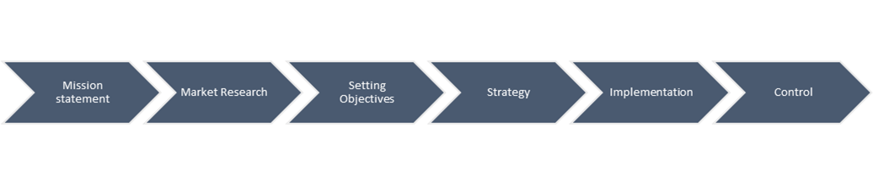
Figure 1 Marketing Planning Process (Hooley, 2017)

PESTLE Analysis

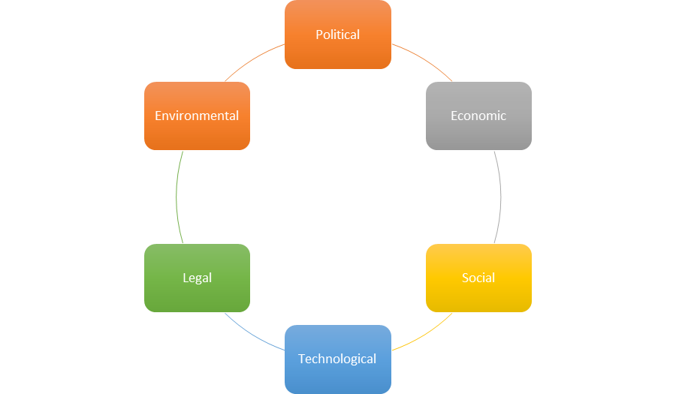
Figure 2 The PESTLE Model

Political Factor: The political environment is comprised of government rules imposed on automobiles and the agreements reached with other governments. Recently, most industrialised countries have passed legislation to punish individuals for possessing fossil-powered cars or to promote and encourage the purchase of greener cars. (Sampson and Chambers, 2000).
This regulation will impact Fontain Motors. Consumers will undoubtedly seek out more ecologically friendly automobiles in the future. That's why they will have to demonstrate competence with Audi's hybrid and electric vehicle lineup to remain compliant with newer rules while maintaining their reputation. Brexit would have entailed Fontain motos harmed had they not been a domestic maker of autos in the United Kingdom. Because in such a situation, delaying a smooth and flawless Brexit would have a detrimental effect on company operations. Since Fontain Motors focuses on marketing foreign, used automobiles, it is now less impacted by Brexit. But there will also be complications if the UK opts for a no-deal Brexit.

Economic Factor: Europe is currently experiencing a difficult economic situation. A poor financial crisis results in a lack of revenue, which results in a lack of demand. This absence of market is particularly pronounced in the case of luxury products. Additionally, during economically challenging times, governments frequently impose substantial taxes on luxury commodities.

Technological factors: The term "technological factors" refers to the influences that affect how a business functions concerning the equipment employed in the business's surroundings. The term "Technological Factors" refers to this quasi-science of seeking to forecast technological advances and estimating their influence on an organization's operations. All companies are investing billions of dollars in research and development so that their cars can be superior to others in the market. Audi is no slouch in this case. Their E-Tron line is very ambitious and well-lauded.

Social environment: Social environment: The sociological climate has a direct impact on market demand. Individuals have preferences and ideas, which vary throughout time and between cultures. Any corporation that sells automobiles must be aware of the several factors with which individuals link. What kind of design do they prefer, what functional needs they expect the car to fulfill, and what type of car they want (Harrison, 2014). Fontain Motors also needs to consider the background, demographics, and needs of its customers. Bringing in excellent value luxury cars alone will not be enough.

Legal factors: Legal factors refer to any regulatory forces which define what a company is permitted or prohibited to accomplish. Political factors include the interaction of business and government. Legal and political aspects might collide when governmental authorities enact legislation and rules that affect corporations' functions. Fontain Motors should focus too much in this respect because they supply cars from a very responsible and reputable manufacturer who has rarely ever had any problems (Harrison, 2014).

Environmental: Environmental: All of the variables in the macro-environment are inextricably linked as our conversation progresses, and we keep coming into the subject of EVs (Harrison, 2014). ). Traditional cars that use fossil fuel have very adverse effects on our environments, which has led to a point where we have no choice but a complete transition to electric vehicles. Better government policies employ heavy influence to get automotive manufacturers to think greener and electric. Yet another reason why Fontain Motors should be expecting to work with many electric vehicles soon.

The Five Forces Model of Porter


Figure 3 Porter's Five Forces Model (Russell, 2018)

This model was established to enable a firm to swiftly assess the critical characteristics of the industry and determine whether entering or remaining in the industry is lucrative. This model will now be used to decide on its competitive environment for Fontain Motors' used car business.

1. Industry Competition: This is the force determining the number of organizations in the industry and the demand for which they compete. If several competitors and insufficient demand, the market becomes highly competitive (Warner, 2010). But it must be considered that Fontain Motors earns most of its money by specializing in a particular niche within this market. That niche is a market for used, well refurbished Audis.

2. Power of New Entrants: The likelihood of a new entrant entering the market where Fontain Motors operates is quite remote. Because the first significant barrier to entry into this market is the massive cash needed even to start trading vehicles in the United Kingdom. Previously, it might have been easy to begin small and grow. Still, with increased rivalry and producers establishing their agreements, it is challenging for a new business to enter this industry (MacKay, 2011). Not to mention the plethora of rules and legal hurdles that companies must jump through to start a car lot in the United Kingdom.

3. Power of Suppliers: Suppliers' influence is considerable in this scenario, as they can attempt to enter the business themselves. Independent dealerships have come under threat in recent years as domestic brands have opened their locations. These businesses have established their reputations and grown their brands through time, and they are not hesitant to explore new markets. They have the funding, infrastructure, and product range to support this as well. Fontain Motors, however, is protected again by its specialty in this case. It is only helping build the brand of Audi, which is good for them. This is why Audi will avoid direct contention with Fontain Motors.

4. Power of Customers: The power of customers is not very easy to specify with the car dealership industry. Each car brand has a unique following and value offering. In almost all cases, the reasons people buy cars are intangible, especially in luxury or sports cars. This model considers how many substitutes and alternatives there are. As far as alternates to the Audi brand go, there are many.
However, there is no sensible alternative to Fontain Motors if you're in the market for a low-priced, pre-owned Audi. However, it is impossible to determine the exact popularity of Audi among clients. Thus, consumer power can be deemed medium.

5. The Threat of Substitutes: According to recent surveys, many other brands are much more renowned than Audi in the UK automotive market. This indicates a significant risk of replacements. However, it has a negligible effect on sales. Because each automobile brand has a devoted fanbase that rarely changes in terms of size or other characteristics. Thus, the threat of alternatives is relatively modest for Fontain Motors.

Swot Analysis
The Swot Analysis will take a broad look at the advantages and disadvantages and being in Fontain Motor's shoes. We will look at the edges, weaknesses, opportunities, and dangers of running in the Fontain Motors market.

Strengths
- A devoted brand presence for both their own and Audi's brands
- Staff that is well-versed both in the Audi brand and in anticipating and meeting the needs of each customer.
- Well-equipped service center, both in terms of Audi-specific equipment and competent engineers and mechanics
Weaknesses
- Redundancy in the selection of products.
- Selling only used cars shrinks the potential market size.
Opportunities
- Audi is far ahead of the competition in terms of developing hybrid-electric luxury automobiles. Fontain Motors should field a credible fleet of cars in time for the electric vehicle revolution.
- Domestic automobile manufacturers and foreign companies with a direct presence in the UK are suffering from the less-than-ideal Brexit negotiations.
Threats
- Other car brands making better EVs
- Too much dependency on one brand can give them undue influence over Fontain Motors.
- Audi could fall out of popularity.
- New regulations that put used car dealers under threat, such as cutting export ties with Germany.

Marketing's Four Ps

Product: The product is what the organization intends to sell in exchange for payment (Schindehutte, Morris, and Pitt, 2009). The development in Fontain Motors has used Audi automobiles at the best possible price, backed up by excellent customer service and car servicing.

Place: The organization's location is just as critical as the products it sells. The site from which an organization conducts business is essential to the product's and firm's future success. This location has been a long-standing dealership for Fontain Motors.

Promotion: Fontain Motors provides luxury automobiles. Conventional marketing strategies will not work. Rather than that, Fontain Motors depends on the strength of its service to permeate the brains of its clients and the individuals they encounter (Russell, 2018). It is built on long-term partnerships with its clients that benefit both parties.

Price: The price is a critical component of Fontain Motors' identity. Because it offers old automobiles while adhering to a strict quality standard, its significantly cheaper pricing translates into exceptional value in the customer's opinion.

Segmentation
The automobile sector can be classified into various segments based on multiple dimensions (Hooley, 2017). Specifically, income, age, and beliefs of the family. For the sake of Fontain Motors, it can be assumed that these are all individuals seeking high-end automobiles. Older generations favor companies that were popular in their youth. Younger generations are more excited than ever about luxury automobiles and have a distinct brand preference. The mean lifespan of the client and the exceptional specimens continue to decline. Individuals with somewhat higher earnings will prefer brand spanking new vehicles that are specially designed to their specifications. Individuals with lower incomes will be prepared to acquire a used car as long as it meets the high standards set by Fontain Motors. If the consumer is single, they are likely to be less concerned with practicalities than if they are a family member. Fontain motors cater to a younger demographic with a lower income and those that fill any family role.

Targeting
Once the market is divided and it is clear to the company which customers can be reached, it selects and creates one of the segments of the market around this one (Hooley, 2017). The target market is then called this category.Fontain Motor's customers are young adults with an annual income of at least $100,000 and ideally single.

Positioning
Positioning entails determining precisely whose identity the firm wishes to adopt in the consumer's eyes (Russell, 2018). Is its goal to be the cheapest or to deliver the highest quality despite the price? Does it wish to offer solely products in which it is an expert or provide a diversity of possibilities to its customers? Fontain Motors has chosen to maintain its image with Audis by refining its present product at a lower price.

Marketing's Contribution to Value Creation

The Marketing Strategy
The goal of marketing and the questions it has posed to businesses have evolved. The marketing notion represents the most recent incarnation of what marketing means to companies.
According to the marketing philosophy, an organization or product optimally centered on the consumer and meets their demands will be the most successful.

Branding
A brand is fundamentally a unique identification for a product or, more broadly, a business. There are frequently multiple items in a market that are meant to meet the need or address the same problems faced by customers (Coomber, 2015). For instance, the concept of a unified, clean, elegant, and functional computer is immediately associated with Apple. Without even a doubt, the image of pure automobile elegance conjures up the Rolls Royce symbol. That's what brands accomplish; they distill the essence of a product into a single simple mark, logo, or moniker.

Fontain Motors' Branding Strategy
Fontain Motors use a strategy known as Product Line Extension Branding. Fontain Motors is already well-known for getting in the best used Audis, renovating them to the maximum extent feasible, and giving customers the optimal combination of features, quality, and price. This is the meaning of their brand to Audi lovers (Lee, 2015). They have no intention to increase into other automobile brands. They prefer to associate their name with a brand as distinguished as Audi's and continue importing the finest Audis.

Matrix by Ansoff and Fontain Motors
Ansoff's Matrix is a strategic model that was developed to assist businesses in determining the direction their goods and markets should take. There are different innovations, new markets, and current products and markets; depending on the larger context, any unique mix of the two may be the best course of action for a business.
For instance, Fontain Motors employs the Market Penetration Strategy. They specialize in selling Audis and are the finest at it. They have no desire to see that change. They wish to continue selling high-quality used Audis to their consumers. They intend to establish themselves as the sole dealer of secondhand Audis in the United Kingdom (Lee, 2015). Given their specialization, they plan to dominate this market entirely.
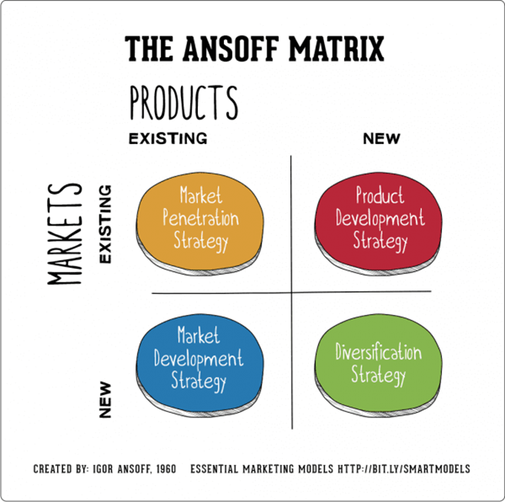
Figure 4 The Ansof Matrix Source: Smart Insights

Engagement of Stakeholders and Marketing Activities
Stakeholders are everyone who directly or indirectly affects the organization. When an organization functions in an environment, it instantly affects the people and businesses in those surroundings (Saarinen, Tinnilä, and Tseng, 2006). The organization impacts its consumers, staff, and local communities. However, it is influenced by it. Vendors and the state due to its rules and laws. They are all members of the organization.
Internal and external stakeholders are the two basic types. Internal stakeholders are those who work within the organization. External stakeholders are part of the organization's environment. These two stakeholder types have distinct ramifications for the company.

Internal Stakeholders

Employees: Employees are the only internal stakeholders directly impacted by any modifications or threats to the organization. Employees are the foundation of any organization. Performing employees benefit the organization. However, every organization's decision affects its personnel. The vast knowledge and wisdom of Fontain Motors' workers is the main reason for their excellent customer reputation. Customers seldom look back because personnel treats them so well.
Managers: Managers have the power to steer an organization's course. The top manager can determine the end goal, and lower managers can decide where to go. One decision can make or break an organization. Managers frequently have a substantial stake in the company. Fontain Motors management maintains contacts with Audi and oversees the servicing department.
Owners: Owners are the most engaged in the organization because losing their assets means losing a lot of money. So they have a big say in big decisions. This, in turn, decides the organization's future. It took time, money, and many other things for Fontain Motors owner to achieve success. This shows how crucial an owner is as a stakeholder.

External Stakeholders

Suppliers: are vital stakeholders since, without them, no product or business exists. The Audi brand is critical to Fontain Motors' distinctive value proposition. Fontain Motors would not exist if Audi did not produce the highest quality cars (Law, 2007).

Government: Policies about regulations and legislation have a huge impact on the way companies do business, or should do business. For example, millions of companies eagerly anticipate the UK government's ultimate Brexit agreement decision since uncertainty about their future in Europe costs them money.
Customers: A company exists to meet a customer's requirement. Customers are an essential stakeholder in a firm (Saarinen, Tinnilä, and Tseng, 2006). Fontain Motors values their customers even though they are devoted and will return (Daum, 2003). They will also tell their friends about Fontain Motors. . But used Audi consumers have come to expect the most excellent quality, and Fontain Motors should comply.

Conclusion
The essay examines marketing's role in an organizational framework. It makes it easier to identify the firm and its product how advertising plans and executes lucrative client relationships. The business background of Fontain Motors offers the audience with a similar context to bounce off many theories. Finally, the essay attempts to transmit the marketing value of a company.

References

Chrzanowska, J. (2010). Qualitative Market Research. London: Sage Publications.
Coomber, S. (2015). Branding. Oxford, U.K.: Capstone Pub.

Daum, J. (2003). Intangible assets and value creation. Chichester, West Sussex,
England: J. Wiley.

Hanson, W. and Kalyanam, K. (2014). Principles of Internet marketing. Mason, Ohio: South-Western.

Harrison, A. (2014). Business environment in a global context. Oxford: Oxford University Press.

Heizer, J., Render, B. and Munson, C. (2016). Operations Management. Pearson
Australia Pty Ltd.

Hooley, G. (2017). Marketing Strategy and Competitive Positioning. Pearson Education Canada.

Law, C. (2007). Restructuring the global automobile industry. London: Routledge.

Lee, A. (2015). The strategy of global branding and brand equity. Abingdon, Oxon: Routledge.
MacKay, C. (2011). Effective Marketing in Easy Steps. Southam: In Easy Steps Limited.

Russell, E. (2018). The fundamentals of marketing. Lausanne: AVA Publishing SA.

Saarinen, T., Tinnilä, M. and Tseng, A. (2006). Managing business in a multi-channel world. Hershey PA: Idea Group Pub.

Sampson, G. and Chambers, W. (2000). Trade, environment, and the millennium. New York: United Nations University Press.

Schindehutte, M., Morris, M. and Pitt, L. (2009). Rethinking marketing. Upper Saddle River, N.J.: Pearson Prentice Hall.

Warner, A. (2010). Strategic analysis and choice. New York [N.Y.]: Business Expert Press.

