Feeling Through Film
Christopher Jones
P145777

3D Filmmaking
5786 words
Scott Smith

Feeling Through Film
Introduction
Film is an artistic medium that has allowed people to push the boundaries of storytelling, A notable form of filmmaking is Animation. To explain animation in a single sentence, it is a series of individual images run in sequence at a set speed known as frame rate, this creates the illusion of movement Animation has allowed artists to push even further past those limits than other forms of media and allows things to be seen on screen that even practical effects, hand built sets and camera tricks can find difficult to recreate.
The aim of this paper is to explore how aspects of cinematography create a connection with an audience and how it is used to trigger an emotional response. Martha Alderson, the author of Plot Whisperer series states that “The most powerful way to reach an audience is through the character’s emotions. For only when we connect with the characters on an emotional level does the interaction become deep and meaningful.” (Alderson, Connecting with Audiences Though Character Emotions)
This dissertation will be focusing on the effects that frame composition, colour and lighting have on emotional state in the audience. The following are summaries of the aspects of cinematography that are important to filmmaking.
Frame Composition is one of the subtler ways that human emotion can be exploited in order to create a connection with characters. Despite being a subtler method of storytelling, it is undoubtedly the most complex of the aspects of cinematography. The correct composition can change how an audience feels, for example; if the shot takes place from a high angle, the audience would be looking down on the character this might suggest that whatever the character is going to face will be a situation out of their control.
Framing is a technique that involves positioning elements and characters within a scene to help tell the story. If for example a character has a domineering personality and has a lot of power, when framed in scenes they may be bigger than other lesser characters and will be more defined from the background. To be more specific; imagine a child playing with their toys if they were close to the camera and taking up the majority of the shot, in terms of frame composition is will suggest that the child is content and confident in what they are doing. However, if you were to position the child further away from the camera further into the background the child would take up less space of the frame. This could suggest that perhaps the child is lonely and less happy with the status quo.
The rule of thirds is used to help shot composition, a grid is created by drawing nine equally spaced lines over an image. The aim is to place the subjects of interest like characters or important props in the areas of the grid where the lines intersect. The logic behind the rule of thirds is that when an object is slightly off centre it looks more natural as things do not tend to be perfect in nature.
Colours have great power within a film, each having their own meaning. They can command the tone of a scene even without the audience being fully aware of it. Colour can affect how we behave and also the way that we feel, alternatively a lack of colour has similar effects. The effects of colour on human psychology has a proven effect on the emotional state of a subject.
Alexander Schauss (Director of the American Institute for Biosocial Research supports this claiming “colour has a direct psychological impact, The electromagnetic energy of colour interacts in some still unknown way with the pituitary gland and pineal glands and the hypothalamus, deep in the brain. These organs regulate the endocrine system, which controls many basic body functions and emotional responses, such as aggression.”
Colour does not just have to be from the set or the costume, coloured lights can be used to provide a cold or warm tone to a shot.
Nothing can tell the audience more about a character's outlook or personality than the lighting in the scene. If a character is displayed with hard sharp lighting they may be an aggressive or oppressive character, if they are shown with soft lighting they may be a friendlier, gentler character. Types of lighting have even created types of genres. Noire is a genre of film that is famous for its cinematography that places the audience in this gritty dark world.
The most basic type of lighting in film is known as three-point lighting. This is used to provide even lighting over a character, when filmmakers use something other than this its usually because there is some kind of meaning that they wish to convey by providing harsher shadows or completely eliminating shadow all together through overexposure, completely washing out the scene.
I will be looking into two specific animated feature films and how they use these aspects of cinematography to both tell the story. These are Netflix’s “The Little Prince” (Osbourne, 2015) which is loosely based on the book “Le Petit Prince” (Saint-Expuréry, 1943) and Disney-Pixar’s “Inside Out” (Docter and Carmen, 2015).

The Little Prince
The title character in The Little Prince (Osbourne, 2015) says “Anything inessential must be made essential”.
I believe that this quote from The Little Prince can be easily applied to cinematography, if something in the frame composition has no purpose. We should consider why it is there and how it can be given purpose.
The Little Prince is a story built around conformity and breaking free from it and nothing shows this better than the camera angles used throughout the beginning of the film. The film primarily focuses on using symmetry to display an authoritarian tone along with cool calm colours like soft blues and greys. These are colours that are intended to subdue the characters and by proxy, the audience.
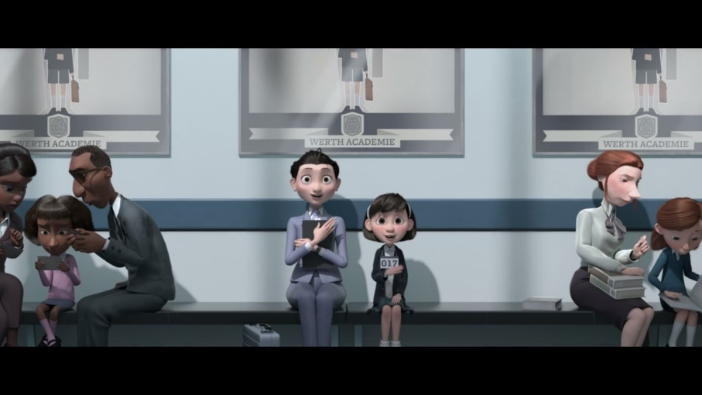

The opening shot of the movie is a symmetrical long shot, this sets the tone for the first eleven minutes. The protagonist, an unnamed little girl and the mother are dead in the centre of the screen, breaking the rule of thirds and looking at directly at the audience. As this is the first shot of the film, perhaps looking at the camera is a way of building a connection between the protagonist and the audience. The characters are there to fulfil their life plan and this comes through in the composition, it all feels very efficient. The characters are always in the centre of the shot with the environments facing flatly towards the camera. The intention of the shot is to make the audience feel uncomfortable and realise that whatever the characters are there to do is not quite right. This comes through in the composition as it is not often that a character will look directly into the camera. When this is done in filmmaking, it is either to used in an uncomfortable situation or as a fourth wall break. As there is no breaking of the fourth wall in this movie, I conclude that the intention of the shot must be the former.
This angle also provides a dead-on view of the propaganda like posters on the walls, this makes it seem to me that this shot is intentionally has these awkward overtones.
The lighting is used to make the main characters stand out from the background as are the colours of the clothes. There is absolutely no confusion about who the main characters are in this scene.

The lighting is soft on the protagonists but much harsher on the characters on the side of the frame. This is to help reflect the optimism that the characters in centre frame are displaying. In contrast, the characters on the sides of the frame are more hunched over as not to draw the viewers eyes to them too much as not to distract from the main characters.
The characters on the sides of the frame create a secondary frame within the frame, we can treat them as being the actual borders of this shot as they help bring focus to the characters within the centre of the frame as well as a possible foreshadowing to how overwhelmed and boxed in the lead will feel in the next scene.
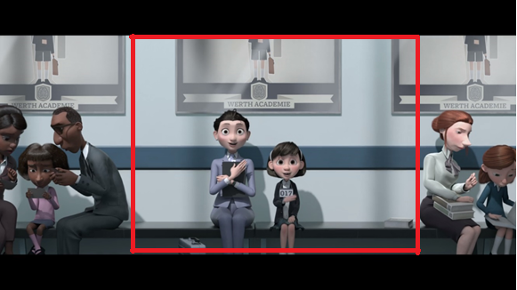

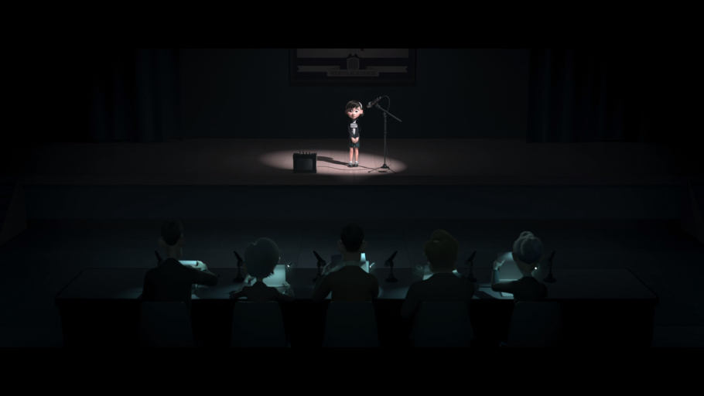
These feelings are amplified in the next shot as the 5 corporate figures move in synchronicity without emotion, observing the protagonist from the darkness. The little girl is the sole character under a spotlight, she is the focus of the room. The child is under immense pressure, and this shot was framed this way to try and make the audience feel this pressure of being the focus of a crowd. The feelings this scene generates are relatable and appeals to an audience, the best way to connect with an audience is to use shared experiences. Near the child is the only piece of asymmetry in the shot which is created by the props near her. It makes the shot look a little more natural and with the elements being closest to the protagonist, we can associate asymmetry with the protagonist as opposed to the symmetrical nature of the panel judging her.

The five synchronised figures of authority each have a cold blue light located below their face providing them each with menacing under lighting, this causes the features of the face to cast hard shadows. This signals to the audience that these characters are not to be trusted, something that’s revealed way later in the story, but the groundwork is being laid throughout the film by the cinematography. To clarify, this type of lighting is known as low key lighting and is often used for horror films.
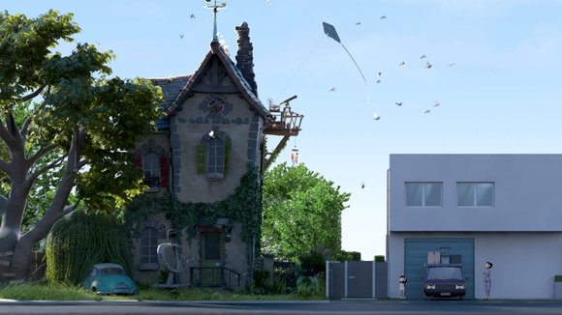

The first major element of asymmetry shows up in the house of the secondary protagonist. We are presented with a shot that demonstrates the differences between the characters, their ideals and the shooting styles of cinematography that is seen throughout. The house of the little girl on the right of the shot is the embodiment of the shots in the film before the character development takes hold. The house is straightforward, efficient and bland.
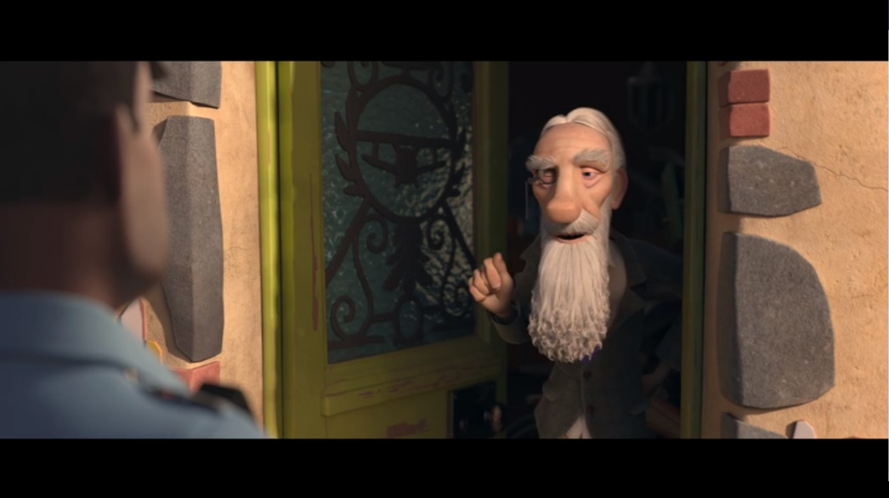
On the other hand, the house of the secondary protagonist on the left of the shot has interesting colour, the building is full of interesting shapes and angles that make it a pleasure to look at. It is the most interesting thing in the shot, it is what the eye of the audience is drawn too. It is the polar opposite of the smaller bland house. The house on the left is also the only house surrounded by untamed plant life, surrounded by nature. It is meant to be viewed as what’s natural by the audience as opposed to the very controlled boxed way that the other home is presented as. This point is reinforced by who lives in each of the houses, the free spirit who lives in the overgrown “natural” house and the mother and child who live in constant worry and lack freedom in the grey box like home on the right.

Later on we physically see the mysterious old man known as the Aviator who lives next door to the protagonist and her mother. It is at this point that everything about the style the cinematography changes. We get natural, aesthetically pleasing angles and shot composition that follow the rule of the thirds. This is the first time we’ve had vivid colour as opposed to the washed-out blues and greys that have set the tone until now. It can be likened to the house mentioned previously, it provides something fresh for the audience to see and to grasp onto. This change in shooting style is to provide contrast between the lives off the Aviator and the little girl. The Aviator lives his life as he pleases and so this is reflected in the eye pleasing cinematic angles uses in shots he is present in. The child’s life however follows a strict schedule and this too is reflected in the very bland uncomfortable angles presented to the audience. When we see in the interior of the Aviator’s home for the first time, it is dimly lit. This is to represent that much of the information about the Aviator is a mystery. This is one of the very few times in the film where the rules used to film the Aviator are broken.
Once the Aviator has left the scene however, everything returns to how it was. The symmetry in the shots comes back, the colour fades back to the cool greys and blues.
The wall of the families’ home is destroyed by the Aviator’s plane propeller and the child waits at home to tell her mother about the damage. She sits in the dark with only a lamp projecting some light onto her face. The character is nervous about discussing the damage but knows it must be done. I find it easy to connect with the character in this scene, which leads me to believe that it is easier for members of an audience to connect with characters over negative experiences than for positive ones as negative experiences tend to leave a bigger impact on a person.
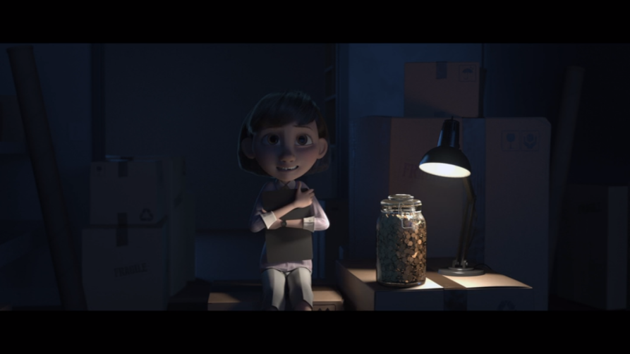

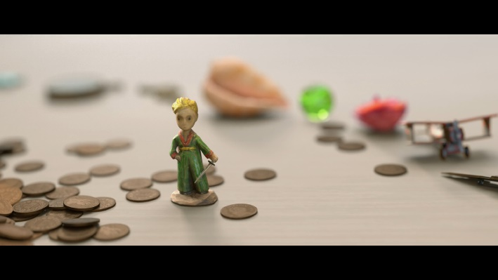
As the film progresses, there is a back and forth between the two styles of cinematography used in the film but as the child’s friendship with the Aviator grows the two styles bleed into each other, and the child’s world gets less and less boxed in and becomes more colourful and vibrant. A primary example being when the old man hands over a jar of pennies, as the child is sorting through this large pile of brown pennies, she finds trinkets that provide contrast to the colours in the shots.
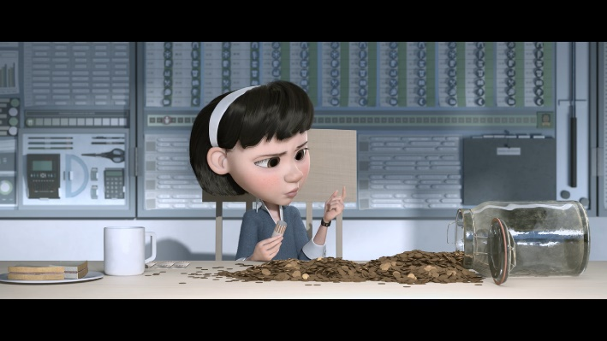
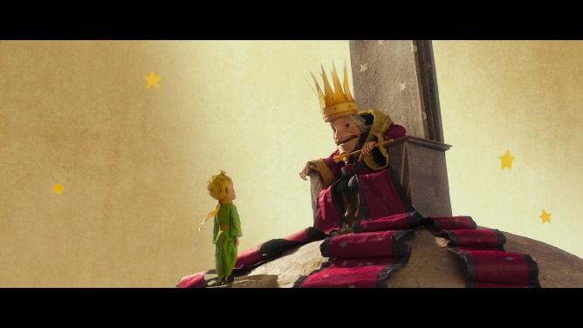
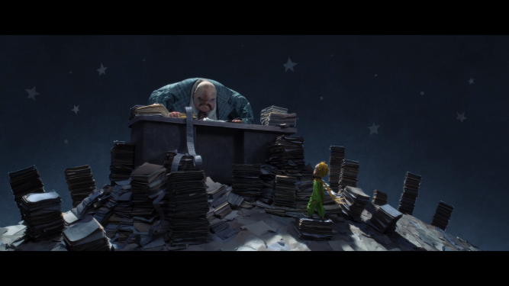
While we are watching this story unfold, the Aviator is telling his own story, the story of the little prince and we are shown this through the imagination of the Little Girl. During these sequences, we have a character called The Little Prince asking advice of other characters and these are often shot from a low angle to show that The Little Prince is requesting something from them, that they have the power even if it is just the knowledge he seeks. The shots that take place in the little girl's imagination tend to follow the more traditional cinematic style that is used when the Aviator is on screen.
During the Little Prince’s travels, he encounters a king who claims to control the sun, despite this being a lie he is ultimately harmless and thus is placed lit with a warm yellow light. To contrast this the Little Prince meets a character called The Businessman who buys and counts the stars. He is a character fuelled by greed so this scene is dark and lit with a cold dismissing blue.
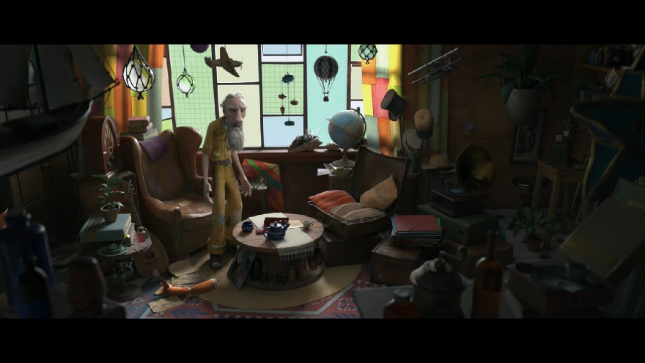

When the Aviator and the little girl have a falling out later on in the movie regarding the Aviator leaving to be with the little prince, this is the only other time in the film where we have a shot of the Aviator that’s not warm and jovial, the first shot being when we first see the inside of the Aviator’s home. The Aviator has lost a friend, and the camera pans to show how large the room is with the audience’s eyes being drawn to the empty chair by the old man. The chair lies in the near centre of the shot but is located close to the large stain glass windows, this draws the audiences eye to it. This chair reveals something important about the character of the Aviator. The chair the girl was sitting in is not a chair at all, it is a suitcase with pillows inside of it. The Aviator has not just lost a friend, he’s lost his only friend. This environmental storytelling adds another layer to the scene and provides extra sympathy for the Aviator from members of the audience who pick up on it.
This is a longshot from a high angle and is used to show the old man's loneliness and how small he feels. This heartbreak causes the old man to have a heart attack, something only revealed through the red flashing of an ambulance as the child arrives home.
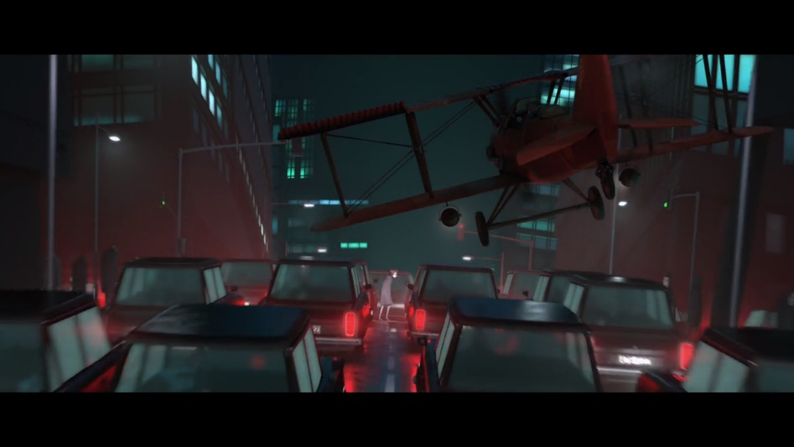

The child steals the Aviator’s plane and flies off to the stars in order to find the little prince. This sequence uses the same type of cinematography that is used in sections in which the Aviator is present and when the little girl is imagining the story of the little prince. This is a case in the movie where the cinematography style makes it more difficult to fully understand what’s going on. Had they either chosen to use different types of composition for both the imagination and aviator sections as they had previously for the little girl, it would be much clearer whether what we are observing is reality.
Based on the cinematography, I would say that this event is taking place in the girl’s imagination, as I believe these shots are taking influence from both types of shot we’ve seen thus far throughout the movie. The camera movements and composition are remnants of the Aviator’s effect on her worldview while the colours and lighting are from her previous outlook before she became close with the Aviator.
I think this is further reinforced on her landing when the little girl is met with a figure of authority. The scene is shot with the same symmetrical type of shot that dominated the first 11 minutes of the film.
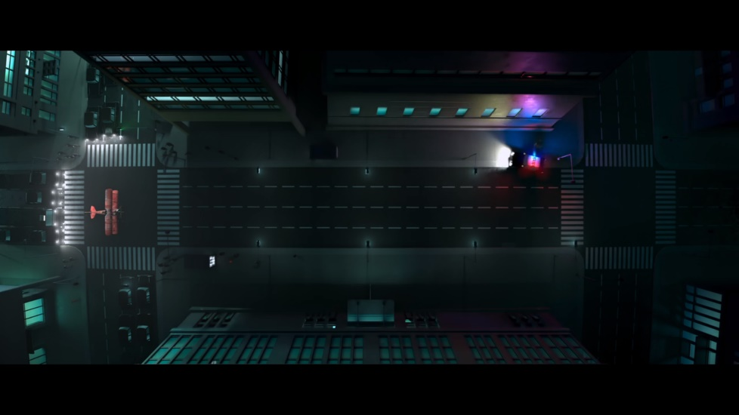

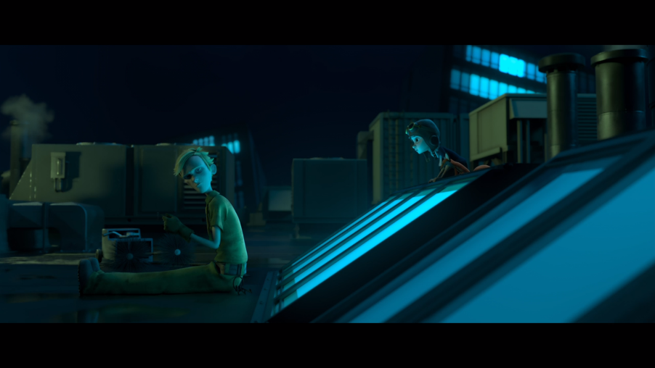

The child eventually find’s the Little Prince and discovers that he’s forgotten everything about who he was and now works for the businessman. The blue lighting over the characters is used to show how passive the Little Prince is being and how he is ready to stay with status quo, despite hating his job. Despite how powerless the Little Prince is, he is trying his hardest to be essential. the sense of powerlessness the blue provides shows that he is failing at this.
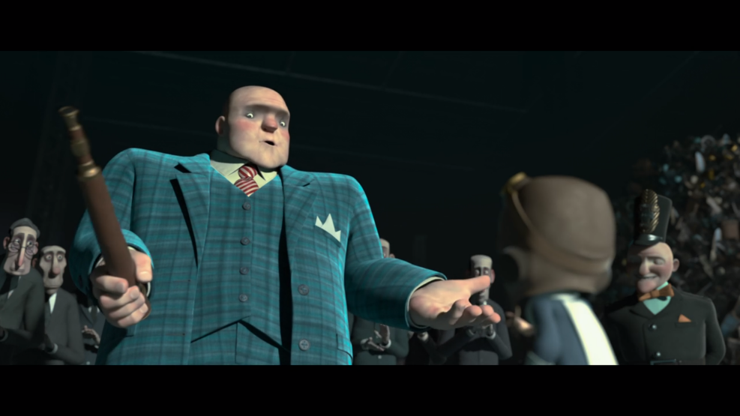

This high angle is used to show that this character called The Businessman is the one with the power. He is literally looking down on the girl and this also comes through in the dialogue, he is talking down to her in both senses as he reveals his plans. He is framed to take up the majority of the shot and his blue suit allows him to stand out from the background. The opposite can be said for his lackeys, they are scattered around the backgrounds of the scene wearing dark colours that cause them to blend into the background.
The Businessman is placed on the left of this scene in this composition, this is often used show that a character is comfortable. The opposite is true for the child, the character on the right of the frame. This is because we naturally read a scene from left to right.
Following this, the girl and the little prince escape. The Little Prince remembers who he is and what he stands for and from this point on the cinematography returns to aesthetically pleasing. The cinematography stays like this because from this point onwards the characters are sure of who they are and what they stand for.
Inside Out
This movie provides the unique opportunity to observe cinematic influences on the emotions of the viewer as the film itself is all about the emotions of its cast.
Lighting and colour have a strong link to emotion in this film, as each of the characters that live within the human cast’s heads are their own emotions and each one gives off light but in different amounts. Colour theory is used as each emotion is colour coded to associate with the emotion’s related colour.
“After selecting a number of paint chips, they decided on a bright red. Almost immediately and without warning, they began to have altercations every night at dinner. It sent them into a tailspin.” (Bellantoni, p2, 2005)
The above quote indicates that bright red is the colour of hostility, and appropriately the character of the emotion Anger is a bright red. The other emotions also follow the theme of being colour coded are:
- Joy who is a bright yellow, the colour most commonly associated with happiness.
- Sadness who is a light blue, a colour that can be associated with melancholy.
- Fear who is a light purple, a colour that is associated with death. This is appropriate as fear is used by the body to keep people out of dangerous situations.
- Disgust who a bright green, the colour of envy and uncomfortableness.
Focusing solely on the character’s Joy and Sadness, based on the level of light they exhibit and their colour, it is easy to tell which character is a representation ofa which emotion.
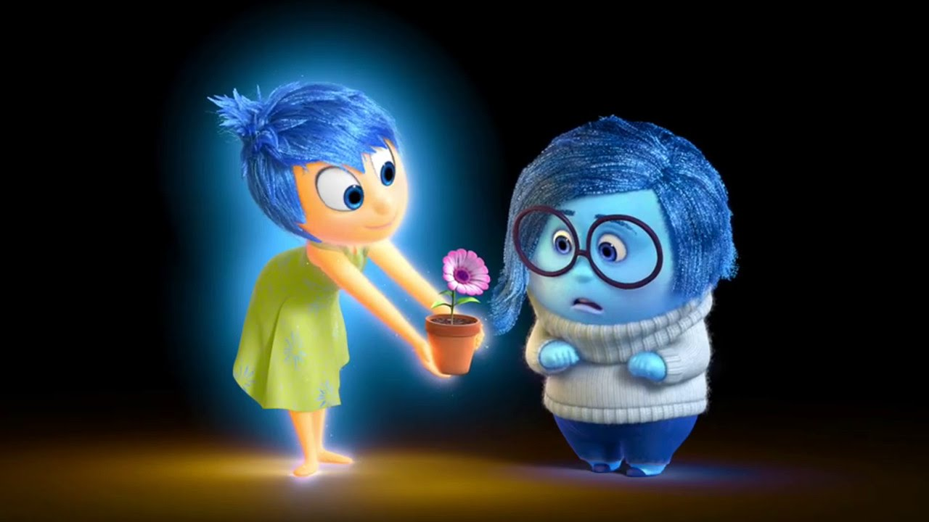
This luminosity can provide difficulties to some cinematography techniques however, for example if a character was feeling sad or defeated the lighting may be positioned in a way that causes hard shadows to fall upon the character. In Inside Out however, that would not be an option for a character like Joy who is a source of lighting herself. From a lighting standpoint, it is impossible for her to be sad. While the character Sadness also gives off light, she provides a lot less allowing the lighting in the scenes to affect her more directly.
In the opening of the film, there is a close up of a baby from a high angle in a white featureless void. The high angle helps get across the point that the child is being looked down on by the parents while the void indicates the babies lack of understanding of its surroundings. These intended to target the maternal and paternal experiences in the audience. To contrast this, we are cast in darkness with the creation of the child’s first emotion, Joy. In some films the darkness would tend to mean sadness or loneliness, but in this case, it represents an absence of all emotion entirely as the baby has yet to experience these things.
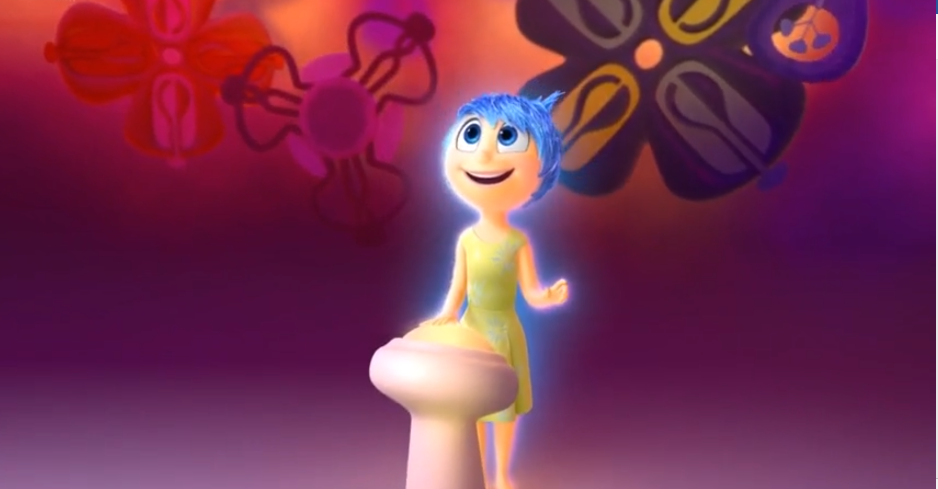
Once the first memory is created the lighting changes and the room is filled with colour to signify the birth of the child’s memories and her imagination. The change signifies that this is a positive event and has the audience link this in their mind.

When explaining the “core memories”, the memories that make up the personality of a person we are shown a long shot of the family playing ice hockey, as the family celebrates they all move in to congratulate Riley. The camera zooms in not just to keep the family the focus of the shot but to help emphasise the feeling of closeness the family is experiencing which further capitalises the film using the shared experiences of family and growing up to develop a connection with the audience.
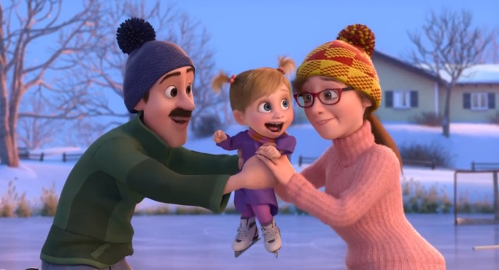
There is a distinct difference in colour pallet between the scenes that take place in Riley’s head and the scenes that take place in the real world.
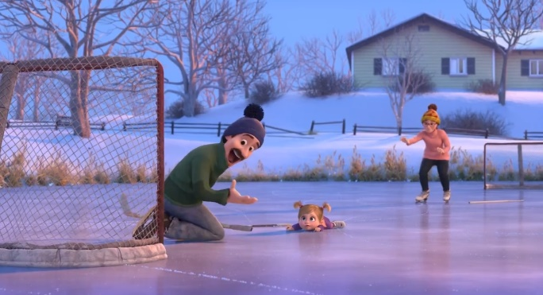
During shots of the emotions at the white control panel, the camera is always static to try and reinforce the idea that these are the characters who are in control. This is in direct contrast to how animated and colourful the characters themselves are. This is also applicable to the control room environment, which is mostly one solid bland colour.
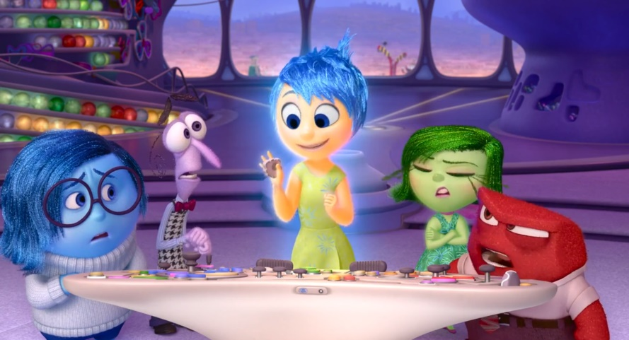

During a scene where the family is playing in their new home the father gets a phone call informing him that he’s needed at work. The camera work which at this point has had a good deal of movement to keep the playing family in the frame and enhance the playful atmosphere finally goes still. The next camera angle shows the parents in the foreground while Riley stands isolated in the background. The purpose of this shot is to indicate that Riley is feeling abandoned by her father. This message is then reinforced by the dialogue of the emotions.
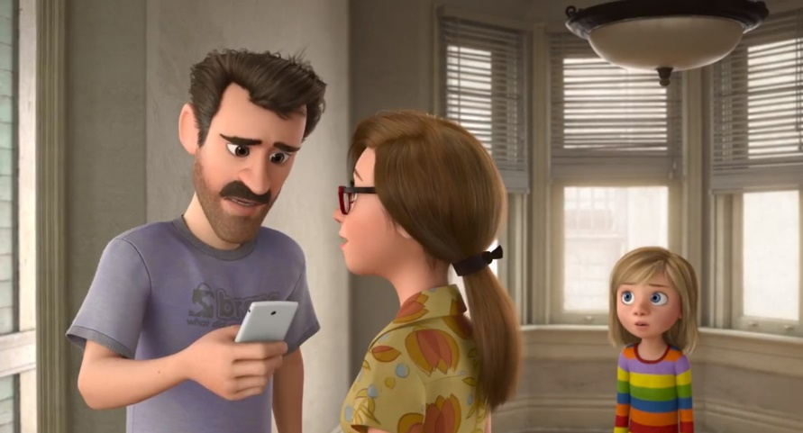

When Joy and Sadness must return to their headquarters, an extreme long shot from a high angle is used to frame the characters as small against the background. This is to show the gargantuan task that lies ahead of them. This shot also serves partially as for environmental storytelling, the majority of the memories lining the shelves being yellow, showing the overly controlling role that Joy has as a member of the emotions in Riley’s head. The yellow dominates the scene, just as Joy has dominion over the over her fellow emotions aswell as Riley’s personality.
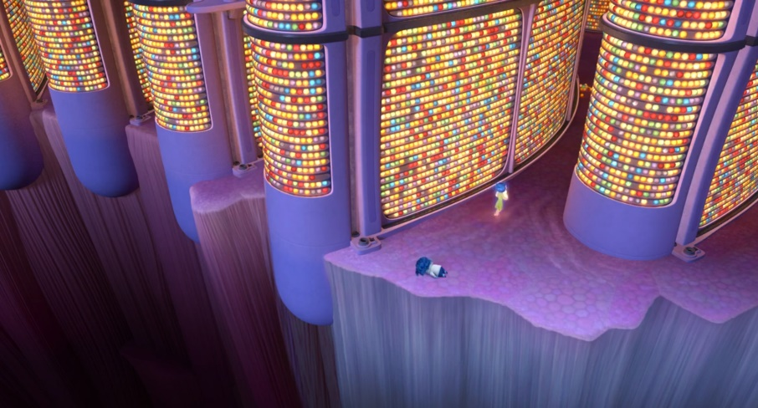

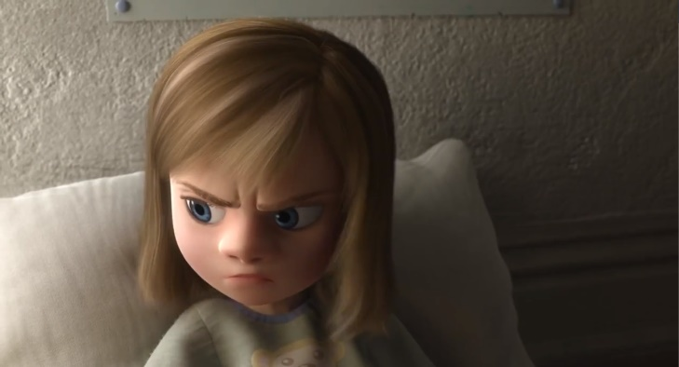
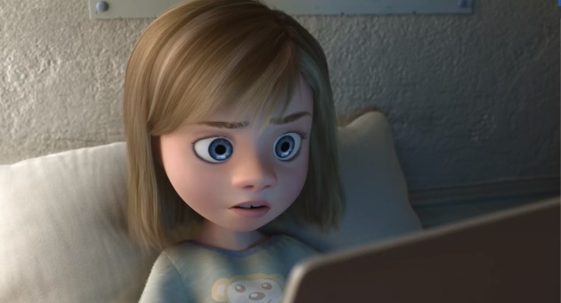
When talking to her friend, a lighting change is used to show her anger. When she is happy, the docile blue light of the laptop is used to soften the shadow on her face but when Riley slams the laptop closed in anger this soft lighting disappears and allows the key light to shine cast a hard shadow on her face.

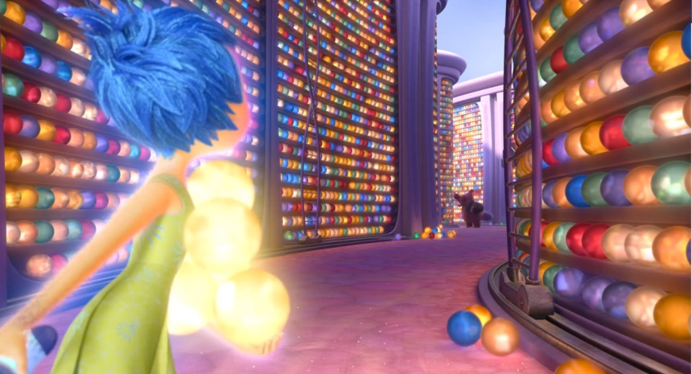
Up until this point, the characters we’ve been introduced too in Riley’s head are either the 5 humanoid emotions or and blob-like workers that roam the halls of her long-term memory. When we are introduced to an unfamiliar element, in this case the imaginary friend Bing Bong. He is presented far away from the protagonists and cast in heavy shadow despite being in an area filled with luminous memory orbs. There is no doubt in my mind the shadow was used to reinforce the unknown nature of this character as the shot breaks continuity with its lighting.

As the group travels through the maze of memories, the lighting is used to indicate the mood of Bing Bong. The conversation starts out jovial and the lighting on Bing Bong helps reflect that but as the conversations begins to travel towards a subject that Bing Bong is not too comfortable with discussing, the lighting changes to reflect this new mood set by the conversation. All the while Joy is completely unaffected by the lighting changes that effect Bing Bong due to the extreme level of luminosity she exhibits.
The entire time Sadness is in the background framed separately from the group in the foreground, this helps exemplify Sadness’s feelings of disconnection from the other emotions.
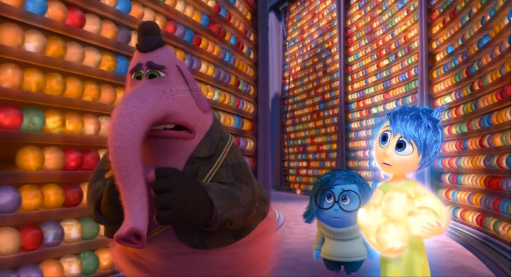
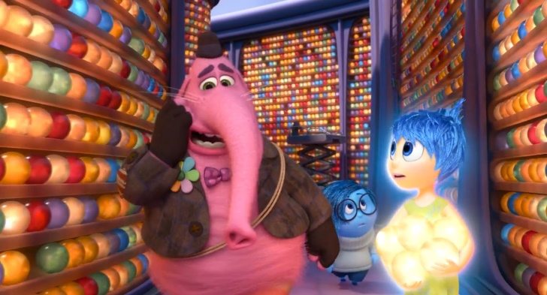

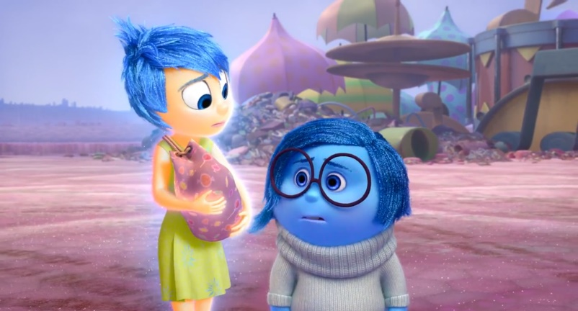
Once Sadness calms Bing Bong after the loss of his cart, Joy finally sees her worth and this is reflected in the way that Sadness is framed in this shot. Up until this point Sadness has been dismissed by Joy and to reflect this was usually placed away from her and in the background. Now that she is the main focus of Joy’s attention she has been moved into centre frame and in front of Joy.

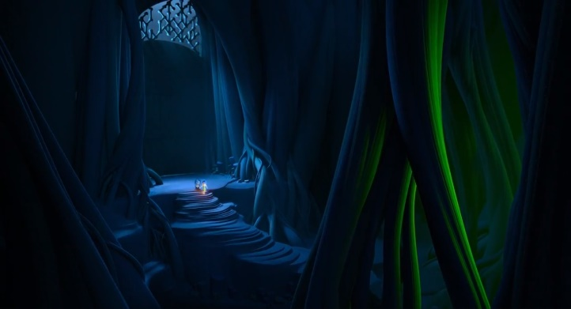
When Bing Bong gets arrested, Joy and Sadness attempt to break him out. We are presented with an extreme long shot from a high angle. The scene is dimly lit with Joy being the only heavy source of light onscreen. The purpose of the shot is to make Joy and Sadness appear as weak in comparison to their impending task of freeing Bing Bong. The camera pulls back even further to make the characters seem even smaller than they are.
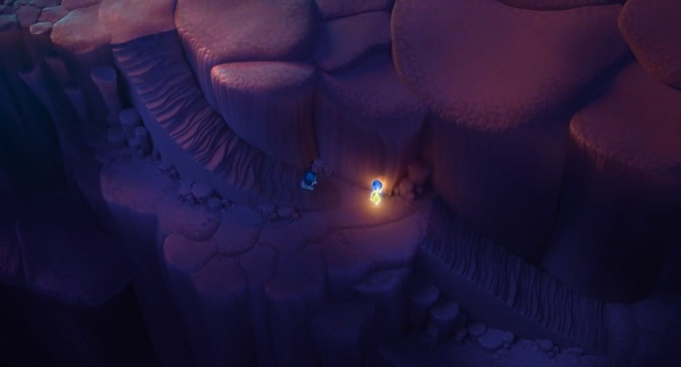
During this sequence is a shot that makes excellent use of the rule of thirds to highlight how dwarfed the characters are by the giant environment they inhabit. There is a green glow incoming from the right of the screen in the direction that the characters are going. This indicates that whatever is casting that green glow will be an obstacle in the protagonist’s path. According to colour theory, green can often be used to represent uncomfortableness or evil. This contributes to the atmosphere that the scene is building.

When Riley decides to run away from home, she is fully covered in shadow as this is a decision is made in anger. She steals her mother’s credit card and runs up the dark stairs. This entire time the mother is standing under the kitchen light, this is to provide a contrast to the shadows that are around Riley.
The wall on the side of the left side frame takes up a large portion of the shot to emphasise that Riley is feeling boxed in and that she has no other choice but to run away from her new home.
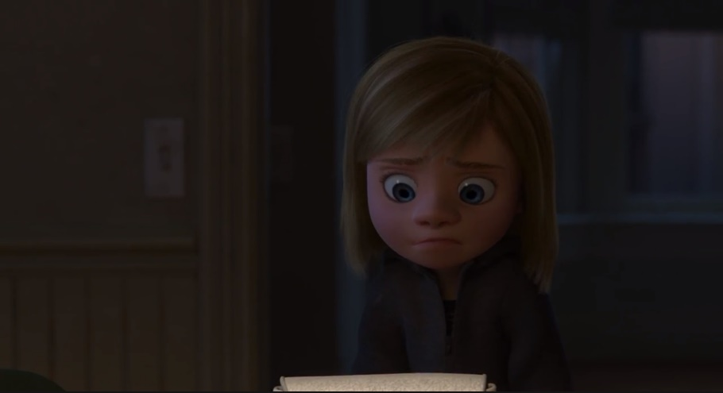

After their escape from Bing Bong’s prison, Joy and Bing Bong wind up in the “memory dump”, a dark pit where everything unneeded it dumped and forgotten. The entire place is cast in darkness with a bare minimum of light. Joy is her own light source however, this represents how she is not going to give up in her attempt to help Riley. Joy is a literal light in the darkness, she represents hope in this place full of darkness. If we read the scene from left to right, we see Bing Bong telling Joy to give up, he is anchoring the scene. On the right of the shot, we have Joy who is attempting to move further right to progress towards her goal.
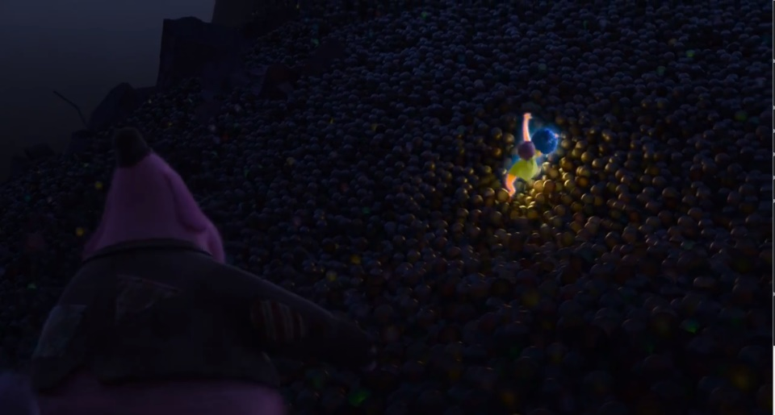

Joy gives up on escape and breaks down crying, however due to her luminosity she can not traditionally be framed as sad by the lighting. Pixar still does find a way to use it to their advantage however, the light from her body is reflected into her eyes to make them appear shinier and wetter.
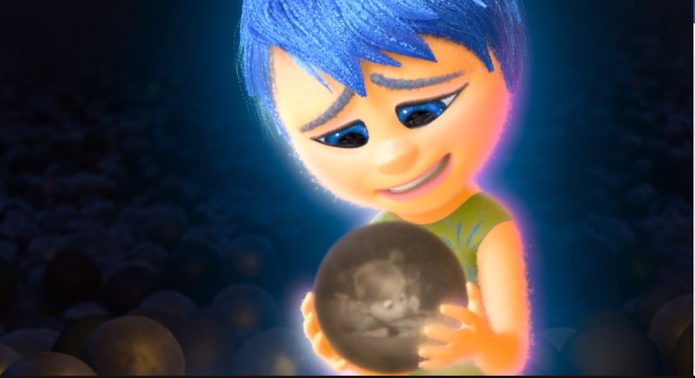

As Riley is queueing up to get into the bus to start her new life as a runaway, the scene is lit by a sickly yellow-green light which is a colour that is meant to be uncomfortable and foreshadow dangers. As Patti Bellatoni says in her book If It’s Purple, Someone’s Gonna Die;
“It’s obviously impossible that David Hand, the director of Snow White and the Seven Dwarfs (1937); Sofia Coppola, director of the Virgin Suicides (2000) and Kasi Lemmons, director of The Caveman’s Valentine (2001) met and decided unanimously to choose green liquid as a metaphor for poison. But choose it they did.” (Bellatoni, p160, 2005)
The shadows on her face are somewhat harsher than is used in the majority of the film, so the key light may have been removed to reduce the softness of the shadow that falls on Riley’s face.
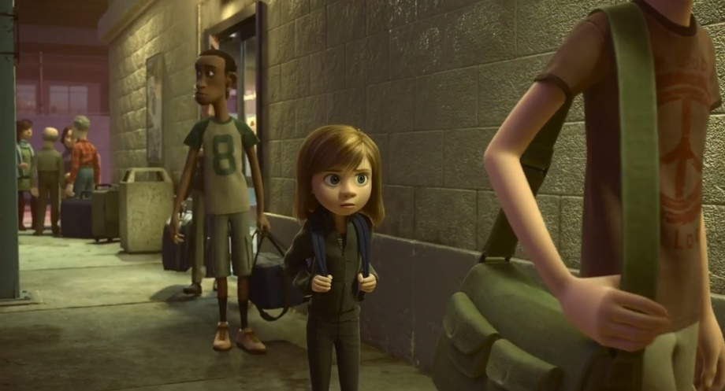
Additionally, there are characters on each side of her in the queue, she is blocked in on both sides of the frame. Riley is framed as being on a set path with nowhere else to go.

Once Riley has returned home she is enveloped by parents in a comforting hug and the colours and lighting are used to support this. Riley’s parents are positioned in the composition in a way as to block Riley’s way offscreen, this is because in this scene they represent safety and security for Riley. The scene is gently lit in a warm yellow and three-point lighting is used to provide soft shadows over the character and to separate them from the background.
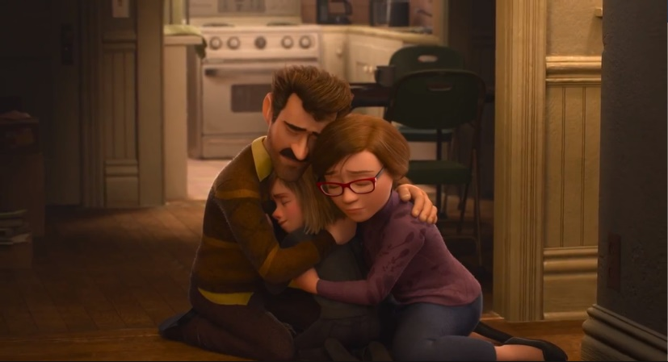

Conclusion
Both stories follow a similar theme of the challenges of childhood, growing up and independence. The Little Prince does this through the demonization and rejection of adulthood while Inside Out does this through the glorification of childhood. Ultimately both protagonists of the films permanently grow as people through the hardship they’ve endured.
Over the course of my analysis of these movies and how the aspects of cinematography capture emotion, I’ve found that whenever a scene elicits an emotional response from me, it is a scene that usually contains overwhelmingly negative emotion. This leads me to believe that the best way for a film to make an emotional connection with the audience is by seeing a character go through trials and hardships. This may be why underdog stories are such a popular subject for sports movies. The worse a character has it in the beginning of their story, the more the character are able to grow as they face adversity in their journey towards their set goal. A story without any growth is not satisfying for the viewer because if the characters are not met with any form of a challenge why should we as an audience care. There is no point in seeing a film about a winner who just keeps winning.
“You have to promise your audience that it will be with it for them to follow your journey and the emotions of the characters. In order to make the journey worthwhile it must be difficult for the characters. No, make it impossible for them. Create obstacles in the way of the character’s goal. This is how the characters grow and how stories become interesting.” (Glebas, p5, 2008)
When cinematography has to display negative emotions that’s when its influence is most noticeable on the frame, whether it is through changing the distance between the subject to the camera or framing the scene to surround the subject with objects. It is a noticeable change from the more open shots that often dominate these films. To give an example of this, lighting in films usually just follows a standard three-point light scheme. A key light for the main source, a fill light to add softer shadows and finally a back light to separate the subject from the environment. Both The Little Prince and Inside Out only break from using key lighting when the scene has a negative tone from it. I propose that this makes lighting the least dynamic aspect of cinematography despite being the aspect that’s easiest for the audience to pick up on. Colour on the other hand has a wide variety of emotions and meanings it can convey in numerous different ways. No matter what setting a film scene is taking place, there is a way that colour can be introduced in a realistic matter whether it is a character’s shirt, the colour of a wall, or a passing lorry. Despite the flexibility of colour however, I feel that while it may have an influence on the emotions of the audience, I believe that the effect is not as noticeable to the audience as lighting. Considering though, that to break the immersion of the audience in a film is something to be avoided in most cases, then perhaps the influence of colour on a scene is more influential as it is less likely to break their immersion than the intensity of low lighting.
When it comes to influencing the emotions of an audience, I conclude that while colour, frame composition and lighting all carry weight in affecting their state of being, it is also possible for them to disrupt the audiences immersion and thus possible to render the emotion impact of the films inert or at the very least diminished.

References
BELLANTONI, P. (2017). IF IT'S PURPLE, SOMEONE'S GONNA DIE. [S.l.]: CRC PRESS.
Cade, S. (2017). Storytelling with Cinematography – Framing + Composition | DSLRguide. [online] Dslrguide.tv. Available at: http://dslrguide.tv/framing-composition/ [Accessed 3 Nov. 2017].
No Film School. (2017). Composition & Framing Can Help You Tell Great Stories with Your Cinematography. Here's How. [online] Available at: http://nofilmschool.com/2015/02/composition-framing-help-tell-great-stories-cinematography [Accessed 3 Nov. 2017].
The Little Prince. (2015). [film] Paramount Pictures.
No Film School. (2017). How to Make Compelling Lighting Decisions that Support Your Story. [online] Available at: http://nofilmschool.com/2015/05/cinematography-tutorial-how-make-compelling-lighting-decisions-support-your-story [Accessed 13 Nov. 2017].
Inside Out. (2015). [film] Pixar.
Go Into The Story. (2017). Movie Analysis: “Inside Out” — Themes – Go Into The Story. [online] Available at: https://gointothestory.blcklst.com/movie-analysis-inside-out-themes-dbeb60322cce [Accessed 16 Nov. 2017].
shanovitz (2017). Lighting in Film. [online] Slideshare.net. Available at: https://www.slideshare.net/shanovitz/lighting-in-film [Accessed 16 Nov. 2017].
Cathrine Kellison, D. (2017). Mastering Film » The Basics of Lighting. [online] Masteringfilm.com. Available at: http://www.masteringfilm.com/the-basics-of-lighting/ [Accessed 16 Nov. 2017].
Storify. (2017). How cinematography effects emotions and feelings of the audience (with image) · breezonthemoon. [online] Available at: https://storify.com/breezonthemoon/how-cinematography-effects-emotions-and-feelings-o [Accessed 20 Nov. 2017].
Photographymad.com. (2017). Rule of Thirds | Photography Mad. [online] Available at: http://www.photographymad.com/pages/view/rule-of-thirds [Accessed 22 Nov. 2017].
Videomaker.com. (2017). Emotional Justification of Shot Choices. [online] Available at: https://www.videomaker.com/article/c06/17192-emotional-justification-of-shot-choices [Accessed 22 Nov. 2017].
No Film School. (2017). A Guide on How to Use Light to Communicate Emotion for Film. [online] Available at: https://nofilmschool.com/2017/06/guide-how-use-light-communicate-emotion-film [Accessed 22 Nov. 2017].
reddit. (2017). How is emotion created through cinematography? • r/cinematography. [online] Available at: https://www.reddit.com/r/cinematography/comments/2tylld/how_is_emotion_created_through_cinematography/?st=jafvuvzr&sh=47153915 [Accessed 25 Nov. 2017].
Hyman, I. (2017). Three Point Lighting: Learn About Key, Fill, and Back Lights. [online] Izzy Video. Available at: http://www.izzyvideo.com/three-point-lighting/ [Accessed 2 Dec. 2017].
Expertphotography.com. (2017). Cite a Website - Cite This For Me. [online] Available at: https://expertphotography.com/frame-within-a-frame-depth-contex/ [Accessed 2 Dec. 2017].
Writersstore.com. (2017). Connecting with Audiences Through Character Emotions. [online] Available at: https://www.writersstore.com/connecting-with-audiences-through-character-emotions/ [Accessed 3 Dec. 2017].
HURBIS-CHERRIER, M. (2017). VOICE & VISION. [S.l.]: ROUTLEDGE.
GLEBAS, F. (2008). DIRECTING THE STORY. [S.l.]: CRC PRESS.
Verywell. (2017). Can Color Affect Your Mood and Behavior?. [online] Available at: https://www.verywell.com/color-psychology-2795824 [Accessed 12 Dec. 2017].
ThoughtCo. (2017). Color Psychology: How Colors Affect Human Behavior. [online] Available at: https://www.thoughtco.com/color-psychology-and-human-behavior-4151666 [Accessed 12 Dec. 2017].
GRUSON, L. (2017). COLOR HAS A POWERFUL EFFECT ON BEHAVIOR, RESEARCHERS ASSERT. [online] Nytimes.com. Available at: http://www.nytimes.com/1982/10/19/science/color-has-a-powerful-effect-on-behavior-researchers-assert.html?pagewanted=all [Accessed 12 Dec. 2017].

