Student name Mohammed Amir Hussain Chaudhary Student registration Number 1711710 Module code MBALCMB7001 Group number One Lecturer’s name dr Olu adegbite Module name MARKETING MANAGEMENT

Executive summery
Marketing management is a process of observing the market, setting objective and goals of a company, establishing the plans step by step, taking decisions for the company and performing them to get the maximum revenue by meeting the consumers' requirements. To analyse Vodafone diverse marketing management approaches such as SWOT has been applied to analyse the micro environment and PEST to analyse macro environment of Vodafone. Furthermore, focusing on various types of improvement methods such as marketing mix, STP and social media approach has been exploited by Vodafone to assess the impact these model have on Vodafone’s marketing strategy. Finally, a critical conclusion and recommendations to solve the challenges faced by Vodafone to improve communication with customers and a way to advance into future for Vodafone.

Contents
Contents 3
Introduction: 5
Overview of Vodafone Plc: 5
Micro environment analysis using SWOT: 7
SWOT Analysis. 8
Macro environment analysis: 8
PEST analysis: 9
Marketing mix of Vodafone: 10
STP Analysis of Vodafone. 12
Social media Approach. 13
Measuring success. 14
Challenges faced by Vodafone. 15
Conclusion. 16
Reference: 19

Table of Figures:
Figure 1: Vodafone in Newbury, Berkshire…………………………………………………5
Figure 2: Vodafone Group Plc Annual Report 2020………………………………………6
Figure 3: PEST Analysis diagram…………………………………………………………...8
Figure 4: Marketing Mix Strategy……………………………………………………………10
Figure 5: The STP model…………………………………………………………...…...…...11
Figure 6: Influencer Marketing……………………………………………………………….12

Introduction:
Marketing management is a process of monitoring the marketing, setting objective and goals of a company, establishing the plans step by step, taking decisions for the company and performing them to get the maximum revenue by meeting the consumers' requirements. To analyse Vodafone diverse marketing management approaches such as SWOT has been applied to analyse the micro environment and PEST to analyse macro environment of Vodafone. According to Zimmerman and Blythe (2017), through marketing, the consumers can gain valuable information of the products, their features and usage. It creates brand awareness and making the business stand out. Furthermore, focusing on various types of improvement methods such as marketing mix, STP and social media approach has been exploited by Vodafone to assess the impact these model have on Vodafone’s marketing strategy. Finally, a critical conclusion and recommendations to solve the challenges faced by Vodafone to improve communication with customers and a way to advance into future for Vodafone.

Overview of Vodafone Plc:
Vodafone is a UK based communications services supplier and the second-biggest mobile phone organisation in the world and the third-biggest mobile network provider in the UK, with 17.2 million customers as of May 2021 and employed over 65,000 employees. According to Kalam (2020), Vodafone initiated as subdivision of Racal, a British electronics and radar company established in the 1950’s. Racal originated its Vodafone subordinate in 1983 and attained the license to build UK’s initial cellular telephone network, it was established in 1985.
Vodafone operates in more than 30 different countries in the world and also has partner operations in many additional places. Vodafone enjoys a substantial share of the telecommunications markets in a numeral of the different countries where it operates.

Figure 1: Vodafone in Newbury, Berkshire
(Source: Vodafone and Flex Legal.
Concepts and resources invested in marketing:
Vodafone is now more focused on providing customer-centric service. Vodafone are emotionally connection with their customers and really put in the effort to work together with their customers in the digital market, globally. Customer centricity is a concept that has stood the test of time for Vodafone. These authors Ghezzi et. al. (2016), digital transformation has aided Vodafone to reach out to millions of customers, this creative process was achieved by interviewing customers across the globe within the markets and the consumers sector, also retained feedbacks and obtained valuable information and data from industry analysts, with the support from their customers across its markets and the backing of their key stakeholders, partner who join them on their digital journey, partners who they can trust and are committed to them, due to these factors the company was able to reach its current success. Resource Vodafone invested in marketing in 2020 is explained in the diagram below.

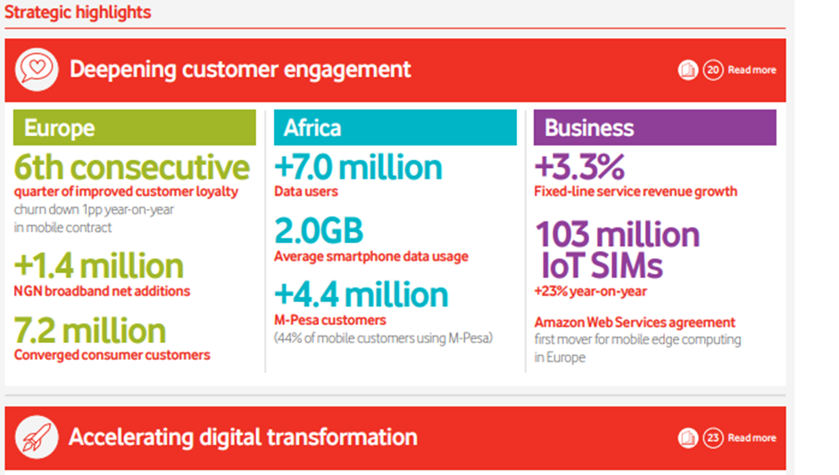
Figure 2: Vodafone Group Plc Annual Report 2020.
(Source: Vodafone Annual report 2020).

In mobile communication advertising market, Vodafone is forested to have the third largest budget for marketing, just after Samsung and Apple. According to Vodafone Group Plc Annual Report 2020. resources invested in 2020 for marketing is £200m a year, or one third of its £600m media budget, on digital advertising. Estimation for 2021 stands £210m just above one third of its annual media budget of 620m, on digital advertising. This indicates that media spending budgets have increased approximately by about 3.8 % in comparison to 2020.
It is assessed that Vodafone has sufficient resources for further development of the business is successfully trading alongside Samsung and Apple. According to Ghosh (2016), different sections of the societies are targeted by Vodafone with their diverse offers. As a result, it utilises selective and distinguished targeting strategies. Vodafone zoo-zoos ad campaign has been effective in generating top of mind awareness between communication services businesses round the globe. According to Batra (2021), in 2021 total revenues rose by 5.7 per cent to £11.1billion in the three months to June 30 in comparison to the prior year as all stores reopened and restrictions were loosened which helped business improve, it can be assessed that this is a positive step in the right direction for Vodafone.
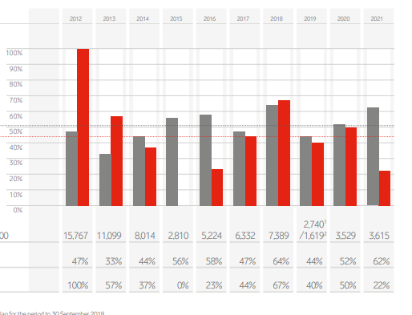
Vodafone’s financial report 2012-2021.

Micro environment:
SWOT analysis is a technique applied by organisations across the globe to assess the eternal business environment. According to Leigh (2009), SWOT is an analytical tool that comprises of 4 elements. “Strengths,” “weaknesses,” “opportunities" and “threats” to scrutinise the internal environment of a business. Below SWOT analysis has been conducted.

SWOT Analysis:

Table: Strength. Table: Weaknesses.
- As of May 2021, Vodafone is the third-biggest mobile network operator UK and has 17.2 million customers.  - Vodafone employed over 65,000 employees and is the globe’s second-biggest mobile phone company. | - Vodafone has to continually face challenges for market share with competitors, in line with the market price.  - Vodafone’s Alcatel 3L 64GB mobile handset which was declined, after its launch by customers, it didn’t meet the customer’s expectations, customers were dissatisfied with the product (Pereira 2013).

(Source: Author)

Table: Opportunities. Table: Threats.
- Focusing on Mobile number portability can assist in convert competitor’s customers to Vodafone’s network.  - Modern and low cost innovative technology can assist the brand to advance and grow rapidly.  - Unexploited rural market can be a massive potential for Vodafone. | - Rivalry from Reliance Jio, Airtel, AT&T etc. Offering low tariffs to customers, effected Vodafone in terms of revenue and mobile subscribers.  - Vodafone is operative in many different countries it is vulnerable to currency fluctuations particularly given the unstable political environment in number of markets across world-wide (Sulphey 2019).

(Source: Author)

Macro environment:
PEST analysis will be applied to probe the Macro environment of Vodafone Plc. Due to Brexit, Vodafone confronted tough times as new regulations and rules were imposed, suppliers were not meeting Vodafone requirement on time and Vodafone was not able to meet customer’s demands on time, this was a challenging time for Vodafone.

PEST analysis:
PEST is an analytical tool that is applied to scanning the macro external environment and assess the challenges that rises for Vodafone. According to Leyva. et. al. (2018), PEST analysis support companies to recognise the wider organisational environment. It stimulates the progression of external and tactical thinking. Once all the data are analysed, it is recognisable that PEST examination will support companies like Vodafone to predict future business challenge and threats in store for them.
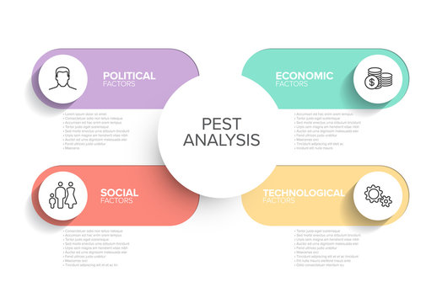
Figure 2: PEST Analysis diagram
(Source: Adobe stock 2021).

Political: factors have forced Vodafone to faced exceptional challenges in Europe. According to Todorova (2003), The level of government interference in Europe has grown leading to higher stress on Vodafone brands. Generally political environment of Europe has impacted economic environment and trade. Government’s behaver concerning Vodafone and its tax administrations all so affected the business. The key markets of Vodafone are Africa, Europe, Asia and Middle East. Political constancy in these counties has impacted the profitability and sales. Although, the desires for technology and technological services around the globe has increased in this generation and government influence and observing have also increased.

Economic factors have constantly resumed as the core framework of international business. According to Mac Shane (2016), the economies of Europe have been performing well before the Brexit. Brexit has generated pressures, which will continue to have an impact on Vodafone’s productivity in UK and Europe. Economic factors are like economical action in a particular country like Spain or its province will affect the employment the purchasing power of individuals staying in that locality. As a result, this impacts the sales and productivity of brands like Vodafone. Besides, increasing competition has also made the economic factors in the area of international business develop. General, economic factors must not and should not be unnoticed in relations to business and its approaches.

Social factors play’s a key role on the social movements, as individual’s way of living are impacting on their buying habits and preferences of individuals in various provinces of the globe have altered a lot, this has had a huge impact on the buying process. According to Lasén (2004), technology companies require to recognise these alterations and accordingly bring up to date their services mix. Worldwide, internet distribution, small retailers and individual’s business users require faster networks. A superior amount of individuals now spends a huge part of their daily time online, for employment or entertaining purpose. Increasing desires for internet constructed services has proven benefiting for international telecommunication brands like Vodafone. Numerous individuals are making purchases online and the value of internet in everyday life of individuals has increased a lot with social media too.

Technological factors
Technology plays an essential part in Vodafone’s business procedures. In recent years, Vodafone established its diverse range of products services, based upon the increasing requirement of the individual person and enterprises customers. According to Dodourova (2003), increasing number of user experience has forced Vodafone to concentrate on this aspect of implementing advanced digital technology into their infrastructure. therefore, the company is able to provide faster and higher broadband to their user, to create a suitability and increase user commitment. Vodafone offers vast range of services such as my Vodafone app website, which can be applied to excess the services. Vodafone also applies digital technology for advertisings. Generally, technology has developed better opportunities and a significant differentiation in the telecom industry since customers’ requirement for connectivity and data has developed quicker expectations within this generation.

Marketing mix of Vodafone:
Marketing strategy developed by Vodafone has been successful applied since the launch of Vodafone in 1985. This strategy has aided Vodafone to achieve the success it has obtained in today’s global market. According to Kotler et. al. (2017), all business requires marketing strategy. It offers the company's services and goods to potential consumers. Establishing the foundation of that strategy are four core marketing principles that support the effective implementation of a marketing strategy.

Figure 2: Marketing Mix Strategy.
(Source: Adobe stock 2021).

.

Product marketing mix strategy applied by Vodafone is they offers core products like post-paid, pre-paid and VAS (Value added services). According to Pereira (2013), Vodafone has products in numerous genera of communication like, smart phones, branded phones sets, voice messaging services, common handsets, internet services and VAS. Vodafone products targets numerous segments via different tariff plans, to make utilisation of data facility compatible and easier, Vodafone introduced their smartphone in 2020, the company announced 5G services as its next steps in increasing its telecom services.

Price is vital for Vodafone to ensured loyal customers are satisfied by providing high quality services to match the pricing. According to Grant and Grant (2008), marketing mix pricing strategy is performed diversely for all the segments that Vodafone targets, depending on various requirements, this is way pricing is done separately, to cater for all. Relaying on the service and its quality, such as high speed, bandwidth, this is how the price of the service or product is confirmed.

Vodafone’s products are priced in comparison to the market value and also assessing their competitors in order gain advantage over their competitors. Before Vodafone delivers a service or a product they utilising their core competencies, so customers obtain the best possible service or product, at the same price in comparison to their competitors. Vodafone’s prices are ranged to match the quality of their services.

Advertising is a key factor to Vodafone, as they are one of the world’s leading telecom brands.
According to Ghosh (2016), the marketing mix promotional strategies of Vodafone is to indorse the products (brand) via digital platforms such as internet, TV, print, billboards etc. The brand is marketed via sports stars & international celebrities like David Beckham, Mary Com, Michael Schumacher, etc. other method applied is using bill boards, TV commercials and other social media platforms, this has increased Vodafone’s brand value. These are the ways Vodafone is promoting their products and goods.

Place where Vodafone is trading from is vital as Vodafone always safeguards its client’s; the place they operate from and their customer’s is their highest priority. Vodafone has over 600 million subscribers global, across one hundred and fifty countries. Vodafone company has a workforce of over 90,000 workers globally. Employees as well as their customers, these are a significant asset in Vodafone’s development.

STP Analysis of Vodafone.
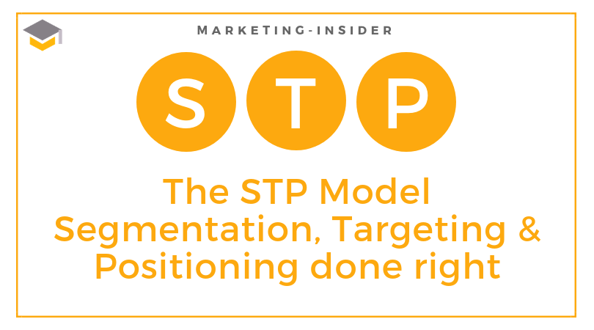
Figure 5: Image of STP model
(Source: marketing insider).

Segmentation is the procedure of separating the whole market of a company into smaller groups of segments, based on company’s market requirements. According to Anwar (2003), Vodafone World-wide enterprise division offers IT services and telecommunications to corporate customers in over 150 countries. Vodafone’s each branch operates in three
(demographic, psychographic and behavioural) segments to serve its clients. Customer’s care segment provides mobile sims, internet packages, mobile data, Vodafone’s world-wide services include IT infrastructure services to accomplished satisfaction to networks bases and marketable homes with NGN fixed-line network by Vodafone etc.

Targeting is when a company entices customers. The market of Vodafone is the mass audience. The average age group is ranged from approximately 17 to 60, they are more tilted toward internet usage, as every generation utilises mobile phones and the internet is exploited immensely. Although, the main focuses of Vodafone are the major wholesalers, entrepreneurs and small retailers who supplies the local community’s. According to Kalam (2020), Vodafone’s target clients comprise multinational firms, large corporates, medium to small business and public sector enterprises.

Positioning is essential, as Vodafone PLC was established in 1985 and have been successfully operating across Europe, Asia, Africa and Oceania. Vodafone are currently the third largest network provider in UK. In customer’s viewpoint Vodafone a reputable brand and positioned themselves as one of the most reliable network service provider in UK. According to Steenkamp. et. al. (2003), from November 2020, Vodafone possesses and operates networks in 22 countries, with partnership networks in 48 additional countries. Its Vodafone Global Enterprise division are supplies IT services and telecommunication to corporate clients in over 150 countries globally.

Social media Approach.


Figure 6: Influencer Marketing
(Source: Modern Talent).
Vodafone applies diverse promoting methods to advertise on social media platforms such as Email to communicate with customers to obtain their feedbacks, search engine optimisation (SEO), Internet promotions, TV, Print, Billboards, Facebook and Twitter and WhatsApp to promote themselves etc. Also the brand is promoted via sports stars & international celebrities like David Beckham, Mary Com, Michael Schumacher, etc. Another form of social media advertising is through sponsorship, this is a key approach applied by Vodafone, this method is applied by sponsoring football games, snooker tournaments, cricket test matches and live concerts etc. researches conducted and all data’s collected by Vodafone has proven that this are the most effective methods of advertising.

Measuring success.
Vodafone’s executive Committee board utilises a number of key performance indicators('KPIs') to monitor groups and regional performance in comparison to the budgets and forecasts as well as to measure progression compared to the group's strategic goals.
In 2002, Vodafone introduced customers care online feedback system, this was the solution to solve the complications and issues faced by customer’s, this was measured by monitoring and analysing the past and present complaints record to assess how effective the method is, it proved to be a successive approach for Vodafone. Additional measuring metric exploited by Vodafone is conducting performance reviews (CPR), analyse the present / past performance of Vodafone, also how Vodafone is performing in comparison to its competitor. This is an effective technique as provides an analytical overall view of the market that Vodafone is trading in.

At present the procedures that are utilised by Vodafone are effective but in future if these strategies become ineffective, then Vodafone requires scrutinising these methods, Vodafone desires to be innovative towards their customers, conduct customer survey’s report, examine what the customer’s requirements and implementing procedures that is satisfying to their customers, so that the customers are emotionally connected to Vodafone and their customer’s experiences meet their expectations. According to Grewal et. al. (2015), this can also be progressive by investing the resources required to improve and implementing the ongoing marketing strategies. Marketing requires time, money, effort, commitment of time, effort and resources. Insufficient businesses don’t ever actually take the time and effort required to develop a comprehensive marketing plan.

Challenges faced by Vodafone.
The desire for innovate technology requires further investments, as technology is changing rapidly.

Vodafone requires creating products and services that enables Vodafone to be sustainable within the market.

There are many communications service and product suppliers that provide various types of offers and discounts, it’s a challenging for Vodafone to retain the existing customers.

Vodafone require competitive priceing methods to retain existing customers and uphold the current market share.

Brexit had a devastating impact on the growth of Vodafone in UK and European countries, as there was restriction imposed on Vodafone’s free trade agreements. changing legislations is a challenge.

Conclusion.
Vodafone has been successfully trading for the last thirty-six years, at present Vodafone are one of the key supplier in communications services and still the unsuccessful in gaining the recognition they deserve or the market shares they ought to retain. In spite of offering a high-speed network, it has deficiencies in establishing distinguished policies for the market it trades in. this can be observed by probing the market shares static charts. Vodafone has unexploited rural market. This can be a massive potential for Vodafone, as their competitor are unsuccessful in achieved this yet. Vodafone has unsuccessful in capturing a niche a market for their product, this has been achieved by their competitors like Samsung and IPhone. Vodafone requires capture a niche market in order to establish their position within the market. Analysations of the annual report of Vodafone indicated that Vodafone are slow in adopting to environmental changes as Vodafone failed to capitalise on the globe pandemic of coronavirus, as majority of businesses and schools were closed in UK and broadband was essential for social, employment and studying purpose, Vodafone was incompetent exploiting this opportunity.

To an extent, Vodafone is unsuccessful in competing with their competitor like Samsung and IPhone in creating a mobile phone handset which is on par level with their competitors. In the early nineties Vodafone dominated the market, they were influencing on their promotional activities with new and modern innovative ads, their marketing strategies worked wonders, Vodafone used sports stars & international celebrities to market their product to gain the trust and commitment of customers. Know, it appears that Vodafone lacks the innovation, motivation and the dedication to create a strategy method to be on level par with their competitors. Vodafone requires to focusing on a balance methodology to mitigate imbalance
factor within the structural framework of Vodafone, as this will create a platform to compete with their competitors and advance into the future. In the era of technology, consumers are vigilant of applying new and innovative technologies.

This his increase their expectations from renowned brand like Vodafone, which has not been upheld, as Vodafone’s competitors launched new innovative products and services, like Samsung launched the new Galaxy Z Fold3 5G and IPhone launched the IPhone 13 Pro Max, Vodafone was unable to launch any innovative products or service to match their rivals. Vodafone has a vast and variety of products, polices that are obsolete these have to replaced or restructured and new and innovate technology is requires to be embraced, as up-to-date innovative and technology can support Vodafone to enhance and development customer’s relationship rapidly.

Recommendations
Vodafone Plc is a renowned brand in the UK market but yet Vodafone’s competitors much advanced in the global market, at present Vodafone possess 14% of the market although, around 89% of the UK’s population and business are utilising the internet on a daily basis. Hence, Vodafone is required to restructure and innovate business marketing strategy to entice appropriate clients. Based on the analysis, below are some recommendations.

As Vodafone shares are at all-time low, Vodafone is highly apprehensive about its stakeholders and clienteles, to stabilise and safeguard the market share, Vodafone’s must apply new marketing strategies such as a combination of total quality management perspective and customer’s relationship management, this will facilitate Vodafone to achieve success and improvements that is essential for them. These strategies will support Vodafone to gain competitive advantage by creating a new image and improving its performance internally and externally. Nevertheless, Vodafone also requires fresh strategies to meet the shortage and lack of competence in their market approach and achieving customer’s satisfaction.

It has been acknowledged that Vodafone lacks innovation and promotion of its products and services, particularly concerning the new Vodafone Alcatel 3L 64GB which was launched recently and the product was declined by, as it didn’t meet the customer’s exceptions, customers were dissatisfied with the product. Vodafone should focus more on its total quality management perspective and customer’s relationship management, which will assist in improving the after-sales services for its future.

As digital technology is applied by everyone, it is essential for Vodafone to innovate to endure applicable technology into such a competitive market. Vodafone requires improve their existing product or services and creating new essential products or services with the support of new technologies, this will enable them to preserve Vodafone’s market share and values. The new products or services will allow Vodafone to meet the customers’ requirements and also enable Vodafone to promote their existing product and services. According to Given (2018), at present Vodafone is worst network provider in Australian, if the signal is non-existent, it is meaningless to have unlimited calls, Vodafone is working to develop its network, but many former clients are understandably unenthusiastic to trust Vodafone.

Analysation of Vodafone also indicates that reorganising the pricing is required, such as Tier pricing or flat pricing. tiered pricing is focused on customer’s experiences service, customers’ requirements and willingness to pay. It’s totally focused on costs and value for customers' whereas. Flat Pricing enables customers to enjoy more services at the price they are willing to pay as many consumers preferred to pay high price for quality services. Fixed prices restrict them to enjoy immense services. Another approach which will be beneficial for Vodafone is the total quality management is viewed as a management structure for a customer-driven industries like Vodafone, as Vodafone desire all employees to constantly improve themselves.
According to Ker and Moloney (2018), Vodafone must connect with its customers anyplace at a sensible price by owning hotspots technologies to connect gadgets and devices with high-speed broadband. It is vital that Vodafone implements the above recommendations, as these recommendations will assist Vodafone to meet the customer’s requirement satisfaction of their customers and fulfil Vodafone’s objectives.

Reference:
      - Adobe stock (2021) marketing mix strategy (online) Available at: https://stock.adobe.com/sk/search/images?k=marketing+mix.Accessed on 10-1-2021.
      - Adobe stock (2020) pest analysis (online) Available at: https://stock.adobe.com/search?k=pest+analysis 9-10-2021.
      - Batra, S., 2021. Case Analysis II: AGR Challenge for Bharti Airtel and Vodafone Idea. Vision, 25(2), pp.258-260.
      - Claessens. M. (2019) Marketing-insider segmentation targeting positioning done right (online) Available at: https://marketing-insider.eu/the-stp-model-segmentation-targeting-positioning-done-right/. Accessed on 20-10-2021.
      - Dodourova, M., 2003. Industry dynamics and strategic positioning in the wireless telecommunications industry: the case of Vodafone Group Plc. Management Decision.
      - Ghezzi, A., Balocco, R. and Rangone, A., 2016. The Open Innovation–Strategy nexus: findings from the Mobile Telecommunications Industry. Management Research Review.
      - Ghosh, C., 2016. A study of Basic Marketing Strategies of Vodafone for Improving Business Performance. International Journal of Management, IT and Engineering, 6(11), pp.84-89.
      - Given, J., 2018. Did it work? An update on the costs and benefits of the transition to digital TV in Australia. International Journal of Digital Television, 9(1), pp.43-52.
      - Grant, R.M. and Grant, R.M., 2008. Cases to accompany contemporary strategy analysis. Malden, MA: Blackwell.
      - Grewal, R., Lilien, G. L., Bharadwaj, S., Jindal, P., Kayande, U., Lusch, R. F., & Spekman, R. (2015). Business-to-Business Buying: Challenges and Opportunities. Customer Needs and Solutions, 2(3), 193-208.
      - Kalam, K.K., 2020. Market Segmentation, Targeting and Positioning Strategy Adaptation for the Global Business of Vodafone Telecommunication Company. International Journal of Research and Innovation in Social Science (IJRISS), 4.
      - Kerr, W.R. and Moloney, E., 2018. Vodafone: Managing advanced technologies and artificial intelligence. Harvard business school, pp.9-318.
      - Kotler, P., Armstrong, G., Harris, L., C., & Piercy, N., (2017). Principles of Marketing: European Edition. 7th European Edition. Harlow: Pearson.
      - Lasén, A., 2004. Affective technologies—emotions and mobile phones. Reciever, Vodaphone, 11.
      - Leigh, D., 2009. SWOT analysis. Handbook of Improving Performance in the Workplace: Volumes 1‐3, pp.115-140.
      - LEYVA, M., HECHAVARRIA, J., BATISTA, N., ALARCON, J.A. and GOMEZ, O., 2018. A framework for PEST analysis based on fuzzy decision maps. Revista espacios, 39(16).
      - MacShane, D., 2016. Brexit: How Britain Left Europe. Bloomsbury Publishing.
      - Pereira, M.M.S.M., 2013. Own-brand mobile phones: the case of Vodafone Portugal (Doctoral dissertation).
      - Steenkamp, J.B.E., Batra, R. and Alden, D.L., 2003. How perceived brand globalness creates brand value. Journal of International Business Studies, 34(1), pp.53-65.
      - Sulphey, M.M., 2019. Could the Adoption of Organizational Ambidexterity Have Changed the History of Nokia?. South Asian Journal of Business and Management Cases, 8(2), pp.167-181.
      - Todorova, M., 2003. Industry dynamics and strategic positioning in the wireless telecommunications industry: the case of Vodafone Group Plc. Management Decision.
      - Vodafone (2020) Vodafone Group Plc Annual Report 2020 (online) Available at
https://investors.vodafone.com/sites/vodafone-ir/files/vodafone/annual-report/vodafone-annual-report-2020.pdf Accessed on 20-10-2021.
      - Zimmerman, A. and Blythe, J., 2017. Business to business marketing management: A global perspective. Routledge.

.

