
Blog 1. Interview
Video

The interview is from my educational field leader- Sophie. Cao. She is the Vice President of Golden Arrow (GR)and the operations of Beijing Center. Her kind of leadership and her Buddhist beliefs have been a big influence for me.
The first aspect of the question concerns the turbulence affecting the organization

Internal – turbulence
How to conduct internal management of employees? Such as performance appraisal, turnover rate, KPI.
I am a Buddhist and a servant leader. I think the responsibility of a leader is to help employees solve problems and improve themselves. Control and assessment in management are not the core factors. My management style ensures the stability of key employees, and more than 70% of them have been senior employees for more than 5 years. The company's contribution per capita is also the highest in the industry.
How to adjust the turbulence between departments? For example, the insufficient quantity of the Marketing Department leads to the poor performance of the sales department.
Leaders should pay attention to the turbulent between internal departments. The market volume of GR is less than other companies. We pay more attention to the quality of service, and the recommendation of old customers is our main source of customers. Of course, I will also increase investment in online advertising and offline campus promotion to seek more customers. In fact, there are many conflicts within the company, such as sales and post-production documents. The key to resolving way is to respond quickly to employee feedback, rather than ignoring employees' voices.
I think the most important skills in leadership are self-control and self-orientation. Both leadership behavior and decision-making process are closely related to these two factors.
Internal – turbulent
1. What turbulences does the company face during the COVID-19 and how to solve them?
Our company faces both internal and external turbulences during this period. Internal turbulences: 1. Employees can't work in the company and can't achieve face-to-face sales and training opportunities. 2. Inability to conduct offline market activities leads to insufficient data to be provided to the sales department. External turbulences: 1. UK universities and embassies closed, training and visa blocked. The number of overseas students decreased due to the severe epidemic in Britain and the United States. 3 The police of Chinese government discouraging studying abroad makes parents and students nervous.

I was the first to try and adjust my strategy. 1. Make it easier for employees to work from home. Such as buying online video equipment. 2. Increase the methods and input of online publicity to reduce the impact of the epidemic on offline publicity. Late due to invalid and suspended. 3. Develop a new online sales manual for the sales staff to help them change the sales model. Keep practicing and adjusting.
Another thing I want to add is the attitude of leaders towards capital. In 2020, the venture capital craze for the education industry, a large number of hot money into the education industry. This situation brought great impact to the company, some investors said that the GR can get a huge investment with coordinate. The requirement was to adjust the product mix and reduce service standards and product prices, which was seriously inconsistent with my corporate culture. I think leaders need to stay awake and stick to their original intentions. Tim, our former language training partner, you know his case. He got venture capital but it didn't work out so well.
The second aspect is how to deal with the emerging leadership dilemma.
What leadership behaviors are important for solving problems?
Try and adjust your strategy. Most of the time, we can't find the best solution directly.
2As a Buddhist, how to adjust the execution of leadership in the face of complex situations?

First of all as a Buddhist I believe in being kind to others. Many overseas study companies have a very strict KPI system, which I think is not suitable for me. Secondly, balancing the goals of the organization is not inconsistent with focusing on the employees. In fact, I prefer to trust the employees more often. I believe my team can face the difficulties and make adjustments. This is the result of the team culture cultivated by years of cooperation and team self-adaptation and self-growth. I don't like leaders who only focus on employees or put people first and just talk about it. Finally, in the face of complex situations, I think leaders should maintain emotional stability, encourage employees to actively try, and not be afraid of making mistakes.
3. How to help the members of the organization grow and make progress together with the company when facing CAS?
Beijing is an international city where young people face enormous economic and social pressures. I think leaders need to find a balance between money and growth. This balance includes the employee's mood, the employee's work intensity, the employee's mental health. In my opinion, an organization with a good corporate culture has vitality, which means the enterprise will grow and improve itself. As I mentioned earlier about leadership self-positioning, if you define yourself as the hero, the core of the team, you're going to miss a lot of voices from below. Examples of failure caused by leaders losing themselves and ego expansion are very common in the business society. Only help the company's core employees grow up quickly. For example, Marry, your former assistant, is now the manager of the UK department and can be responsible for sales, marketing, and university reception. Give employees more opportunities. Only by practicing and learning constantly can employees make progress.

Atresianilova, N. and Zulfa, M., 2017. MODEL OF IMPROVING PERFORMANCE THROUGH HUMAN CAPITAL, ORGANIZATIONAL LEARNING AND SOCIAL CAPITAL IN THE REGIONAL SECRETARIAT OF SEMARANG REGENCY GOVERNMENT. International Journal of Islamic Business Ethics, 2(3), p.96.

Alojairi, A., 2021. Application of Ashby’s Law of Requisite Variety to Interorganizational Conflicts in Nonprofit Organizations. Administration & Society, 53(7), pp.987-1013.
Chen, K., Guo, W., Kang, Y. and Wan, Q., 2020. Does religion improve corporate environmental responsibility? Evidence from China. Corporate Social Responsibility and Environmental Management, 28(2), pp.808-818.
Wang, J. and Lu, J., 2020. Religion and corporate tax compliance: evidence from Chinese Taoism and Buddhism. Eurasian Business Review, 11(2), pp.327-347.

Du, X., 2013. Does Religion Mitigate Tunneling? Evidence from Chinese Buddhism. Journal of Business Ethics, 125(2), pp.299-327.

Hinds, N., 2020. Servant Leadership in Action: How You Can Achieve Great Relationships and Results, by Ken Blanchard & Renee Broadwell (Eds.). Oakland, CA : Berrett‐Koehler Publishers, Inc., 2018. 245 pages, $26.95 (hardcover). New Horizons in Adult Education and Human Resource Development, 32(4), pp.79-81.

Hoch, J., Bommer, W., Dulebohn, J. and Wu, D., 2016. Do Ethical, Authentic, and Servant Leadership Explain Variance Above and Beyond Transformational Leadership? A Meta-Analysis. Journal of Management, 44(2), pp.501-529.

Park, S., Jeong, S., Jang, S., Yoon, S. and Lim, D., 2017. Critical Review of Global Leadership Literature: Toward an Integrative Global Leadership Framework. Human Resource Development Review, 17(1), pp.95-120.

Poulis, K. and Poulis, E., 2016. Problematizing Fit and Survival: Transforming the Law of Requisite Variety Through Complexity Misalignment. Academy of Management Review, 41(3), pp.503-527.
Blog 2:
This is an interview with a successful business leader. The interviewees explained her understanding of leadership from a Buddhist perspective. Many of her ideas and practices are very inspiring to me. Such as how to keep the company growing even if COVID-19 becomes normal. She emphasized that the dilemma of leadership comes from resolving the conflict between external and internal. ( Alojairi, 2021 ) I think self-control and self-awareness are the basis of leadership decision-making and behavior in her interviews. This is the biggest problem in the leadership dilemma.

“Leadership is about serving everyone and solving problems" she said. Get the most out of your employees." While the authors hope that servient leaders are better suited to dealing with complex situations. (Hinds, 2020 )Let's focus on employees first. Managing stress and giving work back to employees is an important component of adaptive leadership. ((Haryokusumo and Wibowo, 2019) For example, according to the different approaches of COVID-19 mentioned in the interview, some of the initial decisions have good effects after implementation, while some choose to stop if the effect is not obvious. All the policies are related to the employee and help the employee to deal with the difficulties. （Hoch et al., 2016 and Dwiartama and Rosin, 2014)A clear self-awareness can help leaders better understand themselves. Therefore, appropriate leadership and management models can be selected.
The servant leadership model mentioned above is closely related to religion. (Chen, Guo, Kang ; Wan, 2020 and Hinds, 2020) According to the research of Du( 2013), the Buddhist Church improves the self-discipline and self-control of Chinese businessmen. (Du, 2013) For Buddhists like Cao and me, religious practice is a very good way to improve our self-awareness. Cao mentioned the previous example of partner entrepreneurship, which I introduced in my class speech. He chose to set up learning centers in big cities during the epidemic period to help Chinese international students better learn online courses. His company had a very successful start, securing more than ￡5 million in investment. At this stage, I think this is a very successful example of sensemaking. (McDaniel, 2008)It is to face the unknown and complex dilemma and innovate new business models.（Larsson and Löwstedt, 2020 and Atresianilova and Zulfa, 2017）

Cao's interview and my personal work experience have directly proved the role of leadership self-efficacy in the leadership dilemma.(Dewall et al., 2011) I focused on the leaders themselves, although different types of leaders have different leadership behaviors. According to Thompson research, (2009) leaders need to have a better understanding of their own characteristics and needs in order to interact with the outside world more effectively.( Thompson, 2009) Through analysis, I believe that many problems of leadership dilemma come from leaders themselves, among which leaders' self-cognition and self-emotion control are important and important factors.

Know yourself, try bravely, keep innovating.

Thompson, N., 2009. People skills. New York: Palgrave Macmillan.( Dewall)

Hinds, N., 2020. Servant Leadership in Action: How You Can Achieve Great Relationships and Results, by Ken Blanchard & Renee Broadwell (Eds.). Oakland, CA : Berrett‐Koehler Publishers, Inc., 2018. 245 pages, $26.95 (hardcover). New Horizons in Adult Education and Human Resource Development, 32(4), pp.79-81.

Blog 3:
When I began to understand the homework requirements of the third part, I found that I had not published any information in the Team. In the last week, I focused on expressing my opinions and found that students' responses were not positive. I started to rethink my Network, and I found that the connections with my classmates in the PhD program were significantly lower than my previous level of social interaction. After I realized this problem, I made some adjustments: in the second week of the course, I started to meet offline with Maggie, Williaml, Eric and other Chinese students in Swansea. However, I found myself still lacking a sense of presence in the DBA community.
This is a very different situation from what I was in before Heart Coronet. I tried to figure out what was limiting my ability to build new networks, and I found that not being able to communicate face to face was holding me back. According to ANT, non-human actors play an important role. For example, when I communicate face to face, I will choose to talk in the field I am good at. I will choose to drink Gongfu tea and burn aloes. These inhuman factors improve the efficiency of my communication. The only form of communication in the DBA is online, and even when students and teachers are in Swansea it is difficult to have face-to-face communication. The change of Actor inactive agent factors leads to low communication efficiency. All these affected my initiative and effect in establishing a new DBA classmate network.（Emery, 2012 and Hoppe and Reinelt, 2010）
After we started to have dinner offline, I found that I gradually deepened my understanding of the individual DBA students. I got help from my classmates on learning methods and curriculum understanding. I got the opportunity to communicate face to face. That is to invite everyone over for tea and dinner. I am a very good cook and speaker, and the results of communication are always very pleasant. I think it was at this point that I really started building and expanding my own DBA network.

Another reflection comes from my knowledge and understanding of social media. In fact, I lack understanding of the concept of network as an organization. Social an important concept in ANT theory which is based on communication and connection. (Dwiartama and Rosin, 2014)These connections cannot be established if the actors themselves do not manifest agency in the form of action. For example, Facebook is a very good unhuman factor, and using this technical platform to build a perfect network is what I lack. Before this, my impression of new media was limited to the company's marketing promotion.
The last interesting phenomenon comes from the content of my messages and the number of responses to my classmates when I post. In fact, I only focus on topics that interest me. For example, my research direction is academic procrastination, and I will focus on the ego factors of leaders. Only a few students who have been interviewed have replied to me. My personal judgment is directly related to my failure to communicate effectively with other students before. ((Dewall et al., 2011))This is a great proof that you can't form a network without establishing relationships.（Emery, 2012） The students who responded, such as W, were examples of weak ties turning into strong ties. (Sundararajan, 2020) After several interviews, we agree with each other. This is the time when we make really transition from strangers to friends.

Hoppe, B. and Reinelt, C., 2010. Social network analysis and the evaluation of leadership networks. The Leadership Quarterly, 21(4), pp.600-619.

Sundararajan, L., 2020. Strong-Ties and Weak-Ties Rationalities: Toward an Expanded Network Theory. Review of General Psychology, 24(2), pp.134-143.

DeWall, C., Baumeister, R., Mead, N. and Vohs, K., 2011. How leaders self-regulate their task performance: Evidence that power promotes diligence, depletion, and disdain. Journal of Personality and Social Psychology, 100(1), pp.47-65.

Dwiartama, A. and Rosin, C., 2014. Exploring agency beyond humans: the compatibility of Actor-Network Theory (ANT) and resilience thinking. Ecology and Society, 19(3).
Blog 4: Network Theory

Blog 4
network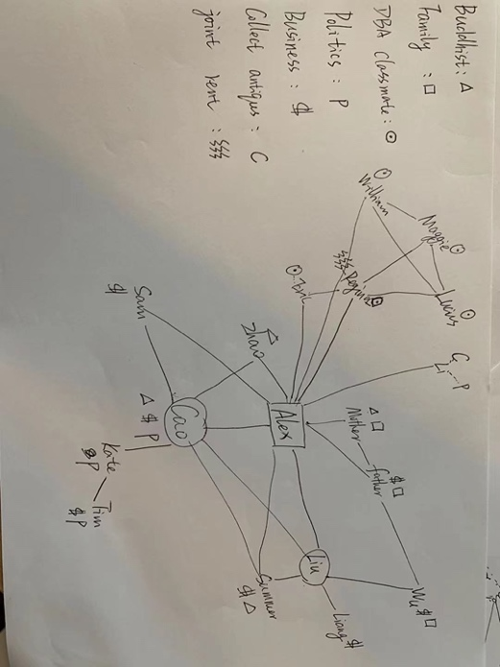
My previous NETWORK resources focus on government, business, collection, religious belief and family. Before this course, I had little contact with DBA students. My personal analysis was the reason for the social dilemma caused by the fear of using a second language and the epidemic. Since my doctoral research direction is academic procrastination, the research objects are our company's customers, and my staff can help me collect data. The resources that are missing are mainly academic support, such as researchers with expertise in quantitative or qualitative analysis or doctors with backgrounds in psychological counseling who specialize in the treatment of procrastination. I need to open up more professionals in my research field.

My Internet Advantages
Be simple and efficient. I cut down the ineffective social contact before. I felt very bad after attending several classmate parties in China. Only three or four students who could communicate effectively were in religious or business circles, and the rest were deleted. 2. There is intersection between different circles, which is very active as a HUB and helps me expand the network. 3. I need to improve my Personal Networking and Strategic Networking. (Cross, Ernst and Pasmore, 2013)
Internet Advantages
1. Be simple and efficient. I cut down the ineffective social contact before. I felt very bad after attending several classmate parties in China. Only three or four students who could communicate effectively were in religious or business circles, and the rest were deleted. 2. There is intersection between different circles, which is very active as a HUB and helps me expand the network. 3. I need to improve my Personal Networking and Strategic Networking.
Disadvantages: 1. The expansion of the network is not enough; 2. The attention to the HUB is not enough; 3. The energy distribution of maintaining the network is less invested in business;
Development plan
Some hubs in the network play a more important role. （For example, Liu in the business system is my assistant who can help me connect all the staff in the company. More importantly, she also intervenes effectively with both human and inhuman factors. I think more support and trust should be given to Hub. The growth of the HUB allows for more efficient maintenance of existing networks, giving leaders the opportunity to expand new networks.
2 There are some people in my network who exist in two or three fields. Cao, for example, has three resources: business, Buddhism and politics. Li is both a businessman and a collector. I found that these crossover people could help me expand my network more efficiently.
Development of new networks and extension of existing networks. A recent example is the establishment of a DBA classmate Network. The expansion of the Buddhist network came to a standstill after I arrived in the UK, mainly due to the lack of Buddhists in the UK and my own lack of social interaction.（ Cross, Ernst and Pasmore, 2013)
Blog 5:
Background and Feeling
There are five members in the fourth group, only Lucius is in China, and the remaining four players are all in Swansea: Alex(Me), William, Regina and Eric. Reflection on the debate of the fourth group started from the group. As mentioned above, I have organized two or three offline gatherings to provide a platform for face-to-face communication. As a matter of fact, I was always the leader of the team at the party. I gave more consideration to the needs of members of the organization and tried my best to meet their different needs. A new problem arises: no one wants to team up with Lucius because he's in China. Lack of communication opportunities and failure to establish effective communication.( Sundararajan, 2020 )On the surface, all the members of the organization said that they didn't care who they were in the group with, so the group work stopped for 2 days. think this is a manifestation of the unwillingness of the members of the organization, including me, to take responsibility. (McDaniel, 2008) I again played the role of the service leader, taking the initiative to choose a team with Lusis and suggesting another with the remaining three. The reason for this decision is that the debate is balanced, given Lucius's and Eric’s British academic competence. It was decided that Eric would be the moderator of the debate and take the lead in the debate practice afterwards.
At the first presentation Lusis and Eric had a serious disagreement. It turns into an emotional confrontation at the end of the discussion, and the emotions are very negative. I initially did not want to play a leadership role in the preparation of the debate, mainly because of concerns about my academic ability and English ability. The decision was influenced by personal factors and prejudices. (Foster, 2013) In order to change the situation to achieve the established goals of the organization, I began to coordinate various opinions, determine the order and content of the speech. A similar situation also happened during the debate. When everyone finished their personal statements and entered the free debate, Eric misremembered the order of their speeches, resulting in a 10-second gap between the students behind. This led the teacher to believe that the debate was over, and neither I nor the other students immediately objected. This situation once again made me question the initiative and responsibility of my team members, including myself. The free debate content of the debate was not completed, which seriously affected my study state. I was also disappointed by the conflict between members of the organization.
Analysis
Regina's social ability mainly lies in her weak ability and desire to express herself in language. She clearly showed her real intention that she could not serve as a leader. I analyzed the situation of Lucius at the beginning of Blog5, and I would prefer Eric to lead the team or play a more important role. Eric studied in Trinity College as an undergraduate with a first-class degree as a postgraduate. His academic ability and English ability are all right. These factors led me to believe that Eric should play the role of balcony, but it turned out that he did not play the role of leader or even the role of important connector. I was disappointed by the result. Analyze the reasons for Eric's failure in leadership behavior. As a servant leader in the team, I didn't have the opportunity to effectively help Eric grow up or try to lead and organize academic activities.

Conclusion and Action Plan

The basic requirement of task leadership is to establish communication and coordinate members to achieve predetermined goals. 1. There should be no prejudice that members of an organization should be able to play a leading role in a certain event. 2. In addition, as a service-oriented leader, they should pay more attention to the growth of members and help them learn effectively and build confidence. I actually started working on it after the debate. I invited Group 4 and Maggie have dinner and tea at home. I assigned tasks in advance and Maggie and Eric explained the assignment requirements for the next submission. Maggie has more than 10 years of experience as a university teacher, with detailed explanations and clear focus. Eric said he would get ready next time. Personally, I think this is the best way to learn, give more trust to the members and help the members of the organization grow.
6.
Sensemaking
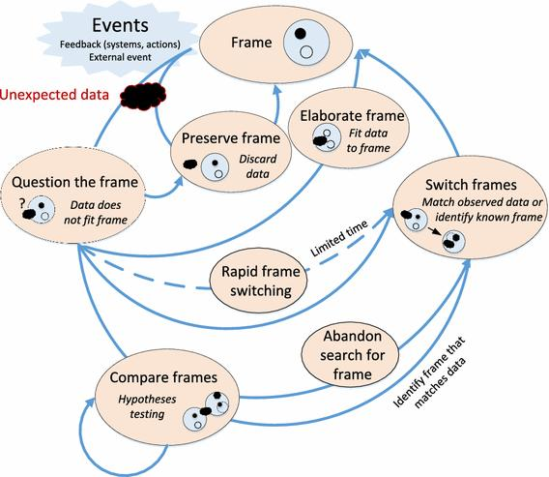Cao's interview mentioned the cases during the COVID-19 which directly proved the role of sensemaking in the leadership dilemma. In my previous defense, I gave an example of my own company in the epidemic, trying, adjusting and continuing to try this cycle. Because my personal experience is concentrated in the education industry. In order to support my point of view, I made a research on the influence of other fields. Internet companies online product process; Think about it, try it, adjust it, go online, adjust it. Considering the huge influence of Internet economy on business model in the 21st world, I think the change of sensemaking is a revolution in the way of thinking and decision-making. The traditional leadership model of planning and control is about to change dramatically.
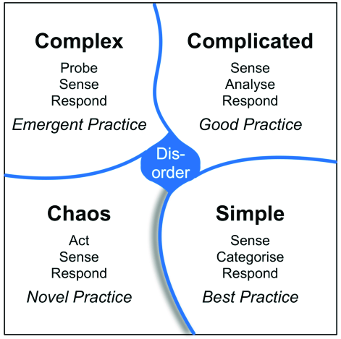
On the application of Cynefin theory
Cynefin theory has four models for dealing with complex situations.

Complicated (the knowable) The analysis tells us what we need to do. For example, we don't know when the COVID-19 will end. But research on a vaccine was necessary, so we recruited experts to speed up development.
Complicated (the knowable) We are not sure what to do or what is right. My education and training company is constantly trying to find new ways to train and adjust previous training programs.
Chaotic (the incoherent) This situation is very urgent, and there is no clear goal or method to solve it. Choose to restart or stop. For example, your phone suddenly dies and you can only choose to repair it or buy another one.
Disorder (not determined) -- inability to judge and analyze, no pattern or direction. Personal advice is to wait or give up.

Blog 7

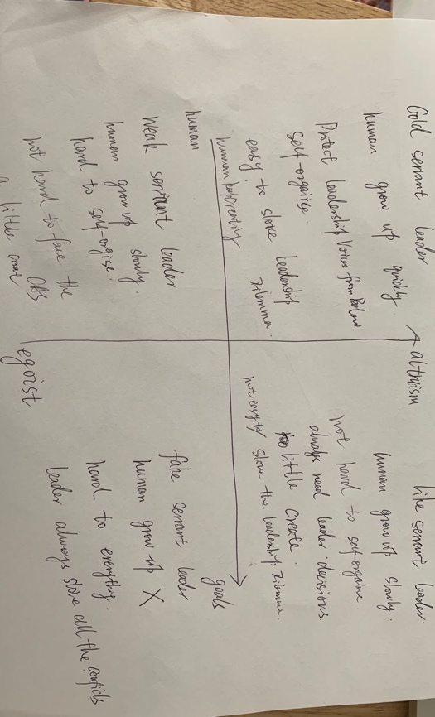

have been interested in servant leadership for several years. （Hoch et al., 2016）In the self-leadership analysis, I found that I was a charismatic leader for many years. I find that more and more leaders are beginning to call themselves service-oriented leaders, emphasizing the importance of people. In fact, we find that many leaders only describe, but do not actually act. L Many friends have asked me before: why I am so hard, always have to deal with a variety of things. Especially when new complications arise, everyone is waiting for the leader to make a decision.
(Dewall et al., 2011)
My model design includes two core factors: egoism or altruism, and whether the focus is on people or goals. I combined adaptive leadership, CAS and leadership behavior to make model design. Only when these two conditions are met, I call such a leader a servant leader. Leadership dilemmas are mitigated by the growth of team members.( Hinds, 2020) On the contrary, self-interested and goal-focused leadership can only be a fake. As time goes by, the trust of the team will gradually be lost, and the cessation of growth of team members will lead to the aggravation of internal and external conflicts. All this will exacerbate the leadership dilemma.( (Teresa M and Mukti, 2008) In CAS, the team's cultural identity and efficiency will gradually decrease.
。

The other two conditions are what I call weak and similar-looking. Weak service leadership is mainly due to the egoism of the leadership will lead to prejudice and lack of purity. Team members just grow more slowly, can face complex situations but are less likely to innovate dramatically. Goal-focused altruists are the ones who look the most like service-oriented leaders. They are often defined as Transformational leadership. The difference is that they are more appropriate to choose material and spiritual motivation followers. The essence is more of a transaction than a service.

In the second part of this Blog I argued the importance of self-awareness as a leader. If leaders and others have a clearer understanding of their own situation in the process of leadership, it will have a positive significance for sensemaking. Another point is about the meaning of leadership self-efficacy. Self-control, self-learning and self-organization are all related to self-efficacy. Because of my intervention and resolution of procrastination I think the point of the model is to make leaders more about themselves than about other factors in the organization.

Reference

Hinds, N., 2020. Servant Leadership in Action: How You Can Achieve Great Relationships and Results, by Ken Blanchard & Renee Broadwell (Eds.). Oakland, CA : Berrett‐Koehler Publishers, Inc., 2018. 245 pages, $26.95 (hardcover). New Horizons in Adult Education and Human Resource Development, 32(4), pp.79-81.

DeWall, C., Baumeister, R., Mead, N. and Vohs, K., 2011. How leaders self-regulate their task performance: Evidence that power promotes diligence, depletion, and disdain. Journal of Personality and Social Psychology, 100(1), pp.47-65.

Atresianilova, N. and Zulfa, M., 2017. MODEL OF IMPROVING PERFORMANCE THROUGH HUMAN CAPITAL, ORGANIZATIONAL LEARNING AND SOCIAL CAPITAL IN THE REGIONAL SECRETARIAT OF SEMARANG REGENCY GOVERNMENT. International Journal of Islamic Business Ethics, 2(3), p.96.

Alojairi, A., 2021. Application of Ashby’s Law of Requisite Variety to Interorganizational Conflicts in Nonprofit Organizations. Administration & Society, 53(7), pp.987-1013.

Chen, K., Guo, W., Kang, Y. and Wan, Q., 2020. Does religion improve corporate environmental responsibility? Evidence from China. Corporate Social Responsibility and Environmental Management, 28(2), pp.808-818.

Wang, J. and Lu, J., 2020. Religion and corporate tax compliance: evidence from Chinese Taoism and Buddhism. Eurasian Business Review, 11(2), pp.327-347.

Du, X., 2013. Does Religion Mitigate Tunneling? Evidence from Chinese Buddhism. Journal of Business Ethics, 125(2), pp.299-327.

Hinds, N., 2020. Servant Leadership in Action: How You Can Achieve Great Relationships and Results, by Ken Blanchard & Renee Broadwell (Eds.). Oakland, CA : Berrett‐Koehler Publishers, Inc., 2018. 245 pages, $26.95 (hardcover). New Horizons in Adult Education and Human Resource Development, 32(4), pp.79-81.

Hoch, J., Bommer, W., Dulebohn, J. and Wu, D., 2016. Do Ethical, Authentic, and Servant Leadership Explain Variance Above and Beyond Transformational Leadership? A Meta-Analysis. Journal of Management, 44(2), pp.501-529.

Park, S., Jeong, S., Jang, S., Yoon, S. and Lim, D., 2017. Critical Review of Global Leadership Literature: Toward an Integrative Global Leadership Framework. Human Resource Development Review, 17(1), pp.95-120.

Poulis, K. and Poulis, E., 2016. Problematizing Fit and Survival: Transforming the Law of Requisite Variety Through Complexity Misalignment. Academy of Management Review, 41(3), pp.503-527.

Hoppe, B. and Reinelt, C., 2010. Social network analysis and the evaluation of leadership networks. The Leadership Quarterly, 21(4), pp.600-619.

Sundararajan, L., 2020. Strong-Ties and Weak-Ties Rationalities: Toward an Expanded Network Theory. Review of General Psychology, 24(2), pp.134-143.

DeWall, C., Baumeister, R., Mead, N. and Vohs, K., 2011. How leaders self-regulate their task performance: Evidence that power promotes diligence, depletion, and disdain. Journal of Personality and Social Psychology, 100(1), pp.47-65.

Dwiartama, A. and Rosin, C., 2014. Exploring agency beyond humans: the compatibility of Actor-Network Theory (ANT) and resilience thinking. Ecology and Society, 19(3).
Blog 4: Network Theory
Wang, J. and Lu, J., 2020. Religion and corporate tax compliance: evidence from Chinese Taoism and Buddhism. Eurasian Business Review, 11(2), pp.327-347.
Vu, M., 2019. Tensions and Struggles in Tackling Bribery at the Firm Level: Perspectives from Buddhist-Enacted Organizational Leaders. Journal of Business Ethics, 168(3), pp.517-537.

Chen, K., Guo, W., Kang, Y. and Wan, Q., 2020. Does religion improve corporate environmental responsibility? Evidence from China. Corporate Social Responsibility and Environmental Management, 28(2), pp.808-818.

