Student Name: Chloe Mason
P Number: 1902424
Programme of Study: BA Set Design
Module: ADAD4019
Title: Everyone is a Designer
Word count: 1550 words

"Design is not a single object or dimension. Design is messy and complex.", ( Natasha Jen). My exhibition will explore; the complex, messy world of design. It will draw upon the audience to find their inner designer and philosopher, as an exhibition would be nothing without an audience. This is why I am making my exhibition accessible for everyone . ‘Accessible design is good design’, (Steve Ballmer). I will be looking at photographer John Thackwray and designer Olafur Eliasson, and a range of thinkers across the world, which I will illustrate and quote through this essay. Bringing all these ideas together to create an exhibition on the high street that explores the complex designs in our own life and challenging our society’s norms and values. “Norms are the agreed‐upon expectations and rules by which a culture guides the behaviour of its members in any given situation”, (Houghton Mifflin), and a bedroom on a high street isn’t exactly seen as a social norm. Being a Set Design student I come to understand that designing a room is simple but designing a room that has been lived in is the tricky part. An idea as simple as an individual bedroom is full of unique designs by deconstructing and placing it on the high street can open up the possibility’s it meaning multiple things.

‘Everyone is a designer’ exhibition will not focus on the work of one individual but the work of everyone around the world. This being inspired by John Threackways ‘My room’ project. My idea will explore his work deeply as I deconstruct and pull his images into real life sets in which an audience can interact with. Placing a bedroom on the street disturbs the norms and values of our society and in turn will make it appealing to an audience to go fourth and interact with such a piece .’Curiosity helps us survive. The urge to explore and seek novelty helps us remain vigilant and gain knowledge about our constantly changing environment’, (Emily Campbell 2015). This idea isn’t deeply thought out, however, was an idea that sprung to mind first. “Make it simple, but significant “ (Don Draper). A simple idea can open up the possibility of having multiple meaning and can be understood by everyone, “most of the fundamental ideas of science are essentially simple, and may, as a rule, be expressed in a language comprehensible to everyone”, (Albert Einstein).

The theme in a way is no theme at all but create by the imagination and philosophers of our society. “Imagination is more important than knowledge”, (Albert Einstein). No text will explain the exhibition, in turn, it will not need text as others will try to explain the concept of this exhibition themselves. These ideas may be placed online as articles or spread across the media. Some may see it as looking at the inequality in our world, people may look to the individual bedroom it is, or may invoke people to explore the world around them more. In turn, it will have the simplest or some ways the deepest of theme of all that being you. You are a designer.“Design is everywhere, and everything we do is designed”, (John Hockenberry). People across the world shape the area they sleep in to suit their means of living, this being; their culture, social class, social status, gender, norms, values or the society you live in overall. You design your bedroom based on the environment around you. ‘A bedroom says a lot about a person — about their lifestyle, their passions, their habits’, (John Thackwray).

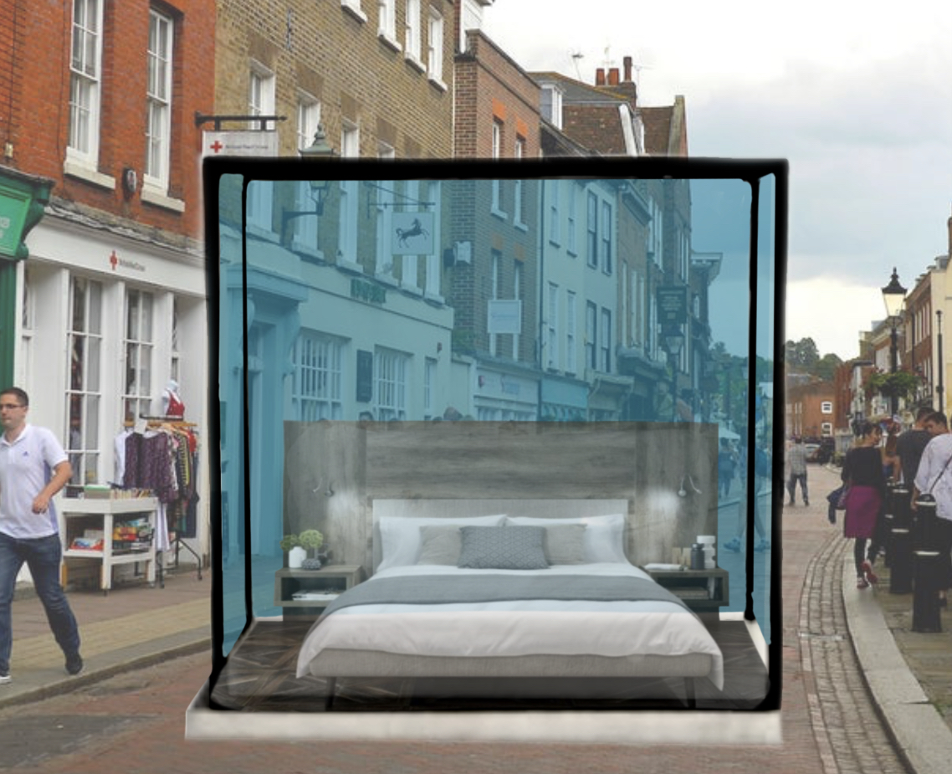
Here I will be explain how the exhibition will take place and I am using Cardiff, Queen Street as an example. The ‘everyone is a designer’ exhibition will take place in all the capitals city’s across the uk. As you can see by the imagine above, which I created digitally using the app ‘Procreate’ on my iPad. This digital picture represent a sets/bedrooms inside a glass box. In doing so, I will be protecting the set from being harmed by the unpredictable British weather. I will selected 4 images from Thrachwray ‘My Room’ project that I feel will have the biggest impact on the audience and will be built in detail to make the scene look as authentic as possible. Being a set design student, I have key skills and knowledge of how to deconstruct an image and create it into a physical set. In doing so, I hope for the audience to deconstruct and create their own understanding of what this exhibition means and it to be spread across the media. These 4 sets will be placed down popular high streets (using Queen Street as an example here) and will be located in these spots as I have highlighted in red X’s below.
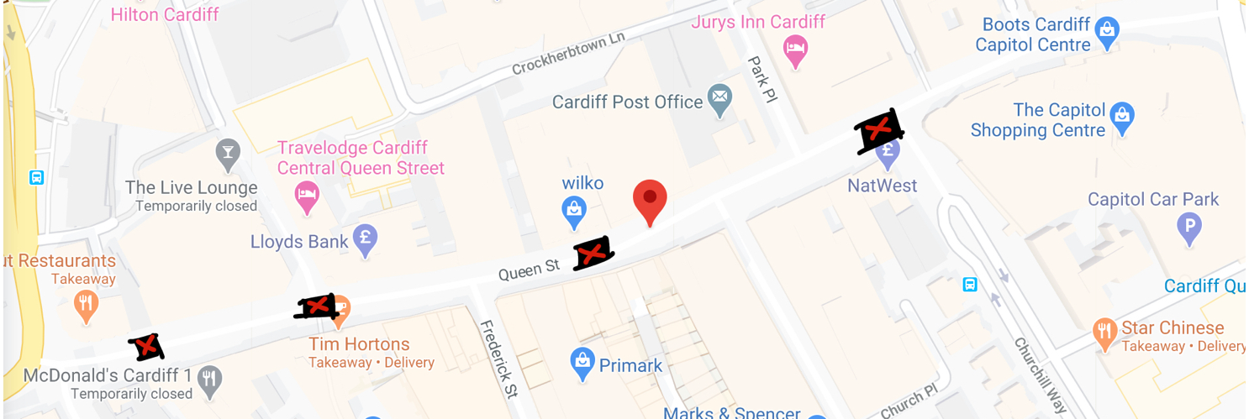

Even though my work seems to focus on John Thachwray work I was also heavily inspired by other artists from around the world. After watching the Netflix series ‘Abstract: the art of design’, I was heavily influenced by designer Olafur Eliasson and was the first to inspire this exhibition. His work itself is beautiful, however, his thought process behind his exhibitions is what inspired me . “For some reason,” he said, “our history has produced the misconception that experiencing individuality has to do with being alone. But being together is greater than being alone, because we can do more. We are more responsible.”(Olafur Eliasson 2014). These words are what inspired me to not focus on one single individual but many as ‘being together is greater than being alone’.
In 2014, Eliasson set up an exhibition outside the Tate Modern Museum, entitled ‘ The Ice watch’. In which, he placed 24 large blocks of centuries old ice, captured from Nuup Kangerlua fjord in Greenland. This being created in the perfect time to illustrate the impact climate change has on our world. “What does it mean to experience something? Does it change you or not change you? It turns out that data alone only promotes a small degree of change. So in order to create the massive behavioural change needed, we have to emotionalise that data, make it physically tangible.’(Olafur Eliasson 2014). By having something physical there for the audience to interact with can make for a more impactful exhibition, this being the exact experience I want to create for the ‘Everyone is a Designer’ exhibition. His exhibition had profound effect on the audience as they could touch and feel the ice, however, they had to sadly watched as the ice blocks melt away in front of their eyes. “It sounds so beautiful…That is air that was trapped before we started polluting the atmosphere. Those bubbles have almost half the CO2 content as the air outside the iceberg. It was trapped maybe 10,000 years ago, maybe 100,000, so you can smell what air used to smell like before we polluted it. And you can take a drink of it, beautiful, natural water.” (unknown interviewer Tim Jonzs 2018).

Finally, I was inspired by John Thackwray, 2011, ‘My Room’ project. However, he described it more as “where people sleep”, (John Thackwray). He took over thousand images from across 55 different countries. “The concept is simple: photographing young men and women born in the 80’s and 90’s, in the places they sleep, all around the world, and interviewing them about their lifestyle, local issues, education, religion, or love”, (John Thackwray). I feel as though his work is relevant now more than ever as cultures from around the world are beginning to interact “from Saudi young women to farmers in the African bush…..This is definitely the connected generation”,( John Thackwray). We may not be able to see them in person but bring these peoples culture and bedrooms into our high street can connect us even more and understand how different our worlds are. “Cultural differences should not separate us from each other, but rather cultural diversity brings a collective strength that can benefit all of humanity”, ( Robert Alan)

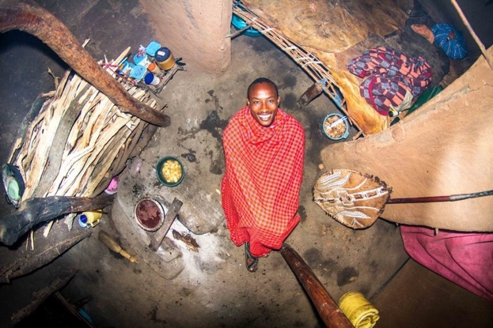
Here are the 4 images I have selected from John Thackwray ‘My Room’ project. (Which have been labelled ‘Bedroom 1-4’ ). Before I reveal to you, the reader, the place and who the person is within this image is, I would like for you to analyse and see what comes to mind first when looking at all 4 images. Do you see the cultural inequality, the violence, do you see smiling faces or do you see how a culture and environment can shape us and how we design our space ?
( Bedroom 1)
( Bedroom 2)



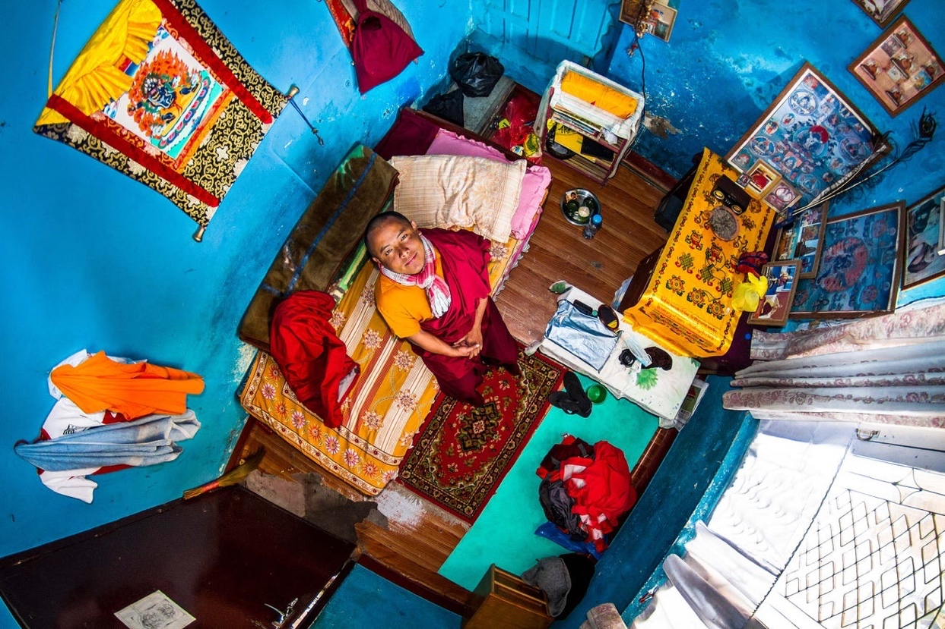
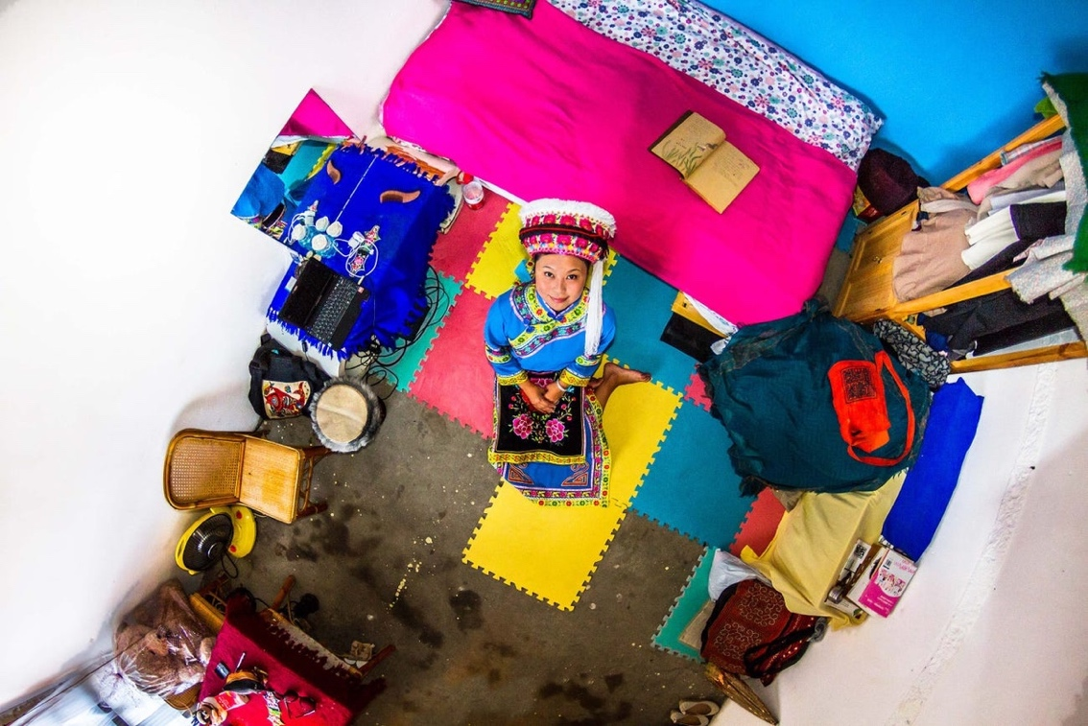
( Bedroom 4)
( Bedroom 3)

- Bedroom 1- Ezekiel, 22, a warrior in Echo Manyata, Kenya
- Bedroom 2- Ben, 22, a film student in Dallas, Texas.
- Bedroom 3- Yuan, 22, a salesperson in Dakli, China.
- Bedroom 4- Pema, 22, a Buddhism student in Kathmandu, Nepal

Overall, the idea is for you the audience to deconstruct these bedroom/cultures. Everyone will view this differently, which is the whole point of this exhibition. “Difference is of the essence of humanity. Difference is an accident of birth and it should therefore never be the source of hatred or conflict. The answer to difference is to respect it. Therein lies a most fundamental principle of peace: respect for diversity”, (John Hume).

Bibliography

(Albert Einstein, Simple ideas quotes)-
https://www.azquotes.com/quotes/topics/simple-ideas.html

(Caroline Forsey, 2019, 27 Quotes About Design to Get Your Creativity Flowing)-
https://blog.hubspot.com/marketing/design-quotes

(Christie Chu, August 20, 2014, Olafur Eliasson Floods Danish Museum with River Installation)-
https://news.artnet.com/exhibitions/olafur-eliasson-floods-danish-museum-with-river-installation-81795

(Dorothy Spears, September 2, 2007, Thinking Glacially, Acting Artfully)-
https://www.nytimes.com/2007/09/02/arts/design/02spea.html

(Emily Campbell, September 24, 2015, Six Surprising Benefits of Curiosity)-
https://greatergood.berkeley.edu/article/item/six_surprising_benefits_of_curiosity

(John Hockenberry, May 9, 2013, We Are All Designers)-
http://bravethewoods.com/john-hockenberry-we-are-all-designers/

(John Hume, 19 Insightful Quotes About Culture)
https://textappeal.com/cultureshocks/insightful-quotes-about-culture/

(Sophie- Claire Hoeller, May 16, 2019, Stunning photos show how different young people's bedrooms look around the world)-
https://www.insider.com/photos-of-bedrooms-in-different-countries-2016-10#one-thing-he-learned-through-this-project-is-that-the-world-is-unfair-15

(Tim Jonzs, December 11, 2018, Icebergs ahead! Olafur Eliasson brings the frozen fjord to Britain)
https://www.theguardian.com/artanddesign/2018/dec/11/icebergs-ahead-olafur-eliasson-brings-the-frozen-fjord-to-britain-ice-watch-london-climate-change

Images

4 Bedroom images-
https://www.demilked.com/bedrooms-around-world-my-room-project-john-thackwray/

Ice Watch picture-
https://olafureliasson.net/archive/artwork/WEK109190/ice-watch

