University of Wales Trinity Saint David
School of Engineering

Failure Mode & Effects Analysis – Technical Report
Engineering Applications & Study Skills – ACMA4007

Samuel Barry
2312272
12/02/2024

Table of Contents
1 Introduction 1
1.1 Aims 1
1.2 Objectives 1
2 Literature Review 2
3 FMEA 4
4 Conclusions 7
5 References 8
6 Appendix A 9
7 Appendix B 10

Introduction
In the ever-changing landscape of the manufacturing sector, it is vital for individuals working in the production business today to know about and manage risks appropriately. It is imperative for engineers to have a significant understanding of risk management, as the decisions and activities they make straightforwardly affect the standard of the result. Considering this, engineers must completely understand the thoughts and techniques of risk management. By having this understanding, they can find and fix potential risks immediately thus safeguarding themselves, other engineers, and the product.

The purpose of this investigation is to investigate how risk management methodologies are utilized in the manufacturing sector in general. This includes looking at all facets of risk. Failure Modes and Effects Analysis (FMEA) is a vital device for overseeing risk.

Aims
The essential aim of this work is to show how significant risk management is in the manufacturing industry, underscoring how pivotal it is for keeping up with tasks, ensuring items are of great, and following all guidelines.

Objectives
One objective is to focus in on Failure Modes and Effects Analysis (FMEA), this study sees how risk management techniques can be utilized to find, assess, and reduce conceivable failure modes and the issues they cause.
A secondary objective is to see the way that engineers can assist with overseeing risks all through the entire life expectancy of an item, from planning and designing to making the item and watching the item leave for the customer.

Literature Review
The literature review centers around what we know and understand about risk management. It inquires as to why risk management is significant and how to utilize devices like Failure Modes and Effects Analysis (FMEA) to bring down risks. Additionally, significant sources like the IMechE Code of Conduct for proficient engineers and related health and safety (H&S) laws are examined.

Manufacturing needs great risk management for various reasons. In view of new advancements, extremely high standards, and worldwide supply chains, (Domínguez et al. 2021) say that the universe of industry is continuously evolving. Engineers have an obligation to follow the IMechE 4 principles of conduct (IMechE.org, 2024), thus ensuring safety and quality are met to high standards. It is extremely important that health and safety guidelines, that are stated within the Health and Safety at Work Act 1974 are followed with strict adherence. As failure to safeguard all bodies within the working environment, could result in fines and potential lawsuits. (HSE, 2013)

A solid method for bringing down risks all through the entire manufacturing process is to utilize Failure Modes and Effects Analysis (FMEA). This technique allows engineers to track down all conceivable failure modes of a product, consider the severity of the failure mode, assess how frequently the failure modes occur and evaluate the current detection systems they have in place. Once identified, setting up safeguarding measures is everything that engineers can do with FMEA to bring down risks before they occur (Schmittner et al., 2014). Manufacturing companies who use FMEAs can focus their efforts into the most severe failure modes to increase their chances of product success, whilst minimizing all other potential failure modes in the process.
Completing an FMEA is significant for better product quality, safety, and consumer loyalty as it can be integrated into quality management frameworks like ISO 9001:2015. (Patrick, B. 2022 Using FMEA to manage risk, 9000 Store. Available at: https://the9000store.com/articles/using-fmea-to-manage-risk/ Accessed: 08 February 2024).
Although it is feasible for errors and cutoff points to occur with FMEA on the grounds that it depends on old information and human choices (Liu et al., 2013), thus suggesting all FMEAs should be continually checked and updated to ensure the best results.

FMEA
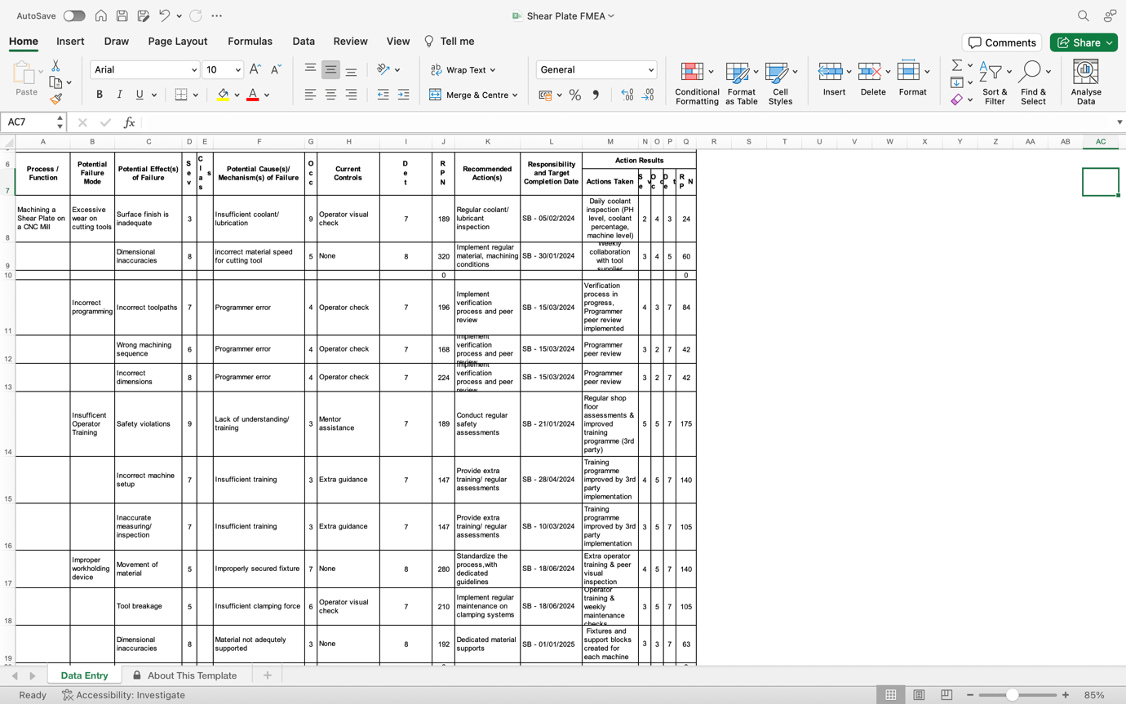

Figure 1 - FMEA Results

As shown in figure 1 these are the results from the FMEA conducted. The FMEA was conducted on the process of manufacturing a shear plate on a CNC milling machine. A shear plate is a pivotal component to a foil tool, the main function of a shear plate is basically a cut edge. The shear plate is manufactured to ensure the foil is cut with extreme precision leaving no witness marks, no feathering, or any little indentations to the foil, which is critical, also it has a slight slope to the front of the shear plate, this is because it has a function of clearing any waste foil. It allows the waste foil to flow over the shear plate and away from the bottom half of the tool which creates the foil trays.

As the FMEA was being conducted, there were 4 potential failure modes which took a high priority to investigate, The 4 potential failure modes were found to be the most problematic to the machining process and diving deeper into the causes and ultimately trying to find a suitable solution was a must. Excessive wear on cutting tools, seems to be an obvious failure mode however, from the investigation it was significant to the shear plates failing on quality checks. The first effect of failure was dimensional inaccuracy, some dimensions on the shear plate are not critical and if these were out of specification it wouldn’t cause many functionality issues. On the other hand, there are a few critical dimensions which must be adhered to otherwise the shear plate is useless. The second effect of failure was poor surface finish, the surface finish does not matter, since the shear plate will be in-between to moving parts, it will be smashed into, causing the surface finish to diminish. However, it still must be to a standard where the foil can glide on, to allow the clearing of it.
The severity given for dimensional inaccuracy was an 8, given the critical dimensions are so crucial to the shear plate and the overall tool it belongs too, if the dimensions are out of specification, it is highly likely that there will need to be rework or a scrapped component, costing time and money. The occurrence of this failure was scored a 5, surprisingly it occurred a lot more than expected which caused a lot of discomfort to the quality team. Simply down to the wrong speeds and feeds. The detection for this was scored an 8, this is purely manual detection, if the operator doesn’t check the speeds and feeds then the issue may not be caught, and the failure can occur. The surface finish severity score was given a 3, meaning that it is not going to stop the functionality of the part from performing at peak. However, the occurrence score was a 9 it almost seemed every time, the failure was occurring and a potential cause for this was a lack of coolant. Detection was scored a 7, again this is purely manual, if the operator doesn’t check the coolant level or if coolant is running. The potential for the failure to occur is almost a given. To combat these failure and potential causes, actions were recommended to help minimize the risk of failure such as regular coolant inspection and regular tool/machining condition inspections. These were proposed as a way of the operator always looking for the key areas of failure, always checking coolant level to minimize the lack of coolant and regular inspections of the tooling and the conditions needed for that tool to perform.

Incorrect programming can be fatal to the process as it could cause a plethora of failures which scrap the part. Such as incorrect tool paths, having the wrong sequence of machining and incorrect dimensions. Each failure mode would have a common cause which is programmer error. The severity of incorrect tool paths is a 7 this is down to potentially a rapid movement crashing into the job or a tool path is drilling instead of tapping. These failures are critical and would cause the component to be scrapped or altered, causing huge time and money setbacks. The occurrence score for each of these failures is a 4, meaning each failure mode happens but since this programme is commonly used, the mistakes are very few and far between. Similarly, each failure mode for incorrect programming has a detection score of 7. The operator is responsible for checking the programme, meaning a manual check is done, which can lead to missed details, again leading to failures. The wrong machining sequence has a severity score of 6, this is due to the machining sequence needing to have certain features machined before finalising the component, otherwise the manufacturing process wouldn’t be able to take place. Such as the aperture in the middle of the component must be one of the first things to be machined before any holes, dowels, and other features are put in. If the sequence is not correct, then it can cause further down the line. Incorrect dimensions is scored an 8 on severity, this is down to all dimensions needing to be right on the programme so it can be machined to the specification given by the customer, if the dimensions are incorrect the component won’t act as intended and become scrap. Each failure mode had the same recommended action, which is to implement a verification process of the programme and get each programme peer reviewed by another qualified programmer. This action is intended to massively reduce errors in programmes allowing the operators to fully concentrate on machining the component.
These failure modes were chosen as they were the most common failures that occurred but also the most detrimental to the functionality of the component, if any of these failure modes were to occur.

Conclusions
In conclusion, this study has illuminated the crucial role that risk management plays in the manufacturing industry, with a focus on how well Failure Modes & Effects Analysis (FMEA) works as a tool for mitigating risks. Throughout different steps of the manufacturing cycle, the FMEA method was extremely helpful in locating, evaluating, and mitigating possible failure modes. As a result of carefully looking at failure modes and how they were ranked, engineers were able to proactively deal with risks and improve quality.
However, the FMEA technique is not perfect as a risk management tool. It does provide an organized way to evaluate risk. How well it works relies on how thoroughly it is analyzed, how accurately the data is entered, and how knowledgeable the people who are involved are, plus it relies on how dedicated a company is on updating and adapting the document to suit the current situation. Constant growth and development of FMEA methods are crucial to mitigating risks within the manufacturing sector.

References

Domínguez, C.R., Mares, J.I.P., Hernández, R.G.Z., 2021. Hazard identification and analysis in work areas within the Manufacturing Sector through the HAZID methodology. Process Safety and Environmental Protection 145, 23–38.

HSE (2013). Legislation: Leading health and safety at work. [online] Hse.gov.uk. Available at: https://www.hse.gov.uk/leadership/legislation.htm.

Institution of Mechanical Engineers (2023). Code of Conduct explained - IMechE. [online] www.imeche.org. Available at: https://www.imeche.org/about-us/imeche-governance/governance-and-finance-reviews/code-of-conduct-explained.

Liu, H.-C., Liu, L., Liu, N., 2013. Risk evaluation approaches in failure mode and effects analysis: A literature review. Expert systems with applications 40, 828–838.

Patrick, B. (2022) Using FMEA to manage risk, 9000 Store. Available at: https://the9000store.com/articles/using-fmea-to-manage-risk/ (Accessed: 08 February 2024).

Schmittner, C., Gruber, T., Puschner, P., Schoitsch, E., 2014. Security Application of Failure Mode and Effect Analysis (FMEA), in: Bondavalli, A., Di Giandomenico, F. (Eds.), Computer Safety, Reliability, and Security, Lecture Notes in Computer Science. Springer International Publishing, Cham, pp. 310–325.

Appendix A

Appendix B

