ACDA5006 L5 -

Electrical Engineering - 2025/2026 1st Semester

HID Global Apprentice

Student No: 2413111

Electrical & Electronic

Engineering

Degree Apprenticeship

Table of Contents
1. Abstract 3
1.1 Design Brief 3
1.2 Summary of Results 3
2. Background Research 4
2.1 AC Principles 4
2.2 RLC Circuit Principles 4
2.3 Power Factor 4
2.4 Resonance 4
2.5 Maximum Power Transfer 4
3. Method 6
3.1 RL Circuit Design 6
3.2 Power Calculations 14
3.3 Plotting Graph of Power Factor and Phase Angle against Capacitor Value 15
3.4 Phasor Diagrams of Resonance 17
4. Results 29
5. Discussion 30
5.1 How Power Factor Relates to Resonance, Maximum Power Transfer and Energy Efficiency 30
5.2 Three Phase Basis for Electricity 30
5.3 Power Factor Correction 31
6. Conclusion 32
7. References 33

Abstract

Design Brief
The design brief that was given to the student is as follows:
“Use Proteus to model and analyse a parallel RLC circuit with components representing elements of an AC system. Rsrc relates to the resistance of the source, including cabling and transformer windings; R and L relate to an inductive load such as a motor, where the resistance relates to the DC resistance of the windings and L is the inductance of the windings; PFC represents the power factor correction capacitor for the load. Apply power factor correction techniques to improve energy efficiency in AC systems, which is critical in industrial applications.”

Summary of Results
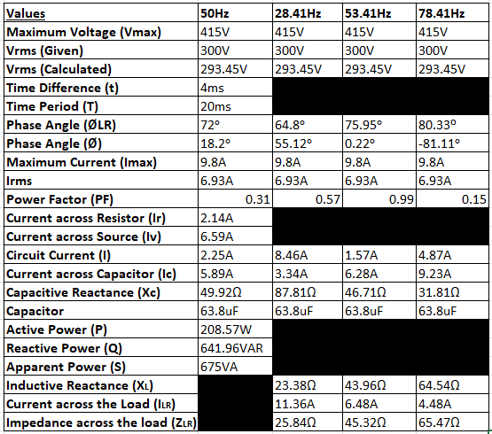

Background Research

2.1 AC Principles
AC is short for alternating current. According to modern physics [1], AC is a form of electrical current that the flow of the electric charge is able to reverse direction unlike DC in which the electric charge only flows in one direction, the current oscillates as a sin wave back and forth.
AC circuits are used in multiple different applications, according to [1] AC is used commonly within power generation and distribution as the properties enable it to be able to be transformed into different voltages which also leads to less losses in energy of long distances. It is also crucial in signal processing and communication systems.

2.2 RLC Circuit Principles
RLC Circuits are circuits that are made up of multiple different components, it has resistors, inductors and capacitors. RLC circuits according to [2] RLC circuits are used to con troll the voltage, current, time and frequency responses, this enables the circuit to be used to shape signals for use in filtering, tuning and noise reduction.
RLC circuits are able to be used with both DC and AC currents, while with DC the capacitors will block current flow after becoming fully charged and the inductor will allow the current to pass but will oppose changes to current. While with AC they act based on frequency which is why it is used for filtering signals and tuning signals [2].

2.3 Power Factor
Power factor according to [3] is a measure of how effective an electrical system is able to convert electrical power into useful work output. Power factor can be rated any value between 1 and 0 with 1 being the highest value and shows that the electrical system is able to convert all electrical power into useful work output.

2.4 Resonance
Resonance in an RLC circuit, according to [4], is when the inductive reactance in the circuit is equal to the capacitive reactance which enables maximum current flow within the circuit, this also means that the voltage and current are in the same phase and has a power factor of 1.

2.5 Maximum Power Transfer
According to [5] , in AC circuits maximum power transfer is when the load impedance of the circuit is equal to the source impedance, this enables electrical systems to operate efficiently, minimise signal loss in communication systems, power systems are more effective and audio systems deliver better performance under these conditions. For DC circuits, maximum power transfer occurs when the load resistance is equal to the internal resistance of the source in a circuit.

Method

3.1 RL Circuit Design
The students first step is to use Proteus to model an RL circuit. This circuit consists of an Rsrc resistor which is the resistance of the source which is 2.4Ω. It has another resistor R which has a value of 11Ω. It has a standard inductor L which is 131mH. All the values used above have been taken from the students, student number, which is 2413111, this is shown in Figure 1 below.
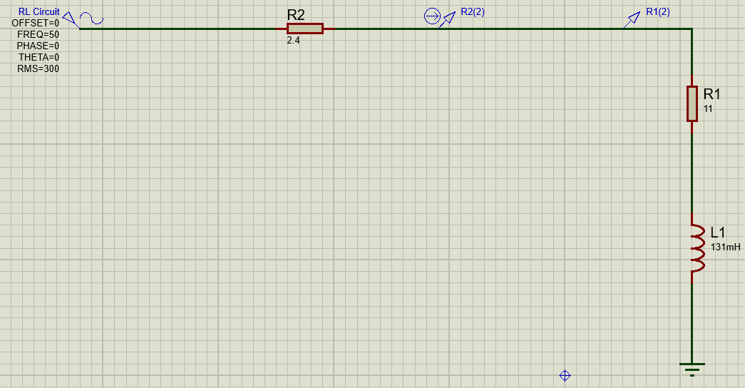
Figure 1 - RL Circuit Design
As shown in Figure 1 above, the circuit is connected to a 300 Vrms, 50Hz sinusoidal source.
Figure 2 - RL Circuit Analogue Analysis
Shown in Figure 2 is an analogue analysis for the RL circuit, from this graph the t value was obtained, which is the time difference between the two waveforms. This was obtained from using two points on the graph along the 0.00 line, one of these points is from the “Voltage RL” waveform and one of the points was from the “Current RL” waveform, as shown circled above in red on Figure 2, the following equation was used:
$$t=Current RL Value at the chosen point-Voltage RL Value at the chosen point$$
$$t=33.8ms-29.8ms=4ms$$
Figure 3 - RL Circuit Analogue Analysis
The next step was to calculate the T value; the T value is the time period for one oscillation of the waveform. To calculate the T value the student chose two points along the “Voltage RL” waveform as shown above in Figure 3 circled in red, as shown below:
$$T=The value at the end point of the chosen oscillation-The value at the start point of the chosen oscillation$$
$$T=59.8ms-39.8ms=20ms$$
The Ø value was then calculated:
$$Ø=\frac{t}{T} x 360$$
$$Ø=\frac{4ms}{20ms} x 360=72°$$

Figure 4 - RL Circuit Analogue Analysis
The student then used the graph, as shown in Figure 4, to obtain values for Irms which is the current rms value and also to obtain the Vrms which is the voltage rms value.
The Imax value was obtained from measuring the peak of the “Current RL” as shown circled in red, the value of the Imax was 9.8A. To obtain the Irms value the following equation was used:
$$Irms=\frac{Imax}{\sqrt{2}}$$
$$Irms=\frac{9.8}{\sqrt{2}}=6.93A$$

The Vmax value was obtained from measuring the peak of the “Voltage RL” as shown circled in red, the value of the Vmax was 415V. To obtain the Vrms value the following equation was used:
$$Vrms=\frac{Vmax}{\sqrt{2}}$$
$$Vrms=\frac{415}{\sqrt{2}}=293.45V$$

The power factor value was then obtained using the following equation:
$$PF=cosØ$$
$$PF=\cos\left(72\right)=0.31$$
The student then did the calculation for the new power factor that would be required as per the design brief which is 0.95.
$$PF=cosØ$$
$$0.95=\cos\left(Ø\right)$$
$$Ø=\cos^{-1}\left(0.95\right)=18.2°$$

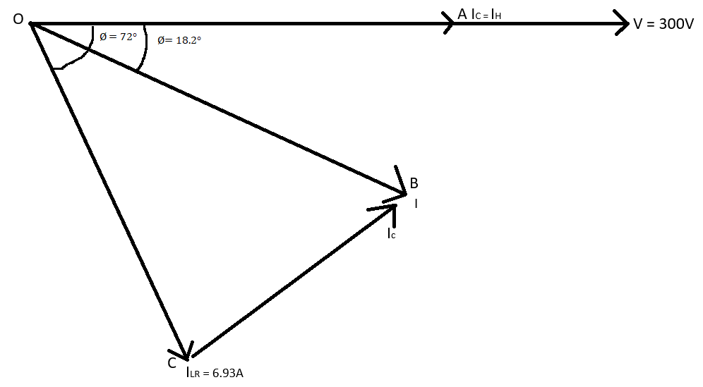
Figure 5 - Phasor Diagram for New Power Factor
Figure 5 shows the phasor diagram that the student created from the values gained.
Using the above phasor diagram the student used trigonometry in order to find the values of current for each different component within the RLC circuit which would then be used to obtain a capacitor value for the new power factor.
In triangle OAC IR was calculated using:
$$\cos{Ø=\frac{Adjacent}{Hypotenuse}}$$
$$\cos{(72)}=\frac{OA}{ILR}$$
$$OA=6.93 x\cos\left(72\right)=2.14A$$
$$OA=IR=2.14A$$
The student then calculated the IV value in triangle OAC:
$$\sin{Ø=\frac{Opposite}{Hypotenuse}=\frac{AC}{OC}}$$
$$\sin\left(72\right)=\frac{AC}{ILR}$$
$$AC=6.93 x\sin\left(72\right)=6.59A$$
$$AC=IV=6.59A$$
The student then uses the triangle OAB to calculate the overall current after PFC:
$$\cos{Ø= \frac{Adjacent}{Hypotenuse}}=\frac{OA}{OB}$$
$$\cos\left(18.2\right)=\frac{IR}{I}$$
$$I=\frac{2.14A}{\cos{(18.2)}}=2.25A$$
Using the triangle OAB to find the value of AB:
$$\sin{Ø=\frac{AB}{OB}}$$
From the previous equation we know OB = I
$$\sin{Ø=\frac{AB}{I}}$$
$$\sin\left(18.2\right)=\frac{AB}{2.25A}$$
$$AB=2.25 X \sin\left(18.2\right)=0.7A$$
As shown in the phasor diagram IC = BC and also known is that AC = AB + BC. So, from this the student was able to deduce that IC = AC – AB:
$$IC=6.59A-0.7A=5.89A$$
$$IC=\frac{Vrms}{XC}=\frac{294V}{XC}$$
Rearrange the equation to obtain the XC value:
$$XC=\frac{294V}{5.89A}=49.92Ω$$
XC is then used to calculate the capacitor value for a power factor value of 0.95:
$$XC=\frac{1}{2πfC}$$
$$49.92=\frac{1}{2π x 50 x C}$$
$$C=\frac{1}{2π x 50 x 49.92}=63.8uF$$
This value was then added to the previous RL circuit to make an RLC circuit as shown below in Figure 6 and Figure 7.
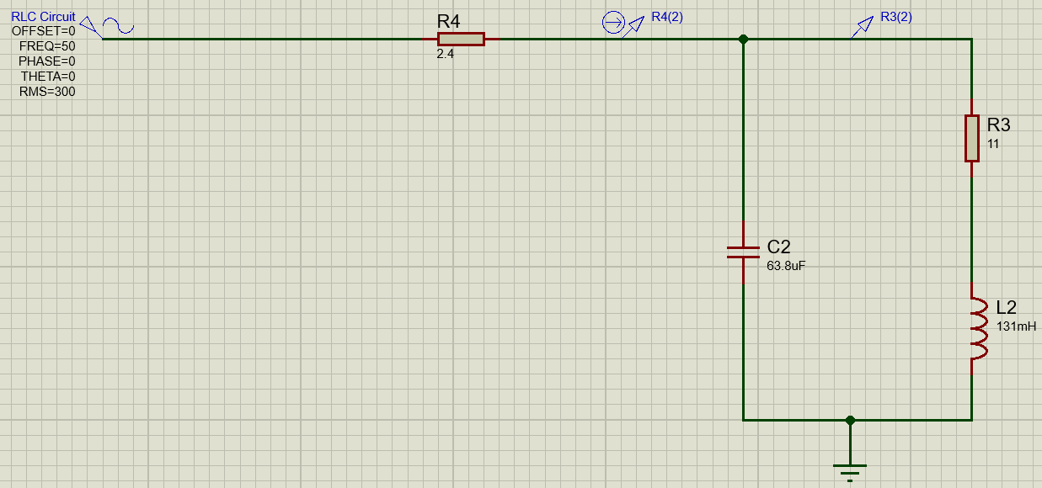
Figure 6 - RLC Circuit with added Capacitor Value

The student then repeated the original calculation for the PFC value using the graph to take two readings at two points along the waveforms at 0 as shown below in Figure 6.
Figure 7 - Analogue Analysis of RLC Circuit
The student then obtained the t and T values from Figure 6 to show a Power Factor value of 0.95 as specified:
$$Ø=\frac{t}{T} x 360$$
$$t=41ms-40ms=1ms$$
$$T=60-40ms=20ms$$
$$Ø=\frac{1x{10}^{-3}}{20x{10}^{-3}}=18°$$
$$Power Factor=\cos{Ø}$$
$$Power Factor=\cos\left(18\right)=0.95$$

3.2 Power Calculations
As stated within the design brief, the student calculated the active power, reactive power and apparent power using values previously obtained from the RLC circuit design stage.
To calculate the active power:
$$P=VI\cos{Ø}$$
$$P=300 x 2.25 x \cos\left(72\right)=208.57W$$
To calculate the reactive power:
$$Q=VI\sin{Ø}$$
$$Q=300 x 2.25 x \sin\left(72\right)=641.96VAR$$
To calculate the apparent power:
$$S=VI$$
$$S=300 x 2.25=675VA$$

3.3 Plotting Graph of Power Factor and Phase Angle against Capacitor Value
The student used proteus to generate the RLC circuit used in Figure 6 and changed the capacitor values to generate an analogue analysis waveform graph to calculate the phase angle and power factor values.
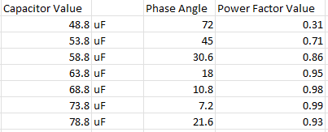
Figure 8 - Values used for the Graphs
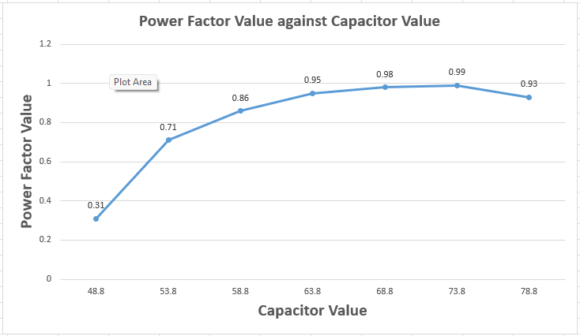
Figure 9 - Power Factor against Capacitor Value Graph
As shown in Figure 9 above, as the capacitor values increase, the power factor value increases as well, they are directly proportional to each other until the capacitor value reaches 73.8uF and has a power factor value of 0.99 and then the power factor value starts to decrease.
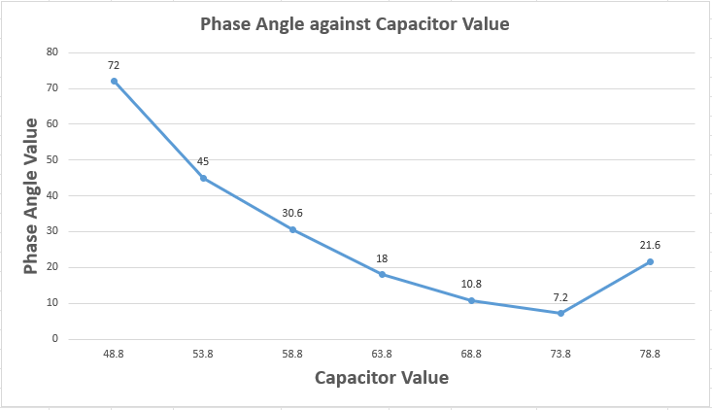
Figure 10 - Phase Angle against Capacitor Value Graph
As shown in Figure 10 above, as the capacitor value increases the phase angle decreases until once again reaching the 73.8uF point then it starts to increase again due to it reaching a 0.99 power factor value.
When the power factor approaches 1, the energy/power in the inductor reduces due to the lagging reactive power being compensated by the capacitor. The current through the inductor also is closer to being in phase with the voltage. When the power factor approaches 1, the capacitor’s energy stored increases alongside the charge and voltage across the capacitor and the energy stored is fully utilized.

3.4 Phasor Diagrams of Resonance
To calculate the resonance frequency, the following calculations were used:
$$Fr=\frac{1}{2π}(\sqrt{\frac{1}{LC}-\frac{R^{2}}{L^{2}}})$$
$$Fr=\frac{1}{2π}\left(\sqrt{\frac{1}{\left(131x{10}^{-3}\right)x\left(63.8x{10}^{-6}\right)}-\frac{{11}^{2}}{{\left(131x{10}^{-3}\right)}^{2}}}\right)=53.41Hz$$
The value was then used to calculate the 25Hz above and below the resonance value:
$$Fr-25Hz=53.41Hz-25Hz=28.41Hz$$
$$Fr+25Hz=53.41Hz+25Hz=78.41Hz$$
To be able to create phasor diagrams the values needed are: ILR, IC, I, ØLR and Ø, the following equations were used to calculate each of these values needed.
For the 28.41Hz value the Figures 8 and 9 show the proteus circuit and analogue waveform generated.
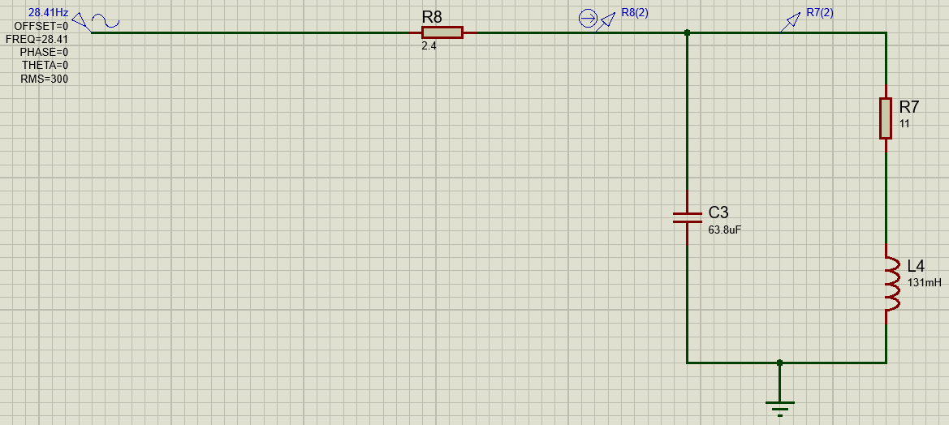
Figure 11 - 28.41Hz RLC Circuit
Figure 12 - 28.41Hz Analogue Analysis
For the XC value:
$$XC=\frac{1}{2πfC}$$
$$XC=\frac{1}{2π x 28.41 x 63.8x{10}^{-6} }=87.81Ω$$
For the XL value:
$$XL=2πfL$$
$$XL=2π x 28.41 x 131x{10}^{-3}=23.38Ω$$
For the ZLR value:
$$ZLR=\sqrt{R^{2}+{XL}^{2}}$$
$$ZLR=\sqrt{{11}^{2}+{23.38}^{2}}=25.84Ω$$
For the ILR value:
$$ILR=\frac{VLR}{ZLR}$$
$$VLR\left(rms\right)=\frac{415}{\sqrt{2}}=293.45V$$
$$ILR=\frac{293.45}{25.84}=11.36A$$
For the IC value:
$$IC=\frac{VC}{XC}$$
$$IC=\frac{293.45}{87.81}=3.34A$$
For the ØLR value:
$$ØLR=\tan^{-1}{(\frac{XL}{R}})$$
$$ØLR=\tan^{-1}({\frac{23.38}{11}})=64.8°$$
For the Ø value:
$$Ø=\tan^{-1}{(\frac{ILR\sin\left(ØLR\right)-IC}{ILR\cos{(ØLR)}}})$$
$$Ø=\tan^{-1}{(\frac{11.36\sin\left(64.8\right)-3.34}{11.36\cos{(64.8)}}})=55.12° (lagging)$$
For the I value:
$$I=\sqrt{{(ILR\cos{ØLR)}}^{2}+{(ILR\sin{ØLR}{-IC)}}^{2}}$$
$$I=\sqrt{{(11.36\cos{64.8)}}^{2}+{(11.36\sin{64.8}{-3.34)}}^{2}}=8.46A$$
The student then used these values to draw a phasor diagram as shown below in Figure 7: 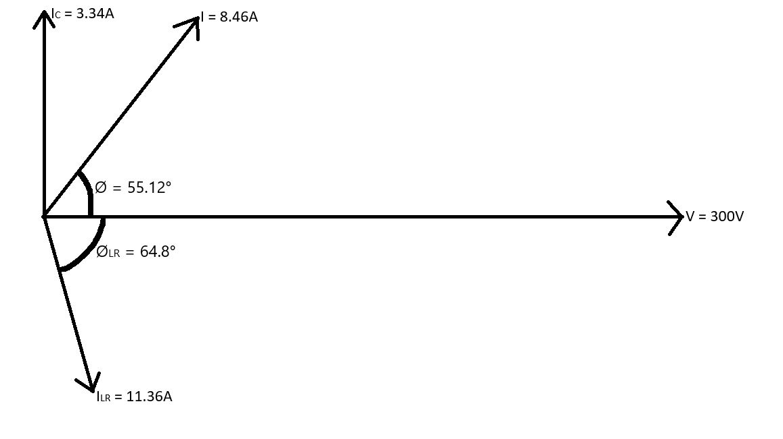
Figure 13 - 28.41Hz Phasor Diagram
As shown above in Figure 10, the voltage value 300V is where all the angles are measured to for the Ø and ØLR values. The Ø and ØLR value for I and ILR represents how much the I value is lagging behind the voltage, which is 55.12° and 64.8°, this shows that the circuit at this frequency is more inductive due to the current lagging the voltage.

The student then repeated the same equations for the 53.41Hz resonance value and generated the circuit and analogue analysis in proteus as shown in Figures 11 and 12:
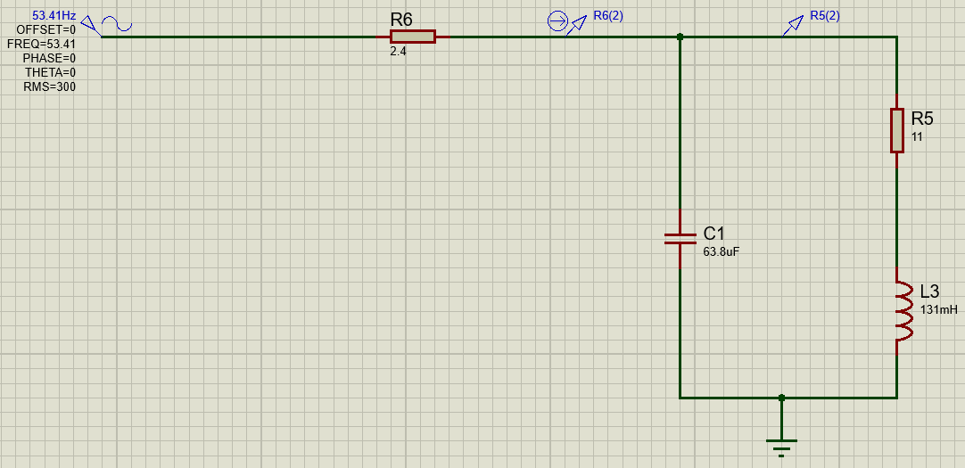
Figure 14 - 53.41Hz Resonance RLC Circuit
Figure 15 - 53.41Hz Resonance Analogue Analysis

For the XC value:
$$XC=\frac{1}{2πfC}$$
$$XC=\frac{1}{2π x 53.41 x 63.8x{10}^{-6} }=46.71Ω$$
For the XL value:
$$XL=2πfL$$
$$XL=2π x 53.41 x 131x{10}^{-3}=43.96Ω$$
For the ZLR value:
$$ZLR=\sqrt{R^{2}+{XL}^{2}}$$
$$ZLR=\sqrt{{11}^{2}+{43.96}^{2}}=45.32Ω$$
For the ILR value:
$$ILR=\frac{VLR}{ZLR}$$
$$VLR\left(rms\right)=\frac{415}{\sqrt{2}}=293.45V$$
$$ILR=\frac{293.45}{45.32}=6.48A$$
For the IC value:
$$IC=\frac{VC}{XC}$$
$$IC=\frac{293.45}{46.71}=6.28A$$
For the ØLR value:
$$ØLR=\tan^{-1}{(\frac{XL}{R}})$$
$$ØLR=\tan^{-1}({\frac{43.96}{11}})=75.95°$$
For the Ø value:
$$Ø=\tan^{-1}{(\frac{ILR\sin\left(ØLR\right)-IC}{ILR\cos{(ØLR)}}})$$
$$Ø=\tan^{-1}{(\frac{6.48\sin\left(75.95\right)-6.28}{6.48\cos{(75.95)}}})=0.22° (lagging)$$
For the I value:
$$I=\sqrt{{(ILR\cos{ØLR)}}^{2}+{(ILR\sin{ØLR}{-IC)}}^{2}}$$
$$I=\sqrt{{(6.48\cos{75.95)}}^{2}+{(6.48\sin{75.95}{-6.28)}}^{2}}=1.57A$$
The student then used these values to draw a phasor diagram as shown below in Figure 8: 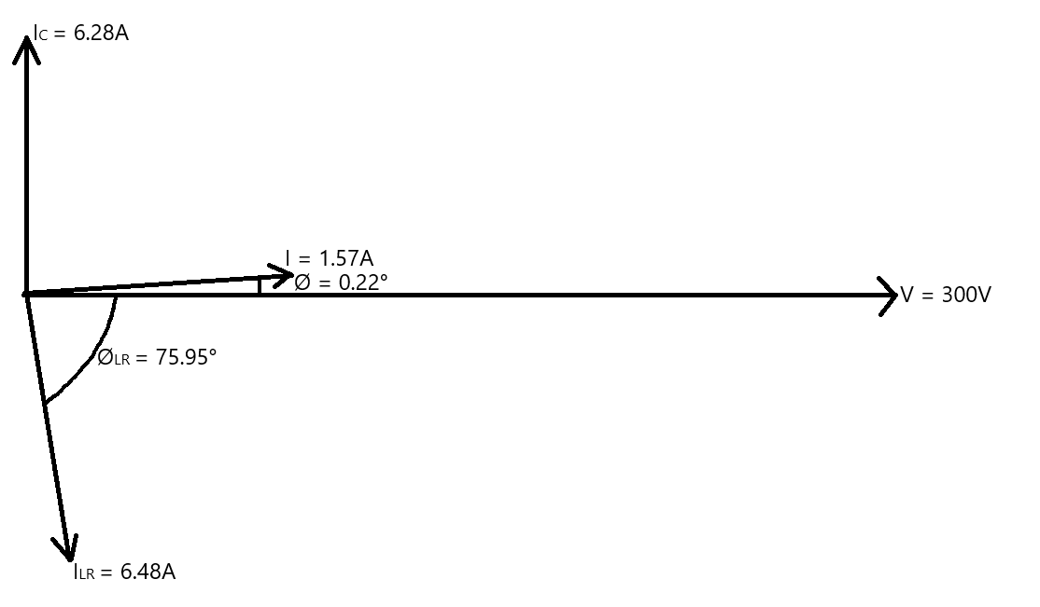
Figure 16 - 53.41Hz Resonance Phasor Diagram
As shown in Figure 13 above, the voltage value of 300V is where the angles Ø and ØLR are measured to. The Ø and ØLR values shows that the I value is only 0.22° lagging behind the voltage this produces a power factor value of 1 as it is the resonant frequency. This shows that the values within the circuit are very close to being almost equal when looking at the Ic and ILR values so there is no dominant value within the circuit as expected at resonance.

The student then repeated these calculations for the 78.41Hz phasor diagram and generated the circuit diagram and analogue analysis in Figures 14 and 15:
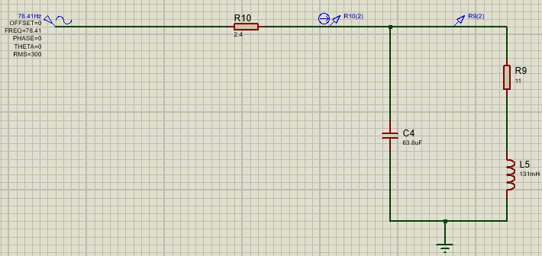
Figure 17 - 78.41Hz RLC Circuit
Figure 18 - 78.41Hz Analogue Analysis
For the XC value:
$$XC=\frac{1}{2πfC}$$
$$XC=\frac{1}{2π x 78.41 x 63.8x{10}^{-6} }=31.81Ω$$

For the XL value:
$$XL=2πfL$$
$$XL=2π x 78.41 x 131x{10}^{-3}=64.54Ω$$
For the ZLR value:
$$ZLR=\sqrt{R^{2}+{XL}^{2}}$$
$$ZLR=\sqrt{{11}^{2}+{64.54}^{2}}=65.47Ω$$
For the ILR value:
$$ILR=\frac{VLR}{ZLR}$$
$$VLR\left(rms\right)=\frac{415}{\sqrt{2}}=293.45V$$
$$ILR=\frac{293.45}{65.47}=4.48A$$
For the IC value:
$$IC=\frac{VC}{XC}$$
$$IC=\frac{293.45}{31.81}=9.23A$$
For the ØLR value:
$$ØLR=\tan^{-1}{(\frac{XL}{R}})$$
$$ØLR=\tan^{-1}({\frac{64.54}{11}})=80.33°$$
For the Ø value:
$$Ø=\tan^{-1}{(\frac{ILR\sin\left(ØLR\right)-IC}{ILR\cos{(ØLR)}}})$$
$$Ø=\tan^{-1}{(\frac{4.48\sin\left(80.33\right)-9.23}{4.48\cos{(80.33)}}})=-81.11° (leading due to-)$$
For the I value:
$$I=\sqrt{{(ILR\cos{ØLR)}}^{2}+{(ILR\sin{ØLR}{-IC)}}^{2}}$$
$$I=\sqrt{{(4.48\cos{80.33)}}^{2}+{(4.48\sin{80.33}{-9.23)}}^{2}}=4.87A$$
The student then used these values to draw a phasor diagram as shown below in Figure 9: 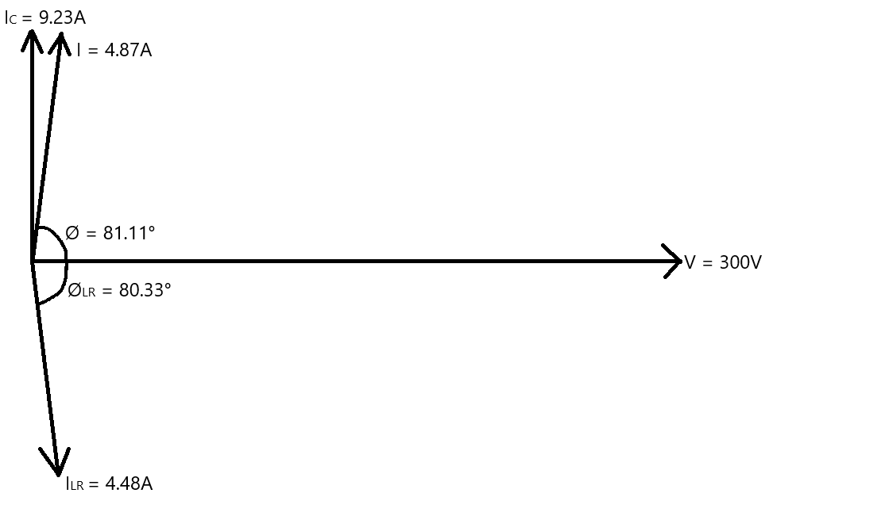
Figure 19 - 78.41Hz Phasor Diagram
As shown above in Figure 19, the voltage value of 300V is the point at which the angles are measured from. The diagram shows that the total current I is 81.11° leading the voltage, which shows that the circuit is highly capacitive and the IC value being the largest current value in the circuit also confirms this.

For the 50Hz phasor diagram, the values are the exact same to the values calculated previously to obtain the capacitor value, these values will be used for the phasor diagram as follows:
$$IC=5.89A$$
$$I=2.25A$$
$$∅=18.2°$$
$$ILR=6.93A$$
$$V=300V$$
For the ØLR value:
$$XL=2πfL$$
$$XL=2π x 50 x 131x{10}^{-3}=41.15Ω$$
$$ØLR=\tan^{-1}{(\frac{XL}{R}})$$
$$ØLR=\tan^{-1}({\frac{41.15}{11}})=75.03°$$
The student then used these values to create a phasor diagram for 50Hz:
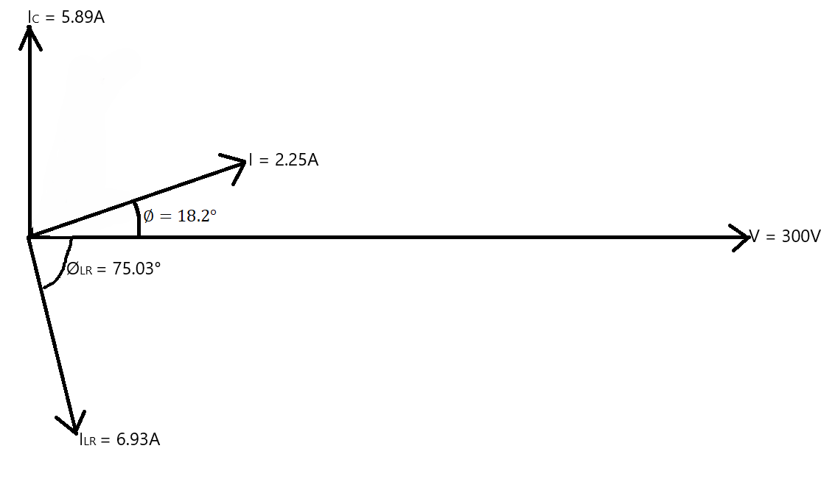
Figure 20 - 50Hz Phasor Diagram
As shown above in Figure 17, the voltage value of 300V is where the phase angles are measured to. The Ic and ILR values show that the circuit is overall inductive as the I value still lags the voltage, but the circuit is not purely just inductive or capacitive due to the small difference between the two current values of Ic and ILR as it has a power factor value of 0.95.

Results
Figure 21 - Table of All Results
Figure 22 - Values used for Graphs

Discussion

5.1 How Power Factor Relates to Resonance, Maximum Power Transfer and Energy Efficiency
According to [6], the power factor is a value between 0 and 1, the 0.95 value is the cos(Ø) value of the phase angle value between the voltage and current. In an RLC circuit resonance occurs when the capacitive reactance and the inductive reactance are equal which makes the circuit purely resistive as the capacitor and inductor cancel each other out [7] and the phase angle between the voltage and current is at 0, which in turn gives a power factor of 1 this shows that the 0.95 value calculated isn’t at resonance but is still very close to it.
According to [8] the maximum power transfer is when the load impedance is equal to the source impedance, the power factor is a main factor when considering this as it affects the efficiency of the circuit due to when the power factor is 1 the power delivered to the load is maximised. According to the following equation only 50% of the input power is used for useful work making the power efficiency of the circuit 50%.
$$Efficiency= \frac{Pout}{Pin}x100\%=\frac{Rl}{Rs+Rl}=50\%$$

5.2 Three Phase Basis for Electricity
According to [9] the UK and through out the developed world, a three-phase system is used for electricity transmission as it is reliable and efficient. The efficiency of a three-phase system is due to the system requiring less conductor material for the same power output as when compared with a single-phase system making the three-phase system more cost-effective than a single-phase system to build and also maintain.
Three-phase systems also have equal distribution of the electrical load across all three phases. Three-phase is also more effective [9] when considering long distance transmission due to it being able use less conductors to transmit the same power when compared to single-phase which enables more efficient power transmission.
According to [10] using more than three-phase systems requires more complex wiring, protection and control systems which in turn makes maintenance on these systems even more complex, while most equipment is standardised to three-phase systems and would require reviews of standards if changed. These factors also show that the overall cost would increase with only a small efficiency gained.

5.3 Power Factor Correction
Power factor according to DigiKey [3] is how efficient the power usage is within an electrical system, with a value between 0 and 1 is given which a value of 1 is considered being the maximum power that the system is able to use. While the lower the value is the more power is being wasted in the system.
Power factor correction is where, according to [11] is adding a component such as a capacitor to an electrical system to improve the efficiency of the power usage within the system, this usually takes the system from a low power factor to a power factor of 0.95+. The benefits of this are that it lowers electricity costs and overall energy consumption due to the power being used more efficiently.

Conclusion
To conclude, the student was able to successfully calculate and complete all tasks given within the design brief, including being able to use power factor correction to increase the power factor to 0.95 using the correct formulas and calculations with the values gained from the student number and enabling the circuit to operate more efficiently. While also being able to explain how resonance, maximum power transfer and efficiency relate to the corrected power factor value.

References

[1] | “Modern Physics,” © 2025 Modern Physics Insights, [Online]. Available: https://modern-physics.org/ac-circuits/.
[2] | X. Lee, “FCPCBA,” FULLTRONICS CORPORATION LIMITED, 15 August 2025. [Online]. Available: https://www.fcpcba.com/tips/rlc-circuit-in-pcb-design/.
[3] | M. D. Lorenzo, “DigiKey,” DigiKey, 19 April 2024. [Online]. Available: https://www.digikey.com/en/maker/tutorials/2024/what-is-power-factor-how-is-it-calculated-and-why-its-important?msockid=075d6a2d39c16a131dc87cb138aa6b53.
[4] | “Electrical4U,” Electrical4U, 30 May 2024. [Online]. Available: https://www.electrical4u.com/resonance-in-series-rlc-circuit/.
[5] | “Electrical Ampere,” 2026 Electrical Ampere, [Online]. Available: https://electricalampere.com/maximum-power-transfer-theorem/.
[6] | “Filo,” AskFilo, 16 February 2025. [Online]. Available: https://askfilo.com/user-question-answers-smart-solutions/power-factor-at-resonance-3234363433333533. [Accessed 2025].
[7] | “Vedantu,” Vedantu, [Online]. Available: https://www.vedantu.com/question-answer/power-factor-of-an-lcr-circuit-at-reso-class-12-physics-cbse-5f3244f7744f3e53bdff51dc.
[8] | C. P. Education, “Cadence,” Cadence, [Online]. Available: https://resources.system-analysis.cadence.com/blog/msa2020-demystifying-maximum-power-output-concepts.
[9] | P. Evans, “The Engineering Mindset,” 20 November 2024. [Online]. Available: https://theengineeringmindset.com/three-phase-power/.
[10] | F. J. Samama, “Studocu,” Islamic University of Technology, 2024. [Online]. Available: https://www.studocu.com/row/document/islamic-university-of-technology/electronic-circuit/reasons-for-limiting-phases-in-power-systems-a-detailed-analysis-4202/137768354.
[11] | “Powersupplymall,” 20 November 2025. [Online]. Available: https://powersupplymall.com/blogs/latest-news-solutions/what-is-power-factor-correction-pfc.

