University of Wales Trinity Saint David

Problem Solving and Decision Making
BMSW 4004

SHORTAGE OF STAFF IN HEALTHCARE
By

Erika Lucaci
2011318

Lecturers: Koushik Modak 02/09/2021

Table of Contents
Section 1: An overview of problems in healthcare 3
Section 2: Shortage of staff in healthcare 4
2.1: Around the World, Health-Care Shortages 5
2.2: Factors Affecting the Health-Care Shortage 5
2.3: Causes of Healthcare Staff Shortages 6
Section 3: Impacts of shortage of staff in healthcare on all stakeholders 7
3.1 Staffing Shortage's Impact on Patient Care 7
3.2 The Death Rate of Patients Has Increased 7
3.3 Burnout among nurses is on the rise. 8
3.4 "Crisis" Pay Has Been Paid by Hospitals 8
3.5: Hospital expenses 8
Section 4: Analysis of decision-making process 8
Section 5: Alternative solution to the problem 10
Section 6: PESTEL analysis in healthcare 11
6.1 Most appropriate options 13
Section 7: Communicating stakeholders 14
Communication for healthcare 15
Section 8: Monitoring and review technique for successful implementation 16
References 17
Appndix 19

Section 1: An overview of problems in healthcare
In different places of the world, the healthcare situation is somewhat varied. On the one hand, there is advanced technical equipment, qualified medical professionals, and quite well healthcare facilities; on the other side, there is the rising expense of health services and an ageing workforce desperately trying to adapt to the future's complications. Many changes have taken place in the healthcare sector, posing unique demands to both large and small medical firms. Fast-changing government rules, technology advancements, and patient expectations have created a new climate in which maintaining a medical practice is no longer only about treating patients. There are situations where people are completely reliant on how well healthcare companies deal with medical issues and minimise inequities in order to deliver quality healthcare services. (Lorkowski et al. 2021).
In today's technology world, the principles of both hardware and software are altering. As shown in a report conducted by the UK Center for Health Alternatives, Iot integrates 48% of medical equipment, with that percentage expected to rise to 70% during the next five years. The linked medical equipment sector is expected to triple in size from 2017 and 2022, according to market-line.
Advanced technologies such as AI and machine learning are now being employed in hospital operating systems such as Appointments Management Platform, Patient Administrative Structure, and Laboratories Management Information System. Integrated medical equipment and Automation operating systems can offer healthcare firms a large amount of data that they can use to gather information. Malicious attackers are drawn to healthcare professionals by connected medical devices and the increased requirement to retain patient information records. Health information breach figures (see appendix, figure 1), as you can see, show a clear increasing trend in security breaches from 2009 to 2018.
Healthcare costs are exorbitant, and it is eventually unaffordable, says Martin Gaynor, an economic historian at Carnegie Mellon University. The health care system has a direct impact on the revenue of healthcare organisations since it prevents people from doing things like getting lab tests or following up with the continuous checkups after a visit, resulting in lower clinical satisfaction. ( Nyashanu et al. 2020).
According to the KF health polling average (see appendix, figure2), while the majority of participants said they could afford their medication, one out of every four people said they had trouble paying for it. According to a survey provided by RX Discounts Technologies at the start of 2019, around a third of a dozen pharmaceutical companies hiked prices on more than 270 pharmaceutical prescriptions. This translates to a 6.3 percent increase in the average prescriptions price. In the twelve months leading up to November, meanwhile, inflation rate in The United Kingdom has only been 2.2 percent.

Section 2: Shortage of staff in healthcare
According to a 2008 report published by the Schools of Public Health, by 2022, more than 250,000 additional medical staff will be required to meet escalating demand. In the same year, the Institute for States and Local Authority Efficiency underlined the labour shortage, noting that local municipalities had vacancy rates of up to 20%. Public health nurses, geologists, and health and environment professionals are in high demand, according to the datasheet. In following publications, the trend has been verified. According to a 2017 update to a previous study by the Association of American Medical Colleges, there will be a shortfall of over 105,000 clinicians by 2030, with a lack of 7,300 t by 2030. (Sharma et al. 2020).

2.1: Around the World, Health-Care Shortages
According to a 2016 report published in Human Resources for Health, 80 million healthcare employees will be needed globally by 2030. Only 65 million medical practitioners are estimated to be available by 202, leaving a 15 million shortfall globally. Even though the minimum criteria for health care employees are 23 skilled professionals per 10,000 people, 83 nations still fall short. The number of children between the ages of five who died in 2012 was 6.6 million. The vast majority of deaths were caused by diseases that could have been prevented or treated. Eighty percent of stillbirths and ninety percent of maternal fatalities occur in just 58 nations. Better health outcomes in some parts of the globe could have a significant impact on these results.
Professional organizations, new and unexpected ethical concerns, certification standards, funding for public-health-related initiatives, and overall changes in the healthcare providers are all variables that impact changes in nursing practice. According to Fishbone diagram (see appendix, figure 3) many elements both inside and outside the program might influence the nursing program's sustainability. Financial funding, norms and regulations, certification, clinical site availability, and institutional factors are all examples of external effects (Yun et al. 2010).

2.2: Factors Affecting the Health-Care Shortage
Several reasons contribute to the shortage of healthcare workers:
• As the aging population, the need for care increases.
• Due to an ageing workforce, many people in the healthcare profession are retiring.
• The prevalence of chronic illnesses is on the rise.
• Educational programmes have a finite number of seats available.

• Recruiting International Healthcare Professionals
According to a 2017 news press release, the proportion of People aged 65 and over would have climbed by 55 percent by 2030. Elderly individuals require two to three times as many procedures, with the majority of the gaps occurring in specialist services. Professionals in the healthcare field are also becoming older. One million nursing staff are beyond the age of 50, according to the Atlantic. Because the majority of nurses beginning their employment before the 1970s, the health service will lose a third of its workforce in the next 10 to 15 years. On the other hand, valuation methods physicians who are willing to fill open positions is not an issue. Due to limited space, about 80 people will be able to attend. (LeBlanc et al 2020).

2.3: Causes of Healthcare Staff Shortages
There are four key reasons for personnel shortages in healthcare, according to a recent article "The 2030 Problem: Caring for Aging Baby Boomers."
- As the Baby Boomer generation ages, there will be a growing demand for care.
- The medical workforce is aging and retiring.
- The number of chronic diseases is steadily increasing.
- There aren't enough new grads to fill all of the open posts.
Simply stated, there aren't enough programs producing trained employees to match current healthcare demands. As if that wasn't enough, many recent graduates work overtime across the year when they are younger. Their habits, however, transform when they have to care for a family. As a result, many medical practitioners opt for non-clinical work to have more versatility in their schedules. As a result, the industry will face a bigger scarcity of trained people (Aluko et al. 2019).

Section 3: Impacts of shortage of staff in healthcare on all stakeholders
When there is a personnel shortage, existing employees' responsibilities and responsibilities increase, leading to mistakes and other irregularities, as well as a negative impact on the performance, customer service, and subsequently organisational outcomes.

3.1 Staffing Shortage's Impact on Patient Care
As a result of the scarcity, nurses are frequently obliged to work heavy workloads under exceedingly stressful conditions, which can lead to fatigue, injury, and low job satisfaction. Nurses working in these environments are more prone to make errors and medical errors. As a result, treatment quality may suffer, leading to avoidable complications like patient harm, emergency hospital overcrowding, and, most alarmingly, greater fatality rates. More inefficiency, suffering, and deaths arise from nursing shortages. In healthcare settings patient-to-nurse ratios, nurses confront weariness and dissatisfaction, while patients face higher mortality and failure-to-rescue rates. (Hassmiller and Cozine 2016).

3.2 The Death Rate of Patients Has Increased
The first of these is patient mortality, which is caused by a nurse shortage and a lack of healthcare workers. Numerous correlation was established between understaffed facilities and increased fatality rates. According to a study published by the National Center for Biotechnology Information, Hartz and colleagues discovered that having a more diverse registered nurse staff was one of the two biggest predictors of lower patient morbidity. Because nurses are overburdened, patients are being neglected and mistreated (Ebadi and Khalili 2014).

3.3 Burnout among nurses is on the rise.
Nurse fatigue among the surviving nurses and healthcare professionals is another factor. Others are left to take up the slack as more nurses depart their employment. Since the start of COVID-19, hospitals have seen a massive spike in the number of patients, forcing numerous staff to deal overnight.

3.4 "Crisis" Pay Has Been Paid by Hospitals
The nursing shortage is also having a financial impact on hospitals. Healthcare firms have become aggressive in employing nurses and giving them fair compensation to keep up with demands. Hospitals now give sign-on incentives, greater healthcare benefits, and pay nearly twice as much for an hourly nurse as they did previously.

3.5: Hospital expenses
Labor expenditures, which comprised salary and bonuses for clinicians, caregivers, technicians, and a variety of other people, contributed to a major amount of overall healthcare costs, as well as cumulative cost increases during the past few years. Non-labor expenditures had risen as well, including medications, professional fees, and the upkeep of equipment and infrastructure improvements, including technologies.

Section 4: Analysis of decision-making process
A decision-making process is a sequence of processes taken by management to conclude. The goal is to develop a systematic decision-making paradigm (see appendix, figure 4). In other words, managers who utilize an ordered and precise procedure are more likely to make successful and effective judgments than those who employ unstructured and unpredictable procedures.

D = problem definition
Making decisions is a problem-solving technique aimed at removing roadblocks to reaching personal or organizational objectives. Managers can take actions to reduce barriers by describing problems or discovering what the obstacles are. Nevertheless, defining the issue is a difficult undertaking. It might be a lengthy procedure. To completely examine the scope of the problem, a manager must interrogate employees and monitor everyday actions and tasks. Senior management, for example, observed that many personnel were late to work and had negative perceptions toward one another and the patients. There was more conflict among employees, which made many of them dissatisfied at work, and they eventually chose to leave the Health Care System of their own volition (Choupin et al. 2021).
E = define the criterion
After you've described the problem, the next step is to define the characteristics. Criteria are the parameters that are used to determine the best solution to an issue. Peter, a first-line supervisor in the personnel manager, is being considered for promotion to the position of management and leadership expert, a higher managerial position. Peter specifies his requirements before accepting the promotion or electing to stay in his present position. He aspires to earn the most money possible, have the flexibility to work autonomously, have a sense of success, work in a nice environment, be appreciated and recognized for his efforts, and can advance.
C = Think about all of your options
The search for numerous available options and solutions is known as examining all possibilities. Many options must be explored, not just the typical two or three. A manager must participate in conceptualizing to generate and analyze as many options as possible to derive all of the options. This strategy provides more options while also improving collaboration and interaction.

I = determine the best option
A manager should be aware that while determining the best alternative from among the numerous options, an additional decision must be of an excellent standard and approved and acknowledged by the group of workers directly affected by the act in the organization. When society refuses to accept the decision, it will not be successful and may even be undermined.
D = devise and carry out a strategy.
Developing and carrying out a strategy is just as crucial as making a decision. The most basic role of a manager is to plan. It gives orders, establishes control, predicts change, and develops strategies for dealing with ambiguity.
E = evaluate and track the progress of the solution
The final element of the DECIDE method is to examine and anticipate the resolution. It is not enough to just make decisions. It's vital to evaluate the decision and consider "what could go wrong." This stage aids in the avoidance, reduction, and eradication of any undesirable consequences that may arise. For instance, a choice may not work after it is made, causing a management to redo the problem defining procedure. Critique is beneficial since it provides information that is pertinent to the decision. Questioning bosses, workers, patients, and other users is part of the control process. (Dewi et al. 2021).

Section 5: Alternative solution to the problem
The Third Global Forum on Human Resources for Health, according to the World Health Organization (WHO), compiled a list of proposed initiatives to alleviate the global shortage of healthcare staff. Here are a few of their ideas:
- To assist human resource development, more technical and political leadership is needed.
- Obtaining trustworthy data for health platforms
- Increasing community and mid-level healthcare workers' acceptance of frontline health services
- Optimizing global healthcare workforce distribution and enhancing retention in low-income nations
- Including health-care employees in the formulation of national healthcare programs
Advancement of learning is the greatest way for students in the healthcare professions to position themselves for one of the many desirable careers that will become available in the coming years. There should be no shortage of chances in public healthcare, especially if you're ready to relocate to suit the requirements of specific geographical locations (Gohar et al. 2020).

Section 6: PESTEL analysis in healthcare
PESTEL Analysis (see appendix, figure 5) is an important part of any healthcare corporation's corporate strategy. In addition, it is a low-cost tool for analyzing the external environment. It aids in the detection of elements that influence the industry and the actions of businesses (Toe et al., 2020). Taking such factors into account, the latter can devise tactics to take advantage of the circumstance. They can also help to lessen and avoid harmful consequences. This technique is useful not only for decision-making in economics but in any sector of life, as the environment affects every person or organization.
The acronym refers to the following factors, which are listed and explained further down:
- Political
As an example, consider the healthcare industry. Political issues, in particular, have a direct impact on this profession and healthcare expenses. Healthcare legislation and medical insurance are two of them. Consider expenditure and personnel policies, as well as Medicare and Medicaid rules.
- Economic
In terms of economic repercussions, inflation and unemployment have an impact on people's ability to obtain coverage and invest money in healthcare. As a result, these factors have a direct impact on the success of healthcare organizations.
- Social or sociocultural
People's cultural ideas and values have a significant effect on their participation in healthcare services. Some societies, in particular, prefer conventional methods. Complementary therapies or herbal treatments are used by others.
- Technological
Moreover, healthcare institutions may incur costs as a result of the development of innovative technical solutions. It has a direct impact on healthcare costs. Furthermore, healthcare organizations will need to focus on teaching their employees how to use the new technology.
- Environmental
Healthcare facilities should strive to enhance their waste disposal systems regularly. The goal is to address the public's environmental concerns in particular. As a result, such actions should be incorporated into the planning process.
- Legal
Finally, taxes laws must be discussed as an issue that affects healthcare companies in this section. The latter, notably, should adhere to the industry's specific regulations. In this section, list all of the factors.

6.1 Most appropriate options
- More capital investment in health worker training and support: The money will be used to train more health personnel in the beginning. More money will be intended to pay their wages as they learn and enter the job. By 2025, health expenditures will have to increase by at least US$ 10 per person per year to train and pay the wages of the six million health workers required in the 57 nations with acute shortages. Achieving that goal in twenty years is a lofty but achievable ambition (Weberg 2010).
- In all nations with severe shortages, a national plan for the health workforce and an increase in the number of health workers are required: That will necessitate political will, a detailed plan for an efficient health workforce, and real investment. Funding should not only go to healthcare practitioners, but also to the management and support staff who help the healthcare system run smoothly.
- Utilization of the existing health personnel in a more efficient manner: Improvements in regulation and management, as well as the creation of clear employment contracts, are simple and affordable initiatives that could help.
- Health workers should be protected and treated fairly: In many underdeveloped countries, they confront harsh and frequently dangerous working conditions as well as little pay.
- Better ways for involving communities and patients more actively in the process of their medical care.
- Health worker training should be oriented toward rural and underprivileged communities, and career incentives should be developed to encourage service in these locations.
- Every country should have comprehensive preparations in place for a workforce response to diseases and catastrophes.
- Early retirement incentives have been reduced.
- Encouragement of women to pursue careers in health care.

Section 7: Communicating stakeholders
Starting with software architecture and extending through assessment, stakeholder support is critical to an effective healthcare and social care system. At every stage of the program, stakeholders to participate to assist create support, provide guidance and direction, and participate in monitoring and quality management activities. Stakeholders include the Governor's office, professional organizations, patient and advocate societies, the State legislature, and the Centers for Disease Control and Prevention. In Integrating Stakeholder in a Care Action Plan, government healthcare professionals and lawmakers can learn about the following subjects (Nkomazana et al. 2015).
- The significance of involving key stakeholders.
- Relationship-building strategies for important stakeholder groups.
- Communication methods for showing the program's worth.
Keeping in touch with stakeholders is another way to secure and sustain their support. By connecting with stakeholders on a regular basis, program workers can promote themselves as the principal contact or channel of communication about the program. Serving as the initial point of contact ensures that expensive branded correct program information and acts as a reference for any concerns or questions they may have (Malakoane et al. 2020).

Communications | Potential Stakeholders | Strategies
Cost Containment | - Agency leadership.  - Governor's office.  - State legislature. | - Be realistic in your expectations.  - Discuss the pros and cons of a slower rate of growth vs lower costs.  - Stress the importance of bettering health outcomes.  - Use what you've learned in other states..
Health Outcomes and Improved Quality | - Agency leadership.  - Governor's office.  - Other State Agencies.  - State legislature. | - Focus on three to five key measures.  - Select sound benchmarks.  - Incorporate within context of overall State chronic disease environment.
Provider Satisfaction | - Agency leadership.  - Governor's office.  - Media.  - Providers.  - State legislature. | - Motivate supplier supporters to contact their State legislators and Governor's office to promote patient care as a supplementary service..
Quality of Life and Patient Satisfaction | - Agency leadership.  - Governor's office.  - Media.  - Patients.  - State legislature. | - Use anecdotes to convey information.  - Analyze Consumer assessment of healthcare providers data for population-based care management.

Communication for healthcare

Section 8: Monitoring and review technique for successful implementation
The World Health Organization is in a position to support on a global scale, and the 2006 World Health Report's focus on the health workers shows their growing concern. Privileged countries' technical assistance programs are only now beginning to respond, such as by funding recurring salary spending, expanding training programs, promoting healthcare professionals working in poor economies, or enabling migrants to momentarily discuss their skills in their native countries without jeopardizing their citizenship status. Appropriate numbers and distribution of health experts are required, yet they are insufficient. Staff must deliver high-quality care that is both responsive and satisfies professional standards, making services more appealing to mothers and regions.
The basic issue behind the flight of healthcare workers from impoverished to better-off areas of the globe, inequitable access to health care, and unequal health outcomes must be recognized: the massive and indefensible income disparity between the few prosperous and the many developing nations. Observation and conversation with people can be quite beneficial in efficiently monitoring circumstances. Policies and reforms are the most effective means of bringing about change in the healthcare system. The programs can be implemented in the following ways: 1) by measuring starting points on the day of the change and comparative with other work units; and 2) by evaluating organizational productivity, output, tardiness, and staff turnover. 3) By keeping financial and usage records; 4) by providing direct input through focus group information sheets; and 5) by tracking problems and documenting the number of complaints (Ramesar,2021).

References
Aluko, J.O., Anthea, R. and Modeste, R.M., 2019. Manpower capacity and reasons for staff shortage in primary health care maternity centers in Nigeria: a mixed-methods study. BMC health services research, 19(1), pp.1-15.
Chopin, O., Andutta, F.P., Etemad-Shahidi, A., and Tomlinson, R., 2021. A decision-making process for wave energy converter and location pairing. Renewable and Sustainable Energy Reviews, 147, p.111225.
Dewi, Nur Kumala, and Arman Syah Putra. "Decision Support System for Head of Warehouse Selection Recommendation Using Analytic Hierarchy Process (AHP) Method." In International Conference Universitas Pekalongan 2021, vol. 1, no. 1, pp. 43-50. 2021.
Ebadi, A. and Khalili, R., 2014. Nursing staff shortage in Iran: a serious challenge. Hayat, 20(1), pp.1-5.
Gohar, B., Larivière, M. and Nowrouzi-Kia, B., 2020. Sickness absence in healthcare workers during the COVID-19 pandemic.
Hassmiller, S.B. and Cozine, M., 2006. Addressing the nurse shortage to improve the quality of patient care. Health Affairs, 25(1), pp.268-274.
LeBlanc, C., Sonnenberg, L.K., King, S. and Busari, J., 2020. Medical education leadership: from diversity to inclusivity. GMS journal for medical education, 37(2).
Lorkowski, J., Grzegorowska, O. and Pokorski, M., 2021. Artificial intelligence in the healthcare system: an overview.
Malakoane, B., Heunis, J.C., Chikobvu, P., Kigozi, N.G. and Kruger, W.H., 2020. Public health system challenges in the Free State, South Africa: a situation appraisal to inform health system strengthening. BMC health services research, 20(1), pp.1-14.
Nkomazana, O., Mash, R., Shaibu, S. and Phaladze, N., 2015. Stakeholders’ perceptions on shortage of healthcare workers in primary healthcare in Botswana: focus group discussions. PloS one, 10(8), p.0135846.
Nyashanu, M., Pfende, F. and Ekpenyong, M., 2020. Exploring the challenges faced by frontline workers in health and social care amid the COVID-19 pandemic: experiences of frontline workers in the English Midlands region, UK. Journal of Interprofessional Care, 34(5), pp.655-661.
Ramesar, S.V., 2021. Performance improvement programs may help reduce the surgical backlog in South African hospitals. International Surgery Journal, 8(6), pp.1945-1950.
Sharma, D., Sharma, A., Monga, D., Hudia, J., and Aggarwal, A.K., 2020. Mitigating Healthcare Workforce Shortage during COVID-19: Indian Context. International Journal of Health Systems and Implementation Research, 4(1), pp.88-102.
Teo, P.C., Lim, K.G.J., Ho, T.C. and Yin, T.S., 2020. Cosmetic Surgery Industry in Brazil: An Assessment Using Cause and Effect Model and Risk Assessment Matrix.
Weberg, D., 2010. Transformational leadership and staff retention: an evidence review with implications for healthcare systems. Nursing administration quarterly, 34(3), pp.246-258.
Yun, H., Jie, S. and Anli, J., 2010. Nursing shortage in China: State, causes, and strategy. Nursing Outlook, 58(3), pp.122-128.

Appendix
Figure 1:
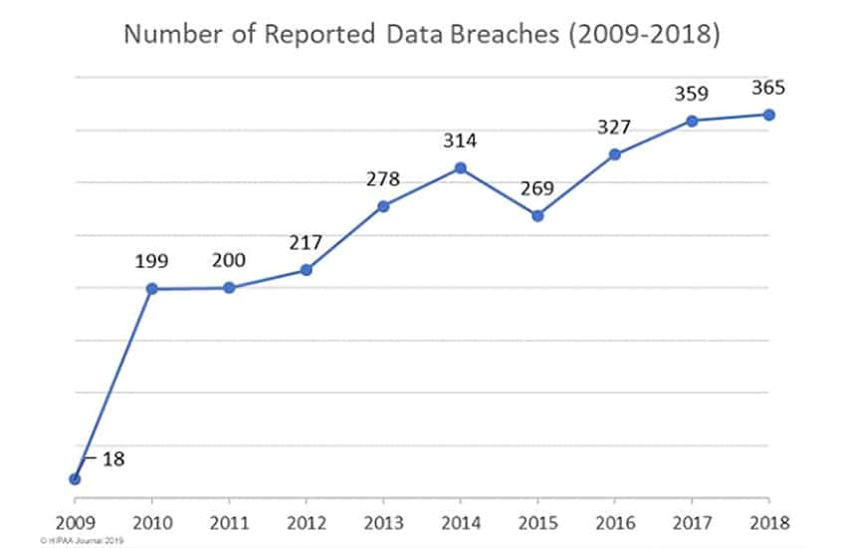
Figure 2:
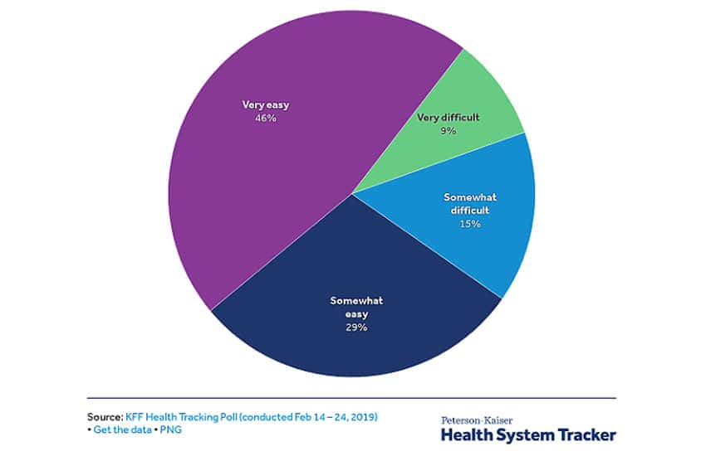
Figure 3:
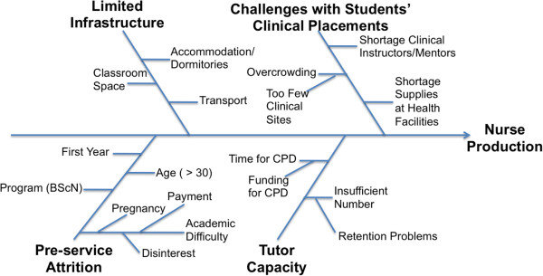
Figure 4:
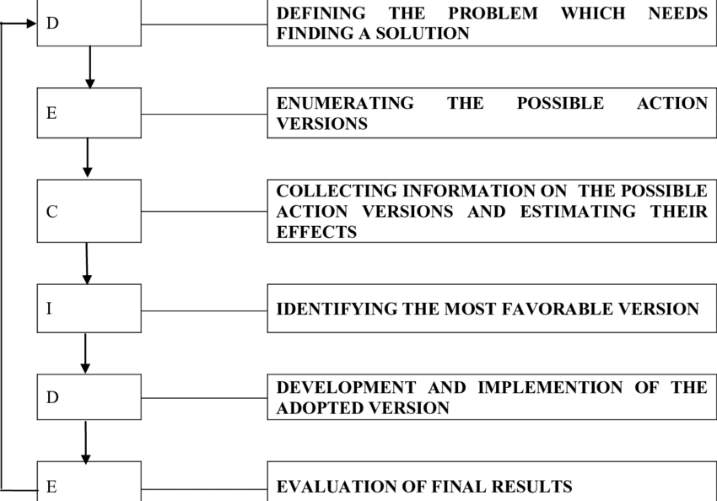
Figure 5:


