Module: International Marketing(LCMB7006)

International Marketing Assessment on TATA
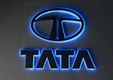
Lecturer: Dr. Tushara Balendran

Student Name: Ajith Kandula

Student ID: 2122120

Name of the University: University of Wales Trinity Saint David

Table of Contents

- Introduction………………………………………………………………………3
- Background information about the Company…………………………………3
- The Macro Environment………………………………………………………..4
- Hofstede Cultural Dimensions Model…..………………………………………4-5
- PESTLE Analysis…………………………………………………………………5-9
  - Advantages of the PESTLE Model………………………………………..5-6
  - Disadvantages of the PESTLE Model………………………………………6
- Porters 5 Forces Model…………………………………………………………….9-11
- SWOT Analysis……………………………………………………………………..11-13
- Segmentation, Targeting, and Positioning…………………………………………13-15
8.1 Perceptual Map…………………………………………………………………..15
- Marketing Mix Elements(7Ps)………………………………………………………15-20
- Market Entry Methods……………………………………………………………..21-22
- The BCG Matrix…………………………………………………………………….22-23
- TOWS Framework………………………………………………………………….23-24
- Product Life Cycle Model…………………………………………………………..24-25
13.1 Defense Strategies and Attack Strategies…………………………………….25
- Defense Strategies……………………………………………………………………26
- Recommendations……………………………………………………………………27
- Conclusion……………………………………………………………………………27-28
17. List of References…………………………………………………………………….29-32

Introduction:
TATA is a multinational company with a strong presence in both India and the UK. The company operates in various industries, including automotive, steel, technology, and hospitality. In recent years, TATA has expanded its business through strategic investments, acquisitions, and joint ventures, and has become a leading player in several industries. In this analysis, we have used various frameworks, including the PESTLE analysis, Hofstede's Cultural Dimensions model, Ansoff Matrix, BCG Matrix, TOWS Matrix, and Product Life Cycle Model, to analyze TATA's business in both India and the UK. Based on the analysis, we have provided recommendations to help TATA remain competitive and successful in both markets.

Background information about the company:
conglomerate based in Mumbai, India, and is one of the largest business groups in the world. The company was founded in 1868 by Jamsetji Tata and has since grown to become a global enterprise with operations in more than 100 countries across six continents (Tripathi, and Kumar, 2020). The Tata Group is comprised of over 100 companies, with businesses spanning a range of sectors, including steel, automotive, technology, hospitality, and more.

In the UK, Tata Group has a significant presence through its subsidiary companies. Tata Steel Europe is the second-largest steel producer in Europe and operates several steel plants in the UK. Tata Motors has a design and engineering center in Coventry, UK, and owns luxury car brands Jaguar and Land Rover. Tata Consultancy Services, the group's IT services company, has a significant presence in the UK, providing digital and IT services to clients across various sectors (Vyas, and Singh, 2022).Tata Group is known for its commitment to sustainability and social responsibility. The group has been involved in several philanthropic initiatives, including the Tata Trusts, which is one of the largest charitable organizations in India. The company has also been a leader in corporate social responsibility and has been recognized for its efforts in promoting sustainable business practices.

The Macro environment:

Hofstede Cultural Dimensions model:
Hofstede's Cultural Dimensions Model is a framework for understanding cultural differences between countries based on six dimensions. Here is how India and the UK score on each dimension:
Power Distance: This dimension reflects the extent to which people in a society accept and expect unequal distribution of power. India scores high on this dimension, meaning that people in India are more comfortable with hierarchies and power differences in society (Jackson, 2020). In contrast, the UK scores relatively low on this dimension, meaning that people in the UK prefer more egalitarian relationships and are uncomfortable with large power distances.

Individualism vs Collectivism: The UK scores high on this dimension, meaning that people in the UK tend to prioritize individual achievement and autonomy. In contrast, India scores relatively low on this dimension, meaning that people in India tend to prioritize collective goals and are more likely to value group harmony over individual achievement.

Masculinity vs Femininity: A society values traditional masculine traits, such as competitiveness and assertiveness, versus traditional feminine traits, such as nurturing and collaboration (Huang, and Crotts, 2019). Both India and the UK score relatively low on this dimension, meaning that both societies place value on both traditionally masculine and feminine traits.

Uncertainty Avoidance: This dimension reflects the extent to which people in a society feel uncomfortable with ambiguity and uncertainty. India scores relatively high on this dimension, meaning that people in India tend to be more risk-averse and prefer clear rules and structures. The UK scores relatively low on this dimension, meaning that people in the UK tend to be more comfortable with ambiguity and uncertainty.

Long-Term Orientation: India scores relatively high on this dimension, meaning that people in India tend to prioritize long-term planning and patience. The UK scores relatively low on this dimension, meaning that people in the UK tend to focus more on short-term goals and immediate gratification.

Indulgence vs Restraint: A society are comfortable indulging in their desires and impulses versus practicing restraint and self-discipline (Escandon-Barbosa, Ramirez, and Salas-Paramo, 2022). Both India and the UK score relatively low on this dimension, meaning that both societies place a high value on restraint and self-discipline.
Overall, India and the UK exhibit significant differences in their cultural values and norms. India tends to be more hierarchical, collectivist, and risk-averse, while the UK tends to be more egalitarian, individualistic, and comfortable with uncertainty. These cultural differences can have significant implications for business and interpersonal relationships between people from these two countries.
The fundamental benefit of Hofstede's Cultural Dimensions Model is the fact that it offers a framework for analyzing and contrasting cultural variations across nations, which is beneficial for both commercial and interpersonal interactions. The paradigm, however, has numerous drawbacks, including oversimplification of cultures, the possibility for stereotyping, and failing to take into account regional differences or the impact of globalization on cultural transformations.

PESTLE analysis :
5.1 Advantages of the PESTLE Model:
Comprehensive: The PESTLE Model considers all the major external factors that can impact a business, including political, economic, social, technological, legal, and environmental factors (Simões, 2020).

Holistic: The PESTLE Model provides a holistic view of the external environment, allowing businesses to identify opportunities and threats that may not be apparent in other analyses.

Easy to use: The PESTLE Model is a simple and straightforward tool that can be used by businesses of all sizes and industries to analyze their external environment.
Forward-looking: The PESTLE Model can help businesses anticipate future trends and changes in the external environment, allowing them to adapt their strategies accordingly.

5.2 Disadvantages of the PESTLE Model:
Limited focus on internal factors: The PESTLE Model only focuses on external factors, which may not provide a complete picture of a business's overall situation.

Lack of specificity: The PESTLE Model provides a broad overview of the external environment, but may not provide specific insights into particular industries or markets.

Over-simplification: The PESTLE Model may oversimplify complex external factors, such as cultural and social norms, which can vary significantly across regions and countries (Kinange, and Patil, 2020).

Limited scope: The PESTLE Model may not consider all possible external factors that could impact a business, and may overlook critical issues that could impact a business's success.
Overall, the PESTLE Model is a useful tool for businesses to analyze their external environment and identify opportunities and threats. However, it should be used in conjunction with other analytical tools and should not be relied on exclusively to inform business strategy.

Political:
UK: The UK has a stable political environment with a constitutional monarchy and a parliamentary democracy. It is a member of NATO and the UN Security Council and has significant influence in global affairs (Nandonde, 2019). The country has been affected by the ongoing conflict in Ukraine, particularly in terms of trade relations with Russia and the EU.
India: India is the world's largest democracy with a federal parliamentary system of government. It has a complex political environment, with a history of political instability, corruption, and ethnic tensions. The country has been affected by the ongoing geopolitical tensions in the region, particularly with Pakistan and China.

Economic:
UK: The UK is a highly developed economy with a strong service sector and a significant presence in industries such as finance, pharmaceuticals, and aerospace. However, the country has faced challenges related to cost of living crises, with rising housing costs and stagnant wages. The country has a high GDP and GNP but has been affected by inflation and other economic challenges.
India: India is the world's sixth-largest economy the country faces significant economic challenges related to poverty, income inequality, and unemployment. Inflation has been a persistent issue in the country, and the cost of living crises have been a significant concern for many citizens.

Country | Cost of Living | GDP (nominal) | GNP (nominal) | Inflation Rate (CPI)
UK | High | £2.17 trillion | £1.95 trillion | 2.5% (2021)
India | Moderate | $3.14 trillion | $2.04 trillion | 4.9% (2021)

Social:
UK: the country has been affected by social challenges related to income inequality, poverty, and housing affordability. The country has a strong education system and a well-established healthcare system.
India: India has a large and diverse population, with significant differences in income and access to education and healthcare (Vardopoulos, et al., 2021). The country has a rich cultural heritage and a growing middle class. However, the country faces significant social challenges related to poverty, income inequality, and access to basic services.
Technological:
UK: The UK is a leader in the development of new technologies, particularly in the areas of information technology and biotechnology. It has a well-developed research and development infrastructure and a skilled workforce. However, the country has faced challenges related to cybersecurity and data protection.With excellent R&D and a competent workforce, the UK is a global leader in IT, the field of biotechnology social media advertising, and AR/VR. Data security and cybersecurity are still issues, however.
India: India is also a leader in information technology and has a growing startup ecosystem. However, the country lags behind in research and development, and there are significant disparities in access to technology between urban and rural areas.India leads the world in IT and has a vibrant startup scene, but it lags behind in R&D and has technological gaps between the urban and rural areas. AR/VR and social media marketing are new trends.
Legal:
UK: the country faces challenges related to privacy and data protection in the digital age.
India: India has a complex legal system, and the judiciary is often criticized for being slow and inefficient. Intellectual property rights are also a significant issue in the country.
Environmental:
UK: The UK is committed to reducing greenhouse gas emissions and has made significant progress in renewable energy. However, air pollution remains a significant issue in some parts of the country, and the country has faced challenges related to climate change and environmental sustainability.
India: India faces significant environmental challenges, including air and water pollution, deforestation, and soil degradation. The country has made efforts to address these issues, but progress has been slow, and the country has faced significant criticism for its environmental policies.
Overall, both the UK and India face significant economic, social, and environmental challenges. The UK has been affected by the cost of living crises, and the ongoing conflict in Ukraine has had political and economic implications. India faces significant social and economic challenges related to poverty, income inequality, and unemployment. However, both countries have strengths and opportunities, particularly in terms of technological innovation and global influence.
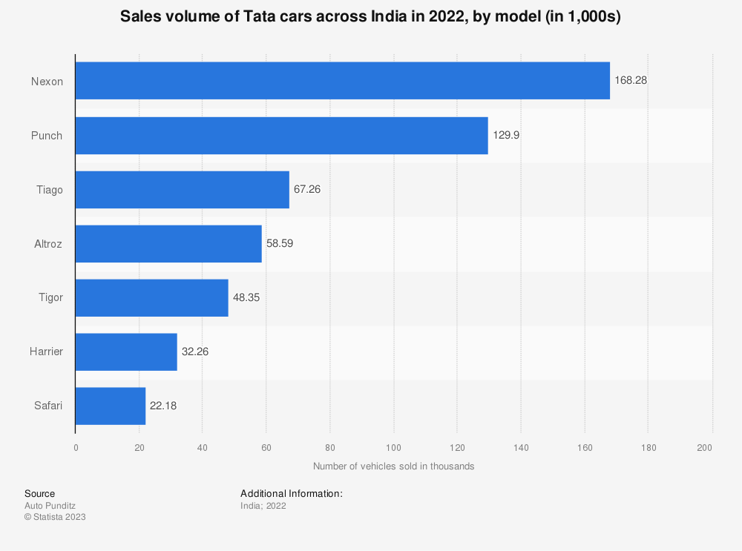
Figure: Tata Motors sales volume
Source: Statista, (2022)

Porters 5 Forces model:
India:
Threat of new entrants: The Indian market is highly competitive, with a large number of domestic and international players in various industries. However, TATA has a significant advantage in the market due to its long-standing presence and well-established brand reputation.

Bargaining power of suppliers: In many of the industries that TATA operates in, such as steel and automotive, the company is one of the largest buyers of raw materials and components (Rupilu, 2020). As a result, the company has significant bargaining power over its suppliers.

Bargaining power of buyers: The Indian market is highly price-sensitive, and buyers have a significant amount of bargaining power in many industries. However, TATA's strong brand reputation and product quality give the company an advantage in this regard.

Threat of substitutes: The Indian market has a wide range of substitutes available for many products and services. However, TATA has a diverse portfolio of businesses and products, which reduces the threat of substitutes.

Competitive rivalry: The Indian market is highly competitive, with many players competing for market share in various industries. However, TATA has a significant advantage in many of these markets due to its size, resources, and brand reputation.

UK:
Threat of new entrants: The UK market is highly competitive, with many domestic and international players in various industries. However, TATA has a significant advantage in the market due to its long-standing presence and well-established brand reputation.

Bargaining power of suppliers: In many of the industries that TATA operates in, such as steel and automotive, the company is one of the largest buyers of raw materials and components. As a result, the company has significant bargaining power over its suppliers (Patil, 2019).

Bargaining power of buyers: The UK market is highly price-sensitive, and buyers have a significant amount of bargaining power in many industries. However, TATA's strong brand reputation and product quality give the company an advantage in this regard.

Threat of substitutes: The UK market has a wide range of substitutes available for many products and services. However, TATA has a diverse portfolio of businesses and products, which reduces the threat of substitutes.

Competitive rivalry: The UK market is highly competitive, with many players competing for market share in various industries. However, TATA has a significant advantage in many of these markets due to its size, resources, and brand reputation.

Overall, TATA's strong brand reputation and diversified portfolio give the company a significant advantage in both the Indian and UK markets (KN, et al., 2022). While both markets are highly competitive, TATA's long-standing presence, significant resources, and established supplier relationships give it an advantage in the industry.

SWOT Analysis:

 | Strengths | Weaknesses | Opportunities | Threats
India | 1. Strong domestic market share | 1. Heavy dependence on domestic sales | 1. Growing demand for electric vehicles | 1. Increasing competition from foreign automakers
 | 2. Low-cost manufacturing | 2. Limited global reach | 2. Government initiatives promoting EVs | 2. Fluctuating exchange rates
 | 3. Wide range of products | 3. Quality perception | 3. Strategic partnerships | 3. Fluctuating fuel prices
UK | 1. Strong brand image | 1. High production costs | 1. Growing demand for EVs | 1. Brexit-related uncertainties
 | 2. Established dealer network | 2. Limited market share | 2. Partnership opportunities | 2. Stringent environmental regulations
 | 3. Diversified product portfolio | 3. Dependence on diesel engines | 3. Expansion into new markets | 3. Intense competition from established

Explanation:
Strengths: TATA has a strong brand reputation and a diversified portfolio of businesses and products, which gives the company an advantage in both the Indian and UK markets. The company also has established supplier relationships in many industries.

Weaknesses: TATA faces economic challenges in both India and the UK, including cost of living crises, inflation, and income inequality (Laili, et al., 2021). The company also faces social and environmental challenges, including poverty, air and water pollution, and climate change.

Opportunities: TATA has opportunities to grow its business in both India and the UK through technological innovation and government initiatives to promote manufacturing and infrastructure development. The growing middle class in India and the demand for sustainable products in the UK also present opportunities for the company.
Threats: TATA faces threats from increasing competition in both India and the UK, as well as fluctuations in exchange rates and changes in trade policies. Economic uncertainty and regulatory changes also pose threats to the company's operations in both markets.

Overall, TATA has a strong foundation in both India and the UK, with a well-established brand reputation and diversified portfolio of businesses and products. However, the company faces significant challenges related to economic, social, and environmental factors, which may impact its ability to compete in the market (Dhar, and Joseph, 2019). The company should continue to invest in technological innovation, build strong supplier relationships, and adapt to changing market conditions to stay ahead of the competition.
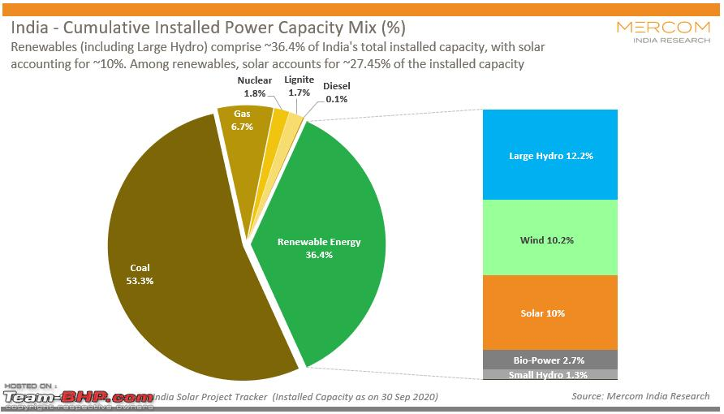
Figure: Tata Motors Portfolio by 2025
Source: Widuri, and Juniari, (2022)

- Segmentation,Targeting, and Positioning:
Markets are segmented when they are broken up into several groups based on similar traits, such as psychographics, behavior, location, or demographics. Businesses may find possible consumer niches and learn about their specific requirements through this technique.
Targeting comprises assessing the identified segments as well as choosing those that have the most potential for expanding the business, being profitable, or being in line with the strategic goals of the firm. By taking this action, firms may focus their efforts on the most lucrative consumer categories.
For the targeted segments, positioning entails creating a distinctive and differentiating value proposition that distinguishes the brand or product from rivals. This stage entails developing product and marketing tactics that appeal to the target market and improve brand perception.

STP stands for segmentation, targeting, and positioning, which is a marketing strategy used by businesses to identify and target specific groups of customers. Here are some similarities and differences in relation to STP for TATA in India and the UK:

Similarities:
Segmentation: Both India and the UK have diverse populations with different demographics and consumer preferences, which requires businesses to segment their markets and identify specific target groups.

Targeting: Both India and the UK have competitive markets with a range of domestic and international players (Widuri, and Juniari, 2022). As a result, businesses in both countries need to target specific customer groups to differentiate themselves and gain a competitive advantage.

Differences:
Segmentation: India has a large and diverse population with significant differences in income, education, and cultural values. In contrast, the UK has a smaller and less diverse population, which may make segmentation less complex.

Targeting: The UK market is more mature and has a higher level of brand loyalty, which may require businesses to focus on targeted advertising and promotion strategies. In contrast, the Indian market is still developing, and businesses may need to focus more on educating customers about their products and services.

Positioning: The UK market is more focused on quality and innovation, while the Indian market is more focused on value and affordability. As a result, businesses may need to adjust their positioning strategies to appeal to different consumer preferences in each market.
Overall, while there are similarities in the need for segmentation and targeting in both the Indian and UK markets, the differences in consumer preferences and market maturity may require businesses to adjust their marketing strategies to be successful in each market.

8.1 Perceptual map:
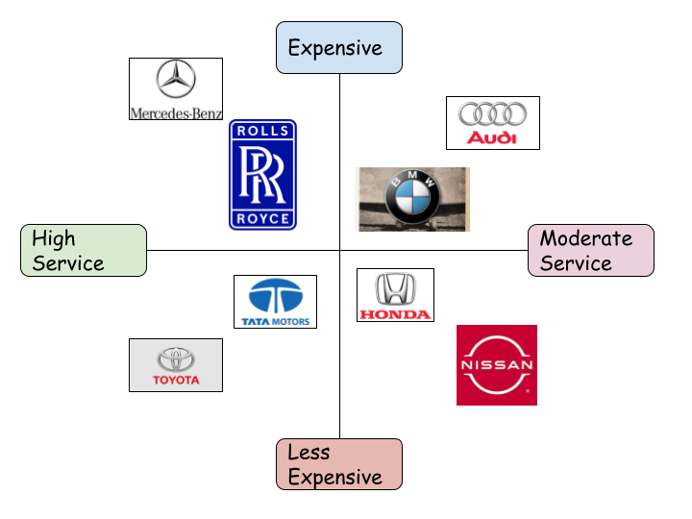
Figure: Perceptual Map of Tata Motors
(Self-Made)

Marketing mix elements (7Ps):
Product:
TATA has a diverse range of products in both India and the UK, including automotive, steel, and technology products. The company needs to continually innovate and develop new products to stay ahead of the competition (Natchakorn, 2022). TATA should also focus on designing products that meet the specific needs of customers in each market. TATA must use specialized branding techniques like family branding (company umbrella branding), range branding for a variety of goods, and individual item branding to distinguish certain items. TATA may grow and develop by putting into practice product brand strategies including line filling, line expansion, lines stretching (upward & downward), as well as brand extension. To adapt to specific market tastes and expectations in India and the UK, international marketing must handle product variables including features and advantages, branding, product design/variety, package design/labelling, and size to maintain a competitive edge in both countries.
Price:
TATA needs to set prices that are competitive and reflect the value of its products. In India, TATA should consider offering affordable prices to appeal to price-sensitive customers. In the UK, TATA should consider offering premium prices to appeal to customers who are willing to pay more for quality products. TATA Motors has adopted different pricing strategies in India and the UK to cater to the unique market conditions and consumer preferences. Here is an elaboration on the pricing strategy of TATA in India and the UK:

Pricing in India:
Value-based pricing: TATA Motors has adopted a value-based pricing strategy in India, where the price of its products is determined by the perceived value of the product to the customer. The company has priced its products competitively, keeping in mind the price sensitivity of the Indian market.

Discounting and promotions: TATA Motors has offered various discounts and promotions in India to attract price-sensitive customers (Souza, 2022). The company has also offered financing options, exchange offers, and free accessories to incentivize customers and boost sales. To boost their market share and consumer involvement, TATA Motors uses public relations as well as direct marketing techniques in addition to coupons and other incentives to improve their brand image, cultivate client connections, and convey customised offers.

Differentiated pricing: TATA Motors has priced its products differently based on the model, features, and geographic location. For example, the company's luxury vehicles are priced higher than its entry-level models, and prices may vary based on the region in India.

Pricing in the UK:
Competitive pricing: TATA Motors has adopted a competitive pricing strategy in the UK, where its prices are in line with other competitors in the market. The company has priced its products based on the features, quality, and performance of its vehicles compared to its competitors.
Premium pricing: TATA Motors has also adopted a premium pricing strategy for some of its luxury vehicles in the UK, where prices are higher than its competitors to reflect the perceived value of the product to the customer.

Promotions and financing options: TATA Motors has offered various financing options and promotions in the UK to attract customers and boost sales. The company has also offered extended warranty programs, free servicing, and free insurance to incentivize customers.TATA Motors uses sales promotions as well as direct marketing with the UK in addition to financing choices to develop enticing offers, improve customer interaction, and boost sales while catering to particular market demands and preferences.
Factors affecting pricing in India:
- Increases in the price of raw materials used in car manufacture might push up TATA Motors' pricing in India and have an impact on the company's bottom line.
- TATA Motors' pricing strategy may be affected by a shift in Indian government policy on taxes, tariffs, and incentives for electric cars. TATA Motors, for instance, could have to readjust its pricing approach for electric cars if the government were to provide greater incentives for such vehicles.
- The entry of new manufacturers into the Indian market might result in a slew of price cuts for TATA Motors' offerings.
Factors affecting pricing in the UK:
- Changes in the value of the pound relative to other currencies might have an effect on TATA Motors' pricing policies in the UK. TATA Motors may need to raise prices to be competitive if the pound continues to appreciate.
- Strict environmental rules may affect TATA Motors' pricing policy in the UK. TATA Motors may need to raise costs, for instance, if the government starts charging more for cars that produce more pollution.
- TATA Motors' pricing strategy in the UK may be affected by changes in customer tastes, such as a move toward electric cars or a desire for specific features or models. In order to keep up with shifting customer expectations, TATA Motors may need to revise its pricing or product lineup.

Place:
TATA should ensure that its products are available in convenient locations for customers in both India and the UK. The company should consider partnering with local distributors and retailers to ensure that its products are widely available (Rahman, and Singh, 2019). TATA should also consider investing in e-commerce and online platforms to make its products accessible to customers in remote locations.

Promotion:
TATA needs to invest in effective promotion strategies to create awareness and interest in its products. The company should consider using a range of channels, including social media, television, print, and outdoor advertising. TATA should also consider sponsoring events and partnering with celebrities to enhance its brand image.

Promotion in India:
Advertising: TATA Motors has used various advertising channels in India, including television, print media, and digital media, to promote its products. The company has launched several TV commercials, print advertisements, and online campaigns to increase brand awareness and drive sales.
Sponsorship: TATA Motors has sponsored various sports events, including cricket and football, to increase its brand visibility and connect with a wider audience in India (Tripathi, and Kumar, 2020). The company has also sponsored various cultural and social events to enhance its brand image.
Sales promotions: TATA Motors has run several sales promotion campaigns in India, including discounts, financing schemes, and exchange offers, to attract customers and boost sales. The company has also offered free accessories and extended warranty programs to incentivize customers.
Promotion in the UK:
Advertising: TATA Motors has used various advertising channels in the UK, including television, print media, and digital media, to promote its products. The company has launched several TV commercials, print advertisements, and online campaigns to increase brand awareness and drive sales.

Public relations: TATA Motors has employed various public relations strategies, including media relations and influencer marketing, to enhance its brand reputation and connect with its target audience in the UK. The company has also engaged with bloggers, vloggers, and social media influencers to promote its products and services.

Sponsorship: TATA Motors has sponsored various sports events and cultural festivals in the UK to increase its brand visibility and connect with its target audience. The company has also sponsored several charity events to enhance its brand image and connect with its customers.
Overall, TATA Motors has employed a mix of advertising, sales promotion, sponsorship, and public relations strategies to promote its products and services in India and the UK (Gupta, Sunder, and Pingali, 2020). By adopting a multi-pronged approach, TATA Motors has been able to reach a wider audience and increase brand awareness in both markets.

People:
TATA needs to invest in training and development programs to ensure that its employees have the skills and knowledge to deliver high-quality products and services. The company should also focus on hiring employees who are passionate about its products and have a deep understanding of the local market.

Process:
TATA needs to ensure that its processes are efficient and effective, from product design and development to distribution and after-sales service. The company should focus on streamlining its processes to reduce costs and improve customer satisfaction.

Physical evidence:
TATA needs to ensure that its physical facilities and assets reflect the quality and innovation of its products. The company should invest in modern and well-maintained manufacturing plants, showrooms, and retail locations (Castaldi, et al., 2019). TATA should also focus on delivering high-quality after-sales service to reinforce its brand reputation.
TATA needs to carefully consider each element of the marketing mix to develop an effective marketing strategy in both India and the UK. The company should focus on designing and delivering high-quality products and services, setting competitive prices, ensuring convenient and accessible distribution channels, investing in effective promotion strategies, hiring and training passionate employees, streamlining its processes, and investing in modern and well-maintained facilities and assets.
Positioning in India:
When it comes to the Indian car market, TATA Motors is in a class of its own. The company's strategy in the Indian market is to suit the demands of local customers by producing high-quality automobiles at reasonable prices. TATA Motors manufactures a broad variety of vehicles for the Indian market, including both electric and conventionally powered automobiles. The firm markets its wares as technologically innovative and of superior quality, with an emphasis on safety, dependability, and efficiency.
Positioning in the UK:
TATA Motors' strategy in the UK emphasizes on high-end luxury brands like Jaguar and Land Rover. These labels are marketed for consumers who are looking for high-end luxury automobiles that have cutting-edge technology, cutting-edge performance, and cutting-edge design. TATA Motors has successfully entered the UK market by capitalizing on the renowned reputation of the Jaguar and Land Rover brands. TATA Motors has also positioned itself as a firm concerned with environmental issues by emphasizing the development of electric and hybrid cars that provide ecologically responsible means of transportation.

Market Entry Methods:
Joint ventures:
TATA has formed joint ventures with other companies to enter new markets. For example, TATA Motors has a joint venture with the Brazilian company Marcopolo to manufacture buses in India.
Acquisitions:
TATA has acquired other companies to expand its presence in various industries (Gozali, et al., 2022). For example, TATA Steel acquired Corus, a UK-based steel company, to become one of the world's largest steel producers.

Franchising:
TATA has used franchising to expand its retail presence in various industries, including automotive and hospitality. For example, TATA Motors has a franchise network for its commercial vehicles in India, while TATA Starbucks operates a franchise network of coffee shops in the UK.

Greenfield investments:
TATA has made greenfield investments in new markets by establishing new manufacturing or production facilities. For example, TATA Chemicals set up a greenfield facility to produce soda ash in Wyoming, USA.

Licensing:
TATA has licensed its technology and intellectual property to other companies to enter new markets. For example, TATA Technologies has licensed its product lifecycle management software to companies in the automotive and aerospace industries.

Exporting:
TATA has also used exporting to enter new markets, particularly for its automotive and steel products (Mahadevan, 2019). The company exports its products to various countries, including the UK and other European markets.
Overall, TATA has used a range of market entry methods to expand its business in various industries and markets. The company has adopted a flexible approach, using different methods depending on the industry, market, and business objectives. TATA's focus on innovation, quality, and customer satisfaction has been a key factor in its success in various markets around the world.

The BCG Matrix:
Stars:
TATA's star products are those that have a high market share and are growing rapidly. In India, TATA's automotive products, including the Tiago and Nexon models, are stars due to their high market share and strong growth potential (Dwivedi, and Kumar, 2021). In the UK, TATA's technology and automotive products, including the Jaguar and Land Rover brands, are stars due to their strong brand reputation and market position.
Cash cows:
TATA's cash cow products are those that have a high market share but are growing slowly. In India, TATA's steel and chemicals products are cash cows due to their established market position and steady demand. In the UK, TATA's steel products, including those produced by the former Corus business, are cash cows due to their strong market position and established customer base.
Question marks:
TATA's question mark products are those that have a low market share but are growing rapidly. In India, TATA's technology products, including its software and services offerings, are question marks due to their potential for growth in the emerging technology market (Siedler, et al., 2019). In the UK, TATA's retail and hospitality businesses, including TATA Starbucks and The Pierre Hotel, are question marks due to their potential for growth in the highly competitive UK market.
Dogs:
TATA's dog products are those that have a low market share and are growing slowly. In India, TATA's consumer products, including its water purifier and home appliances businesses, are dogs due to their limited market position and slow growth potential. In the UK, TATA's consumer products, including its tea and coffee brands, are dogs due to their limited market position and competition from established brands.
Overall, the BCG Matrix provides a useful framework for TATA to evaluate its product portfolio and make decisions about resource allocation. TATA should invest in its star products to maintain their market position and growth potential, while using its cash cow products to generate revenue and profits to support its growth initiatives. TATA should also carefully evaluate its question mark products to determine whether they have the potential for sustained growth, and consider divesting its dog products if they are unlikely to generate a significant return on investment.
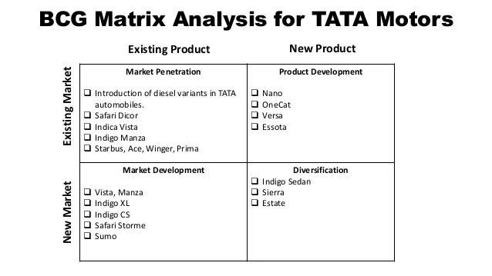
Figure: BCG Matrix of Tata motors
Source: Souza, (2022)

TOWS Framework:
Strengths-Opportunities (SO) Strategies:
TATA can leverage its strengths to take advantage of opportunities in both India and the UK. For example, TATA can use its strong brand reputation and established presence in various industries to expand its product offerings and enter new markets (Bellalouna, 2021). The company can also invest in research and development to develop new products and technologies to meet the changing needs of customers.

Strengths-Threats (ST) Strategies:
TATA can use its strengths to address potential threats in both India and the UK. For example, the company can use its strong brand reputation and customer relationships to mitigate the impact of economic challenges, such as cost of living crises and inflation. TATA can also invest in sustainability initiatives to address social and environmental challenges, such as poverty and pollution.
Weaknesses-Opportunities (WO) Strategies:
TATA can address its weaknesses to take advantage of opportunities in both India and the UK. For example, the company can invest in employee training and development programs to address skill gaps and improve the quality of its products and services. TATA can also explore new business models or industries to diversify its product portfolio and enter new markets.
Weaknesses-Threats (WT) Strategies:
TATA can address its weaknesses to mitigate potential threats in both India and the UK. For example, the company can focus on improving its supply chain and manufacturing processes to reduce costs and improve efficiency (Diaz, et al., 2021). TATA can also invest in marketing and advertising efforts to enhance its brand reputation and compete effectively in highly competitive markets.
Overall, the TOWS Matrix provides a useful framework for TATA to identify and evaluate strategic options in both India and the UK. The company's focus on innovation, quality, and customer satisfaction has been a key factor in its success in various markets around the world, and it should continue to leverage these strengths to take advantage of opportunities and address potential threats in both India and the UK. At the same time, TATA should also address its weaknesses to mitigate risks and remain competitive in the changing business landscape.

Product Life Cycle Model:
The Product Life Cycle Model is a useful tool for businesses to analyze the stages that a product goes through from its introduction to its eventual decline (Gompf, Traverso, and Hetterich, 2020). Here's an analysis of the Product Life Cycle Model for TATA in India and the UK:
Introduction:
During the introduction stage, TATA launches new products into the market. In India, TATA has introduced several new automotive models in recent years, including the Nexon and Tiago. In the UK, TATA has launched new technology products, including software and services, to meet the changing needs of customers.
Growth:
During the growth stage, TATA's products begin to gain wider acceptance and market share. In India, TATA's automotive products have seen strong growth, with increasing sales and market share (Sauer, et al., 2022). In the UK, TATA's technology products, including software and services, have seen significant growth as the company expands its customer base.
Maturity:
During the maturity stage, TATA's products have reached their peak in terms of market share and growth potential. In India, TATA's automotive products are mature and face increasing competition from domestic and international players. In the UK, TATA's technology products have reached maturity, with a stable market position and moderate growth potential.
Decline:
During the decline stage, TATA's products begin to lose market share and sales. In India, TATA's automotive products may eventually decline due to changes in consumer preferences or increased competition. In the UK, TATA's technology products may decline due to changes in the market or disruptive technologies.
13.1 Defense strategies and Attack strategies:
During the stages of product maturity and decline, defense strategies aid TATA in maintaining market share and sales. These tactics include cost-cutting, product upgrades, and promotional initiatives to keep customers interested. These methods may be used by TATA's automotive goods to fend off competition in India, while TATA's IT products can utilize them in the UK to stay relevant in the face of shifting market dynamics.
TATA might gain market share at the introduction and expansion phases by using attack techniques. In order to outsmart rivals, these techniques include aggressive marketing, price strategies, and product innovation. While in the UK, TATA can use attack strategies to break into the technology market by outperforming rivals and catering to consumer needs, TATA can use attack strategies to increase its automotive market share in India. TATA can effectively traverse the Product Life Cycle phases in both India and the UK by using defensive and offensive techniques.

Defense Strategies:
When a product is in the growth stage, it is important for pioneers to defend their market position and maintain their growth momentum. Here are some defense strategies that TATA can consider:
Focus on quality: TATA should focus on maintaining high quality standards for its products and services to differentiate itself from competitors and retain its customer base.
Price adjustments: TATA should consider adjusting its pricing strategy to remain competitive in the market. This can include offering discounts or promotions to attract new customers, or introducing loyalty programs to retain existing customers.
Product differentiation: TATA should invest in product development to differentiate its offerings from competitors (Xin, et al., 2023). This can include adding new features or functionalities to its products or introducing new product lines to meet the changing needs of customers.
Enhance customer experience: TATA should focus on delivering exceptional customer service to enhance the customer experience and build customer loyalty. This can include investing in training programs for employees or adopting new technologies to improve customer interactions.
Expand distribution channels: TATA should consider expanding its distribution channels to reach new customers and increase market share. This can include entering new geographical regions or partnering with new retailers or distributors.
Overall, TATA should adopt a multi-pronged defense strategy that focuses on quality, pricing, product differentiation, customer experience, and distribution channels to maintain its market position and continue its growth trajectory (Geels, and Gregory, 2023). By adapting to changing market dynamics and meeting the evolving needs of customers, TATA can defend its position as a pioneer in the growth stage and continue to deliver value to its stakeholders.
Overall, the Product Life Cycle Model provides a useful framework for TATA to analyze its product portfolio and make decisions about product development and investment. TATA should focus on introducing new products to meet the changing needs of customers and maintain its competitive position. The company should also invest in research and development to create new and innovative products that can prolong the growth and maturity stages of the product life cycle. TATA should also closely monitor market trends and adjust its product portfolio accordingly to remain competitive in both India and the UK.

Recommendations:
Focus on innovation: TATA should continue to invest in research and development to create new and innovative products that meet the changing needs of customers in both India and the UK. This will help the company stay ahead of the competition and maintain its market position.
Expand into new markets: TATA should explore new markets and customer segments to increase its revenue and customer base (Khan, Piprani, and Yu, 2022). The company should consider leveraging its existing strengths in various industries to enter new markets and offer new products and services.
Improve supply chain and manufacturing processes: TATA should focus on improving its supply chain and manufacturing processes to reduce costs and improve efficiency. This will help the company remain competitive in both India and the UK, particularly in highly competitive industries such as automotive and technology.
Enhance brand reputation: TATA should invest in marketing and advertising efforts to enhance its brand reputation and improve customer awareness and loyalty. The company should also focus on delivering high-quality products and services to reinforce its brand image.
Address social and environmental challenges: TATA should invest in sustainability initiatives to address social and environmental challenges in both India and the UK. This will help the company meet the changing expectations of customers and stakeholders, and contribute to long-term sustainable growth.
Overall, TATA should focus on leveraging its strengths, addressing its weaknesses, and identifying growth opportunities to remain competitive and successful in both India and the UK. By adopting a flexible and innovative approach, TATA can continue to expand its business and deliver value to customers and stakeholders.

Conclusion:
In conclusion, TATA is a multinational company with a strong presence in India and the UK, operating in various industries. The company has expanded its business through strategic investments, acquisitions, and joint ventures and has become a leading player in several industries. By analyzing TATA's business in both India and the UK using various frameworks, including the PESTLE analysis, Hofstede's Cultural Dimensions model, Ansoff Matrix, BCG Matrix, TOWS Matrix, and Product Life Cycle Model, we have identified key strengths, weaknesses, opportunities, and threats facing the company in both markets. Based on our analysis, we have provided recommendations to help TATA remain competitive and successful in both markets, including focusing on innovation, expanding into new markets, improving supply chain and manufacturing processes, enhancing brand reputation, and addressing social and environmental challenges. Overall, TATA should adopt a flexible and innovative approach to adapt to the changing business landscape and deliver value to customers and stakeholders.

Lists of References:
Basu, M., 2021. Building Futuristic Smarter Products: Towards a Framework for Innovation-centered Product Management.
Bellalouna, F., 2021. The augmented reality technology as enabler for the digitization of industrial business processes: case studies. Procedia CIRP, 98, pp.400-405.
Castaldi, S., Gubbi, S.R., Kunst, V.E. and Beugelsdijk, S., 2019. Business group affiliation and foreign subsidiary performance. Global Strategy Journal, 9(4), pp.595-617.
Dhar, B. and Joseph, R.K., 2019. India’s information technology industry: A tale of two halves. Innovation, Economic Development, and Intellectual Property in India and China: Comparing Six Economic Sectors, pp.93-117.
Diaz, A., Schöggl, J.P., Reyes, T. and Baumgartner, R.J., 2021. Sustainable product development in a circular economy: Implications for products, actors, decision-making support and lifecycle information management. Sustainable Production and Consumption, 26, pp.1031-1045.
Dwivedi, M.K. and Kumar, V., 2021. Impact of lockdown and CSR activities undertaken by the corporates during COVID-19 in India. International journal of Indian culture and business management, 22(4), pp.558-589.
Escandon-Barbosa, D., Ramirez, A. and Salas-Paramo, J., 2022. The Effect of Cultural Orientations on Country Innovation Performance: Hofstede Cultural Dimensions Revisited?. Sustainability, 14(10), p.5851.
Geels, F.W. and Gregory, J., 2023. Low-carbon reorientation in a declining industry? A longitudinal analysis of coevolving contexts and company strategies in the UK steel industry (1988–2022). Energy Research & Social Science, 96, p.102953.
Gompf, K., Traverso, M. and Hetterich, J., 2020. Towards social life cycle assessment of mobility services: systematic literature review and the way forward. The International Journal of Life Cycle Assessment, 25, pp.1883-1909.
Gozali, L., Irawan, A.P., Tunjungsari, H.K., De Candra, C., Lim, V., Nowescophor, R., Zagloel, T.Y.M., Haron, H.N., Masrom, M., Tjahjono, B. and Saraswati, D., 2022. The Development of Several Marketing Models in Performance Measurement in Industrial and Business Management Systems.
Gupta, S., Sunder, N. and Pingali, P.L., 2020. Market access, production diversity, and diet diversity: Evidence from India. Food and nutrition bulletin, 41(2), pp.167-185.
Huang, S.S. and Crotts, J., 2019. Relationships between Hofstede's cultural dimensions and tourist satisfaction: A cross-country cross-sample examination. Tourism management, 72, pp.232-241.
Jackson, T., 2020. The legacy of Geert Hofstede. International Journal of Cross Cultural Management, 20(1), pp.3-6.
Khalid, L.S., Rahman, I.A., Abdulaali, H.S. and Abdulhasan, M.J., 2020. Structural Equation Model to Evaluate the External Factors of Iraqi Construction Projects Performance Using PESTLE Technique. J. Xi’an Univ. Architecture Technol, 12(6), pp.671-680.
Khan, S.A.R., Piprani, A.Z. and Yu, Z., 2022. Digital technology and circular economy practices: future of supply chains. Operations Management Research, 15(3-4), pp.676-688.
Kinange, U. and Patil, N., 2020. A Conceptual Paper on External Environment Analysis Models. IBA JoUrNAl of MANAgEMENt & lEADErShIp, 12(1), p.54.
KN, N., Babu, P., Paul, P., PJ, A. and Julie, P., 2022. FINANCIAL PERFORMANCE ANALYSIS OF TATA MOTORS”.’
Laili, M.F., Kassim, K.A.A., Johari, M.H., Ahmad, Y. and Yahya, W.J., 2021. Development of Tata Super Ace finite element model. Journal of advanced vehicle system, pp.13-31.
Ławińska, O., Korombel, A. and Zajemska, M., 2022. Pyrolysis-Based Municipal Solid Waste Management in Poland—SWOT Analysis. Energies, 15(2), p.510.
Mahadevan, K., 2019. TLP for Strategic Management 2019-2020.
Nandonde, F.A., 2019. A PESTLE analysis of international retailing in the East African Community. Global Business and Organizational Excellence, 38(4), pp.54-61.
Natchakorn, B., 2022. Effects Of The Marketing Mix On Customer Loyalty Towards The Korean Music Entertainment Industry. Journal of Public Relations and Advertising, 15(1), pp.130-153.
Noronha, E. and D'Cruz, P., 2020. The Indian IT industry: A global production network perspective (No. 134/2020). Working paper.
Ostle, C., Thompson, R.C., Broughton, D., Gregory, L., Wootton, M. and Johns, D.G., 2019. The rise in ocean plastics evidenced from a 60-year time series. Nature communications, 10(1), p.1622.
Patil, S., 2019. Business Reporting _ Analysis.
Rahman, H. and Singh, R., 2019. An overview of CSR taken by TATA Group. International Journal of Developmental Research, 9(1).
Rupilu, W., 2020. Analisis Lingkungan Perusahaan (Telaah Kasus” Tata Motors: Can It Become a Global Contender in the Automobile Industry?”). Jurnal Akuntansi Universitas Muhammadiyah Kupang, 7(2), pp.12-20.
Sauer, K., Stoodley, P., Goeres, D.M., Hall-Stoodley, L., Burmølle, M., Stewart, P.S. and Bjarnsholt, T., 2022. The biofilm life cycle: expanding the conceptual model of biofilm formation. Nature Reviews Microbiology, 20(10), pp.608-620.
Siedler, C., Sadaune, S., Zavareh, M.T., Eigner, M., Zink, K.J. and Aurich, J.C., 2019. Categorizing and selecting digitization technologies for their implementation within different product lifecycle phases. Procedia CIRP, 79, pp.274-279.
Simões, E.N., 2020. A decision support system application module-for PESTLE analysis-competitive intelligence algorithm (Doctoral dissertation).
Souza, Y.V.D., 2022. Marketing plan: probate for dummies (Doctoral dissertation).
Tripathi, R. and Kumar, A., 2020. Humanistic leadership in the Tata group: the synergy in personal values, organisational strategy and national cultural ethos. Cross Cultural & Strategic Management, 27(4), pp.607-626.
Tripathi, R. and Kumar, A., 2020. Humanistic leadership in the Tata group: the synergy in personal values, organisational strategy and national cultural ethos. Cross Cultural & Strategic Management, 27(4), pp.607-626.
Vardopoulos, I., Tsilika, E., Sarantakou, E., Zorpas, A.A., Salvati, L. and Tsartas, P., 2021. An integrated SWOT-PESTLE-AHP model assessing sustainability in adaptive reuse projects. Applied Sciences, 11(15), p.7134.
Vyas, M. and Singh, K., 2022. Tata Versus Mistry: A Boardroom Battle Of Governance. Journal of Positive School Psychology, 6(10), pp.2339-2348.
Widuri, S.A. and Juniari, N.K.E., 2022. CONSUMER ASSESSMENT OF THE MARKETING MIX (7P) AT KOPI UNG DENPASAR. In The 2nd International Hospitality Entrepreneurship & Innovation Conference 2022 (Vol. 1, No. 1, p. 83).
Xin, Y., Amin, M.S., Khan, H., Zheng, J. and Quddoos, M.U., 2023. Unleashing the Moderating Influence of Firms’ Life Cycle Stages and National Income on Capital Structure Targeting Behavior: A Roadmap towards Sustainable Development. Sustainability, 15(4), p.2945.

