Utilising the Entrecomp Framework, critically evaluate your own creativity and enterprise skills and consider how you might be able to develop the creative and enterprising skills of primary learners through your own pedagogy.
Creativity and enterprise are central features of modern life that should be developed and extended throughout a school career (Donaldson, 2015, p.28). Despite Donaldson recognising that in Successful Futures, it has not always been the case that creativity and enterprise have been developed appropriately within Wales. Recent curriculums have been based towards children learning subject knowledge to pass tests but, what use is knowledge when the children are unable to use it in a creative manner. The education system and the confines of working to a regime has been inhibiting and decreasing children’s and adults creativity. This is supported by George Land who found during testing for creativity that the older a person got the less creative they became. Land and Jarman (1993) concluded that rather than creativity being fostered and enhanced, non-creative behavior was being learned as creative opportunities are limited as children go through education. However, Donaldson (2015) states that the world that children are growing up in today is moving away from ‘learning about’ to ‘learning to’, with an emphasis on the application and development of higher-order skills, particularly creativity, entrepreneurship and digital literacy. If the children of the future are able to know how to use the knowledge they have, then not only can they take part in a world that is ever changing but, they may even be able to provide innovative ideas to preserve and improve the world they live in that is faced with fast-paced change and worry. However, with previous and current curriculums being highly prescribed and given high accountability for results, the culture within schools has become less creative, which in turn has had a negative effect on the creative approach of teachers (Donaldson, 2015). Moving forwards, teachers need to be able to teach creatively and teach for creativity.
Enterprise and creativity are very much linked as an enterprising education involves equipping learners with an enhanced capacity to generate ideas and skills to make those ideas happen. The Entrecomp framework supports this as it aims to build a bridge between education and the workplace by bringing entrepreneurial skills that children will require later in life into education (Bacigalupo et al, 2016). The idea generation process is very much part of the creative thinking, whilst making those ideas happen has a strong relationship with entrepreneurship. The inclusion of enterprise in children’s education allows them to understand that their ideas can be made into products and can produce a successful business. This is supported by Bacigalupo et al (2016) as they suggest that entrepreneurship can be broadly defined as the capacity to turn ideas into action which strongly links with the idea that creative or divergent thinking plays a part in the idea generation to begin with.
When it comes to creativity it is essential that the environment around both the learners and the teacher support the development of creativity. As Thorne (2007) suggests that it is about how a teacher creates an environment where creativity can thrive that can unleash the potential of the learners and the teacher. The Reggio Emilia philosophy emphasises the importance of the environment as one of the three core principles of the Regio Emilia philosophy (The Scots College, no date). Furthermore, Vecchi (2010, xxi) states that the environment of the school needs much attention because of its contribution to learning; it can provide opportunities to enhance well-being, children’s ability to express values, ideas and emotions; and for its capacity to allow and encourage ways of seeing and exploring.
Different conditions and stimuli support being creative for different people. Whilst it may seem impossible to achieve the right environment to foster all children’s creativity; a survey from Thorne (2003, cited in Thorne, 2007) revealed that outside environments, working in groups and as individuals and even having deadlines to meet are all possible stimuli for being creative or innovative. However, in a learning environment, it is also important that children are allowed to ask questions and be curious without being shutdown. By closing down children’s questions and thoughts, teachers are suppressing children’s creative minds. Children are curious and they may ask questions that challenge teachers showing a depth of knowledge beyond their years. However, when a child asks a question that the teacher may not have the answer to, teachers should encourage children to explore the question to find out the answers. Despite the fact that this may come away from direct learning intentions to the lesson, it can also have a positive effect on the children’s interest of the topic as a whole. Thorne (2007) supports this as she states that when learning is driven by natural curiosity it allows for a more absorbing experience and helps develop children’s concentration.
For teachers there are a variety of things they can do to foster children’s creativity; simply beginning lessons with an unusual object to foster children’s curiosity can bring enhance their creative minds as they come up with various ideas to what it may be or could be used for (Jones and Wyse, 2004). Within the classroom and lessons, children should be encouraged to take risks. Allowing children to take risks can allow them to think outside of the norm without fear of being wrong but with a positive attitude to learning from mistakes; getting an answer wrong can become a means of being constructive to get the correct answer. This is supported by Jones and Wyse (2004) as they suggest that pupils must be able to manage risk and learn from their mistakes; opportunities for exploration and play without fear of being wrong provides the optimum creative learning experience.
As teachers are at the forefront of a child’s learning, they very often take the blame for children not achieving their potential. However, national curriculums and testing have played a part in teachers not being able to teach to their full potential by constraining them to strict guidelines that the curriculum provides. Donaldson (2015) supports this as he states that the high degree of prescription and detail in the national curriculum has created a culture within which the creative roles of schools and teachers have diminished, creating an underdeveloped workforce. Fortunately, moving forwards the new curriculum states that the intention is to release the creativity and energy of teachers to provide rich learning for children (Donaldson, 2015, p.64). The idea of going from a scripted curriculum to a more creative curriculum may worry some teachers as they have been used to teaching what has been scripted on the national curriculum. Although the thought of freedom and creative teaching sounds like there may be more work upon the horizon in terms of planning and resources, teachers should not worry but be excited as collaboration can be the answer. Despite the fact that as a teacher there are times where the stress of school life may feel too much and time needs to be taken to recharge in order to be inspired and enable you to work more effectively; doing something different, taking a break or using other staff for support can help create ideas for lessons (Thorne, 2007).
In order for an educator to develop a creative learning environment for children, they must first be creative themselves. NACCCE (1999) support this as they state that in order for children’s creative abilities to be developed they must be within an atmosphere in which the teacher’s creative abilities are properly engaged. The teacher must therefore be able to teach creatively and understand how to teach for creativity. Teaching for creativity can involve various techniques that facilitate creative thinking but creativity is not something that can be taught by direct instruction. This is supported by Wilson (2010) who states that teaching for creativity is about identifying children’s creative strengths and fostering their creativity. By using Bob Eberle’s ‘scamper’ mnemonic teachers are able to teach for creativity by helping children overcoming functional fixedness. Functional fixedness is described as a mental block against using an object in a new way (Duncker, 1945 cited in Mayer, 2010). By giving children an object and asking them if they can find other purposes for it or adapt it, can help them to think creatively. ‘Scamper’ in itself offers seven techniques alone to promote creative thinking.
Creative teaching implies that a teacher has used their imagination and approached the learning in such a way that it ensures the children are engaged and interested in what they’re learning about (NACCCE, 1999). This is an essential part of good teaching because ensuring the children are motivated to learn by using creative approaches enhances the learning process, thus improving children’s knowledge and understanding of the area of learning. However, whilst teaching creatively has its benefits in terms of motivating the children to learn in an engaging environment, it may not necessarily encourage the children’s own creative thinking. Teaching for creativity is therefore essential to develop young children’s creative approaches and attitudes towards life. As previously mentioned, the recent national curriculums have suppressed teachers opportunities to teach creatively and teach for creativity (NACCCE, 1999).
Creativity is not only vital for children’s education but is an essential part of their whole lives. If teachers can develop and foster children’s capacity to think creatively then children will be able to face problems with the confidence that they can come up with a variety solutions to solve those problems. Furthermore, Thorne (2007) states that creativity is not just important for creative occupations but, it is essential in almost every aspect of peoples lives which is why it is vital that schools foster creativity. The world that children live in is changing at a rapid pace and the skills that were thought to be required for life and that were admirable for jobs have changed significantly. NACCCE (1999, p. 61) further state that developing creative abilities is of fundamental importance in meeting the challenges of economic development.
Creativity is an integral part of education currently and even more so going into the future. As time has moved on, educators have come to realise the importance of teaching for creativity and teaching creatively. Creativity and enterprise are an integral part of the new curriculum in Wales, as one of the four purposes that underpins Success Futures is for children to be enterprising and creative contributors (Donaldson, 2015). When children are young, Gardner (2006) argues that they all have the ability to be creative and that they all take part in the elixir of creativity. This emphasises the importance of nurturing creativity from a young age through children’s education.
When it comes to creativity and myself I have always tended to identify myself as an uncreative person, as within school being creative was always heavily linked with being good at expressive arts subjects. However, as a teacher I find myself trying to be more creative than I ever thought I could be. When teaching children, I try to do so by teaching creatively and looking for ways that are engaging, hands-on and practical for them to learn. Teaching in such a way is supported by Barnes (2011) as he suggests that creative teaching enhances learning and makes it more accessible to the children. The thought process I had as a child is supported by Robinson and Aronica (2015) as they state that a myth about creativity is that it is only about the arts. However, when teaching children different subjects and topics, I find myself being creative across all of those domains. As Robinson and Aronica (2015) state, creativity is possible in all areas of human life whether it be science, the arts, mathematics, literacy or any other subjects within a school curriculum.
The Entrecomp framework has been developed to strengthen human capital, employability and competitiveness by addressing the skills challenges that people face; everyone should have certain competences needed for personal development, social inclusion, active citizenship and employment (Bacigalupo et al, 2016). Despite their being an emphasis on entrepreneurial skills within the Entrecomp framework there are aspects directly linked to creativity as one of the fifteen competencies within the framework is creativity; there are also other competencies that are able to link strongly with creativity and creative thinking within the framework.
The Entrecomp framework describes creativity as being able to develop several ideas and opportunities to create value, explore and experiment with innovative approaches and being able to combine knowledge and resources to achieve valuable effects (McCallum et al, 2018). However, in order to evaluate my own creativity critically I can use the Entrecomp framework to delve deeper into creativity and assess myself against progression levels on different threads within the creativity competence. Within the creativity competence there are five threads to assess myself against to understand how creative I am, then to further understand what I can do next to become more creative and I look at the next step to see how to become more creative. According the Entrecomp framework I would put myself at a level three due to the descriptors matching my skills at level three for developing ideas, defining problems and being curious and open, whilst I fit into level four for being innovative and level two for design value. Using the Entrecomp framework allows me to understand that in terms of creativity I am currently building my independence on my own and with peers which involves taking and sharing some responsibilities (Bacigalupo et al, 2016).
As the Entrecomp framework suggests that I am at level three for being curious and open it suggests that I am able to experiment with my skills and competences in situations that are new to me (McCallum et al, 2018). As this statement links strongly to risk taking, I believe that within my PTE I have undertaken this often as I apply skills and competences that I have already from previously taught lessons and try to introduce them into new lessons and topics which I have never taught before. In order to move forward in relation to being curious and open the Entrecomp framework suggests that I should actively search for new solutions that meet my needs (McCallum et al, 2018). Therefore, in future when teaching new topics or even topics I have taught before, I will actively seek out advice from peers and use teaching resources to meet the needs of the pupils within the lessons to ensure a more creative approach to teaching so that that the pupils have opportunities to be creative within their learning. Such an approach to planning is supported by Donaldson (2015) as he suggest that sharing good practice and taking part in joint planning will increase the likelihood of success.
In relation to the developing ideas thread from the Entrecomp framework, measuring myself against the levels I concluded myself to be at level three as I am able to experiment with different techniques to generate alternative solutions to problems by using available resources in an effective way (McCallum et al, 2018). This has been evident during lessons and planning I look to use resources not just within the classroom but around the whole school to make learning for the children more interactive and not just limited to the walls of the classroom. By using both the indoor and outdoor environment allows children to make connections across areas of learning and experience by integrating subject knowledge and real-life experiences (Wood, 2015). Also when faced with behaviour problems or additional learning needs I have experimented with different techniques to suit individual children to support their individual needs. Trial and error with individual behavioural strategies was especially evident to ensure that certain children were able to take part in lessons appropriately and move forward in their learning (Appendix 2). Moving forward to level four, I need to be able to test the value of my solutions with end users (McCallum et al, 2018). In order to do so I would need more time with the individuals in the learning environment to fully assess the productivity of their learning in relation to the behaviour strategies used within the classroom. On PTE implementing behaviour strategies and being able to fully assess their productivity can be difficult over a four-week period as it takes children time to adapt. This is supported by DCELLS (2006) as they state that building positive relationships with children is at the heart of all interactions with them and this takes an investment of time and effort.
When it comes to defining problems, I have assessed myself against the Entrecomp framework and concluded myself to be at level three as I am able to take part in group dynamics aimed at defining open-ended problems (McCallum et al, 2018). During my PTE very often as a teaching team we would work together to establish the best way to teach the children different lessons in order to make them engaging and appropriate for all abilities within the classroom. This is supported by my formative assessment as it states that I settled into the teaching team well and built very good working relationships with staff (Appendix 1 & 3). Moving forward to achieve level four on the Entrecomp framework I need to begin to reshape open-ended problems to fit my skills (McCallum et al, 2018). I aim to do this by being more independent in the process of solving open-ended problems and by coming up with a greater fluency of ideas. By coming up with a greater fluency of ideas and thinking divergently I can then find the right solution to a lesson idea for example by picking an idea that is suitable. The process of using divergent thinking and convergent thinking is called lateral thinking, which De Bono (1970) supports as he states that lateral thinking involves restructuring patterns and provoking new ones. By thinking in such a way, I should be able to reshape problems to fit my skills.
Design value is a thread that I concluded myself to be at level two based on the criteria from the Entrecomp framework as I consider myself to be able to improve existing products, services and processes so that they can better meet my needs, or those of my peers (McCallum et al, 2018). I concluded that I am at level two because during my PTE I was able to adapt work and work sheets that I made to suit children’s different abilities (appendix 4). Whilst work sheets are sometimes seen as a shortcut for teachers in lessons, it can also provide the teacher with more time to ensure learning is effective rather than time being wasted during the lesson for children to draw tables than to achieve the learning intention for that lesson. Lee (2014) supports the use of worksheets when used appropriately as he states that when worksheets are paired with proper teaching methods, they can help to draw students’ interests. Moving forward in design value, I must try to identify basic functions that a protype should have to illustrate the value of my idea to (McCallum et al, 2018). In order to achieve this, I will ensure that when creating lesson plans or ideas that they include the correct success criteria to ensure that children can successfully understand their learning during the lesson. The use of appropriate success criteria is supported by Hattie (2009) as he states that the use of success criteria is a common theme of success as they give purpose to a lesson.
The final thread of the creativity competence is to be innovative, which is something I believe I am at level four. I conclude this because I am able to judge if an idea, product or process is innovative or just new to me (McCallum et al, 2018). I am able to do this by researching the product, process or idea using various methods to clarify how innovative it is. Furthermore, on PTE I created a focus task for a money-based activity using a Gingerbread Man theme for children to help the baker who had dropped his coins into the baking mix. The children had to find the coins and match them to the correct price on the price list. Such approaches to teaching over my PTE had been noted by my class mentor and were said to be innovative and creative which had enabled me to hook the children into their learning experiences (appendix 1).To move forward I would ensure that the children in my class environment are aware of how to check whether their ideas are innovative or just new to them. For a product, process or idea to be innovative it does not need to solve a problem that was previously unsolved; it may just be a product or process that can solve the existing problem in a quicker or more cost effective manner (Taylor, 2017). Personally, moving forward I would also need to become more aware of how innovations diffuse in society, culture and the market (McCallum et al, 2018). I can do this by using further research and exploring examples of innovative products looking at the predecessors of the newer innovative products. In a classroom environment this can be done by seeing how the children respond to innovative lesson ideas and whether their learning is successful and engaging.
As previously discussed, the Entrecomp framework contains fifteen competencies of which some link directly to creativity as a competency on its own. Another of the competencies within the Entrecomp framework is motivation and perseverance; this competency is essentially about staying focused and not giving up (McCallum et al, 2018). Overall, I conclude myself at level three when it comes to motivation and perseverance.
A problem within education is the use of extrinsic motivation that teachers use to encourage children to learn or complete tasks. This is supported by Desailly (2012) as she suggests that the use of extrinsic motivation does not teach children to motivate themselves or to understand the importance of tasks for their own sake. However, motivating the children is still central to the world of the teacher (Barnes, 2011). Therefore, using the Entrecomp framework to assess where my motivation and perseverance is may help to understand how I can better motivate children with their learning. The motivation and perseverance competence contains five strands which are: stay driven, be determined, focus on what keeps you motivated, be resilient and don’t give up.
When it comes to staying driven, I am able to anticipate the feeling of achieving my goals and this motivates to continue due as I know the feeling that can be achieved upon completion (Bacigalupo et al, 2016). Having set myself many goals through sporting backgrounds and achieved many of them, I am aware of the feeling upon completion; this drives me on to set more goals and motivates me to complete them (Appendix 5). This element of staying driven is strongly linked being determined; as mentioned I enjoy setting challenges to motivate myself whether it be through sport or even academically. Completing my BA Primary Education with QTS is a challenge that I have set myself based on the desire I have to achieve my degree and teach children (Bacigalupo et al, 2016). Moving forwards in terms of staying driven and being determined, I will try to share the motivation I possess with others in order to motivate them to commit to whatever it is they want to achieve. The importance of teacher motivation is supported by Tomlinson (2008, cited in McQuown, 2011) as she suggests that students are more engaged and motivated when a teacher is engaged and motivated in what they are teaching.
Having a focus when it comes to motivation and perseverance is important because without having a focus there may be a lack of reason to continue or persevere. There are two different types of factors that can motivate people, personal and external factors. However, some people are more motivated by external reward than internal reward. I am able to tell the difference between external and personal factors that motivate me or others when creating value (Bacigalupo et al, 2016). This is evident as motivating factors for myself are intrinsic and extrinsic; there are extrinsic rewards for completing sporting events. However, intrinsically the motivation to succeed comes months before hand due to the training that goes into completing an event. Every piece of training or learning that I take part in provides me with intrinsic satisfaction of feeling healthy and better about myself. Educationally this is seen within children, despite the fact children want to finish their work for a reward or to avoid any punishments; sitting with a child and helping them with their learning so that they understand a mathematical concept and are able to complete it on their own provides them with intrinsic satisfaction (Appendix 7).
Within a school environment, it is important to ensure that children are motivated personally to learn and not just externally motivated by reward schemes. Extrinsic motivation from rewards eventually wears off on students which results in a lack of engagement in their learning (McQuown, 2011). This is supported by Jones and Wyse (2004) who suggest that motivating children through intrinsic rewards are worth pursuing. Furthermore, Craft (2002) states that extrinsic motivation can even undermine creativity whilst McQuown (2011) suggests that the root of being engaged and remaining engaged is intrinsic motivation.
Curiosity remains an important factor in relation to intrinsic motivation. Curiosity ensures intrinsic motivation and an internal focus as a curious child wants to find the answer for themselves. Da Vinci (1998) named curiosita as one of his seven principles that resonate with creative people; curiosita is an insatiably curious approach to life and unrelenting quest for continuous learning (Thorne, 2007, p.35). Such a quest for continuous learning relates strongly to intrinsic motivation and links undoubtedly to Donaldson’s (2015) curriculum as he strives for children to become lifelong learners. Donaldson (2015) states that lifelong learning depends on the skills of a good teacher to establish children’s intrinsic motivation and satisfaction by ensuring they understand the satisfaction that comes from succeeding with challenging tasks. As pupil voice becomes more evident in schools, children’s intrinsic motivations should propel them forward in their learning as they begin to have a greater say in what it is they’re learning about. Moving forwards, I need to be able to use strategies to stay motivated; in order to do so, I will ensure that I can set goals and evaluate my progress towards those goals in due course. This is supported by Desailly (2012) as she suggests that self-evaluation should be a constant process throughout a piece of work.
Resilience and not giving up are two other threads under motivation and perseverance. Such components are invaluable when trying to stay motivated as overcoming simple adversities to achieve a goal may be part of the process (Bacigalupo et al, 2016). Such a process was evident on PTE during a Welsh lesson as having completed an introduction the children were set on task. It became apparent that during the focus task, children were unsure on what they were doing. Rather than allowing the idea to continue and hope for the best, it was important to stop and bring the children back together to re-explain what it is they were doing in a more informative way (appendix 6). Moving forwards, I need to be able to judge when it is not worth continuing with an idea as there may be more productive things that can be done (Bacigalupo et al, 2016). In order to do achieve this level on the Entrecomp I will ensure the use of mini plenaries are more evident in lessons in order to assess children’s learning throughout the lesson. This will allow me to understand where the children are in their learning and whether the task is appropriate or not. This is supported by Joyce-Gibbons (2016) who suggests that the use of a mini-plenary allows a teacher to address any shortcomings in their planning; allowing a teacher to either amend the lesson or stop because the lesson idea may not be worth continuing with at that time. Not giving up in an important aspect of persevering and staying motivated, as working hard to achieve goals may be part of the process (Bacigalupo et al, 2016). On PTE I regularly arrived early and left late to be able to achieve my goal of completing PTE successfully whilst planning and marking to a high standard (Appendix 3). Moving forward I may need to learn to delay achieving goals in order to gain greater value, thanks to prolonged effort (Bacigalupo, 2016). To achieve level three on the Entrecomp framework I can delay certain goals to ensure greater value in other goals. Wilson (2010) supports this as he suggests that setting smaller achievable goals can help towards a greater collaboration in achieving a final end goal.
Whilst the Entrecomp framework is one way of measuring creativity and enterprise, there are other ways of testing creativity. Dr E. Paul Torrance created the benchmark method for assessing creativity; the Torrance Tests of Creative Thinking aided the theory that IQ tests alone were enough to measure real intelligence (Thorne, 2007). The Torrance Test measured four criteria; fluency, flexibility, originality and elaboration. Those four criteria of the Torrance Test are all elements of divergent thinking which Joy Paul Gilford suggested is a thought process used to generate creative ideas by exploring many possible ideas or solutions (Briggs, 2014). Divergent thinking allows for creative thinking; schools and educators can use divergent thinking techniques such as brainstorming to encourage children’s creative thinking and ideas. Briggs (2014) states that scientists have found a direct correlation between divergent thinking and entrepreneurial potential which has a direct link to one of Success Futures four purposes. Children to be enterprising, creative contributors who are ready to play a full part in life and work (Donaldson, 2015). Essentially, being able to think creatively is a skill that modern day employers require from their employees as creative thinking entails many characteristics that employers want. Within Donaldson’s enterprising and creative contributors umbrella term, he states that children will be able to take measured risks, lead and play different roles in part of a team, connect and apply their knowledge and skills to create new ideas and products and to express their ideas and emotions through different media (Donaldson, 2015).
The need for creativity within education is explicit; the benefits of creativity for both teachers and children cannot be disguised. Creative teachers are able to challenge, engage and motivate their pupils whilst children’s creative thinking skills help to develop their intellectual and academic skills that will last a lifetime (Desailly, 2012). As creativity becomes of great importance within education and life, like other parts of education it is destined to want to be tested. However, testing for creativity comes with its limitations, not least because defining creativity is an elusive thing to do and when done it can still be interpreted in different ways (Joubert, 2001 cited in Desailly, 2012). Despite this, Ken Robinson defines creativity as the process of having original ideas that have value (Robinson and Aronica, 2015). However, Gardener (2006) argues that as there are many forms and elements to creativity, a generalisation of creativity is destined to be weak. Therefore, when defining creativity becomes so difficult, testing creativity also has its problems. Despite the Torrance Test setting the benchmark for assessing creativity and incorporating the elements of divergent thinking it does follow a test procedure, which suggests that it only measures creativity on request as opposed to a persons creativity in daily life (Craft, 2002).
The Entrecomp framework acts as more of a ladder with next steps and objectives that you achieve as you go through life. This is supported by Penaluna (cited in McCallum et al, 2016) as he suggests that learners will have different starting points on the Entrecomp framework for their skill development, suggesting that naturally some people may be working towards different levels of the framework depending on their creative thinking ability or dependent on what activity they may be doing. Some of the Entrecomp framework competencies link very strongly to elements that are already evident in school and contribute to children developing their creativity; with that in mind it acts as a great tool for teachers to use for themselves and children not to assess against but, to formatively look at what their next steps are in terms of improving their creative and entrepreneurial skills. This is further supported by the Welsh Government (2015) who suggest that with careful planning and appropriate professional learning, nurturing the creativity of children can bring about significant improvements in motivation, behaviour and attainment (Welsh Government, 2015). Thorne (2007) suggests that everyone has the capacity to be creative therefore the need for schools to foster originality, innovation and creativity has never been greater. Furthermore, creativity is predicted to be the fastest rising skillset across all industries in the next decade as employers expect creativity skills to grow in importance in the next few years (Skills Development Scotland, 2018).
(Word Count: 5494)
Reference List
Bacigalupo, M., Kampylis, P., Punie, Y., Van den Brande, G. (2016). EntreComp: The Entrepreneurship Competence Framework. Luxembourg: Publication Office of the European Union; EUR 27939 EN; doi:10.2791/593884
Barnes, J. (2011) Cross-Curricular Learning 3-14. 2nd Ed. London: SAGE.
Briggs, S. (2014) 30 Ways to Inspire Divergent Thinking. Available at: https://www.opencolleges.edu.au/informed/features/divergent-thinking/ (Accessed: 4th January 2020).
Craft, A. (2002) Creativity and Early Years Education. London: Continuum.
DCELLS (2006) Practical Approaches to Behaviour Management in the Classroom. Cardiff: Crown.
De Bono, E. (1970) Lateral Thinking: A Textbook of Creativity. Middlesex: Penguin Books.
Donaldson, G. (2015) Successful Futures. Cardiff: Crown.
Gardner, H. (2006) Multiple Intelligences: New Horizons. BasicBooks: New York.
Hattie, J. (2009) Visible learning: a synthesis of over 800 meta-analyses relating to achievement. London: Routledge.
Jones, R. and Wyse, D. (2004) Creativity in the Primary Curriculum. London: David Fulton Publishers.
Joyce-Gibbons, A. (2016) ‘Observe, interact and act: teachers’ initiation of mini-plenaries to scaffold small-group collaboration’, Technology, Pedagogy and Education, 26(1), pp. 51-68. DOI: 10.1080/1475939X.2016.1173089
Land, G. and Jarman, B. (1993) Breaking Point and Beyond. San Francisco: HarperBusiness.
Lee, C. (2014) ‘Worksheet Usage, Reading Achievement, Classes’ Lack of Readiness, and Science Achievement: A Cross-Country Comparison’, Internation Journal of Education in Mathematics, Science and Technology, 2(2), pp. 96-106. Available at: https://files.eric.ed.gov/fulltext/EJ1066356.pdf (Accessed 6th January 2020).
McCallum E., Weicht R., McMullan L., Price A. (2016) EntreComp into Action: get inspired, make it happen (M. Bacigalupo & W. O’Keeffe Eds.) , EUR 29105 EN, Publications Office of the European Union, Luxembourg, 2018. ISBN 978-92-79-79360- 8, doi:10.2760/574864, JRC109128.
McQuown, A. (2011) Focus and Motivation: Two Contributing Factors that Lead a Student to Academic Success. Available at: https://files.eric.ed.gov/fulltext/ED523515.pdf (Accessed: 8th January 2020).
NACCCE (1999) All our futures: creativity, culture and education. London: DfEE.
Robinson, K. and Aronica, L. (2015) Creative Schools: Revolutionizng Education from the Ground Up. St Ives: Allen Lane.
Taylor, S. (2017) ‘What Is Innovation? A Study of the Definitions, Academic Models and Applicability of Innovation to an Example of Social Housing in England’, Open Journal of Social Sciences, 5(11), 128-146. DOI: 10.4236/jss.2017.511010
The Scots College (no date) What is the Reggio Emilia philosophy? Available at: https://www.tsc.nsw.edu.au/tscnews/what-is-the-reggio-emilia-philosophy (Accessed: 2nd January 2020).
Thorne, K. (2007) Essential Creativity in the Classroom. Abingdon: Routledge.
Vecchi, V. (2010) Art and Creativity in Reggio Emilia: Exploring the role and potential of ateliers in early childhood education. Oxon: Routledge.
Welsh Government (2015) Creative learning through the arts: an action plan for Wales. Cardiff: Crown.
Wilson, A. (2009) Creativity in Primary Education. 2nd Ed. Exeter: Learning Matters Ltd.
Wood, E. (2015) ‘Cross-curricular learning and teaching in EYFS and Key Stage 1’, in Kerry, T. (ed.) Cross-Curricular Teaching in the Primary School. 2nd Ed. OXON: Routledge.
Skills Development Scotland (2018) Introduction to Creativity Skills. Available at: https://education.gov.scot/improvement/Documents/dyw41-intro-to-creativity-skills18.pdf (Accessed: 9th January 2020).
Mayer, R. (2010) ‘Problem Solving and Reasoning’, in Peterson, P, Baker, E. and McGaw, B. (ed.) International Encyclopedia of Education. 3rd Ed. London: Elsevier Science.
Appendices

Appendix 1

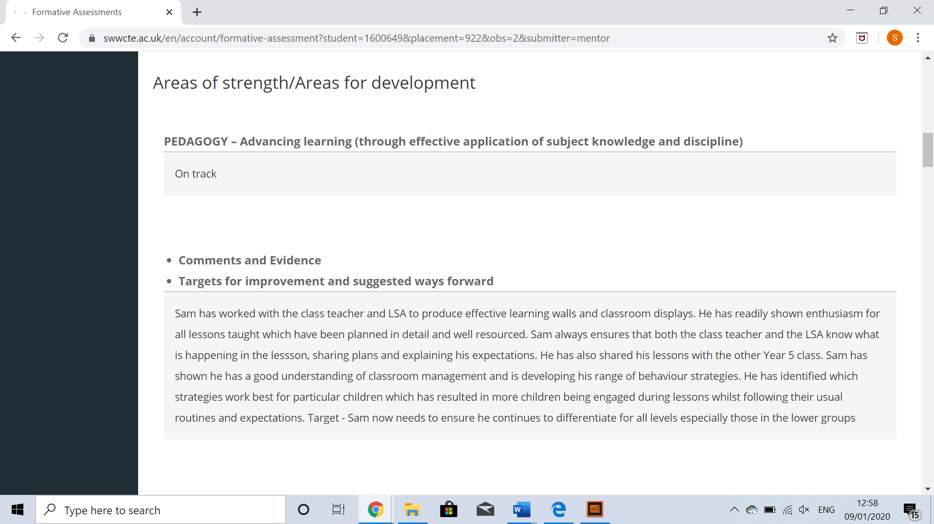
Appendix 2


Appendix 3


Appendix 4


Appendix 5

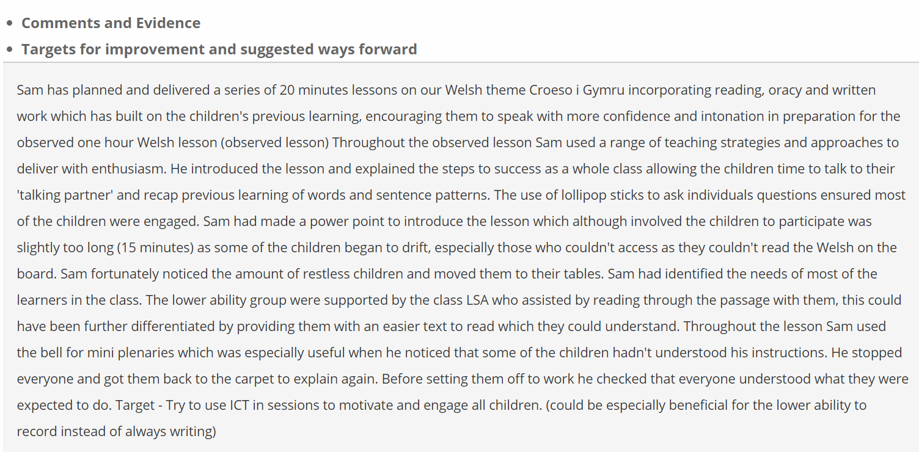
Appendix 6

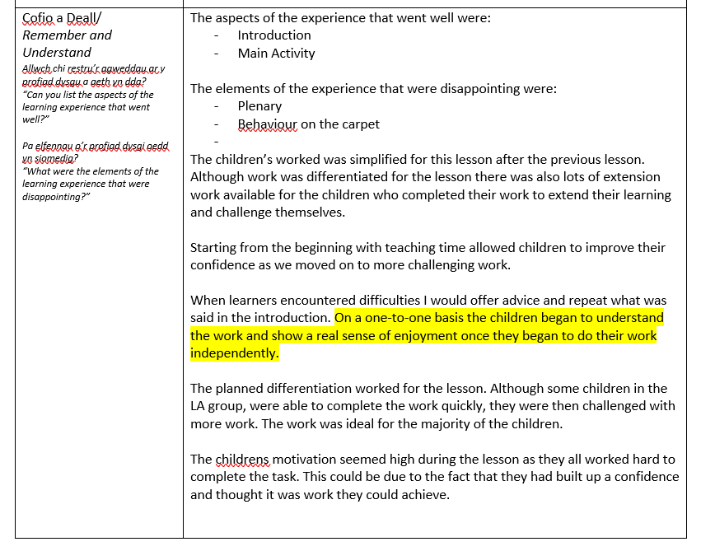
Appendix 7

