
Programme: Master of Business Administration
Module: International Marketing: Principles and Practices
Assignment
Title: A Comparative Analysis of Louis Vuitton’s International Marketing Mix: A Study of France and India
Student Name: Shubham Yadav
Student ID: 2504020
Submission Date: 24th April 2026
Word Count: 5471

Table of Contents
Section 1: International Marketing Analysis of Louis Vuitton in the host country, France, and the second country, India 4
1. Introduction and Company Background 4
2. PESTEL Analysis 4
2.1 PESTEL Analysis of France and India’s Premium Luxury Fashion House 5
2.1.1 PESTEL Similarities and differences 10
2.2 Cultural Analysis using Hofstede Model 11
2.2.1 Advantages and disadvantages of the Hofstede model 13
3. STP Analysis 13
3.1 Segmentation 14
3.2Targeting 14
3.3 Positioning 15
3.4 Comparison of the STP approach across both countries 16
4. Marketing Mix 7Ps 17
5. Directional Strategy in India 23
6. Ethical Issues in India 25
7. Recommendations 26
Section 2: Reflective Account Using Gibbs’ Reflective Model 27
1. Description 28
2. Feeling 28
3. Evaluation 29
4. Analysis 29
5. Conclusion 30
6. Action Plan 30
References 32

Section 1: International Marketing Analysis of Louis Vuitton in the host country, France, and the second country, India

1. Introduction and Company Background
There are many people who feel that Louis Vuitton (LV) is a perfect example of how to have a successful brand that combines the uniqueness of the artisanal way of making things with the ability to be successful on a global scale. This report will not simply provide a descriptive analysis of the LV brand; instead, this report will examine the way in which LV manages the “Global-Local” paradox. Factors such as LV’s historical legitimacy and integration within France play a fundamental role in its dominance of the marketplace (Philippe et al., 2022). Conversely, in India, LV primarily finds itself in a market where social signalling, prestige, and status are the driving forces behind consumer behaviour, rather than traditional heritage. Using the PESTEL model allows an analysis of the macro-environmental drivers associated with the conditions that influence both entry and development into each market.
In addition, the STP model enables an evaluation of whether the "prestige for all" strategy is causing brand dilution as LV's strives to satisfy the needs of the Indian middle-class market. Finally, evaluating the 7Ps model in relation to the ethical considerations for LV in the developing market will give a critical analysis of the viability of their current approach. Furthermore, the study will contain directional development strategies, ethical considerations and a reflective account using Gibbs reflective cycle.

2. PESTEL Analysis
A PESTLE analysis is a strategic framework that is used to monitor and analyse multi-dimensional macro-level external factors, including political, sociocultural, technological, legal, and environmental factors, to assess the dynamics of an industry (Karadzhov and Patarchanova, 2025). To assess macro-level market potential across India and France, PESTEL analysis has been used here.

2.1 PESTEL Analysis of France and India’s Premium Luxury Fashion House
France
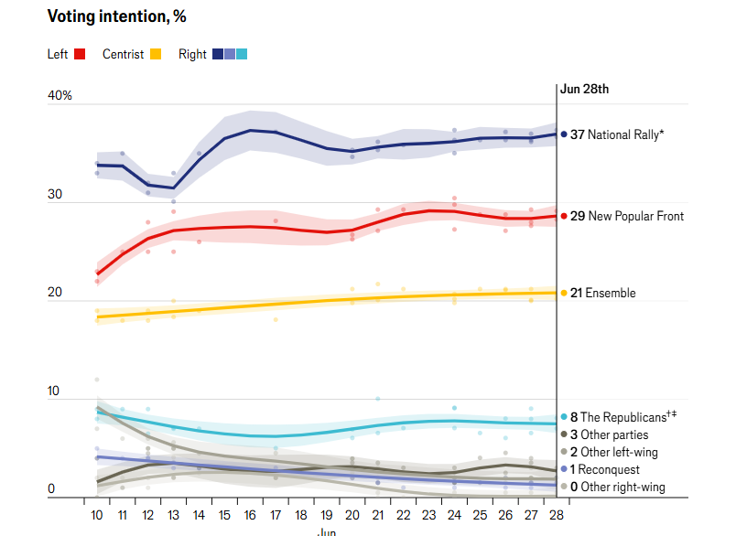
Figure: Voting intention, % of France
Source: (The Economist, 2024)
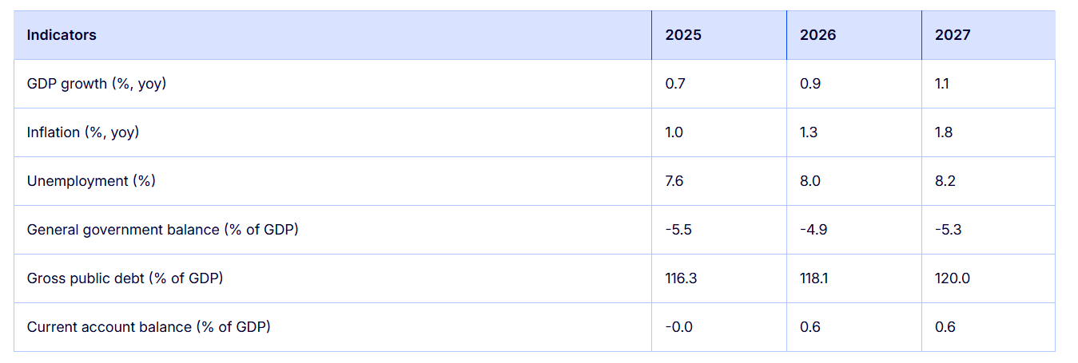
Figure: Economic forecast for France
Source: (European Commission, 2025)
France
Political Factors: Unfavourable
A long-standing tradition of France being a low-risk source of business opportunity has ended with the recent legislative elections held in March 2024 that resulted in a great deal of fragmentation within the structure, thereby creating an overall "hung parliament." This has complicated business or longer-term financial planning among these conglomerates (The Economist, 2024). Although a major priority of the French government is tourism policies as a means to promote tourism throughout the country, one of the many reasons for the French government to be slow or to struggle to implement these policies.
India
Political Factors: Unfavourable
Although the political environment in India is stable, it is a challenging environment owing to the protectionist fiscal policies in the country. For instance, the high import duties on luxury items, which may even go up to 30-45%, put Louis Vuitton in a "pricing trap" where the prices end up being much higher than in Dubai or Europe (Luxury Daily, 2025). As per Press Information Bureau (2019), India allows 100% FDI in single-brand retail. The presence of a number of bureaucratic levels and the need to have local partners, such as LVMH and Reliance Brands, impose a "cost of doing business."
France
Economic Factors: Favourable (with Caution)
Although France has a well-established economy that offers solid income levels, it is now considered a mature or ‘old’ economy and therefore relies heavily on external tourism to drive its growth. Due to this slow growth and the current economic situation in France (where GDP growth has stalled out at an annualised rate of 0.7% to 0.9%, and inflation/operating costs are on the rise), the brand could be said to be housing immature ‘VIC’s (European Commission, 2025). The EU's estimated public debt growth is based on existing data showing that the amount currently owed will increase from 113.2% of GDP today up to approximately 120% of GDP by 2027 (European Commission, 2025). Also, based on existing projections from the luxury goods sector for 2025, it is expected that luxury goods sales will be worth $24.6 to $25.8 billion (USD); and that they will again grow significantly beyond $32 billion (USD) by 2031. Revenue reported by LVMH for 2025 including total annual sales amounted to €80.8 billion (EUR) (LVMH, 2024).
India
Economic Factors: Favourable
India's economy is the fastest growing among major economies, with a projected GDP Growth rate of 7.4% up to 2025-26. The targeted growth in the number of high earners (HENRY) and total luxury spending projected to reach $12.1 billion in 2025 provides a solid basis for continued growth (IANS, 2025). However, this is critically balanced against extreme income inequality, which confines the primary target audience to ultra-metropolitan hubs like Mumbai and Delhi, though emerging wealth in Tier-2 cities is beginning to decentralise this demand.
France
Social Factors: Favourable
In France, luxury is not only not bought, but it is also a cultural institution. This is a tradition that is so ingrained that LV is able to draw strength from its "symbolic capital” which new brands cannot match (Mammadova and Abdullayev, 2025). LV also has to carefully navigate the shift towards Gen Z values, where status is no longer defined by brand logos, but actual ethical stands.
India
Social Factors: Mixed
In India, luxury is used for social signalling. Indian consumers differ from their French counterparts in that they do not opt for "discreet luxury" (Devanathan, 2023). Rather, they look for brand logos and celebrity brand associations, such as Bollywood/Cricket.
France
Technological Factors: Favourable
The high digital infrastructure proficiency in France allows LV to fully understand an omnichannel strategy (Bertrand and Glebova, 2024). By applying "artificial intelligence (AI) based personalisation to enhance the customer experience and developing Digital Product Passports to bridge the gap between traditional and modern methods of doing business", LV has positioned itself as a leader in technology-driven solutions (Wünderlich et al., 2025).
India
Technological Factors: Favourable
The rapid digitalisation of India is a critical force multiplier for LV. India is the leading user globally in terms of the number of bytes consumed through data. Digital narratives on Instagram and WhatsApp are therefore important in connecting with young and technologically astute "Generation Z." The technological dilemma is closing the gap between every form of channel. Although most of the luxury sales occur in brick-and-mortar stores for the tactile experience, LV must also excel in integrating "physical" for customers in remote areas where they do not have a physical store (McKee et al., 2025).
France
Environmental Factors: Unfavourable (High Risk)
Environmental standards in France are some of the highest in the world. The regulatory framework in which LV has to operate, such as the AGEC Law (Anti-Waste) and the EU's "Green Claims Directive," puts immense pressure on LV to demonstrate its sustainability (Chandra Manivannan et al., 2025). Whilst the "LIFE 360" program indicates some positive trends, the very nature of luxury goods production in high volume is fundamentally at odds with green concepts (Langlais and Marich, 2024). Non-compliance with such stringent standards will result in serious damage to LV's reputation and accusations of "greenwashing" from a very cynical French public.
India
Environmental Factors: Unfavourable (High Risk)
Environmental pressure in India is increasing. The introduction of the Environment Audit Rules 2025 and the tightening of greenhouse gas emissions are increasing pressure on luxury supply chains to comply. Although the Indian consumer has traditionally put luxury before the environment, a new second-hand luxury market for the circular economy is emerging, expected to reach $33.6 billion by 2033 (Research and Markets, 2025). Non-compliance with the "Green Mandates" risks damaging the reputation of the globally aware elite in India.
France
Legal Factors: Favourable (Strategic Advantage)
France possesses strong intellectual protection legislation globally, providing a powerful "moat" for Louis Vuitton's business operations. France's strong legal system regarding counterfeit goods protects the exclusivity of Louis Vuitton (Louis Vuitton, 2025). This, however, must be weighed against France's restrictive labour laws and large social contributions, both of which increase the price of producing "Made in France" products relative to other markets in the world. As such, Louis Vuitton can maintain a very high premium on the goods that it sells.
India
Legal Factors: Unfavourable
LV is very exposed to India’s enormous counterfeit market. In addition, new regulations for 2025, which include Digital Product Passports and stricter ESG requirements, will add another layer to compliance expenses (Haque, 2025). The speed at which the legal system resolves commercial disputes is another factor discouraging big-ticket infrastructure investments in the region.

2.1.1 PESTEL Similarities and differences
Political and Legal (Distinction): Various factors make the French Government's enforcement of Intellectual Property (IP) laws very mature and strict. India, on the other hand, has complicated but developing rules regarding duties charged on imported luxury items as well as Foreign Direct Investment (FDI) into single-brand retail stores.
Economics (Distinction): The consumption rates of luxury goods are significantly different in France and India. France has a great degree of disposable income available to its citizens, whereas it currently appears as though the luxury industry in India is thriving, however, there is a dramatic level of wealth inequality.
Social (Distinction): French people have highly individualistic social values, and the level of power distance in France is lower than in India. Conversely, the Indian population has collectivist values and a higher degree of power distance.
Technology (Similarities): There is a large percentage of the population in both France and India who own smartphones, which allows LV to use technology to communicate with their customers.

2.2 Cultural Analysis using Hofstede Model
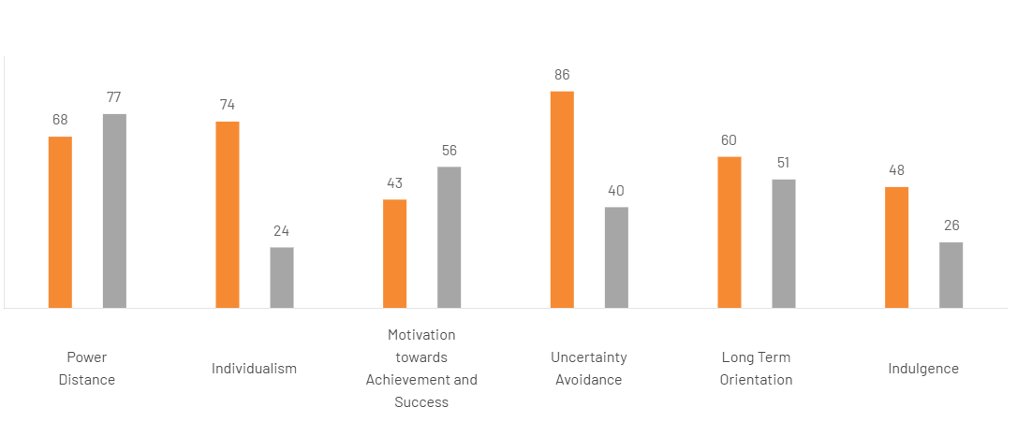
Figure: Hofstede’s Comparison between France and India
Source: (The Culture Factor Group Oy, 2020)
Here, Hofstede’s cultural dimensions framework has been used to depict the nature of luxury consumption behaviour between India and France.
Power Distance: Status vs. Hierarchy (India 77, France 68)
This is because India’s higher score implies a highly stratified society in which the role of luxury is seen as a vital means of stratification. In India, an LV bag is a highly visible marker of "arrival" and success (The Culture Factor Group Oy, 2020). Although the French market is also a high-scoring market, the lower relative position implies that in France, there is more "democratisation" of luxury and association with cultural intellectualism rather than simple hierarchy (Barrère, 2021). LV’s difficulty in the Indian market is how to maintain "distance" without being inaccessible to the rising middle class.
Individualism: Personal Expression vs. Social Validation (France 71, India 48)
The contrast is interesting and critical; French consumers (71) see luxury as an extension of self, an intimate appreciation of craftsmanship and "art de vivre," while India’s relatively lower score (48) suggests a collectivist mindset in which luxury is heavily influenced by family, peers, and the "wedding economy" (Zheng, 2026). In India, LV is not just selling to an individual; it is selling to a group that expects brand equity.
Masculinity: Achievement vs. Quality of Life (India 56, France 43)
The masculine nature of Indian society (56) promotes a culture of conspicuous consumption that is focused on success and competition. This is where LV’s more competitive product ranges can flourish. In France, a score of 43 indicates that society prefers the feminine qualities of discreet luxury and tradition, where showing off is considered bad taste. LV therefore has to find a balance between Logomania in Mumbai and Quiet Luxury in Paris.

2.2.1 Advantages and disadvantages of the Hofstede model
Advantages | Disadvantages
It maps prestige/collectivism in India vs. individuality in France. | The model ignores the intra-country diversity of India.
It helps to understand status vs exclusive needs. | Fails to capture evolving millennial trends in both markets.
It reduces risk by the adaptation of promotional strategies across borders. | It often leads to oversimplification and Cultural nuances are lost in that measurement.

3. STP Analysis
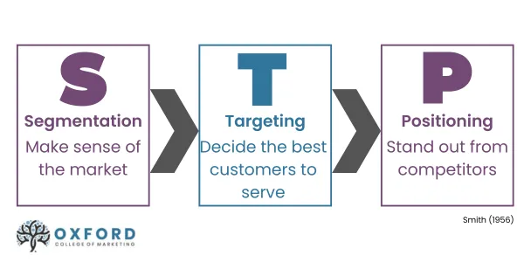
Figure: STEP Framework
Source: (Allen, 2020)

3.1 Segmentation
Louis Vuitton’s segmentation approach is one of complex segmentation that reveals stark contrasts between a saturated heritage market and a volatile emerging one. In the French market, Louis Vuitton’s demographic segmentation is becoming increasingly defensive. In terms of psychographics, this group is one that requires luxury to be "intellectually" infused and to be able to exhibit "quiet exclusivity" as a cultural statement (Singha et al., 2025). In terms of behavioural segmentation, this group is one that is loyal to Louis Vuitton but is also extremely cynical and critical of luxury goods that are overly diluted in their approach.
In contrast, Louis Vuitton’s segmentation approach in India is one that is extremely aggressive and bifurcated. While maintaining a strong segmentation approach towards the high-end UHNWI consumer base, Louis Vuitton is increasingly looking towards the High Earner, Not Rich Yet and upper-middle-class consumer base (McKinsey & Company, 2025). In terms of psychographics, this group is one that sees luxury goods as a performance statement that allows for social mobility and prestige. In terms of behavioural segmentation, this group is one that is heavily influenced by the "celebrity industrial complex" and is a "brand first" consumer base.

3.2 Targeting
Louis Vuitton's focused targeting strategy is influenced by two different pressures: one of retaining market dominance in France, and the other of creating market dominance in India. For France, Louis Vuitton targets a "legacy elite" and a global influx of tourists for whom Louis Vuitton is a certainty (Don-Alvin Adegeest, 2025). As a targeting segment, this market has low price elasticity and high elasticity for uniqueness, creating a precarious situation for Louis Vuitton's attempt to increase production volumes. This targeting segment is precarious for Louis Vuitton, given its maturity, but is further threatened by geopolitical events.
In India, targeting is strategically aggressive and youthful, pivoting away from traditional old-money to target “New Age” entrepreneurs, digital influencers and Bollywood’s celebrity ecosystem. By focusing on Tier-1 hubs like Delhi and Mumbai, LV captures a segment that uses luxury as social leverage. However, this forward-looking approach faces a “Loyalty deficit”; unlike the heritage-loyal French consumers, the emerging Indian affluent is highly fickle, frequently switching between competing European houses (ET BrandEquity, 2025).

3.3 Positioning
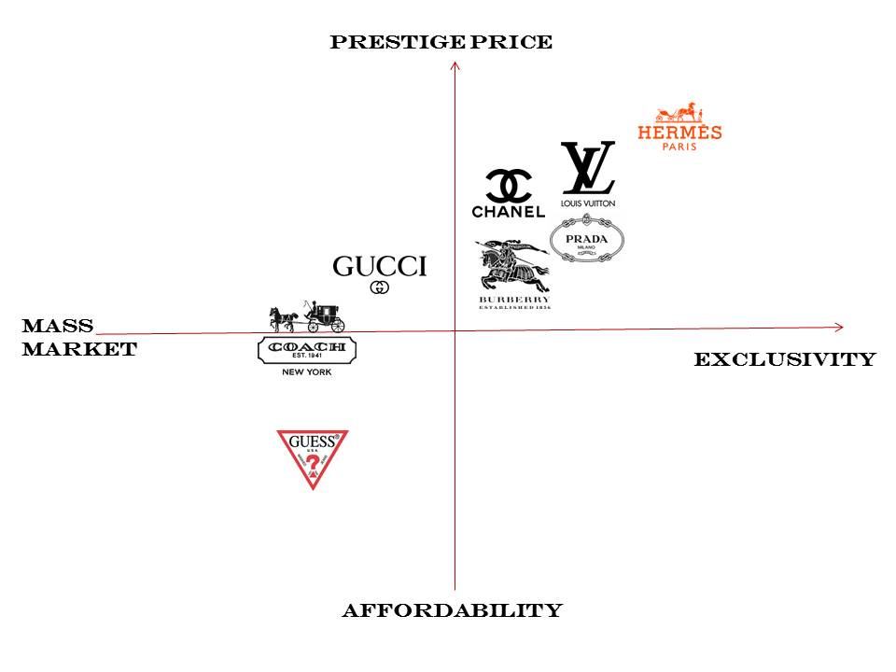
Figure: Perceptual Map of LVMH in France.
Source: (Google Image)
The perception map displays fashion brand positioning relative to prestige pricing and affordable price point, one axis; Exclusivity and mass market appeal make up the second axis. Brands like hermes, Louis Vuitton, and Chanel are in the same intersection on both axes as labeled with 'prestige pricing' as on one side of the axis and 'exclusivity' at the other end; on opposing sides of these two positions, Coach and Guess reside in their respective places of affordability and mass market appeal. The Louis Vuitton brand has a strong presence in France, its strength lies in the "Maison" aspect of its image, which reflects both heritage and craftsmanship (Biondo, 2023). In India, it is grounded in perception as an aspirational status symbol.

3.4 Comparison of the STP approach across both countries
Louis Vuitton (LV) adopts a single strategy for targeting high-end consumers globally by implementing a consistent segmentation, targeting, & positioning (STP) approach. However, the 7P’s (Marketing Mix) are adapted to suit local conditions throughout the world. For example, in France, LV utilizes a strategy based on historical heritage and timeless luxury, while in India it uses a combination of luxury products and cultural significance to promote its products based on different types of events (such as weddings) (Sujata Assomull, 2023).

4. Marketing Mix 7Ps
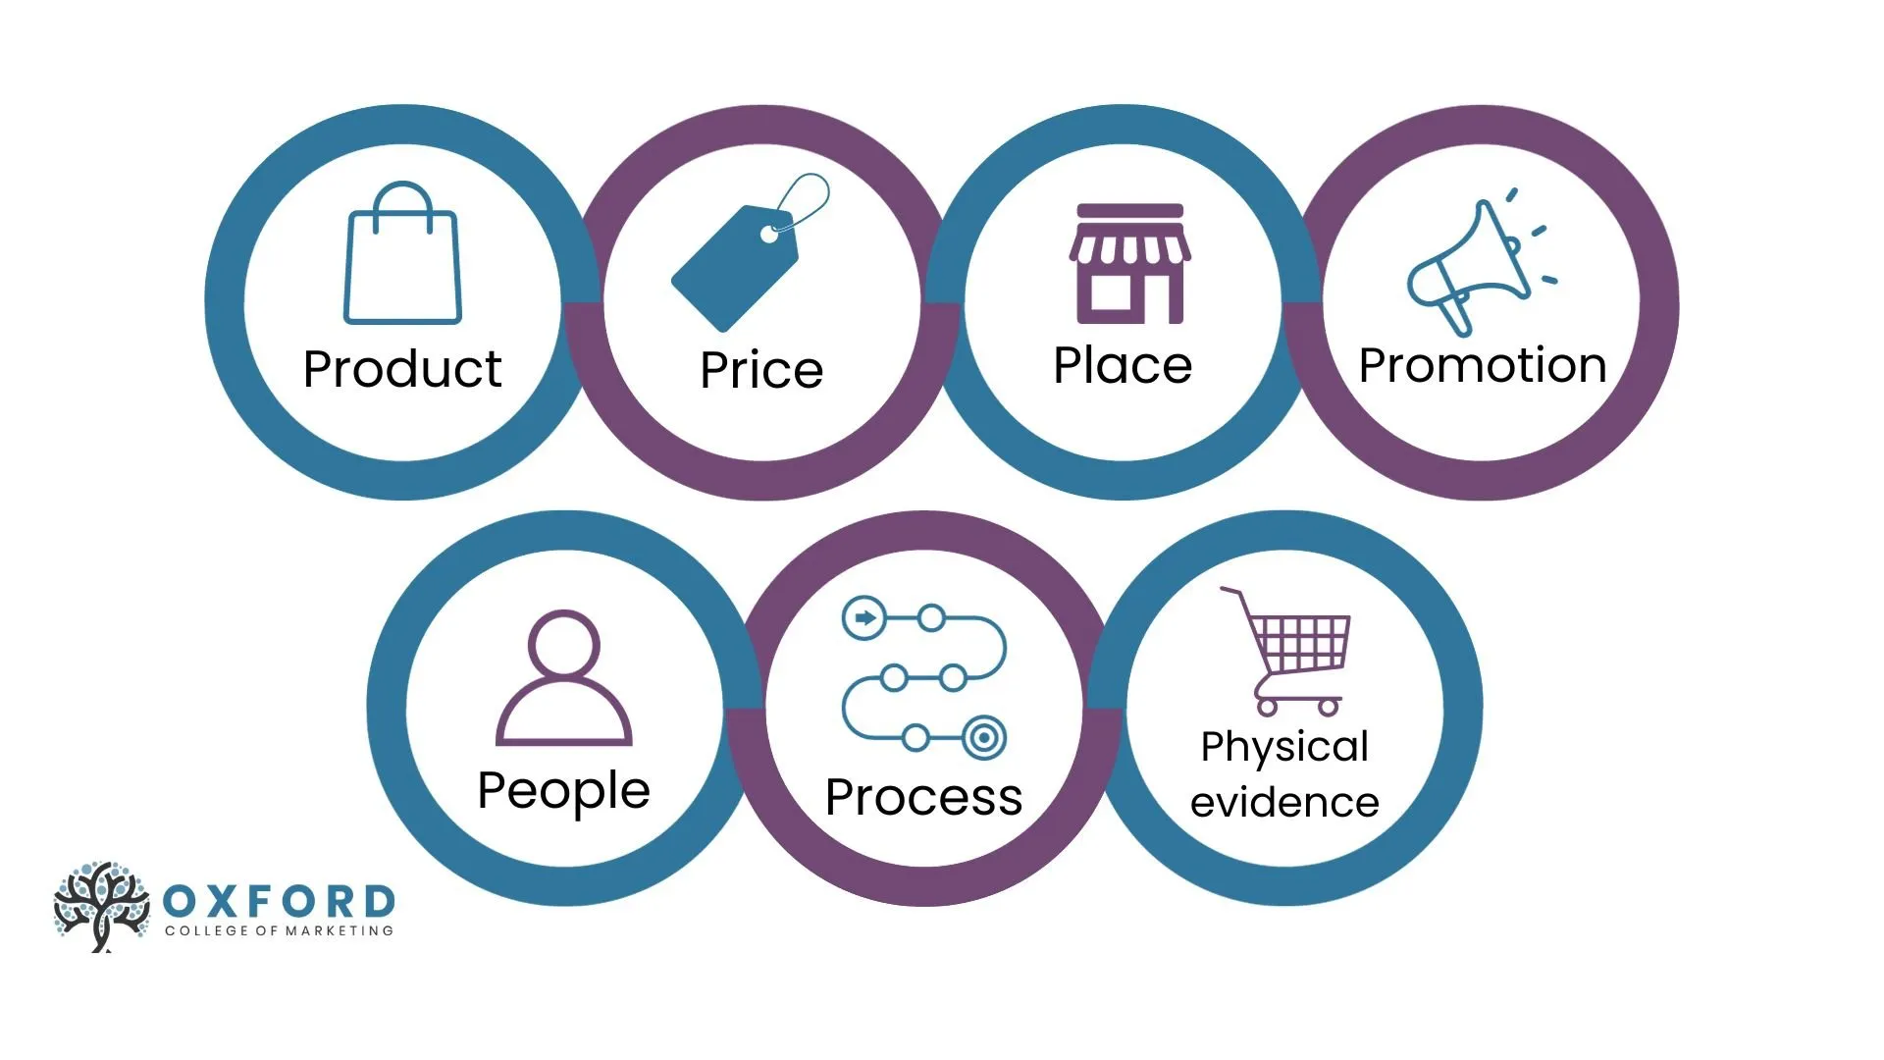
Figure: 7Ps Marketing Mix
Source: (Allen, 2020)
Product
Even though Louis Vuitton produces similar products in both India and France, there are still significant differences regarding its craftsmanship and quality assurance. He (2023) has stated that the products of Louis Vuitton are significantly luxurious, and it has a monogram canvas approach for making it harder for other companies to copy its products. The company has a careful selection of products to gain more love and trust from its customers (He, 2023). Thus, in both countries, it focuses on providing ready-to-wear clothes and accessories. However, there are differences in production strategies in both countries, since India, it focuses on affordable yet luxurious products, tailored demand, and exclusivity and prestige with its no-discount policy, while in France, it focuses on heritage, tradition, exclusivity, and innovation for producing “cult” items. The products of the company include handbags, leather products, ready-to-wear garments, shoes, accessories, fragrances, and jewellery. Other products of the company India include men’s bag, footwear, ready-to-wear clothes, perfumes and jewelry, and more, meanwhile, in France include handbags, accessories and gifts, travel kits, fragrance and more.
Price
Price refers to the difference in the revenue gained by the company in each country. The figure depicts that the total revenue worldwide is $37,770 million in 2025, with the company generating the most revenue in 2023, which is $42,169 million (Rocco, 2026). The price differences are also significant in both countries, with India having products from over ₹2,00,000, and France having €1,500 approximately.
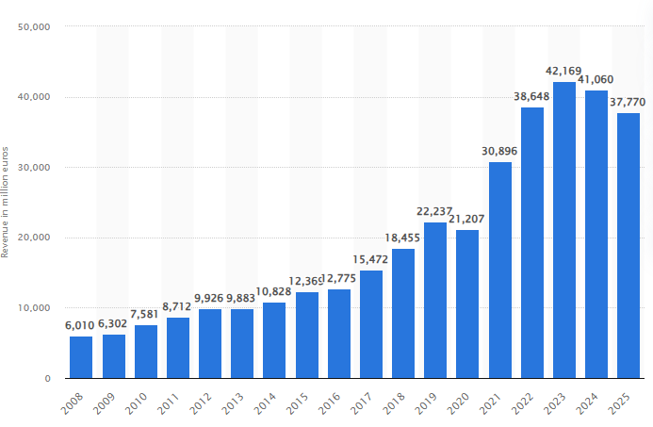
Figure: Total Revenue of Louis Vuitton
(Source: Rocco, 2026)
An article by Brand Equity (2026) explains that the company in India have faced significant revenue growth, most importantly in 2025, of almost INR 428 crore with a 35.4 per cent year-on-year growth. For iconic, high-demand items, purchasing in Paris can save you a significant amount of money. It is highly recommended to check both the French and Indian Louis Vuitton official websites, accounting for the current exchange rate, before buying. In India, the company uses a non-discounting pricing strategy, while France uses the value-based pricing strategy.
Place: Favourable (Strategic Scarcity)
The distribution strategy of Louis Vuitton shows how it balances over-accessibility and selective inaccessibility through its highly controlled, exclusive distribution. In its home market, LV has an omnipresent, almost “institutional” presence, with flagship stores such as its location on the Champs Élysées being “high volume luxury cathedrals” preying on global tourist flows (Vuitton, 2024).
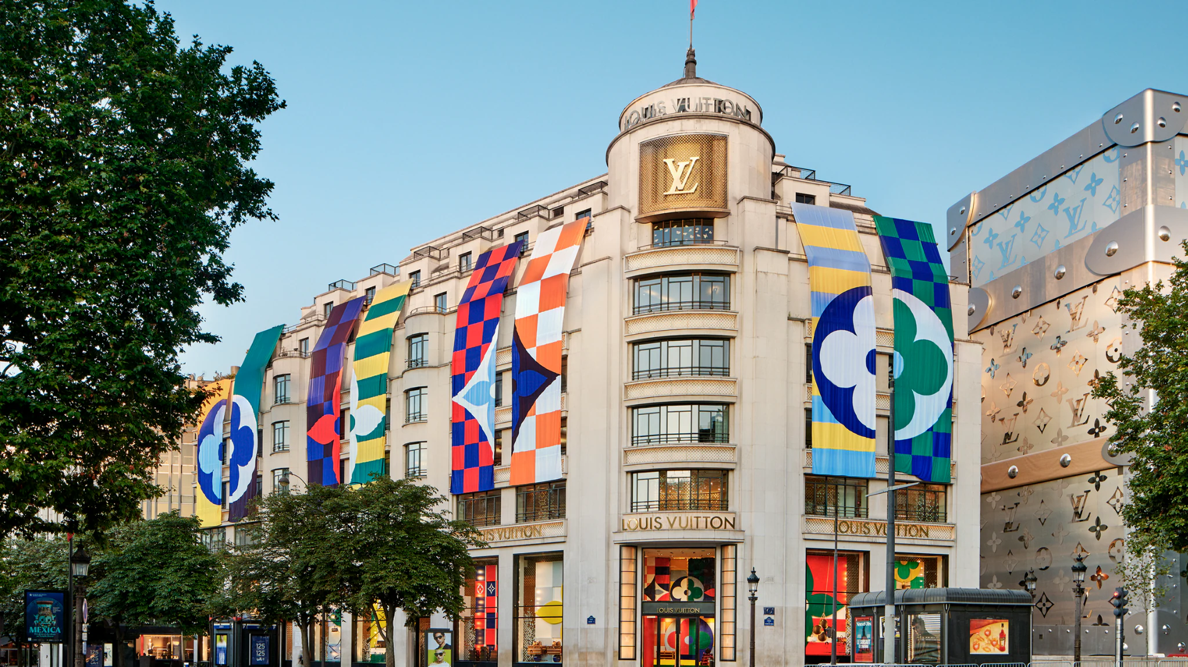
Figure: Louis Vuitton Maison Champs-Élysées Store in Paris
Source: (Vuitton, 2024)
The danger is one of over-commercialisation, where the brand feels less like an elite house and more like a tourist commodity. In India, by contrast, LV has a microscopically limited presence in ultra-premium locations such as Delhi’s DLF Emporio (DLF Emporio, 2026).
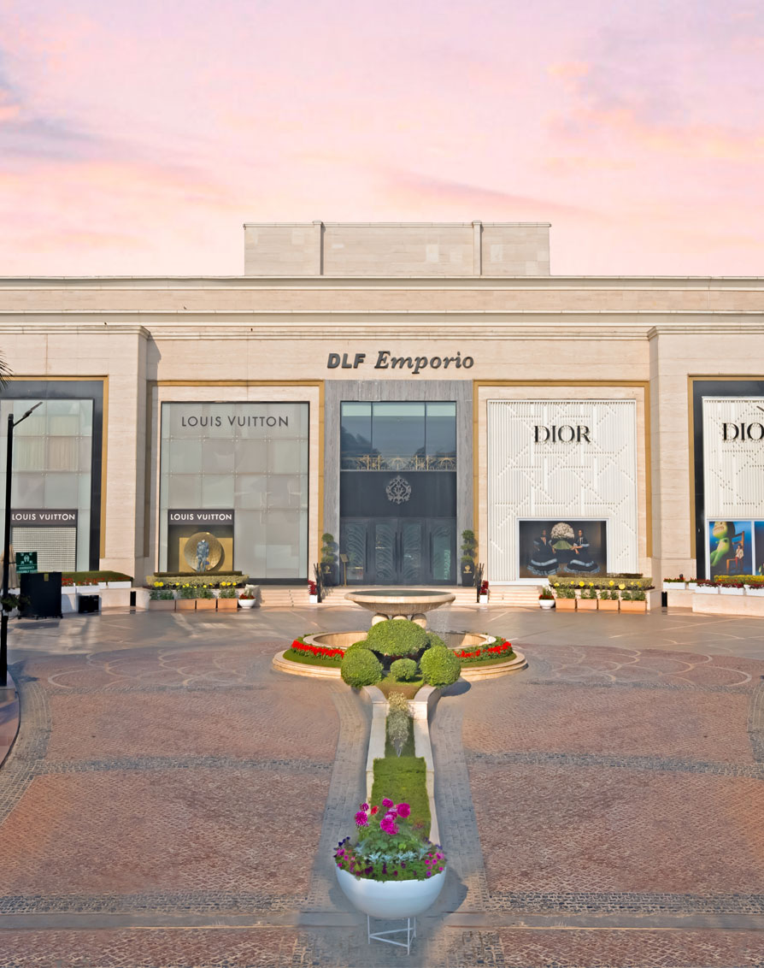
Figure: DLF Emporio
Source: (DLF Emporio, 2026)
This is an important part of its defence strategy, making do with an underdeveloped luxury infrastructure in India by effectively turning logistics into marketing.
Promotion: Mixed (Cultural Schism)
LV’s promotional strategy emphasises the "global soul" with "local tactics." In the case of the French market, the brand’s strategy is based on "high culture" integration with minimal advertising efforts in order to maintain the aura of effortless superiority. In the Indian market, however, the strategy is heavily dependent on celebrities (Liu, 2024). LV’s strategy of being associated with the Bollywood-industrial complex and the likes of Instagram influencers makes the brand more of a "trend" brand than a "classic" brand. This is because the brand equity is highly sensitive to the popularity of local celebrities in the "Gen Z" segment of the Indian market.
People
The "People" section highlights the significant change in transactional elegance to relationship-based hospitality. In France, the service is a form of art, a subtle, professional, individualistic approach. In India, the brand needs to adopt the hyper-concierge approach. Indian consumers, being collectivistic and hierarchical in their approach, expect high engagement in their services (Saxena, 2025). Louis Vuitton currently employs more than 34,000 people in over 60 countries worldwide; These employees work at 460+ retail locations and 21+ manufacturing facilities (primarily located in France, Italy & USA), with an employee population representing over 140 nationalities.
Process
While LV aims for a "Seamless global journey," the truth is that there is an operational disconnect. Indian call centre Louis Vuitton has a dedicated phone line (1800 103 9988) and also offers 365 days’ exchanges. In contrast, the France operation has in-store specialists in flagship stores (e.g., Champs-Élysées) plus a Europe-wide central line (Vuitton, 2024). The Indian operation provides extended flexibility and accessibility, while the French experience is designed to provide a high degree of efficiency, however, for some clients the directness of the French experience may come across as impersonal.
Physical Evidence
Physical evidence is the final anchor for standardisation. In France, boutiques are historical monuments that reinforce LV's position as a champion of French culture. In India, where the outside world is hardly conducive to notions of 'luxury' design, the inside world of the store has to be a seal of opulence in its own right. The unique monogram and strong packaging create what could be seen as a type of "tangible social proof" to the status-seeking Indian consumer. This sensory consistency provides the assurance that regardless of where they are consuming the same myth of excellence (be it Paris or Mumbai), even though their motivation for doing so is opposite from one another.
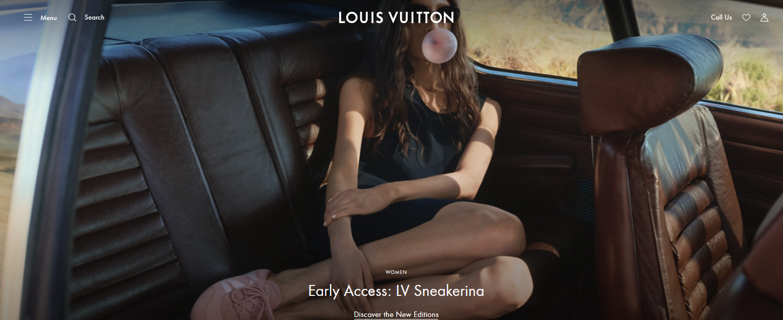
Figure: LV India
Source: (Vuitton, 2024)
Louis Vuitton has a delicate balancing act between global and local in their strategy using the 7 Ps model. The LV brand has a standardised visual identity using "Physical Evidence"; however, on a per-country level, there are many variations of how LV markets and sells their products in India as compared to France, where the French place a higher priority on tradition than the Indians do on the "relationship" aspect of purchasing products from LV.
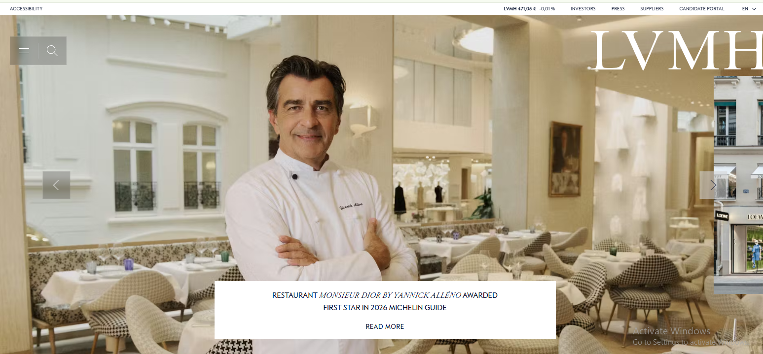
Figure: LVMH France
Source: (LVMH, 2025)
As LV continues to grow in India, its operational excellence and the perceived scarcity of its products versus the need to maintain credibility and authenticity will be a major factor in how LV grows its brand in India.
Similarities
Louis Vuitton (LV) maintains an exquisite balance between global standardisation and local adaptation. The similarities include the use of identical, iconic branding and packaging, and high-quality “Physical Evidence” in both the French and Indian markets, ensuring consistent brand perception (Liu, 2025). Overall, the company owns direct stores across the world and does not rely on partnerships with other parties. hence, premium luxury, high-end environments remain intact across different countries, such as India and France
Differences
In France, boutiques are historically reinforcing deep-rooted tradition, whereas in India, the store interior is a self-contained “Seal of opulence” used to maintain a proper tangible social proof in an otherwise non-conductive environment. It can be deemed that the LV prioritises traditional heritage, while in India, people prefer LV as a part of an aspirational base to showcase their social status and a greater focus on the “relationship” aspects of purchasing brand authenticity (George and George, 2023).

5. Directional Strategy in India
As it is evident from before, even though the company in India has a major focus on affordable yet luxurious fashion, it still faces significant challenges in managing its directional strategy in the country. The figure depicts the cultural authenticity strategy used by the company (Patel, 2026). However, due to the high pricing of its products in India, this strategy failed significantly and failed to meet the expectations and values of its customers. The company has a significant focus on aesthetics for its Indian customers, but the development strategy of the company faced significant challenges.
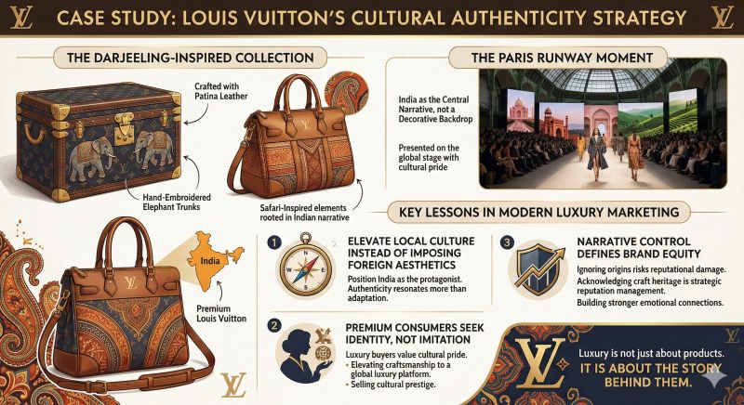
Figure: Cultural Authenticity of Louis Vuitton
(Source: Patel, 2026)
The challenges the company has faced in India are a lack of luxury infrastructure, high import duties and regulatory hurdles, counterfeit and brand dilution, nurturing a new consumer base, generic global campaigns, and operational challenges. The figure below depicts the ansoff matrix and its factors (Refer to Figure) (Oxford College of Marketing, 2023).
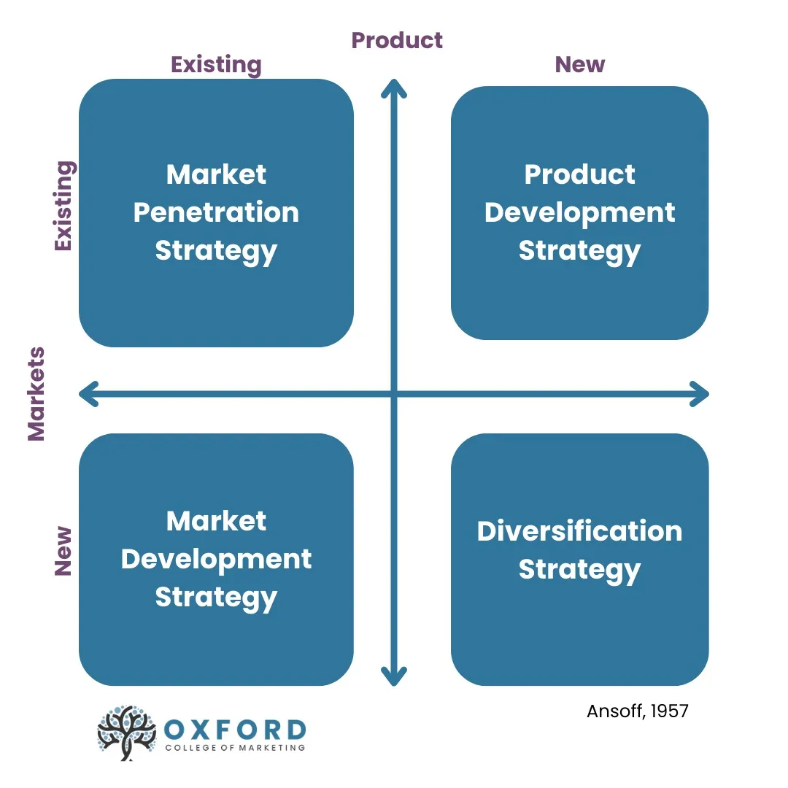
Figure: Ansoff Matrix
(Source: Oxford College of Marketing, 2023)
It is evident that in India, the company uses market development for its younger generation, while in France it uses market penetration for digital integration, and product development for exclusive experiences. Lai (2022) has stated that this company has a greater operating model and it tries to create a decentralised organisation. Therefore, to mitigate the identified challenges, it needs to focus on 100% foreign direct investment localised marketing strategy, expanding retail footprint, diversifying product lines, and focusing on e-commerce or digital approach.

6. Ethical and Unethical Issues in India
One such firm is Louis Vuitton, a firm that operates under the umbrella of LVMH. Louis Vuitton has faced a number of ethical problems in India, especially in the context of its labour practices, cultural insensitivity, and environmental concerns. Despite the fact that Louis Vuitton is extremely particular about sustainable and luxury products, the firm has faced a number of problems in India in the context of its practices in the country. The latest addition to the list of such companies in the luxury retail industry is Louis Vuitton, the flagship firm of LVMH. An investigation has been initiated by the Dutch authorities against Louis Vuitton in the context of money laundering practices by the firm (Nair, 2025). The LV stores in the Netherlands have accepted $3.5 million in cash from a Chinese tourist, which is much beyond the permissible limits under the law, in the last two years (Refer to Figure). In several instances, the Delhi High Court has ordered permanent injunctions on the manufacture and sale of products which have infringed upon the trademarks of Louis Vuitton, including the brand's "LV" logo, the Toile Monogram pattern, and the Damier design, in products like wallets, bags, and belts (Times Entertainment, 2025). Apart from the aforementioned ethical problems faced by Louis Vuitton, the firm has also faced a number of problems in the context of intellectual property in India.
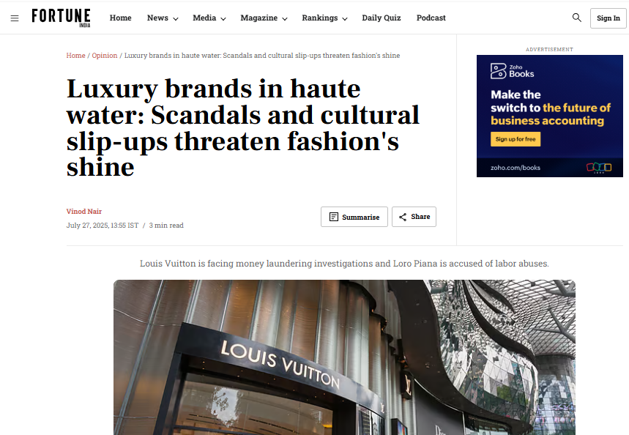
Figure: Issues Faced in India
(Source: Nair, 2025)

7. Recommendations
Strengthening Localised Market Strategy through Tiered Pricing
Louis Vuitton has to ensure that it is able to match its product portfolio with the requirements of consumers in India. Therefore, it is recommended that a tiered pricing model be adopted. For this purpose, it is recommended that new collections be designed for India. In addition to this, small leather goods can also be helpful in this context. For example, Zara is one such brand that has been able to localise its product portfolio so that it is able to match the requirements of consumers in India (Martin Roll, 2021). The adoption of tiered pricing and adapting products to meet customer needs, just like Zara, Louis Vuitton is able to improve product portfolios in order to meet customer needs and purchasing power in the Indian market.
Controlled Localisation Strategy
Accordingly, the suggested recommendations for Louis Vuitton include application of the strategy called “controlled localisation,” thus blending exclusiveness with culture fit in both markets. Indeed, while promoting its heritage and sustainable approach in France, LV should become part of the idea of “quiet luxury” characteristic of French culture. As for India, localisation efforts should be made through promotion of capsule collections and celebrity endorsers, along with restricted distribution, in order not to overexpose the brand.
According to Shen (2024), a very good example of a company utilising the concept of Controlled Localisation effectively is Hermès. While preserving their identity all around the world because of their uniqueness as far as their product line goes, they also manage to localise themselves in countries like India. These measures taken by them include creating products with cultural consideration, avoiding saturation by not expanding the outlets, and even resisting the temptation of promotion despite increased interest.

Section 2: Reflective Account Using Gibbs’ Reflective Model
Gibbs’ Reflective Cycle is a reflection tool that is used for providing a robust insight into the experiences one may face during the assessment of the whole report. Figure depicts the six stages and assess its utilisation below (McLeod, 2025).
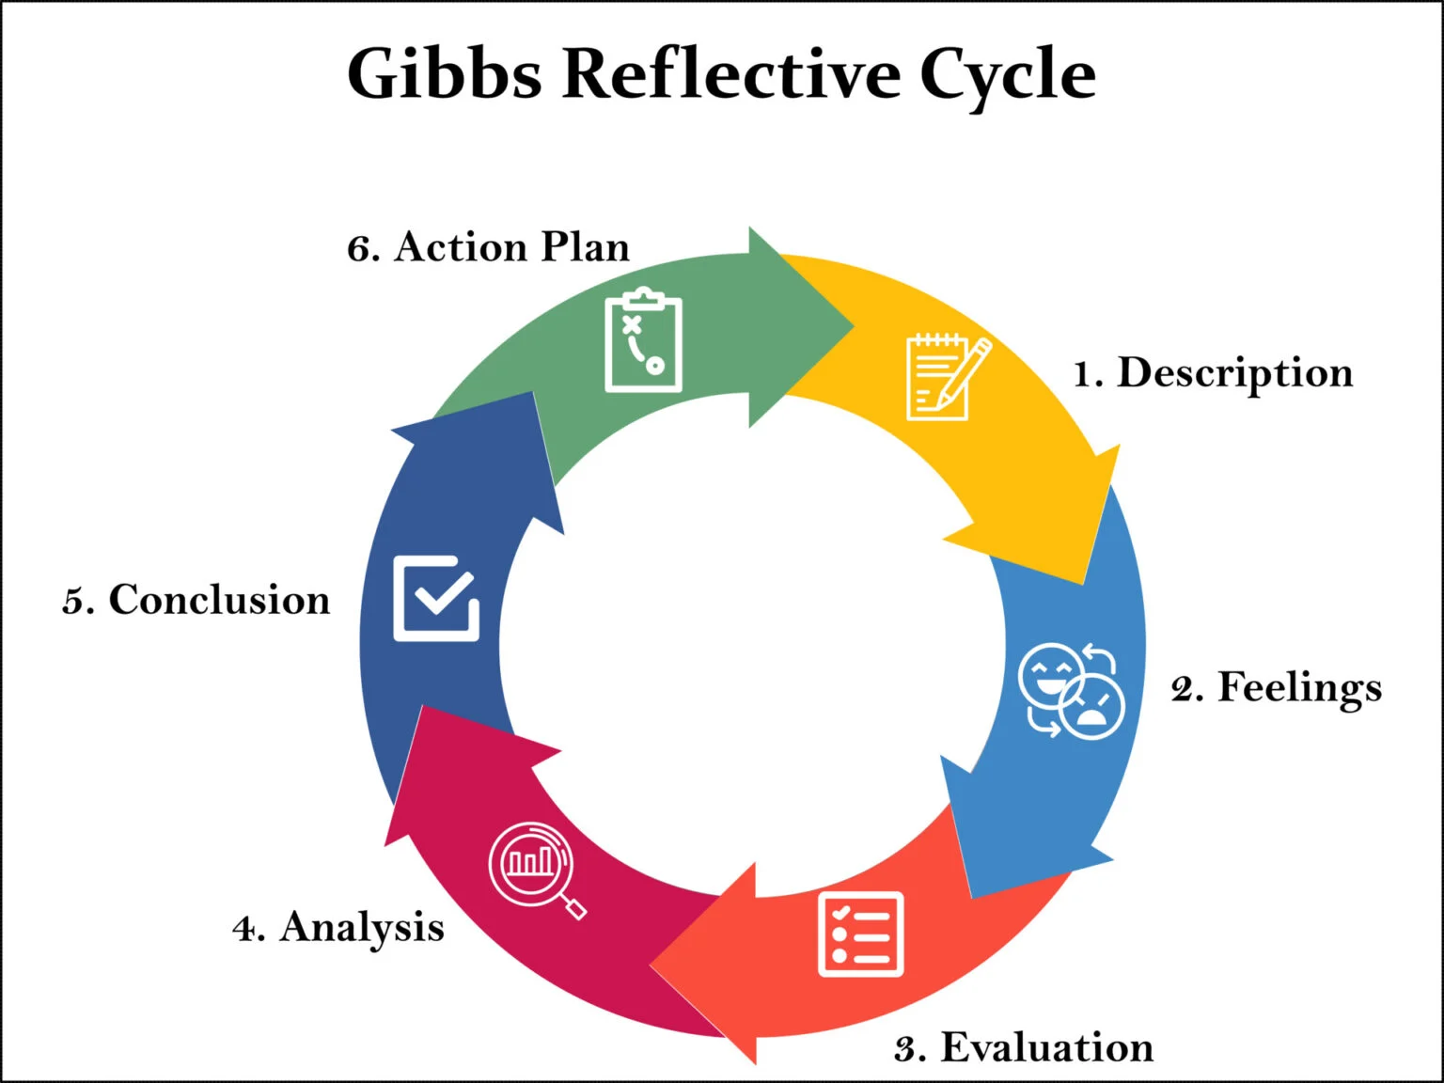
Figure: Gibbs’ Reflective Cycle
(Source: McLeod, 2025)

1. Description
After assessing the above report, I have come to this statement that assessing it was impactful for me, as it helped me understand and gauge my strengths and weaknesses regarding my skills. In this report, I have attempted a thorough comparison between India and France regarding the marketing strategies of Louis Vuitton. I have known this company to be a luxurious company; however, I did not know that the company also tried to focus on affordable items. Therefore, during the assessment of this report, the frameworks I have used have also provided me with significant knowledge about how the company operates in both countries.

2. Feeling
During the assessment, I have felt that this assessment was quite a challenge, since I have realised that I lack the necessary skill of researching for this report. At the beginning, I felt significantly at ease since there was not much to research, but during the assessment of the frameworks, I felt helpless due to weakness. I also felt that assessing for a different framework and aligning it with the marketing strategies of both companies. After finishing the report, I felt that this had significantly increased my understanding of the market of Louis Vuitton in both India and France. At one point, I also felt quite an emotional impact during this assessment, and after the assessment, even though I felt helpless, I felt gradually at ease. This reflection also gave me a sense of clarity and a step-by-step approach for understanding my strengths and weaknesses.

3. Evaluation
During the assessment, one key weakness that I have found is Researching Issue; however, it is not the only issue I have found. Only after the assessment of this report have I realised that I also lack patience significantly. We all know that patience is a virtue, and in this regard, Vaynerchuk (2022) has stated that patience is a crucial trait in building the character of an individual. Lack of patience can also cause significant unfairness, insecurity, pressure and other situational factors during my assessment. Thus, I need to have a mindset of mindfulness, meditation, and focus on identifying triggers, and active listening. Lack of patience can lead to worse consequences, including mistakes in assessment, poor decisions, emotional distress, and damaged relationships. Therefore, I have successfully evaluated these weaknesses, and through strength assessment, I can also become diligent and resilient in my work.

4. Analysis
The weaknesses I have found in myself after the assessment of this report are the issue of research skills and a lack of patience. Kamalakannan (2024) has stated that researching involves finding existing information efficiently and using it while maintaining its authenticity. The challenges I have faced because of this skill are having a narrow knowledge about something, a lack of structure, unclear objectives, and other factors. On the other hand, I also have a lack of patience, since I struggle with unfairness, insecurity, and other deep-rooted habits.
However, with weaknesses come strengths, and the strengths I have are critical thinking and time management. Critical thinking has helped me get out of my issues regarding researching. Rusmin et al. (2024) have stated that critical thinking is a crucial skill for navigating through complex tasks, and it helps to explore other significant skills for education or work. Thus, critical thinking improves critical thinking, enhances problem-solving, increases creativity, and improves communication. On the other hand, I also have robust time management skills, since I always schedule out my tasks before approaching them. Therefore, both these skills have helped me significantly during my assessment.

5. Conclusion
In conclusion, it can be said that the assessment of this report has so far been influential for me, since it helped me understand my strengths and weaknesses. I have also found out ways in which I can improve and gain a better insight into my skills. I faced quite a few challenges during this assessment; however, my skills have helped me mitigate them significantly. I have gained understanding from several articles, and it has helped me garner a broader vision regarding this topic. The comparison of the marketing strategies of India and France has thus become robust with the skills I already had, and I gained during this assessment.

6. Action Plan
Skills to Improve | Resources | Responsible People | Timeframe
Researching Skill | I can utilise databases such as Google Scholar, SAGE, or ERIC to gain a broader sense of knowledge regarding various topics. | I take help from active learners and individual researchers to gain improved time management, while also gaining mentorship from others. | 1 month
Lack of Patience | I can develop my patience level by building tolerance to discomfort and practising gratitude for gaining physical relaxation. | I can get help from mental health professionals and psychologists to calm myself from stress and anxiety. | 2 months
Table 1: Action Plan
(Source: Self-Created)
For improving my research skills and lack of patience, I need to focus on utilising resources and getting help from the necessary people for improvement within a timeframe. I can improve my research skills in 1 month by focusing on using various databases, such as Google Scholar, SAGE, and more or gaining mentorship or advice from mentors or active learners. On the other hand, I can improve my patience level by developing my tolerance through discomfort, or getting advice from mental health professionals or psychologists.

References
Allen, A. (2020). Finding the right customers with the STP model. [online] Oxford College of Marketing Blog. Available at: https://blog.oxfordcollegeofmarketing.com/2020/06/24/finding-the-right-customers-with-stp-model/ [Accessed 27 Mar. 2026].
Allen, A. (2020b). The 7Ps of The Marketing Mix. [online] Oxford College of Marketing. Available at: https://blog.oxfordcollegeofmarketing.com/2020/10/08/understanding-the-7ps-of-the-marketing-mix/ [Accessed 27 Mar. 2026].
Barrère, C., 2021. The French luxury model. Économie appliquée: archives de l'Institut de science économique appliquée, (1), pp.51-80.https://shs.hal.science/halshs-03495849/document
Bertrand, M. and Glebova, E., 2024. How digital transformation impacts customer experience in the hard luxury industry: Consensus on omnichannel strategy. Athens journal of business & economics, 10(3), pp.183-216.https://savearchive.zbw.eu/bitstream/11159/653918/1/1892097133_0.pdf
Biondo, S., 2023, July. Corporate fashion museums communication strategies: The case of the Louis Vuitton Maison de Famille in Asnières-sur-Seine. In International Conference on Fashion communication: between tradition and future digital developments (pp. 304-315). Cham: Springer Nature Switzerland.https://link.springer.com/chapter/10.1007/978-3-031-38541-4_28
Brand Equity (2026). LOUIS VUITTON INDIA RETAIL PRIVATE LIMITED - 2026 Company Profile & Financials - Tracxn. [online] Tracxn.com. Available at: https://tracxn.com/d/legal-entities/india/louis-vuitton-india-retail-private-limited/__QCAPywYYxyPgek2jPBZMLObO3T_ivacKTYDrl3b0NOs [Accessed 27 Mar. 2026].
Chandra Manivannan, A., Bhatnagar, A., Niinimäki, K., Panneerselvan, L. and Palanisami, T., 2025. Evaluating textile waste management policies: Lifecycle gaps and opportunities for improvement. Waste Management & Research, p.0734242X251393613.https://journals.sagepub.com/doi/abs/10.1177/0734242X251393613
Devanathan, S., 2023. Exploring identifiers in the luxury consumer segment–An Indian perspective. International Journal of Professional Business Review: Int. J. Prof. Bus. Rev., 8(4), p.36.https://dialnet.unirioja.es/servlet/articulo?codigo=8956439
DLF Emporio (2026). DLF-Emporio: About Us. [online] Dlfemporio.com. Available at: https://www.dlfemporio.com/Home/aboutus [Accessed 7 Apr. 2026].
Don-Alvin Adegeest (2025). Louis Vuitton is navigating an evolving global luxury landscape. [online] FashionUnited. Available at: https://fashionunited.uk/news/fashion/louis-vuitton-is-navigating-an-evolving-global-luxury-landscape/2025042281195 [Accessed 27 Mar. 2026].
ET BrandEquity (2025). Luxury houses eye India, but barriers remain. [online] ETBrandEquity.com. Available at: https://brandequity.economictimes.indiatimes.com/news/marketing/luxury-brands-target-india-amid-challenges/125376221 [Accessed 27 Mar. 2026].
European Commission (2025). Economic forecast for France. [online] Economy and Finance. Available at: https://economy-finance.ec.europa.eu/economic-surveillance-eu-member-states/country-pages/france/economic-forecast-france_en [Accessed 27 Mar. 2026].
George, A.S. and George, A.H., 2023. Leveraging the ego: An examination of brand strategies that appeal to consumer vanity. Partners Universal International Research Journal, 2(3), pp.94-108.https://puirj.com/index.php/research/article/view/134
Haque, M.A., 2025. Blockchain Technology As A Tool For Supply Chain Transparency In The Fashion Industry: Aligning With SDGs And ESG Goals. Digital Repository of Theses.https://repository.learn-portal.org/index.php/rps/article/view/1130
He, X. (2023). Research on Louis Vuitton’s Marketing Based on 4P Theory. Advances in Economics, Management and Political Sciences, [online] 6(1), pp.162–166. Available at: https://aemps.ewapublishing.org/media/af7377da9e0341babab87365f00a580b.marked_K9cbXaP.pdf [Accessed 27 Mar. 2026].
IANS (2025). India’s Luxury Goods Market To Reach $12.1 Billion By 2025: Report. [online] www.ndtv.com. Available at: https://www.ndtv.com/lifestyle/indias-luxury-goods-market-to-reach-12-1-billion-by-2025-report-9496298 [Accessed 27 Mar. 2026].
Kamalakannan , A. (2024). CHALLENGES FACED BY RESEARCHER - A HYPOTHETICAL VIEW. Indian Journal of Psychology, [online] 3(1), pp.163–167. Available at: https://www.researchgate.net/publication/378690360_CHALLENGES_FACED_BY_RESEARCHER_-_A_HYPOTHETICAL_VIEW [Accessed 27 Mar. 2026].
Karadzhov, V. and Patarchanova, E., 2025. How to create the best PESTEL analysis. International Journal of Digital Research, 1(3), pp.8-20.https://ijdr.net/wp-content/uploads/2025/11/Vol-1-Issue-3-Whole-Issue.pdf#page=8
Kim, W. and Ha-Brookshire, J.E., 2026. What makes it a dupe? Exploring consumer understanding of legally copied products in the fashion industry. Fashion and Textiles, 13(1), p.4.https://link.springer.com/article/10.1186/s40691-026-00457-y
Lai, C.S. (2022). The Strategy and Competitor Analysis of LVMH. www.atlantis-press.com, [online] pp.549–557. Available at: https://www.atlantis-press.com/proceedings/fmet-22/125978294 [Accessed 27 Mar. 2026].
Langlais, M.R. and Marich, A., 2024. Should we track our children?: An exploratory examination of life360 and interpersonal and relational well-being. The Family Journal, 32(4), pp.605-612.https://journals.sagepub.com/doi/abs/10.1177/10664807241269455
Liu, H., 2025. China's Luxury Fashion Landscape: Unravelling the Dynamic Strategies of Internationalisation for Luxury Fashion Retailers. In Dynamic Fashion Marketing (pp. 61-72). Routledge.https://api.taylorfrancis.com/content/chapters/edit/download?identifierName=doi&identifierValue=10.4324/9781003519744-7&type=chapterpdf
Liu, X., 2024. Analysis Of Marketing Strategy of Age Z Luxury Group-----Take Louis Vuitton as An Example. connections, 37.https://pdfs.semanticscholar.org/f3bc/56ab29d300b31116ac1c6579420c08721070.pdf
Louis Vuitton (2025). Explore a Selection of the Maison’s Creations. [online] Louis Vuitton. Available at: https://in.louisvuitton.com/eng-in/homepage [Accessed 27 Mar. 2026].
Luxary Daily (2025). Tariffs and their effect on luxury goods: Even the ‘de minimis‘ exemption is no more. [online] Luxury Daily. Available at: https://www.luxurydaily.com/tariffs-and-their-effect-on-luxury-goods-even-the-de-minimis-exemption-is-no-more/ [Accessed 27 Mar. 2026].
LVMH (2024). Solid performance in a disrupted global economic a... - LVMH. [online] Lvmh.com. Available at: https://www.lvmh.com/en/publications/solid-performance-in-a-disrupted-global-economic-and-geopolitical-environment [Accessed 7 Apr. 2026].
LVMH (2025). LVMH, world leader in high-quality products. [online] www.lvmh.com. Available at: https://www.lvmh.com/en [Accessed 7 Apr. 2026].
Maheshwari, K. and Zaidi, M.A.A., 2025. Quiet Luxury in India: Aspirational Consumption and Accessibility in the Age of Social Media.https://www.researchgate.net/profile/Ahmed-Zaidi-6/publication/391841895_Quiet_Luxury_in_India_Aspirational_Consumption_and_Accessibility_in_the_Age_of_Social_Media/links/6865557239c3583512062ed6/Quiet-Luxury-in-India-Aspirational-Consumption-and-Accessibility-in-the-Age-of-Social-Media.pdf
Mammadova, E. and Abdullayev, A., 2025. Cultural industries and national economic competitiveness: A global perspective. Porta Universorum, 1(3), pp.322-344.https://egarp.lt/index.php/JPURM/article/view/273
Martin Roll (2021). The secret of Zara’s success: A culture of customer co-creation. [online] Martin Roll. Available at: https://martinroll.com/resources/articles/strategy/the-secret-of-zaras-success-a-culture-of-customer-co-creation/ [Accessed 27 Mar. 2026].
McKee, S., Sands, S., Cohen, J., Ferraro, C. and Pallant, J., 2025. Crafting Digital Experiences: Relational Strategies for SME Brands in Direct-to-Consumer Markets. Australasian marketing journal, p.14413582251356706.https://journals.sagepub.com/doi/abs/10.1177/14413582251356706
McKinsey & Company (2025). The State of Fashion 2025. [online] McKinsey & Company. Available at: https://www.mckinsey.com/~/media/mckinsey/industries/retail/our%20insights/state%20of%20fashion/2025/the-state-of-fashion-2025-v2.pdf [Accessed 27 Mar. 2026].
McLeod, S. (2025). Gibbs Reflective Cycle. [online] Simply Psychology. Available at: https://www.simplypsychology.org/gibbs-reflective-cycle.html [Accessed 27 Mar. 2026].
Nair, V. (2025). Luxury brands in haute water: Scandals and cultural slip-ups threaten fashion’s shine. [online] Fortune India. Available at: https://www.fortuneindia.com/opinion/luxury-brands-in-haute-water-scandals-and-cultural-slip-ups-threaten-fashions-shine/ 125227 [Accessed 27 Mar. 2026].
Oxford College of Marketing (2023). Using The Ansoff Matrix to Develop Marketing Strategy. [online] Oxford College of Marketing. Available at: https://blog.oxfordcollegeofmarketing.com/2016/08/01/using-ansoff-matrix-develop-marketing-strategy/ [Accessed 7 Apr. 2026].
Patel, S.S. (2026). How Louis Vuitton Turned Cultural Authenticity into a Luxury Strategy. [online] LinkedIn. Available at: https://www.linkedin.com/posts/saraah-salim-patel_how-louis-vuitton-turned-cultural-authenticity-activity-7434892899978375168-ik_w [Accessed 27 Mar. 2026].
Philippe, D., Debenedetti, A. and Chaney, D., 2022. How brands mobilize status, reputation, and legitimacy cues to signal their social standing: The case of luxury watchmaking. Marketing Theory, 22(3), pp.333-358.https://journals.sagepub.com/doi/abs/10.1177/14705931221089327
Press Information Bureau (2019). Guidelines for Single Brand Retail Trade. [online] Pib.gov.in. Available at: https://www.pib.gov.in/newsite/PrintRelease.aspx?relid=192173 [Accessed 27 Mar. 2026].
Research and Markets (2025). European Secondhand Luxury Goods Market Forecast, 2025-2033 - Escalating Demand for Sustainable and Unique Luxury Choices Driving the Market to Reach $36.3 Billion by 2033. [online] Yahoo Finance. Available at: https://finance.yahoo.com/news/european-secondhand-luxury-goods-market-163800359.html [Accessed 27 Mar. 2026].
Rocco, B. (2026). LVMH Group’s fashion and leather goods revenue worldwide 2025| Statista. [online] Statista. Available at: https://www.statista.com/statistics/306624/global-revenue-of-lvmh-group-s-fashion-and-leather-goods-segment/?srsltid=AfmBOoqRgEpe56kYvph-QEsOjlYgyefCyeeAOnIf0g_IFArG7q4TjEmU [Accessed 27 Mar. 2026].
Rusmin, L., Misrahayu, Y., Pongpalilu, F., Radiansyah, R. and Dwiyanto, D. (2024). Critical Thinking and Problem-Solving Skills in the 21st Century. Journal of Social Science, [online] 1(5), pp.144–162. Available at: https://www.researchgate.net/publication/384909685_Critical_Thinking_and_Problem-Solving_Skills_in_the_21st_Century [Accessed 27 Mar. 2026].
Saxena, K. (2025). Crazy rich Indians: Luxury concierge firms are taking on several out-of-the-world requests from country’s. [online] The Economic Times. Available at: https://m.economictimes.com/industry/services/hotels-/-restaurants/crazy-rich-indians-luxury-concierge-firms-are-taking-on-several-out-of-the-world-requests-from-countrys-ultra-wealthy/articleshow/122133327.cms [Accessed 27 Mar. 2026].
Shen, J. (2024). Analyzing The Strategies on The Success of Hermes Sales. Transactions on Economics Business and Management Research, [online] 13, pp.319–323. doi:https://doi.org/10.62051/03k37f61.
Singha, R., Singha, S., Haokip, A.D., Sreethi, R.R. and Thomas, R., 2025. Luxury Consumption: The Decision Process. In Effective Marketing and Consumer Behavior Tactics for High-End Products (pp. 167-200). IGI Global Scientific Publishing.https://www.igi-global.com/chapter/luxury-consumption/380502
Sujata Assomull (2023). India’s bridal shopping season is here. How can luxury brands tap in? [online] Vogue. Available at: https://www.vogue.com/article/indias-bridal-shopping-season-is-here-how-can-luxury-brands-tap-in [Accessed 7 Apr. 2026].
The Culture Factor Group Oy (2020). Country comparison tool. [online] Theculturefactor.com. Available at: https://www.theculturefactor.com/country-comparison-tool?countries=france%2Cindia [Accessed 27 Mar. 2026].
The Economist (2024). France Election Poll tracker: Will Le Pen’s National Rally Beat Macron’s alliance? [online] The Economist. Available at: https://www.economist.com/interactive/france-elections-2024-polls-macron-le-pen [Accessed 27 Mar. 2026].
The Economist (2024b). France Election Poll tracker: Will Le Pen’s National Rally Beat Macron’s alliance? [online] The Economist. Available at: https://www.economist.com/interactive/france-elections-2024-polls-macron-le-pen [Accessed 27 Mar. 2026].
Times Entertainment (2025). Why you need to stop buying fake Louis Vuitton bags right now! [online] The Times of India. Available at: https://timesofindia.indiatimes.com/life-style/fashion/style-guide/why-you-need-to-stop-buying-fake-louis-vuitton-bags-right-now/articleshow/117591812.cms [Accessed 16 Apr. 2026].
Vaynerchuk, G. (2022). Lack of Patience is Your Biggest Mistake. [online] www.linkedin.com. Available at: https://www.linkedin.com/pulse/lack-patience-your-biggest-mistake-gary-vaynerchuk [Accessed 27 Mar. 2026].
Vuitton, L. (2024). A Legendary History. [online] in.louisvuitton.com. Available at: https://in.louisvuitton.com/eng-in/magazine/articles/a-legendary-history [Accessed 27 Mar. 2026].
Vuitton, L. (2024b). Louis Vuitton Maison Champs-Élysées. [online] @LouisVuitton. Available at: https://in.louisvuitton.com/eng-in/point-of-sale/france/louis-vuitton-paris-champs-elysees [Accessed 7 Apr. 2026].
Vuitton, L. (2024b). LOUIS VUITTON - Official India Website. [online] in.louisvuitton.com. Available at: https://in.louisvuitton.com/eng-in/homepage Accessed 7 Apr. 2026].
Wünderlich, N.V., Blut, M., Brock, C., Heirati, N., Jensen, M., Paluch, S., Rötzmeier-Keuper, J. and Tóth, Z., 2025. How to use emerging service technologies to enhance customer centricity in business-to-business contexts: A conceptual framework and research agenda. Journal of Business Research, 192, p.115284.https://www.sciencedirect.com/science/article/pii/S0148296325001079
Zheng, C., 2026. “My daughter got married”: intergenerational negotiation of weddings among well-educated urban women in post-patriarchal China. The Journal of Chinese Sociology, 13(1), p.3.https://link.springer.com/article/10.1186/s40711-026-00254-6

