
Module Code: BMIH4002
Module Name: Food and Beverage Operation
Assignment Title:Menu
Assignment No: 2
Student ID:2238715
Student Name:Catalina Coman
Word Count: 400 words

Table of Contents
1 PART 1: 3
1.1 Restaurant concept 3
1.2 Target audience 3
1.3 The reason behind menu choices 5
2 Part 2: 6
2.1 Menu Design 6
3 References: 6

PART 1:

Restaurant concept
A restaurant concept is basically the overall theme and idea that defines a restaurant, and various factors contribute towards the restaurant concept (DiPietro, 2017; Koh et al., 2020). The name of the restaurant is Chung Kiwa café that is initiated to serve both the Chinese and Korean people. It is comprised of some very famous cuisines from China and Korea to serve a broader audience in an authentic way. The architecture and designs of restaurants will provide people with the original feeling of being in China and Korea to attract people towards it. The décor will be done considering the culture and traditions of both countries while offering exotic food that many people savour, as it creates a significant impact on people (Wulandari et al., 2019; Hasan, 2022). The authentic feel will be given by efficiently providing a fine dining experience that is attained through traditional and homey interiors.

Target audience
The target audience of any restaurant represents the group of consumers that is aimed to attract a hotel (Carroll and Kovács 2021; Erkmen 2019). By analyzing the target market, the business plan is refined, and it also helps in identifying direct and indirect competitors. Menu and services are the primary reasons behind target visits of the target audience, and it will determine what is offered (Chua et al., 2020; Singh et al., 2021). The target market of Chung Kiwa café is mainly Chinese and Korean people around the UK, but the restaurant has also focused on other people who like Chinese and Korean cuisines. Chinese and Korean cuisines are one of the fastest-growing cuisines in terms of popularity around the globe and have become ever-present around the dinner table in the UK (Chen et al., 2019).
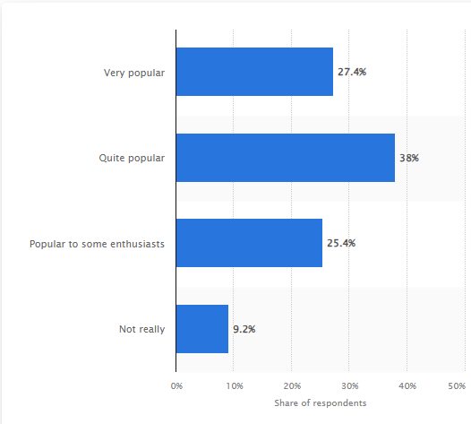
Figure 1: Popularity of Korean cuisines in the UK in 2019
(Source: Statista 2023)
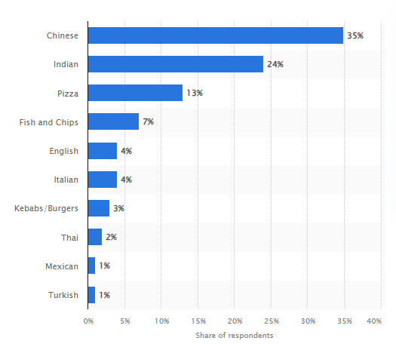
Figure 2: UK takeaway cuisines among consumers 2017
(Source: Statista, 2023a)

The reason behind menu choices
Menu choices in a restaurant are one of the primary reasons why target audience is attracted to and appealed to (Wallace, 2022). Some of the very famous and traditional dishes of China and Korea are incorporated within the menu, which will comprise Kung pao chicken, sweet and sour pork, tofu and a very famous Chinese hotpot. Furthermore, for people who love Korean cuisine, kimchi. Bulgogi, Korean fried chicken and samgyeopsal will be served. The fusion of Chinese and Korean cuisines enables attracting a broader range of audience. The Chung Kiwa café will also serve some of the very famous sweet dishes of Korea and China that will complement the meal being offered. It has been noted that Korean and Chinese cuisine is one of the top-liked cuisines in the UK, indicating demand for Chinese and Korean fusion among people around the UK.

Part 2:

Menu Design
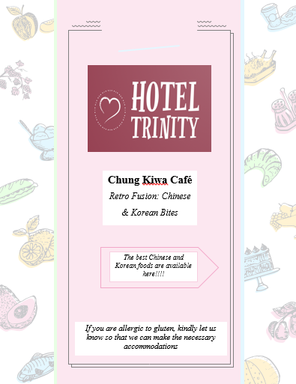
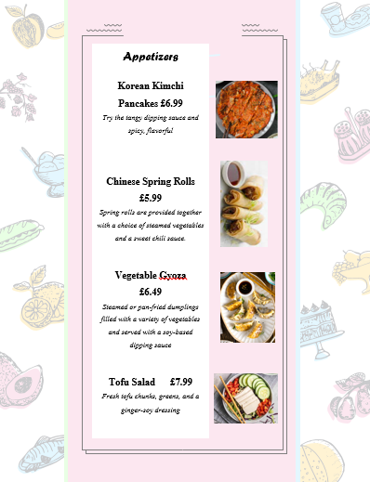
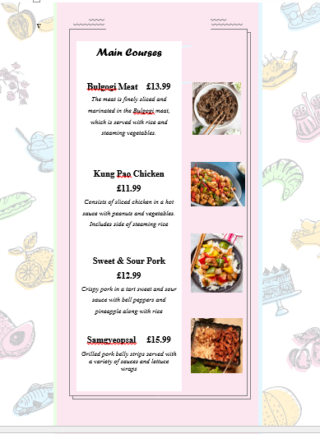
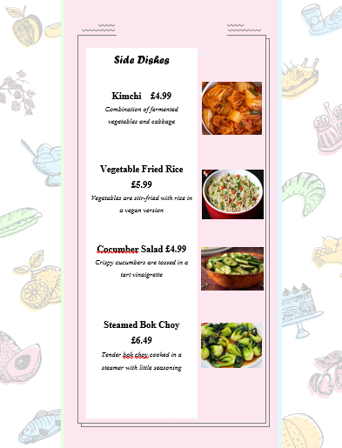
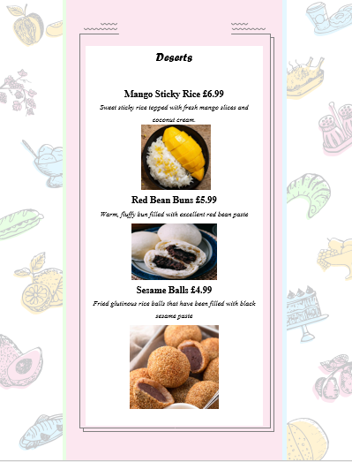
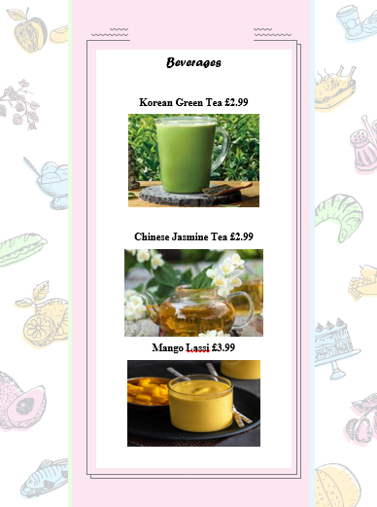

References:
Carroll, G.R. and Kovács, B., 2021. Authenticity: Meanings, targets, audiences and third parties. Research in Organizational Behavior, 41, p.100149.
Chen, W., Tajeddini, K., Ratten, V. and Tabari, S., 2019. Educational immigrants: Evidence from Chinese young entrepreneurs in the UK. Journal of enterprising communities: People and places in the global economy, 13(1/2), pp.196-215.
Chua, B.L., Karim, S., Lee, S. and Han, H., 2020. Customer restaurant choice: an empirical analysis of restaurant types and eating-out occasions. International journal of environmental research and public health, 17(17), p.6276.
DiPietro, R., 2017. Restaurant and foodservice research: A critical reflection behind and an optimistic look ahead. International Journal of Contemporary Hospitality Management, 29(4), pp.1203-1234.
Erkmen, E., 2019. Managing restaurant attributes for destination satisfaction: what goes beyond food?. Administrative Sciences, 9(1), p.19.
Hasan, A.A.T., 2022. Perceived value and behavioral intentions toward dining at Chinese restaurants in Bangladesh: the role of self-direction value and price fairness. South Asian Journal of Marketing, 3(2), pp.116-134.
Koh, Y., Lee, M., Kim, J. and Yang, Y., 2020. Successful restaurant crowdfunding: the role of linguistic style. International Journal of Contemporary Hospitality Management, 32(10), pp.3051-3066.
Singh, G., Slack, N., Sharma, S., Mudaliar, K., Narayan, S., Kaur, R. and Sharma, K.U., 2021. Antecedents involved in developing fast-food restaurant customer loyalty. The TQM Journal, 33(8), pp.1753-1769.
Statista 2023. Popularity of South Korean cuisine in the United Kingdom in 2019. [Online] Available at https://www.statista.com/statistics/1002689/south-korea-korean-food-popularity-in-the-uk/ [Accessed on 5 October 2023]
Statista 2023a. Favorite takeaway cuisine among consumers in the United Kingdom (UK) in 2017. [Online] Available at https://www.statista.com/statistics/760306/the-uk-s-favorite-takeaway-cuisines-united-kingdom/ [Accessed on 5 October 2023]
Wallace, M.D., 2022. Practical Business Strategies Independent Quick Service Restaurants Use to Sustain beyond Five Years. Open Journal of Business and Management, 10(4), pp.1952-1986.
Wulandari, R., Tandri, R.A. and Putra, A.A., 2019. Factors affecting the choice of Chinese restaurants in Bandung: Important of ambience. In 6th Bandung Creative Movement 2019 (pp. 338-341). Telkom University.

