
MSc Data and Artificial Intelligence
ACCA7026
L7 Artificial Intelligence

Report
“Credit Risk Prediction Using Machine Learning”

Lecturer: Malik Mehmoud

Name of the Student: Rohan Mendapara

Student ID:2520811

Abstract
The assessment of the credit-risk is effective in helping lenders for the identification of the capacity of borrowers to repay loans and maintain payment obligations. The study is being developed for the comprehensive and critical evaluation of the framework of linear and custom machine learning models for the effective prediction of default capacity based on the data of Lending Club loans_full_schema. The study is based on the 10,000 observations gathered from the dataset and has 56 variables in the imported dataset. After removing the unpaid loans, the modelling sample included the 454 paid loans, where 447 were fully paid, and seven were charged-off loans. The study uses the median value to replace the missing values with the most frequent values in the data. With the help of stratified cross-validation and a set of held-out trials, the best baseline and tuned Logistic Regression (LR) and Gradient Boosting (GB) models have been assessed. The results from the evaluation, however, represented a test accuracy of 98.90%. On the other hand, all the models have resulted in zero precision, recall and F1-score for the default class. The best ROC-AUC results of the study have also resulted in the Baseline Gradient Boosting (0.7111), which represents the sensitive test set size, with the help of only one default. The results from the data analysis have also confirmed that the overall accuracy, despite having a high rate, was not effective in detecting defaults. The existing models are not suitable for operational utilisation as the current sample of resolved loans demands the identification of feature mapping errors due to inadequate treatment for imbalance management and threshold tuning, and weaker fairness testing.

Table of Contents
Abstract 1
1. Introduction and Problem Statement 5
1.1 Background of Credit Risk Prediction 5
1.2 Machine Learning in Financial Lending 5
1.3 Problem Statement 6
1.4 Research Objectives 6
2. Literature Work 6
2.1 Credit-scoring models 6
2.2 Imbalance, evaluation and explainability 7
2.3 Fairness and governance 7
3. Methodology 8
3.1 Research design and dataset 8
3.2 Exploratory analysis and feature preparation 10
3.3 Preprocessing, modelling and validation 11
4. Experiments and Results 12
4.1 Hyperparameter optimisation and cross-validation 12
4.2 Held-out test performance 13
4.3 Interpretability and fairness outputs 16
5. Discussion 18
5.1 Model comparison and generalisation 18
5.2 Interpretation, fairness, and ethics 18
6. Conclusion and Recommendations 19
References 20
Appendix: Code with Evidence 23

List of Table
Table 1. Dataset and target profile generated from the notebook outputs. 9
Table 2. Three-fold stratified cross-validation results. 13
Table 3. Held-out test-set results; precision, recall and F1 refer to the default class 14

List of Figure
Figure 1. Target distribution and class balance. Source: notebook output based on Lending Club data. 9
Figure 2. Percentage of missing values in the filtered modelling dataset. Source: notebook output. 10
Figure 3. Observed default rate by Lending Club loan grade. Source: notebook output 11
Figure 4. Corrected three-fold cross-validation visualisation reconstructed from the notebook metrics 13
Figure 5. Confusion matrices for all four models on the test set. Source: notebook output 15
Figure 6. ROC curves for the four evaluated models. Source: notebook output 16
Figure 7. Precision-recall curves and average precision scores. Source: notebook output 16
Figure 8. Permutation importance for the tuned Gradient Boosting model. Source: notebook output 17
Figure 9. Global mean absolute SHAP importance for the tuned ensemble. Source: notebook output 17

1. Introduction and Problem Statement

1.1 Background of Credit Risk Prediction
The assessment of the credit-risk is one of the major requirements for financial performance evaluation for any business. This helps lenders identify the borrowers who will actually pay up from the others and helps in the management of the data for better business decisions and profitability. Especially, businesses that have to deal with borrowing and lending must have the capacity for effective identification, as the approval of defaulters in this aspect will directly impact the profit of the organisation and will create a scenario that will directly create a situation where the lender will have to take legal action to recover the money. Evidence from recent studies has highlighted that the repayment outcome can have a direct impact on the payment outcome. However, the impact can have differentiation based on the sample size and time [2]. The effective credit model must identify these patterns and understand the patterns of working while focusing on the hold-up under scrutiny.

1.2 Machine Learning in Financial Lending
The logistic Regression in this aspect is one of the major approaches that can have a direct impact on the method of measurement, as these numbers can easily explain when increasing the risk. This, eventually, however, assumes that the overall procedure works through the linear form, which further creates the issue in the identification of complex situations or tricky relationships, unless they are clearly indicated. The steps from Gradient Boosting can provide more flexibility in this aspect with the help of decision building through the step-by-step approach and reducing the previous through continuous learning [18]. Recent studies have also represented that machine learning models can bring the real edge to credit scoring, but do not have anyone-size-fits-all framework that can be applied thoroughly [3]. It is suggested to implement a marginal improvement within these models for s clear, reliable results at a reasonable cost [4]. Again, in case of any high-stakes decisions, a marginal improvement in discrimination can directly impact the assessment and the challenges to the overall assessment or governance [15].

1.3 Problem Statement
One of the primary difficulties and the credit score is the class imbalance. Where defaults are rare, a minority class can often be classified with high accuracy through the prediction of the most common non-default class in almost all cases. Brown and Mues [20] have shown that the imbalance within the credit data can directly alter the behaviour of classify while studies have also recommended that cost-sensitive learning and optimisation of the overall threshold can have a direct impact on the cost-sensitive learning [8]-[10]. The precision, recall and the F1 score are crucial for small numbers of positive and precision-maintained information. Then, ROC analysis in the classification of the positive class [19].

1.4 Research Objectives
The fundamental research question being assessed in the study is not only the identification of the models that can achieve the highest accuracy but rather focusing on the model that can reliably identify default borrowers while focusing on generalisation under a situation of imbalance. The fundamental goal of the study is also to create, compare and assess critically the Logistic Regression and Gradient Boosting models for data collected from the structured Lending Club. This further helps in processing the data and tuning the model of both frameworks while comparing their performance and generalisation capability.

2. Literature Work

2.1 Credit-scoring models
From the evaluation of the experts and statistical scorecards, it has been highlighted that credit scoring is important for the data-driven machine learning implementation. Dastile, Celik and Potsane [4] have highlighted that frameworks like Logistic Regression, decision trees, Support-Vector Machines and ensemble methods are effective for the design and processing of the design of the sample construction through the evaluation of the design, which can have a direct impact on the results. From the perspective of the Lending Club research, Croux et al. [2] have shown that the borrower and contractual characteristics are having a close correlation related to default risk. On the other hand, Ariza-Garzón et al., [3] have highlighted that non-linear models have an effective prediction to capture the non-linear effects in the features through SHAP explanations. Bazzana, Bee and Khatir [11], on the other hand, have stated that the machine learning benefits over the benefits of Logistic Regression can be constrained, which further demands the Evidence-Based Selection of the individuals rather than having any algorithm-centred selection.

2.2 Imbalance, evaluation and explainability
Class imbalance, as highlighted in recent studies, is one of the major issues in the default cases, as these are rare but costly. A collaboration of the weighted SMOTE and ensemble learning, as represented by Abedin et al. [8], along with threshold optimisation and under sampling, has been further studied by Leevy et al. [9]. Similarly, Bui and Ta [10] have also proposed an interpretable ensemble for imbalanced credit data. These studies collectively show that a high level of accuracy can reduce or hide the failures of minority groups. From the perspective of imbalanced classification, Saito and Rehmsmeier [19] have also suggested using the precision-recall curves directly on the positive predictions and detected events.
Explainability, in these aspects also needs to be reduced as the lending outcomes have real-world impact on people. Bussmann et al. [5] and Kyeong and Shin [12] have demonstrated that explainable techniques can help in the evaluation of credit-risk identification. The study by Lundberg et al. [14] further provides a consistent approach to explain trees both locally and globally with SHAP. However, Chen, Calabrese and Martin-Barragán [7] have highlighted that the imbalance in the class can cause feature rankings and explanations of the values to be unstable. An explanation can only be understood through the description of the behaviour of the model and not as evidence of a causal credit-risk relationship.

2.3 Fairness and governance
Fairness, in the aspect of the credit measurement, might conflict with predictive utility and profitability. In credit scoring, the trade-off is discussed by Kozodoi, Jacob and Lessmann [6] and Lessmann and Bikand [7]. These studies collectively offer methods to test and diagnose unfair credit scoring models. Further, the trade-offs have been discussed by Kozodoi, Jacob and Lessmann [6] and Lessmann and Bikand [7] for the testing and diagnosing of unfair credit scoring models. Brotcke [17] have also noted that the bias needs to be maintained effective when using machine learning in the credit decision-making process. Governance frameworks, on the other hand, also require effective documentation, validation and monitoring. The NIST AI Risk Management Framework [16] have recommended the Lifecycle governance, and good creditworthiness assessment and monitoring have already been mandated by the European Banking Authority [17]. These principles are applicable for the explainable technology models, as without integrity, the models can be inappropriate due to a poor fit of data, poor validation or poor performance when the model is applied to subgroups.

3. Methodology

3.1 Research design and dataset
The train-test structure, with the help of the stratified distribution, can have a direct impact on the linear and non-linear classifiers, which were previously assessed against each other in a quantitative experimental design. The notebook imported from the OpenIntro dataset loans_full_schema.csv is a version of the Lending Club loans [1] dataset which has detailed observations in the table below. This featured with the help of 10,000 observations and 56 columns have been effective in highlighting the distribution. Among these results the 9,375 loans were current, 447 were fully paid, 67 were in the grace period, 66 were 31-120 days late, 38 were 16-30 days late, and seven were "charged off". The analysis highlights that not all of these loans were resolved and can be in a final repayment state and were not included. The study is because only fully paid and charged-off outcomes were included, as there were no loans that were not in a final repayment state.
Dataset characteristic | Notebook output
Imported observations | 10,000
Imported variables | 56
Current loans | 9,375
Fully paid loans | 447
Charged-off loans | 7
Final modelling sample | 454
Default rate | 1.54%
Imbalance ratio | 63.9:1

Table 1. Dataset and target profile generated from the notebook outputs.
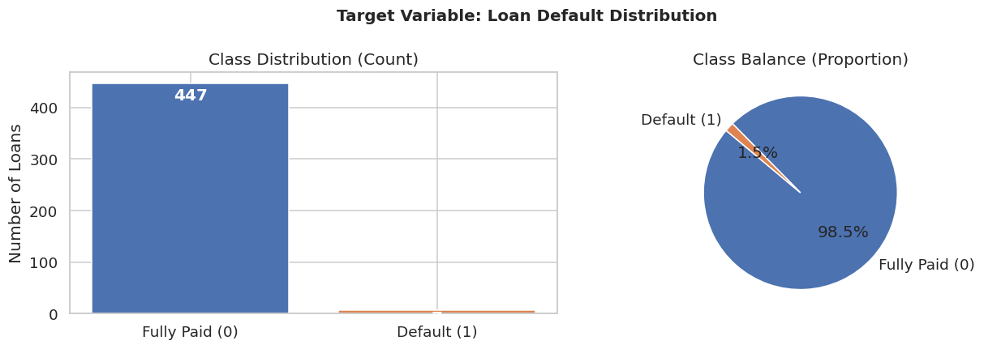

Figure 1. Target distribution and class balance. Source: notebook output based on Lending Club data.
The analysis highlighted that 95.46% of observations were selected, removing the not resolved and not assigned incorrect outcome cases. However, the population size that could be used decreased, and only seven positive cases remained. This process overall highlighted the validity of the labels and diminished statistical reliability.

3.2 Exploratory analysis and feature preparation
Exploration examined the target distribution, missing values, correlations and default rates by grade. Ten fields contained missing observations, including several joint-income variables with very high missingness. The missing-value profile supported explicit imputation rather than complete-case deletion, which would have further reduced an already small sample.
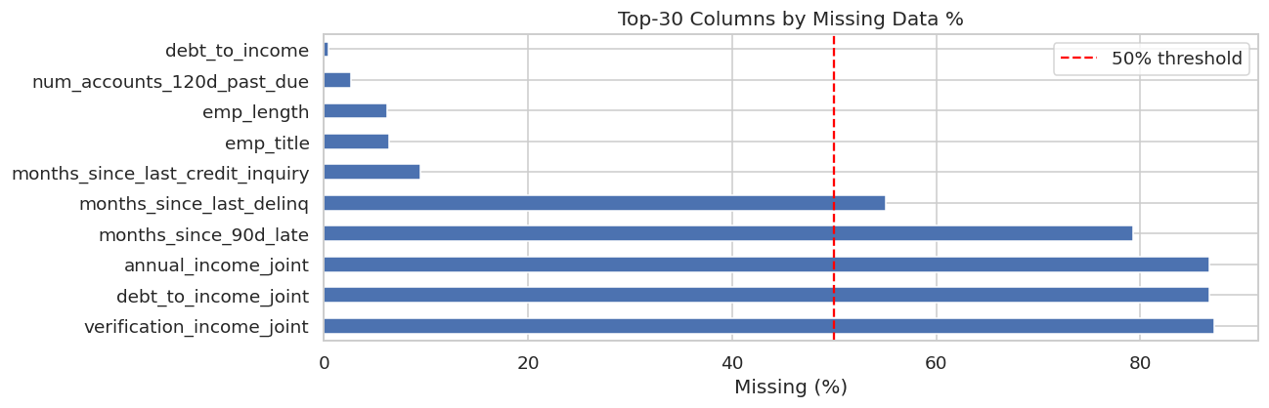

Figure 2. Percentage of missing values in the filtered modelling dataset. Source: notebook output.
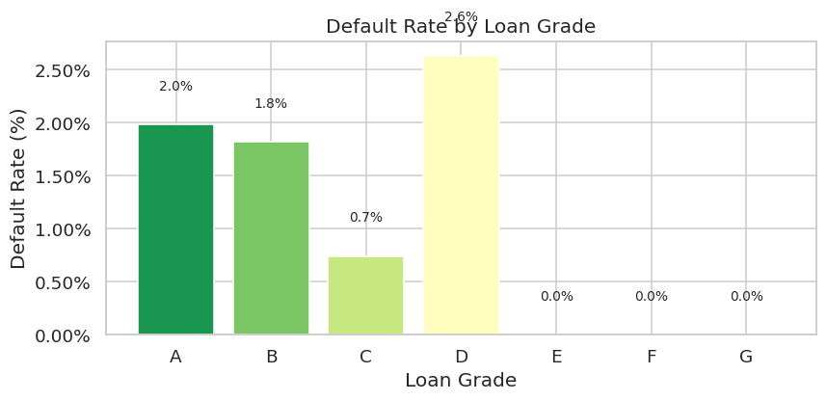

Figure 3. Observed default rate by Lending Club loan grade. Source: notebook output
From the evaluation of the finalised data, it has been highlighted that the initial predictors were 20, which are considered to be financially relevant, but the differences in schemas warranted only 5 predictors: term, instalment, grade, sub_grade, and emp_length that needed to be included. For instance, the notebook asked for annual_inc and data, but the dataset variables were annual_income and debt_to_income. The mismatch limited the model to 5 predictors, which is why there was only an instalment and the target in the correlation analysis. This restriction must not be hidden, as this can directly impact the quality of the output of the data evaluation and the quality of the model.

3.3 Preprocessing, modelling and validation
Numeric variable imputation with the median and standardisation have been conducted. The categorical variables have been replaced with the common category and then coded binarily with an order. The categorical variable has been replaced with the implications of the common category and binary code. The values that were not identifiable were coded as -1.
The observation overall was differentiated into an 80:20 ratio, having the effect of training with 363 observations and a test set with 91 observations. The sixth default in this training set and one default within the test set were selected. The baseline logistics regression with the use of 100 estimators, learning rate 0.1, and maximum depth of three was assisted from the perspective of L1 and L2 penalty along with regularisation value. The primary difference between the performance of the baseline and tuned ensembles is not necessarily due to tuning, as the two ensembles used different estimators.
There was a stratified cross-validation for final comparison with the three-fold results. However, the heading in the notebook has highlighted the five-fold. Accuracy and default precision, recall, F1, ROC-AUC, Average Precision and the confusion matrices were investigated. Permutation importance, Logistic Regression coefficients, SHAP and partial dependence plots were one of the major aspects of the interpretation. Fairness analysis was attempted within available socioeconomic subgroups, but was not possible for age and gender, and was too small for stable group comparisons.

4. Experiments and Results

4.1 Hyperparameter optimisation and cross-validation
The tuned Logistic Regression with the value of C=0.001 used the linear solver used L1 regularisation. After this severe penalty, all fitted coefficients were set to 0, and the best validation ROC-AUC was 0.5000. The tuned histogram-based Gradient Boosting in the study have been effective for the selection of the learning rate and the learning rate to be 0.0851, maximum depth 5, 113 iterations, 45 leaf nodes, minimum leaf size 24, and L2 regularisation 0.4498. The best validation ROC-AUC was 0.4930.
Model | CV Accuracy | CV F1 | CV ROC-AUC
LR baseline | 0.6143 ± 0.0506 | 0.0000 ± 0.0000 | 0.2059 ± 0.0549
LR tuned | 0.9835 ± 0.0000 | 0.0000 ± 0.0000 | 0.5000 ± 0.0000
GB baseline | 0.9725 ± 0.0039 | 0.0000 ± 0.0000 | 0.3887 ± 0.1016
GB tuned | 0.9835 ± 0.0000 | 0.0000 ± 0.0000 | 0.4930 ± 0.0248

Table 2. Three-fold stratified cross-validation results.
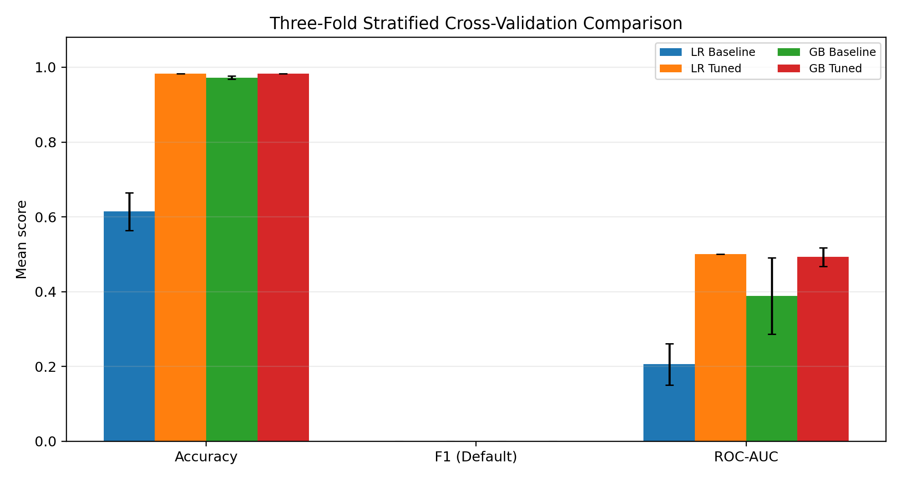

Figure 4. Corrected three-fold cross-validation visualisation reconstructed from the notebook metrics
Although tuned models achieved higher accuracy, none successfully identified default cases, indicating that accuracy alone was not a reliable performance measure.4.2 Held-out test performance
Model | Accuracy | Precision | Recall | F1 | ROC-AUC
LR baseline | 0.5385 | 0.0000 | 0.0000 | 0.0000 | 0.4667
LR tuned | 0.9890 | 0.0000 | 0.0000 | 0.0000 | 0.5000
GB baseline | 0.9670 | 0.0000 | 0.0000 | 0.0000 | 0.7111
GB tuned | 0.9890 | 0.0000 | 0.0000 | 0.0000 | 0.5222

Table 3. Held-out test-set results; precision, recall and F1 refer to the default class
Baseline Logistic Regression resulted in 41 false positives and missed the default but correctly classified 49 of the 90 non-default cases. Baseline Gradient Boosting correctly classified 88 non-default cases and have resulted the 2 false positives and missed the default. Both tuned models effectively identified all 90 non-default cases, while the default case was correctly highlighted as one of the non-default cases by both models. With a 98.90% accuracy both the results were successful, as a trivial model that always classified an observation as fully paid.
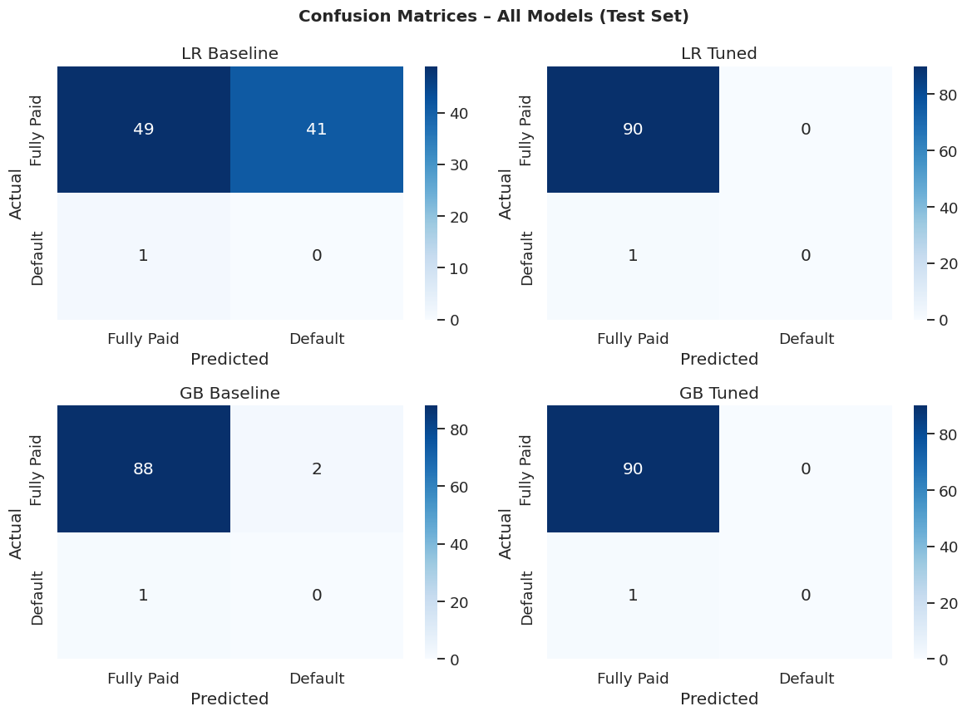

Figure 5. Confusion matrices for all four models on the test set. Source: notebook output
The Baseline Gradient Boosting have achieved the highest ROC-AUC value of 0.7111. However, this was highly dependent on the one positive test observation. The precision-recall analysis was more effective. On the other hand, with average precision scores ranged from 0.011 to 0.036, which is in the ballpark of the prevalence of the test set, resulting in 1.10%. Neither of the models exhibited practically useful minority class discrimination.
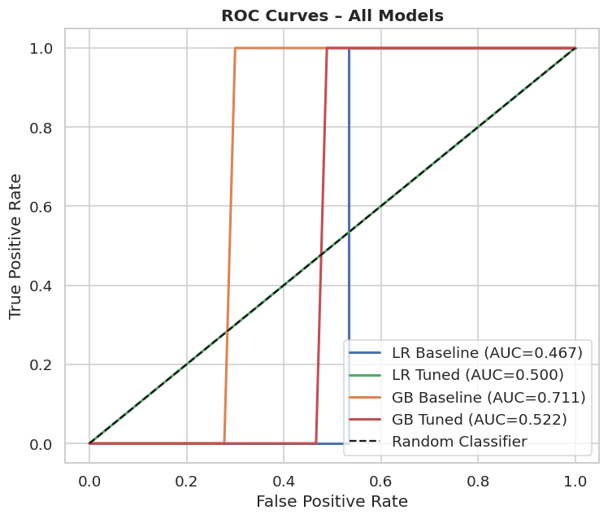

Figure 6. ROC curves for the four evaluated models. Source: notebook output
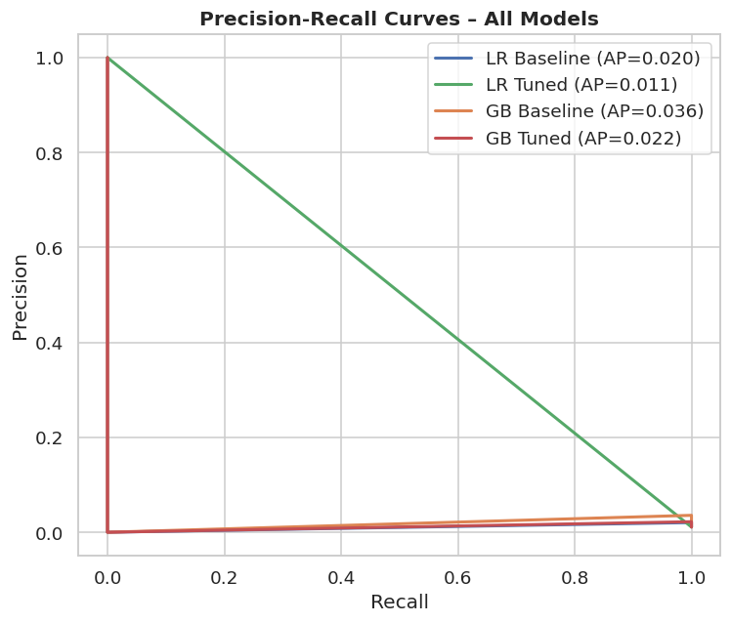

Figure 7. Precision-recall curves and average precision scores. Source: notebook output

4.3 Interpretability and fairness outputs
The strongest positive contributors highlighted from the analysis were the instalment and length of employment, as measured by permutation importance and then the state of large uncertainty. The negative permutation importance highlights the alterations of the variable which have directly created an increase in ROC-AUC, suggesting unstable or noisy data. Instalment was rated No. 1 with SHAP, followed by sub-grade and employment length. This is the disagreement between methods, which compares in the similarly perspective with the warning given by Chen et al. [7] regarding the possible destabilisation of explanations based on the credit model.
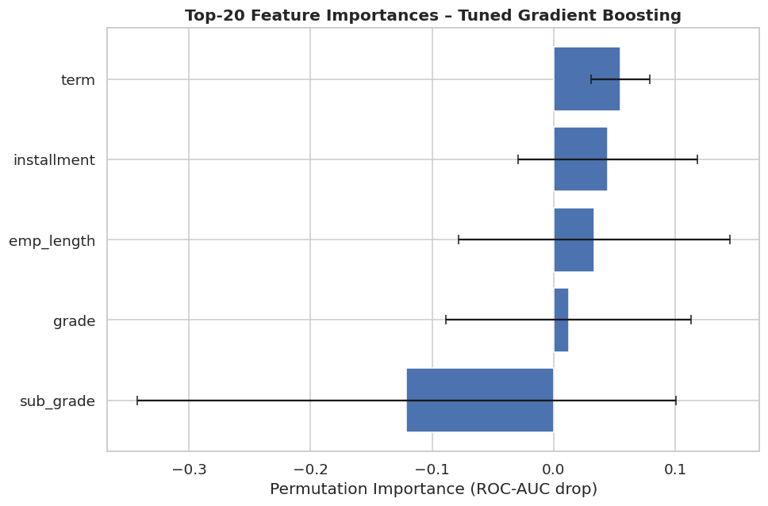

Figure 8. Permutation importance for the tuned Gradient Boosting model. Source: notebook output
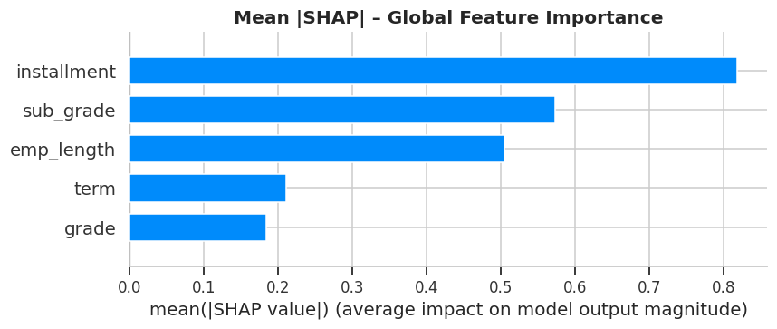

Figure 9. Global mean absolute SHAP importance for the tuned ensemble. Source: notebook output
The Logistic Regression coefficients resulted in 0 due to the use of strong L1 regulations. Partial dependence has also been highlighted a small decrease in model output across terms with an irregular instalment relationship, which, however, learned from just six training defaults and should not be assumed to be causal. The fairness code generated no reliable subgroup statistics, as age and gender were missing.

5. Discussion

5.1 Model comparison and generalisation
The results do not show any superiority in the uniform aspect in the tuned Gradient Boosting. Tuned Gradient Boosting's test ROC-AUC was only slightly higher than that of random ranking, while Baseline Gradient Boosting had the highest test ROC-AUC. One of the major outcomes of the study was the establishment of the default recall of zero and default F1. The ensemble thus did not provide any proven operational benefit at the applied threshold. This contrasts with Lending Club studies from the perspective of the predictors and larger samples, where the recent strides [2] [3] have shown that the failure in the present was the result of the target scarcity and feature loss, not the inability of either algorithm.
The high accuracy reflected class imbalance rather than effective default prediction, as all models performed poorly on the minority class.

5.2 Interpretation, fairness, and ethics
The interpretability outputs reflect the mechanisms of the models and are not validations of the model. SHAP and permutation importance presented different feature ranks, and the linear model removed all the features' importance. These explanations, therefore, do not constitute reliable predictors of default, but rather of unstable fitted behaviour. Rudin [15] states that when making high-stakes decisions, the model should be interpretable and reliable whenever possible, but in this case, it is not, and the post hoc explanation does not address the real issue of the model's predictiveness.
The relevant protected attributes were not provided, and the numbers of events in the subgroups were too small to establish fairness. Proxy analysis in the current research can be utilised from the perspective of a substitute for socioeconomic variables [6], [13]. For responsible use, it is essential that the effective retrieval of the documents and review by humans occur, and there would be documented limitations, appeal mechanisms, and continuous monitoring as expected by NIST and EBA [16] [17].

6. Conclusion and Recommendations
The study developed and evaluated Logistic Regression and Gradient Boosting models to predict loan default using Lending Club data.The model performance was not consistent in the identification of the defaulting loans. Tuned Logistic Regression and tuned Gradient Boosting had 98.90% accuracy with only one default in the test set. For all the models, the precision, recall and F1 score were 0. Baseline Gradient Boosting achieved the highest ROC-AUC but was not sufficiently stable to deploy.
The first suggestion is to use a significantly larger set of fixed-up Lending Club loans with adequate numbers of charged-off outcomes to support stratified training, validation, and temporal testing. Second, the names of the features should reflect the real schema, allowing annual income, debt-to-income ratio, home ownership, loan purpose, and interest rate and credit-history measures to be evaluated. To avoid leakage, post-outcome variables should be excluded. Third, both baseline and tuned ensembles need to be generated using the same ensemble estimator.
Class weighting, threshold optimisation, cost-sensitive learning, and thoroughly tested resampling further need to be compared from the perspective of the event sample increment. Evaluation must include the precision-recall AUC, balanced accuracy, and calibration and cost-based measures. The notebook should consider an educational demonstration of an experiment and not an operational credit decision implementation before these conditions are being fulfilled.

References
[1] T. T. Adewale, T. D. Olorunyomi, and T. N. Odonkor, “Big data-driven financial analysis: A new paradigm for strategic insights and decision-making,” Journal of Financial Innovation and Analytics, vol. 1, no. 1, pp. 1–15, 2023.
[2] V. Chamola, V. Hassija, A. R. Sulthana, D. Ghosh, D. Dhingra, and B. Sikdar, “A review of trustworthy and explainable artificial intelligence (XAI),” IEEE Access, vol. 11, pp. 78994–79015, 2023.
[3] Y. Ge, Z. Li, and J. Zhang, “A simulation study on missing data imputation for dichotomous variables using statistical and machine learning methods,” Scientific Reports, vol. 13, no. 1, Art. no. 9432, 2023
[4] W. K. Ali, “Enhancing machine learning model accuracy with effective data scaling strategies,” 2025.
[5] C. Nwoke, S. Ivanov, and E. Petrova, “Enhancing clinical trial interpretation through SAS-based data visualization,” International Journal of Advanced Research in Engineering and Related Sciences, vol. 1, no. 7, p. 1, 2025.
[6] T. Althaqafi, F. Saleem, and A. A. M. Al-Ghamdi, “Enhancing student performance prediction: The role of class imbalance handling in machine learning models,” Discover Computing, vol. 28, no. 1, Art. no. 79, 2025.
[7] M. Maftoun, E. Zia, N. Shadkam, S. S. Salehi Komamardakhi, Z. Mansor, M. A. Nematollahi, E. Arslan, and R. Alizadehsani, “Malicious URL detection using optimized HistGradientBoosting classifier based on the grid search method,” in Proc. International Conference on the Dynamics of Information Systems, Cham, Switzerland: Springer Nature Switzerland, Jun. 2025, pp. 353–364.
[8] A. Pfob, S. C. Lu, and C. Sidey-Gibbons, “Machine learning in medicine: A practical introduction to techniques for data pre-processing, hyperparameter tuning, and model comparison,” BMC Medical Research Methodology, vol. 22, no. 1, Art. no. 282, 2022.
[9] A. V. Ponce-Bobadilla, V. Schmitt, C. S. Maier, S. Mensing, and S. Stodtmann, “Practical guide to SHAP analysis: Explaining supervised machine learning model predictions in drug development,” Clinical and Translational Science, vol. 17, no. 11, Art. no. e70056, 2024.
[10] M. A. Kabir, M. U. Ahmed, S. Begum, S. Barua, and M. R. Islam, “Balancing fairness: Unveiling the potential of SMOTE-driven oversampling in AI model enhancement,” in Proc. 9th International Conference on Machine Learning Technologies, May 2024, pp. 21–29
[11] E. Owusu, R. Quainoo, S. Mensah, and J. K. Appati, “A deep learning approach for loan default prediction using imbalanced dataset,” International Journal of Intelligent Information Technologies, vol. 19, no. 1, pp. 1–16, 2023,
[12] X. Zhu, Q. Chu, X. Song, P. Hu, and L. Peng, “Explainable prediction of loan default based on machine learning models,” Data Science and Management, vol. 6, no. 3, pp. 123–133, 2023,
[13] X. Li, D. Ergu, D. Zhang, D. Qiu, Y. Cai, and B. Ma, “Prediction of loan default based on multi-model fusion,” Procedia Computer Science, vol. 199, pp. 757–764, 2022,
[14] V. Moscato, A. Picariello, and G. Sperlí, “A benchmark of machine learning approaches for credit score prediction,” Expert Systems with Applications, vol. 165, Art. no. 113986, 2021,
[15] P.-C. Ko, P.-C. Lin, H.-T. Do, and Y.-F. Huang, “P2P lending default prediction based on AI and statistical models,” Entropy, vol. 24, no. 6, Art. no. 801, 2022,.
[16] A. Akinjole, O. Shobayo, J. Popoola, O. Okoyeigbo, and B. Ogunleye, “Ensemble-based machine learning algorithm for loan default risk prediction,” Mathematics, vol. 12, no. 21, Art. no. 3423, 2024,
[17] H. Li and W. Wu, “Loan default predictability with explainable machine learning,” Finance Research Letters, vol. 60, Art. no. 104867, 2024
[18] S. Shi, R. Tse, W. Luo, S. D’Addona, and G. Pau, “Machine learning-driven credit risk: A systemic review,” Neural Computing and Applications, vol. 34, no. 17, pp. 14327–14339, 2022
[19] A. Alonso Robisco and J. M. Carbó Martínez, “Measuring the model risk-adjusted performance of machine learning algorithms in credit default prediction,” Financial Innovation, vol. 8, Art. no. 70, 2022,
[20] N. Wattanakitrungroj, P. Wijitkajee, S. Jaiyen, S. Sathapornvajana, and S. Tongman, “Enhancing supervised model performance in credit risk classification using sampling strategies and feature ranking,” Big Data and Cognitive Computing, vol. 8, no. 3, Art. no. 28, 2024

Appendix: Code with Evidence


