Tabbed Application (Set up as “Tabbed Application”)

1. Choose Tabbed Application when setting up a Project

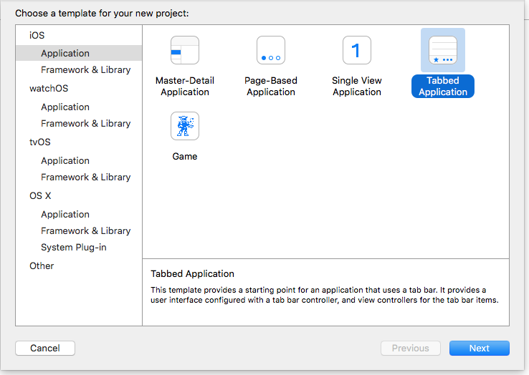

2. Open Main.storyboard and by default, you will find two tabs:

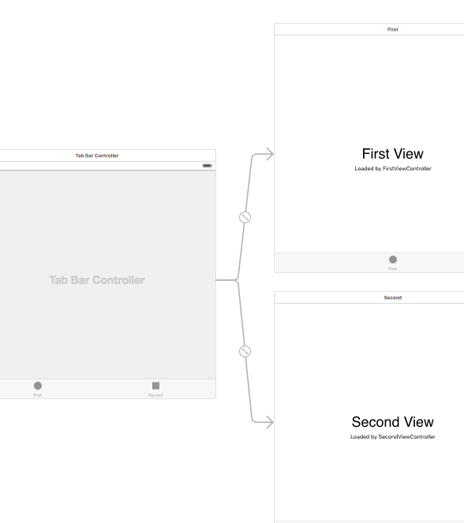

(Note: each tab has an associated .swift file – FirstViewController.swift and SecondViewController.swift)

3. Run the simulator and you have two tabs available:

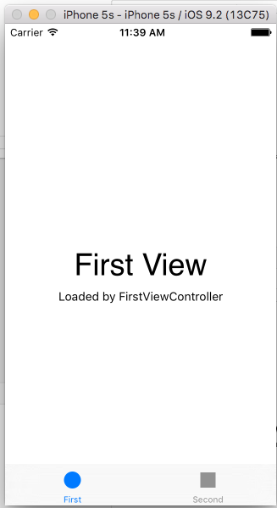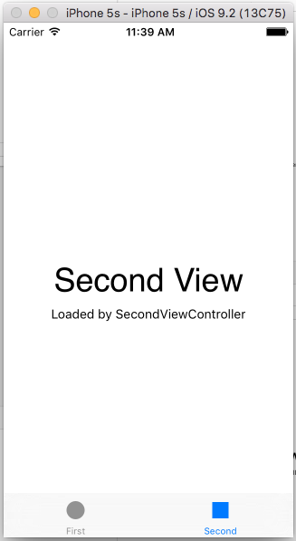

4. Drag and drop a third ViewController (put a label with ThirdView on it temporarily):

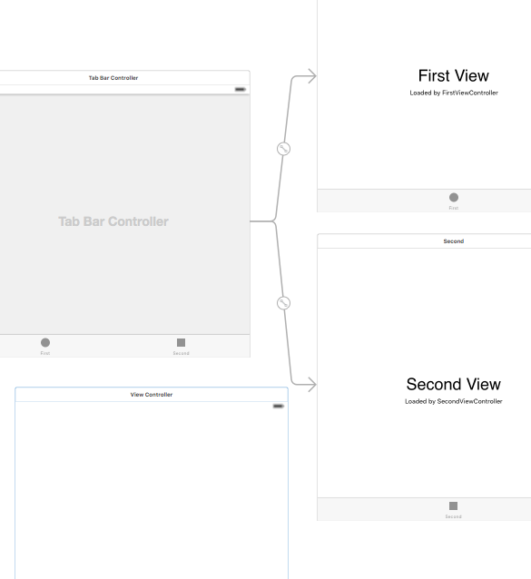

5. CTRL/Drag from Tab Bar controller to the new View Controller:

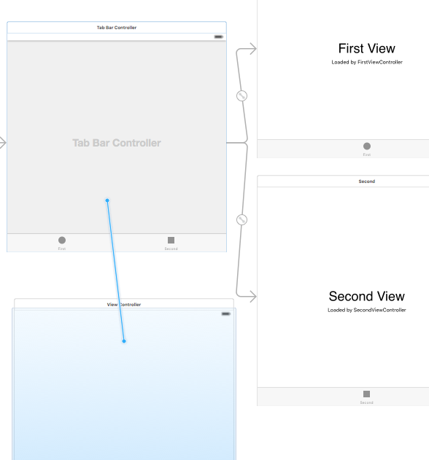

6. Select Relationship Segue – View Controllers

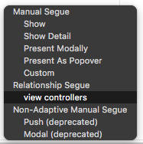

7. The new controller is now linked to the Tab Bar Controller:

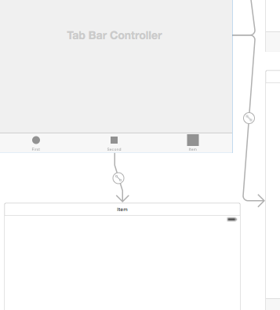

8. Change the name of the new scene as required:

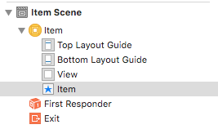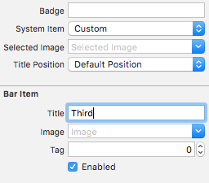

9. Change System Item to “Downloads”

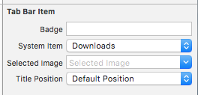

10. Run in the simulator – we now have 3 tabs – First, Second and Third

11. Put whatever labels, buttons etc that are required on each page – you now have a tabbed app.

12. We can add to the View Controller of the first and second tabs to do something when the app is loaded.

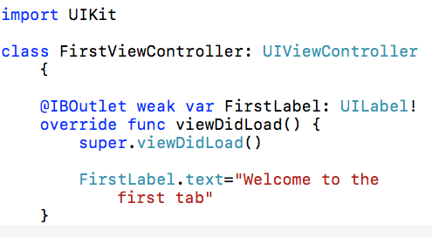

13. At the moment, our third tab does not have a controlling .swift file. We need to create one.

Right click on your Project folder and select "New File"

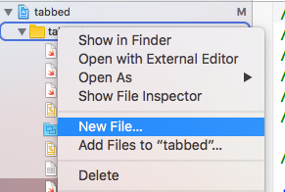

Select "Cocoa Touch Class"

Name your new class ThirdViewController.swift and make sure it is a subclass of UIViewController

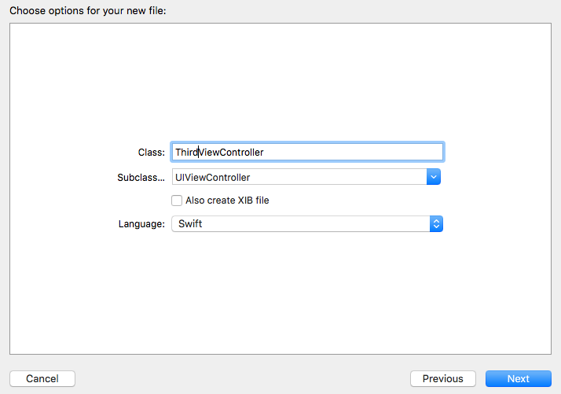

Now we need to link the new ThirdViewController.swift file with our new tab.

Select the third tab (click on the yellow button at the top to be sure) and go to Identity Inspector. Change the Class to ThirdViewController:

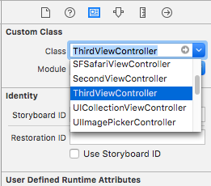
14. You can now use your new ThirdViewController.swift file to control your third tab.


