Name: Olivia Hall
Student number:
Module: Changemakers: Building your personal brand for sustainable employment
Module code: BMHP5051
Lecturer:
Assignment title: Component 2: Assignment report
Introduction
This report explores the knowledge, skills and professional attributes needed to become a Children and Families Social Worker in the United Kingdom. The role was selected because it aligns with my long-term career aspirations and my interest in supporting vulnerable children and families to achieve positive outcomes. Children’s social workers play a vital role in safeguarding children, promoting their welfare and working collaboratively with families and other professionals to assess needs, manage risk and provide right support. This report will analyse the employability skills needed for the role, evaluate my current abilities and experiences, and present a realistic five-year action plan for achieving my career goal while developing my professional identity and personal brand.

Job Advertisement and Job Role
The job advertisement selected for this report is for a Children and Families Social Worker with Birmingham Children’s Trust (Birmingham Children’s Trust, 2026). This role has been chosen because it reflects my long-term career aspiration of working within children’s social care and safeguarding. The position involves assessing the needs of children and families, managing complex cases, developing care plans and working collaboratively with other professionals to promote positive outcomes for children. The person specification highlights the importance of communication, analytical thinking, professional judgement, teamwork, and resilience, alongside a commitment to safeguarding and child-centred practice. These responsibilities align closely with the knowledge and skills I am developing through my Health and Social Care degree and represent the professional standards I aim to achieve in my future career.

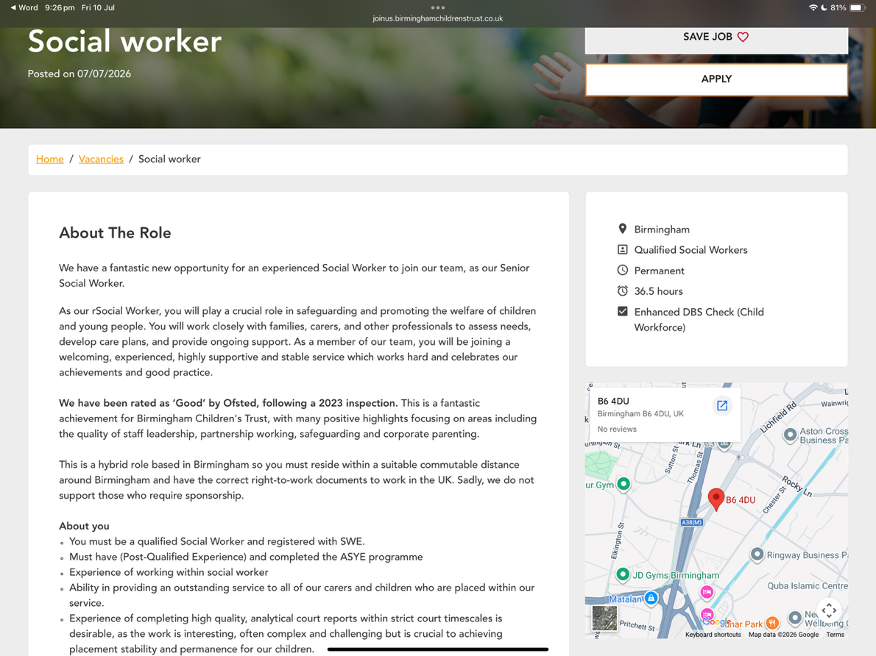
Figure one- About the Role

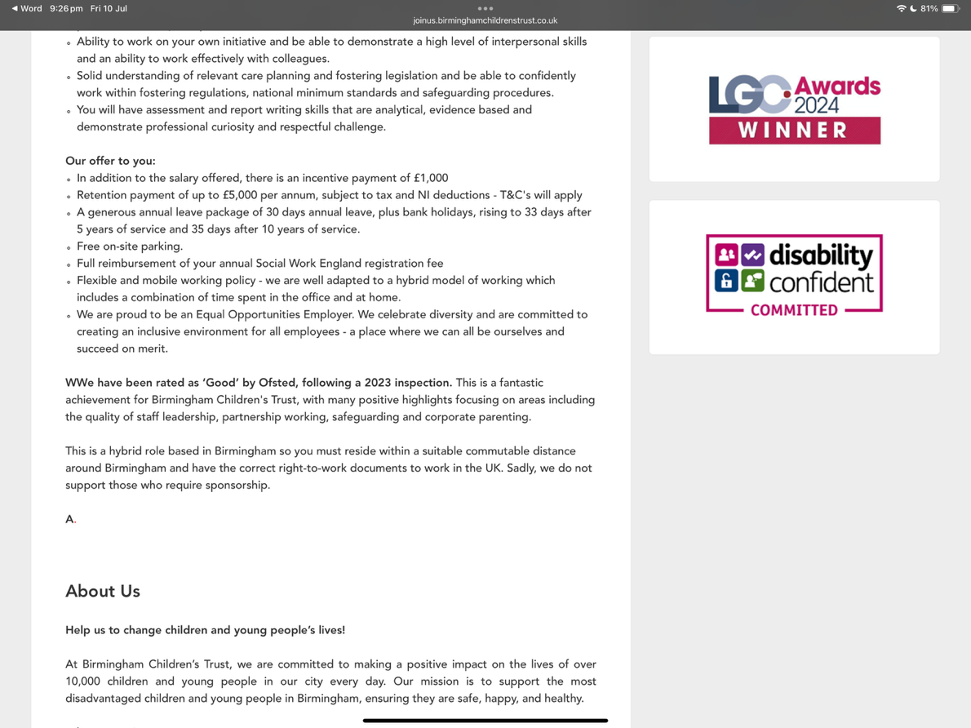
Figure two- What the Job Offers

Figure three- Values and Safeguarding

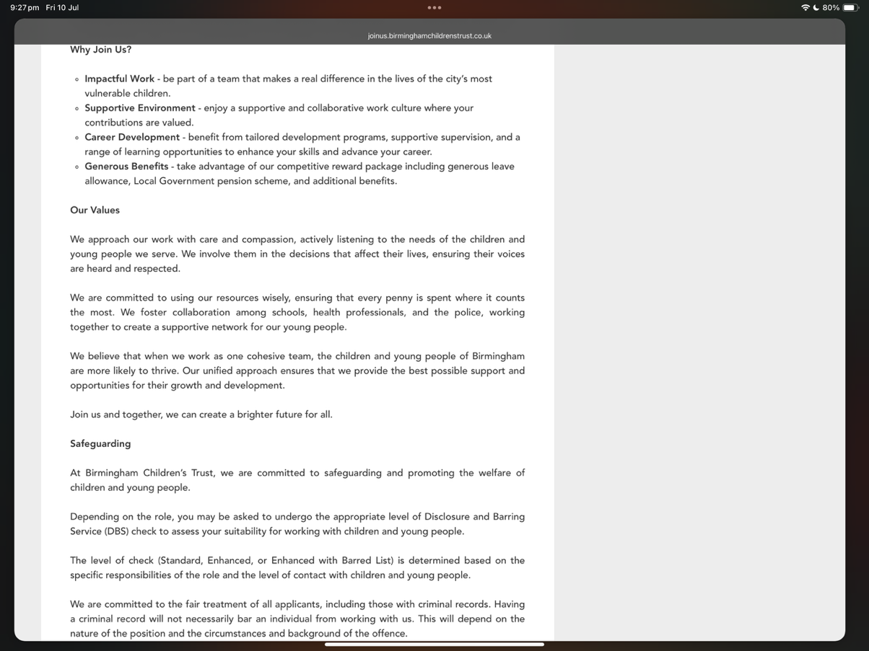
Birmingham Children’s Trust (2026)

Employability Skills Required for a Children and Families Social Worker
Children and Families Social Workers require a broad range of employability skills to safeguard children, promote their welfare, and work effectively with families experiencing complex challenges. One of the most important skills is effective communication, as social workers must build trusting relationships with children, parents and carers while also communicating professionally with colleagues from education, healthcare, the police, and other agencies. Effective communication supports correct information sharing, collaborative decision-making, and child-centred practice (Department for Education, 2023).

Another essential skill is analytical thinking and problem-solving. Social workers are responsible for assessing risk, interpreting information from multiple sources, and making evidence-based decisions that prioritise the safety and wellbeing of children. This requires critical thinking, professional judgement, and the ability to respond appropriately in complex and sometimes unpredictable situations (Social Work England, 2022).

Teamwork and partnership working are also fundamental to the role. Children rarely receive support from a single service, meaning social workers must work collaboratively with professionals from different organisations to coordinate interventions and achieve positive outcomes. Effective multi-agency working reduces risk, improves communication, and ensures that children and families receive the right support (Department for Education, 2023).

In addition, social workers must demonstrate resilience, organisation, and professionalism. Managing demanding caseloads, keeping accurate records, and working within legal and ethical frameworks require excellent time management and emotional resilience. Upholding professional standards, keeping confidentiality, and engaging in continuous professional development are essential to delivering safe, effective, and person-centred practice (Social Work England, 2022).

Evaluation of My Current Skills and Experience
My current qualifications, employment history and academic studies have provided me with a solid foundation for pursuing a career as a Children and Families Social Worker. I am currently studying for a BSc in Health and Social Care, which has developed my understanding of safeguarding, child development, person-centred practice, partnership working, and professional ethics. These areas of knowledge are directly relevant to children’s social work and have strengthened my understanding of how professionals work collaboratively to improve outcomes for vulnerable children and families.

Alongside my degree, I hold a Level 2 qualification in Childcare and completed a nursery placement, where I gained experience supporting children’s learning, wellbeing, and development. This experience improved my communication skills and taught me the importance of adapting my approach to meet the individual needs of each child. It also introduced me to the responsibilities of safeguarding and working professionally within a childcare setting.

I have also worked in retail for almost seven years, progressing to the role of Key Holder. Although this role was outside health and social care, it enabled me to develop valuable transferable skills, including communication, teamwork, organisation, problem-solving, and the ability to remain calm when working under pressure. Supporting customers with unique needs and collaborating with colleagues helped me build confidence when interacting with a wide range of people. I believe these experiences would allow me to build positive relationships with children, families, and professionals within a social work setting.

My greatest strength is my commitment to supporting children and families while staying empathetic, organised, and willing to learn. I believe my unique selling point is the combination of my childcare knowledge, university studies and extensive experience working with the public. These experiences have strengthened my interpersonal skills and reinforced my motivation to pursue a career where I can make a meaningful difference to people’s lives.

Although I have developed many relevant skills, I recognise that I need to gain direct experience within statutory children’s social care. I would also like to develop my knowledge of child protection assessments, court processes, and report writing, as these are essential aspects of the role. To support my development, I plan to learn from experienced social workers through placements, mentoring and supervision while continuing to engage in training and professional development opportunities. Feedback from tutors, practice educators and future colleagues will also help me build the confidence and competence needed to become an effective and reflective social worker.

Action Plan and Five-Year Timeline
Timeframe | Goal | Actions | Expected Outcome
Year 1 (2026-2027) | Complete my BSc Health and Social Care degree | Successfully complete all modules, continue developing knowledge of safeguarding and child development, attend careers events and seek voluntary experience with children and families. | Graduate with a strong academic foundation and gain additional experience relevant to children’s social work.
Year 2 (2027-2028) | Begin qualifying social work training | Apply for a Social Work England-approved postgraduate course (or other qualifying route), continue developing reflective practice and complete any required placements. | Develop the knowledge, values and practical skills needed to become a qualified social worker.
Year 3 (2028-2029) | Gain practical social work experience | Complete placements, learn from experienced practitioners, improve assessment, report writing and risk management skills, and receive regular supervision and feedback. | Increase confidence and competence in statutory social work practice.
Year 4 (2029-2030) | Qualify and begin professional practice | Register with Social Work England, apply for a Children and Families Social Worker position, and compete the Assessed and Supported Year in Employment (ASYE) | Begin practising safely and effectively while continuing professional development.
Year 5 (2030-2031) | Continue professional development | Attend specialist safeguarding and child protection training, undertake regular CPD and explore opportunities to specialise within children’s services. | Develop into a confident, knowledgeable, and reflective social worker capable of supporting children and families effectively.

My action plan has been designed to provide a realistic pathway towards becoming a Children and Families Social Worker. My immediate priority is to successfully complete my Health and Social Care degree while continuing to strengthen my understanding of safeguarding, child development and partnership working. Alongside my academic studies, I intend to seek voluntary opportunities that will allow me to gain additional experience supporting children and families, helping me develop the practical skills valued by employers.

Following graduation, I plan to complete a Social Work England-approved postgraduate qualification to become eligible for professional registration. During this stage, I will focus on developing my assessment, communication and report-writing skills through supervised placements and reflective practice. Once qualified, my aim is to secure a Children and Families Social Worker position and complete the Assessed and Supported Year in Employment (ASYE), which will help me transition safely into professional practice. Over the longer term, I intend to engage in continuous professional development by attending specialist training, keeping my knowledge up to date, and learning from experienced colleagues. This structured approach will enable me to build the confidence, competence and professional judgement needed to provide high-quality support to children and families.

Building My Personal Brand
Building a strong personal brand is essential for demonstrating professionalism and credibility within health and social care. As an aspiring Children and Families Social Worker, I want to develop a professional identity that reflects the values expected of the profession. This means approaching every opportunity with compassion, acting ethically, and showing a genuine commitment to improving outcomes for children and families. Developing a positive reputation will also demonstrate that I am committed to lifelong learning and prepared to work effectively within multidisciplinary teams.

To strengthen my personal brand, I will develop a professional LinkedIn profile that highlights my qualifications, experience, and career aspirations. Rather than simply promoting my achievements, I will use the platform to engage with current research, safeguarding guidance and discussions relating to children’s social care. Attending careers fairs, training events and workshops will allow me to learn from experienced practitioners while expanding my professional network. I will also continue to reflect on my practice, act on constructive feedback, and actively seek opportunities to develop new knowledge throughout my career. By keeping a professional presence both online and in person, I hope to build trust and demonstrate that I am ready to meet the expectations of a future Children and Families Social Worker.

Promoting My Professional Identity
Promoting my professional identity will be an important part of preparing for a career in children’s social work. I recognise that employers look beyond academic qualifications and value candidates who can demonstrate professionalism, self-awareness, and a genuine commitment to the role. For this reason, I will ensure that every stage of my application reflects the standards expected within the profession.

My CV and cover letter will be tailored specifically to each role I apply for, ensuring they clearly show how my qualifications, work experience and transferable skills meet the requirements outlined in the job description. Rather than listing responsibilities, I will offer examples that show my ability to communicate effectively, work collaboratively, and adapt to different situations. Copies of my CV and cover letter are included in Appendix A and Appendix B to show how I would present my experience to prospective employers.

Alongside written applications, I will keep a professional online presence through LinkedIn by keeping my profile up to date and engaging with topics relevant to children’s social care. I will also continue to reflect on my development, seek feedback, and identify opportunities to strengthen my knowledge. Presenting myself consistently across both online platforms and job applications will help demonstrate that I am prepared to meet the expectations of a future Children and Families Social Worker.

Building a Professional Network for Successful Employment
Developing a strong professional network will play a significant role in helping me achieve my goal of becoming a Children and Families Social Worker. Building relationships with experienced professionals will give opportunities to gain advice, learn from different perspectives, and develop a greater understanding of the realities of social work practice. Networking can also increase awareness of employment opportunities, professional development events and current issues affecting children and families.

As I continue my studies, I plan to attend university careers fairs, workshops, and employer events to meet professionals working within children’s services. I also intend to build connections through LinkedIn by engaging with social workers, local authorities and organisations involved in safeguarding and child welfare. Joining professional organisations, such as the British Association of Social Workers (BASW), will allow me to access guidance, resources, and opportunities to continue developing my knowledge. In addition, I hope to learn from experienced practitioners through placements, mentoring, and constructive feedback. Developing these professional relationships will strengthen my confidence, support my ongoing development, and help me prepare for a successful career in children’s social work.

Conclusion
This report has explored the knowledge, skills and professional qualities needed to become a Children and Families Social Worker, using a current job advertisement to show the expectations of the role. It has shown that successful social workers require a combination of professional knowledge, effective communication, critical thinking, and the ability to build positive relationships with children, families, and other professionals. Reflecting on my own qualifications, work experience and personal attributes has highlighted that I already have many transferable skills, while also identifying areas that require further development before I am ready to practise professionally.

Creating a realistic five-year action plan has reinforced the importance of continuous learning, gaining practical experience and engaging in professional development throughout my career. In addition, considering how I will build my personal brand, promote my professional identity, and develop a professional network has shown that becoming a successful social worker involves more than achieving academic qualifications. It also requires professionalism, self-reflection, and a commitment to lifelong learning.

Overall, this report has strengthened my understanding of the steps required to achieve my long-term career goal of becoming a Children and Families Social Worker. I am motivated to continue developing my knowledge, skills, and practical experience so that I can make a positive contribution to the lives of children and families while upholding the values and standards expected of the profession.

References
Birmingham Children’s Trust (2026) Social Worker vacancy. Available at: https://joinus.birminghamchildrenstrust.co.uk/ (Accessed: 2 July 2026).

British Association of Social Workers (2025) About BASW. Available at: https://www.basw.co.uk (Accessed: 3 July 2026).

Department for Education (2023) Working together to safeguard children: A guide to multi-agency working to help, protect and promote the welfare of children. Available at: https://www.gov.uk/government/publications/working-together-to-safeguard-children%E2%80%932 (Accessed: 2 July 2026).

LinkedIn (2025) LinkedIn. Available at: https://www.linkedin.com (Accessed: 1 July 2026).

Social Work England (2022) Professional standards. Available at: https://www.socialworkengland.org.uk/standards/professional-standards/ (Accessed: 5 July 2026).

Social Work England (2025) Becoming a social worker in England. Available at: https://www.socialworkengland.org.uk/registration/apply-for-registration/becoming-a-social-worker-in-england/ (Accessed: 5 July 2026).

Skills for Care (2024) Continuing professional development (CPD). Available at: https://www.skillsforcare.org.uk (Accessed: 5 July 2026).

University of Wales Trinity Saint David (2024) Guide to Harvard referencing. Available at: https://www.uwtsd.ac.uk/library/referencing/ (Accessed: 2 July 2026).

(CV and Cover Letter at the bottom).

Appendix A- Curriculum Vitae (CV)
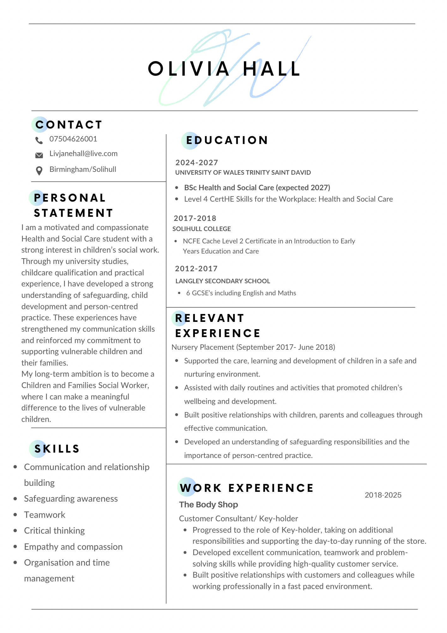

Appendix B- Cover Letter


