Celtic Caterers Assignment
Clear and easy to read.
Good annotation of relationships
1-1 relationship ??

ERD
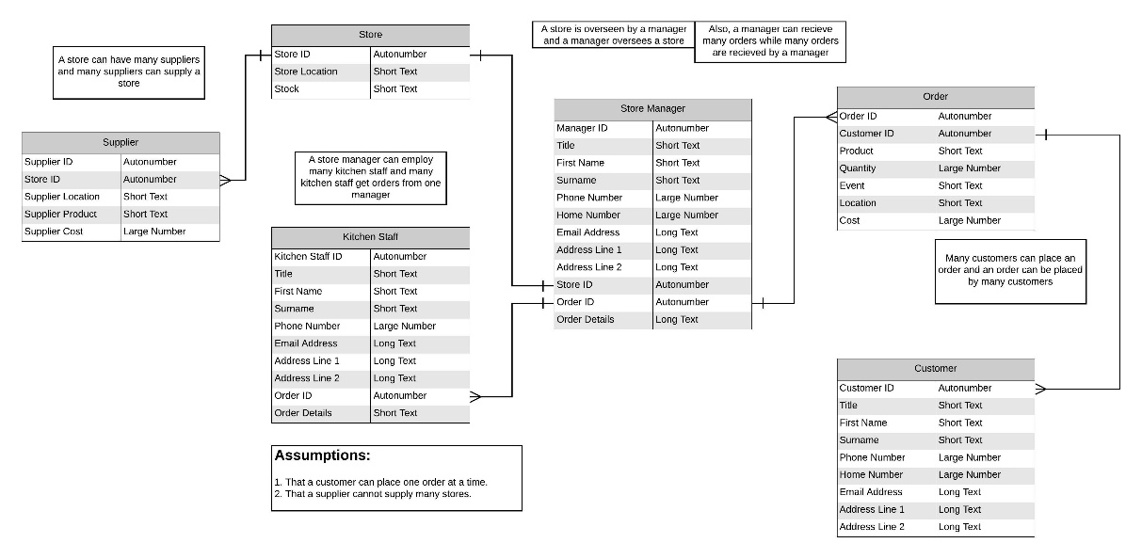
An entity relationship diagram of the assignment, based on the information provided. This operates on the assumptions that a customer can place one order at a time and that a supplier cannot supply many stores.
Data Flow Diagram Level 0
Clear and easy to read.
Suitable data flows.
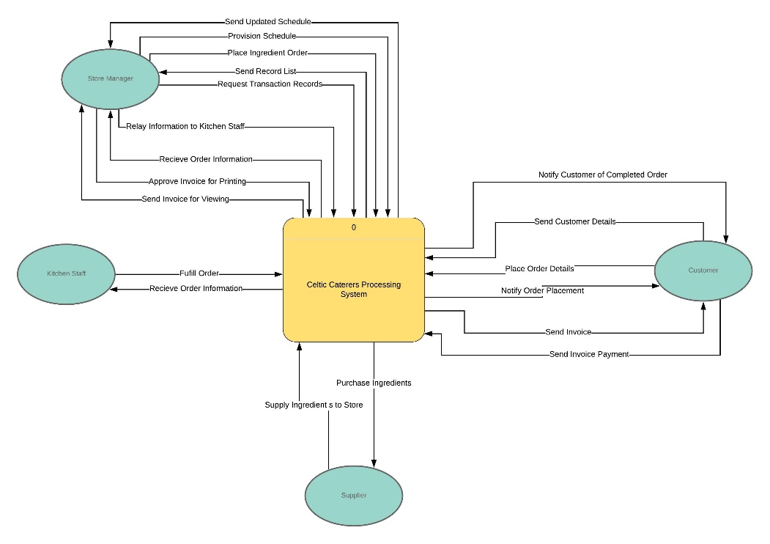
A Level 0 Data Flow Diagram of the assignment, based on the information provided. This helps define the relationship between the system and the external entities. It also highlights the importance of the store manager and the customer in this diagram.
Data Flow Diagram Level 1
Clear and easy to read.
Remember convention for repeated items.
Some additional data stores and flows may be required, but good attempt.
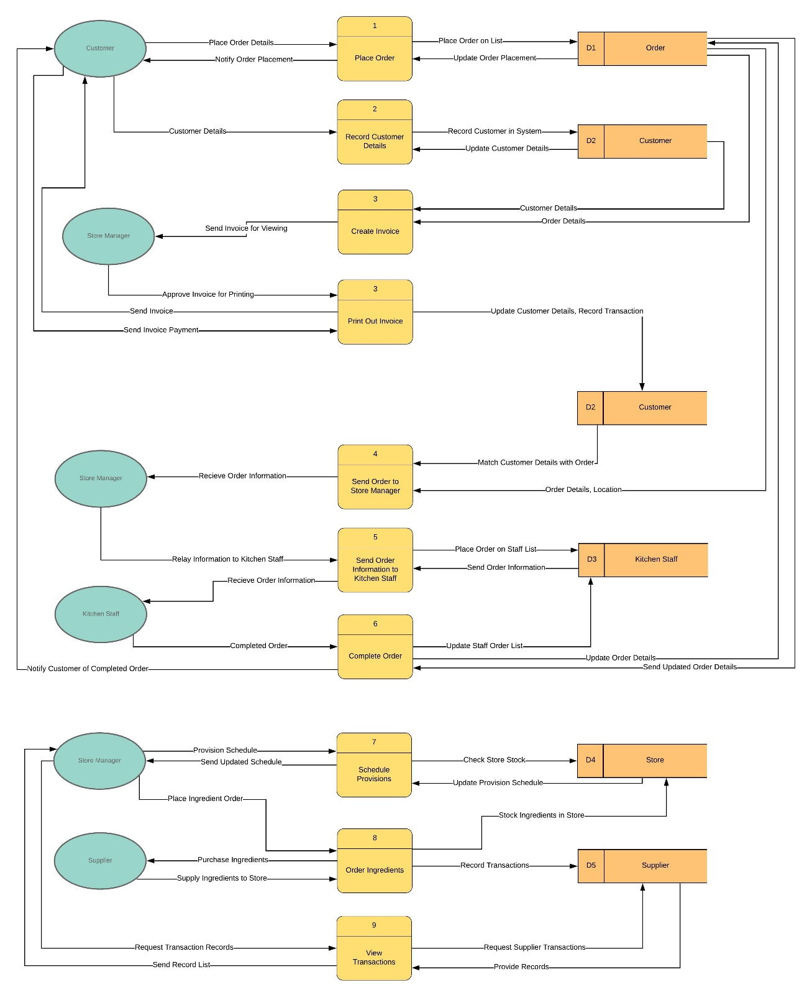
A Level 1 Data Flow Diagram of the assignment, based on the information provided. This expands more on the processes of the system and how data flows for each process. It also expands on the relationship between the external entities and the data stores of the system. D2 was duplicated in order to prevent the design from overlapping.

