The Importance of ‘hospitality provision and service experience’ in Tourism & Events

Elijah Thomas
Student Number: 2313487
Word Count: 1871
Module Lecturer: Debbie Jenkins
Module: Hospitality and Guest Service Management

Contents Page

Introduction to Swansea Hotels…

Hospitality Provision within Swansea’s hotel sectors the standards of service provided…

Service Culture changes and rising industry trends…

Swansea’s image of hospitality comparison to other regions…

Performance recommendations for Swansea’s hotel provision and practice…

Summary and impact of hospitality and future sustainability of guest culture…

Introduction

This report’s purpose is to dive into Swansea and investigate its hotel provision, to investigate key components that help make the hotel and hospitality industry around Wales. Being how hospitality is presented, what standards the hotel provision provides highlighting key strengths and weaknesses, how service culture, guest service strategies and industry trends have changed in the recent age along with finally Swansea’s image of hospitality compared to other case studies identifying performance recommendations for the future sustainability of guest culture and Swansea’s hotel and hospitality provision. Soloman suggested that the hospitality industry provides essentials such as a bed, room, sink and a meal into an experience that is warm, comforting, and magical (Solomon, 2016). This report discusses the importance of this and how this relates to these concepts for the hotel industry, particularly looking at the hotels in Swansea being Marriott delta and Morgans hotel.

Hospitality provision and standards available across Swansea hotels

The hospitality industry provides professional lodging plus food and beverage services in Swansea it originated in the 1500’s and was a social virtue (Heal, 1990). This is shown in the Delta Marriott and the Morgans Hotel hospitality is taking it a step further and not just meeting guests’ expectation but creating a wow factor to provide excellent guest experience (Ford and Sturman, 2018). A wow factor would be hotel personalization which has become increasingly prominent through innovative technology services like hotel chatbots which wow the customer through convenience and creates less staff error. This goes into the difference in Morgans and Delta being a unique boutique and a chain. Chain hotels such as Delta are dependable and have set standards when providing hospitality, allowing guests to have certain expectations however a boutique hotel such as Morgans it is a cultural and authentic experience catered around Swansea these leads guests to a unique experience where their standards can exceeded and provide a more personal experience. (Group, 2023)

Investigating into reviews across Swansea hotel provision these are two contrasting reviews of Delta Marriott and the Dragon hotel with Delta having high standards and Dragon having low standards. Reviews investigate a hospitality business and rate stars between 1-5 on the service experienced by a consumer Reviews hold high importance in the hospitality industry as reviews hold the power to set out standards before the customer even arrives. This helps future consumers decide on whether to try a hospitality business in the future and negative or positive reviews can spread word of mouth and create reputation. Which is why it is important for hotels to check reviews and try and create good ones (Tewari Nandi and Mishra, 2023).

An example of a hotel in Swansea with high standards and a variety of guests services is the 4 Star Delta Marriott located by Swansea Marina they offer a variety of services (Refer Appendices A) (www.marriott.com, n.d) Delta being owned by Marriott shows high value in hospitality excellence. The Marriott company’s value is pursuing excellence as their “Dedication to the customer shows in everything we do” is their key value (Marriott International, n.d.).

(Appendices C)
This most recent review states high standards of service provided with the 5-star rating and plenty of amenities. The review mentions the staff being helpful which is highlighted across the restaurant and the Marriott experience stating to be one of the best for location and experience. This review falls in line with the Marriotts key value in excelling in hospitality providing high guest standards (Tripadvisor, n.d.).

Contrastingly however the Dragon hotel lacks in hospitality standards. The dragon has a limited number of facilities (See appendices A) Requiring work being done to provide a high standard of hospitality. Not being an international chain like Marriott, they do not have any public values when providing hospitality. A lack of hospitality training within the hotel provision leads to high turnover which will mean that the Dragon may have issues leading to staff ill prepared to provide excellent services. (Maniscalco, 2021)

(Appendices D)
This review from a customer who stayed at the dragon hotel highlights the opposite of good standards and hospitality being provided, Not only did the customer not have their issue with the room heating get solved but was openly told by the hotel that none of the staff care which goes to show that the review will not attract new customers and may cause the Dragon to lose out business. Overall, it does not fall in line with hospitality standards (Tripadvisor, n.d.) This overall shows Swansea has some weaknesses when it comes to hospitality as well.

Changing service culture, Guest service strategies and industry trends

Guest service strategies , Service culture and industry trends are always changing. So are the consumers as well. As of 2023 there have been five trends on the rise when it comes to the hotel industry that have shaped change. Rising technology has created a demand for smart technology, virtual reality, and robot assistants. Along with a demand from consumers for a unique and sustainable experience (Siteminder, 2020). Reasoning for these trends is technology and hospitality have grown more consumers have been looking for a thrill and unique experience, but with the risk of climate change it also clear that the new generation of consumers Gen Z consider climate change. In 2022 a study on Gen Z’s influence on decision making when purchasing that between 55-62% prefer to buy with sustainable brands (Appendices B) Linking this to Delta they plan to be zero food waste within the next five years, which is a big development for sustainability branding and for Gen z’s purchasing in the future (Wood, 2022)

This goes into who the new generation of consumers are, it has become a fact that customers demand green products in any hospitality service provision across most demographics with climate change (Han, 2021). Likewise, with the trend of robots and increasing technology it is encouraged across the hotel provision to provide robotic assistants since there is a desire for unique interaction if it is still integrated with human reaction according to Gen Z (Qu et al., 2023), These needs and desires are common. However, there are many target markets of customers between Swansea’s hotel branch and other regions who have differing needs and wants. The highest demographic traveling within the past few years have been for families, leisure, and business demographics. (www.rsmuk.com, 2023). Who all have specific needs and wants as a consumer. For young people now there is little offering for hotels that appeal to young people, comparing this the moxie hotel in London where they offer nightclubs, games rooms and social areas for young people to talk Swansea particularly lacks in this area in hospitality (www.marriott.com, n.d.)

This is why guest service strategies and culture are important. Consumers have specific needs and wants for business this could be a quiet space, Families (Link to delta), and leisure it could be leisure activities or even simple directions. Service culture can be defined as a culture that supports customers through certain policies, procedures, and actions (Hudson and Hudson, 2022). Following Disney’s quality service compass (B-san’s Blog, 2019) (Appendices F) it provides integration, Guestology, delivery system and quality standards which thousands of hospitality businesses follow worldwide. As such a good service culture following this compass an example would be From the Delta Marriott providing who when a business customer they provide them with a quiet space and fast Wi-Fi despite not asking for it. This in line studies the guests need, provides a quality service, This and then delivers it and integrates it into the customer experience. Going hand in hand with this is guest service strategies, which is what is used to provide and keep customer service excellence consistent for example loyalty schemes, getting to know your customers and providing a unique experience (acquire.io, 2022)

Swansea’s image of hospitality

Swansea’s Hospitality Image holds high hospitality excellence. An article from Swansea council shows how important tourism is too Swansea supporting over five thousand jobs and providing over five hundred jobs with hospitality (Swansea, n.d.). Morgans Hotel’s is a small boutique four star and one of Swansea’s biggest representatives when it comes to guest culture. When investigating into Morgan’s Hotel Sophie Morgan the events co-ordinator stated that Morgans hotel speaks to their guests and remembers details of them, for example where they are visiting or what they are doing around Swansea which adds to the hospitality experiences making guests feel valued (Anon, n.d.). This adds to Swansea’s image of hospitality positively as it makes Swansea’s hospitality feel less large and the city small and welcoming. Customers who feel like they go within the hotel provision of Swansea and feel like they know the people there will feel like they are able to come back,

Comparing this to another region such as London it differs, London is a region with hundreds of restaurants, hotels and events opening making it one of the world leading hospitality areas Globally. (www.london.gov.uk, n.d.) (Refer Appendix E) This gives London’s image of hospitality a large and professional impression contrasting with Swansea’s where it is a smaller city and more personalized however because of this higher standard is to be expected. Taking London Savoy as an example for comparison the Savoy is a 5-star hotel in London offering a wide range of services (The Savoy, 2018). The savoy provides an image of hospitality to London that is a lot more modern and luxurious. The Savoy prioritises remanning up to date with guest technology and keeping up to date with trends due to the competitive hospitality industry. They are up to date with latest guest technology checking in on mobile, mobile apps and recently have started to build technology to support 2G-5G devices.

Performance recommendations

To improve Swansea’s hotel provision’s success in delivering hospitality the first recommendation would be to integrate more guest technology. With Swansea being a smaller destination for hospitality compared to other regions using robots or guest service technology can help wildly improve a guests experience not having to care of the mundane tasks can allow for Swansea’s hotel provision staff to focus on providing hospitality and getting to know their customers better (Cobanoglu, 2022). This would allow them to focus more on standards and hospitality and be able to provide a more personal and luxurious experience like the Savoy.

Secondly would be to create loyalty programs. More Loyalty programmes across Swansea’s hotel provision would allow for a more personal relationship for locals and frequent travellers and an individualized touch to the experience, Staff being able to give out personal rewards to their customers will help encourage guests to revisit and be familiar with the hotel provision in Swansea. Which will allow the hotels to get to know them better and provide better hospitality based of their needs and wants.

Conclusion and Future sustainability of guest culture

The hotel provision in both Swansea and London are extraordinarily successful both having strengths and weaknesses, however, to sustain guest culture and provide hospitality excellence it is important to always keep up to date with trends, know your consumers and be able to assess reviews and identify shortcomings and achievements. This will allow the hotel provision in Swansea to thrive and allow the hotel provision to expand because practicing better hospitality will attract new customers and profit for modern technology and guest strategies to be put into place to further provide that excellence that will please the guest.

Appendices

A:
Swansea Hotel Audit | Facilities | Standards provided | Customer impression and ratings | Improvements
Delta Marriott | - Sustainable practices and policy  - Free Wi-Fi,  - Housekeeping  - Room service  - Drycleaning,  - Meeting spaces  - Wake up calls.  - Fine dining restaurant  (www.marriott.com, n.d.). | Marriott sticks to the four-star rating system service provision | 4.0 rating on trip star  The Delta Marriott’s strongest point is its location and service provision | - Providing events
Dragon Hotel | - Restaurant  - Partnered leisure facilities (Golf venues)  - Events and weddings | The Dragon hotel is rated at 3 stars and sticks to 3-star service provision | 3.5 rating on trip advisor  The dragon hotels strongest point is being affordable and providing basics.  However, its weakest points are the staff being uncaring and hotel cleanliness. | - More facilities  - Staff training  - Room refurbishes.  - More attention to the restaurant may be beneficial

B:
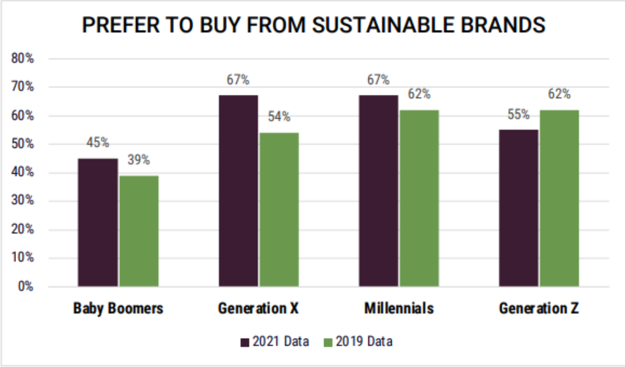

C:
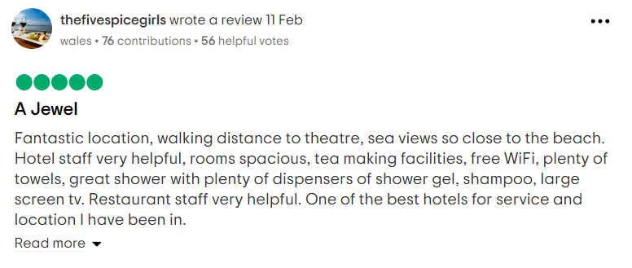

D:
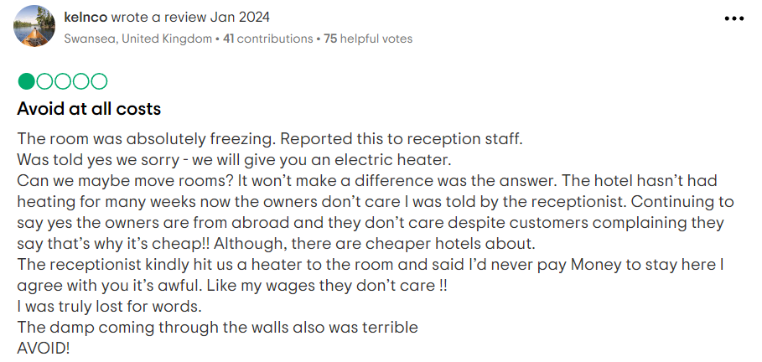

E:
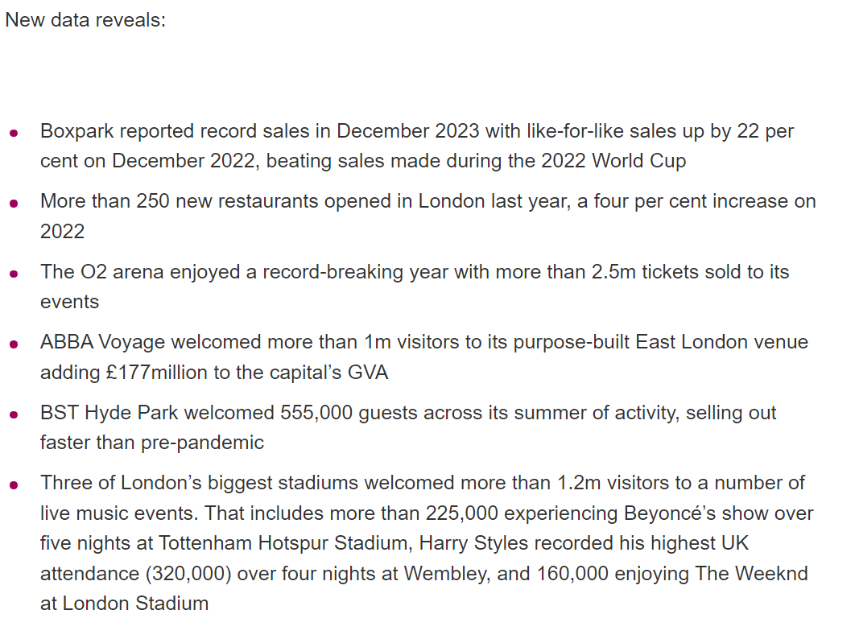

F:
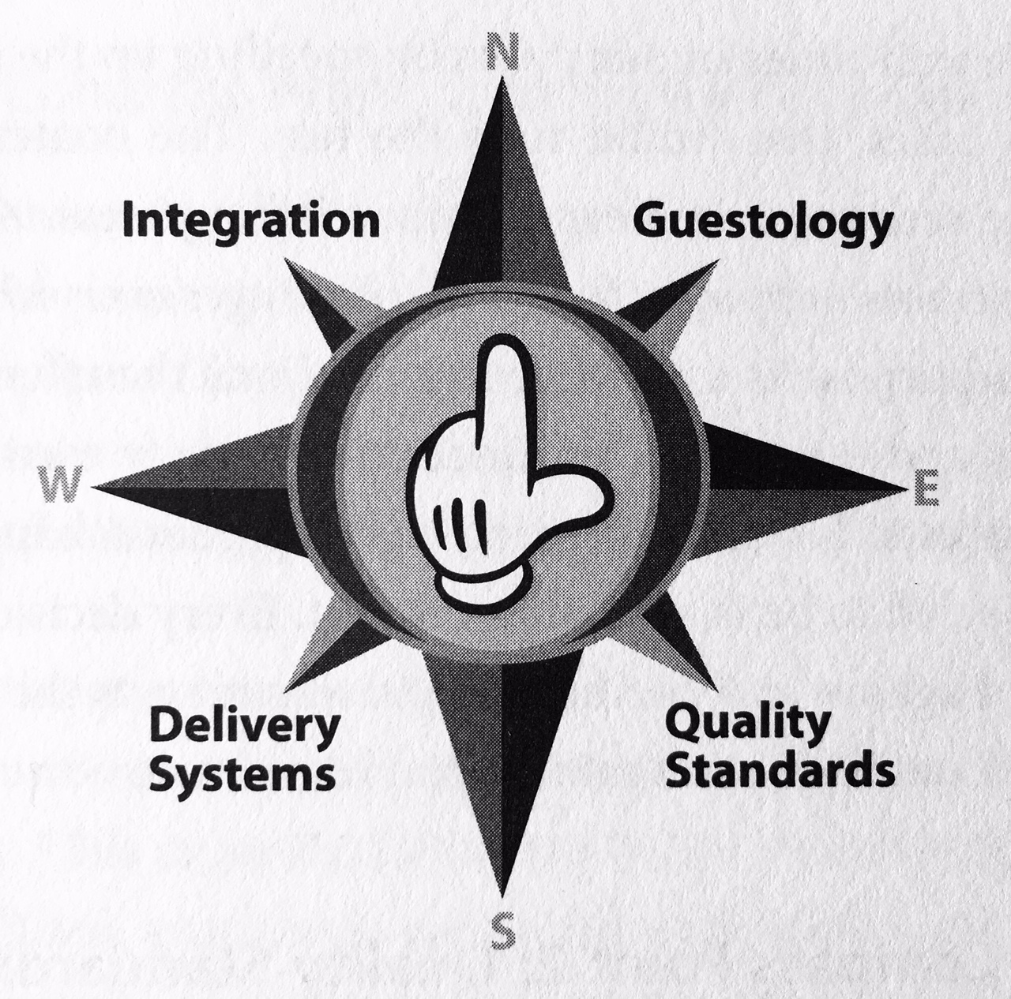

References

Reference list
acquire.io. (2022). Customer Service Strategy: The Ultimate Guide - Acquire. [online] Available at: https://acquire.io/blog/customer-service-strategy.
Anon, (n.d.). Morgans Hotel – Luxury Rooms in the Heart of Swansea. [online] Available at: https://www.morganshotel.co.uk/.
B-san’s Blog. (2019). Be Our Guest: The Disney Quality Service Compass. [online] Available at: https://bsans.blog/2019/02/18/be-our-guest-the-disney-quality-service-compass/comment-page-1/ [Accessed 20 Mar. 2024].
Cobanoglu, C. (2022). The Pros and Cons of Using Robots in Hotels. [online] Hospitality Technology. Available at: https://hospitalitytech.com/pros-and-cons-using-robots-hotels.
Ford, R.C. and Sturman, M.C. (2018). Managing Hospitality Organizations: Achieving Excellence in the Guest Experience. [online] Google Books. SAGE Publications. Available at: https://www.google.co.uk/books/edition/Managing_Hospitality_Organizations/6GR1DwAAQBAJ?hl=en&gbpv=1&dq=Hospitality+excellence&printsec=frontcover [Accessed 17 Feb. 2024].
Group, U.M. (2023). Chain vs Boutique Hotels: Which Is Best? [online] Hotelier & Hospitality Design. Available at: https://hotelierandhospitality.com/2023/07/13/chain-vs-boutique-hotels-which-is-best/ [Accessed 19 Mar. 2024].
Han, H. (2021). Sustainable Consumer Behaviour and the Environment. [online] Google Books. Routledge. Available at: https://www.google.co.uk/books/edition/Sustainable_Consumer_Behaviour_and_the_E/v9tKEAAAQBAJ?hl=en&gbpv=1&dq=Hospitality+consumers+sustainability&printsec=frontcover [Accessed 17 Mar. 2024].
Heal, F. (1990). Hospitality in Early Modern England. [online] doi:https://doi.org/10.1093/acprof:oso/9780198217633.001.0001.
Hudson, S. and Hudson, L. (2022). Customer Service for Hospitality and Tourism. [online] Google Books. Goodfellow Publishers Ltd. Available at: https://www.google.co.uk/books/edition/Customer_Service_for_Hospitality_and_Tou/POxeEAAAQBAJ?hl=en&gbpv=1&dq=Service+culture+in+hospitality&pg=PA78&printsec=frontcover [Accessed 17 Mar. 2024].
Maniscalco, P. (2021). The Importance of Training & Development in Hospitality. [online] Novative. Available at: https://www.novative.com/en/hospitality-the-importance-of-training-development-in-hospitality/#:~:text=Insufficient%20training%20and%20development%20in%20hospitality%20also%20play [Accessed 19 Mar. 2024].
Marriott International. (n.d.). Core Values & Heritage. [online] Available at: https://www.marriott.com/culture-and-values/core-values.mi#:~:text=Our%20core%20values%20make%20us%20who%20we%20are..
Qu, Y., Lv, X., Chen, G., Qiao, G. and Xu, S. (2023). Consumer Psychology in Tourism and Hospitality. [online] Google Books. Frontiers Media SA. Available at: https://www.google.co.uk/books/edition/Consumer_Psychology_in_Tourism_and_Hospi/2-vIEAAAQBAJ?hl=en&gbpv=1&dq=Hotel+consumers+2020&pg=PA261&printsec=frontcover [Accessed 17 Mar. 2024].
Siteminder (2020). Hotel trends: the Biggest Indicators in the Hotel and Hospitality Industry. [online] SiteMinder. Available at: https://www.siteminder.com/r/hotel-trends-hotel-hospitality-industry/.
Solomon, M. (2016). The Heart of Hospitality: Great Hotel and Restaurant Leaders Share Their Secrets. [online] Google Books. SelectBooks, Inc. Available at: https://books.google.co.uk/books?id=2LRSDwAAQBAJ&printsec=frontcover#v=onepage&q=transforms%20essentials&f=false [Accessed 16 Mar. 2024].
Swansea. (n.d.). New report reveals how crucial tourism is to Swansea’s economy. [online] Available at: https://www.swansea.gov.uk/article/25004/New-report-reveals-how-crucial-tourism-is-to-Swanseas-economy.
Tewari Nandi, V. and Mishra, A. (2023). THE INFLUENCE OF ONLINE REVIEWS ON CONSUMER DECISION-MAKING IN THE HOTEL INDUSTRY. [online] researchgate.net. Available at: https://www.researchgate.net/publication/373823626_THE_INFLUENCE_OF_ONLINE_REVIEWS_ON_CONSUMER_DECISION-MAKING_IN_THE_HOTEL_INDUSTRY [Accessed 16 Mar. 2024].
The Savoy (2018). The Savoy London. [online] The Savoy London. Available at: https://www.thesavoylondon.com/.
Tripadvisor. (n.d.). DELTA HOTELS BY MARRIOTT SWANSEA - Updated 2023 Reviews. [online] Available at: https://www.tripadvisor.co.uk/Hotel_Review-g186466-d192327-Reviews-Delta_Hotels_by_Marriott_Swansea-Swansea_Swansea_County_South_Wales_Wales.html.
Tripadvisor. (n.d.). THE DRAGON HOTEL - Updated 2023 Reviews (Swansea). [online] Available at: https://www.tripadvisor.co.uk/Hotel_Review-g186466-d192328-Reviews-The_Dragon_Hotel-Swansea_Swansea_County_South_Wales_Wales.html.
Wood, J. (2022). Gen Z Cares about Sustainability More than Anyone Else and Is Starting to Make Others Feel the Same Way. [online] World Economic Forum. Available at: https://www.weforum.org/agenda/2022/03/generation-z-sustainability-lifestyle-buying-decisions/.
www.london.gov.uk. (n.d.). New data shows London’s world-leading hospitality industry and livemusic events defied all expectations in 2023 | London City Hall. [online] Available at: https://www.london.gov.uk/new-data-shows-londons-world-leading-hospitality-industry-and-livemusic-events-defied-all.
www.marriott.com. (n.d.). Hotel near Swansea.com Stadium| Delta Hotels Swansea. [online] Available at: https://www.marriott.com/en-gb/hotels/cwlsd-delta-hotels-swansea/overview/ [Accessed 18 Feb. 2024].
www.marriott.com. (n.d.). Overview. [online] Available at: https://www.marriott.com/en-us/hotels/lonof-moxy-london-stratford/overview/.
www.rsmuk.com. (2023). Hotels and accommodation outlook | RSM UK. [online] Available at: https://www.rsmuk.com/insights/consumer-markets-outlook-2023/hotels-and-accommodation.

