Portfolio Development Assignment Kathrine 2204818 [Animation and VFX]

Database 1
Personal Showreel 2
Professional Business Card 2
References 3

Database
PPD_CompanyDatabas_KathrineWilliams-Kirby.xlsx

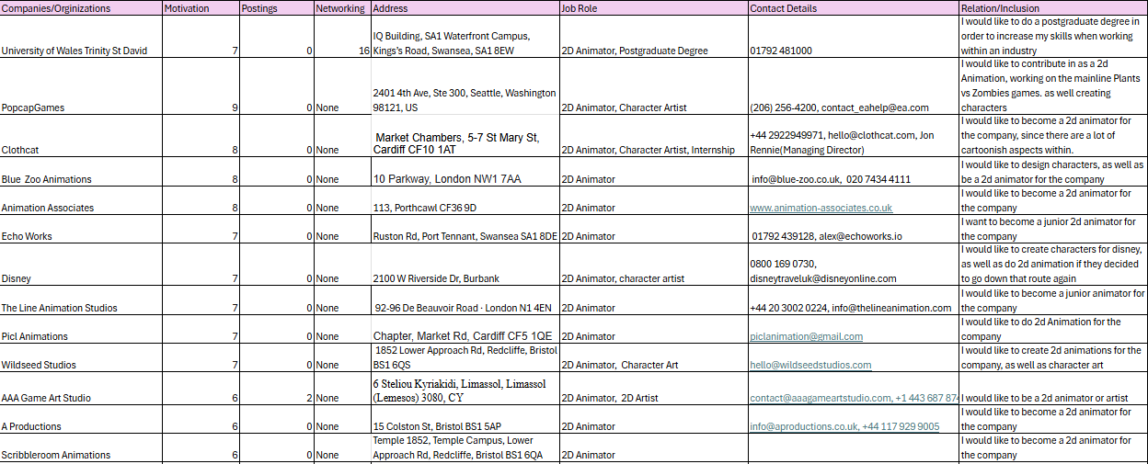
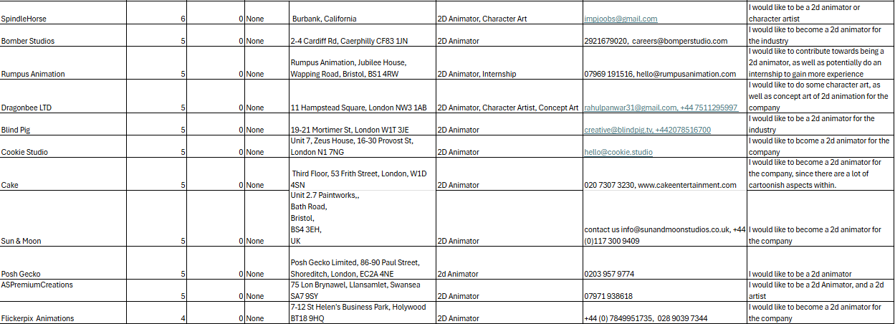

Personal Showreel

https://youtu.be/Q8T6YpYSXmw

Professional Business Card
Old Business Card

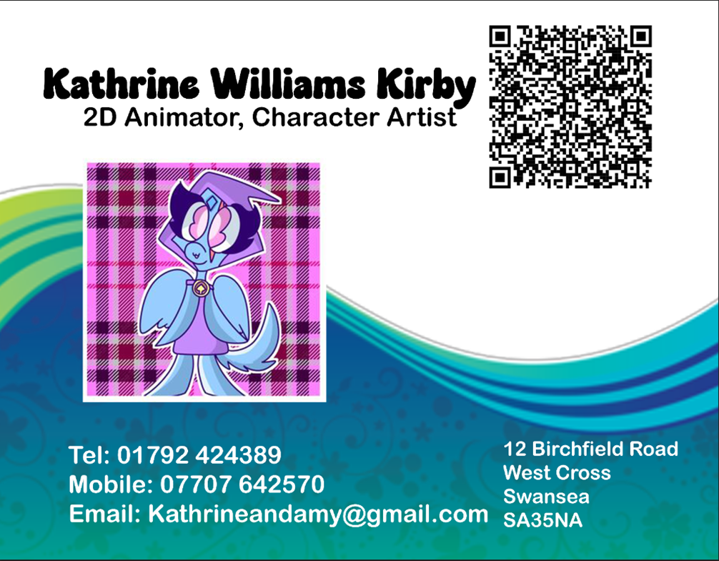

New Business Card

Back Card Design
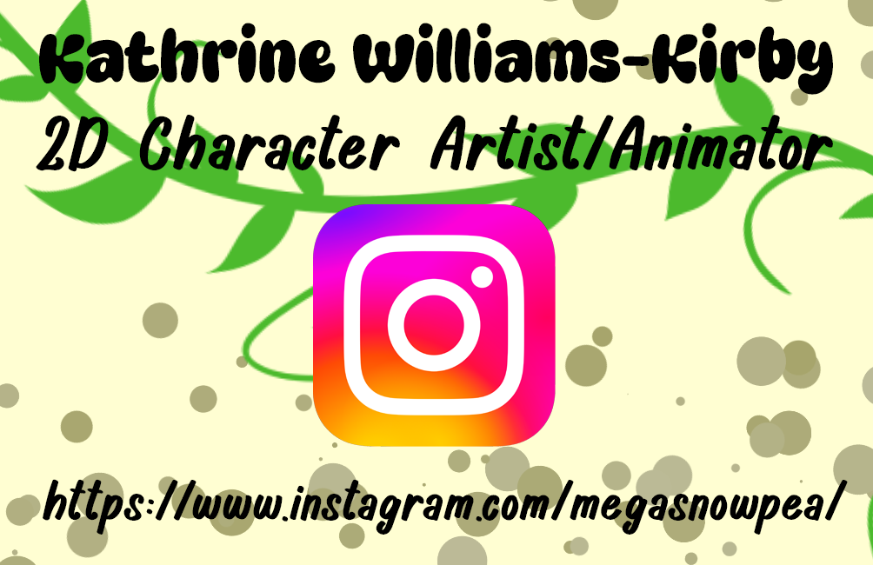

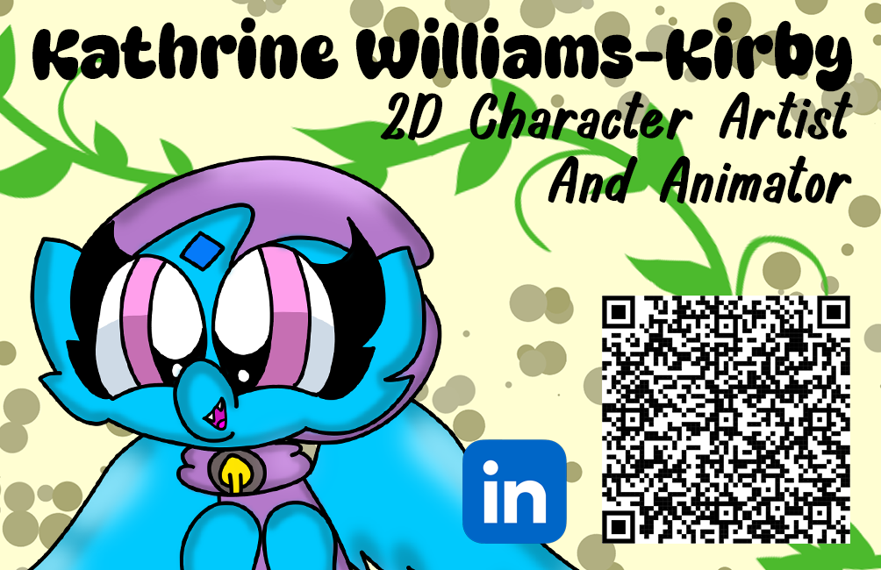
Front Card Design

References
[1] “Business Card PNG Picture”,Pngtree, 2025,[Online], Available:https://pngtree.com/freepng/business-card_4143616.html[Accessed 13/02/2025]

[2]”How to Design a Business Card | Do's and Don'ts for Business Card Design”, Visme, 2020, [Online], Available:
https://www.youtube.com/watch?v=4p_JVwpmf7U[Accessed 30/01/2025]
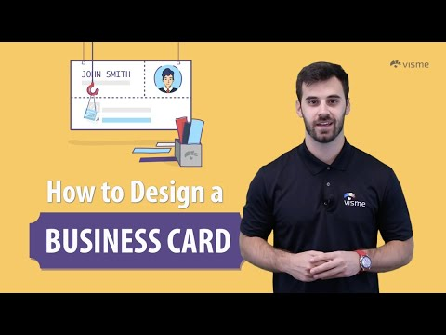
[3]”Creating a Showreel - Step by step full process “, Kayla, 2024,[Online], Available:
https://www.youtube.com/watch?v=jP0f2P8bX5I [Accessed 30/01/2025]
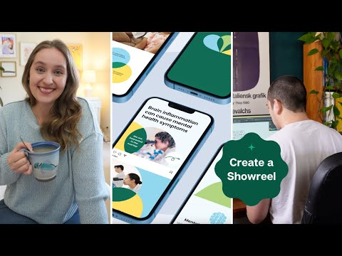
[4]”How to Create a Professional Visiting Card Design in Canva | Business Card “, GraFeeXa, 2024,[Online], Available:
https://www.youtube.com/watch?v=MLMThNnrneM[Accessed 30/01/2025]
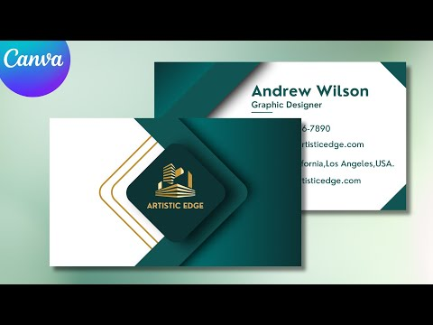
[5]”Best Showreel Videography Designs of 2024 - 2025 “, M. Christopher De Guia, 2025, [Online], Available:
https://www.designrush.com/best-designs/video/showreel#item-2[Accessed 30/01/2025]
[6]”20 Tips For An Amazing Showreel | Motion Graphics & Animation”, Ben Marriott, 2020, [Online], Available:
https://www.youtube.com/watch?v=yedsKSMD_k8[Accessed 30/01/2025]
[7]”Making your First Animation Demo Reel (And showing off my first reel)
“, Dong Chang, 2022,[Online], Available: https://www.youtube.com/watch?v=lZt8Wh9p2LM[Accessed 01/02/2025]
[8]”How to Create Professional Business Cards For Free 2025 (Step-by-Step)”, StartupWise, 2024,[Online], Available:
https://www.youtube.com/watch?v=wM1D5Hc3XA8[Accessed 01/02/2025]
[9]”How to Design a Professional Business Card in Canva! *Full Tutorial*”, Jeremy's Tutorials, 2023,[Online], Available:
https://www.youtube.com/watch?v=XRw4zisHmKI[Accessed 01/02/2025]
[10]”6 Golden Rules For Business Card Design (QUICK FIRE TIPS)”,
Satori Graphics, 2019,[Online], Available:
https://www.youtube.com/watch?v=5zS-5XDo4WQ[Accessed 01/02/2025]
[11]”TOP 10 VIRTUAL JOB INTERVIEW TIPS! (How to PASS an Online Zoom, Skype, or HireVue Job Interview!)”, CareerVidz, 2021,[Online], Available:

https://www.youtube.com/watch?v=PpbhaVjV2QIp[Accessed 02/02/2025]
[12]”5 Things Every Business Card Should Have”, Skyberry Studio, 2015,[Online], Available:
https://www.youtube.com/watch?v=Jg-9Lp6jLGU[Accessed 02/02/2025]
[13]” Designing A Business Card That Doesn't Suck! (6 Pro Tips)”, Satori Graphics, 2021,[Online], Available:
https://www.youtube.com/watch?v=JiBCYPAKydQ[Accessed 02/.02/2025]
[14]”Creating A Demo Reel With Premiere Pro”, Kurt B, 2024,[Online], Available: https://www.youtube.com/watch?v=DLlkVaE8DQE[Accessed 11/02/2025]
[15]”Motion Graphics Showreel 2023”, Cloudwalk Motion Pictures, 2023, [Online], Available|: https://www.youtube.com/watch?v=HCkgL4WKKH8[Accessed 11/02/2025]
[16]”How to Create a Portfolio & Demo Reel for Animation!”, Jesse J. Jones, 2023, [Online],
Available: https://www.youtube.com/watch?v=aXJ9kxuVW-Q[Accessed 11/02/2025]
[17]”How to JOB HUNT for ARTISTS / ANIMATORS”, mewTripled, 2023, [Online], Available:https://www.youtube.com/watch?v=xWVKjkCWVcs[Accessed 11/02/2025]
[18]”Concept art show reel”, Teesside University, 2019, [Online], Available:https://www.youtube.com/watch?v=sHw-hfpj-z0[Accessed 13/02/2025]
[19]”2D Animation Reel 2022”, Curie Lu, 2023, [Online], Available: https://www.youtube.com/watch?v=OzUnqQk4eOg[Accessed 13/02/2025]
[20]”Animation Demo Reel - Winter 2021”, lemoncholy, 2021, [Online], Available: https://www.youtube.com/watch?v=FdE5G95B7Mg[Accessed 13/02/2025]
[21]”DEMO REEL - Sheridan Animation Year 1 Semester 1”,Lukosei, 2022,[Online], Available:https://www.youtube.com/watch?v=1pupCAXcGf0[Accessed 13/02/2025]
[22]” Concept Art Showreel 2020”, 予Penny, 2020,[Online], Available: https://www.youtube.com/watch?v=2pP2WPNAZMY[Accessed 13/02/2025]
[23]”Portfolio Reel - GOBELINS Summer School 2023 (ACCEPTED)”, Erin Basca, 2023,[Online], Available: https://www.youtube.com/watch?v=b6WjuET3b8o[Accessed 13/02/2025]



