Ispas Cristina

This is a report about the research and developing strategy for the new business plan called American Queen which will be a food van that will promote traditional American street food
American queen
Business plan

American QUEEN -Business plan

Prepared by Ispas Cristina-Georgiana
Student number: 1905821

Prepared for
Managing Enterprise in the 21st Century Module
BMSW4006_CARD
University of Wales Trinity Saint Davies

June 3rd, 2020

Executive summary

This report will approach The American Queen food van that will be opening soon, with all the steps that we must follow to manage a successful long-term business. In the beginning, the researcher will present an overview of the business plan followed by the operation that must be completed with details about the type of the product that will be offered and which human resources needed. The goal of the business plan is to bring the American taste in Cardiff and manage to have a profitable company. The future products must be according to the market request, the target of the business, and apply for all customers categories (Vincent A. Gabriel, 2015).

Contents
1.0 Introduction for the business plan 5
2.0 Overview of the business plan 5
2.1 Company name 5
2.2 Mission statement 6
2.3 The purpose and objectives of the company 6
2.3.1 The purpose of the company 6
2.3.2 Scope of the company 6
2.3.3 SWOT of the company 7
2.4 The legal identity of the company 7
2.5 Products and services of the company 7
2.5.1 Prices for products 9
2.5.2 The location of the company 10
2.5.3 The products/services not offered by the competition 10
2.5.4 The influence of section 2.5 with customers 10
3.0 Operations of the company 11
3.1. Delivery products to customers 11
3.2 The sale plan and event calendar 12
3.3 Human Resources Management 12
3.3.1 Recruiting and training process 12
3.3.2 Staff members, their roles in the company and salary 13
3.3.3 Service attend 13
3.3.4 Manager 13
3.3.5 Chefs 13
3.3.6 Cooks 14
3.3.7 Kitchen worker 14
3.3.4 Organizational Chart 14
3.3.5 Equipment 15
3.3.6 Total costs for equipment 17
3.3.7 Health and Safety Procedures 17
4.0 Marketing and promotions 18
4.1 Marketing Activities 18
4.1.2 Research of the Market 18
4.1.3 Results of the market research 19
5.0 Promotion Activities 19
5.1 Types of promotion 19
5.2 Customer Relations 19
5.3 Social Media 19
5.4 Vend at Local Events 20
5.5 Follow-ups on Customers 20
6.0 Financial resources 20
6.1 Personal savings 20
6.2 Investments from family and friends 20
6.3 Donations 21
6.4 Bank loan 21
7.0 Cash Flow Statement 21
8.0 Conclusion 22
9.0 References 23

1.0 Introduction for the business plan

The food van revolution come to life, the excitement behind and the public engagement that must be created with seriousness and professionalism conform with the report of Technomic food industry consulting firm that shows on July 2011 a 91% of customers believe that food trucks are a trend with ,,staying power,,(D. Weber,2012) . American Queen is a food van that allows customers to have the high-quality traditional dishes at affordable prices and giving their customer the unique experience to see that everything is prepared in front of them (Daily News, 2011). The street food is the easily and fast way to grab your favorite meal (A.P. Simopoulos,2016). Most important thing regarding a food van is the rare form of dining were the costumers can eat relax without thinking about the restaurant formality (Morris, 2016).

2.0 Overview of the business plan

The new company that will be opening soon in Cardiff city center is a food van that will offer the customers traditional American street food. In the meantime, satisfy and adapt to the customers market demand. Operating a successful food van will depend on the following essential conventions: a practical strategy with a strong basis and dedicated with the ability to sacrifice to achieve the goals and technical skills. Lastly, the basic knowledge in management, finance accounts, and market analysis.

2.1 Company name

The researcher chooses to name the company American Queen, showing the part of the world that the products are coming from, as well referring to the superiority of the taste offered to the customers. American queen is illustrating by his name what type of products will be introducing the new customers in the famous American culinary history.

2.2 Mission statement

The mission is to offer to customers the best quality, a wonderful experience by trying the American street food dish.
The values of the company are the commitment towards its customers, high standards in satisfaying their demands as well as the flexibility of the company in pleasing all types of customers. The vision of the company is to offer the most authentic American street food in the heart of Cardiff (Thrillist, 2018).

2.3 The purpose and objectives of the company

The purpose and the goals of the organization is to achieve on the market and grow in the business area by extending with opening more food trucks and being known as a business that cooks amazing food and has excellent reviews that will result increasing sales and make profit. In the order to create a legacy that’s known for the traditional American food and taste to improve customer service (B. Finch,2016).

2.3.1 The purpose of the company

The main purpose of the company is to extend on the market, become aware of the market challenges and overtaking the competitors with what are their offer at the moment on market (Morris, 2016). This can be achievable by prevented problems before it happened and keep it on the track without losing customers by including in the menu creativity to face the competitivity (A.P. Simopoulos & R.V. Bhat, 2016).

2.3.2 Scope of the company

The scope of the organization is to grow on the market and to be able to open a food van in the city center to fulfill the customers’ demands. The high quality of the new products and provoke good impact for customers.

2.3.3 SWOT of the company

For a better understanding of the scope of the organization is by applying a SWOT analysis (A. Sarsby,2016)
• Strengths of the company are the amazing prices at the high quality of the American street food dishes bringing old recipes in comparison with the competition, applying discounts for customers by providing special treatment to customers according to their age and the flexibility, creativity of personalizing their menu.
• The weakness of the future company can be the online order and delivery.
• Threats of the company can be missing space for customers to enjoy their meal such as bunches or chairs and table with some of the competitors.
• Opportunities for the future company can try to obtain permission to rent space for customers to enjoy their meal and do only order to avoid wasting time and collect themselves.

2.4 The legal identity of the company

Based on the research that the creator of the company did for choosing the legal identity that is the most suitable, the results show that a sole trader company is most advantage because of the low-cost for legal identity,2017). The researcher of the future business will set up as, he must resolve first of all, the licenses, permits and all the paperwork that will allow it to open the business.

2.5 Products and services of the company

American Queen food van will be offering a unique flavor brought straight from America to capture the target customers. The cuisine type will adopt traditional American street food with the fantastic taste of the products. The impact of the food van will have on customers is to surprise them with the traditional taste and affordable prices pleasantly. A real advantage in front of competitors can be well-established recipes and the opportunity to leave customers personalized their menu, and everything will be served to the customers by the friendly employee.
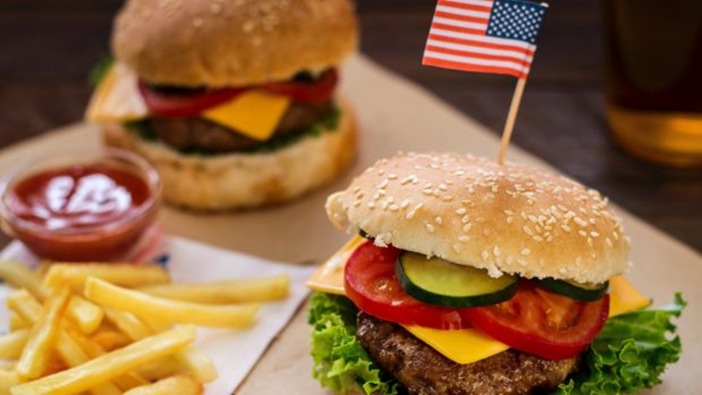

2.5.1 Prices for products

The importance of setting right prices for the products of a food van can be a crucial component to run it, prices can directly affect the ability of sell, cover the costs, and generate profit for the company. Typically, the prices of menu items must be according to costs of preparing it and demands.
To determine the optimal price for the future products\services the owner must take a better lock of the competition to establish if his products\services are comparable if they have more features sets, in this case the products can be the same price such as the competitors but with a higher quality or can be a little bit less.
The best way to calculate price is to combine the two formulas of markup % and margin %. The markup% is equal with selling price minus cost of the products divided by cost of the products and the margin % is equal with selling price minus cost price divided by the selling price
Products | Cost for one product | Selling price for one product
Burger | 0.80 | 2.50
Chips | 0.50 | 2.50
Fresh drinks | 1.10 | 2.00
Deserts | 2.50 | 4.00
Menu | 8.00 | 15.00

2.5.2 The location of the company

The American Queen will be located in Cardiff city center between the John Lewis and Library. The location is chosen in city center because can be easily observe by all the future customers. The area is surrounded by offices and is a permanent busy area. The location represents an advantage for the company because is no other food van in the area.

2.5.3 The products/services not offered by the competition

Despite all the restaurants in the area the food van, American Queen will offer future customers the opportunity to grab a quick meal before work or in their breaks with not time waist. The difference between American Queen and the competitors is the quality of the food, the way that customers can personalized their meal and can clearly see how products are cooked in front of them plus the speed of processing their meal.

2.5.4 The influence of section 2.5 with customers

Products and services of the company is influence customers to buy not only a brand but a traditional dish at affordable prices despite the restaurants, holding a great advantage the speed in processing the orders and the best quality for a food van.

3.0 Operations of the company

The practice of controlling the existing resources of a business to facilitate the production and delivery of products and services is the operations management. It has been the focus of research over the past four decades. It implies that operations management has evolved through diverse topics such as total quality management.
In particular, operations in an established business such as the American Queen entail legal issues, risk management, business operations, selection of facilities, designing, and management of HR.

3.1. Delivery products to customers

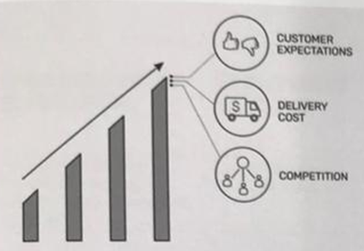

As the diagram illustrate the delivery of products of the American Queen. However, this will depend on the cost of delivery, competition, and customers’ expectations. The business should be dependent on modern technology to develop a delivery process that meets customer needs. However, this not only fulfills both logistics and operational challenges in the American Queen, but it helps in business expansion within the city Centre of Cardiff. Most products of the American Queen are perishable, and they are delivered to potential clients within 24 hours.

3.2 The sale plan and event calendar

The company establish a sale plan that will be active all the week, Monday to Friday from 8am till 5 pm and for Saturdays and Sunday will approach events such as parties. Can also be found near to the parks or next to the beaches. Customers can see the plan event on the website of the company or on Facebook page.

3.3 Human Resources Management

The strategy of the American Queen is to operate with four employees and the founder as the CEO. The four workers are all full-time because they are expected to play critical roles in the business. In this business, all the staff members including chefs are the essential employees.
Staffing in food van is always set up to enable operation of a small staff of individuals assuming a variety of roles (Myrick, n.d.). The size of the food van determines the number of employees that the American Queen will have to operate efficiently. Since the American Queen is planning to start with one food van, the owner will spread the staff responsibilities to cover the all the parts of the company.

3.3.1 Recruiting and training process

The business will recruit creative members with the capacity to customize traditional dishes for customers and make healthy and tasty meals. The manager will offer training for the new staff offering details about their duties and responsibilities respecting the health and safety rules by offering a brief about the legislation and the lows.
Many candidates are considered for the open position. It implies that the company will get beyond friends and family members. Since the owner knows what the business is looking for, it is crucial to eliminate most applicants and focus on the best quickly. Moreover, it is important to include others in the hiring decision to provide insights to the business. It can consider several methods of assessing prospective employees, but depending on the positions, there are important evaluation techniques such as kitchen testing. All recruited employees are expected to report to the business owner, who is the CEO of the American Queen food.

3.3.2 Staff members, their roles in the company and salary

The owner of the company will have four staff members, and these are service attendants, manager, chefs and cooks and kitchen worker. The duties and the salary will be different regarding with the position that will be occupied in the company.

3.3.3 Service attend

Salary £ 8.6 per hour. This will work in the front of the house, and it will be responsible for taking orders from customers, serving foods and beverages, preparing itemized checks, and accepting payments from customers. Therefore, he or she must be an expert in the hospitality sector, polite and always reliable. The service attendant should be familiar with the menu of the American Queen, including the preparation of food, the taste and whether special orders are allowed. Additionally, the service window attendant should know the daily specials so that they can inform the customers.

3.3.4 Manager

The salary will be £15.89 per hour. The role of the manager is to run the show in the back of the house. The responsibilities of the manager include all functions in the food van business, from overseeing the kitchen and van operations to filling the register of employees. However, these responsibilities can be split with the business owner, who is the CEO of the company. Therefore, the owner should work and help the manager for achieve better results. The manager will open and close the food vans, purchase food and beverage inventories, trains and managers workers, cooperate with the suppliers, and supervise the van’s advertising. Depending on the number of food vans the company owns, the manager assumes all administrative and managerial responsibilities of the kitchen while maintaining a dual role as either a chef or a cook.

3.3.5 Chefs

The salary will be £12 per hour. As a back-house employee, chefs are responsible for all kitchen activities in this company. Therefore, they should take part in the hiring and training process for cooks. The chefs will be responsible for the daily menu and preparing the list for supplies, and the duties to keep control of the expire date of the products.

3.3.6 Cooks

The salary £12.50 per hour. They are one of the most significant parts of the food van business experience because no matter how well the service the American Queen is, its customers will judge through the taste of the meal. The responsibility of the cooks can include more than just cooking. Thus, cooks may be responsible for the supervision and training of other staff members in the kitchen. The American Queen should consider the experience of cooks when hiring. The best scenario is to recruit individuals with experience, eagerness, and keen understanding of the food styles that the vans will be selling. When cooks are professionally trained, they will be able to handle the busy kitchen with speed since the food vans can run faster than the restaurants. The cooks should possess safety certification such as SERV Safe because it is a requirement for all food van workers.

3.3.7 Kitchen worker

The salary will be £8.60 per hour, kitchen workers measure ingredients. Additionally, they are responsible for cleaning, peeling, and slicing vegetables and fruits for making salads. Cooks may also be required to move the prepared foods from the commercial kitchen to the van. Additionally, cooks are responsible for unloading the van at the end of the day, then wash it before bringing it back to the commercial kitchen.

3.3.4 Organizational Chart

There are specific staff needs in food van. Therefore, the organizational structure of the American Queen food has to be in line with the employees’ needs for proper functioning (Wickford, 2019). However, the size of the business often determines its ultimate structure. In this business, employees are expected to take more than one role because it is still a small establishment. Moreover, there are similar basic frameworks in food business regardless of the size.
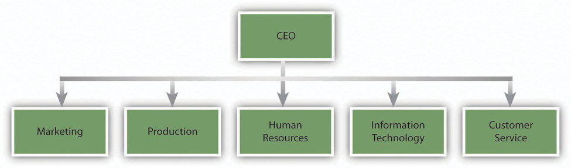

3.3.5 Equipment

For everything to work smoothly and in the same time to be on the right way, the owner must assure the right equipment such as the figure show:

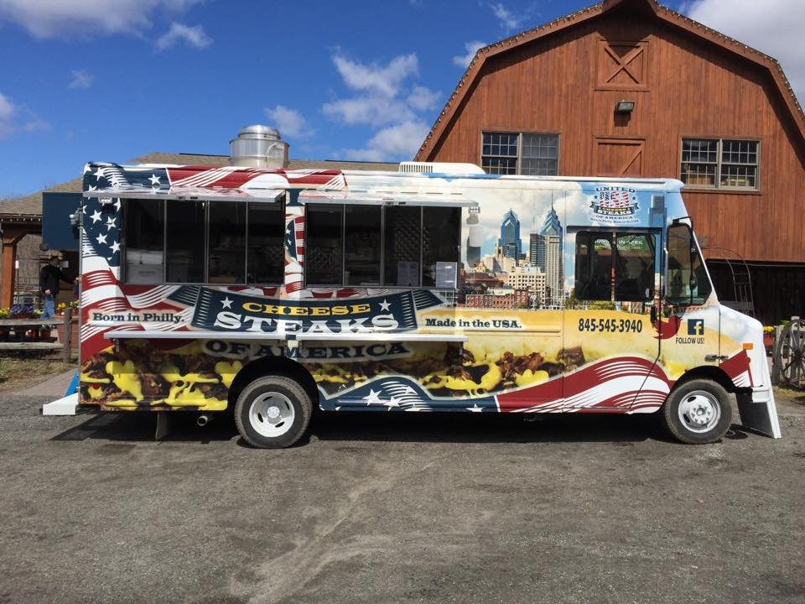

1.The van 15.000 £

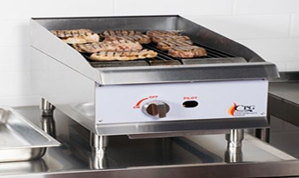
2. Cooking equipment. 3500 £
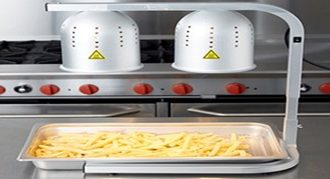

3.Warming and holding equipment.1500 £

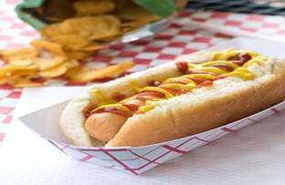

4. Serving equipment and disposables.1000 £

Since the American Queen will be serving customers on the go, it will need to stock up several disposable serving supplies. Therefore, there should be ample space for storing the supplies since running out of them would mean that the window could be closed for the delay.
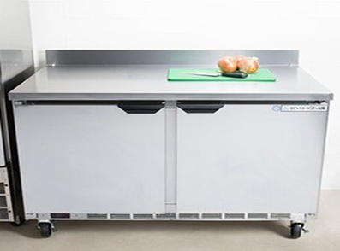

5.Refrigeration equipment.1500 £

The possession of refrigeration equipment in the food van helps in keeping ingredients fresh. There should be one refrigerator per van for the major food items such as beverages. Since refrigeration often comes in different varieties, it can be customized for food van offerings.

3.3.6 Total costs for equipment

The owner will must invest for the new business only on equipment the amount of £22,500.

3.3.7 Health and Safety Procedures

In the UK, all food businesses are required to register, except food manufacturers. As the owner of the American Queen Food, the researcher will have the required level of training to manage effectively the business. The first step before opening the company is the legal structure that it is required to register the food business with the local authority this process can be done online and will cost the owner a basic package at £14.99. After that, they will get the Environmental Health to search on the case of the future business and finally obtain a food hygiene certificate, which can be done online and costs about £30. All of this proves that the members or employees know precisely the rules of health and safety procedure, proving the knowledge of what hand washing represents. There is a broad provision of responsibilities for workers in the Health and Safety at Work Act 1974. Therefore, it will be my responsibility as a sole trader that the staffs are secure in terms of their welfare. This will be achieved by fitting fire extinguishers at various points of the food van.

4.0 Marketing and promotions

The importance of marketing and promotion is to offer a better perspective over the business, in the case of the food van American queen can establish a strong connection between the future customer and company.
The promotions are strategies that highlight the services and products that the company is offering following the 4Ps: product/service, place, price, promotion as a way to present them self’s in certain light in the eyes of customers

4.1 Marketing Activities

There is an increasing growth of competition among the food vans, and therefore, the American Queen should utilize all its strengths to be successful. The food van marketing strategies can help the American Queen to improve its mobile food business and attract the attention of hungry customers. The following are some of the marketing and promotional activities to be used by the American Queen on its products and services.

4.1.2 Research of the Market

The first step in starting a market research and achieving a business plan is by creating an online questionnaire for a better understanding of customer interest and market research regarding street food (Vincent A. Gabriel,2015).Based on the strategic online questionnaire requested for the modules BMSW4002 Digital skills and research methods were 11 individuals participate the results are in the favor of the future company, their answers can help the business to be on the right track and ensure a continuous success by analyzing the results for only five of the questions as is followed in section 2 (Ian B. ,2008).

4.1.3 Results of the market research

To set up a business plan a market research is required to seek out very deep and dissect relevant information in order to succeed in business and have a knowledge about the future customers. Based on the answers of the online questionnaire the owner can identify the customers’ demands and profile.

5.0 Promotion Activities

The role of promotions activities is to make future customers aware about the products and services and convince them about the quality and to invite to check out. The promotion strategy is to influence customers and offer them a direct and clear message.

5.1 Types of promotion

The most commune ways to promote a business are online, posters or brochures there are quite accessible for everyone with not so much costs and will make customers aware about the products. The total costs for promotional activities for posters and brochures are £ 200, on the other side online promotion is cheaper and sometimes can be free with the same impact.

5.2 Customer Relations

This is the simplest way of attracting repeat customers by having excellent relation skills. To maintain good customer relationship, customer service officer should start smiling to customers after the meal with a polite thank you and paying attention to customer needs. This can be achieved by training employees of the American Queen to be accommodative, polite, and courteous at all times. In case of a challenge, the business should be ready and willing to meet its customer satisfaction.

5.3 Social Media

The American Queen should sign up on social media pages such as a Facebook account for its mobile food business. Moreover, the business must include photos of its food products and the van. More importantly, the business should give the reason to respond and ask open-ended questions.

5.4 Vend at Local Events

The owner should personally attend farmers markets, local festivals where it can hand out samples. Moreover, the owner should talk to the event-goers and convince them why they should try the food van of the American Queen. This will create awareness and market the food van within Cardiff.

5.5 Follow-ups on Customers

The manager should make personal follow-ups with customers, and this can be done both inside and outside the food van. For example, after customers have finished their meals, the manager can speak with them and thank them as well as ask them if they were satisfied with the meals. Similarly, the manager can follow up on customer service problems, especially if some of them leave negative comments. The manager should apologies for their bad experience and offer to solve the issue next time they visit the food van.

6.0 Financial resources

Financial resources are the essence for the future company they can be many types of sources, but in this case the researcher will present the sources that will be using for the business as are detailed in the sections bellowed.

6.1 Personal savings

Even though it is great to start the business by considering debts, it is scary to depend on the personal account because the owner is likely to go out of the business, including personal savings. Therefore, personal savings are crucial for starting the business because it is a sole trader.

6.2 Investments from family and friends

A sole trader can depend on friends and family members for a source of funds because there is no need for bank requirements.

6.3 Donations

As a sole trade opening a new company any donation is more then welcome, this can help the company to save money. Donation can be materials such as equipment aliments or unmaterial such as a legal advice or can be offer products to promote another brand.

6.4 Bank loan

A bank loan is a key source of business finance for new companies, means to borrow amount of money and return them in certain period of time plus a rate of interest. In our case the owner already managed to purchase a low in total of £ 30.000 that can help cover a part of the total costs.

7.0 Cash Flow Statement

Cash flow for 12 months is presented in the follow picture:
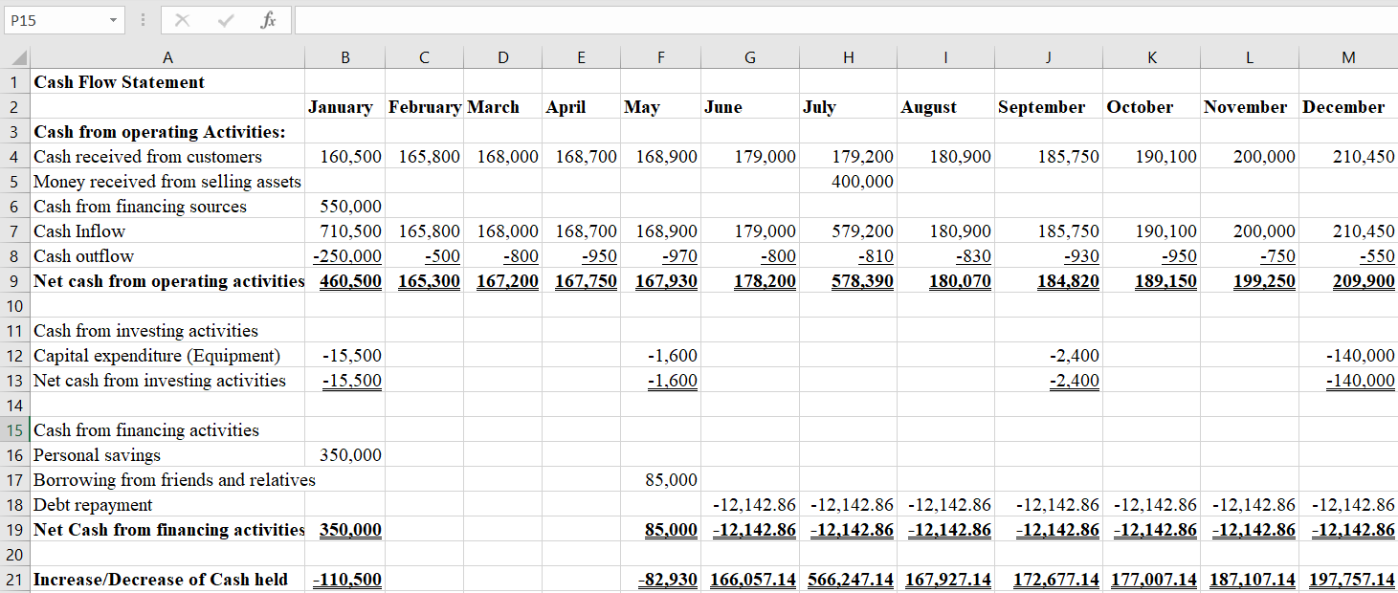

8.0 Conclusion

Even though the business has future viability in the hospitality sector, but there is constant change in consumer demands. However, the use of technology has changed the nature of consumer expectations. Hence, it has raised the concern on customer experience and engagement. Since customer satisfaction is the most important, this is a major business risk. Moreover, consumer perception risk exists as terrorism not only affect locations but also it creates a chilling of leisure around the city. Regarding the company American Queen food van, is most important to put customers in the first place and take account of their demands managing to succeed on the market and to be able to adapt to any critical situation. A happy customer means profit and at the same time keep on the right track the business and helps to grow and achieve success.

9.0 References

1. D. Weber,2012, The food truck handbook published by John Eiley & Sons, New Jersey
2. A.P. Simopoulos and R.V. Bhat, 2016, Street food, published by Karger.
3. Vincent A. Gabriel, 2015, Street food success. How to succeed as a street operator, published by Smart business series.
4. B. Finch,2016, The Sunday Time create success, How to write a business plan, published by Kogan.
5. A. Sarsby, November 2016, Swot analysis, A guide to swot for business studies students, published by Leadership library.
6. J. Agyeman & C. Matthews & H. Sabel, 2017, Food truck, cultural identity, and social justice, published by The MIT Press
7. Daily News, 2011. Food trucks not passing by. [Online] Available at: https://www.preparedfoods.com/articles/110060-food-trucks-not-passing-by [Accessed 25/6/2020].
8. Morris, M., 2016. The great American protein switch. [Online] Available at: https://fuelingfitnessvt.com/category/uncategorized/page/6/ [Accessed 25/6/2020].
9. Thrillist, 2018. The 101 dishes that changed America. [Online] Available at: https://www.thrillist.com/eat/nation/most-important-dishes-food-that-changed-america [Accessed 25/6/2020].

10. Myrick, R., n.d. Determine your food truck's staffing needs. [Online] Available at: https://www.dummies.com/business/start-a-business/determine-your-food-trucks-staffing-needs/ [Accessed 25/6/2020].
11. Wickford, H., 2019. Organizational structure of a restaurant. [Online] Available at: https://yourbusiness.azcentral.com/organizational-structure-restaurant-2980.html [Accessed 25/6/2020].
12. Ian B. ,2008, Questionnaire Design: How to Plan, Structure and Write Survey Material for effective market research, second edition, published by Kogan Page.
13. Riley J., 2018, Sources of Finance - Bank Loans. [Online] Available at: https://www.tutor2u.net/business/reference/sources-of-finance-bank-loans [Accessed 25/6/2020].

