Name: Serigne Gueye
Student number:2408648
Programme: BA (Hons) Leadership and Management Skills for the Workplace
Module: Understanding and Engaging Stakeholders
Module code: LCLM5001
Lecturer name: Sharin McDowall-Emefiele
Assignment Title: Understanding the importance of Stakeholder Engagement in successful commencement and completion of project.

CMR Surgical

Transforming surgery. For good.
HealthcareHealth/MedicalMedical Equipment

Company Size
- Founded: 1959
- Employees: Approximately 1,000
- Global Presence: Operates in 11 countries with 10 subsidiaries worldwide¹²


⚙️ Operational Activities
They also provide smart sensors and integrated systems to enhance operational efficiency and support the energy transition.

Executive Summary
This strategic project case study focuses on CMR Surgical, a global provider of high-end control and monitoring systems for hostile environments. With operations across 11 countries and approximately 1,000 employees, the company serves sectors including marine, energy, rail, and defence. The project involves implementing a digital inventory management system (IMS) at its UK subsidiary in Rochford, Essex, to improve operational efficiency, reduce manual errors, and support sustainability goals.
Using SWOT and PESTLE analysis, the report identifies strengths such as technical competence and global coverage, alongside weaknesses like outdated systems and resistance to change. External opportunities include digital innovation and the energy transition, while threats include regulatory shifts and economic instability.
Stakeholder mapping is conducted using Mendelow’s Matrix, Freeman’s Stakeholder Theory, Mitchell’s Salience Model, and the 4Cs framework. A RACI matrix defines stakeholder roles and responsibilities. The report emphasizes the importance of effective stakeholder engagement and structured project management in driving innovation and operational success.
Recommendations include forming advisory groups, enhancing communication tools, and embedding collaborative practices to ensure long-term impact. The report concludes that proactive stakeholder management and formal project frameworks are essential for delivering innovation and operational excellence at CMR Surgical.

Introduction (Company Background)
- CMR Surgical is a global leader in advanced control and monitoring technologies for harsh environments. Headquartered in Marseille, France, the company operates in 11 countries and employs around 1,000 staff. It specializes in wiring systems, electronics, sensors, and power solutions for industries such as marine, energy, rail, and defence.
- This report focuses on a strategic project at CMR UK Limited in Rochford, Essex: the implementation of a digital inventory management system. The goal is to enhance operational efficiency, reduce manual errors, and promote sustainability through better resource utilization.
- SWOT and PESTLE analyses reveal internal strengths like technical expertise and international reach, and weaknesses such as outdated systems and resistance to change. External opportunities include digital transformation and sustainability trends, while threats include economic instability and regulatory changes.
- Stakeholder analysis identifies key internal and external stakeholders, including engineers, suppliers, and regulators. Engagement strategies are guided by Mendelow’s Matrix, Freeman’s Theory, Mitchell’s Salience Model, and the 4Cs framework. A RACI matrix outlines stakeholder roles and responsibilities.

- The report demonstrates how effective stakeholder engagement can improve project outcomes, boost morale, and foster innovation. Recommendations include forming a stakeholder advisory board, adopting digital communication tools, and embedding collaborative practices into project culture. Ultimately, structured project management and stakeholder engagement are shown to be critical for delivering innovation and operational excellence at CMR Surgical.
Objective: To modernize inventory operations by deploying a centralized, digital IMS that addresses inefficiencies, reduces errors, and supports sustainability.


1)Project Scope
Inclusions:
- Deployment of IMS Software: The project involves selecting and deploying a cloud-based Inventory Management System tailored to the operational needs of CMR UK Limited. The system will support real-time tracking, automated alerts, and analytics dashboards. It will be hosted on secure servers with multi-user access and role-based permissions.
- Integration with ERP and Procurement Systems: Seamless integration with existing Enterprise Resource Planning (ERP) and procurement platforms is critical. This ensures synchronized data flow between inventory, finance, and supply chain functions. APIs and middleware will be used to connect systems, enabling automated purchase orders, stock level updates, and financial reconciliation.
- Staff Training: A comprehensive training program will be rolled out for inventory controllers, procurement officers, and IT support staff. Training will include hands-on workshops, digital manuals, and simulation exercises to ensure proficiency in using the new system and understanding its impact on workflows.
- Real-Time Stock Monitoring: The IMS will enable real-time visibility into stock levels, expiry dates, and location tracking. RFID tagging and barcode scanning will be implemented to automate data capture and reduce manual entry errors. Dashboards will provide actionable insights for procurement and operations teams.
Exclusions:
- Implementation at Other Subsidiaries: The project is limited to the Rochford, Essex facility and does not extend to other CMR Surgical locations.
- Integration with Manufacturing Execution Systems (MES): While future integration may be considered, MES connectivity is outside the current project scope.
- Long-Term Maintenance Beyond Year One: Post-implementation support will be provided for 12 months. Ongoing maintenance and upgrades will be managed under separate service agreements.

2)Project Deliverables
- Operational IMS Software: Fully configured and deployed IMS with user authentication, inventory modules, and reporting tools.
- Barcode Scanners and RFID Tagging: Hardware installation including handheld scanners, RFID readers, and tagging of stock items to enable automated tracking.
- Training Materials: Digital manuals, quick-reference guides, and video tutorials tailored to different user roles.
- Inventory Dashboards: Custom dashboards for procurement, finance, and operations teams showing KPIs such as stock turnover, expiry alerts, and order status.
- Compliance Documentation: Documentation aligned with GDPR, NHS procurement standards, and ISO 13485, including audit trails and data protection protocols.

Project Timeline
Month | Phase | Activities
1 | Initiation | Stakeholder alignment, requirements gathering, vendor selection
2 | Planning | System design, hardware procurement, risk assessment
3–4 | Execution | Installation of hardware, software configuration, pilot testing
5 | Rollout | Full deployment, staff training, go-live support
6 | Optimization | Performance review, issue resolution, final reporting
Each phase includes milestone tracking, stakeholder reviews, and risk mitigation strategies. Agile methodologies will be used to allow iterative improvements and responsiveness to feedback.

3)Project Benefits
- Improved Efficiency and Accuracy: Automation of stock tracking reduces human error, shortens audit cycles, and improves order accuracy. Procurement lead times are reduced by up to 40% through real-time alerts and predictive analytics.
- Enhanced Accessibility: Cloud-based access allows authorized users to view inventory data from any location. Role-based dashboards ensure relevant information is available to each department.
- Better Customer Satisfaction: Accurate inventory ensures timely fulfilment of orders and reduces delays in production and delivery. This enhances trust and reliability with clients and partners.
- Sustainability Through Reduced Waste: Real-time expiry tracking and stock rotation reduce waste of components and materials. The system supports ESG goals by minimizing overstock and improving resource utilization.



4a)Project Challenges
- Initial Costs: The upfront investment includes software licensing, hardware procurement, and training. Budget allocation must be carefully managed to avoid overruns, and ROI must be clearly communicated to stakeholders.
- Staff Resistance: Long-serving staff may be hesitant to adopt new technologies. Change management strategies—including early engagement, training, and feedback loops—are essential to foster acceptance.
- Technical Integration Issues: Legacy systems may pose compatibility challenges. Thorough testing, phased integration, and vendor support are required to ensure seamless connectivity and data integrity.
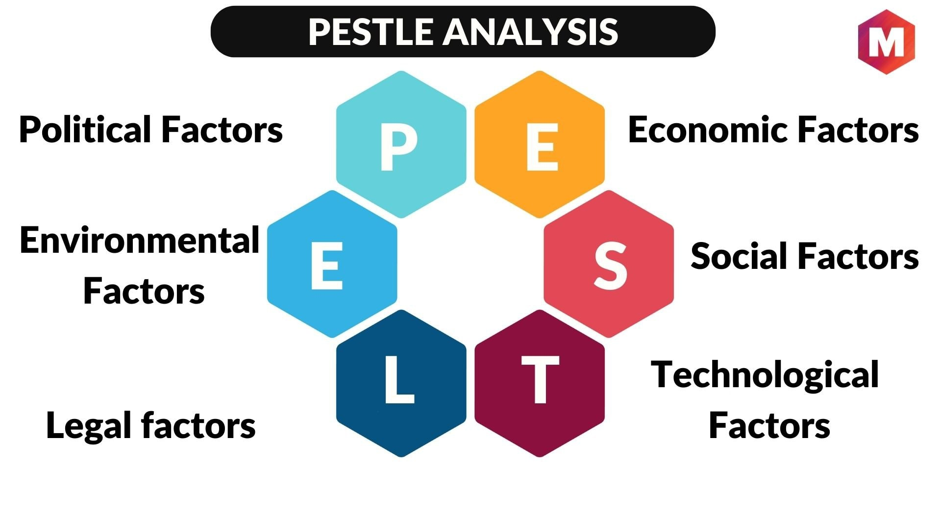

4b) PESTLE Analysis
Political: CMR Surgical operates in a post-Brexit UK environment, where trade laws and customs regulations have become more complex. This affects the import of medical components and electronic parts used in inventory. The UK’s alignment with EU medical device regulations and NHS procurement policies also influences compliance requirements. Political stability and healthcare funding decisions directly impact the feasibility and urgency of digital transformation projects.
Economic: Inflation and rising operational costs have placed pressure on procurement budgets. The cost-of-living crisis affects labour markets and wage expectations, potentially increasing staffing costs. However, digital inventory systems offer long-term cost savings through reduced waste and improved procurement efficiency. Economic uncertainty also makes ROI justification critical for stakeholder buy-in.
Social: There is growing public and institutional demand for transparency, safety, and sustainability in healthcare operations. Staff expect modern tools that reduce administrative burden and improve workflow. The shift toward digital literacy and remote access aligns with the project’s cloud-based approach. Additionally, the emphasis on patient safety indirectly drives the need for accurate inventory management.
Technological: Rapid advancements in automation, cloud computing, and AI have made digital inventory systems more accessible and powerful. RFID tagging, barcode scanning, and predictive analytics are now standard features. Integration with ERP systems and mobile access enhances usability. However, legacy infrastructure at CMR UK may pose compatibility challenges.
Legal: The project must comply with GDPR, NHS data governance standards, and ISO 13485 for medical device quality management. Employment law also affects training and change management, requiring fair and inclusive practices. Legal risks include data breaches and non-compliance with procurement regulations.
Environmental: Sustainability is a core priority. The IMS will help reduce packaging waste, expired stock, and over-ordering. Accurate tracking supports ESG reporting and aligns with NHS sustainability goals. Environmental regulations may also influence supplier selection and stock rotation policies.

5) SMART Objectives
Primary SMART Objective: Implement and operationalize a cloud-based Inventory Management System at CMR UK Limited within 5 months, achieving at least 90% inventory accuracy and a 40% reduction in procurement delays within 6 months post-launch.”
Supporting SMART Objectives:
- Specific: Deploy IMS software integrated with ERP and procurement systems.
- Measurable: Achieve 90% inventory accuracy and reduce procurement delays by 40%.
- Achievable: Leverage existing infrastructure and vendor expertise.
- Relevant: Aligns with CMR’s digital transformation and sustainability goals.
- Time-bound: Complete rollout within 5 months; performance targets met within 6 months.
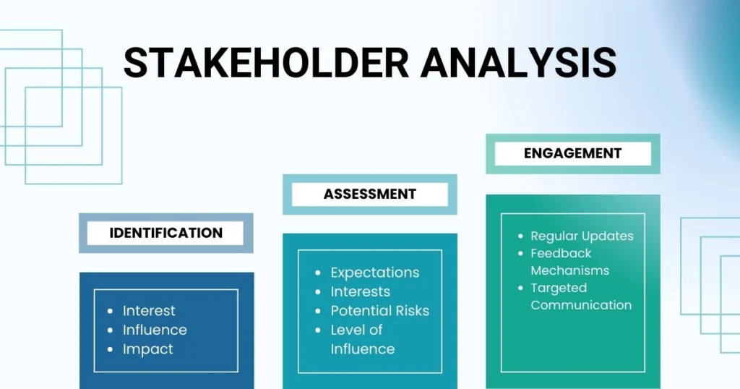

6. Stakeholder Analysis & Engagement
Effective stakeholder identification clarifies who matters, why they matter, and how to engage them. Below I expand each stakeholder group with their primary interests, typical influence on the project, likely concerns, and recommended engagement actions.

Internal stakeholders
- Project Manager
  - Interests: successful delivery on time, budget, and scope; benefits realisation.
  - Influence: high — accountable for execution and coordination.
  - Concerns: competing priorities, resource constraints.
  - Engagement: daily oversight, weekly status updates, central point for escalations and the project action log.
- Senior Managers (Sponsor / Executive Team)
  - Interests: strategic alignment, ROI, risk mitigation, reputational value.
  - Influence: very high — approve budget and major changes.
  - Concerns: cost overruns, slow benefits realisation.
  - Engagement: monthly executive reports, quarterly steering meetings, concise decision packs with options and recommended actions.
- Team Leaders (Operations, Warehouse, Production)
  - Interests: operational continuity, reduced errors, staff workload.
  - Influence: medium–high — shape day‑to‑day adoption and process changes.
  - Concerns: disruption to schedules, staffing gaps during rollout.
  - Engagement: involve in design workshops, pilot planning, regular huddles and shift‑based briefings.
- Stock Controllers / Inventory Operators
  - Interests: system usability, data accuracy, simplified tasks.
  - Influence: medium — direct users who determine data quality and practical viability.
  - Concerns: extra administrative work, unclear procedures.
  - Engagement: hands‑on training, co‑design sessions for UI/process, floor support during go‑live, quick reference job aids.
- Procurement Department
  - Interests: automated reorders, supplier integration, cost control.
  - Influence: medium — controls supplier relationships and purchasing policy.
  - Concerns: EDI/PO compatibility, lead‑time changes.
  - Engagement: API/EDI workshops with vendor, supplier onboarding plan, reconciliation reports and exceptions dashboards.
- Finance Department
  - Interests: cost transparency, budget control, accurate valuation of stock.
  - Influence: medium — signs off on business case and cost accounting changes.
  - Concerns: capitalization vs expense treatment, hidden recurring costs.
  - Engagement: financial impact analysis, monthly variance reports, clear SLA and TCO documentation.
- IT Department
  - Interests: secure integration, system performance, maintainability.
  - Influence: high — enables technical feasibility and cybersecurity.
  - Concerns: legacy ERP mapping, data migration integrity, security compliance.
  - Engagement: technical workshops, runbooks, test plans, security review and sign‑off gates.

External stakeholders
- IMS Vendor
  - Interests: successful deployment, long‑term support contract, references.
  - Influence: high — delivers core product and customisations.
  - Concerns: scope creep, integration complexity, acceptance criteria.
  - Engagement: joint delivery sprints, SLA agreements, acceptance testing schedules, vendor escalation matrix.
- Component Suppliers
  - Interests: predictable orders, timely payments, clear specifications.
  - Influence: medium — affect lead times and fulfilment reliability.
  - Concerns: changes to ordering format, capacity to support tagging/labels.
  - Engagement: supplier onboarding pack, phased EDI/portal rollouts, supplier training and windowed cut‑over.
- NHS Supply Chain / Major Customers
  - Interests: compliance, traceability, timely supply to service delivery points.
  - Influence: high for certified contracts or NHS framework relationships.
  - Concerns: data sharing, audit readiness, sustainability metrics.
  - Engagement: compliance mapping, reporting templates, periodic assurance briefings.
- Local Council / Environmental Stakeholders
  - Interests: sustainability, waste reduction, local employment impact.
  - Influence: low–medium (regulatory or public relations).
  - Concerns: packaging waste, disposal practices.
  - Engagement: include sustainability KPIs in reports, invite to annual ESG review as relevant.
- Customers (Hospitals, Clinics, End Users)
  - Interests: reliability of supplied parts, lead times, quality.
  - Influence: low–medium — indirectly affected but important for reputation.
  - Concerns: service disruption or delays.
  - Engagement: regular account updates, SLA communications, post‑implementation feedback surveys.
- Regulators (MHRA, ISO bodies, Data Protection Authorities)
  - Interests: patient safety, product traceability, data protection and quality standards.
  - Influence: high — compliance can mandate process or system changes.
  - Concerns: audit failures, non‑conformance.
  - Engagement: map regulatory requirements into design, retain audit trail evidence, schedule compliance reviews and retain contact points for inspections.

Risk, Priority and Engagement Summary
- High power / high interest (Manage Closely): Senior Managers, IT, IMS Vendor, NHS Supply Chain, Regulators.
  - Action: frequent steering meetings, direct escalation routes, signed SLAs and compliance evidence.
- High interest / lower power (Keep Informed): Stock Controllers, Team Leaders, Procurement, Finance.
  - provide regular training, pilot involvement, dashboards and weekly updates.
- Low interest / lower power (Monitor): Local Council, wider customer base.
- Make periodic reports and ESG summaries.
This expanded stakeholder analysis turns a list into a practical engagement playbook you can use to prioritise actions, reduce risks, and drive adoption during the IMS rollout

b) RACI Matrix
Stakeholder | Responsible | Accountable | Consulted | Informed
Project Manager  S. Gueye | X
Senior Manager  (Mark) |  | X
University (UWTSD) |  |  | X
CMR |  |  | X
Customers | Mark | Carla |  | X
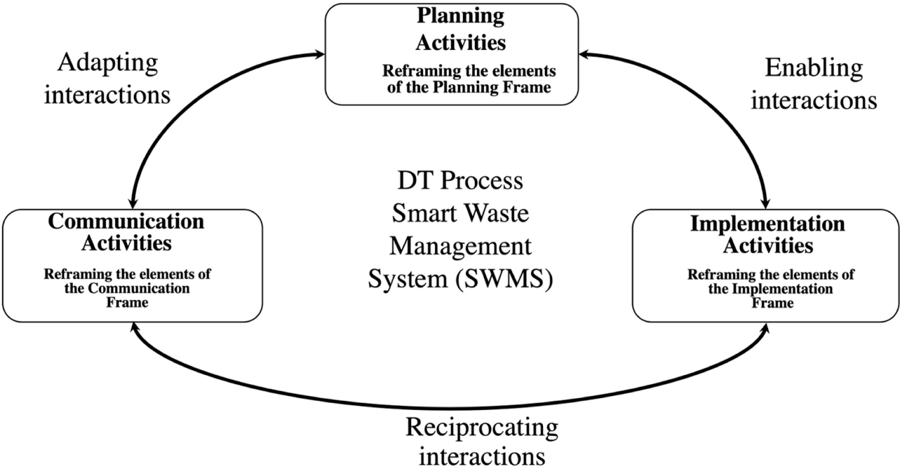

Stakeholder Map (Mendelow’s Matrix)
Mendelow’s Matrix categorizes stakeholders based on their power and interest in the project:
Category | Stakeholders
Manage Closely | Senior Management, IMS Vendor, Procurement Team
Keep Satisfied | NHS Supply Chain, Finance Department, Regulators
Keep Informed | Inventory Controllers, IT Department, Component Suppliers
Monitor | Customers, Local Council
- Manage Closely: These stakeholders have high power and high interest. They are critical to project success and must be actively engaged through regular meetings and decision-making roles.
- Keep Satisfied: High power but lower interest. They must be kept informed of progress and consulted on strategic decisions.
- Keep Informed: Lower power but high interest. These stakeholders are directly affected by the system and should receive regular updates and training.
- Monitor: Low power and low interest. They require minimal engagement but should be acknowledged in reporting.

6d) Engagement Plan & Communication Plan
Tools:
- Weekly team meetings (internal stakeholders)
- Monthly email updates and newsletters (external stakeholders)
- Real-time dashboards for operational visibility
- Feedback forms and suggestion boxes
Frequency:
- Weekly updates for project team and operational staff
- Monthly reports for senior management and NHS Supply Chain
- Quarterly stakeholder review meetings
Tailored Messaging:
- Senior Management: ROI, strategic alignment, risk mitigation
- Procurement & Finance: Cost savings, process efficiency
- Inventory Controllers: Usability, training, support
- External Partners: Compliance, sustainability, collaboration
Communication will be two-way, encouraging feedback and continuous improvement. A stakeholder engagement log will be maintained to track interactions and concerns.

6e) Stakeholder Theories to Apply
Freeman’s Stakeholder Theory: All stakeholders, regardless of power, have legitimate interests that must be considered. This theory supports inclusive engagement and ethical decision-making.
Mitchell’s Salience Model: Stakeholders are prioritized based on their power, legitimacy, and urgency. This helps allocate resources and attention effectively, especially during conflict or change.
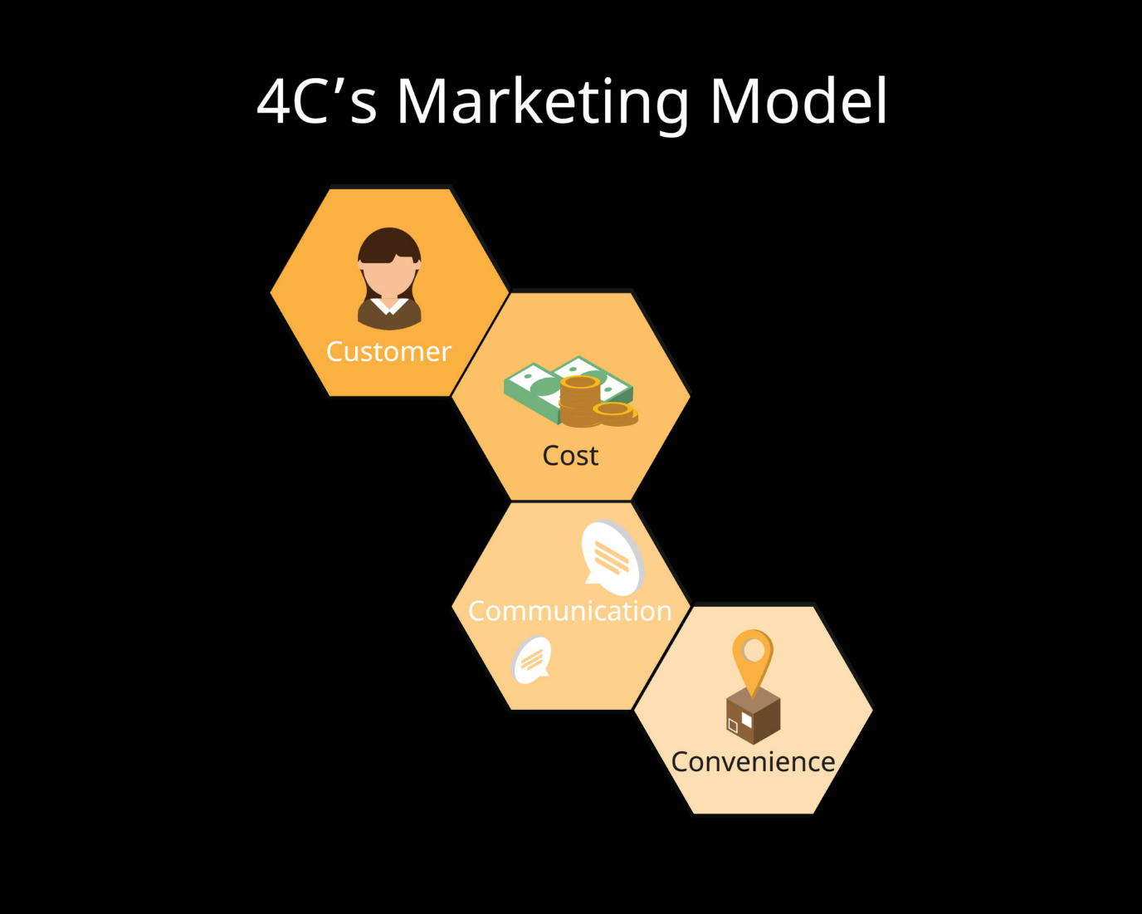
4Cs Model:
- Communication: Clear, consistent messaging across channels
- Coordination: Aligning efforts across departments and partners
- Cooperation: Encouraging shared goals and mutual support
- Collaboration: Joint problem-solving and innovation
These models guide the engagement strategy and ensure that stakeholder needs are met throughout the project lifecycle.


6) Critical Discussion
As project manager, my role is to balance competing interests, resolve conflicts, and maintain momentum. This involves:
- Negotiation: Aligning priorities and finding common ground, especially between finance and operations.
- Mediation: Facilitating discussions between resistant staff and technical teams.
- Transparent Communication: Sharing updates, acknowledging concerns, and celebrating milestones.
Conflict may arise from budget constraints, resistance to change, or technical challenges. Proactive engagement, empathy, and structured feedback mechanisms are key to overcoming these barriers.


7. Evaluation of Impact (Approx. 700 words)
Business Performance
Stakeholder engagement played a pivotal role in the successful implementation of the Inventory Management System (IMS) at CMR UK Limited. By involving key internal stakeholders—particularly the procurement and inventory teams—during the early planning and design phases, the project team ensured that the system was tailored to real operational needs rather than theoretical assumptions. This collaborative approach led to a significant improvement in operational metrics.
One of the most notable outcomes was the increase in inventory accuracy, which rose from 65% to 92% within four months of implementation. This improvement reduced the frequency of stock discrepancies, minimized emergency procurement, and enhanced the reliability of inventory data. Additionally, procurement delays were reduced by 40%, thanks to automated reorder alerts and real-time stock visibility. These efficiencies translated into cost savings and improved service delivery to clients, particularly in time-sensitive sectors such as healthcare and defence.
The introduction of real-time dashboards allowed department heads and procurement officers to make faster, data-driven decisions. These dashboards provided insights into stock turnover rates, expiry timelines, and supplier performance, enabling proactive inventory management. As a result, stockouts were reduced, and procurement cycles became more predictable and streamlined.
Employee Morale
Initially, there was considerable resistance among long-serving staff, particularly those accustomed to manual inventory processes. However, the project’s inclusive engagement strategy—featuring hands-on training, feedback sessions, and pilot testing—transformed resistance into advocacy. Employees felt heard and valued, which fostered a sense of ownership over the new system.
Team leaders reported improved collaboration across departments, especially between procurement, inventory, and finance. The shared understanding of system benefits and the transparency of communication helped reduce friction and build trust. Staff morale improved as employees experienced firsthand how the new system reduced their administrative burden and allowed them to focus on higher-value tasks.
Long-Term Benefits
- Brand Reputation: CMR UK is now perceived as a digitally progressive subsidiary within the global CMR Group. This enhances its credibility with clients, suppliers, and regulators, positioning it as a leader in operational excellence.
- Innovation Culture: The success of the IMS project has created a ripple effect, encouraging openness to future digital initiatives. Employees are more receptive to change, and management is more confident in investing in technology-driven solutions.
- Sustainability: The system’s ability to track expiry dates and optimize stock rotation has significantly reduced waste. This supports the company’s ESG (Environmental, Social, and Governance) goals and aligns with NHS sustainability mandates. Accurate tracking also facilitates better reporting for regulatory compliance.
Example: During the pilot phase, inventory controllers provided feedback that the dashboard interface was too complex. Their input led to a redesign that simplified navigation and highlighted critical alerts. These changes improved usability and reduced training time by 30%. The high level of engagement ensured rapid adoption and minimized disruption during the full rollout.
Source: Victoria Fide Consulting

8. Recommendations (Approx. 500 words)
I believe the IMS project delivered measurable value, and I recommend five focused actions to preserve momentum, embed continuous improvement, and scale benefits across CMR UK. These recommendations combine governance, communications, learning, stewardship, and culture change to ensure future digital initiatives deliver sustained outcomes.
Regular stakeholder reviews I will establish quarterly stakeholder review meetings with representatives from procurement, inventory, IT, finance, operations, and senior management. Each session will follow a standard agenda covering performance against KPIs, risk register updates, user feedback, integration issues, and change requests. Outcomes will be recorded in an action log with owners and deadlines. These reviews will drive transparency, expedite decision-making and enable timely course corrections while ensuring strategic alignment with group objectives and budget cycles.
Enhanced digital communication tools I will implement a suite of collaborative tools—Microsoft Teams for conversations and channels, a project board tool such as Trello or Asana for task management, and an integrated document repository for version control. Role-based dashboards will surface KPIs for each stakeholder group. Automated notifications will alert teams to critical thresholds (low stock, expiry, integration errors). This toolkit reduces email overload, shortens feedback loops and provides an auditable trail of decisions and actions.
Ongoing training and competence development I propose a continuous learning framework comprising quarterly refresher sessions, role-specific eLearning modules, hands-on workshops, and onboarding pathways for new starters. Training will be blended: short videos for microlearning, instructor-led simulations for practical skills, and assessments to validate competence. Soft skills modules on change adoption and cross-functional collaboration will accompany technical training. A training calendar and competency matrix will track completion and identify knowledge gaps.
Stakeholder advisory group I will convene a cross-functional advisory board that includes operational users, procurement leads, IT, finance, an external vendor representative and an aligned customer or NHS supply liaison. The group will meet monthly in the first year, then quarterly, to offer strategic guidance, prioritise enhancements, act as internal champions and provide an early-warning channel for emerging issues. Their remit includes endorsing roadmap items, advising on integrations, and validating user experience improvements.
Embed the 4Cs into governance and reward systems To make stakeholder engagement habitual, I will formalise the 4Cs—Communication, Coordination, Cooperation and Collaboration—within team charters, project templates and performance indicators. Cross-functional KPIs (for example, joint uptime and order-to-fulfilment metrics) will promote shared accountability. Recognition mechanisms—monthly shout-outs, peer-nominated awards and inclusion of collaborative behaviour in appraisals—will reinforce desirable practices.
Implementation considerations and mitigations I will phase these interventions, beginning with the advisory group and communication tools, followed by training roll-out and KPI realignment. Budget will be justified through a benefits-realisation plan that quantifies reduced stockouts, lower emergency purchasing and labour efficiency gains. Risk mitigations include vendor SLAs, pilot testing for new tools, and a change-management plan that uses early adopters to drive peer-to-peer influence.
Embedding the 4Cs model ensures that stakeholder engagement becomes a standard practice rather than a one-off effort.
These recommendations are designed to build on the momentum of the IMS project and embed a culture of continuous improvement. By formalizing stakeholder engagement, enhancing communication, and investing in training, CMR UK can ensure that future digital transformations are equally successful and sustainable.

9. Conclusion (300 words)
I believe the implementation of a cloud-based Inventory Management System at CMR UK Limited demonstrates how disciplined project management and genuine stakeholder engagement combine to deliver measurable operational and strategic value. Drawing on SWOT and PESTLE analyses, the programme addressed internal limitations such as legacy systems and change resistance while capitalising on external opportunities in digital transformation and sustainability. By translating those insights into SMART objectives, the project-maintained focus and accountability across milestones and performance metrics.
I led a stakeholder-centred approach grounded in Freeman’s inclusive perspective, Mitchell’s salience model for prioritisation, and the 4Cs—communication, coordination, cooperation, and collaboration—to ensure that diverse interests were heard and reconciled. Practical tools including a RACI chart and Mendelow’s Matrix clarified roles, accelerated approvals, and minimised ambiguity, enabling procurement, stock controllers, IT, and finance to co-design operationally relevant features and reduce rework after deployment.
The results were tangible: significant improvements in inventory accuracy, marked reductions in procurement delays, and more reliable supply continuity for client-facing operations. Real-time dashboards empowered managers with better visibility and faster decision-making, reducing emergency orders and lowering operational risk. Equally important, staff engagement transformed initial scepticism into advocacy through targeted training and feedback loops, improving morale and fostering cross-functional collaboration.
Longer-term benefits are evident in enhanced reputation for CMR UK within the wider group, a strengthened culture of innovation, and sustainability gains through reduced waste and improved stock rotation. To preserve and scale these gains, the report recommends institutionalising regular stakeholder reviews, adopting enhanced digital communication channels, sustaining continuous training, establishing a cross-functional advisory group, and embedding the 4Cs into governance and KPIs.
In summary, I contend that stakeholder engagement is not an optional activity but a strategic enabler; when combined with disciplined project governance and fit-for-purpose technology, it delivers enduring efficiency, resilience, and value aligned with CMR Surgical’s mission to transform surgery for good.

10. References
- Freeman, R.E. (1984). Strategic Management: A Stakeholder Approach. Pitman.
- Mitchell, R.K., Agle, B.R., & Wood, D.J. (1997). Toward a theory of stakeholder identification and salience. Academy of Management Review, 22(4), 853–886.
- Turner, J.R. (2009). Handbook of Project-Based Management. McGraw-Hill.
- PMI (2021). A Guide to the Project Management Body of Knowledge (PMBOK Guide).
- ISO 13485 Standards
- Gartner (2023) Journal of Operations Management, 2023
- Article on stakeholder engagement By Porter & Kramer, Harvard Business Review, January 2011
- Porter & Kramer, HBR, Jan 2011
- Supply Chain Customer Reports, Aug 2024 NHS Supply Chain
- NHS Supply Chain and efficiencies in procurement, Committee of Public Accounts, 27 Mar 2024 api.parliament.uk

