The Snettisham Torc: A Biography by David Trowt.

Introduction:
The idea of a piece of art being Celtic conjures, at least for most in the modern era, a picture of swirling patterns, knotwork and elaborate jewellery. Modern-day silversmiths create objects that are mass produced and inscribed with a perceived pattern of Celtic origin, but the question that must be asked in these cases and, in those of objects found buried for hundreds of years, is what makes them Celtic? Lloyd and Jennifer Laing describe Celtic Art thus, ‘Celtic is a term applied to art in a diversity of styles’. This implies that the Celts drew inspiration from different sources in their art to produce their own version of it. The most common term for the beginnings of this style of Celtic Art is La Tène. This is a style of art produced from the western Switzerland region of Europe during the later Iron Age period of around 500BCE up until the first century BCE and is one that, in very broad terms, set the standard for the art that followed it in the British Isles. An example of this styling is the Great Torc (figure 1) found near Snettisham, described by the British Museum as a ‘technical masterpiece.’ It is this torc that will be discussed with this essay in the following paragraphs with the overriding question, what makes it Celtic?
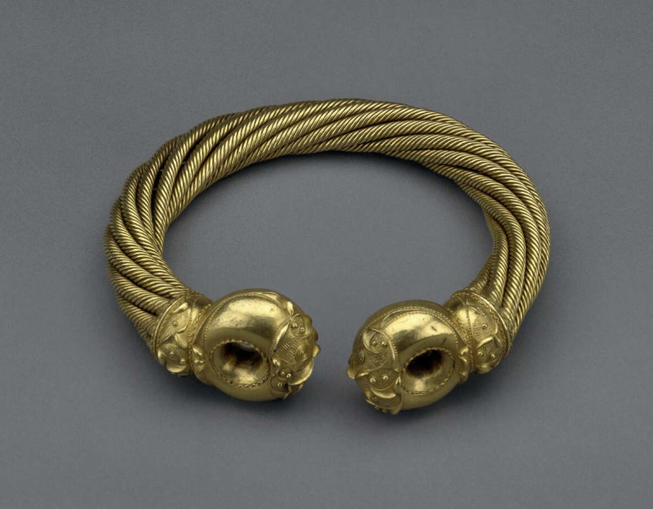
Figure 1

Discovery:
The first parts of what went on to become known as the Snettisham Hoard were first discovered by a ploughman, Ray Williamson, in a field at Ken Hill, Snettisham in 1948. Whilst ploughing he found four gold torcs, in mostly complete condition. His colleague, Tom Rout in 1950, whilst also ploughing, found firstly a single gold torc with a ring fitted into one terminal, this was designated as Hoard D for the site. A week later he discovered a further deposit and within which an item that has become known as the Great Torc, pictured above. Also found with this discovery were a gold bracelet, a broken gold alloy torc (secured through one of the torc terminals) and a gold coin, which was found wedged in the ropes of the larger torc; figure 2 shows a reconstruction of this. These items were designated as Hoard E, and this hoard along with Hoard D were handed in to authorities. Both lots were subsequently declared as a Treasure Trove which the British Museum describes thus:
Treasure Trove was a royal prerogative that gave the Crown the right to any gold or silver that had been hidden, provided the owner was unknown and that he or she had hidden it with a view to recovering it.
Following their designation as Treasure Trove, the artifacts were, after some time, acquired by the British Museum in 1951 where it has been analysed using various scientific methods.
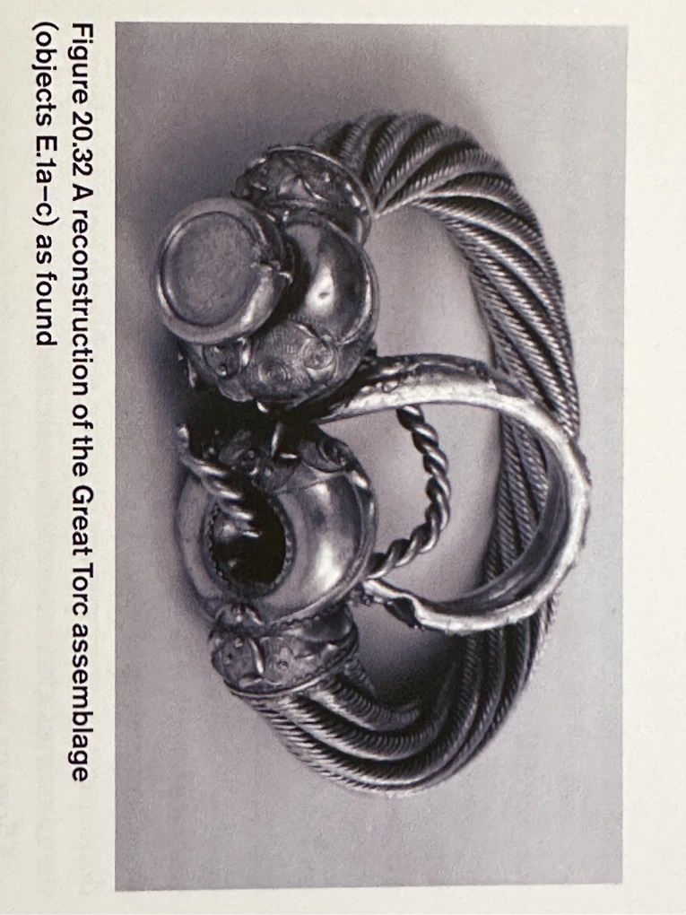
Figure 2
The coin found in one of the terminals of the Great Torc has been dated by the British Museum as around 60BCE, this gives a date for the Great Torc of a similar timeline, the museum dating it, taking wear and style into account, to 150-50BCE.

Description:
The Great Torc has a weight of 1085g and is 20cm in diameter. Whilst the torc is referred to as being made of gold, it is in fact made from a gold/silver alloy (usually with small amounts of copper as well), called Electrum. The torc is comprised of eight strands of alloy, each formed from eight wires twisted together into a cable. These eight cables are then twisted in a clockwise direction (coiled) to form a larger, thicker cable, around a hollow core, which was then soldered into the end terminals. Ruth and Vincent Magaw describe the terminal design as showing ‘basketry work, shaped to fit the areas of decoration, together with small raised dots with three or four punched indentation and larger raised concentric circles.’ They go on to describe ‘raised sinuous edging to the decorated areas’ whilst ‘punched dots provide edging to defined areas within the design’. They conclude their description by saying that ‘The spindly raised ridge curves have concave endings, and form slender commas or trumpet coils.’ The British Museum suggest that the markings on the terminals were ‘gently hammered’ using a ‘chasing tool with a rounded tip’ which then created the patterns described. They also note that the Newark and Sedgeford torcs have a similar design inscribed. The Grotesque torc, which was found during the excavations of Snettisham in 1990 and attributed to Hoard L show markedly different styling, which the British Museum describes as a ‘Plastic Style’. This was a style developed in the early third century BCE which used animal and human faces in what Laing describes as ‘grotesque modelling’. One reason for this could be that this torc was an earlier style made years prior to the Great Torc, this also shows in the terminals which are hand-crafted sheet metal as opposed to the cast-style of the Great, Newark and Sedgeford torcs.
The terminals, which are in the Torus style, were initially thought to have been casted-on, but closer examination by the British Museum has found that they were cast separately and then soldered on, by evidence of molten metal filling the gaps of the wires, fusing them together along with the terminal ends themselves. The museum note that cracking has appeared on these terminal ends, showing that they were not fully soldered during the process and thus becoming weaker with time and use. Evidence of wear is also evident in the neck ring wires, as shown in some wires creating grooves in adjacent wires where they press during bending when being put on or taken off.

Styling:
When looking at the styling of the Great Torc it should be noted that the two terminals actually differ from each other in design. This is unusual as most torcs of that era, including the previously mentioned Grotesque torc, the Newark and Sedgeford torcs too, have mirroring designs on both terminals. Whether this means that the Great Torc terminals were made by two different craftsmen or the same one choosing different designs is unclear and ultimately a subject for a different essay as the overall design is of the same format.
The Great Torc has been classed as being in Style V and is, in the words of Laing, ‘without any continental parallel,’ meaning that there are no comparisons to any continental art forms made at that time. This numerical styling is based on a system put forth by J.M de Navarro who was attempting to break away from the terms used by Paul Jacobsthal for different styles of Celtic art, those being Early (Style I), Waldalgesheim (Style II, also referred to as the Vegetal style), Plastic and Sword (Style III). Styles IV and V were coined by Dr Ian Stead as a continuance of this naming process to distinguishing art types, in this case with the Insular British Style. Whilst there are other methods of referring to these eras, the ‘Style’ form is the one that will be used in this essay.
The terminals and collars have what the British Museum describe as ‘raised curvilinear’ design on them as described above, but of note are the designs used namely, the trumpet and teardrop motifs, basket-weave punching, raised knobs and concentric circles. The collars follow the same pattern with a teardrop design and basket-weave hatching along with raised knobs and punched dots. The British Museum, when showing the collar laid out, say it forms the shape of ‘an elongated lyre’, a pattern indicative of Style II Continental art. This ‘lyre’ style, which has been used since the Style I era, can be seen on the Bronze disc recovered from Auvurs-sur-Oise, France and dates to the early fourth century BCE (figure 3 below). This lyre pattern is seen in a symmetrical pattern around the face of the disc.
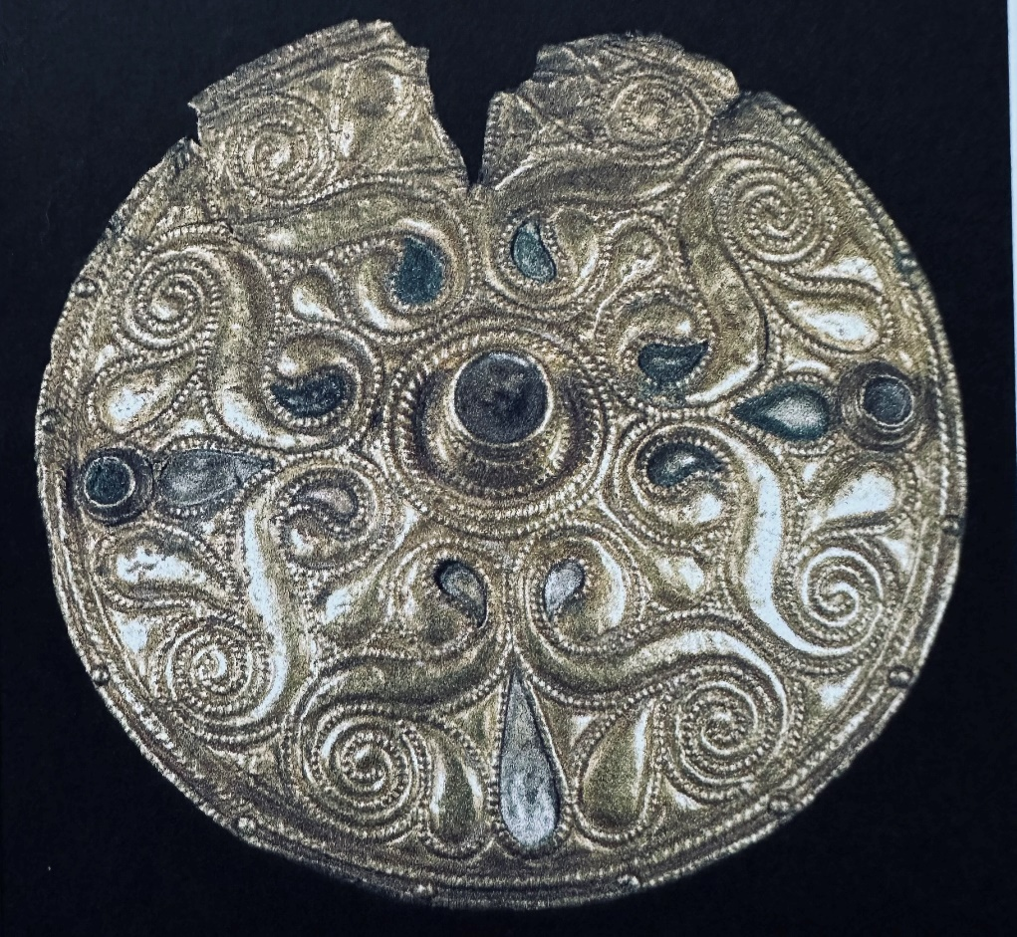
Figure 3
The raised concentric circles are also something seen in earlier forms of continental art, namely the late Style I era. An example of this can be seen on the Disc found at Saint Jean-sur-Tourbe, Marne, France and dates to the late fifth or early fourth century BCE, (figure 4).
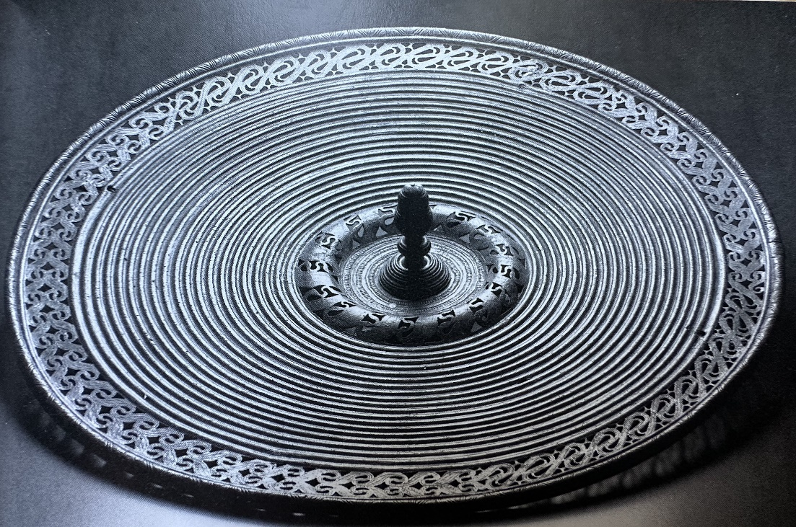
Figure 4
The basket-weave filling on the terminals is, according to Laing, an ornamental style of the Style V period of Insular Britain. It too though, has parallels in earlier forms of Celtic art. Whilst not basket-weave, the infilling used on this scabbard is reminiscent of the same design practice (figure 5).
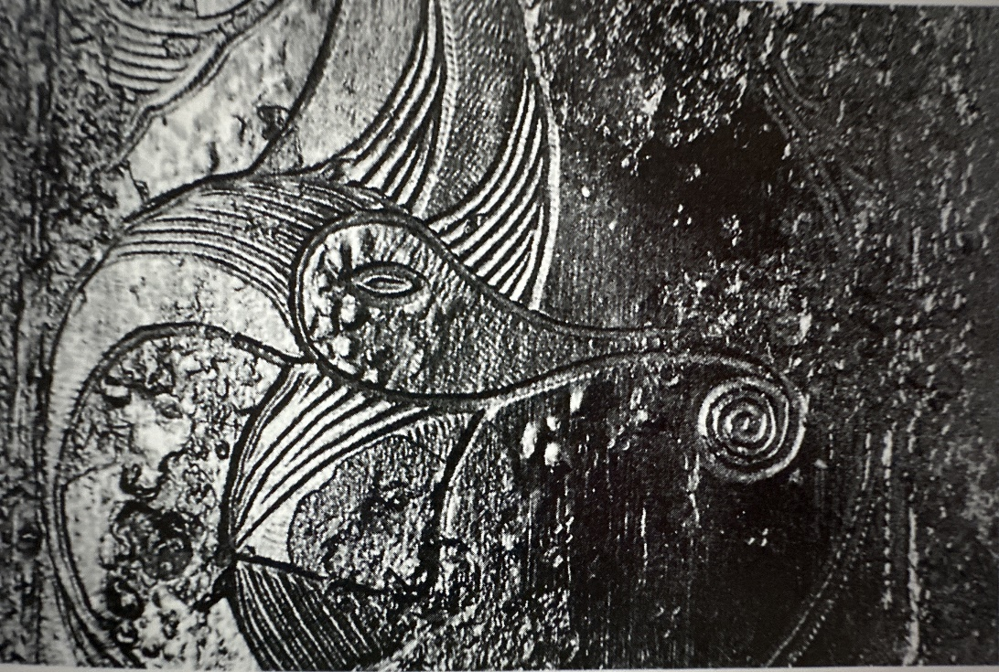
Figure 5
The Great Torc, whilst distinctly an Insular style piece and with comparisons to other Insular pieces, clearly shows influences from the Continental Celtic styles that preceded it.

Exhibition and Interpretation:
The Great Torc was found in a farmers field, but since it’s discovery it has travelled far. Not long after its finding, Sir Stephen Lycett Green took the Great Torc and showed it to King George VI, who upon being told it belonged to him (through Treasure Trove) reportedly wore it on his neck, but this was later denied by Sir Stephen but to think of the torc, after so many centuries, being worn by another king is thought provoking.
The British Museum bought the Great Torc in 1951 and from then it has been examined in detail and extensively studied, resulting in some of the information shown above. The torc has been displayed numerous times by the museum at various locations around Britain and in Australia. The torc was a feature of the Celts: Art and Identity exhibition in London and Edinburgh in 2015-2016 and is currently displayed at The British Museum in London.

Torcs have been attributed to the Celts since classical authors first described them. Cassius Dio, when describing Boudicca said, ‘around her neck was a large golden necklace’ and the British Museum speaking of Barry Cunliffe’s book Iron Age Britain, he writes of Greek Historian Polybius (200-118BCE) describing Celtic warriors at the battle of Telemon in 225BCE as being ‘richly adorned with gold torcs and armlets’. This shows that torcs were an important part of Celtic culture and thus the burial of these precious items brings questions of why. Cunliffe considers the burials to be a ‘votive offering’ which is a point echoed by the British Museum in their extensive breakdown of the hoards found at Snettisham. It should be noted though that most votive offerings are made in or near water and the Snettisham hoard has neither nearby.
The items found in the hoards at Snettisham, including the Great Torc show evidence of extensive use, meaning that these items were likely personal possessions worn by a person or people prior to depositing into the ground. The Great Torc was found linked to other, similar designed items, which could mean that they were owned by the same person making an offering. Not everyone agrees with this theory of the hoards being votive in nature though. Dr Ian Stead’s theories of the artifacts being buried for safekeeping, are discussed by the museum and whilst his theory has merit, they point to the location being a religious site given it’s raised location overlooking the land and the sea in the distance. This gives further credence to the site being a burial site used for offerings, them saying that ‘In short, Snettisham is viewed as a centre for ritual activity’. The theories for these burials seem to be many, ultimately, we can not know exactly why they were buried only that they were and have now been recovered, studied and appreciated by us, as a modern people.

Conclusion:
The Great Torc is a beautiful piece of Insular Celtic art that shows evidence of an expansive Celtic history in its decoration and formation. It is fairly unique with its differing terminals, and its construction is impressive with its eight coiled ropes making it very thick and sturdy whilst retaining its flexibility. The soldering does seem a little out of place as the overall construction seems very good, yet the terminals show signs of not being soldered fully; there seems to be no logical reason for this. The torc and the artifacts found with it have provided years of study and discussion on not only their creation and styling, but also their reason for being where they were discovered. The question of whether it is a votive offering or not is an expansive one, but whatever its reason for being where it lay, it is a fascinating piece of British history that deserves its place on display for generations of people to enjoy.
Bibliography:
Cunliffe, Barry, The Ancient Celts, (Oxford: Oxford University Press, 2018).
Dio, Cassius, Roman History Books 61-70, (London: Harvard University Press, 1925).
Encyclopaedia Britannica, Electrum, 8 March 2025. https://www.britannica.com/science/electrum [accessed 26 March 2025].
Laing, Lloyd and Jennifer, Art Of The Celts, (London: Thames And Hudson Ltd, 1992).
Machling, Tess, ‘Pattern And Purpose: A New Story About The Creation Of The Snettisham Great Torc’, The Big Book Of Torcs, 29 May 2022. https://bigbookoftorcs.com/2022/05/29/pattern-and-purpose-a-new-story-about-the-creation-of-the-snettisham-great-torc/ [accessed 31 March 2025].
Machling, Tess & Williamson, Roland, ‘Thoughts On The Grotesque Torc And The Snettisham (Ken Hill) Hoards In The Light Of New Research’, Big Book Of Torcs, 22 September 2020. https://bigbookoftorcs.com/2020/09/22/thoughts-on-the-grotesque-torc/ [accessed 21 March 2025].
Megaw, Ruth and Vincent, Celtic Art: From Its Beginnings To The Book Of Kells, (London: Thames And Hudson Ltd, 1991).
The British Museum, Celts: Art And Identity, ed. by Julia Farley and Fraser Hunter, (London: The British Museum Press, 2015).
The British Museum, The Snettisham Hoards: Volume 1, ed. by Julia Farley and Jody Joy, (London: The British Museum, 2024).
The British Museum, The Snettisham Hoards: Volume 2, ed. by Julia Farley and Jody Joy, (London: The British Museum, 2024).
The British Museum, ‘Torc’, (date unknown). https://www.britishmuseum.org/collection/object/H_1951-0402-2 [accessed 21 March 2025].

Lloyd and Jennfier Laing, Art Of The Celts, (London: Thames And Hudson Ltd, 1992), p. 8.
The British Museum, ‘Torc’ (date unknown). https://www.britishmuseum.org/collection/object/H_1951-0402-2 [accessed 21 March 2025].
The British Museum, Celts: Art And Identity, ed. by Julia Farley and Fraser Hunter, (London: The British Museum Press, 2015), p. 41.
Tess Machling & Roland Williamson, ‘Thoughts On The Grotesque Torc And The Snettisham (Ken Hill) Hoards In The Light Of New Research’, Big Book Of Torcs, 22 September 2020. https://bigbookoftorcs.com/2020/09/22/thoughts-on-the-grotesque-torc/ [accessed 21 March 2025].
The British Museum, The Snettisham Hoards: Volume 1, ed. by Julia Farley and Jody Joy, (London: The British Museum, 2024), p. 8.
Ibid., p. 26.
Ibid., p. 26.
The Treasure Trove regulations have now been superseded by the Treasure Act 1996.
The British Museum, Celts: Art And Identity, p. 106.
The British Museum, The Snettisham Hoards: Volume 1, p. 365.
The British Museum, ‘Torc’, (date unknown). https://www.britishmuseum.org/collection/object/H_1951-0402-2 [accessed 29 March 2025].
Encyclopaedia Britannica, Electrum, 8 March 2025 https://www.britannica.com/science/electrum [accessed 26 March 2025].
Ruth and Vincent Megaw, Celtic Art: From Its Beginnings To The Book Of Kells, (London: Thames And Hudson, 1991), p. 215.
Ibid., p. 215.
Ibid., p. 215.
The British Museum, The Snettisham Hoards: Volume 2, ed. by Julia Farley and Jody Joy, (London: The British Museum, 2024), p. 473.
Ibid., p. 473.
Lloyd and Jennifer Laing, Art Of The Celts, p. 66.
The British Museum, The Snettisham Hoards: Volume 2, p. 468.
Ibid., p. 468.
Ibid., p. 499.
Tess Machling, ‘Pattern And Purpose: A New Story About The Creation Of The Snettisham Great Torc’, The Big Book Of Torcs, 29 May 2022. https://bigbookoftorcs.com/2022/05/29/pattern-and-purpose-a-new-story-about-the-creation-of-the-snettisham-great-torc/ [accessed 31 March 2025].
Lloyd and Jennifer Laing, Art Of The Celts, p. 108.
Ibid., p. 108.
Ibid., p. 41-42.
The British Museum, The Snettisham Hoards: Volume 2, p. 522.
Ibid., p. 522.
Barry Cunliffe, The Ancient Celts, (Oxford: Oxford University Press, 2018), p. 254.
Lloyd and Jennifer Laing, Art Of The Celts, p. 46.
Ruth and Vincent Megaw, Celtic Art: From Its Beginnings To The Book Of Kells, p. 129.
The British Museum, The Snettisham Hoards: Volume1, p. 13.
The British Museum, ‘Torc’, (date unknown). https://www.britishmuseum.org/collection/object/H_1951-0402-2 [accessed 31 March 2025].
Cassius Dio, Roman History Books 61-70, (London: Harvard University Press, 1925), p. 85.
The British Museum, The Snettisham Hoards: Volume 2, p. 546.
Barry Cunliffe, The Ancient Celts, p. 288.
A votive offering was an offering to the gods and deposited somewhere, like a burial or river/lake without the intention to recover. Items were often broken in order to signify a ritual ‘killing’ of the item to give it more purpose.
The British Museum, The Snettisham Hoards: Volume 2, p. 498.
Ibid., p. 584.
Ibid., p. 585.
Ibid., p. 586.

