

Name and Student ID: Pawel Szpinek 2440926
Module Code: LCBB5014
Module: Data Handling and Business Intelligence
Lecturer: Dr Xavier Matieni
Subject: Report The Letterbox Movie Classification Dataset

Table of Contents
1. Introduction
2. Data Cleaning and Preparation
3. Descriptive Statistics and Summary
4. Trend Analysis and Visualisation
5. Statistical Analysis Using SPSS-Style Procedures
6. Insights and Recommendations
References
Appendices: Excel/SPSS-Style Outputs
Appendix A1. Descriptive Statistics
Appendix A2. Genre Rating Output
Appendix A3. Histogram Output
Appendix A4. Scatter Plot Output
Appendix A5. Group Statistics
Appendix A6. Independent-Samples T-Test
Appendix A7. Pearson Correlation Matrix
Appendix A8. Regression Model Summary
Appendix A9. Regression Coefficients

1. Introduction
The rapid growth of digital platforms has increased the importance of data-driven decision-making within the film and entertainment industry. Streaming services, review platforms and distributors now collect substantial quantities of information about audience preferences, viewing activity and engagement. Business intelligence (BI) can transform these data into useful evidence that supports content acquisition, marketing, recommendation systems and audience-retention strategies. Provost and Fawcett (2013) argue that data science is most valuable when analytical evidence is connected to practical business decisions rather than treated as an isolated technical exercise. This report analyses the Letterbox Movie Classification Dataset, which contains 10,000 film records and variables including title, director, genre, average rating, runtime, original language, watches, likes and fans. The purpose of the report is to identify patterns in viewer behaviour and investigate factors associated with film popularity and higher ratings. Moreover, it demonstrates how Excel-style descriptive and visual analysis can be combined with SPSS-style inferential statistics. The analysis has four objectives. Firstly, the dataset is examined and prepared to ensure that relevant variables are suitable for analysis. Secondly, descriptive statistics are used to summarise ratings, watches, likes, fans and runtime, alongside key categorical variables. Thirdly, trends across genres and languages are explored visually. Finally, hypothesis testing, correlation and multiple regression are used to investigate whether observed relationships are statistically significant. The findings are then interpreted from a BI perspective and translated into recommendations for media and entertainment decision-makers.

2. Data Cleaning and Preparation
Data cleaning is necessary because the quality of analytical conclusions depends on the quality and consistency of the underlying data. Hair et al. (2019) emphasise that screening data before statistical analysis is important because missing values, coding errors and extreme observations can distort results. The supplied dataset contained 10,000 observations and 17 variables. An initial inspection showed no missing values in the main variables used in this report: Average Rating, Watches, Likes, Fans and Runtime. Consequently, no imputation or case deletion was required for these measures. The dataset was also checked for duplicated rows and inconsistent values. No completely duplicated records were identified. However, duplicated film titles were present. These were not automatically removed because identical titles can refer to different films or releases, and deleting them solely on title would risk removing valid observations. The field labelled “Unnamed: 0” was treated as an index rather than an analytical variable. Categorical data required particular attention. Genres were stored as multi-value lists; therefore, they were separated into individual genre categories when conducting genre-level analysis. Original Language was retained as a categorical variable, while a new analytical grouping was created to compare English and non-English films. Runtime was kept as a numerical variable. Although extreme runtimes were observed, including a maximum of 907 minutes, these values were retained because an extreme value is not necessarily an error. Overall, the cleaning process prioritised accuracy, consistency and transparency, which are essential characteristics of reliable BI systems.

3. Descriptive Statistics and Summary
Descriptive statistics provide an overview of the dataset and help identify central tendencies, variation and unusual distributions before inferential tests are performed (Field, 2018). The mean Average Rating was 3.27, with a standard deviation of 0.53. Ratings ranged from 1.08 to 4.71, while the median was 3.27. The similarity between the mean and median indicates that the rating distribution is broadly centred around the same value. The average Runtime was 103.17 minutes and the median was 99 minutes. However, runtime showed considerable variation, with a standard deviation of 38.07 minutes and values ranging from 2 to 907 minutes. Therefore, the median should be considered alongside the mean when interpreting a typical film length. Audience-engagement measures were substantially more skewed. Films received an average of 170,315 Watches, yet the median was only 18,425. Similarly, the mean number of Likes was 43,735, compared with a median of 3,394, while Fans averaged 1,653 but had a median of only 24. These large differences indicate strong positive skew, meaning that a relatively small proportion of films attract extremely high engagement. Consequently, management decisions based only on averages could overstate the performance of a typical film. Moreover, BI dashboards should present medians, ranges and distributions alongside headline averages. English was the dominant original language, representing 8,074 films (80.7% of the dataset). The next most frequent languages included Italian (396), Japanese (308) and French (291). Genre analysis showed that Drama was the most common genre, appearing in 4,416 records, followed by Comedy, Thriller, Action and Horror. However, frequency does not necessarily indicate stronger audience evaluation, and this is explored further in the trend analysis.

4. Trend Analysis and Visualisation
The genre analysis identified meaningful differences in average ratings. Among genres represented by at least 100 films, Documentary achieved the highest mean rating at approximately 3.64. History and War also achieved comparatively strong ratings, while Drama performed well despite being the most frequently represented genre. In contrast, several mainstream genres, including Action, Science Fiction and Horror, recorded lower average ratings. Figure 1 therefore demonstrates that the most common or commercially visible genre is not necessarily the highest rated. However, rating and reach should be treated as different dimensions of performance. Some genres with moderate ratings attracted high viewing levels, while specialist genres could achieve strong ratings with smaller audiences. For example, Documentary films were highly rated but generated much lower average Watches than several mainstream categories. This suggests that niche content may produce strong satisfaction among a smaller audience, whereas mass-market genres may generate greater reach without equivalent rating performance. Such a distinction is particularly important for streaming businesses because a title can be valuable through audience scale, loyalty, critical appreciation or a combination of these outcomes. Language produced another important pattern. English-language films had a mean rating of 3.21, whereas non-English films averaged 3.51. This difference suggests that the dominance of English content in the dataset does not automatically translate into higher audience evaluation. Nevertheless, the result should be interpreted cautiously because language may be associated with genre, distribution, audience self-selection or other unmeasured characteristics. Figure 2 shows the distribution of Average Rating and supports the descriptive finding that most films cluster around the central rating range. Figure 3 shows a strong positive relationship between Watches and Likes. The scatter plot demonstrates that films watched by larger audiences generally receive more likes, although the spread becomes greater at high engagement levels. Visualisation is therefore useful in BI because it communicates patterns that may be less obvious in numerical tables and allows managers to compare audience reach, satisfaction and engagement more effectively.

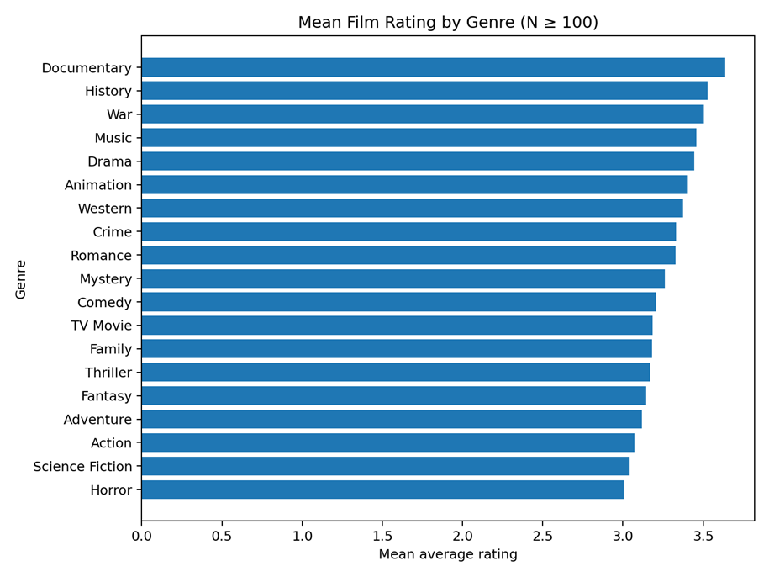
Figure 1. Mean film rating by genre (genres with at least 100 films).
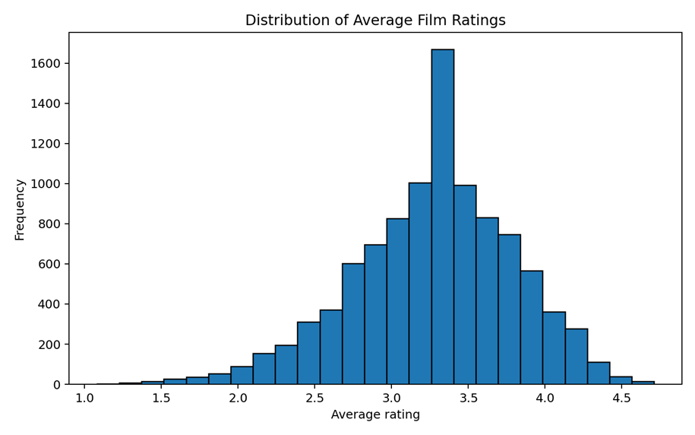
Figure 2. Distribution of Average Rating

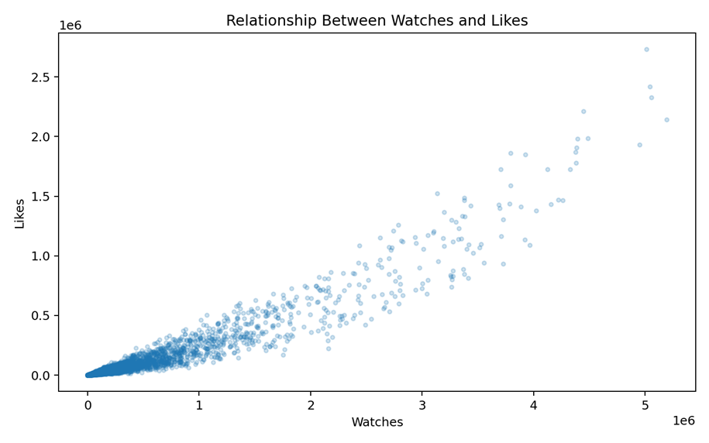
Figure 3. Scatter plot showing the relationship between Watches and Likes.

5. Statistical Analysis Using SPSS-Style Procedures
Inferential statistics were used to assess whether the observed patterns were statistically meaningful. Field (2018) explains that hypothesis testing can help determine whether a difference is unlikely to be attributable to random sampling variation, while correlation and regression can evaluate the strength and predictive value of relationships. An independent-samples Welch t-test compared Average Rating for English and non-English films. The null hypothesis stated that there was no statistically significant difference in mean rating between the two language groups. English-language films had a mean of 3.21 (SD = 0.52, n = 8,074), while non-English films had a mean of 3.51 (SD = 0.46, n = 1,926). The test found a statistically significant difference, t(3219.60) = -24.88, p < .001. The null hypothesis was therefore rejected. However, this result does not demonstrate that language causes higher ratings; it identifies an association that may be influenced by other characteristics. Pearson correlation analysis was then used to examine relationships between quantitative variables. Watches and Likes showed an extremely strong positive correlation, r = 0.951, p < .001. Therefore, films with more Watches generally also accumulated more Likes. Average Rating was positively correlated with Likes (r = 0.290) and Fans (r = 0.251), although these relationships were much weaker than the Watches-Likes relationship. Runtime had only weak positive relationships with Watches (r = 0.146), Likes (r = 0.129) and Fans (r = 0.088). Consequently, runtime alone appears to have limited practical value for explaining engagement. A multiple regression model was also estimated using Fans, Likes and Runtime to predict Average Rating. The model was statistically significant, F(3, 9996) = 403.31, p < .001, and produced R² = 0.108. Therefore, the predictors explained approximately 10.8% of the variance in Average Rating. Fans, Likes and Runtime were statistically significant predictors in the model. Nevertheless, the relatively low R² indicates that most variation in ratings is explained by factors not included in these variables. Moreover, with a sample of 10,000 records, even small effects may reach statistical significance. Practical importance should therefore be considered alongside p-values.

6. Insights and Recommendations
The analysis provides several implications for BI decision-making in the entertainment industry. Firstly, organisations should distinguish between audience reach and audience satisfaction. High Watches do not automatically indicate high ratings, while specialist genres may achieve strong ratings with smaller audiences. Consequently, performance dashboards should combine KPIs such as Watches, Likes, Fans and Average Rating rather than relying on a single measure. Secondly, the higher mean rating for non-English films indicates a potential opportunity for international-content strategies. Streaming platforms and distributors could consider stronger investment in multilingual catalogues, subtitling, dubbing and recommendation systems that expose audiences to relevant non-English titles. However, further analysis would be required before making major investment decisions because the observed language difference may reflect confounding variables. Thirdly, the very strong association between Watches and Likes suggests that increasing discoverability may support engagement. Personalised recommendations, targeted marketing and better content placement may therefore contribute to greater interaction. In contrast, runtime displayed only weak relationships with engagement, suggesting that runtime should not be treated as a primary predictor of success. The analysis has limitations. The dataset does not include detailed viewer demographics, marketing expenditure, production budgets, release windows or recommendation exposure. Furthermore, the statistical procedures identify association rather than causation. Future analysis could incorporate these additional variables and examine changes over time. Overall, the findings demonstrate that BI can support more informed entertainment decisions; however, analytical results should be combined with contextual knowledge and managerial judgement.

References:
Davenport, T.H. and Harris, J.G. (2007) Competing on Analytics: The New Science of Winning. Boston, MA: Harvard Business School Press.
Field, A. (2018) Discovering Statistics Using IBM SPSS Statistics. 5th edn. London: SAGE.
Hair, J.F., Black, W.C., Babin, B.J. and Anderson, R.E. (2019) Multivariate Data Analysis. 8th edn. Andover: Cengage.
Provost, F. and Fawcett, T. (2013) Data Science for Business: What You Need to Know About Data Mining and Data-Analytic Thinking. Sebastopol, CA: O’Reilly Media.

Appendices: Excel/SPSS-Style Outputs
The following outputs were generated directly from the supplied Letterbox dataset. They reproduce the statistics required by the assessment in Excel/SPSS-style tables. They are not screenshots captured from the licensed IBM SPSS application.

Appendix A1. Descriptive Statistics
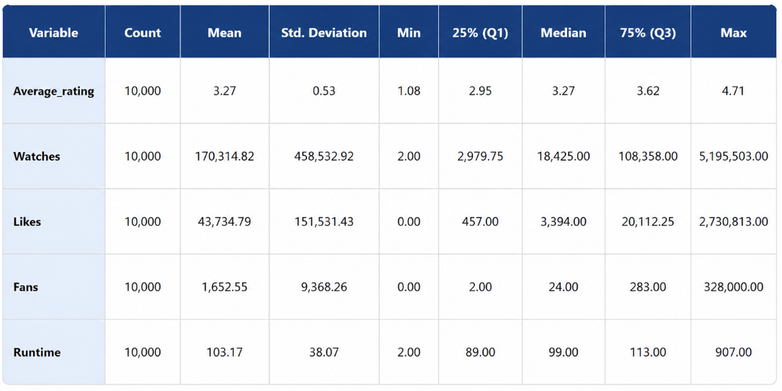

Appendix A2. Genre Rating Output

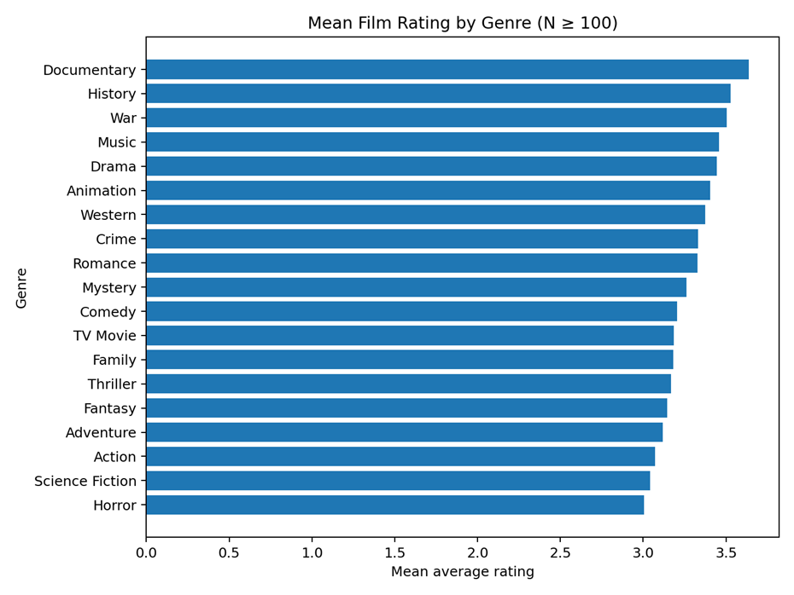

Appendix A3. Histogram Output

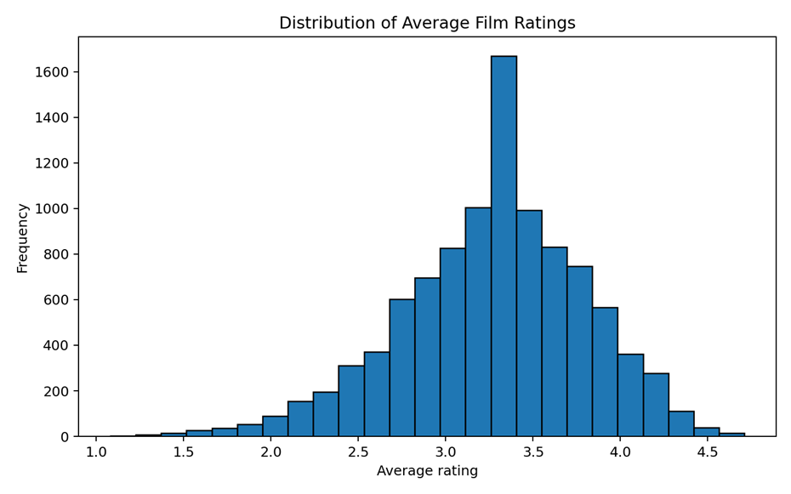

Appendix A4. Scatter Plot Output

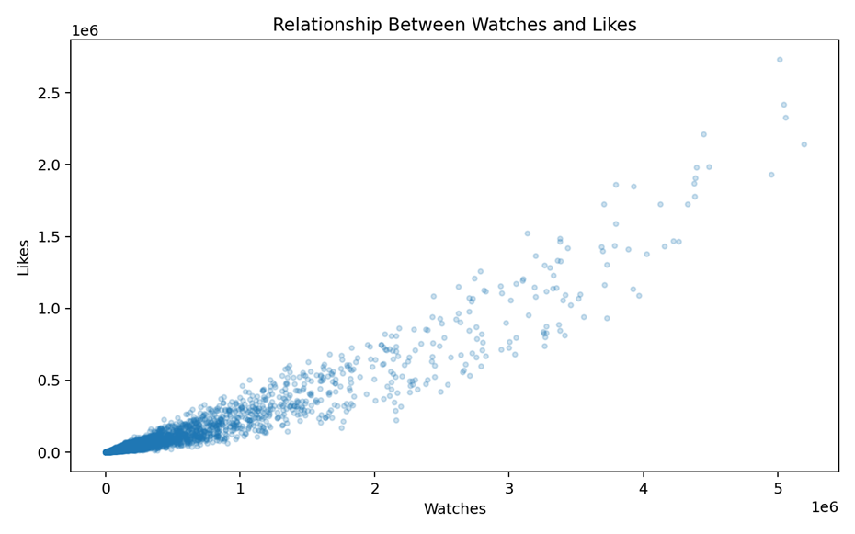

Appendix A5. Group Statistics

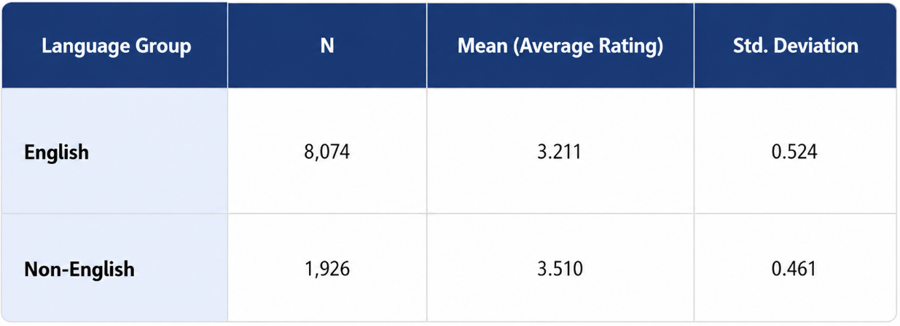

Appendix A6. Independent-Samples T-Test

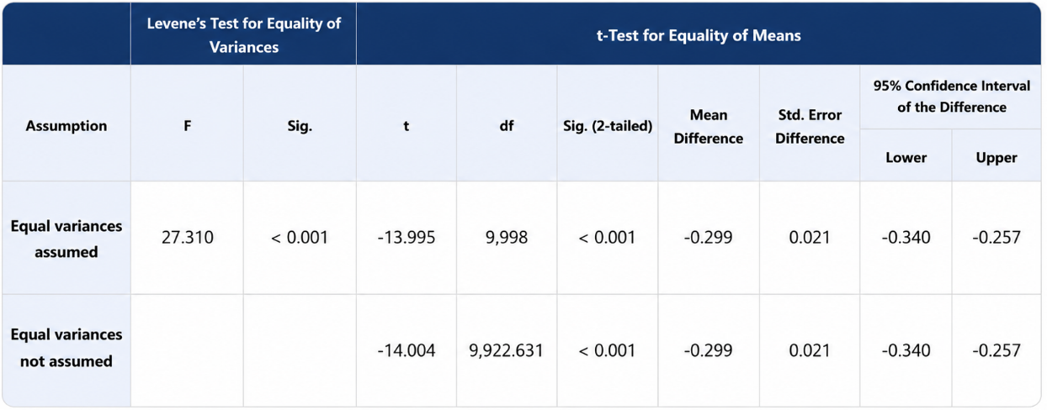

Appendix A7. Pearson Correlation Matrix

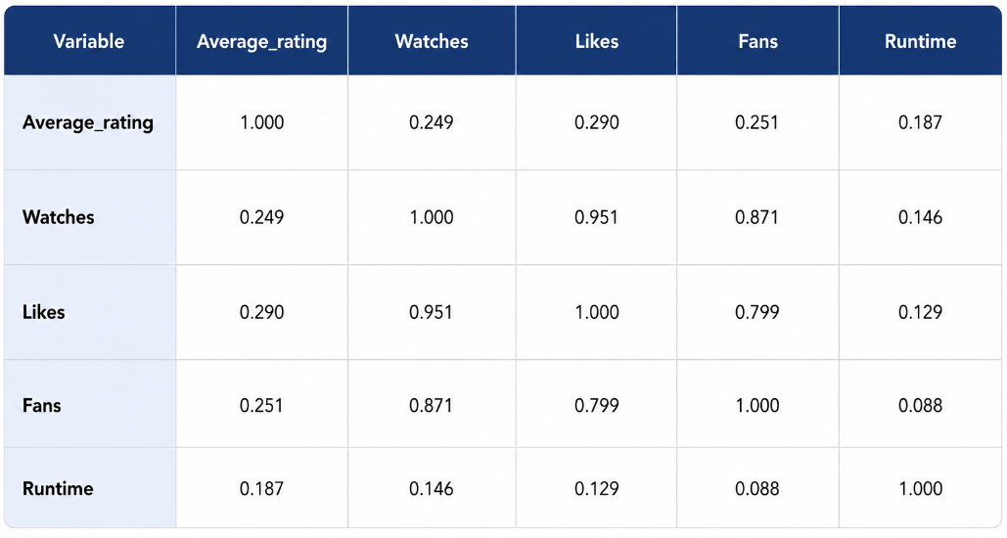

Note. With N = 10,000, the displayed non-zero correlations are statistically significant at p < .001.

Appendix A8. Regression Model Summary

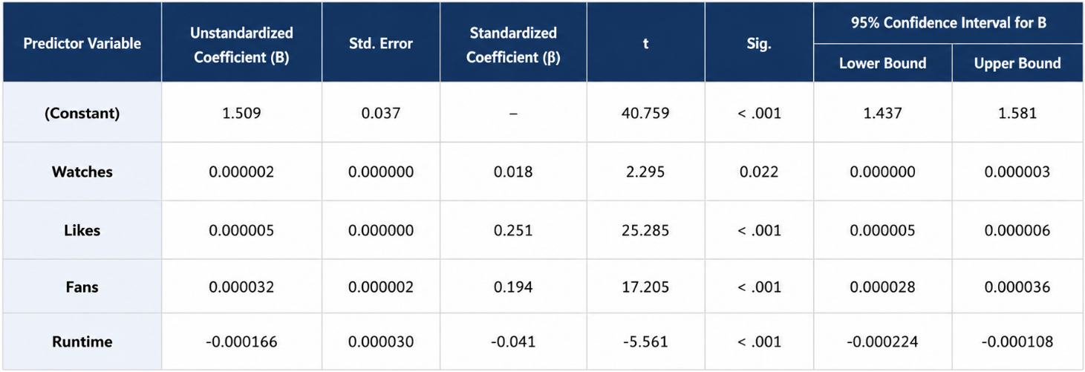

Appendix A9. Regression Coefficients

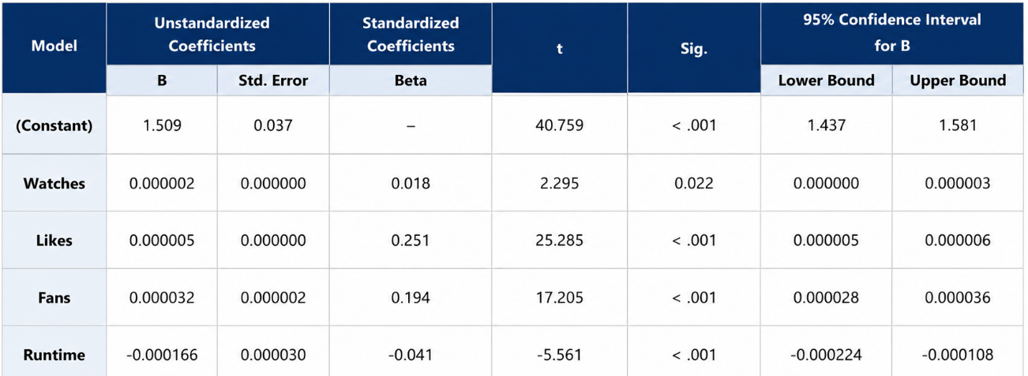

Dependent variable: Average Rating. Predictors: Fans, Likes and Runtime.

