John Dunkley-Williams (1903715)
20/01/2020
Module
Following are the BPMN and UML diagrams for programing a Lego Mindstorm Robot to draw 4 different shapes, with repeated increasing sizes.
Computational Thinking Level 4 Assessment
Lego Mindstorms

BPMN

Rectangle
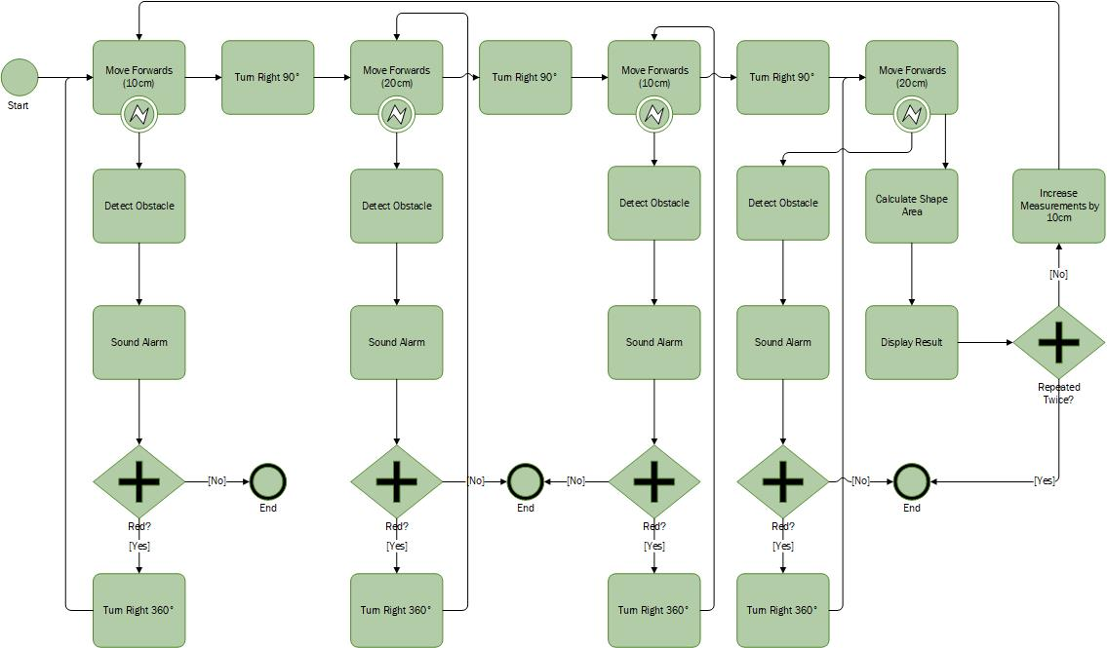

Triangle
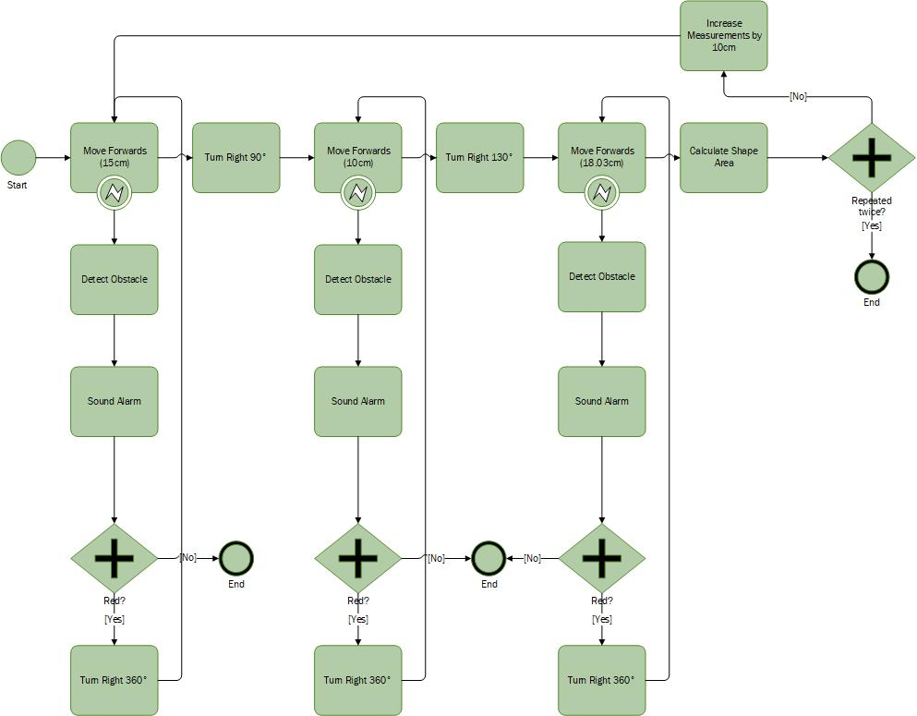

Circle in Square
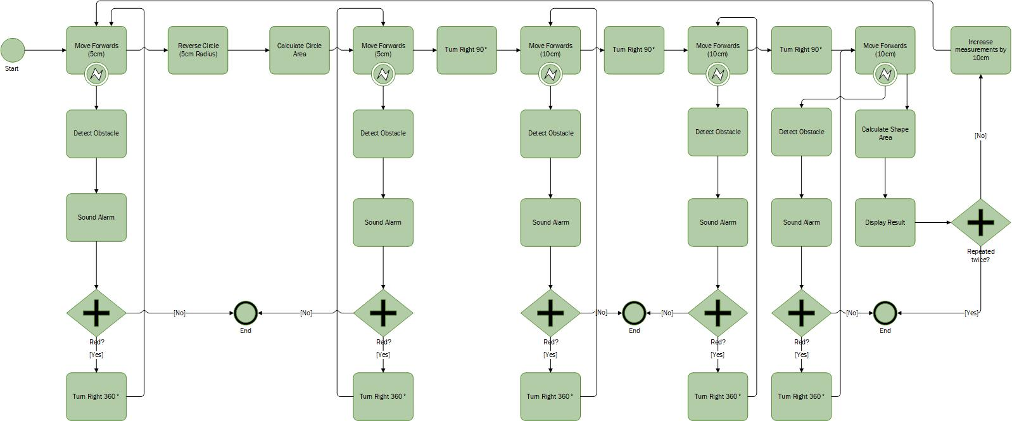

Symbol 4
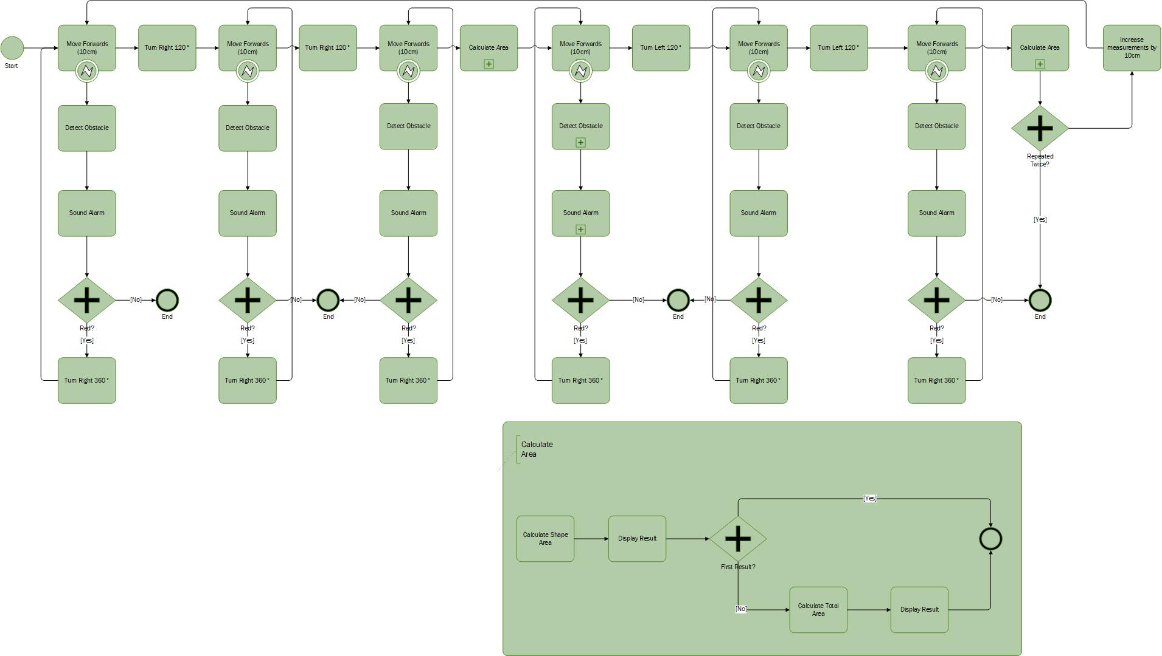

UML

Rectangle
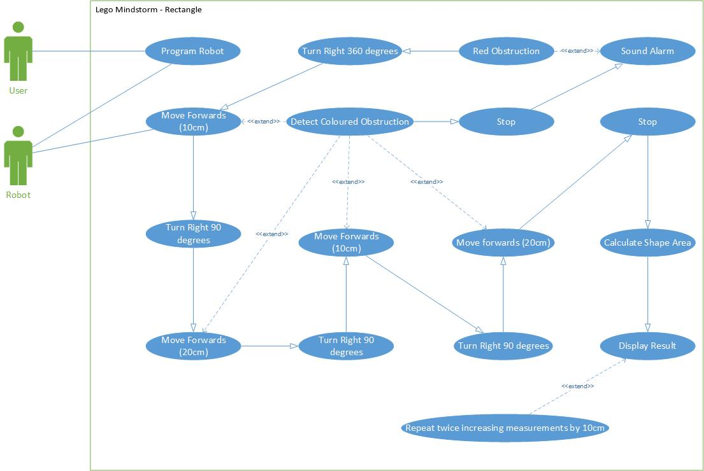

Triangle
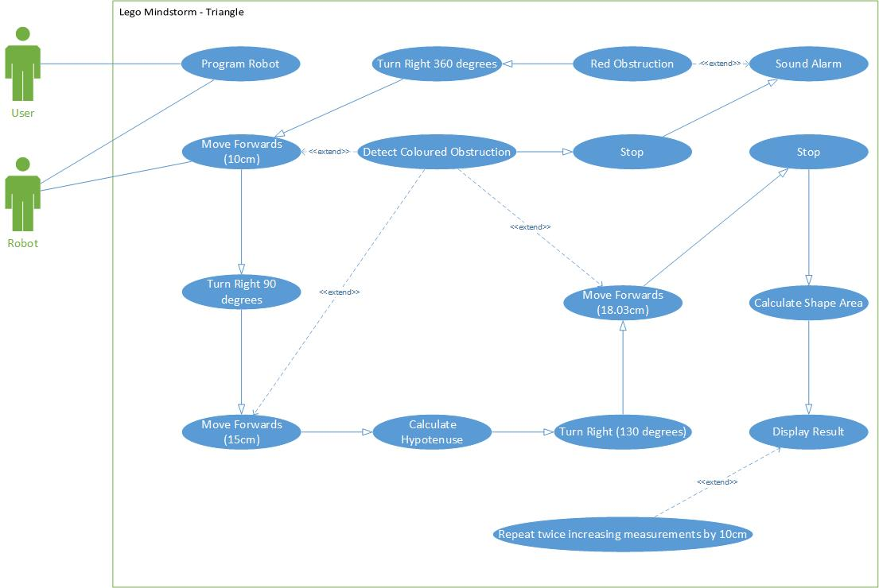

Circle in Square
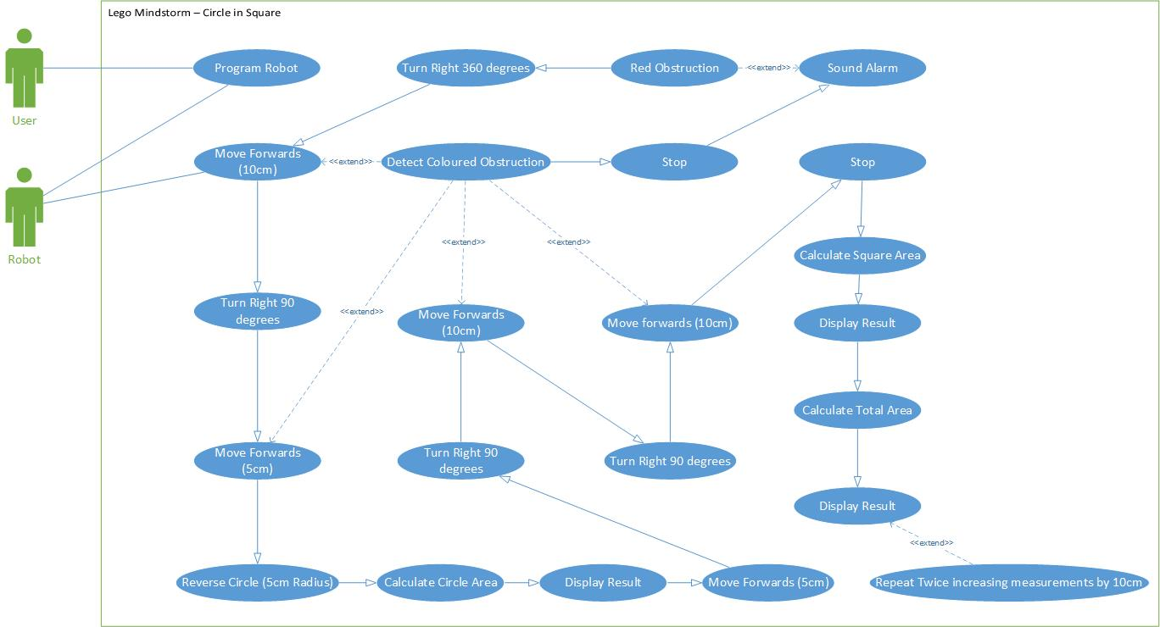

Symbol 4
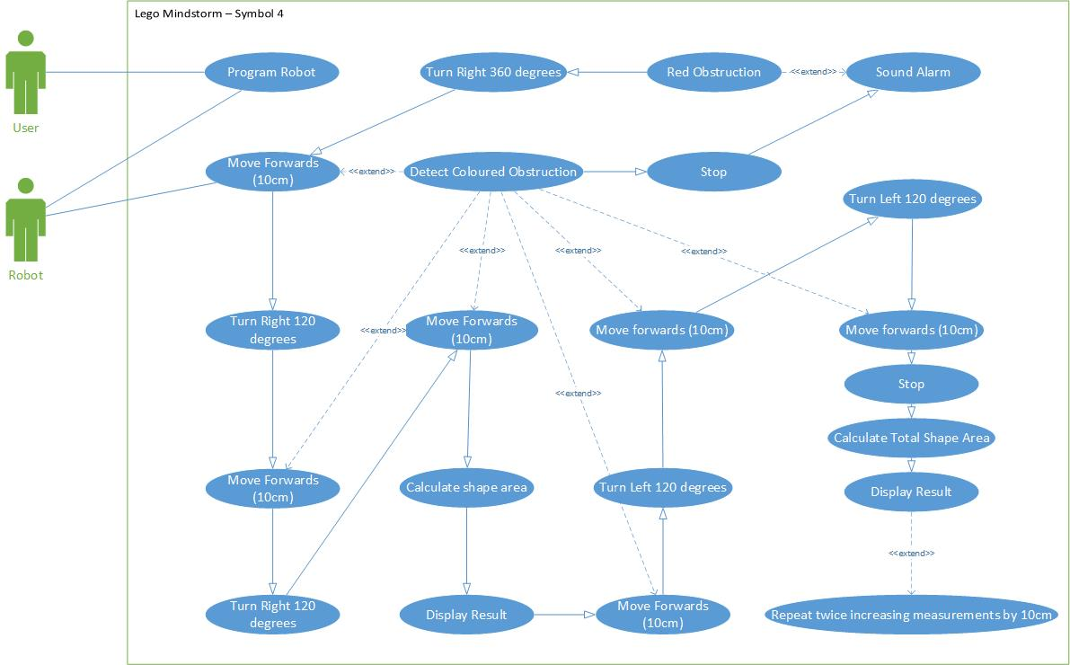

Building the Robot

Computational Thinking- Design and Implementation of a Lego MindStorms Solution
Group 1
See evidence of MindStorms solutions to problems provided below:
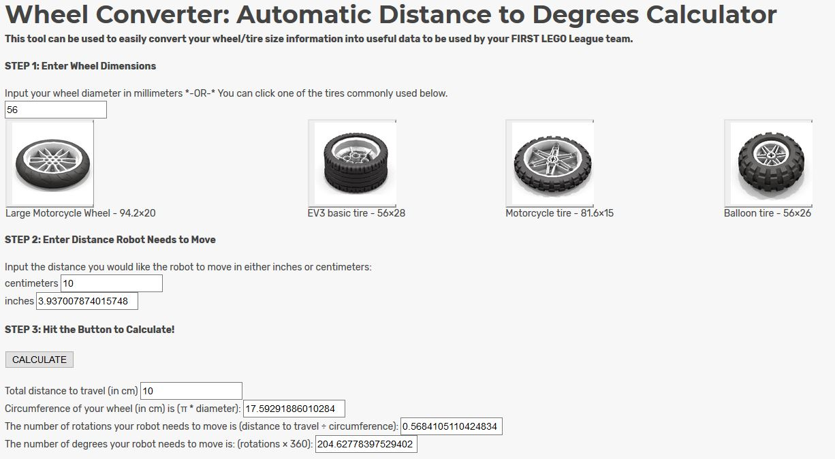
We began by using EV3: Lessons wheel calculator to determine our values.

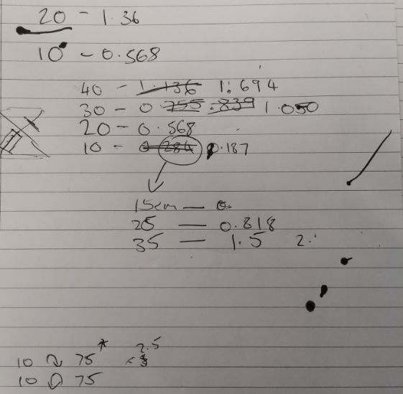

We had to adjust our initial workings as there was inconsistencies perhaps due to the surface and traction of the pen. We often experienced varied results from the same inputs, and so every calculation was a process of trial and error rather than actual maths.

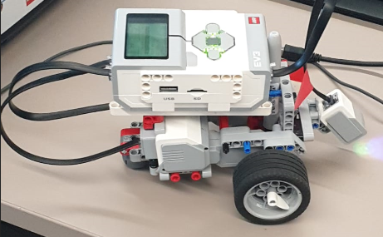
While a few of the team began working out the rotation values the rest built the robot, including a colour sensor.

The first shapes attempted were the rectangles as displayed below:
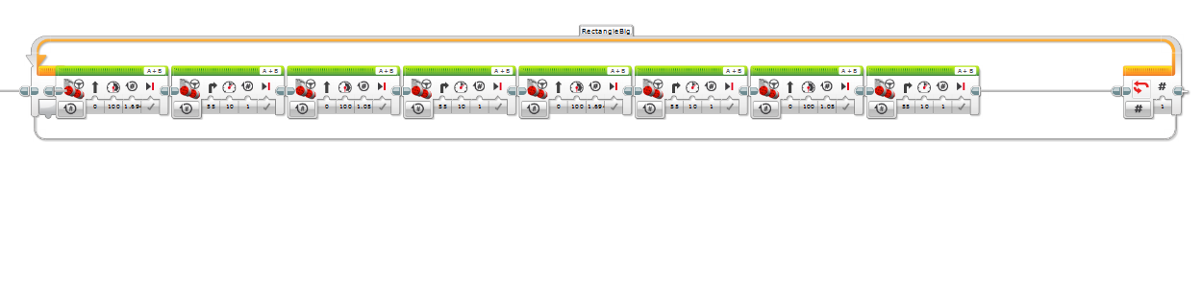
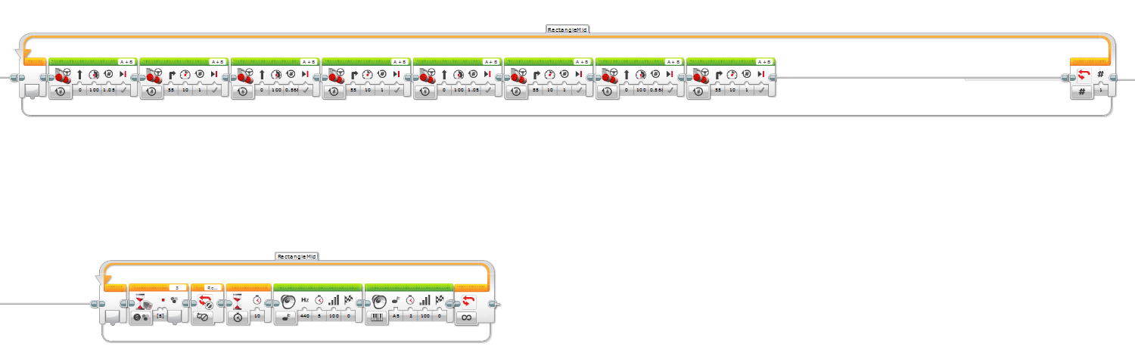
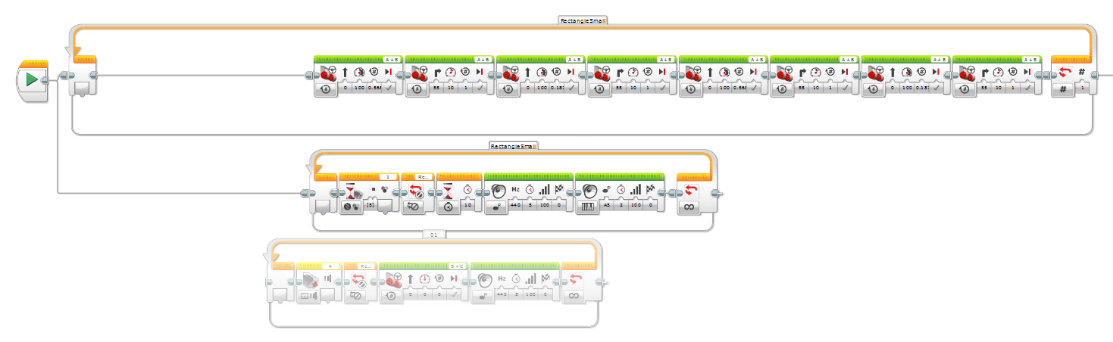
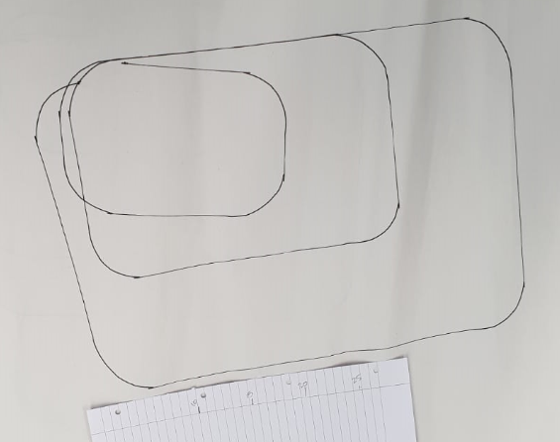
We programmed 3 rectangles to be drawn with values that increased each time.

We then attempted a tringle using a similar method:

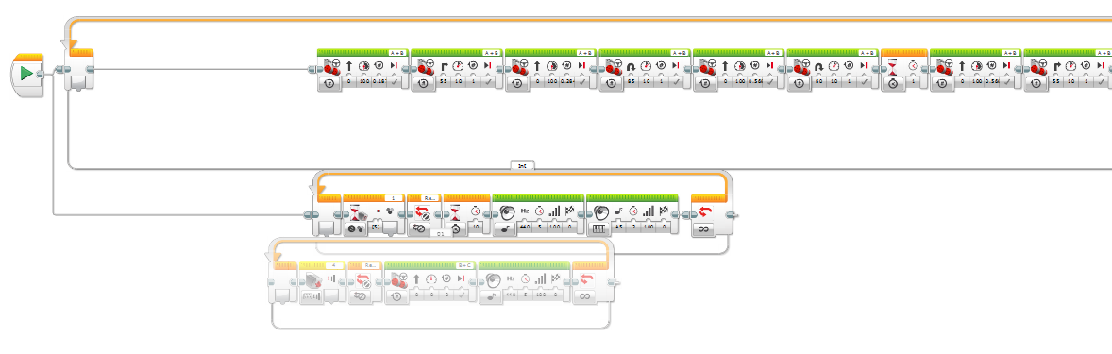
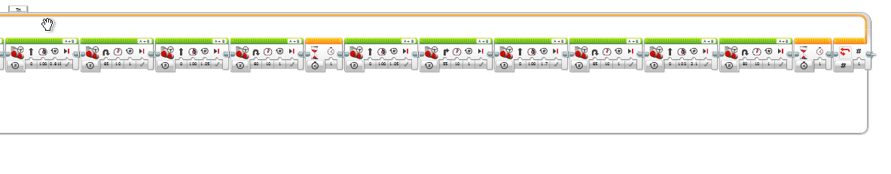
With some adjustments to the values we were able to draw three triangles with relatively decent accuracy. We actually had a better result from our initial test, drawing over many other test shapes, but as we repeatedly experienced, the exact same program yielded varying results.

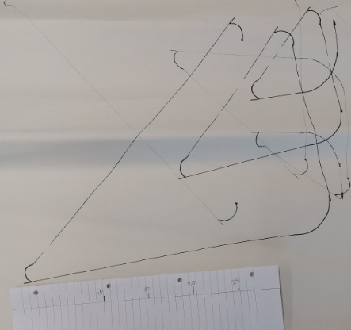

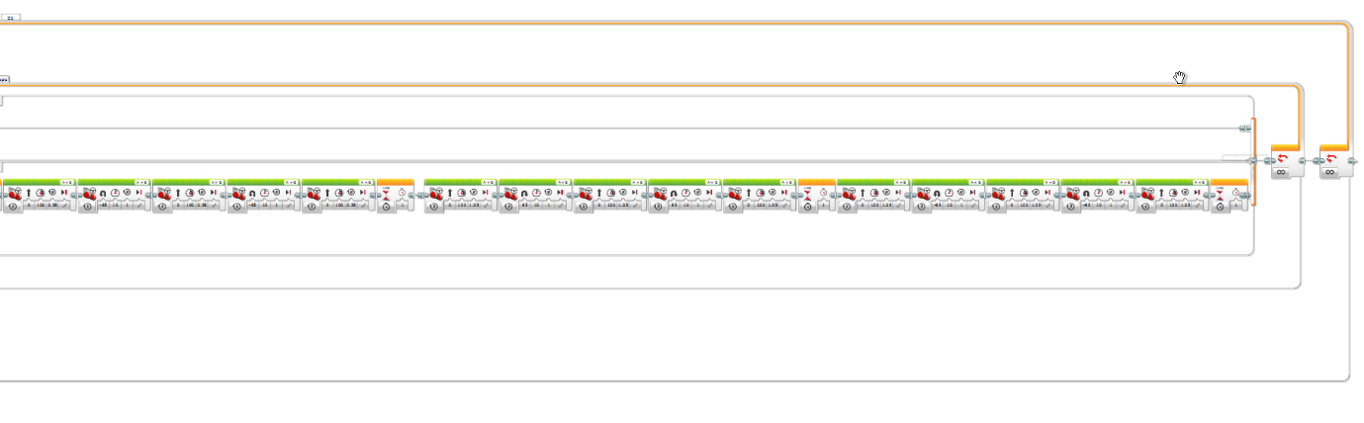
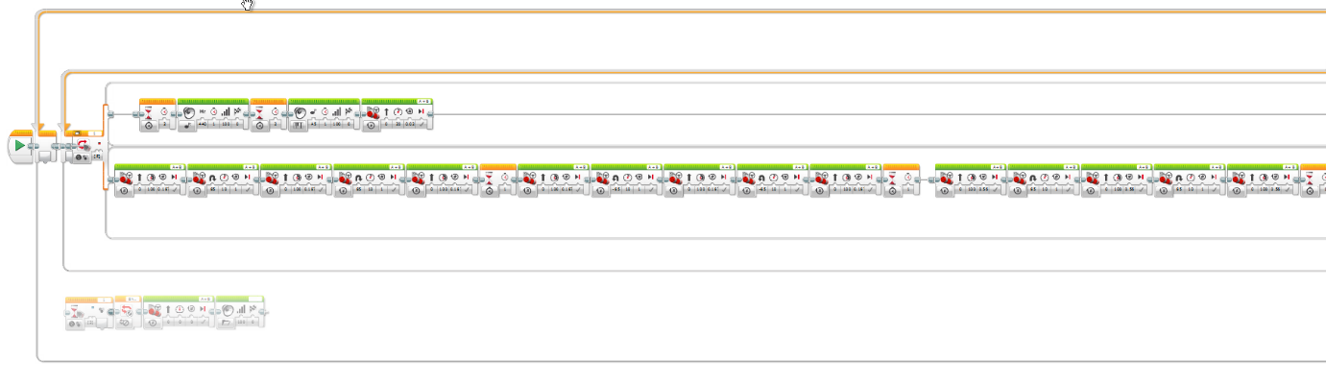
The next shape attempted was the join symbol:

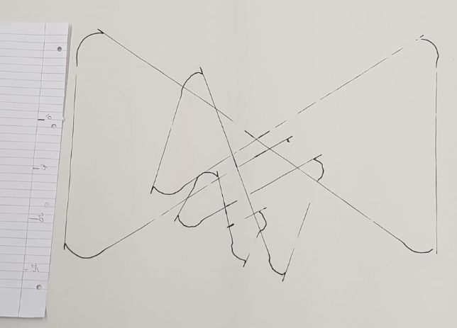

The quality of the largest shape convinced us that our angle measurements (repeated throughout) were within the 20% allowance, but again, there was a lack of consistency between the shapes.

We finally attempted the circle within the square but were unable to complete it before running out of time:
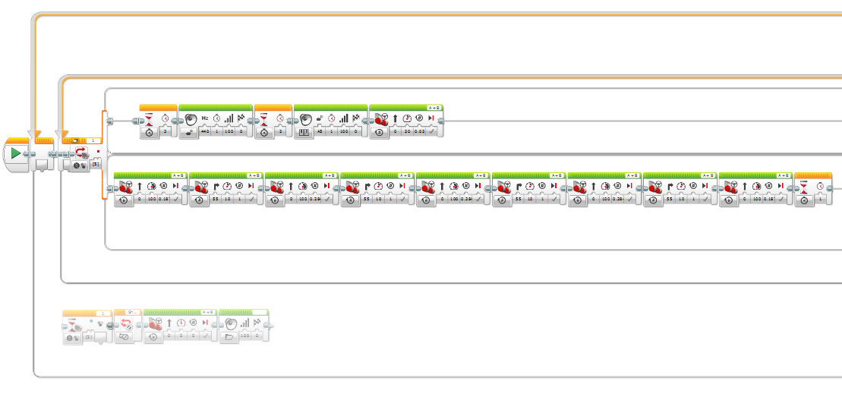
We were able to draw a decent square, but lacked time to program the circle.
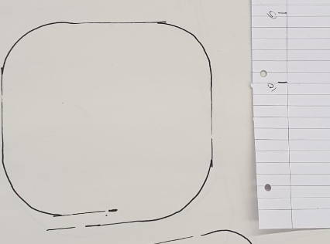

We also attempted to programme a light sensor to detect red tape, stop, play a tone and then continue with the shape. This was successful and demonstrated to David. The problems arose when we added another colour so eventually we ended up disconnecting that part of the process.
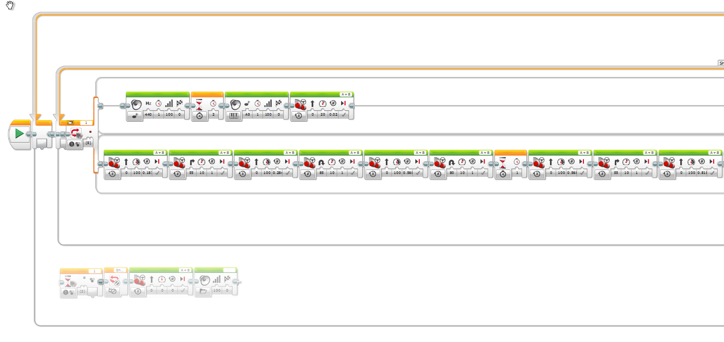
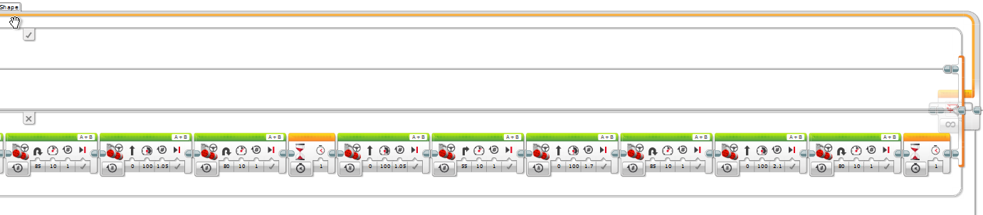

Overall, the biggest challenge was overcoming the inconsistent results with identical programs. The inconsistency was undoubtedly due to the friction of the pen, the carpet and the paper. Which we tried our best to hold flat during the trials.
None the less, we were able to create 3 out of the 4 shapes within the 20% margin of error, and program the colour sensor to detect a red obstacle, sound an alarm, and resume the program on removal.

