

The Global Business Environment

Assessment 1: Environmental Analysis of the UK fashion industry

Student Name: Anastasia Slepuhin
Student Number: 2013044

Module Lecturer’s Name: Hossein Shokri

Executive Summary

The business environment in which a firm operates greatly influences the success and failure of that organization. The COVID-19 pandemic and its consequential economic fallout have had a severely detrimental impact on the business environment of most industries. One such industry is the fashion industry. The COVID pandemic has brought about numerous changes in the political, economic, social, technological, legal, and environmental factors and this has made the business environment of the fashion industry quite adverse for its participants. Moreover, the pandemic has also caused certain structural changes to the fashion industry. For example, the bargaining power of buyers has increased during the pandemic. Similarly, the threat of substitutes has also increased. All of these changes in the business environment have brought about numerous challenges for the key players in the industry. For example, there is the challenge of declining sales and profitability. Similarly, greater pressure from suppliers to pay promptly is another challenge for the firms in the fashion industry. To address these challenges and to grasp any opportunities, fashion companies must adapt their business model and strategies. One way to do this is to make changes to the value chain of the company. This report shows how some fashion firms have been better able to cope with the pandemic by changing their value chain.

Table of Contents
Executive Summary ii
1. Introduction 1
2. Impact of pandemic and major forces shaping the business environment of the fashion industry 2
2.1 PESTLE analysis 2
2.2 Porter’s 5 forces analysis 3
3. Opportunities and challenges of key players in the fashion industry and adaptation of some firms to the changing business environment 6
4. Conclusion 9
References 10

Introduction
The COVID 19 pandemic has had an immense adverse impact on many different industries. It has resulted in unprecedented pressure on global health organizations, forced not so essential businesses to go into shuttering, and has forced the supermarkets to revise their stocking policy. Similarly, the pandemic has had a detrimental effect on the fashion industry around the world as well (Fair, 2020). As a fiscal heavy weight around the world, especially in developing countries, the fashion industry's deterioration due to covid pandemic would mean loss of jobs for thousands of designers, artists, workers around the world. This would have a diverse negative impact on the social, political, economic condition of the concerned country. This report will analyze how the pandemic has impacted the business environment of the fashion industry and affected the major stakeholders of the fashion industry.

Impact of pandemic and major forces shaping the business environment of the fashion industry
The impact of the COVID pandemic on the business environment of the fashion industry can be better understood by applying the PESTLE analysis and the porter’s 5 factors analysis.

PESTLE analysis
The PESTLE analysis is a model that evaluates the business environment of an industry. This model examines the political, economic, social, technological, legal, and environmental factors that shape the business environment of an industry (Marmol, Feys & Probert, 2012). The given image below represents the key forces making up the PESTLE framework.
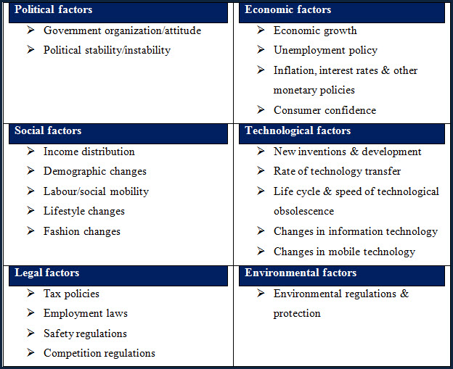
Figure 1:PESTLE Analysis, source: (Marmol, Feys & Probert, 2012)
Firstly, in terms of the political environment, UK’s decision to leave European Union will negatively affect the fashion industry of the UK, which is already suffering from the covid pandemic. This is because the fashion companies of the UK will no longer have tax-free access to the large EU market like before. Consequently, the business environment for the fashion industry will become less conducive for business (Smith, 2009). Secondly, the economic condition during the pandemic is also quite severe. Most of the major economies are facing hardship and slowdown. The GDP growth rate of the UK has also declined over the past few years. There has been a rise in the unemployment rate of the country. All of this is likely to reduce people’s tendency to spend on fashion products and this will harm the fashion industry (Heizer, 2020). Thirdly, the social factors that may affect the fashion industry include changes in customers' taste and sense of fashion. Moreover, it can be predicted that even if the pandemic goes away, there is a risk that people will reduce organizing and attending public events like weddings, restaurant gatherings, etc. and this will harm the sales of fashion retailers and companies (Fair, 2020). Furthermore, changes in consumer buying habits are also causing the British fashion industry to perform weaker as consumers are giving more emphasis on health, food, and safety products rather than fashion products. This pandemic will increase demand for protective gear and fashionable masks which is an opportunity for fashion retailers in the UK (Fair, 2020). Retail brands will need to shift towards selling more “casual wears” rather than selling going wears, sales of which is stimulated by public and private events, which has almost come to a standstill due to pandemic. Fourthly, technological factors have also evolved recently in the fashion industry due to the pandemic. UK Fashion retailers who do not have online selling platforms will be hit by the pandemic more severely (Nandonde, 2019). For example, British brand “Primark” has predicted a loss of 1-billion-dollar revenue due to the closure of its 305 physical stores worldwide as it does not have any online sales facility (Primark UK, 2021). On the other hand, online fashion retailers like “Asos” and “Boohoo” reported a 40 % increase in sales during the last four months of 2020. Sales on online platforms are rising after the covid pandemic. Thus, fashion companies operating in this business environment should consider investing in their online presence. Fifthly, in terms of the environmental factors, the Corona situation will make consumers take their spending decisions based on sustainability, ethics, value, and care for the environment (Tripathi and Reddy, 2012). Thus, fashion companies should try to incorporate these aspects in their business model. Lastly, legal factors such as changes in the government's tax policies or other legislations will impact the fashion industry. For example, changes in government regulations related to workplace safety, social distancing, etc. will influence the working hours, office policies of the fashion companies in the UK. To summarize, the overall business environment has become harsher for the fashion industry due to the various implications of the COVID-19 pandemic.

Porter’s 5 forces analysis
Porter’s five forces analysis is also conducted to evaluate the business environment in which a company is operating. This model examines five factors to understand the competitiveness of an industry (Tripathi and Reddy, 2012).
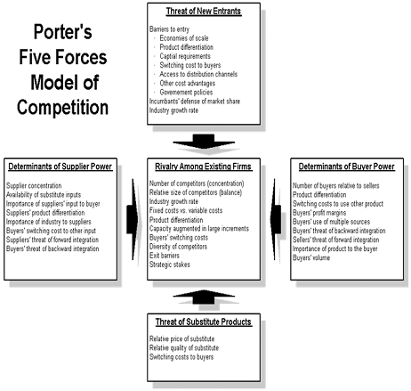
Figure 2: Porters Five-Factor Analysis, Source:(Tripathi and Reddy, 2012)

Porter’s analysis will evaluate an industry from the perspective of five factors. Firstly, the threat of new entrants is moderate for the fashion industry because of the existence of barriers to entry (Umarkhodjaeva, 2020). Because of the uncertain conditions of the market due to covid 19, a lower number of new businesses will be eager to enter the market now and as a result, the threat of new entrants for the existing firms in the industry will be moderate. Moreover, the high brand images of existing firms will also act as a deterrent to existing companies (Chappel, 2020). Secondly, the “bargaining power of suppliers” in the fashion industry has always been quite low since most suppliers belong to underdeveloped countries and are very much reliant on the orders given to them. Thus, they rarely bargain aggressively with fashion companies. Moreover, the number of suppliers is quite large, and these suppliers have had to undercut each other’s prices to get business orders. This also reduces their bargaining powers. Thirdly, although the UK fashion market had low bargaining power of buyers since fashion products are brand oriented and price inelastic, in these days of covid-19, buyers have got a moderate level of bargaining power as they have become quite price sensitive (Fair, 2020). As a result, they are either buying cheap fashion products or are not buying at all. Fourthly, the “intensity of the competitive rivalry” is quite high in the market since there is a large number of firms in the UK fashion industry. Finally, the “threat of substitute products” is moderate as many firms are offering a variety of clothing and fashion choices to the customers and customers can easily switch from one fashion brand to another. Moreover, the threat of substitutes is also higher now as many customers might substitute expensive fashion products with cheaper alternatives. To mitigate this threat, firms in the fashion industry should try to differentiate their products or develop customers’ loyalty towards their brand. Overall, the business environment of the fashion industry has become less auspicious for business due to the factors described above.

Opportunities and challenges of key players in the fashion industry and adaptation of some firms to the changing business environment

The changing business environment of the fashion industry has brought about numerous opportunities and challenges for the key players in the fashion industry. One of the main challenges faced by the fashion firms of the UK is a loss in sales and profitability. The overall decline in spending among customers due to the economic fallout of the pandemic is likely to affect non-necessity products like fashion items very severely (Chappel, 2020). Another challenge faced by the firms is in terms of adaptation of their product portfolio. Companies operating in the fashion industry have to always evolve to reflect the latest changes in consumer taste and shopping preferences. The pandemic is likely to bring about such changes in customer taste and the fashion industries have to update their product portfolios accordingly (Dauvergne, 2008). For example, the sale of masks has skyrocketed due to the pandemic and many alert fashion firms have introduced branded masks in their product portfolio. Thus, this challenge is also an opportunity for the key players in the fashion industry. The need to minimize the cost of production and operation is yet another challenge that has become extremely prominent due to the pandemic. In response to the falling sales and profitability, fashion companies must reduce their cost of operations to remain competitive (Plunkett and Attner, 2014). Thus, key players in the fashion industry must identify measures to streamline their costs. Other challenges arising from the pandemic include managing complicated relationships with suppliers vying for their receivables, adhering to stringent government health, safety, and lockdown policies, addressing the concerns of environmental groups, etc. In addition to the challenges, the COVID pandemic has brought about certain opportunities as well for the key players of the fashion industry. As already discussed, one opportunity is to redesign the existing product portfolios to better reflect the changed customer taste. Another opportunity is to contribute to society in this troubling time through the CSR expenditures of the fashion firms (Taylor, 2020). The COVID-19 pandemic has made many people financially vulnerable. Fashion companies in the UK can divert their annual funds reserved for corporate social responsibility motivated spending to the rehabilitation of individuals affected by the pandemic. This makes business sense as well, as such spending will improve the image of the fashion firms and should enhance customer’s loyalty to their brands.
In face of the above challenges and opportunities, some firms in the UK such as “Asos” have been better able to adapt by making changes to their value chain. Porter’s value chain represents a number of primary and secondary activities that together add value to the market offering and value proposition of a company (Walters and Rainbird, 2004). Famed management consultancy company, Mckinsey & Company stated that adapting the value chain is a must for companies trying to survive the pandemic.

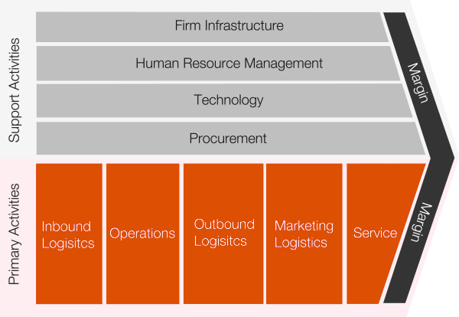
Figure 3: Porters Value Chain Analysis, Source:(Walters and Rainbird, 2004)
Primark, a renowned British fashion retailer, suffered a loss of almost 1 billion dollars as it exclusively relied on its physical stores and failed to “go online” during the pandemic. Since the physical stores had to be closed for prolonged periods due to the lockdown, there was a loss of sales revenue and profits. In contrast, another British company “Asos” changed its value chain due to the challenges of physical selling during the pandemic (Asos.com, 2021). Asos changed its “marketing logistics” activities to focus more on online sales through its e-commerce website instead of sales through physical stores. In order to facilitate this change, Asos invested heavily in its “technology” support activities. So much so that the CEO of Asos, Mr. Nick Beighton said that “digitalization, agility and connectivity” these three things have helped Asos to cope with the pandemic. Moreover, the provision of “services” to customers also had to be modified and employees had to be trained accordingly. This necessitated Asos to rethink its human resource management policies and activities (Asos.com, 2021). Asos also faced the challenge of experiencing declining sales of one of its most famous products; “outdoor wear” because of people's reluctance and inability to hang out in the outdoors during the pandemic. In response to this, Asos shifted its focus from “going out gear” to more casual wear as the possibility of “going out” was restricted during lockdown. To do this, Asos had to make changes to its “inbound logistics” function of the value chain. Asos either canceled or re-phased the sourcing of half a billion-dollar worth of “going out wear”. Similarly, the “procurement” activities of the value chain had to be modified to cater to the new product strategy of the company. Finally, to adhere to the various healthcare and lockdown policies recommended by the government, Asos had to make changes to its “firm infrastructure” and “operations” activities. All in All, Asos was able to better able to cope with the pandemic and be successful in the fashion industry by making prudential changes to its value chain (Taylor, 2020).

Conclusion
In conclusion, it can be said that the COVID-19 pandemic has greatly disturbed the fashion industry. The business environment has become less conducive for fashion firms in the UK and many small firms have had to either shut down their businesses totally or limit the scale of their operations. Moreover, the pandemic has exposed the key players in the fashion industry to numerous challenges, albeit providing some opportunities as well. A strategic modification of the value chain has been a potent way for some firms in the fashion industry to better adapt to the repercussions of the COVID-19 pandemic. This suggests that it is imperative for all firms in the fashion industry to be constantly aware of the changes taking place in their business environment and adapt to those changes swiftly and with alacrity.

References

ASOS. 2021. ASOS | Online Shopping For The Latest Clothes & Fashion. [online] Available at: <https://www.asos.com/> [Accessed 14 March 2021].
Chappel, K., 2020. PANDEMIC IMPACT ON FASHION CONSUMPTION CHANGE: FOCUSING ON COVID-19. Global Fashion Management Conference, 2020, pp.645-646.
Dauvergne, P., 2008. The Shadows Of Consumption. Cambridge, Mass.: MIT Press.
Fair, A., 2020. PANDEMIC IMPACT ON FASHION CONSUMPTION CHANGE: FOCUSING ON COVID-19. Global Fashion Management Conference, 2020, pp.645-646.
Harris, N., 2000. Harvard Business Review On Managing The Value Chain. Boston, MA: Harvard Business School Press.
Heizer., 2020. Principles Of Operations Management. Harlow, United Kingdom: Pearson Education, Limited.
Marmol, T., Feys, B. and Probert, C., 2012. PESTLE Analysis.
Nandonde, F., 2019. A PESTLE analysis of international retailing in the East African Community. Global Business and Organizational Excellence, 38(4), pp.54-61.
Plunkett, W. and Attner, R., 2014. Introduction To Management. Belmont, Calif.: Wadsworth.
Primark.com. 2021. Primark UK | Fashion, Home & Beauty | Take Care, Stay Safe. [online] Available at: <https://www.primark.com/en> [Accessed 14 March 2021].
Smith, M., 2009. Business Environment. Oxford: Elsevier Science & Technology.
Taylor, F., 2020. The Principles Of Scientific Management. La Vergne: Neeland Media LLC.
Tripathi, P. and Reddy, P., 2012. Principles Of Management. New Delhi: Tata McGraw-Hill.
Umarkhodjaeva, M., 2020. Analysis of Factors Affecting the Institutional Environment of Small Business Management in the Food Industry. Journal of Advanced Research in Dynamical and Control Systems, 12(7), pp.300-313.
Walters, D. and Rainbird, M., 2004. The Value Chain. [Bradford, England]: Emerald Group Pub.

