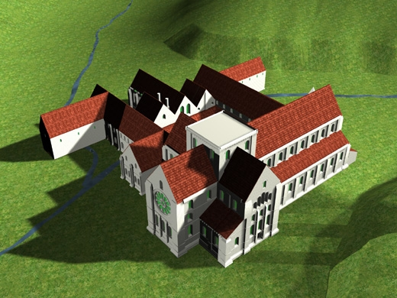
Figure 1 - Reconstruction of the Cistercian abbey of Roche seen from the north east.
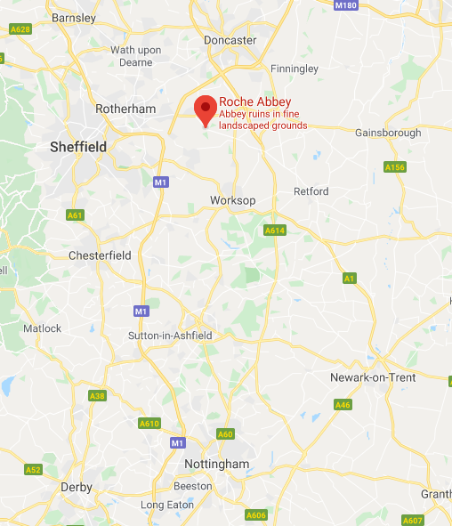
Figure 2 - Roche Abbey and the surrounding towns and cities.
Figure 1 shows a reconstruction of the Cistercian abbey of Roche in the county of York, nine miles from the towns Doncaster and Worksop and a short distance from the border of Nottinghamshire. The abbey is situated near modern-day Sheffield. The abbey was built by a group consisting of an abbot, twelve monks and twenty lay brothers from Newminster Abbey in Northumberland. Newminster Abbey had been founded just nine years earlier by monks from Fountains Abbey in Yorkshire, making Newminster it’s mother abbey.
In keeping with the Cistercian tradition of founding a monastery in loco horroris et vastae solitudinis, translated as “a barren and howling waste” the abbey was founded in a “densely wooded valley”. The land was donated to the monastery by Richard de Buili and Richard Ditz Turgis, two local lords who owned the valley. These lords acted as patrons and protectors of Roche Abbey. The name of the abbey, Roche, can be translated from French as ‘rock’. The original name for the abbey was Sancta Maria de Rupe, “from the Latin rupes, ‘rocks’ or cliff’” named for its “distinctive limestone outcrops framing three sides of the valley.” Sancta Maria de Rupe translates to “Saint Mary of the Cliff” A dedication to the Virgin Mary, mother of Jesus. This was perhaps to show their dedication to Mary, but it could have also been to invoke her name for protection.
The valley chosen as a particularly barren and howling waste was favourable because it contained the Maltby Dike, a river. In a style similar to Fountains abbey, several buildings were constructed over the river, with no buildings after them. In Roche abbey, these buildings were the frater – the refectory, a communal dining area, the dorter – the dormitory, and the reredorter – a communal latrine. The layout of these rooms ensures that the reredorter was the last room before the river flowed away from the abbey, ensuring a fresh supply of water, without any waste in. Just after the reredorter was the Infirmary lodgings, presumably from which any waste was also put into the river to be disposed of.
There are many aspects that we can see throughout the image that are reminiscent of many abbeys, including the cross-shaped church, including the transepts which contain private chapels. We can also see a tower that was built over the intersection of the transepts and the quire. The lack of roof on the tower is a point of interest. A roof could indicate that the tower was used to house bells, with the roof hiding the bells from public viewing, but the lack of a roof indicates that it might have just been a regular tower. The abbey itself was built in the gothic style and has been regarded as “the country’s first authentic Gothic building.” This gothic style was utilised in many Cistercian monasteries built during and after the twelfth century. Although the abbey was constructed in the gothic style, the layout of the buildings was seen throughout any different monasteries and was not exclusive to the Cistercians. The abbey at Cluny has an extremely similar layout, showing that it was a Benedictine tradition.
Figure 1 also shows us a rather large stained-glass window that is present on the easternmost wall of the church, which would have been viewable when praying facing east, either from the altar or from the quire. From examining The Rule of Saint Benedict, in which it is stated that lavish buildings, garments and decorations should be kept, it would be easy to think that this inclusion is out of place. Abbeys were a place of dedication both to the Virgin Mary and God, and were allowed pieces of grisaille glass, a fairly simple formed of stained glass including few colours and simple designs. This later evolved into stained glass dedicated to the Virgin Mary and involved more lavish forms of stained glass. Perhaps such a lavish form of stained glass was seen as a form of dedication to God and a way to show his love in a very obvious way, by having his light shine through the window each morning, spreading colours and an incredible sight over the altar. This, however, does conflict somewhat with the plain life of the Cistercians and seems more fitting of a Cluniac church.
From figure 1, we can also see several other rooms surrounding a cloister; a central area allowing for ease of travelling between buildings. The other rooms would have included a library, a vestry – a room for storing important items needed for ceremonies, a chapter house – in which meetings could be held between the abbot, prior and perhaps visitors, and areas for the monks to read, write and work in.
In conclusion, the recreation of Roche Abbey, as seen in figure 1 tells us many things about the Cistercian’s way of life, and how they constructed their abbeys. It also shows us that the areas they chose to establish their new monasteries may have been in loco horroris in spirit, but in reality, the areas may have been quite lovely.

Cistercians in Yorkshire Project, The Cistercians in Yorkshire (n.d.) <https://www.dhi.ac.uk/cistercians/roche/> [accessed 28 February 2020].
Google Maps, Roche Abbey - Google Maps, 2020 <https://www.google.com/maps/place/Roche+Abbey/@53.4024905,-1.1857001,17z/data=!3m1!4b1!4m5!3m4!1s0x48790adb89df2dc3:0xfc705d4c0be45a08!8m2!3d53.4024873!4d-1.1835114> [Accessed 01/03/2020].
James Hobson Aveling, Yorkshire: The History of Roche Abbey, from Its Foundation to Its Dissolution (Worksop: Robert White, 1870), p. xx.
See Figure 2.
English Heritage, History of Roche Abbey | English Heritage (2020) <https://www.english-heritage.org.uk/visit/places/roche-abbey/history/#a2-roche-h> [accessed 28 February 2020].
Peter J. Fergusson, 'Roche Abbey: The Source and Date of the Eastern Remains', Journal of the British Archaeological Association, 31.1, (1971), 30-42 (p. 31).
Deuteronomy 32:10.
Fergusson, Roche Abbey, p. 31.
Fergusson, Roche Abbey, p. 30.
English Heritage, History of Roche Abbey.
English Heritage, History of Roche Abbey.
Marten Kuilman, 3.3.1.2.2. The Latin cross type | Quadralectic Architecture (2010) <https://quadralectics.wordpress.com/3-contemplation/3-3-churches-and-tetradic-architecture/3-3-1-the-form-of-the-ground-plan/3-3-1-2-the-cross-shaped-plan/3-3-1-2-2-the-latin-cross-type/> [accessed 28 February 2020].
Fergusson, Roche Abbey, p. 30.
The Rad Trad, The Rad Trad: Abbey of Cluny (2013) <http://theradtrad.blogspot.com/2013/05/abbey-of-cluny.html> [accessed 1 March 2020].
Cistercians in Yorkshire Project, Spirituality (n.d.) <https://www.dhi.ac.uk/cistercians/cistercian_life/spirituality/index.php> [accessed 1 March 2020].

