Programme Name: Master of Business Administration (MBA)
Module Name and Code: Human Capital Management (LCMB7023)
Title of Submission: Designing a Human Capital Architecture for Strategic Renewal: The Case of Helios Urban Mobility (HUM)
Lecturer's Name: Vasilios Tavlaridis, Gladius Kulothungan, Eno Maycock, Hoang Nguyen

Student Name : Janvi Radadiya
Student ID : 2538338
Word Count: 2717
Submission Date: 17-07-2026

Table of Contents
Introduction 3
TASK A: Socialisation, Identity & Business Activism 3
1. Traditional Onboarding versus Strategic Organisational Socialisation 3
1.1 Traditional Onboarding 3
1.2 Strategic Organisational Socialisation 3
1.3 Critical evaluation: 4
2. Strategic Socialisation Framework for Helios 8
2.1 Proposed framework 8
2.2 Justification 10
3. Building Organisational Citizenship and Business Activism 10
3.1 Organisational Identification 10
3.2 Ethical Professionalism 11
3.3 Business Activist Mindset 12
TASK B: Job design 13
1. Proposal of an innovative job design strategy 13
1.1 Critique of traditional design 13
1.2 Integrated job architecture for Helios Urban Mobility 14
2. Stimulating intrinsic motivation and supporting innovation through the design 17
2.1 Stimulating intrinsic motivation with the design 17
2.2 Supporting innovation, goal setting theory and performance management cycle through human capital agility 20
2.3 Strategic evaluation of proposed job design 20
TASK C: Reflective report 22
1. Introduction 22
2. Using AI as a decision-support tool in strategic HR practices 22
3. Professional reflection on capability development 22
4. Personal development plan 23
Conclusion 24
Reference list 25

Introduction
Onboarding programs, in case of poor designing can lead to confusion and feeling disconnected from company culture. According to Insight Global 2025 Employee Sentiment Report, 22% of employees resign from their jobs within the first 90 days of onboarding, whereas only 35% of employees feel connected with their jobs (ET, 2025). It is imperative that employees feel connected with company culture and ethos to feel engaged and being productive. In case of high attrition rate and lack of engagement, it can be perceived that a company is failing to connect with its employees, which can be overcome with effective job design.

TASK A: Socialisation, Identity & Business Activism

1. Traditional Onboarding versus Strategic Organisational Socialisation
Helios Urban Mobility (HUM) reported core HR issues, including a lack of structured onboarding, leaving new employees unproductive for 8 months, declining employee engagement by 54%, and a high attrition rate of graduates or future leaders. To accelerate employee productivity and retention rate, a strategic organisational socialisation can be imperative to assimilate organisational culture among recruits.

1.1 Traditional Onboarding
This typically involves an administrative standpoint, a procedural approach, and bureaucratic supervision. Bound by compliance, stringent rules, and passive training, traditional onboarding leads to information overload and a high attrition rate (Didion et al. 2024).

1.2 Strategic Organisational Socialisation
Alternatively, it is a planned and targeted onboarding process where recruits become aware of the organisational culture and master the skills for their job (Junça Silva et al. 2026). Prioritising relational elements, this onboarding strategy aims to immerse employees in the organisational culture. However, this onboarding strategy is resource-intensive.

1.3 Critical evaluation:
Situational factors
According to “Van Maanen and Schein's Socialisation Theory”, traditional onboarding follows collective ideology by clustering all recruits together with highly formal and random progression, but strategic organisational socialisation prioritises individualised or personalised coaching, accompanied by an informal and sequential training approach to foster signature strength (Godinho et al. 2023).
Stakeholder interest
Through the lens of “Psychological Contract Theory”, traditional onboarding sets unrealistic expectations for employees, but strategic socialisation establishes mutually respectful expectations, which pave the foundation for long-term commitment (Somu and Ali, 2025; Week 3 Lecture note).
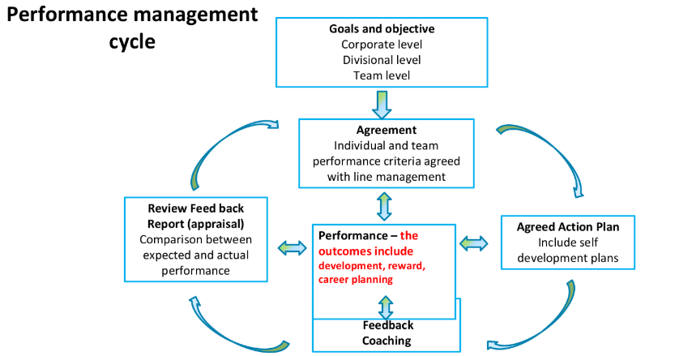
Figure 1: Managing probability for achieving success
(Source: Recruitment and Performance, P.20)
HRM policy choices
According to “Identity Construction Theory”, traditional onboarding compels recruits to make sense of the organisational environment on their own, but strategic socialisation acknowledges employees’ independent identities, assimilating in the organisational culture. From the perspective of performance management, employees should be guided, monitored, rewarded as per contribution, and subjected to a continuous and comprehensive natural process of management, supporting future career growth (Recruitment and Performance, P.20).

HR outcomes
Traditional onboarding resembles hard HRM principles, but strategic socialisation embodies soft HRM principles (Week 1 HCM Lecture, p.15). In 2025, 52% of employees expressed intentions to leave their jobs; poor onboarding strategy strongly correlates with this desire (Gallup, 2025).
Long-term effectiveness
In a nutshell, evaluating the problems of HUM, integrating strategic organisational socialisation emerges as a more competent HR policy to encourage long-term commitment and increase employee retention rate (Week 1 HCM Lecture, p.13).
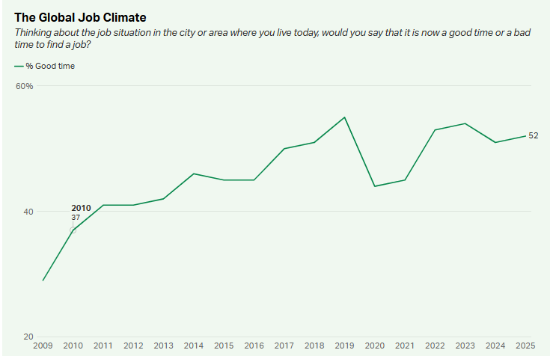
Figure 2: More than fifty percent of employees seeking to leave their current job roles
(Source: Gallup, 2025)
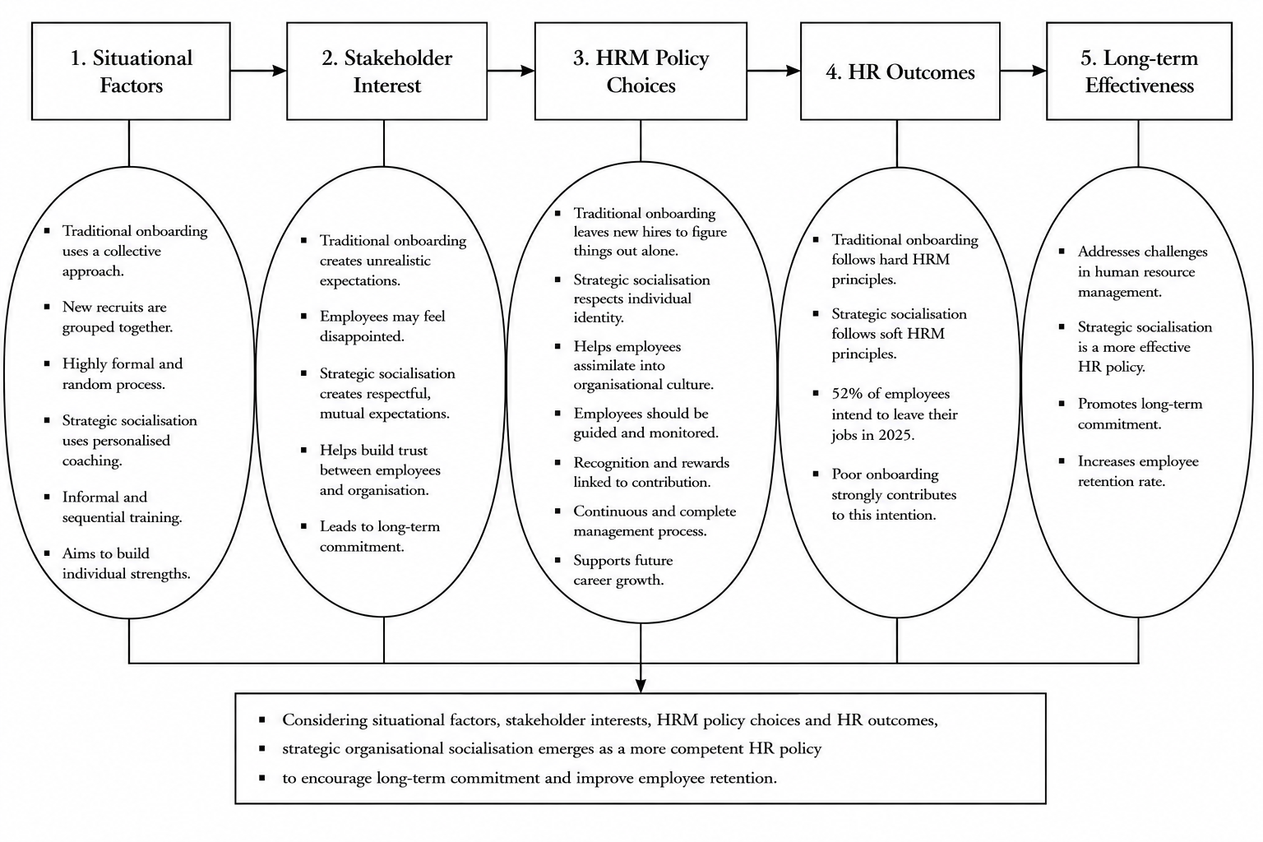
Figure 3: Factors contributing to designing HR policy
(Source: Inspired by Week 1 HCM Lecture, p.13)

2. Strategic Socialisation Framework for Helios

2.1 Proposed framework
Pre-onboarding
Challenges of Helios recruits
Uncertainty about job roles and expectations (aligns with Psychological contract theory’s mutual expectations).
Proposed HR intervention
Developing a welcome portal, assigning a paired assignment with a peer, and clearly stating expectations can be effective.
Expected outcome
Helios can expect reduced uncertainty, good rapport with onboarding buddy, and justification about managerial expectations of performance aligns with Goal Setting theory (Recruitment and Performance, p.24).
First 90 days
Challenges of Helios recruits
Culture shock, adjustment issues (psychological, interaction, and work atmosphere), information overload, and unclear rules.
Proposed HR intervention
Offering structured guidance, organised step-by-step training programs, learning, facilitating cross-functional networking opportunities to build cross-team collaboration competency, and providing monthly performance feedback.

Expected outcome
Helios may expect accelerated productivity (aligns with Goal Setting theory), increased engagement, and fostering sense of belongingness underpinning the “Expatriate adjustment phase” and reaching “adaptation” stage (Expatriation and international recruitment risk analysis, p. 19).
Year 1
Challenges of Helios recruits
Uncertainty about career trajectory, high attrition rate, and lack of long-term commitment to Helios,
Proposed HR intervention
Implementing effective mentoring and initiating succession planning,
Expected outcome
Helios can expect increased engagement and retention rate.

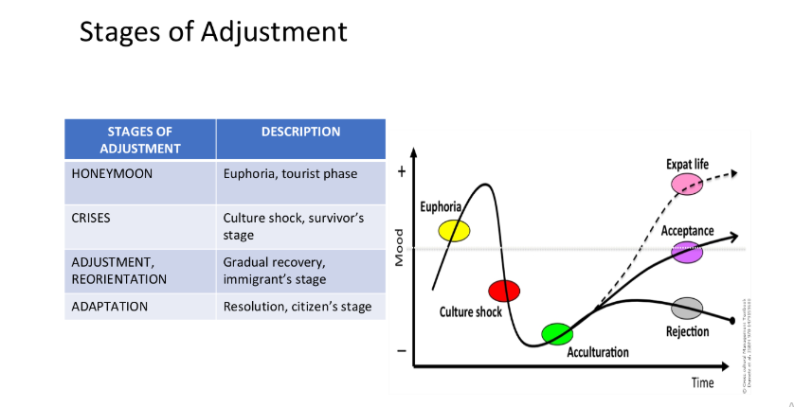
Figure 4: Expatriation stage adjustment
(Source: Expatriation and international recruitment risk analysis, p. 19)

2.2 Justification
From the viewpoint of “Assessing Potential for Strategic Socialization”, a justification for proposed socialization can be obtained (Week 3 Lecture, Slide 18).
Many assessors
HR team, job assignment with onboarding peer, digital welcome portal, clear outline of performance expectations, 360⁰ performance feedback from self and team leader, collaborative cross-functional performance, succession planning, and mentoring will be the trained evaluator to assess employee competence and job performance requirements.
Manage/Individual
Helios can implement clear communication about job role and performance, meeting with the HR manager and team leader, self-reflection about one's own performance against established goals, career aspirations discussions and career development planning, and offering structured mentoring.
Strategic justification
Person-centric training and guidance increase engagement, strengths association with core organisational values, building trustworthiness, encouraging improved productivity, aspiring to a long-term commitment and increasing retention rate can be achieved by Helios.

3. Building Organisational Citizenship and Business Activism

3.1 Organisational Identification
Proposed mechanisms
“Social Identity theory” may serve as a guiding philosophy to foster a sense of shared value, strengthen organisational value, and amplify brand value for HUM (Mittal et al. 2022). Clear value imposition helps employee to resonate with HUM’s values deeply, instead of solely being concerned about their job roles.

3.2 Ethical Professionalism
Proposed mechanisms
The performance management principle with fair performance/planning (unbiased but considerate job distribution), fair performance management, and fair appraisal can be applied to uphold ethical integrity (Recruitment and Performance Management, p.27).
The professional development, learning, and training is globally growing at a CAGR of 5.01% till 2031, signifying the monumental value of investing in employee well-being and skill enhancement initiatives (Mordor Intelligence, 2026). Contextually, Harvard HRM practices also should serve as a strong mechanism to look into stakeholder interests, ensuring employee wellbeing, and implementing fair reward systems as part of HR policy, to observe HR outcomes of increased employee competence and long-term commitment to decrease employee turnover (Week 1 HCM Lecture, p.13; Junça Silva et al. 2026).
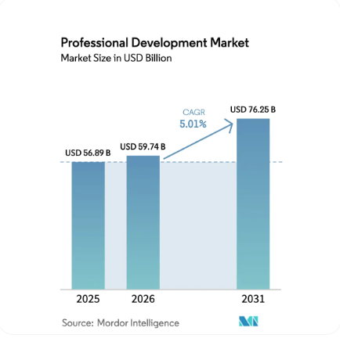
Figure 5: Growth of professional development initiatives
(Source: Mordor Intelligence, 2026)

3.3 Business Activist Mindset
Proposed mechanisms
Ulrich's HR Business Partner Evolution should guide HUM to enhance the efficacy of HR practices, recruitment and communication strategy to be more considerate toward employee needs (Week 1 HCM Lecture, p.27). In this case, Helios should encourage them to transform their talent management strategy and modify their core operational strategy to ensure that their HR policy and organisational goals are clearly aligned to generate value for stakeholders.
Integrating the Stakeholder Capitalism Perspective, HUM should create value for not only their shareholders, but also for employees, customers, administrative bodies, the local community, ad environment to foster a business activist mindset (Freeman and By, 2022).
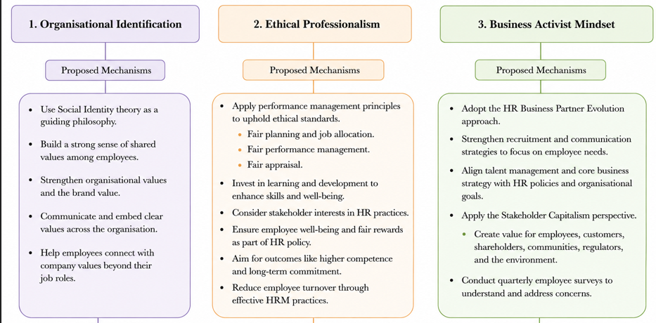
Figure 6: Conceptual representation for developing business activism
(Source: Self-developed)

TASK B: Job design

1. Proposal of an innovative job design strategy

1.1 Critique of traditional design
Traditional job design is effective in maintaining role clarity, operational efficiency, and standardisation for a stable working environment and routine practices but fails in employee engagement (20% treduction in 2026) (Gallup, 2026). Reiche (2023) argued that the traditional method shows rigidity with specific job boundaries, with narrow specialisation and limited autonomy, leading to less engagement, adaptability and creativity. On the other hand, an innovation-driven company like Helios Urban Mobility needs to focus on cross-functional collaboration, requiring continuous capability development.
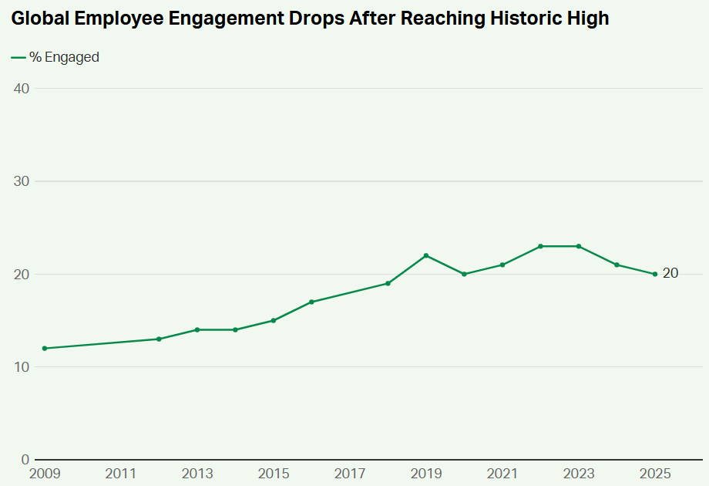
Figure 7: Global employee engagement rate
(Source: Gallup, 2026)

1.2 Integrated job architecture for Helios Urban Mobility
Strategic Layer | Design Mechanism | Theoretical Basis | Application within HUM | Strategic Value
Layer 1: Job Enrichment | Skill variety: Cross-functional innovation squads  Task identity, significance: end-to-end project ownership  Autonomy, feedback: Project outcome | Job Characteristics Model | Design conception and implementation supported by AI engineers, mobility analysts and software developers | Enhanced autonomy, skill variety, and comprehensible task identity
Layer 2: Employee Agency | Task Crafting: Employee-led innovation projects, sustainability initiatives  Relational crafting: ideathons and international collaborations  Cognitive crafting: acknowledging roles | Job Crafting Theory | Tasks and international team relations are strengthened with positive career aspirations | Increased engagement, ownership and innovation
Layer 3: Skills Ecosystem | Skill-centric practices: Skills taxonomy, capability mapping, marketplace of internal talent and rotational assignments | Skills-Based Architecture | Competency-oriented task deployment | Flexible work responsibilities and capabilities with retention
Layer 4: Goal Alignment | Skill improvement, learning milestones, innovation objectives, and sustainability KPIs | Goal-Setting Theory | Strategic priorities are aligned with organisational and individual goals | Resilience for goal achievement with increased motivation and commitment
Layer 5: Performance Governance | Planning and managing performance: Continuous coaching,  Reviewing: feedback dashboards, sprint reviews, feedback dashboards  Rewarding and development: developmental appraisal | Performance Management Cycle | Continuous learning, motivation and monitoring with recognition | Strategic adaptability with spontaneous performance improvement
Table 1: Job design architecture with strategies
(Source: Influenced by Sion, 2025; Liu et al., 2023; Locke and Latham, 1990; Recruitment and performance management PPT)
The existing job structures are focused on employee roles instead of innovation criteria in the AI-enabled mobility environment. Therefore, the reconceptualisation of jobs is implemented in the adaptive job architecture here to enhance capability systems and facilitate growth opportunities. JCM principles are adopted at operational levels to maximise autonomy, skill variety and task significance (Cotič et al., 2025). Strategic empowerment through job crafting experiences ensures participation, cross-border initiatives and sustainable practices in projects with innovation challenges.
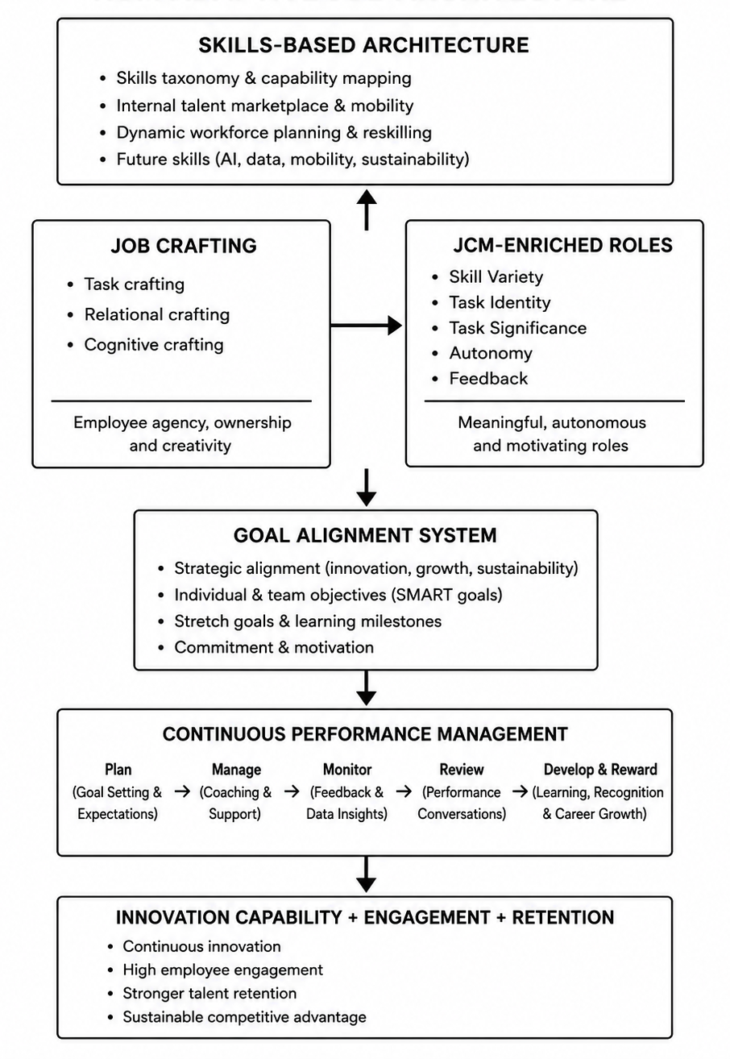
Figure 8: Adaptive job architecture of Helios Urban Mobility (HUM)
(Source: Self-developed)
The skill-based approach has ensured the shifting and management of talent away from rigid hierarchies based on capability portfolios. Spontaneous redeployment of talent based on international projects and expatriation needs has helped to strategically align goals and team performance as defined by Goal-setting theory (Piyasena, 2026).

2. Stimulating intrinsic motivation and supporting innovation through the design

2.1 Stimulating intrinsic motivation with the design
Intrinsic motivation through job design
The proposed architecture is effective in boosting intrinsic motivation through meaningfulness, autonomy, competence, ownership and continuous learning with differentiated job roles. According to the views of Damanik et al. (2026), JCM-oriented positioning ensures standard employee position through decision-making authority, complete project involvement and diversified responsibility delegation. On the other hand, the goal-setting theory is effective in increasing employee efforts, self-efficacy and persistence through clearly disseminated strategic objectives. Hence, innovation targets, career aspirations and learning milestones are achieved, aiming for individual growth based on organisational priorities to develop sustained motivation and engagement.
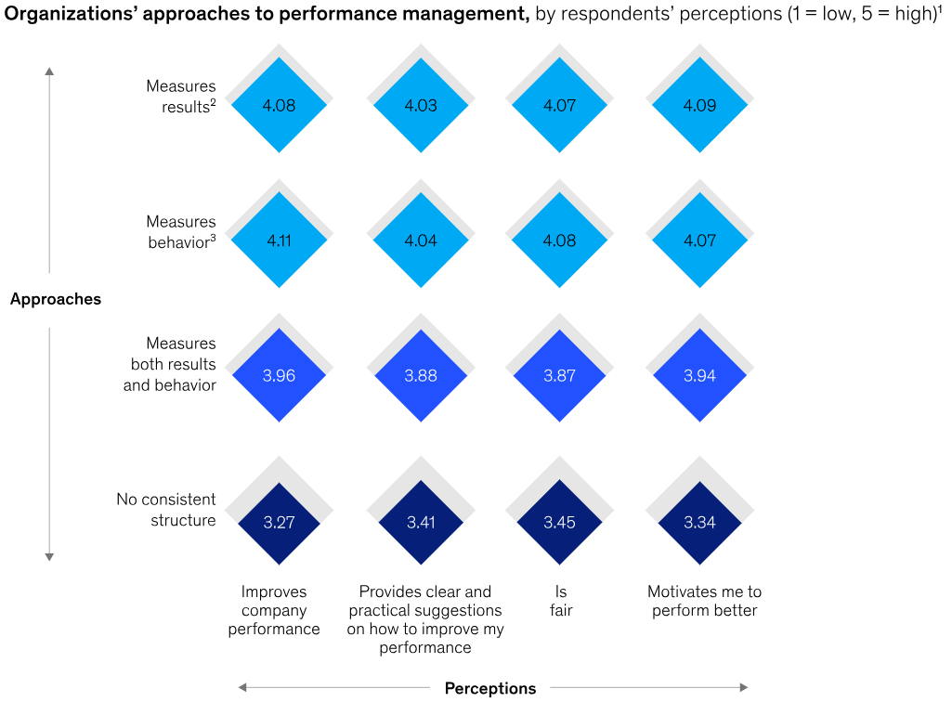
Figure 9: Employee motuvation and perfrimamce approaches
(Source: Komm et al., 2024)
Innovation through an adaptive work system
Experimentation, cross-functional knowledge exchange, internal mobility and employee agency create dynamic career opportunities leading to motivated employees under the adaptive work system. Proactive participation of employees under the job crafting principle helps to maintain sustainability initiatives in innovation projects (Messmann, 2023). Likewise, skills-based architecture has facilitated work environment optimisation with emerging capabilities.

Potential organisational outcomes:
Indicator | Current | Target
Engagement | 54% | 70%
Ramp-up time | 8 months | 5 months
Graduate retention | baseline | +20%
Internal mobility | baseline | +30%
Innovation participation | baseline | +40%
Table 2: Organisational outcome under intrinsic motivation strategies
(Source: Self-developed)
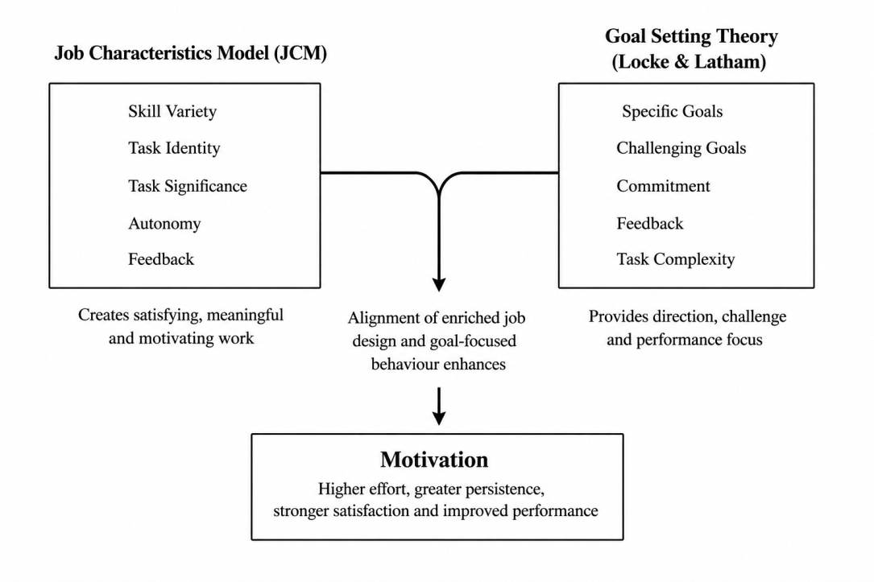
Figure 10: Intrinsic motivation based on JCM and goal-setting theory
(Source: Self-developed)

2.2 Supporting innovation, goal setting theory and performance management cycle through human capital agility
Human capital agility refers to the employees’ capability to adapt and learn based on organisational needs. The proposed architecture optimises it through internal mobility, experimentation opportunities and cross-functional collaboration. Depending on emerging capabilities, skill-based responsibility deployment ensures efficient knowledge sharing and proactive problem-solving (Nadeem, 2024). Moreover, continuous learning opportunities are facilitated through goal-oriented developmental processes that facilitate adaptive behaviour and capability rearrangement. Therefore, innovation capacity and skill sources can be improved with spontaneous responsiveness from the organisation.
Planning: Innovation targets are used with joint establishments and career aspirations, along with developmental objectives.
Managing Performance: Performance control through continuous coaching, guidance and monthly developmental meetings supports learning through skill acquisition and adaptive capability building (Yertas, 2024).
Reviewing: Regulation evaluation through 360-degree feedback and project assessment reduces the capability gap in performance and improves innovation contribution.
Rewarding and Development: Skill recognition and promotional strategy dependent internal mobility opportunities enhance employability and retention through career progression.

2.3 Strategic evaluation of proposed job design
The proposed job architecture aims to improve employee engagement and retention by offering a sustainable mechanism of workforce motivation, talent retention and innovation facilitation. The strategy encompasses elements of job responsibility and offering enrichment, continuous development opportunities and strong employee agency. According to the study of Ajewumi (2024), innovative job responsibilities and participation are dependent on strong workforce agility, strategic alignment of goals and employee needs and engagement in organisational vision. Nonetheless, successful implementation of job architecture is essentially guided by managerial capability, cultural readiness, infrastructure and investment scope in learning systems to facilitate a flexible career option. The framework aims to provide a futuristic goal of talent engagement and retention despite the implementation challenges to achieve innovation-driven, high-performing and adaptive workforce.

TASK C: Reflective report

1. Introduction
The reflective section strives to evaluate the responsible use of Artificial Intelligence (AI) for decision-making while examining professional capability development and future learning options.

2. Using AI as a decision-support tool in strategic HR practices
AI is a strategic tool used in HR practices to support evidence-based decision-making through the process of data collection, its analysis for trend identification and scenario evaluation. Accessing data from contemporary literature and its scientific system, this has been improved with AI tools that efficiently derive strategic recommendations. On the contrary, Martins et al. (2022) argued that AI use as an augmentative tool is limited to sorting and visualising data only. According to Schön's perspective of reflection-in-action and reflection-on-action, subjective analysis and professional judgement are dependent on critical thinking ability and informed decision-making through valid AI-generated insights (Writing Your Reflective Log PPT). Extensive application of AI-generated results can influence findings with algorithmic bias while limiting stakeholder perspectives and contextual analysis.

3. Professional reflection on capability development
What?
The reflective model of Driscoll demonstrated a structured evaluation system that highlights different levels of capabilities applied in a consultancy project. My HR management concepts and practicality have been strengthened with the integration of socialisation strategies, innovative job design theories and business activism concepts that aid the agility of an organisation along with employee engagement and sustainable performance.
So what?
From the module exercise, I have gained ample experience in data synthesis from academic evidence while critically analysing it with the aid of theoretical foundation to derive practical recommendations for HR intervention for both Helios Urban Mobility (HUM) and its workforce. Commercial awareness, ethical judgement and evidence-based decision-making have highlighted the complex business challenges and their key drivers to draw new architecture of sustainable HRM processes (Ezeafulukwe et al., 2022). Additionally, the use of AI requires critical augmentation to ensure its alignment with professional judgment required by HR professionals supporting contextual understanding without algorithmic bias.
Now what?
In future projects, I plan to improve skills in behaviour analytics, consultancy communication and strategic influence over performance. These capabilities can optimise professional skills on data-driven decision-making, strategic recommendations and stakeholder management systems for a dynamic organisational environment with digital operations.

4. Personal development plan
Capability Area | CIPD Professional map domain | Goal | Development Activity | Timeline
Ethical and strategic decision-making | Purpose and Values | To enhance ethical judgement with responsible use of AI in HRM | Participation in workshops, reflective learning | 6 months
HR strategies with evidence | Core Knowledge and Core Behaviours | To improve analytical capability for professional consultancy reports | HR analytics training; participation in CPD activities | 12 months
Strategic influence with people analytics | Specialist Knowledge | To develop expertise in stakeholder engagement and critical decision-making based on evidence | Professional course and projects | Ongoing
Table 3: Personal development plan
(Source: Self-developed)
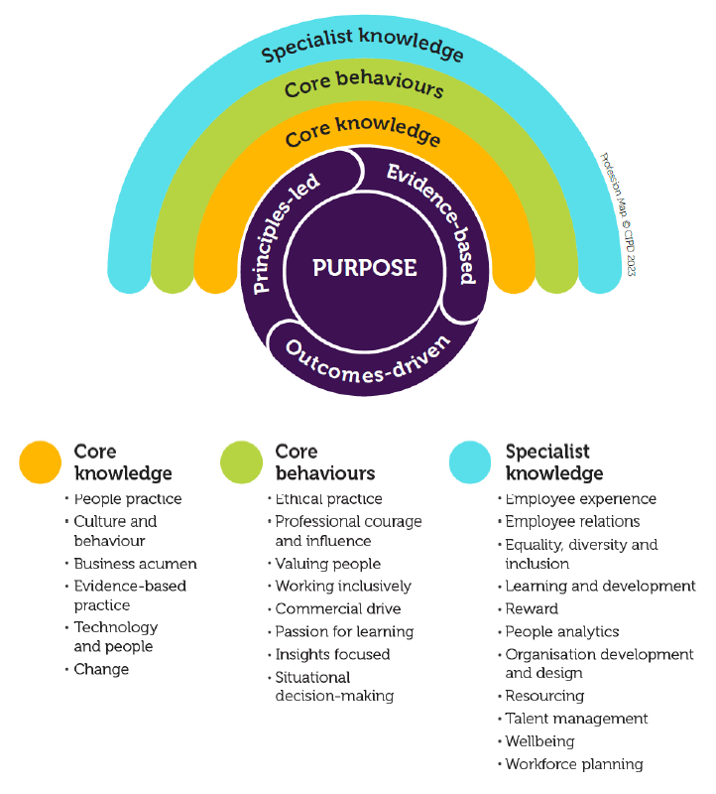
Figure 11: CIPD professional map
(Source: CIPD professional map full standards)

Conclusion
It can be concluded that AI-enabled insights and critical human judgments need to be aligned to promote efficient management strategy implementation. Continuous professional development and knowledge enhancement based on the CIPD professional map is the source to improve HR practices.

Reference list
Ajewumi, O.E., (2024). The influence of agile organizational design on employee engagement and performance in the digital age. International Journal of Research Publication and Reviews. https://doi.org/10.55248/gengpi.5.1024.2702
Cotič, L.P., Man, M.M.K., Soga, L.R., Konstantopoulou, A. and Lodorfos, G., (2025). Job characteristics for work engagement: autonomy, feedback, skill variety, task identity, and task significance. Global Business and Organizational Excellence, 44(5), pp.75-85. https://doi.org/10.1002/joe.22295
Damanik, E.O.P., Munte, R.N., Siagian, E.M. and Purba, D.T., (2026). A Human Resource Management Model Based on Work Discipline and Supervision to Enhance Employee Career Promotion. Fundamental and Applied Management Journal, 4(2), pp.386-404. https://doi.org/10.66314/famj.v4i2.782
Didion, E., Perello-Marin, M.R., Catala-Perez, D. and Ambrosius, U., (2024). Mapping the organizational socialization and onboarding literature: a bibliometric analysis of the field. Cogent Business & Management, 11(1), p.2337957. https://doi.org/10.1080/23311975.2024.2337957
ET, (2025). 22% of employees quit within 90 days, citing poor onboarding and training: Survey. Available at: https://hrme.economictimes.indiatimes.com/news/industry/22-of-workers-leave-their-jobs-in-90-days-due-to-poor-onboarding-key-findings-from-insight-global-survey/124088570 (Accessed: 25 June 2026)
Ezeafulukwe, C., Okatta, C.G. and Ayanponle, L., (2022). Frameworks for sustainable human resource management: Integrating ethics, CSR, and data-driven insights. Journal of Sustainable Management and Practices. https://doi.org/10.30574/wjarr.2022.13.3.0151
Freeman, E. and By, R.T., (2022). Stakeholder capitalism and implications for how we think about leadership. Journal of Change Management, 22(1), pp.1-7. https://doi.org/10.1080/14697017.2022.2037184
Gallup (2026). State of the Global Workplace 2026. Available at: https://www.gallup.com/workplace/349484/state-of-the-global-workplace.aspx (Accessed: 25 June 2026)
Gallup, (2025). Why Do Employee Retention Metrics and Attraction Research Matter?. Available at: https://www.gallup.com/467702/indicator-employee-retention-attraction.aspx [Accessed: 2 July, 2026]
Godinho, T., Reis, I.P., Carvalho, R. and Martinho, F., (2023). Onboarding handbook: An indispensable tool for onboarding processes. Administrative sciences, 13(3), p.79. https://doi.org/10.3390/admsci13030079
Junça Silva, A., Faria, C. and Lopes, R.R., (2026). Onboarding for success: exploring the effects of socialization tactics on newcomer well-being. International Journal of Organizational Analysis, 34(2), pp.657-680. http://dx.doi.org/10.1108/IJOA-01-2025-5165
Komm, A., Weddle, B, and Maor, D. (2024). What employees say matters most to motivate performance. In McKinsey & Company. Available at: https://www.mckinsey.com/capabilities/people-and-organizational-performance/our-insights/what-employees-say-matters-most-to-motivate-performance (Accessed: 24 June 2026)
Liu, G., Peng, H. and Wen, H., (2023). How self-leadership promotes job crafting: Based on the perspective of self-determination theory. Frontiers in Psychology, 14, p.1079196. https://doi.org/10.3389/fpsyg.2023.1079196
Locke, E. A., and Latham, G. P. (1990). ‘A theory of goal setting and task performance’. Upper Saddle River, NJ: Prentice Hall.
Martins, N.C., Marques, B., Alves, J., Araújo, T., Dias, P. and Santos, B.S., (2022). Augmented reality situated visualization in decision-making. Multimedia Tools and Applications, 81(11), pp.14749-14772. https://doi.org/10.1007/s11042-021-10971-4
Messmann, G., (2023). Fostering proactive behaviour: The role of work‐related reflection, psychological empowerment, and participative safety for innovative behaviour and job crafting. International Journal of Training and Development, 27(1), pp.99-116. https://doi.org/10.1111/ijtd.12286
Mittal, S., Gupta, V. and Motiani, M., (2022). Examining the linkages between employee brand love, affective commitment, positive word-of-mouth, and turnover intentions: A social identity theory perspective. IIMB Management Review, 34(1), pp.7-17. https://doi.org/10.1016/j.iimb.2022.04.002
Mordor Intelligence, (2026). PROFESSIONAL DEVELOPMENT MARKET SIZE & SHARE ANALYSIS - GROWTH TRENDS AND FORECAST (2026 - 2031). Available at: https://www.mordorintelligence.com/industry-reports/professional-development-market [Accessed: 2 July, 2026]
Nadeem, M., (2024). The golden key: unlocking sustainable artificial intelligence through the power of soft skills!. European American Journals, 12(4), pp.1-18. https://doi.org/10.37745/bjms.2013/vol12n4118
Piyasena, K.G.C.C., (2026). Goal-Setting Theory in Employee Performance Management: A Contemporary Analysis and Application. Sri Lankan Journal of Human Resource Management, 16(01). https://doi.org/10.31357/sljhrm.v16.8715
Reiche, B.S., (2023). Between interdependence and autonomy: Toward a typology of work design modes in the new world of work. Human Resource Management Journal, 33(4), pp.1001-1017. https://doi.org/10.1111/1748-8583.12495
Sion, A., (2025). Theoretical insights into the influence of enterprise architecture on job architecture. In International Conference of Management and Industrial Engineering (Vol. 12, pp. 102-110). https://doi.org/10.56177/12icmie2025.150
Somu, S. and Ali, N.A., (2025). Remote onboarding and beyond: Fostering organizational citizenship behavior through psychological channels. Journal of Economics and Management, 47, pp.413-448. https://doi.org/10.22367/jem.2025.47.16
Yertas, M., (2024). The role of training and continuous development in improving employee productivity and its impact on company financial performance. Atestasi: Jurnal Ilmiah Akuntansi, 7(2), pp.1362-1379. https://doi.org/10.57178/atestasi.v7i2.1047

