Name: Hannah Louise Jones
Student number: 1151203
Module Code: ECIE6002
Module name: Moving away from the traditional classroom- The silent digital revolution in education.

Digital becoming the traditional within our classrooms.

Table of Contents
Blog 1 – Digital Competence 2
References 5
Blog 2 - A Whole new digital world. 6
References 9
Blog 3 - Technology and ME… 10
References 14
Blog 4 – Just Google it! 15
References 20

Blog 1 – Digital Competence

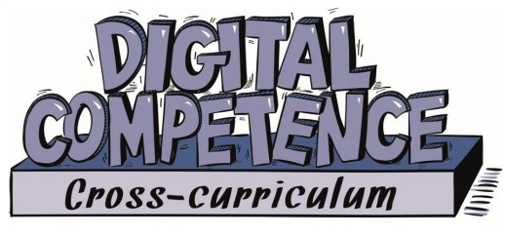
(Donaldson, 2015)

You first need to understand what digital competence is…it is the ability, knowledge and skills used to access technology using various systems, software and hardware correctly and confidently applying this skills set to a wide range of subjects as one of the three cross-curricular responsibilities, not to be confused with the subject information communication technology (ICT) (Welsh Government, 2018).

In the report ‘Successful Futures’ Donaldson (2015) asserts…
“Children and young people need to learn how to be more than consumers of technology and to develop the knowledge and skills required to use that technology creatively as learners and future members of a technologically competent workforce.” (Donaldson, 2015).

Twinkl (n.d.) states “The DCF which stands for Digital Competence Framework in Wales 2022, also known as "Cymhwysedd digidol" in Welsh, is an integral part of the new Curriculum in Welsh schools”. Children and young people's lives depend more and more on digital competency for a variety of purposes, including communication, networking, information sharing, pleasure and entertainment. The ability to creatively use digital technology skills is becoming more and more common in the modern workplace. It should be the duty of all educators to promote the growth of digital competencies and the abilities and know-how to do so (Donaldson, 2015). Below are the 4 mains strands of the DCF and the elements of each.
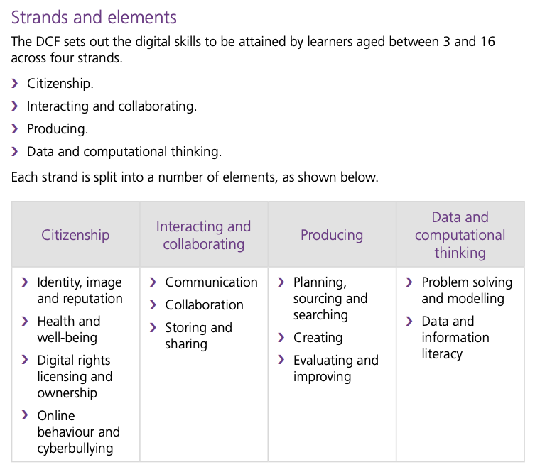
Welsh Government (2018)

Citizenship

Citizenship is a vital strand of the DCF, it focuses on developing skills so that learners can become positive digital citizens who contribute to the world around them, able to navigate through a rapidly changing digital world (Welsh Government, 2018). Within a school environment children will be supervised to discover what it means to be a responsible digital citizen and be able to consider their place as a digital citizen (Twinkl, n.d.).

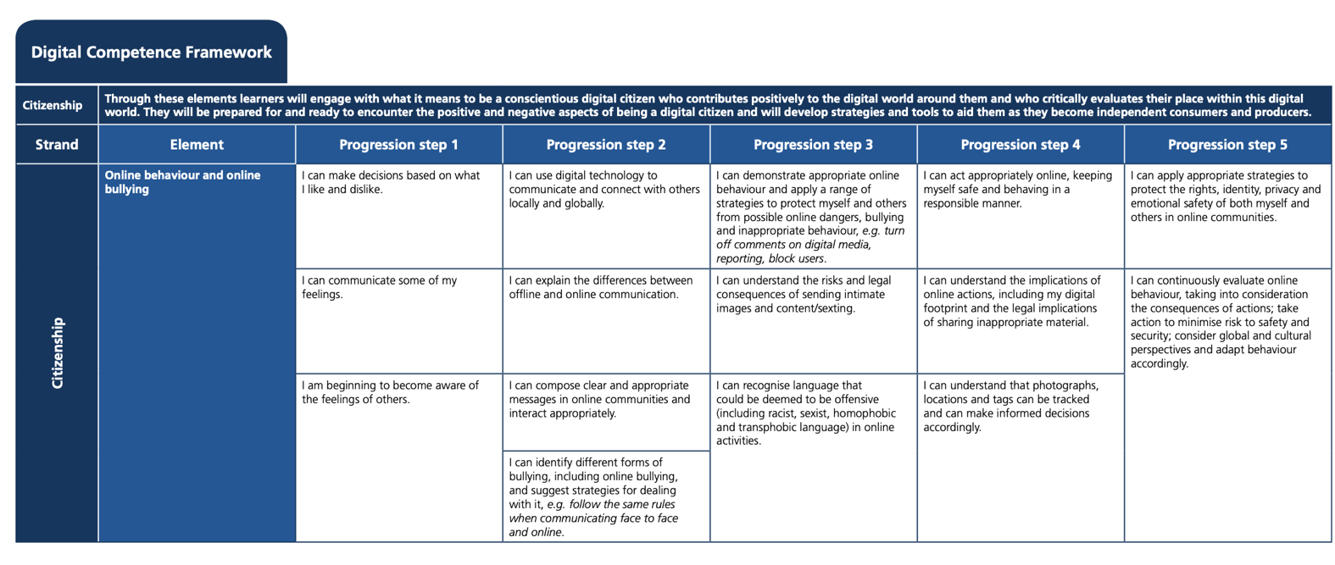
(Gov.Wales, 2020)

Above is the Online behaviour and Online bullying element of citizenship. Children will build skills and progress through the progression steps. In secondary school through subjects such as Health and Wellbeing where they look at difference aspects of cyber bulling and online behaviours. Such as in year 8 they investigate inappropriate online behaviours such as stalking, abusing trust and radicalisation, they will look at examples, what to do if they experience them (Roc, 2018). Children are encouraged to report any incidents as per the schools anti-bullying policy. The school encourages this and has multiple ways a child can do this such as the bully button on their website, report incidents to a staff member, they even follow the guidance given by the police vis the “School Beat” guidance ([School A], 2020a). The skills students learn and the knowledge on how to stay safe online can be used throughout life. They will know what to do if they experience and aspects of these steps and can act appropriately and source help if needed.

References
Donaldson, G. (2015) Successful Futures. Available at: https://www.gov.wales/sites/default/files/publications/2018-03/successful-futures.pdf (Accessed:17th January 2024).
Edwards, A. (2019) Digital Competence: Improving Pupils’ Digital skills, Digital competence: Improving pupils’ digital skills. Available at: https://www.estyn.gov.wales/blog/digital-competence-improving-pupils-digital-skills (Accessed:18th January 2024).
Gov.Wales (2020) Digital Competence Framework. Available at:https://hwb.gov.wales/api/storage/d26af733-abd1-4d33-92fe-4ea8eb1d928f/dcf40620.pdf (Accessed:17th January 2024)
Roc. (2018) Digital Competence Framwork Citizenship mp4. [Video] (YouTube) Available at: https://www.youtube.com/watch?v=S66ttq6IicM&t=37s (Accessed: 18th January 2023)
Twinkl (n.d.) DCF Wales. Available at: https://www.twinkl.co.uk/teaching-wiki/dcf-wales (Accessed: 19th January 2024).
Welsh Government (2018) Digital Competence Framework guidance. Available at: https://hwb.gov.wales/storage/337437b8-cfe3-4305-ae32-f47ad82f3e76/digital-competence-framework-guidance-2018.pdf (Accessed:19th January 2024).

Blog 2 - A Whole new digital world.

Let me take you on the digital magic carpet and explain to you how it is affecting our youth of today.

Many people may look at children using their devices rather than interacting with peers and think they are losing the ability to socialise. However, at the tips of their fingertips they have the world wide web as their best friend. They can communicate with various group chats at one time rather than spending time with just one group in the real world. That is in fact the issue, they are socialising but not face to face and it is this skill and ability they are lacking from turning to technology to socialise. On their devices they could be communicating with anyone in any part of the world but is this really socialising. Gone are the days you use your mobile phone for just a simple text or phone call, now they use a wide variety of social media apps such as Facebook, Instagram, SnapChat, Whatsapp, Twitter and TikTok just to name a few. Rafalow (2020) asserts “These practices also help the development of digital skills like facility with digital platforms and online communication”. Nevertheless, with these readily available 24/7 socialising and communicating with the world never stops, this can be difficult for those children experiencing bullying, it becomes cyber bullying which can be relentless and doesn’t stop at the school gates.

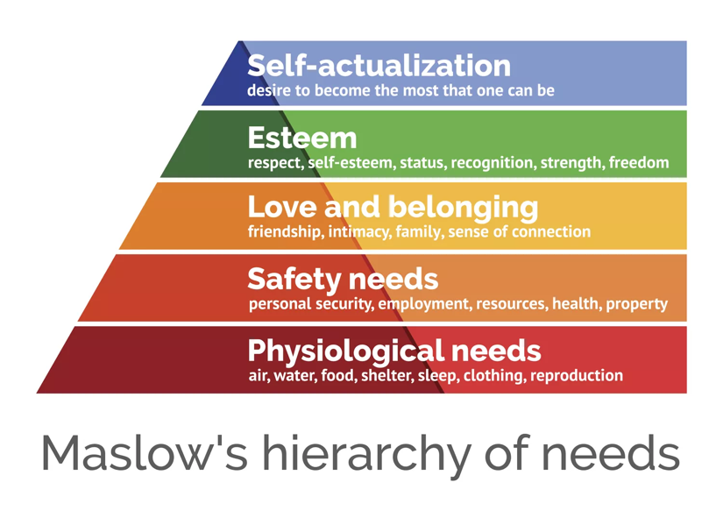
(Hopper, 2020)

When looking at the use of technology it is important children stay safe online. Safety is one of the levels of Maslow’s hierarchy of needs along with love and belonging, which includes friendships and a sense of connection. It is important children use technology correctly and understand the risks and dangers that comes with using devices to access the internet. It is also crucial that technology doesn’t cause them to feel isolated or distant and for young people to have a healthy balance of friendships on and off technology. Mcleod (2024) states “Maslow asserted that so long as basic needs necessary for survival were met…higher-level needs (e.g., social needs) would begin to motivate behavior.”

Marshall Mcluhan had his famous idea “the medium is the message” meaning it is not the message that the media delivers but the way the medium affects human consciousness and society, with media now having a social effect rather than just a tool to convey content. (Staunton, 2016) You can see this theory greatly with the likes of social media such as TikTok where trends or crazes appear via influencers who participate in them or begin them. Others then want to join in. An example of this would be the latest craze with the drink Prime. Two YouTube, influencer stars created a drink and the internet went wild. With other influencers promoting it and then students see and what to join in too. This begins to get dangerous with certain aspects such as body image and cosmetic procedures. Social media greatly affects young people and influencers play a huge part in portraying unrealistic bodies or procedures to create an unrealistic look. However, with this being readily available for young people to see it can create low self-esteem and insecurities that shouldn’t be there.

Connectivism theory was created in 2005 by two theorists, George Siemens and Stephen Downes they believed because the use of technology changed how students can access information had changed learning as well, it encourages group collaboration and education through online resources (Pappas, 2023). Kurt (2023) states “Connectivism is an innovative learning theory …It underscores the pivotal role of digital tools in modern education, recognizing that our era of connectivity offers limitless avenues for shaping our learning journeys”. Learning Theories (2023) states “Connectivism is a learning theory that explains how Internet technologies have created new opportunities for people to learn and share information across the World Wide Web and among themselves”. There are many benefits of connectivism theory such as motivation from students leading their own learning experience and are responsible for their own learning, to collaborate with peers helps them work together to problem solve and share knowledge (Pappas, 2023). With the new curriculum in Wales being pupil centred and driven, connectivism supports this and creates students to be actively responsible for their own learning with the teacher guiding students to become navigators in their own learning. Ways in which teachers can used connectivism in the classroom room, in their lessons is through game sand a student’s innate desire for challenge and reward (Kurt, 2023).

It is important to keep learners safe in this digital world, they are taught what to look out for and how to get help, there are policies in place to help support this. Wales Safeguarding Procedures (2021) reminds us that safeguarding is everyone’s responsibility, with technology quickly evolving the information about online abuse becomes outdated so as practitioners it is important to stay up to date with information and advice (Wales Safeguard Procedures, 2021).

References

Hopper, E. (2020) Maslow’s hierarchy of needs explained, ThoughtCo. Available at: https://www.thoughtco.com/maslows-hierarchy-of-needs-4582571 (Accessed: 18th January 2024).

Kurt, S. (2023) Connectivism Learning Theory. Available at: https://educationaltechnology.net/connectivism-learning-theory/ (Accessed: 18th January 2024)

Learning Theories (2023) Connectivism (Siemens, Downes). Available at: https://learning-theories.com/connectivism-siemens-downes.html (Accessed: 19th January 2024)

Mcleod, S. (2024) Maslow’s hierarchy of needs, Simply Psychology. Available at: https://www.simplypsychology.org/maslow.html#:~:text=There%20are%20five%20levels%20in,esteem%2C%20and%20self%2Dactualization. (Accessed: 20th January 2024).

Pappas, C. (2023) Everything You Need To Know About The Connectivism Learning Theory. Available at: https://elearningindustry.com/everything-you-need-to-know-about-the-connectivism-learning-theory (Accessed:19th January 2024)

Rafalow, M.H. (2020) Digital divisions: How schools create inequality in the tech era. Chicago: The University of Chicago Press.

Staunton, T. (2016) Marshall McLuhan, “The Medium Is The Message” – Theories Every Careers Adviser Should Know. Available at: https://runninginaforest.wordpress.com/2016/02/12/marshall-mcluhan-the-medium-is-the-message-theories-every-careers-adviser-should-know/(Acessed: 18th January 2024)

Wales Safeguard Procedures (2021) All Wales Practice Guide. Available at: https://safeguarding.wales/documents/53/safeguarding-children-from-online-abuse.pdf (Accessed: 19th January 2024)

Blog 3 - Technology and ME…

My Role

I am a level 3 Learning Support Assistant (LSA) who currently works with a Visually Impaired student who accesses the curriculum through braille. Part of my role is to create resources to aid his learning such as transcribing work into braille and creating tactile diagrams. Since beginning secondary school the student has begun using technical devices to support his learning. He used to reply on a old fashioned braille, which was big, clunky and heavy to carry around. The decision was made on starting secondary school he would move to Braillenote touch which is the size of a tablet with a braille keyboard over the top. This device can be used, to produce written work, send emails, browse the internet and read books in braille. It’s very versatile and means this student can access the curriculum easier than with the previous device. He also uses his own device to use the voice over to do research and various other apps that help him both academically and socially. This has been a real benefit to his learning and he can often do tasks independently unlike before when he relied more on his LSA to access the work.

During the pandemic - COVID

COVID changed education for many, going from the traditional classroom set up to having online lessons from home overnight. However not all students could use the facilities online and struggled to access their lessons and work. These students may have struggled because they must share a device as a family rather than having one each in the household. Others didn’t have internet so they couldn’t get online to join their lessons. This is known as Digital Poverty Learning Hive (2024) asserts “Digital poverty is the term used to refer to those who live without, or with very minimal, access to the internet and digital technologies capable of connecting to it”. The school tried to combat this by giving Chromebooks out on loan to those families with one device or no devices to ensure students could do their schoolwork. Dongles were given out to family who did not have internet. This allowed those students who perhaps were struggling because of poverty a fair chance to access education and made the situation inclusive again. Students who were most affected by this digital divide are free school meal (FSM) children and students with special education needs and disabilities (SEND) due to their specialist in school support was removed and not available to assist them with their learning (Learning Hive, 2024). These children were invited into school to access the hub run by school staff, for those key worker children, free school meal children and those with ALN needs. Although those children in poverty were helped during the pandemic since returning to school there is still a divide, and it becomes apparent when children are using bring your own device rather than using the school Chromebook. Rennie and Smyth (2020) state “The term also describes the discrepancy between those who have the skills, knowledge and abilities to use technologies and those who do not”. More often than not the skills students lack come from their parents lacking the same skills. My school offers online support for families in order to improve their skills to be able to help their children or just to understand what they are doing online. They appreciate some of the systems used in school are new for parents so they offer courses which are free, to learn about the Google tools that they use in school and training courses are also available for parents via the links on the website ([School A], 2024a).

Are there benefits?

Yes there are!
The pandemic and the way students worked in lockdown had changed their traditional classroom into a digital one. While most students are discussing which era Taylor Swift is in, we are fully swing into the digital era of education and no one seems to be looking back. Which technology advances around every corner and the DCF put in place learning is fast in becoming technology lead. Which is not sure a bad thing!
With the ability to post work to a Google Classroom for students to access from anywhere. This helps greatly with behaviour situations and removing students from a classroom. Now those staff members don’t need a stack of resources to pick from the child can now access the lesson remotely from remove via the Google classroom. Another example if a child is off ill for a period of time, such as after a medical procedure or long-term illness and cant access school then they can access it from their home to stay up to date and not miss out on their work so they have less to catch up on. Some teachers have been known to set up a Google meet for their students in this position so that they can still be part of the lesson.
Many people are struggling to get tickets to the Taylor Swift eras tour however the ever-growing digital era within the classroom is the place to be for many students, whose normal way of learning is becoming technologically based. With the development of Artificial intelligence (AI) we may see schools start to begin using it. Although this is a scary thought, it is fascinating how they propose to use it. AI is already having a positive impact on the education sector with their use to help teachers with their workload by creating a virtual assistant. However, this does not mean teachers would be replaced by AI as they are irreplaceable. There are still discussions as to how AI will help students and how that would work with regards safeguarding (GOV.UK, 2023).

There are also benefits for ALN students for their normal way of working which will then follow them through to put exam concessions in place. Such as a wood processor if they regularly use a laptop to complete their classwork. There are also programmes such as claro reader which is a google extension and will read the text from the screen, from word documents and even websites. This is helpful for those students with dyslexia and makes things more accessible for those students who struggle to read or can’t read. This then becomes an exam concession, which is either a reading pen or that function on a device. These readers take over from the normal person reader as they can be used in the reading sections of English papers where a human is not allowed to read for a child.

Theory
Urie Bronfenbrenner’s theory ecological systems theory looks at the child and implies they are influenced by factors around them both nature and nurture, as the child grows these have major influence on their development (Bates, 2019). These factors could be influences such as digital poverty which would affect the child and their learning, this will then develop into adulthood as they would have lacked the skills required to progress within in the workplace.

References

[School A] (2024a) [School A] ONLINE LEARNING TUTORIALS. Pembrokeshire: [School A]. Unpublished

Bates, B. (2019) Learning Theories Simplified. 2 edn. London: Sage Publications Ltd.

GOV.UK (2023) Artificial intelligence in schools – everything you need to know. Available at: https://educationhub.blog.gov.uk/2023/12/06/artificial-intelligence-in-schools-everything-you-need-to-know/ (Accessed: 20th January 2024)

Learning Hive (2024) Digital Poverty and its impact on education inequality Available at:https://www.learninghive.co.uk/blog/digital-poverty-and-education-inequality (Accessed: 20th January 2024)

Rennie, F. and Smyth, K. (2020) Digital Learning: The key concepts. 2nd edn. Oxon: Routledge

Blog 4 – Just Google it!
Just
it!

(Wikipedia, 2023)

Google Workspace for Education.

This software package is what is used in my organisation throughout the whole curriculum by every member of the school. Below show some elements of the software package…

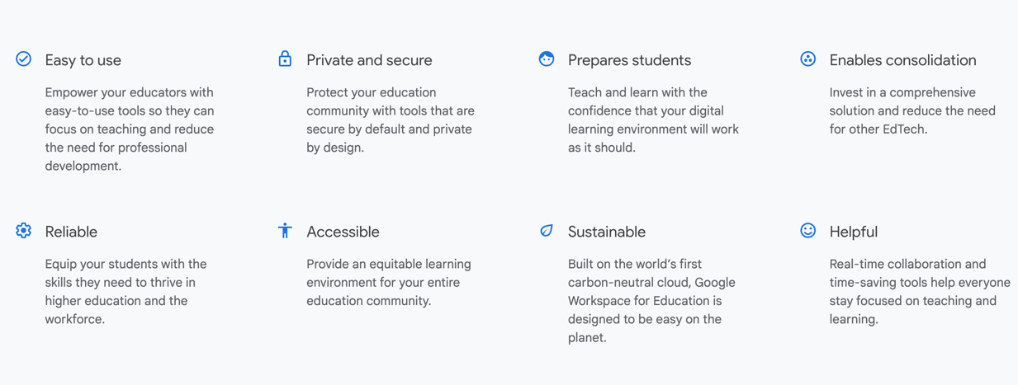
(Google for Education, n.d)

Google for Education (n.d) states “A suite of secure, easy-to-use tools designed for teaching and learning”.

How do we use it?

My school is a 11-18 mainstream secondary school who have been awarded Google Reference status, schools are awarded this for their outstanding use of technology which we have gained using innovative methods of teaching and learning through Google workspace for education ([School A], 2024a).
The school have utilised google tools effectively throughout the day-to-day operations and teaching and learning practices. Teaching staff implement the educational apps during their lessons to aid teaching and learning ingraining Google workspace into everyday lessons. Everyone at the school has access to the software this is both in and out of school. Below are just some of the apps both staff and pupils have access to.

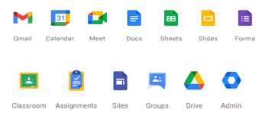
(Abraham, 2023)

Pupils are encouraged to access these apps via the class sets of Chromebooks within each learning area or in the ICT suites in set lessons. These have been funded by the school and trusties. The school also allow students to bring their own devices to school under the BYOD policy, which enables students to use their mobile phones or other devices using the school day while connected to the safe and secure. The schools Bring Your Own Device (BYOD) policy has been set up due to the school recognising that it supports learners in their learning, this policy informs students of how they are expected to use their devices in accordance to the rules and procedures stated within to make sure they use devices appropriately and safely ([School A], 2024b).

Using this software package staff can create a range of interesting lessons and improve their practices, teaching and their learning. Main (2023) asserts “Dewey argued that teachers have a responsibility to create an environment that fosters inquiry and exploration and encourages student autonomy, creativity, and critical thinking”. Many subjects have different ways of using the software to suit them. Within Art and Design, they use it to create digital portfolios which can be used to track progress by both the teacher and pupil. Pedagogy4Change (2022) states Dewy believed “Children are first and foremost interested in moving, communicating, exploring the world, constructing and expressing themselves artistically”. They also use the creative aspects of slides to present their work in alternative ways such as a time lapse of the creation of a piece of work. Languages use the apps to uploads voice memos of pupils specking in a language then they can give verbal feedback which is recorded and saved to access later. Allowing the student to look back and use the feedback to progress and improve. Expressive Arts within music also use the recording function and will give real time feedback, again where the student can have a record of verbal feedback which they can access later.

The Jamboard app is used as a starter or plenary to introduce topics or to recognise understanding. The students are asked to all contribute to the same sheet where all their knowledge is collated and discussed. The ability to collaborate is run throughout the software package with many apps such as Google docs, sheets and slides pupils can work on the same document to complete group tasks. The teacher can also access these documents and give instant feedback and monitor pupil progress. Lev Vygotsky believes in the zone of proximal development which is the difference between independent level and then the level after peer or adult guidance, he suggests children develop skills and strategies through interaction with peers this is often referred to as scaffolding (Mcleod, 2023). With the instant feedback from staff and the collaborate aspect of the Google apps, students can develop as they work on tasks.

The software isn’t just used to raise standards with pupils but also with staff, transforming how professional learning is delivered by creating bespoke training depending on individual staff needs using data gathered by surveys through Google forms. Colleagues then support each other while developing their own leadership skills, using their Google level 2 training. Staff have also used this software package throughout COVID, especially during lockdown. Google meet allowed lessons to continue while work was set on the Google classroom for students to complete then hand in. To implement this software, a team of digital leaders were formed from a range pupil from all key stage groups. These students promoted digital. Safety and took assemblies to inform their peers. The They also created the pupil web through Google sites to allow students a tailored webpage with quick easily accessible links to meet their peers needs.

There must be a flaw?

This software package is for all to use in both primary and secondary school settings however as accessible as it is it is still inaccessible for some. The pupil who I work with is Visually impaired he can access some aspects of the software however not completely. He uses a device called a Braillenote touch to complete his work which is digital device which is accessed using braille. He uses his phone to access the Google classroom to read the task however once the task is completed the function to hand in the work is unavailable. This means he must email the work directly to the teacher or to me to print in Braille and print. This means any feedback is emailed to him, his work cannot be accessed as he is completed it meaning he doesn’t have access to instant feedback like the other pupils. He also struggles with the software such as sheets and slides as these cannot be created through the note touch and braille, so his work constantly has to be adapted and changed to be accessible ensuring he achieves the same learning outcome. There is room for some of these problems to be improved and made accessible. Such as the ability to access Google classroom on the note touch rather than using multiple devices. The note touch already has the ability to access the internet and use Google the search tool and Gmail so there is scope to expand its capabilities allowing inclusivity for pupils such as the one I currently work with. Overall, the Google workspace for education is fantastic software package that can be used from a variety of devices and both in school and in the home environment and for most it is easy to use and allows both independent and group work collaboratively, giving instant feedback and instant advice and help from the teacher. With new technology advances happening all the time there is room for improvement as with anything.

When looking at the DCF you can recognise this software package supports it and aids implementing it within the curriculum. The school is using the software to make the students aware of their online behaviour and possible dangerous and develop skills to become better citizens. They will learn to collaborate and interact with both staff and peers online communicating through Google meets or responding to feedback. Pupils access a wide variety of multimedia to be able to explore different creativity skills while using the Google workspace. Finally, they will use and build on skills to problem solve and use data while using this package that meets the last strand of Data and computational thinking.

References

[School A] (2024a) [School A] Google Reference School. Pembrokeshire: [School A]. Unpublished

[School A] (2024b) [School A] BRING YOUR OWN DEVICE POLICY for Pupils/Parents KEY STAGE 3, 4 & 5. Pembrokeshire: [School A]. Unpublished
Abraham, R. (2023) Google Workspace for Education tiers, Teq. Available at: https://www.teq.com/google-workspace-education-tiers/ (Accessed: 21 January 2024).
GOOGLE WORKSPACE FOR EDUCATION. Available at: https://edu.google.com/intl/ALL_uk/workspace-for-education/editions/overview/ (Accessed: 21 January 2024).
Main, P. (2023) John Dewey’s theory, John Dewey’s Theory. Available at: https://www.structural-learning.com/post/john-deweys-theory#:~:text=John%20Dewey’s%20educational%20philosophy%20emphasizes,their%20relationship%20with%20the%20learner. (Accessed: 21 January 2024).
Mcleod, S. (2023) Vygotsky’s zone of Proximal Development & Scaffolding Theory in Psychology, Simply Psychology. Available at: https://www.simplypsychology.org/zone-of-proximal-development.html (Accessed: 21 January 2024).
Pedagogy4Change. (2022) Great pedagogical thinkers: John Dewey. Available at: https://www.pedagogy4change.org/john-dewey/ (Accessed: 21 January 2024).
Wikipedia. (2023) .Google. Available at: https://en.wikipedia.org/wiki/.google (Accessed: 21 January 2024).

