

John Hamilton
2221981

Material Science: ACDA 6016
Fatigue Failure of Oceangate Submersible Carbon Fiber Reinforced Polymer (CFRP) Hull

University of Wales Trinity Saint Davids (UWTSD)

BSc Ordinance, Munitions and Explosive (OME)
Academic Year: 2025-2026

Abstract

Contents
Abstract 2
List of Figures 2
List of Tables 3
1 Introduction 3
2 Components and Operating Failure Mechanisms 4
2.1 Carbon Fibre Hull 4
2.2 Hull Design 5
2.3 Environmental Factors 6
3 CFRP Theory 6
3.1 CFRP Fracture Mechanics 6
3.1.1 Key Failure Mechanisms 6
3.1.2 Difference Between CFRP and Metal Fracture and Fatigue 7
3.1.3 Factors Influencing CFRP Fatigue 8
3.2 Buckling Under External Pressures 9
4 Preventative Measures 9
4.1 Inspections 9
4.1.1 Manual Inspection 9
4.1.2 Automated Visual Inspection (AVI) 10
4.2 Optical Microscopy 10
4.3 Non-Destructive Testing (NDT) Methods 10
4.3.1 Ultrasound Testing 10
4.3.2 Eddy Current Testing (ECT) 11
5 Recommendations 12
5.1 Material Change 12
5.1.1 Steel Alloy 12
5.1.2 Titanium Steel 13
6 Conclusion 14

List of Figures
Figure 1- CFRP Body of Submersible 4
Figure 2- Oceangate Hull Design 5
Figure 3- Comparison Graphs Between CFRP and Steel 7

List of Tables
Table 1-Key Failure Mechanism Definitions 6

1 Introduction

Material Fatigue is defined as progressive damage which occurs when a material is subject to cyclic or fluctuating loading [1]. This therefore makes processes which undertake regular cyclic loading or fluctuating loading dangerous as the material can weaken over time and can eventually lead to fracture fatigue within a material. Some examples of where disasters have occurred due to incorrect mitigative measures being enforced to reduce the risk of fatigue include Versailles train crash 1842, The Boston Molasses Disaster 1919 and the Echede Train Disaster [2]. Remedies can also be made to ensure that fatigue is limited such as applying suitable surface finishes to the material, Blending out corners of the material or putting the material into a state of compression. Examples of processes which undergo Material fracture also can occur from fatigue, this occurs when a material fails and deforms which leads to the propagation of cracks through a material [3].

Polymers suffer fatigue just like metal materials but the reasons for fatigue differ due to differences in structures as polymers are composed of large molecules which comprise of repeating monomer units. In comparison, metals are element solids which have a crystalline structure and metallic bonding. Generally, polymers are stronger than polymers with respect to tensile strength and structural toughness, However some human engineered composites such as carbon-fibre and Kevlar can outperform some metals depending on the environment which they are used in [4].

The Oceangate submersible was designed to be a tourist attraction to customers and allowed for experiences to be undertaken to explore the Titanic shipwreck [5]. The Oceangate submersible regularly conducted tours of the Titanic shipwreck and explored depths of approximately 3800~4000 feet below sea level which produced vast amounts of pressure on the submersible system. The submersible had the capability to transport five passengers including the captain and submerge at a speed of 2.9 knots. The Oceangate design was established as being unsuitable to withstand the pressures applied in the ocean and many organisations who corresponded with Oceangate had the concern that the submersible may implode during an expedition [6]. The submersible design consisted of a carbon fibre cylindrical hull, Titanium Bow/Aft end caps with viewing windows for passengers, Pressure hull and vertical and horizontal thrusters which allowed the submersible to rotate. The design was identified as an experiment, and the carbon fibre hull was used in any other design prior to the Oceangate design. This therefore meant that the operating environment for the vessel was not considered prior to undertaking the expeditions.
The Titan Submersible undertook eighty-seven dives previously prior to the catastrophic 88th dive and the resultant factor of the implosion was entirely due to fatigue on the carbon fibre hull [7]. The Oceangate submersible imploded and all members on board died as a result. The carbon fibre hull implode due to fatigue caused by cycling loads which produced stresses on the material until eventually the structural integrity of the material was not sufficient for the pressures applied at that depth.

2 Components and Operating Failure Mechanisms

2.1 Carbon Fibre Hull

The ocean gate Carbon Fiber Reinforced Polymer (CFRP) is a polymer which was evaluated and used by Stockton Rush as part of the submersible design and was the first submersible to use this material for undertaking deep sea excavations. CFRP was used as this material has attractive properties for deep sea exploration such as high stiffness, high tensile strength, low thermal expansion, lightweight and is stronger per unit weight than steel. CFRP can be as thin as human hair and can get its strength when multiple fibers are twisted together like rope yarn. CFRP is manufactured by heating long strands of fiber to hot temperatures without allowing for oxygen contact during the process. This is when carbonization occurs which leaves the fibers with long, tightly interlocked chains of carbon atoms with only some non-carbon atoms remaining [8].

Therefore, many advantages were present to using this material for a submersible design however, this eventually led to complacency from the Ocean gate company as this material was not sufficiently assessed for the environment it was to be used in. Figure 1 demonstrates the application of CFRP for the submersible to be used for deep sea exploration to the titanic shipwreck [9].
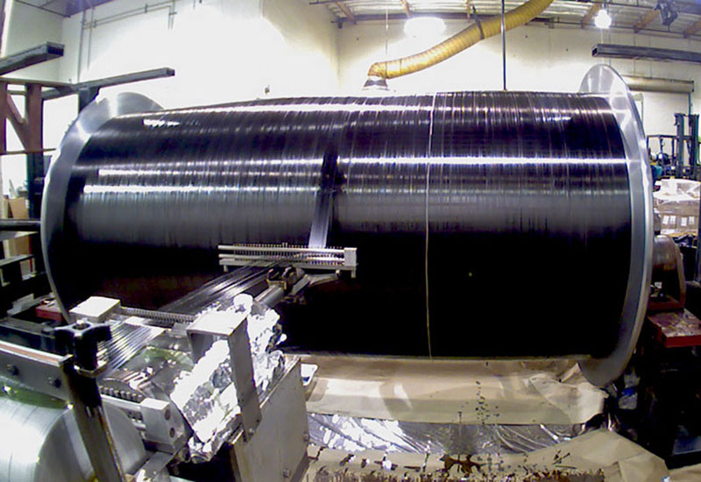
Figure 1- CFRP Body of Submersible

CFRP configures of multiple fibers connected in a cross-stitching pattern which uses the force of friction to enable for the strength of the material, a downside to this material is that when fibers break the material becomes weaker and with each use without replacing the fibers the risk of fatigue becomes greater as more fibers break. This was something in which the Chief Executive Officer (CEO) did not take into consideration during the design of the submersible and the consequence of this was that the hull underwent fatigue on multiple dives which ensured implosion during a dive.

2.2 Hull Design

The Ocean gate submersible design was given a teardrop shaped design which enable the submersible to travel to the seabed at a quicker rate. However, this provided a compromise on the stress distribution as elements of the submersible were put under more stress than others due to unequal pressure distribution especially at depths of 3800-4000 meters below sea level. Figure 2 highlights the submersible design and the flaws which are present in the hull shape which enabled for more stress in weaker areas of the design [10].

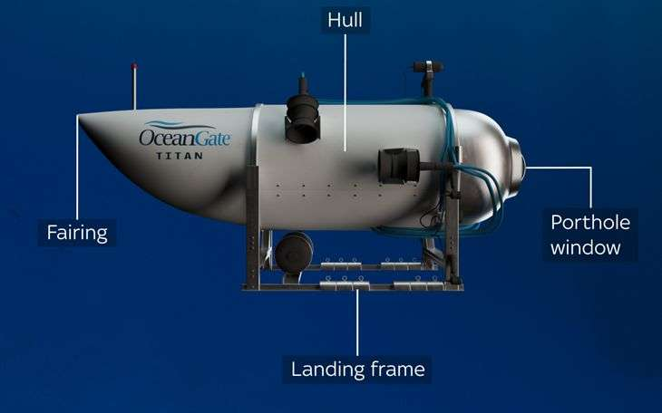
Figure 2- Oceangate Hull Design

The points of the submersible which were susceptible to the most pressure were the central section and the joints between the titanium end cap and CFRP hull which therefore enabled for the vessel to be more susceptible to implosion. The primary weakness with the structural integrity of the vessel was the interface between the titanium end cap and rings and the cylindrical CFRP main body.

2.3 Environmental Factors
The ocean gate submersible was often left in open environments which therefore mad ethe system more susceptible to moisture ingress and ultimately affecting the structural integrity of the vessel. The rapid accelerations between heated and cooled elements meant that the matrix modulus was reduced, and interfacial strength was impacted negatively which accelerated fatigue damage over time and dives. Furthermore, multiple dives were undertaken without sufficient Quality Assurance (QA) practices implemented to inspect damage to the structural integrity of the vessel. This therefore meant that damage accumulation occurred after each individual dive which demonstrates that fatigue was inevitable to occur during a dive.

3 CFRP Theory

3.1 CFRP Fracture Mechanics

3.1.1 Key Failure Mechanisms
CFRP fracture mechanics involve intricate failure modes such as matrix cracking, fiber pull-out and delamination which are distinct from metals. Typically, failure often initiates at stress concentrations which allows for crack growth to occur. The overall processes are brittle like fractures which are less visually apparent than ductile metals. Key failure mechanisms include kink bands in compression (fiber buckling) and matrix-dominated failures in tension. This is often preceded by matrix cracking, which affects the materials ultimate strength despite its high fiber tensile strength [11]. Table 1 displays definitions of key failure mechanisms.
Table 1-Key Failure Mechanism Definitions
Key Failure Mechanism | Definition
Matrix cracking | Cracks form in polymer resin, which often initiate at defects or stress risers prior to catastrophic failure.
Fiber pull-out | Fibers disconnect from the matrix as a crack propagates, which dissipates energy.
Fiber fracture | High-strength fibers break, either individually or groups which contributes to a final failure.
Delamination | Separation between composite layers.
kink bands | Under compression, fibers buckle, forming localised bands when matrix failure and fiber breakage occur [12].

3.1.2 Difference Between CFRP and Metal Fracture and Fatigue
The material CFRP fractures differently to metals and in particular display different characteristics such as the materials brittle behaviour and stress concentrations. Typically composites often fail suddenly with little plastic deformation, as opposed to ductile metals which yield prior to failure. In terms of stress concentrations, composite materials have sharper crack tips which lead to high local stresses whereas ductile metals have blunt crack tips which reduces stress in the material. Figure 3 displays a comparison graph between CFRP and Steel looking at an S-N curve between the two materials. Figure 4 uses the Paris-Erdogan graph to compare composite materials and metallic materials build-up rior to fracture occurring due to fatigue.

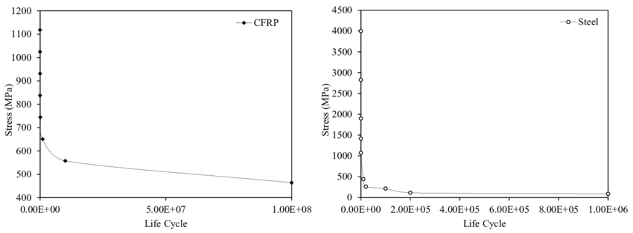
Figure 3- Comparison Graphs Between CFRP and Steel [13]

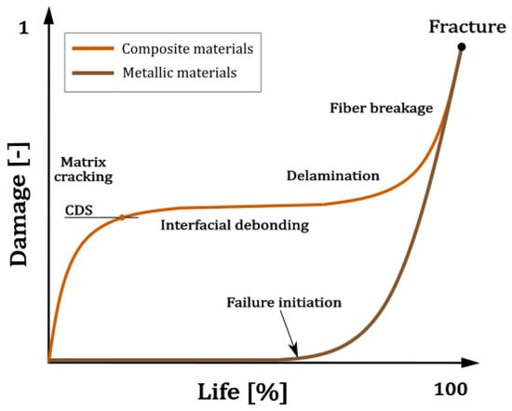
Figure 4-Metallic and Composite Comparison Fracture Paris-Erdogan Graph [14]
Figure 4 shown above shows the damage-life comparison between composite materials and metallic materials under fatigue loading and enables to demonstrate how damage is accumulated over a service life. The metallic materials displays almost no measurable damage for most of its life and only really displays damage at the latter stage of its life. This also shows that as a crack is initiated damage accelerates and the life of the material deteriorates until fracture. Unfortunately, this therefore means that metallic materials often give little warning prior to fracture and the fatigue life is dominated by crack initiation.
In contrast, the composite materials experience matrix cracking at a very early stage in the components life and damage typically starts to occur early even at low loads. During the materials mid-life interfacial debonding occurs which consists of fiber-matrix separation which allows for damage to grow slow but steadily, however the structure can still carry a load. During the components end of life stage, fiber breakage occurs, and eventually final fracture is achieved. This graph ultimately demonstrates from a composite perspective composites accumulate damage throughout the life of the material but do show progressive degradation which enables for failure mechanisms to be identified.
Overall, when stressed beyond their yield point metals undergo plastic deformation, therefore absorbing energy which results in permanent bending or stretching. This visible change provides an indicator that the material is about to fail. CFRP composites lack a traditional yield point, these materials remain stiff and elastic until reaching their ultimate tensile strength and at this point failure occurs. This failure makes damage difficult to predict prior to the occurrence of failure [13].

3.1.3 Factors Influencing CFRP Fatigue
There are many factors which can influence the fracture of CFRP such as the loading modes, the fiber/matrix interface, weave/architecture and manufacturing defects. Loading modes such as sheer, tensile, compressive and mixed mode loading can cause unique failure patterns. The fiber/matrix interface is also critical as this binding matrix must hold strong carbon fibers together to create a durable material, in CFRP this is typically a resin. The fiber orientation can also affect the CFPR fracture as well as manufacturing defects such as entanglement and misalignments.

3.2 Buckling Under External Pressures
Buckling under external pressures is important as this is a critical failure mode for thin-walled structures where gradual external pressures cause a significant change in structure shape, leading to a potential collapse of the material and permanent deformation. This occurs by a structure experiencing significant external pressures which then overcome the structures’ ability to resist the pressure and finally energy causes the structure to dimple inwards [15].Figure 4 shown below displays a pipe which had endured external pressure until the point of permanent deformation.

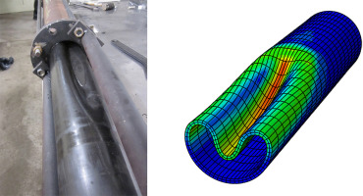
Figure 5-Pipe Buckling Under External Pressure

4 Preventative Measures

4.1 Inspections

4.1.1 Manual Inspection
A preventative measure which could have potentially mitigated the risk of the submersible imploding could have been by undertaking manual inspections pre and post dives which provide an opportunity to analyse any damage to the vessels hull. Detailed surface checks should have been undertaken to identify potential voids, cracks or rough spots within the material, typically using specialised mirrors or flashlights.
The limitation to this preventative measure however is that this only identifies damage at surface-level and hence does not provide an in-depth analysis of the entire hull structure such as delamination or subsurface voids.

4.1.2 Automated Visual Inspection (AVI)
Another preventative measure which could have been established prior to undertaking the fatal dive was introducing Automated Visual Inspections(AVI). These inspections use cameras, Artificial Intelligence (AI) and sensors to check structures for defects. These methods establish a more reliable and accurate approach to identifying structure damage.

4.2 Optical Microscopy

Optical microscopy uses light microscopy to analyse the CRFP structure, this method primarily focuses on fiber/matrix interface, void content, alignment of fibers and defects such as pull-outs or cracks. Typically for larger areas digital stitching is used and fluorescence for subsurface damage which may not be visible during a visual inspection. The result of this testing helps to predict performance, understand failure mechanisms and predict future performance of the structure. Figure 5 below demonstrates optical microscopy of CFRP which identifies an area where the matrix is more prominent which may lead to failures. This could have been used to prevent Ocean Gate from imploding.

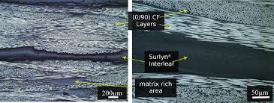
Figure 6- Optical Microscopy of CFRP

4.3 Non-Destructive Testing (NDT) Methods
Non-Destructive Testing (NDT) is a useful method of identifying internal flaws such as cracks, delamination, voids and fibre issues without damage to structures and specifically useful in the case of identifying these key failure mechanisms in the hull of the Ocean gate Titan submersible. NDT uses practises such as ultrasound testing, Infrared (IR) thermography, Eddy Current Testing (ECT) and X-Ray/CT scans to identify these anomalies.

4.3.1 Ultrasound Testing
Ultrasound Testing uses high-frequency sound waves and penetrates these into materials which enable for internal flaws with structures to be found. This method can also be used to measure material thickness or characterise specific properties without damaging the object.
Ultrasound testing uses a pulse/receiver which transmits an electrical pulse to a transducer, this transfers them into high-frequency sound waves. These sounds wave then transfer into a material in vibrated patterns, should the vibrations interact with a discontinuity (eg void or crack) energy is returned in the form of an echo. The echoes are then converted back into electrical signals which enables for a value to be obtained for analysis. Figure 7 below shoes the process in a diagram highlighting the identification of a crack in a material.
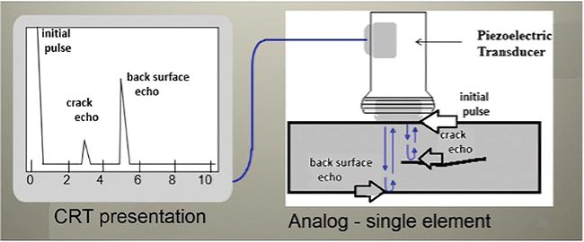
Figure 7-Ultrasound Testing Diagram [17]

4.3.2 Eddy Current Testing (ECT)
Another NDT practise which could have been used to identify the potential cracks and voids in the CFRP structure prior to the oceangate Titan submersible imploding is ECT. This practise uses Electromagnetic Induction to identify surface and subsurface materials without damaging sections of a structure.
This practise is undertaken by using an alternating current in a coil which enables for a magnetic field to be created, inducing eddy currents in the testing material, defects within the material disrupt these currents, changing the impedance of the coil which is then used to recognise flaws in the material. Figure 8 below demonstrates the set-up of the ECT and how this method is used to identify key failure mechanisms in materials.

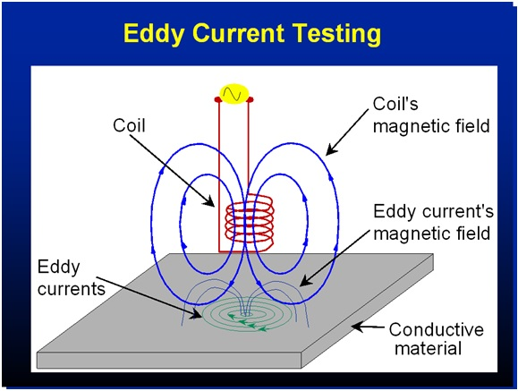
Figure 8-ECT Diagram [18]

5 Recommendations

5.1 Material Change

5.1.1 Steel Alloy
A recommendation which could be made to ensure that the Ocean gate disaster does not occur again would be to change the material. The submersible should have had materials similar to a submarine which could handle the intense external pressures applied from deep sea exploration. Most submarine hulls are constructed using steel alloys which allow for permanent deformation to be resisted, and the high tensile strength of the steel alloy ensures that the hull does not implode during dives.
Furthermore, steel alloys maintain structural integrity despite being subject to repeated stress cycles. They resist cracking and fatigue, which is essential for long deployments. Another positive impact to creating steel alloys as a hull is that this material is corrosion resistant, these allow corrosion resistance in saltwater environments. It can also be discussed that other materials can also be used instead of carbon fiber to withstand harsh pressures such as Titanium, Aluminium (in specific sections) and other composites. Figure 9 shows a steel alloy and how this material is impacted by stress over repeated cycles.

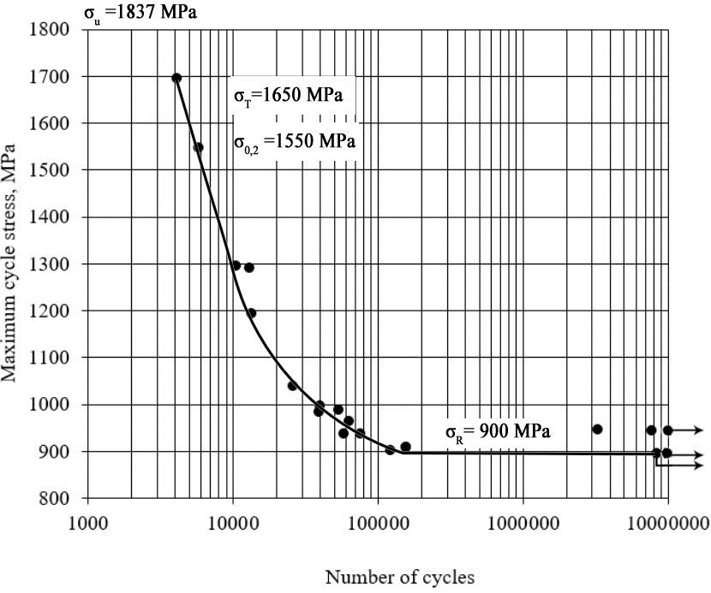
Figure 9- Steel Alloy Fatigue Curve [19]
The graph shown in figure 9 highlights that the steel alloy can undertake few cycles at high stress cycles, but this is important to bear in mind that the pressure at which the Titan submersible would have experienced would have been equivalent to 40 MPa which is far less than shown in this figure. This graph also shows that the steel alloys Ultimate Tensile Strength (UTS) is 1837 Mpa and the yield strength shown from this graph is 1650 Mpa. As shown in this graph the curve flattens which indicates that 900 Mpa is the fatigue endurance limit, this therefore shows that this material would’ve been more suitable to use for deep sea exploration than composite CFRP and should have been taken into consideration.
Some limitations to using steel, is that coatings or protections may require to be implemented, and this may affect fatigue performance depending on the allow used. Furthermore, when brittle fatigue fracture and this therefore does not give any warning as to when this will occur.

5.1.2 Titanium Steel
Another course of action which could be proposed to eliminate the risk of the Titan submersible disaster occurring again would be to completely build the hull out of titanium steel and not just the end caps. Titanium steel is used to construct submarines as the material is strong, light, corrosion proof in water and non-magnetic which allows for deeper dives to be achieved, higher speeds and more importantly for submarines better stealth. In comparison to steel, titanium is strong like steel but is much lighter, allowing for increased control and manoeuvrability during operation. This therefore, allows for faster acceleration, greater top speeds and greater capacity.
Another benefit to using titanium steel instead of composite is that similarly to steel Titanium does not rust in sea water, even at great depths. This enables for an extended service life and reduces long-term maintenance dramatically.
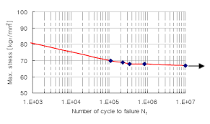
Figure 10-Titanium Fatigue Curve [20]

Figure 10 shows that at high stresses, titanium life is decreased but at lower stresses the titanium component life is extended allowing for more cycles until fatigue failure. The graph in figure 10 shows that the curve does not come completely horizontal and that even at long life and multiple cycles the material still demonstrates fatigue failure. This therefore may provide an estimation of an UTS of 950-1000 Mpa which is much lower than steel. The arrow shows that the specimen survived the test experienced which resulted in the creation of the graph but does not guarantee infinite life. This therefore means that crack initiation continues at low stresses enabling for cracks to propagate slowly and steadily.
Furthermore, a potential limitation of using titanium as opposed to steel is that microcracks can form early which therefore requires a robust inspection regime especially on a submersible such as Titan. Finally, titanium is expensive and Is difficulty to manufacture especially during machining and welding processes.

6 Conclusion
In conclusion, There were many failings which contributed to the ocean gate submersible disaster resulting in implosion of the vessel. The main contributor however was the design which incorporated CFRP as the submersible hull which was expected to endure multiple deep-sea explorations reaching and experiencing pressures up to 40 Mpa at depths of 3800-4000 metres below sea level. This report explored the unsuitability of this material and the impact of fatigue on composites which demonstrate early damage over cycles which contribute to matrix cracking and eventually the interface between fibers and the matrix and affecting the overall material structure of the component.
The risk of this occurring again should be eliminated by using a different material such as titanium or steel alloy which can withstand these pressures and is evidently used in the design of submarines. Ultimately steel would have been the ideal material for strength and has a higher UTS which would’ve enabled to easily withstand these pressures at this depth, for performance it may have been better to create the submersibles hull from titanium as this enables for vessels to accelerate quicker. Ultimately, this disaster occurred due to cost-cutting and not installing a vigorous inspection regime to understand the damage which was occurring below surface level of the material.

References

[1] | S. H. a. A. Haider, Renewable Polymers and Polymer-Metal Oxide Composites, Metal Oxide Series, 2022.
[2] | Element, “5 Disasters Caused by Material Fatigue and What We Learned From Them,” Element, [Online]. Available: https://www.element.com/nucleus/2016/5-disasters-caused-by-material-fatigue-and-what-we-learned-from-them. [Accessed 1st December 2025].
[3] | S. L. K. a. M. V. K. Norman E. Dowling, “Material Behaviour of Materials,” in Material Behaviour of Materials, Global Edition, pp. 294-296.
[4] | D. Mcclements, “Polymer v metal what are the differences,” Xometry, 15 April 2023. [Online]. Available: https://www.xometry.com/resources/materials/polymer-vs-metal/#:~:text=Polymers%20are%20composed%20of%20large,used%20for%20strength%20and%20conductivity.. [Accessed 1 December 2025].
[5] | MCcraren Compliance , “Safety Leadership – OceanGate Submarine Tragedy – Innovation Versus Safety,” MCcraren Compliance , [Online]. Available: https://mccrarencompliance.com/safety-leadership-oceangate-submarine-tragedy-innovation-versus-safety/#:~:text=By%20now%20most%20everyone%20has,to%20look%20outside%20the%20craft.. [Accessed 1 December 2025].
[6] | B. Suryanarayanan, “The engineering flaws of the Titan,” The Tartan, 2024 October 2024. [Online]. Available: https://the-tartan.org/2024/10/07/the-engineering-flaws-of-the-titan/. [Accessed 1 December 2025].
[7] | D. K. Odom, “How Many Dives OceanGate's Titan Submersible Completed Before It Imploded,” Screen Rant, 11 June 2025. [Online]. Available: https://screenrant.com/how-many-dives-oceangate-titan-submersible-complete-before-implosion/#:~:text=The%20Titan%20Had%2087%20Dives%20Before%20It%20Imploded&text=OceanGate%20dubbed%20the%20Titan%27s%20expedition,%27t%20all%20successful%20dives.). [Accessed 1 December 2025].
[8] | Innovative Compsotite Engineering , “ What is Carbon Fiber?,” Innovative Compsotite Engineering , [Online]. Available: https://www.innovativecomposite.com/what-is-carbon-fiber/#:~:text=Carbon%20fiber%20can%20be%20thinner,coated%20in%20resin%20or%20plastic.. [Accessed 9 December 2025].
[9] | JEC, “OceanGate selects Toray as provider of prepreg carbon fiber for deep-sea submersible hull,” JEC, [Online]. Available: https://www.jeccomposites.com/news/spotted-by-jec/oceangate-selects-toray-as-provider-of-prepreg-carbon-fiber-for-deep-sea-submersible-hull/. [Accessed 9 December 2025].
[10] | St Kittens & Nevis Observer , ““Buy Myself a Congressman”: The Arrogance That Sunk Titanic Minisub.,” St Kittens & Nevis Observer , 16 October 2025. [Online]. Available: https://www.thestkittsnevisobserver.com/buy-myself-a-congressman-the-arrogance-that-sunk-titanic-minisub/. [Accessed 10 December 2025].
[11] | B. R. S. D. A. J. D. S. &. V. S. D. Barty Wardell, “Fracture mechanics characterises fibre entanglement,” Fracture mechanics characterises fibre entanglement, 2025.
[12] | T. M. a. M. I. Mototsugu Sakai, “Fracture toughness and fiber bridging of carbon fiber reinforced carbon composites,” in Fracture toughness and fiber bridging of carbon fiber reinforced carbon composites, Elsevier, 1991, pp. 231-250.
[13] | j. c. P. A. M. A. D. J. J. M. C. a. F. B. Anis Mohabeddine, “International Journal of Fatigue,” International Journal of Fatigue, vol. 148, 2021.
[14] | M. S. P. Z. P. S. a. G. L. Szymon Duda, “Multiaxial Fatigue Behavior of CFRP Thin-Walled Tubes: An Experimental Study with Analysis of the Acoustic Signals,” Multiaxial Fatigue Behavior of CFRP Thin-Walled Tubes: An Experimental Study with Analysis of the Acoustic Signals, vol. 17, no. 19, 2025.
[15] | Mwalloys , “Is Carbon Fiber Stronger than Steel?,” Mwalloys , [Online]. Available: https://www.google.com/search?q=how+does+carbon+fiber+fracture+differently+to+metals+&sca_esv=be40058fb533a05b&source=hp&ei=6IRbafjcJsa3hbIPkImJgQU&iflsig=AOw8s4IAAAAAaVuS-AcFWsRsq3L_MzyjO2-yWA1wT9rx&ved=0ahUKEwj48JrGi_SRAxXGW0EAHZBEIlAQ4dUDCBU&uact=5&oq=. [Accessed 3 January 2026].
[16] | T. G.-G. a. H. S. Neda Fazlalipour, “A review of buckling capacity of steel cylindrical shells under external pressure: Reinforcements and imperfections (2005–Present),” A review of buckling capacity of steel cylindrical shells under external pressure: Reinforcements and imperfections (2005–Present), vol. 217, 2025.
[17] | Power, “Understanding Ultrasonic Examination in the Power Industry,” Power, 1 May 2023. [Online]. Available: https://www.powermag.com/understanding-ultrasonic-examination-in-the-power-industry/. [Accessed 2026 January 5].
[18] | The Merick Group, “What is ECT,” The Merick Group , [Online]. Available: https://www.merrickgroupinc.com/articles/what-is-eddy-current-testing/. [Accessed 5 January 2026].
[19] | Research Gate, “Peculiarities of deformation of thin-sheet TRIP steel under static and fatigue loading,” Research Gate , [Online]. Available: https://www.researchgate.net/figure/Fatigue-curve-Stress-Life-Diagram-for-23Kh15N5AM3-Sh-steel-alloy_fig2_349019949. [Accessed 5 January 2026].
[20] | Research Gate , “Design of new root-form endosseous dental implant and evaluation of fatigue strength using finite element analysis,” Research Gate , [Online]. Available: https://www.researchgate.net/figure/S-N-Curve-of-Titanium-Alloy-Ti-6Al-4V_fig5_40721705. [Accessed 5 January 2026].

