Solution to the problem of Caribbean Coffee information system security based on improved IT framework and model
Xin Yue
Abstract
With the development of information technology, the information level of some companies is getting higher and higher. Because of the huge base of employees and international customers, it will face great pressure for their employees and customers to use personal devices to access the company's network resources. The security of personal employee data and customer data is the most concerned problem of the company. The equipment and business systems managed by the company's IT operation and maintenance department are increasing year by year, and the complexity of the system is getting higher and higher. However, the growth of IT operation and maintenance personnel is limited, and the frequent occurrence of equipment and systems makes the staff pressure doubled. How to manage the increasingly large and complex information system has put forward higher and higher requirements for IT operation and maintenance department. This paper compares and improves three network security frameworks, namely Information Technology Infrastructure Library (ITIL), International Organization for Standardization 27001, and Payment Card Industry's Data Security Standard (PCI DSS), and applies them to solve the problems faced by Caribbean Coffee.
Key words: Data Security, Information Technology Infrastructure Library, International Organization for Standardization 27000, Payment Card Industry's Data Security Standard

- Introduction
With the increasing number of people using the Internet in the world, the demand and dependence on Internet-based information leads to more and more people's higher expectations of obtaining information. On the one hand, information is more and more easy to obtain, on the other hand, the security and reliability of information become more and more important. The vast majority of enterprises rely on the Internet, which makes enterprises easy to become the target of attacking information, or property security and intellectual property rights are threatened, so more professionals with the ability to protect these assets are needed. Hundreds of millions of Internet users can access the enterprise's Internet at any time and any place, which means that attackers can also access and attack everyone’s online information. Now more and more people choose online shopping, personal information and property security is becoming more and more important. As a result, the threat of attacks from criminals, hackers and government entities is growing. Information technology professionals are expected to have the best skills and experience to face these possible situations, so as to ensure the security of enterprise and personal information and property in a diversified information environment. For enterprises, it is necessary to employ professional IT personnel to encrypt enterprise information security to prevent internal information and intellectual property leakage. For individuals, the network security framework will protect personal information security and personal information property security in the process of online shopping. In the next section of this article, we will research three security frameworks and models and compare them. We will also apply these three security frameworks and models to solve the problems faced by Caribbean Coffee.
- Security Frameworks and Models
The three models and frameworks are Information Technology Infrastructure Library, International Organization for Standardization 27000, and Payment Card Industry's Data Security Standard. This paper will discuss and compare the three frameworks from the aspects of their characteristics, functions and functions.
2.1 Information Technology Infrastructure Library (ITIL)
Information Technology Infrastructure Library (ITIL) describes in detail the comprehensive checklists, tasks, procedures and responsibilities applicable to any organization. It includes a set of best practices for all IT organizations. No matter how big these organizations are and what technology they use. ITIL is developed on the basis of practice rather than theory. It collects and analyzes the information of various organizations in solving service management problems, finds out the practices that are beneficial to customers, and finally forms ITIL. At present, ITIL has become the standard of IT service management in the world. When using ITIL's processes and best practices for internal IT service management, it can not only provide users with satisfactory services to improve customer experience, but also ensure that the process is cost-effective.
The core module of ITIL is service management, which includes 10 processes and one function. These processes and functions can be summarized into two process groups, which are called service support process group and service provision process group. The service support process group summarizes a management function and five operation level processes related to IT management, which are accident management, configuration management, problem management, release management and change management. The service delivery process group summarizes five tactical processes related to IT management, which are service level management, IT service financial management, IT service continuity management, capability management and availability management. The service desk is a single point of contact between IT departments and IT service users. It promotes the integration of organizational business processes and service management infrastructure by providing a dedicated and centralized service point of contact. The main function of the service desk is to coordinate the contact between customers and IT departments, provide support for IT service operation, so as to improve customer satisfaction. The ten processes and functions are as follows.
2.1.1 Service Desk
The main function of the service desk is to connect customers and it service departments. The main task is to coordinate the direct relationship between customers and service departments, deal with emergencies and improve customer satisfaction.
2.1.2 Incident management
Incident management is responsible for recording, classifying and arranging accidents by experts and supervising the whole process until the accidents are completely solved. The purpose of incident management is to restore it system to the service level defined by service level agreement with the least possible impact on customers and business.
2.1.3 Problem management
Problem management refers to the service management process that can find out the potential causes of accidents, formulate solutions to accidents, and prevent accidents from happening again by investigating and analyzing the weak links of IT infrastructure, so as to minimize the impact of accidents and problems on the business. Problem management emphasizes to find out the root cause of the accident, so as to develop appropriate solutions or preventive measures to prevent its recurrence, which is different from the speed of accident recovery emphasized by accident management.
2.1.4 Configuration management
Configuration management is a process of identifying and confirming system configuration items, recording and reporting configuration item status and change requests, and verifying the correctness and integrity of configuration items. The purpose of configuration management is to provide a logical model of IT infrastructure and support other service management processes, especially change management and release management.
2.1.5 Change management
Change management is a service management process that controls change in any aspect of infrastructure or services in the shortest disruption time. The goal of change management is to ensure that in the process of change implementation, the standard methods and steps are used to implement the change as soon as possible. Through this method, the impact of business interruption caused by the change on the business is minimized.
2.1.6 Release management
Release management is a management process to publicize and distribute the modified or new configuration items that are imported into the actual application after testing. Release management, also known as software control and distribution, is controlled by change management process.
2.1.7 Service level management
Service level management is a service management process composed of a series of activities such as planning, drafting, negotiation, monitoring and reporting for signing service level agreements (SLAs), and evaluation of service performance after signing service level agreements. Service level management aims to ensure that the quality of IT services required by the organization can be maintained and gradually improved within a reasonable cost.
2.1.8 IT financial service management
IT financial service management is responsible for budgeting and accounting the cost of IT services provided by IT service providers, and charging the corresponding service fees to customers. It includes three sub processes, namely, IT investment budget, IT service cost accounting and service billing. Its goal is to reduce the risk of cost overrun, reduce unnecessary waste and reasonable guidance through excessive service costs Customer behavior, so as to ensure that the final IT services provided in line with the principle of cost-effectiveness. The budget and accounting information generated by IT service financial management process can provide decision-making basis for service level management, capability management, IT service continuity management and change management.
2.1.9 IT service continuity management
IT service continuity management refers to the management process of having sufficient financial, technical and management resources to ensure it service continuity after a disaster. The focus of IT service continuity management is the ability to provide reservation level IT services after service failure, so as to support the business continuity of the organization.
2.1.10 Capability management
Capability management is a service management process that maximizes the efficiency of IT resources through reasonable service capability under the dual constraints of cost and business requirements. Capability management process includes three sub processes: resource capability management, service capability management and business capability management.
2.1.11 Usability management
Availability management optimizes and designs the availability of IT infrastructure by analyzing the availability requirements of users and businesses. Availability management makes the design of IT services based on real needs by positioning the availability requirements of business and users, so as to save the operation cost of IT services and avoid excessive availability level in IT service operation. Availability management is a forward-looking management process.
2.1.12 The process of ITIL
Service management processes aim to transform the service provider's resources into valuable customer services. These services are to be made available at levels of cost, quality, and risk. The process of ITIL is distinguished between service lifecycle processes and supporting processes. The lifecycle processes (LP) in ITIL are directly concerned with managing the service provider’s range of services. There are five service lifecycle processes. LP1: Set the strategic direction, LP2: Design new or changed services, LP3: Build new or changed services, LP4: Operate the services, LP5: Improve the services. The supporting processes (SP) in ITIL provide various kinds of support to the service lifecycle processes. There are the twelve supporting processes. SP1: Set up and maintain the service management system, SP2: Maintain the service portfolio, SP3: Manage customer relationships, SP4: Manage configuration information, SP5: Assess and coordinate changes, SP6: Manage projects, SP7: Ensure security, SP8: Prepare for disaster events, SP9: Ensure compliance, SP10: Manage human resources, SP11: Manage suppliers, SP12: Manage service financials. The ITIL process is shown in Figure 1.
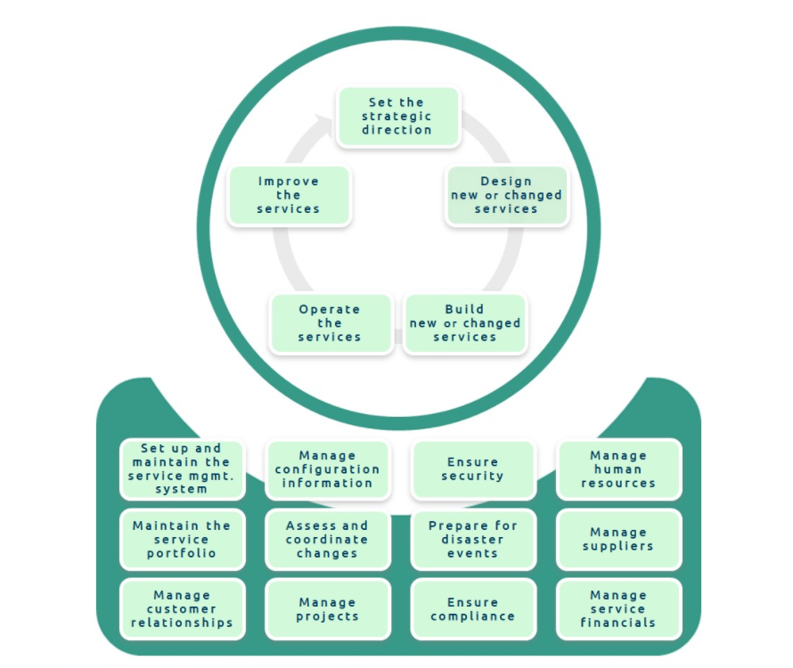
Fig 1. The process of ITIL
2.2 Information Organization for Standardization 27000 (ISO)
The ISO27000 series of standards originated from BS7799 which was designated by British Standards Association in 1995, and was improved by ISO17799 which was formed after the adoption of ISO standard.
ISO and IEC have jointly formulated ISO27000 series standards, which provide guidance for the construction of Information Security Management System (ISMS). The standard includes information confidentiality, IT technology security, information protection and other issues, and is applicable to organizations of all sizes. This standard system formulates new information security management related standards every year. Among them, ISO27001 standard mainly includes the main body of 10 chapters and Appendix A. The text includes the scope of the standard, the quotation, terms and definitions in ISO27000 system, enterprise environment and stakeholders, information security leadership and senior support, information security management system planning, risk disposal stage, risk assessment, information security management system support, information security management system operation, information security management system performance improvement, information security management system The improvement of the whole management system and the reference control objectives and measures in Appendix A. The first to the third chapters are about the specification of standard writing and the definition of use, and do not involve the actual requirements themselves. From the fourth chapter to the tenth chapter, the construction requirements of enterprise information security management system are formally introduced. Through the establishment, operation, evaluation and improvement of information security management system, the requirements are elaborated, and the guiding opinions are put forward for the whole life cycle of ISMS.
Compared with other security standards, such as NIST framework of the United States and classified protection requirements of information security issued by the Ministry of public security of China, ISO27001 standard focuses more on describing the role of management in information system, and describes more management related scenarios. It is an information security ontology with high adaptability and independent of concrete implementation.
Enterprises usually carry out ISO27001 certification, which is the authoritative certification for the construction of enterprise information security system in line with the standards. ISO27001 standard document is the most fundamental evaluation standard for the evaluation of enterprise information security construction by ISO authorized certification bodies. When enterprises apply for ISO27001 certification, they usually need to go through these processes: the planning and preparation of information security management system, the preparation of information security system documents, the operation of information security management system, the audit and review of information security management system. Benefits of ISO27001 are shown in Figure 2.
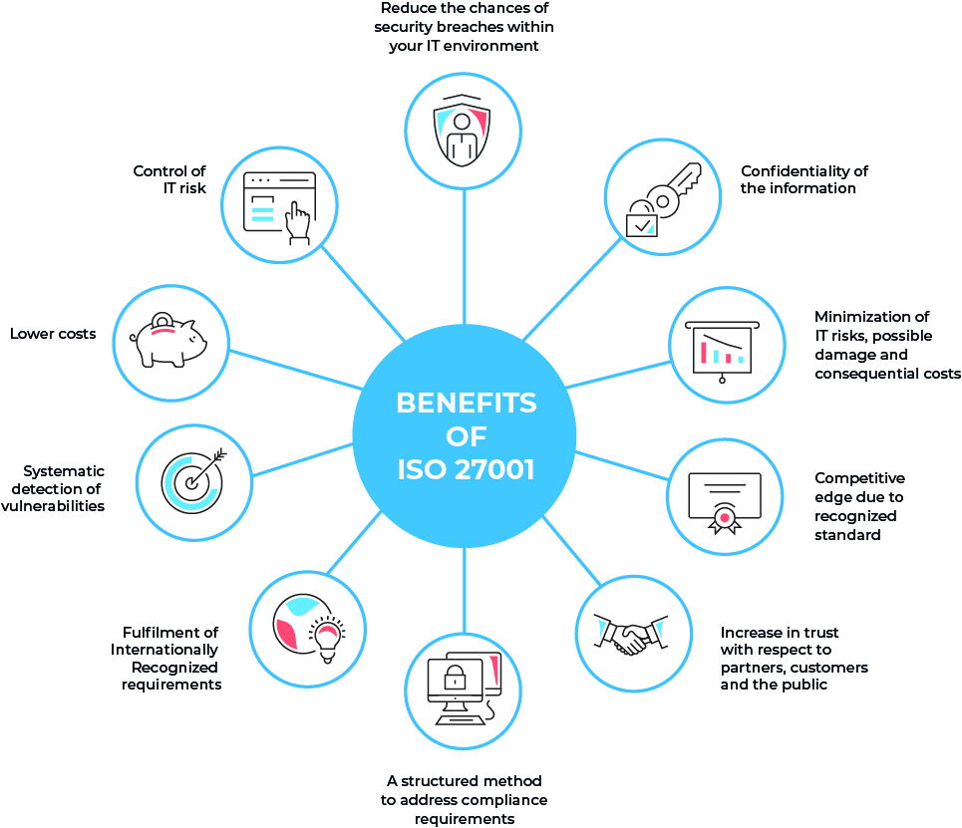
Fig2 Benefits of ISO27001
2.3 Pay Card Industry’s Data Security Standard (PCI DSS)
PCI security standards committee is a professional and unified information security standards committee jointly organized by American Express, American Discovery financial services, JCB, MasterCard and visa in autumn 2006. It is responsible for the implementation and promotion of PCI DSS and other payment card data protection standards. PCI DSS is a set of requirements formulated by PCI security standards committee to ensure the security of cardholder data, which is conducive to the wide adoption of unified data security standards worldwide. It is mainly applicable to entities that need to store, process or transmit cardholder data during daily operation, including service providers, merchants, processing institutions, etc.
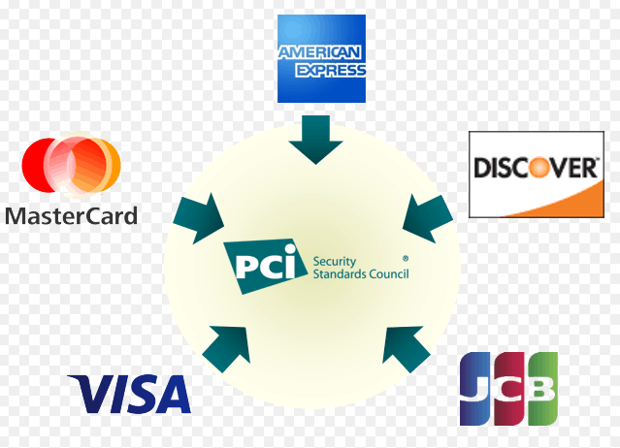
Fig 3. Payment Card Industry's Data Security Standard
PCI DSS puts forward 12 specific requirements for the security construction of payment system from the following aspects: building and maintaining a secure network, regularly monitoring and testing the network, protecting cardholder data, maintaining information security strategy, implementing strict access control measures and maintaining vulnerability management procedures. Build and maintain a secure network, install and maintain firewall configuration to protect cardholder data, system password and other security parameters. Do not use the default configuration provided by the supplier. Protect the stored cardholder data and encrypt the cardholder data in the open public network. Use antivirus software to maintain vulnerability management program and update regularly, develop and maintain security system and application program. Strict access control measures are implemented. Only those who have business needs can access cardholder data. Each user with computer access rights is assigned a unique ID to restrict the physical access to cardholder data. Regularly monitor and test the network, track and monitor all operations of accessing network resources and cardholder data, regularly test security systems and processes, and maintain information security policies for all personnel.
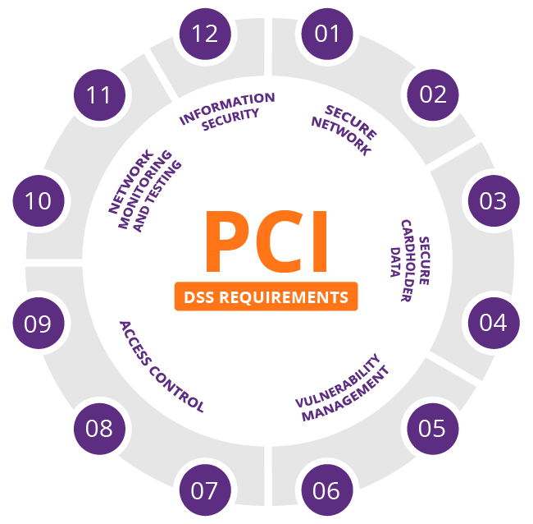
Fig 4. PCI DSS Requirements
- Discussion and Comparison
ITIL is a set of best practice framework and effective methods used by IT organizations to plan, implement, research and develop, operate and maintain high-quality IT services. It is a set of universally implemented de facto standards and norms, which is mainly applied to it service management. It constantly explores and practices the way, content, service management mode, service level and service ability of IT services, and gradually summarizes and refines a set of excellent IT services Effective standard method process. The purpose of ITIL implementation is to provide enterprises with high quality and quantifiable IT service management practices. ITIL has become an international common standard with process as the main line, standardization as the framework and management as the core, which is applied to organizations with different technical levels and different scales of business requirements.
ISO27001 focuses on the organization and management of information security, and management usually uses a variety of strategies, management processes to reflect, so the completeness of the document system is a very important part of ISO27001 system. According to the requirements of ISO27001, the review enterprise should establish documentable information, such as information security manual including enterprise information security objectives and scope, evaluation report including enterprise risk assessment results, etc., and the documents should meet the requirements of ISO27001. At the same time, we will also conduct on-site audit on the asset management of the existing facilities and equipment of the enterprise, and ask questions about important processes, such as checking whether the assets are marked, and whether the computer room has security measures to restrict access.
PCI DSS is the product of the information age, which provides cardholders with a variety of payment services. Because its business data transmission depends on the application of the Internet, the data content involves the user's magnetic card information, password and other sensitive information. For users, system security is very important, system security management should meet the mandatory requirements of the country where the enterprise is located. As early as many years ago, ISO27001, which has become an international standard, has been widely concerned and recognized. Some countries and organizations have put forward mandatory certification requirements for their partners. With the development of information technology, in order to ensure the security of payment card business system, it is very necessary to test the security compliance of the system according to the relevant laws and regulations and industry standards. PCI DSS should also become a more explicit mandatory requirement.
- Applying three security frameworks to solve the information security problem of Caribbean Coffee shops
Blue Mountain Peak coffee from Jamaica is one of the best and most popular blended coffees in the world. It is the star product of Caribbean Coffee company. Caribbean Coffee has a wide range of businesses around the world. The company uses cloud services to provide IT services to employees and customers. With the continuous growth of the global use of the Internet, companies and users have an increasing demand and dependence on Internet-based information. It is estimated that nearly 95% of the company's network is wireless. The company also has a lot of online and social media to promote its marketing activities. This creates more and more threat of attack information.
Owing to its large staff and international customer base, the company has recently come under immense pressure to allow both its staff and customers to use their personal devices to access the company's network/resources. The security of personal employee data and customer data is the main concern of the company. The company is also concerned about protecting its intellectual property. Information security is the top priority of the company, but everything is chaotic. As such the threat of an attack from individuals, criminals and government entities grows daily, Caribbean Coffee companies need to do more to protect these assets.
This paper designs a stable framework for Caribbean Coffee company. The framework uses ITIL as the main line and uses ISO27001 and PCI SSC as a supplement to compose the security framework and solve the information security problem. The framework is shown in Figure 5.
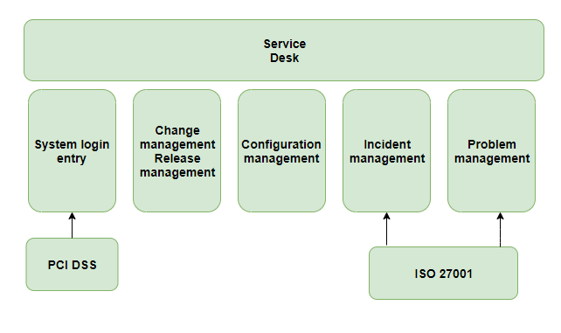
Fig 5. The security framework for Caribbean Coffee
Login through the unified entrance, access and management control through web, and handle business processes and orders with reliable, efficient, convenient and procedural operation.
Through change management and release management, the new service online, online service change and service termination are approved and released to ensure that the risk in the process of service change and release can be controlled.
Through configuration management, the configuration information during the service change is updated to ensure the maintenance of a configuration management database that accurately reflects the service information.
Through event management, we can accept, process, track the faults and service requests of online services, so as to ensure that we can quickly solve the faults and data query and other service requests in the service process.
Through problem management, we can analyze the causes of major events and repeated events of online services, and fundamentally solve the potential causes of events.
PCI DSS is introduced into the system login portal. When customers pay, the security framework is established, it will accept credit cards, process the transactions, store this data or transmit credit card data. By putting this security framework in place, PCI has improved the security of the complete payment process. Payment security is very important to modern commerce. This strict security framework enables enterprises to process payment information safely and reduce the opportunities of identity theft and fraudulent transactions.
ISO27001 is introduced into incident management and problem management to standardize documents. ISO defines the organization's objectives and environment, and determines the overall policy and strategy of information security. ISO develops the principles and methods of risk assessment for the company, implements risk assessment, and formulates the principles and methods of risk disposal, so that employees can deal with risks according to the assessment results and treatment plans.
- Conclusions
Through this research and comparison of three security frameworks, I have a deeper understanding of data security. This paper integrates these three frameworks to solve the security problems encountered by Caribbean coffee companies. Through the security framework proposed in this paper, we can solve the problems faced by the company, such as information security pressure, customer payment security and risk management. In the future, we can learn more network security knowledge to improve the framework and further solve the practical network security problems.

Reference:
[1] Disterer G. ISO/IEC 27000, 27001 and 27002 for information security
management[S]. 2013
[2] ISO/IEC 27001: Information Technology, Security Techniques, Information
Security Management Systems, Requirements[S]. ISO/IEC, 2005.
[3] Jan Van Bon. IT Service Management: An Introduction Based on ITIL[M]. Zaltbommel: Van Haren,2005.
[4] Tomada Scientific K.IT Infrastructure of Data Center Service Based on ITIL[J]. Fujitsu and Technical Journal. 2010, (4):344-351.
[5] PCI Security Standards Council, Payment Card Industry Data Security Standard (Version 2.0) [S]. 2010.10.

