
MBA GENERAL MANAGEMENT
HUMAN RESOURCE MANAGEMENT
LCMB7000

ASSESSMENT 1

STUDENT NAME: RISHAN THEKKE PEEDIYEKKAL KALATHIL
STUDENT ID : 2211582

Executive Summary
It is impossible to accurately or confidently forecast the future. Nevertheless, everyone who engages in the labor market makes preparations for the future. Working Futures was founded on the premise that everyone may benefit from knowing more about the society they will likely live in if predictions are thorough, methodical, consistent, and transparent. The estimates from Working Futures are based on an assessment of the macroeconomic and labor market environment in the future. Considering all of the issues surrounding Brexit, this is particularly challenging right now. As a result, there are several hazards and difficulties associated with the forecast. The effect of Brexit on the market and immigration restrictions is the most noteworthy of these.

Content

Executive Summary 2
Content 3
1.0 The current state of the labor market in the UK 4
2.0 The emerging changes in Human Resourcing Strategies in the post-Covid, post-Brexit external environment 8
3.0 Conclusion 13
References 14

1.0 The current state of the labor market in the UK
The UK employment rate for July-September 2022 was 75.5%, about the same as the previous quarter but lower than before the coronavirus (COVID-19) epidemic (December 2019-February 2020). 1.1% lower. The number of blue-collar collections has declined over the previous three months, but the total of self-employed contractors has increased. The greater detailed extrapolation for wage workers in October 2022 shows a monthly increase of 74,000 from the revised September 2022 figures to a staggering 29.8 million. The unemployment rate fell by 0.2 percentage points to 3.6% in the quarter to September 2022. In the last three months, the number of unemployed people decreased in all periods (Leaker, 2022).
From July to September 2022, the rate of financial inoperativeness ascended by 0.2 percentage facts. It now stands at 21.6%. The sum of people who have been recurrently unfriendly produced a record high over the furthermost current three-month timeframe, which underwrote to an escalation in economic inactivity. There are people who are financially inactive due to continuing sickness. It exposed that, in the 3 months prior to the interview, more than two-thirds of individuals who would turn out to be persistently ill in 2021 and 2022 have been idle for further reasons.
The expected number of openings decreased by 46,000 in the quarter to 1,225,000 from August to October 2022. Despite falling for four straight quarters, the number of openings is still very high. Companies are now indicating deferring acquisition as a result of monetary challenges in a growing number of cases. Between July and September 2022, workers' consistent pay (except incentives) and overall compensation (with bonuses) both increased by an average of 6.0% and 5.7%, respectively. This is the most substantial growth in regular pay that has been detected since the coronavirus outbreak.
The average normal salary growth from July to September 2022 in the corporate market was 6.6%, whilst it was 2.2% in public organizations. At the peak level of the coronavirus breakout, this is the most advancement for the corporate sector and the widest difference between the government and corporate domains.
Normal pay dropped by 2.7% over the period of the year, while total compensation fell by 2.6% in actual terms (inflation-adjusted). Despite being considerably less than the unprecedented decrease in actual normal salary seen from April to June 2022 (3.0%), this remains one of the worse development reductions since comparable statistics began in 2001. The monthly labor disagreement records have been reintroduced this month. 205,000 days have been lost to labor disagreements in September 2022.
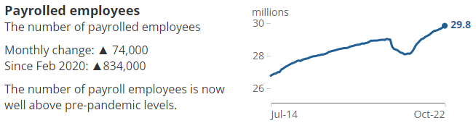
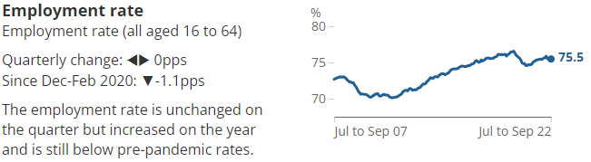
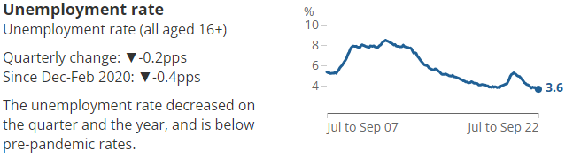
Latest indicators

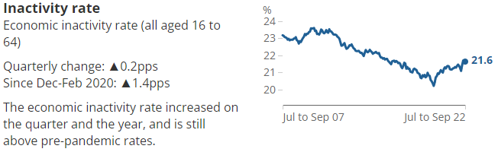
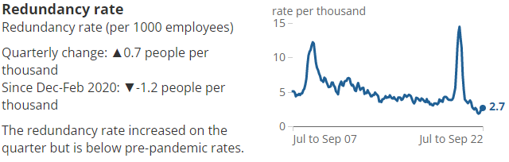
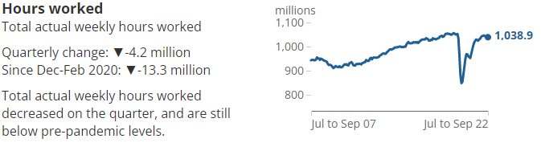
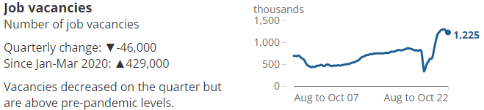

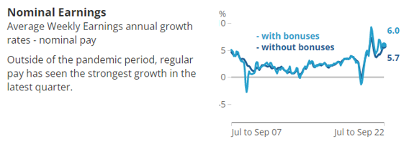
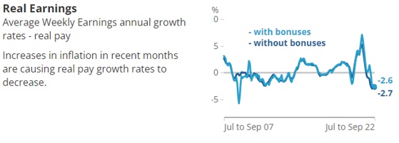

2.0 The emerging changes in Human Resourcing Strategies in the post-Covid, post-Brexit external environment
The demographic statistics considered in the most recent Labor Force Survey (LFS) forecasts are dependent on anticipated development rates for the UK, the EU, and non-EU people from Real Time Information (RTI) statistics for 2021 trends. As a result, the overall population utilized for the LFS does not reflect the variations in migrations, birth rate, death rates, or other factors that have occurred after June 2021. As a result, level predictions may be either too low or too high, and hence should be employed with care. However, robust rate forecasts will be provided. New regulatory structures are being established in the wake of the UK's departure from the EU to facilitate the endorsement and execution of high requirements for UK economic figures. The legitimacy and integrity of the UK's information service will increase thanks to these governing mechanisms, which will also encourage global comparison (Donnelly, 2022).
The new National Statistician's Committee for Advice on Standards for Economic Statistics will serve as the focal point of this novel governance system (NSCASE). NSCASE will aid the UK by assuring that its actions for impacting and approving international statistics values are amongst the best in the world. The National Statistician will receive guidance from NSCASE that covers the complete spectrum of economic information areas, such as the national financial records, fiscal information, pricing, trade and balance of payments, and labor-market data (Shibata & Pizzinelli, 2022).
Brexit impact on workforce trends
EU citizens used to have till June 30, 2021, to offer up an application to stay in the nation following the UK's official removal from the EU on January 31, 2020. As of this prose, upwards of 500,000 applications have been still awaiting out of the total 6,015,400 applications reported by the Organization as of June 30, 2021. The burdens that HR professionals are bearing on the representation of the company given this level of ambiguity since it is difficult (Aizenman & Ito, 2020).
Managing Exit from the EU is not an easy process. There are constantly likely to be a variety of diverse obstacles and difficulties to conquer while actually moving throughout the procedure, despite the fact that recognize that organizations on both parts of the water have been attempting their best to be ready for it (Ramani, 2021).
Though it is a hard responsibility, however, can make sure that is helping the people's requirements while also creation plans for tomorrow by setting distinct objectives. In the section underneath, go over the numerous effects to take into account when conduct the effects of Brexit and ways to guide the team through the upcoming stage of the path.
- General Employment
Despite initial concerns regarding the way Brexit will impact employment, employment stages have increased fairly quickly as of the 2016 vote to leave the European Union. Despite a decline in employment advancement in 2019, there are even now a lot of interactive roles and a challenging workforce industry.
- Effect on recruitment
Further companies are reportedly experiencing problems discovering suitable individuals as a result. This is partly because more recent increases in the number of EU citizens working in the UK have not sustained employment growth.
According to the CIPD's Labour Market Outlook (LMO) study, the percentage of corporations disclosing difficult-to-fill vacancies increased from 56% in the Spring 2017 study to more than 75% (61%) of organizations in the Spring 2019 report. In response, many businesses are raising salaries, especially for key employees and recent employs. According to the LMO Autumn 2019 survey, 59% of corporate sector businesses said they raised salaries to address their hiring difficulties.
Furthermore, it appears that many workers are experiencing wage strain due to the competitive employment market. But why has a corporate investment in skills been declining during this time span is puzzling.
- Working with migrant workers from the EU
It appears that Brexit has not dimmed firms' enthusiasm for hiring EU migrant employees given the declining availability of skills and labor. At the beginning of 2018, approximately two-thirds of the organizations declared individuals would continue to employ EU citizens. As the main rationale for hiring EU citizens, organizations occasionally point to their choice to select only the greatest competent job seekers rather than taking people who applied' nationalities into consideration. The primary defense offered for semi-skilled or unqualified roles was that businesses couldn't fill individuals with residential applicants.
To ensure people keep going to get entry to the competence their entrepreneurs' demand, companies must ensure that enterprises have carried the necessary safeguards before the execution of fresh migrant constraints in 2021.
- Overcoming recruitment challenges
Organizations can expand their brand, increase their employee offer with non-financial encouragements, or surge recruitment methods that are inclusive in order to recruit employees in addition to raising salaries. These will not only handle employment challenges in the short time but create their corporations further desirable as a company in the long term. Similarly, strategies like offering versatile arrangement and explicit professional expansion will aid businesses in bringing in and retaining the talent and skills they need.
- Workforce planning and growth
Workforce planning and improvement would take priority because of the lack of skilled workers and labor, which can be ended not as good as by significant scratches after Brexit once the free movement is ended. Employers must prioritize strategic workforce planning more urgently if they want to respond quickly. This strategy will assist define the skills and knowledge needed today and in the foreseeable, which will enable the concentration of the necessary learning and development.
Although 72% of firms had a designated budget for training, data from the beginning of 2018 indicated that this sector's growth was fairly sluggish. Upwards of half (55%) claimed that their spending on training and skill enhancement has not changed as a result of the UK's decision to leave the EU, although 20% requested that it has decreased as a result. This proves how several businesses are cutting back on training and growth when they should be making investments more to safeguard against the real risk that the current skills shortage will worsen after Brexit.
It's worthwhile to know that corporations who hire EU people have a substantially higher likelihood of spending on training and actively looking to hire from a broader series of excluded or vulnerable groups, including older employees and those from minority cultural origins. This proves how several businesses are cutting back on training and growth when they should be making investments more to safeguard against the real risk that the current skills shortage will worsen after Brexit.
- Take care of the present moment
There are numerous practical factors to take into account, and therefore recognize that it may seem overwhelming. This is why taking care of the now comes before considering the perspective. Economic doubt carried on by Brexit has subsidiary effects on matters like rewards, monetary benefits, and pensions.
According to the latest economic deal, conducting operations with the EU has become more expensive, and companies that mainly rely on support from the EU, such as via the Common Agricultural Policy, may be undergoing budget deficits. Additionally, the UK is no more bound by EU law, thus certain laws and guidelines governing things like pensions may be altered or abolished.
- Reflect how Brexit will affect hiring in the future
The most crucial aspect for companies to accomplish is to ensure that their personnel has the essential documentation to be residing and employing in the UK, according to Anna Stobart, initiator, and director of Hafton Consultancy Ltd. By requesting established or pre-settled position within the European Settlement Structure by June 30, 2021, EU citizens could assist their citizens living in the UK.
The post-Brexit immigration process is in effect as of today because this deadline has passed. The hiring procedure is identical for executives located in the UK and executives from the US with operations in the UK. HR specialists could support incoming talent with gaining authorization for these credentials from authorities before to their presence in the UK. Workers operating in a professional association with specific skills will require to ensure these are "legally recognized."
It is vital to understand that there are discrepancies in the documentation among EU nations, so UK nationals operating in an EU country will be required to request approval from the countries they are located in to carry on employment. Afterward prudently studying all of the material provided by the European Commission, should support the impacted workers in gaining the necessary permits and making the necessary plans so that they can stay in the country where they are based.
The fact that there are no more open movements of people between both the UK and EU countries is crucial information for US industries to think of. Whenever administering present EU citizens in UK offices, the appropriate documents would be required, and vice versa.
- Recognize salary variances
In spite of the documentation issue, companies should be cautious about hiring employees on UK pay if they reside in a nation with a distinct cost of living because hybrid employment could quickly turn out to be the standard as a consequence of the epidemic. This may be a murky topic; therefore, the company desires to have a well-defined rewards policy, according to Anna Stobart of Hafton Consultancy Ltd.
After gathering domestic marketplace pay information for the individual's location and evaluating what is appropriate for both the firm in general and its workers, it is necessary to revise an individual's agreement if it states that they are engaged in the UK although are actually operating from abroad.
- Be open with the staff
Brexit is not just carrying about a variety of new laws and standards that companies must be aware of; it also has a consequence on the workforce's psychological health. We all know that organizations are experiencing variation for a variety of causes, but it's important to recognize and control the stress that Brexit is causing individuals who may be impacted.
Taking a clear grasp of why Brexit is affecting various aspects of the enterprise and then conveying this to the staff combined with a plan for handling the effect are two ways to prevent this. Reflect the variety of resources existing, such as the thorough Brexit Hub from the Chartered Institute of Personnel and Development, and use the connection of colleagues to exchange expertise.
After that, must recurrence this to the staff so they are conscious of it and get a sense of being included in the process. Moreover, this will rise their confidence in the company and confirm that employees remark organizational leaders as effectively guiding employees into a post-Brexit environment.

3.0 Conclusion
Although the UK economy is facing significant challenges, the labor market is still surprisingly tight. Although an economic downturn might cause vacancies to decline from their high levels, the labor supply situation is still worrying, and hiring difficulties don't seem to be going away very immediately. As they struggle with inflationary challenges at a period when the state has proposed a significant budgetary increase, Bank of England officials are understandably concerned about the restrictive job market driving robust nominal wage increases.
Numerous commercial organizations from a variety of industrial sectors, geographical areas, and nations have been compelled to alter their usual business practices, such as how companies interact with clients, vendors, and human resources. According to the feedback from the organizations, they have had to rapidly reorganize, reconstruct, and rearrange their workforces and corporate concepts to adopt particularly the digital operations framework (VOM), which includes working from home (WFH), a hybrid strategy of completely working on-site, in workplaces or shops where it exists especially essential. The demographic statistics considered in the most recent Labor Force Survey (LFS) forecasts are dependent on anticipated development rates for the UK, the EU, and non-EU people from Real Time Information (RTI) statistics for 2021 trends. New regulatory structures are being established in the wake of the UK's exit from the EU. The UK's formal exit from the European Union (EU) was announced on January 31, 2020. People of the EU had until June 30, 2021, to apply to persist in the country. HR professionals are bearing on the representation of the company given this level of ambiguity since it is difficult.

References
Aizenman, J. & Ito, H., 2020. Post covid-19 exit strategies and Emerging Markets Economic Challenges. Review of International Economics.
Donnelly, S., 2022. Post-Brexit financial services in the EU. Journal of European Public Policy.
Herz, B. & Van Rens, T., 2020. The labor market in the UK, 2000–2019. IZA World of Labor.
Jones, M., 2021. Disability and Labor Market Outcomes. IZA World of Labor.
Leaker, D., 2022. Labour market overview, UK: November 2022. [Online]
[Accessed 17 December 2022].
Ramani, S., 2021. EU–gulf relations in Post-Brexit environment. Post-Brexit Europe and UK.
Shibata, I. & Pizzinelli, C., 2022. Has covid-19 induced labor market mismatch? evidence from the US and the UK. IMF Working Papers.

