
Student Name : Flory Calin
Student ID: 1807318
An Assignment on

Academic and Employability Skills

Table of Contents
Introduction: 3
How learning in the module has helped to improve the academic skill and employability: 4
Academic writing, skills and employability: 4
Research method which helps academic skill and employability: 4
The gap in skills: 6
SWOT analysis: 7
Personal development plan: 7
Action plan: 8
Conclusion: 10
References: 11

Introduction:
It is the goal for a student to make the opportunity for a good career in the professional life. For a good career, a student has to develop some employability skills with the academic learnings. In the modern world, employers want people who have good academic knowledge as well as good skills in modern technology. For this, the students have to achieve good skills in using modern technologies. The employers, especially the multinational companies, want experience in doing business research and a good learning on research and analysis. The student having experience of conducting business research are preferred. This report will discuss the learning about employability, the gap in the personal skills and the ways to solve those gaps.

How learning in the module has helped to improve the academic skill and employability:
I have learned to write the academic contents, conducting and explaining the academic research. This module was for providing research and software skills to help in the higher education of the students and to help the students to improve their employability skills.

Academic writing, skills and employability:
Communication skill is considered a necessary skill for any employee (Caruso and Salovey, 2014). For an employee, it is necessary to communicate with different parties like a senior officer, juniors, subordinates, customers, external parties etc. In the business world, written communication is the most popular way of communication is written communication can be used as evidence. For this, every employee have to communicate with other parties by using written communication and this needs a well written communication skill. Academic writing helps the students to improve their written skills which help them in the professional career in making written communication. The academic writing skills are developed by the student by writing about various academic topics and theories. If students practice academic writing skills, they have to write something with various current business issues and it will help them to write something attractively in the means of good presentation. Actually good presentation in writing is a gradual process and it improves with practice. If students practice academic writing, their written skills will be improved. Moreover, it will also help them to learn new thing as they have to write something with various current business and other issues which will increase their knowledge. This improvement in the written skills and the increase of knowledge will help the students in the professional career. The students who have good writing skills will be able to communicate effectively using the written communication in their job-life. But if the students don’t have good written skills, they will suffer at the beginning of their career. As communication skills is an employability skill, academic writing help to improve the employability skills by improving the written communication skills of the students. Thus the written academic writing helps the students to improve their employability skills.

Research method which helps academic skill and employability:
Research is a systematic investigation for finding something new (Hind and Moss, 2011). This something can be new things, new theory or new knowledge about something. In more clear language, research is the activities of analysing the available data and facts to know something new which has not been knowing yet. For example, by conducting a research on the employees of a business, it is possible to find out the opinion of the employees about reducing or increasing the working hour. This is a research as the opinion of the employees about increasing or decreasing the working hour of them can be found and this s a new thing. Before conducting the research, it was not possible to know what the employees will react if the management of a company will increase the working hour or will decrease the working hour. In academic life, the students have to conduct small-scale business and academic research as per the course requirement. As a student, I have done it also. Working on a research project helped me to improve my skills which will help me in the upcoming days. The initial stage of an academic research is to select the research topic. I had to choose a research topic for doing my academic research. This helped me to learn how to select a topic for doing a research. After selecting the research topic, I had to find out the proper method of data collection method and how the research data would have to be collected. This helped me to improve my decision-making skills as I had to make decisions about the data collection methods and the way of data collection. In the academic research, I actually worked to find something new about leadership management. After selecting the data coaction method, I had to prepare a questionnaire by which I collected data from the respondents as a part of that academic research. Thus the research helped me to prepare a questionnaire which will help in the corporate life to collect any data by preparing a questionnaire. In doing the research, I had to face some problems and to complete the research successfully as it was my one of the academic requirements. Facing problems in doing the academic research helped me to develop my problem-solving skills which are considered as a precious skill in professional life. This will help me in my professional career to deal with regular business and management problems. Thus, the academic research helped me a lot to improve my skills which will be count as a qualification of me in my professional career.
In conducting any academic research, the primary or secondary research method can be followed (Overtoom, 2010). If I followed the primary research method, I used to collect data from the primary source. On the other hand, if I used secondary research method, I used to collect data from previously published research, newspaper and journals. The primary research method needs good communication skill as the data have to be collected from the primary data sources. This research method helped me to improve my communication skills. Moreover, the in this research method, I had to use a sampling method to select the sample from which data would be collected. I learned using sampling there and I hope it will help me in my career in doing business research sampling. The secondary research method needed to collect data from various published journals and sources. In collecting data from these sources, I had gained some knowledge about data collection and finding out the significant findings of research by conducting academic research by using the secondary research methods. Thus the research methods helped me to learn many things which helped me to improve my employability skills and I expect that I will be benefited by that knowledge in my career.

The gap in skills:
In the more business era, it is foolish to not to improve the knowledge and skills and be static (Qureshi and Hassan, 2013). To cope up with the changing business world, an employee has to identify the gap of his/her skills and try to improve the skills where s/he has a gap. In my career, I tried to find out my gap of skills and also solved the gap by following a process. The process I followed is known as a carrier skills gap analysis process.
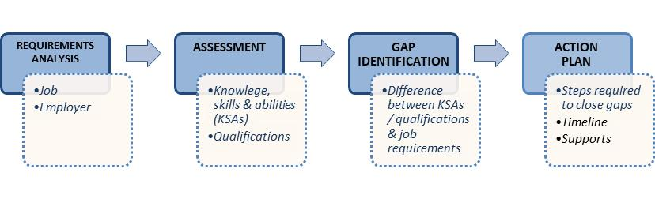
Figure 1: Skills gap analysis proves; Zoller and Preston, (2018).
In the first stage of the analysis process, I have to analyse the types of job I required and the target employer where I want to enter. I want to start my professional career in a multinational company. After this stage, I have to make a self-assessment by comparing the required skills I will need for the target job or employers. In the assessment process, I have compared my skills to the skills needed for getting a job in a multinational company. On the third stage, I found out some of my skill gaps in which improvement is necessary to get my expected job in the expected organisation. In the fourth stage, I prepared an action plan to improve my skills and to reduce the skills gap I have.

SWOT analysis:

Strength | - Academic knowledge  - Hard working  - Challenge taker  - Self-motivator  - Multi-tasking ability  - Knowledge about the current business world and economics  - Good at written communication and verbal communication.
Weakness | - Poor public speaking  - Lack of practical experience  - Workaholic  - Not changing mind during the middle state of a task even if it seems good to do that.  - Poor computer skills
Opportunities | - Leadership skills  - Good academic and business knowledge.  - Ability to cope up with the new situation
Threats | - Poor skills in digital technology  - Lack of public speaking skills  - Poor business presentation skills.

Personal development plan:
To develop my personal skills, I will follow a personal development process or cycle. The process will be started by identifying the personal development I will need for reducing the skill gaps. After identifying the skills I will have to improve, I will prepare a personal development plan to improve my skills. The third stage of the development plan is taking action i.e. implementation of the plan I prepared on the previous stage. In the third stage, I will get the results and compare it with my expectations. If my expected results will not be solved, I will take measures to achieve the expected development in my skill gaps.
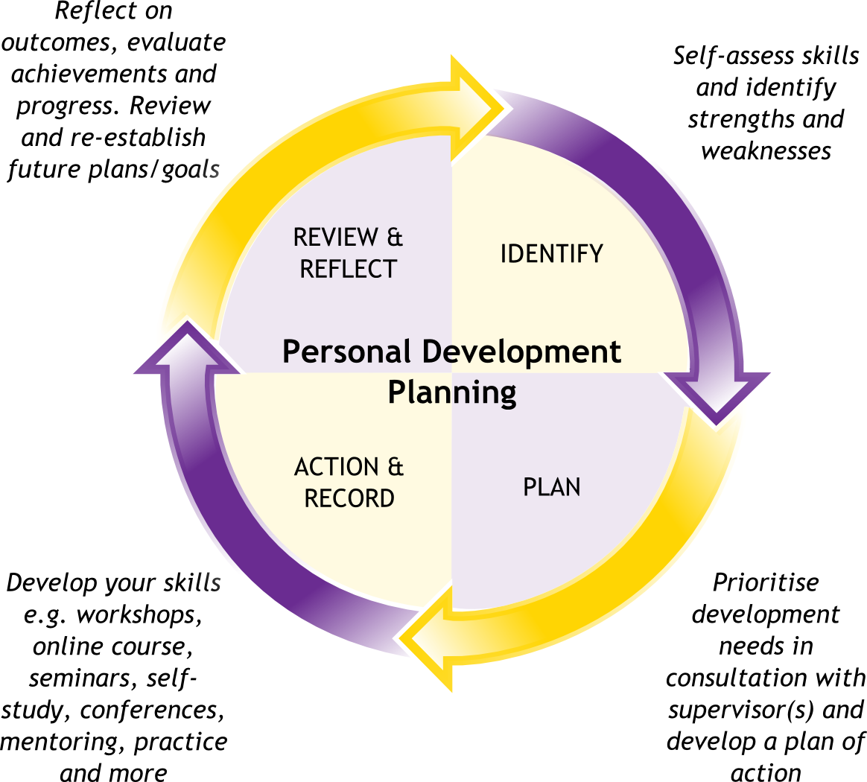
Figure 2: Personal development plan; Source: Adair and Allen, (2003)

Action plan:
To improve my skills, I have to prepare an action plan. From my SWOT analysis, I found that I have a weakness in public speaking, computer skills and communication skills. I have to try to make the development of this weakness for success in the professional career. The action plan will help to improve my skills. Here is my action plan:
Skills |  | Activities | Resources | Success criteria | Time
Public speaking |  | Public speaking courses, presentation courses, self-practice | Public speaking practising organisations and clubs. | Able to make a presentation in front of the public. | 3 months
Computer skills |  | Doing computer course and practising myself | Computer, software like MS Family, hardware, internet | Able to prepare a business plan using MS Excel and Word. Able to prepare a business presentation. | 2 months
Communication skills |  | Join in a communication development course and increase the extent of communication in daily life. | Communication development courses, internet. | Able to make an effective communication with a totally unknown person. | 5 months

Conclusion:
A student should be prepared for taking the challenge to do well in the professional career. It will be easy for them to get success if they have skills and knowledge. The easiest way of improving skills and gaining knowledge it taking care of these in the student life. In the student life, the students have huge time and they can use their time in developing themselves for taking the challenges of the professional life. For this, the students should identify their gap in skills and their weakness to improve those gaps and weakness. A proper action plan should be prepared by them to improve their skills and gaps to get success in the upcoming days.

References:
Adair, J. and Allen, M. (2003). The concise time management and personal development. London: Thorogood.
Caruso, D. and Salovey, P. (2014). The emotionally intelligent manager. San Francisco: Jossey-Bass.
Hind, D. and Moss, S. (2011). Employability skills. Sunderland: Business Education.
Overtoom, C. (2010). Employability skills. Columbus, OH: ERIC Clearinghouse on Adult, Career, and Vocational Education, Center on Education and Training for Employment, College of Education, the Ohio State University.
Qureshi, A. and Hassan, M. (2013). Impact of performance management on the organisational performance: An analytical investigation of the business model of McDonalds. International Journal of Academic Research in Economics and Management Sciences, 2(5).
Zoller, K. and Preston, K. (2018). Enhancing your executive edge.

