Article 19 of the UNCRC  “Governments must do all they can to ensure that children are protected from all forms of violence, abuse, neglect and bad treatment by their parents or anyone else who looks after them”.  (UNCRC, 2021).  The Best ways schools can provide support for children  - Nurturing sessions (breakfast clubs).  - Creative session such as music and art to promote positive mental health.  - After school clubs.  - A positve behaviour policy within the school.  - Safe and quiet areas in the school.  - Programmes to support anger management, mindfuleness.  - Regular meetings with parents. |  | Childline (Swansea)-01792 456545  Mind- 01792 642999  AADAS Swansea- 01792 530719  Social Services Swansea- 01792 775501 |  | 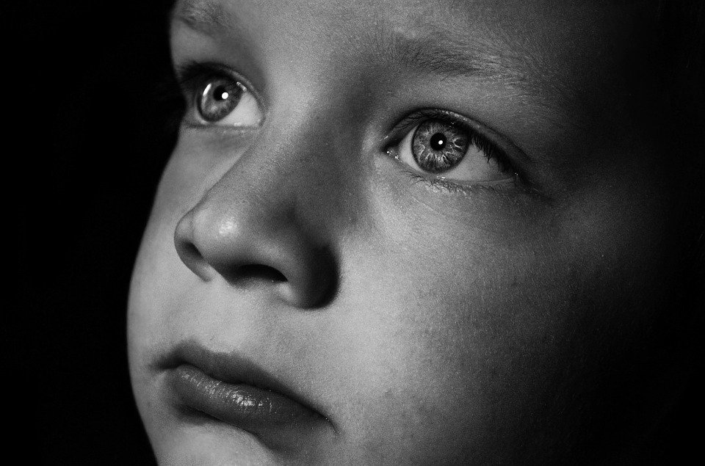  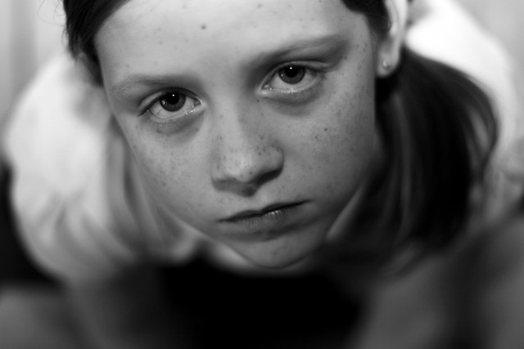
 | 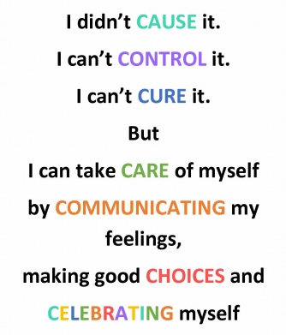
 |  |  |  | Keeping our children safe from ACEs
If you feel that you might be in an ACEs situation as a child or still are, then please do not suffer in silence, the support numbers below are landlines to someone that can help:
(Black, 2019).
What are Adverse Childhood Experiences? (ACEs)  According to public health wales (2021) Adverse childhood experiences is when an individual experience a traumatic event. This occurs in childhood or infancy and will drastically affect health and well-being of a person. |  | The lifelong and generational risks of toxic stress  According to Joining forces for children (2021) toxic stress affects children as they grow older and lead to many common health and behavioral issues later in life which are highlighted above. ACES alter the brain chemistry and lead to people being more prone to risk-taking behavior (Waite & Ryan, 2019).  As previously mentioned, ACES can lead to risk-taking behaviors. These behaviors can have a variety of negative impacts on people such as:            Physical and mental health  Severe chronic lung Depression stroke heart disease  obesity disease            Diabetes Cancer Suicide Broken STDs  Attempts bones            Behavioral  Smoking alcohol Lack of physical Drug abuse Missing s abuse activity work |  |  | “1 in 6 adults expereinced four or more types of ACEs”. (CDC, 2019).  Maslow’s Hierarchy of Needs
Starecheski (2015) highlights three categories in which ACEs can be identified, these are abuse, neglect, household dysfunction. Below, in the diagram it shows you what these ACEs may look like:  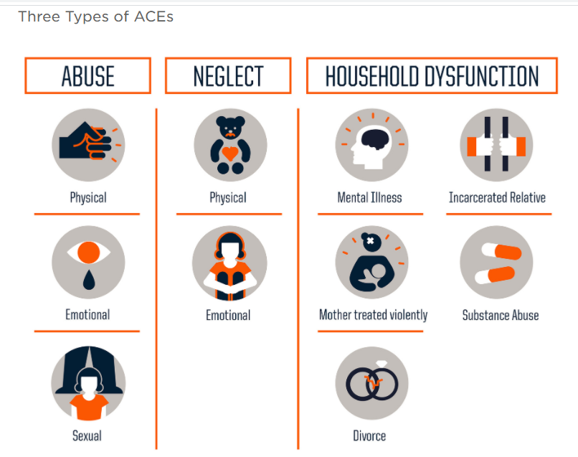 |  |  |  |  | 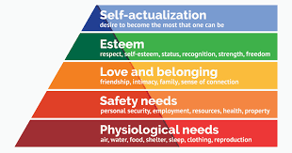  McLeod (2020) highlights Maslow’s hierarchy of needs, that if a child’s needs are not being met then there the path to self-actualization, the desire to become most than one can be, could be hindered. ACEs can cause a problem for this for example, if a child’s safety needs are not met, because of physical or sexual abuse then the next stage love and belonging could not be fulfilled, because the child will not trust and learn to form healthy friendships or relationships.  (McLeod, 2020).

REFERENCE LIST
Black. C (2019), The seven C’s helping kids cope with addiction. Eluna Network: United States. Available from:
https://elunanetwork.org/resources/coping-with-addiction-for-kids-the-seven-cs. [Accessed 26/03/21].
Centre for disease control and Prevention (2019) Adverse childhood experiences (ACEs): Preventing early trauma to improve adult health. CDC: United States. Available from:
https://www.cdc.gov/vitalsigns/aces/index.html#:~:text=1%20in%206%20adults%20experienced,by%20as%20much%20as%2044%25. [Accessed 26/03/21].

Grey. D (2020) Adverse childhood experiences (ACEs) - how can schools support children and young people who live in difficult circumstances? Estyn: Cardiff. Available from:
https://www.estyn.gov.wales/blog/adverse-childhood-experiences-aces-how-can-schools-support-children-and-young-people-who-live. [Accessed 26/03/21].
McLeod. S (2020), Maslow’s Hierarchy of Needs. Simple psychology. Available from:
https://www.simplypsychology.org/maslow.html. [Accessed 26/03/21].
Public health wales (2021) Adverse Childhood Experiences. NHS Wales: Cardiff. Available from:
https://phw.nhs.wales/topics/adverse-childhood-experiences/#:~:text=What%20are%20Adverse%20Childhood%20Experiences,and%20well%2Dbeing%20of%20people. [Accessed 25/03/21].
Starecheski. L (2015) Take the ACE quiz-and learn what it does and Doesn’t mean. NPR. United Kingdom. Available from:
https://www.npr.org/sections/health-shots/2015/03/02/387007941/take-the-ace-quiz-and-learn-what-it-does-and-doesnt-mean. [Accessed 26/03/21].
UNCRC (2021), What is the UNCRC: Article 19: Protection from violence, abuse and neglect. UNCRC. United Kingdom. Available from:
https://www.unicef.org.uk/what-we-do/un-convention-child-rights/ [Accessed 27/03/21].
Waite. R & Ryan. R (2019), Adverse childhood experiences, Routledge, Oxon.

Rationale
The purpose of this rationale is to highlight key policies and procedures, such as the children’s act; every child matter and the UNCRC, when dealing with safeguarding and child protection issues, with evidence and research to back up points made. This rationale will include definitions and how policies have evolved over time. This rationale will also look at how systems have failed with the result of two children being murdered at the hands of family members, and failed by the system, which will then discuss the Laming report for both cases. This rationale will also look at the barriers between multi-agencies and how schools promote child welfare. This rationale will also look at a leaflet on safeguarding children from ACEs and the importance of raising awareness about this issue.
According to the NSPCC (2021) Safeguarding is defined as the action taken to promote the welfare of children and protect them from harm. The NSPCC also state safeguarding means to protect children from abuse and maltreatment, to prevent harm to a child’s health and development, the child will grow up with the provision of a safe and effective care, and the child has the best outcomes in life. According to Hooper (2020), Maslow’s Hierarchy of needs can easily be incorporated in the definition of safeguarding, for example a child needs to feel safe and if they do not feel safe then the child will grow up not being able to love and trust and build relationships or even form friendships. According to Hall (2013) there is no clear definition of child protection, safeguarding refers to all children, however child protection distinctly refers to a child at risk of harm. With the two definitions in mind, it is paramount to have policies and procedures in place to ensure a child can fulfil milestones and prosper in a safe environment.
According to Evans (2013) the children’s act 1989 gave the child rights to protection from abuse and exploitation and the right to enquiries when there are safeguarding concerns. The key points that Evans highlights of the children’s act is the best place for a child to stay is their home; the welfare of the child is the paramount consideration; parents are to be involved in any legal proceedings regarding their children; partnership between parents and the local authority should promote the welfare of the child; the child’s needs arising from race, culture, religion and language must be taken into account and children should not be removed from their family or contact terminated, unless it is absolutely necessary to do so. With this policy in place children should and will be safe, however this was not the case.
According to Holt (2001) Victoria Climbie was eight years old when she died in the hands of her aunt and her aunt’s boyfriend. Holt also stated that there were numerous occasions where Victoria could of be saved, on her many visits to two hospitals, been seen by doctors; nurses; social workers; police and so, this little girl’s suffering did not need to go on for the timeline that it did. Following this, the Victoria Climbie enquiry, which was conducted by Lord Laming in 2003, it was brought to light how many professionals were involved, but did nothing:
“But Victoria’s case was altogether different. Victoria was not hidden away. It is deeply disturbing that during the days and months following her initial contact with Ealing Housing Department’s Homeless Persons’ Unit, Victoria was known to no less than two further housing authorities, four social services departments, two child protection teams of the Metropolitan Police Service (MPS), a specialist centre managed by the NSPCC, and she was admitted to two different hospitals because of suspected deliberate harm”. (Laming, 2003, pg. 15).
The inquiry brought about many recommendations that needed to happen to ensure that what happened to Victoria, did not happen again, recommendations such as better communication, better IT systems and information sharing between professionals. Every child matter (2003) framework came into place, section 4, which highlights early intervention and effective protection. With Victoria in mind, this section looked at improving information sharing, establishing a common assessment framework (so the information will follow the child and not be duplicated), there would be an identified lead professional to take the lead on each child’s case, there would be an integration of professionals and a co-locating service in and around schools such as flying start and so on, so there was early monitoring of children, and support for the family.
The 1989 children’s act was amended in 2004. According to the Welsh government (2016) the children act 2004 builds on and strengthens the framework set out in the children act 1989. The main amendment to the framework, was that it was everyone’s responsibility to safeguard children and protect them from harm. This statement is back up by the UNCRC, section 19:
“Governments must do all they can to ensure that children are protected from all forms of violence, abuse, neglect and bad treatment by their parents or anyone else who looks after them”. (UNCRC 21).
Unfortunately, with the frameworks and legislations being altered and the Laming report filled with many recommendations to better the social service, police and medical systems, another child lost their life at the hands of his parents. According McNicoll (2017) baby Peter Connelly (AKA baby P), died in 2007 after suffering months of abuse, he suffered more than fifty injuries. Lord Laming conducted a report into Baby Ps case, and found that, once again another child was failed by professionals, and could have been saved on many occasions. Laming (2009) states that every child matter is the way forward and that integrated services is best outcome to ensure the safety and welfare of children.
Cleaver et al (2009), highlights that effective collaboration between professionals is the cornerstone to a successful children’s safeguarding system. According to the Welsh government (2017) the families first program was appointed to improve outcomes for children, young people, and families. It places an emphasis on early intervention, prevention, and providing support for whole families, rather than individuals. The program promotes greater multi-agency working to ensure families receive joined-up support when they need it. The intention of the program is to provide early support for families with the aim of preventing problems escalating. Smith (1999) argues that a multidisciplinary team often involve disagreement over ideas, theories, opinions, and attitudes can affect the outcome of safeguarding situations. As previously mentioned, the effect of poor multidisciplinary team’s collaboration results in the loss of children’s lives.
Schools play a vital role in the safeguarding and protection of children. According to the DfE (2020) the roles and responsibilities of staff within school include identifying concerns early, provide help for children and prevent concerns from escalating. The DfE also state that all staff should provide a safe environment for the child thrive and learn. Any staff member who has a child protection concern should follow the protocols set out within their setting, the designated safeguarding lead or deputy should be informed, and records kept for evidence purposes should the situation merit further investigation. For schools to promote positive welfare the DfE also state that staff should be aware of the child protection policy, behavior policy, the code of conduct, the safeguarding response to children who go missing from education and everyone is aware who is the safeguarding lead and deputy. Training and awareness are imperative in safeguarding issues, staff also should have the standard two year child protection training in order to understand the ever evolving cruelty and dangers that poses a threat to children and young people.
The reason I chose Adverse Childhood Experience (ACEs) as a subject to talk about within my leaflet, is to raise awareness on a very broad problem that affects one in six adults. ACEs covers so many child protection issues that can affect a child, which can lead to very traumatic and life changing choices, which can affect a person’s health and mental health. The leaflet is aimed at people aged from 12 upwards and can be utilized within school settings, doctor’s surgeries, its easy to follow and breaks down the effects of ACEs in diagram form for people who may have difficulty reading. The leaflet is also aimed at professionals who work in a school, the section which relates to what schools can do to help support children is a quick and easy checklist education professional can look at and relate back should the need for it occurs. The leaflet breaks down Maslow’s hierarchy of needs to show how important each is for a person to feel self-actualization and worth, and by experiencing ACEs this can hinder that. At the back of the leaflet, there are helplines numbers for children and adults who may be suffering the effects of ACEs, and at the end is a statement which is meant to empower and make people mindful that the situations in which they find themselves are not their fault. Unfortunately, it is out of their control; however, by raising awareness it will hopefully help them make positive choices for themselves and provide a better future for their own family; thus, not causing a domino effect and history repeating itself. Due to the leaflet being applicable to many people and professionals, it is clear to say it is a versatile and informative resource to be utilized.
To conclude this rationale, it is evident to say that safeguarding and child protection policies are ever evolving to ensure that the safety and welfare of children are met. The children’s act (1989) is a key policy in which the recent policies and frameworks have bloomed. Evidently, because of the death of two children, it does highlight the important factor that communication and collaboration is lacking across all professionals involved. The Laming report on both cases made recommendations to back up the salient point just made, and I would like to think that these recommendations have been highly considered and that effective practices will take place. Every child matter (2003) was a positive reflection that Laming recommendations were being implicated and that multidisciplinary teams are becoming widely utilized all over the UK and around the world, to ensure the safety and welfare of all children. The UNCRC is clearly seen throughout safeguarding frameworks, also Maslow’s hierarchy of needs can clearly be incorporated into safeguarding, if the child is suffering from abuse then the need for love and belonging could be hindered due to the break down of trust. Schools play a vital role in the safety and protection of children; it is paramount that early intervention takes place to ensure support and care are there for the child and their family. Collaboration, training, and information sharing key tools when it comes to child protection and safeguarding issues.

Reference
Cleaver. H et al, (2009), Safeguarding Children: A Shared responsibility. Wiley-Blackwell: West Sussex.
DfE (2021), Keeping Children Safe in Education. Department for Education. England. Available from:
https://assets.publishing.service.gov.uk/government/uploads/system/uploads/attachment_data/file/954314/Keeping_children_safe_in_education_2020_-_Update_-_January_2021.pdf. [Accessed 27/03/21].
Evans. M (2013) Policy Guide: Children act 1989 Amended 2004. MA Education Limited: Wales. Available from:
https://www.nurseryworld.co.uk/features/article/policy-guide-children-act-1989-amended-2004 [Accessed 27/03/21].
Hall. A (2013) Safeguarding in Schools: Protecting Children. Reducing risk: Definition of Child Protection. Generate Press: United Kingdom. Available from:
https://www.safeguardinginschools.co.uk/definition-of-child-protection/ {Accessed 27/03/21].
HMSO (2003) Every child matter. HMSO. United Kingdom. Available from.
https://assets.publishing.service.gov.uk/government/uploads/system/uploads/attachment_data/file/272064/5860.pdf. [Accessed 27/03/21].
Hopper. E, (2020), Maslow’s Hierarchy of needs Explained. Thought Co: United States.
Laming. L (2003) The Victoria Climbie Inquiry, section 1.16, pg16. HMSO. United Kingdom.
Laming. L (2009), The Protection of Children in England: A Progress Report. Democracy and Governance: England. Available from:
https://democracy.medway.gov.uk/Data/Children%20and%20Adults%20Overview%20and%20Scrutiny%20Committee/20091022/Minutes/och20091022r-14.pdf. [Accessed 27/03/21].
McNicoll. A (2017), Ten years on from Baby P: Social Work’s story. MA Education: Wales. Available from:
https://www.communitycare.co.uk/2017/08/03/ten-years-baby-p-social-works-story/. [Accessed 27/03/21].
NSPCC (2021), Safeguarding Children and Child Protection. NSPCC: United Kingdom. Available from:
https://learning.nspcc.org.uk/safeguarding-child-protection#:~:text=Safeguarding%20is%20the%20action%20that,to%20children's%20health%20or%20development&text=taking%20action%20to%20enable%20all,to%20have%20the%20best%20outcomes. [Accessed 27/03/21].
Smith. K (1999) Managing Conflict in Multidisciplinary Teams. Asee. Minnesota. Available from:
file:///C:/Users/CG/Downloads/managing-conflict-in-multidisciplinary-teams%20(2).pdf. [Accessed 27/03/21].
Welsh Government (2016) Responsibilities under the Children Act 1989, and the Children act 2004. Welsh Government: Cardiff. Available from:
https://law.gov.wales/publicservices/social-care/Local-authority-responsibilities/Safeguarding/safeguarding-children/responsibilities-under-children-act-1989-and-children-act-2004/?lang=en#/publicservices/social-care/Local-authority-responsibilities/Safeguarding/safeguarding-children/responsibilities-under-children-act-1989-and-children-act-2004/?tab=overview&lang=en [Accessed 27/03/21].

